

Student name: Bahja Salah
Student ID: 2438654
Module name: Introduction to Public Health
Module code: (LCHS4008_LON)
Lecturer name: Patronella Ganza

Introduction.
For this report it focuses on Heart disease.
This assignment will explore its causes, symptoms, prevention strategies, and treatment options in detail and I will explain the factors influencing the health and wellbeing of people affected by the disease/condition and people around them.

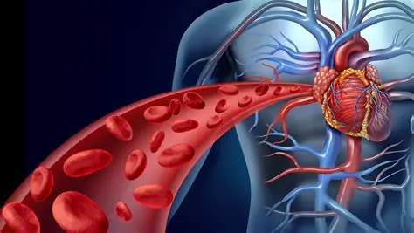

Definition of Heart Disease.
Heart disease is defined as a range of conditions that affect the heart’s structure and function, including coronary artery disease, heart failure, arrhythmias, and valvular heart disease. It forms the core of cardiovascular diseases, which are disorders of the heart and blood vessels and represent the leading cause of death globally. From a public health perspective, heart disease is particularly significant because the majority of cases are preventable through lifestyle modifications and upstream interventions targeting behavioural and environmental risk factors. (World Health Organization, 2023).
One of the primary causes of heart disease is the buildup of fatty deposits, known as plaque, in the arteries, a condition called atherosclerosis. This buildup can restrict blood flow, leading to serious complications such as heart attacks and strokes. Other risk factors include high blood pressure, high cholesterol levels, smoking, obesity, lack of physical activity, and unhealthy diets. (NHS, 2024).
Heart disease can develop over time and may not show symptoms in its early stages, making it particularly dangerous. However, it is often preventable through lifestyle changes such as maintaining a balanced diet, regular exercise, avoiding tobacco, and managing stress. (NHS, 2024)
Causes of Heart Disease.
Heart disease can be caused by a variety of factors, including lifestyle habits and medical conditions. The main causes include: (Centers for Disease Control and Prevention, 2024)
- Unhealthy diet, High intake of fatty, salty, and processed foods
- Lack of physical activity, leads to obesity and weakens the heart
- Smoking, damages blood vessels and reduces oxygen supply
- Excessive alcohol consumption
- High blood pressure (hypertension)
- High cholesterol levels
- Diabetes
- Obesity
Some risk factors, such as age, family history, and genetics, cannot be controlled. However, many causes are related to lifestyle and can be managed. (American Heart Association, 2024).
Symptoms of Heart Disease:
The symptoms of heart disease vary depending on the type, but common signs include:
Chest pain or discomfort (angina)
Shortness of breath
Fatigue or weakness
Dizziness or fainting
Swelling in the legs, ankles, or feet
Irregular heartbeat (palpitations)
In some cases, heart disease may not show noticeable symptoms until a serious event, such as a heart attack, occurs. (World Health Organization, 2023).

Levels of Incidence Demonstrating Severity (Worldwide and UK)
Heart disease is considered a major global health issue due to its extremely high incidence, prevalence, and mortality rates. Statistical data clearly demonstrates the severity of this condition both worldwide and within the United Kingdom. (NHS, 2024)
Worldwide Statistics.
Globally, heart disease (cardiovascular disease) is the leading cause of death, highlighting its serious impact on public health.
- Around 19.4 million people died from cardiovascular diseases in 2021
- Approximately 612 million people worldwide are living with cardiovascular disease, heart disease accounts for about one-third of all global deaths
- The number of cases has more than doubled since 1990, showing a rapidly increasing burden
- These figures demonstrate that heart disease is not only widespread but also increasing due to factors such as ageing populations, poor diet, obesity, and physical inactivity.
(World Health Organization, 2023)
United Kingdom Statistics
In the United Kingdom, heart disease also represents a significant health concern:
- Cardiovascular disease causes around 1 in 4 deaths in the UK (British Heart Foundation data)
- Millions of people in the UK are currently living with heart and circulatory diseases
- Coronary heart disease remains one of the most common causes of death in England
- Although death rates have declined over time due to better treatment, the overall number of cases remains high (World Health Organization, 2023)
What These Statistics Show
- These incidence and prevalence levels clearly demonstrate that heart disease is:
- A global epidemic affecting hundreds of millions
- A leading cause of death, both worldwide and in the UK
- A long-term health burden, with many people living with the condition
- A preventable disease in many cases, linked to lifestyle factor
(World Health Organization, 2023)

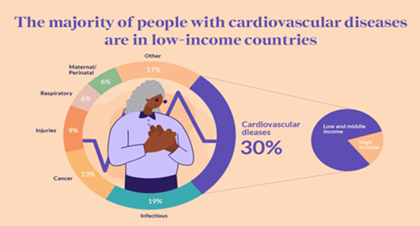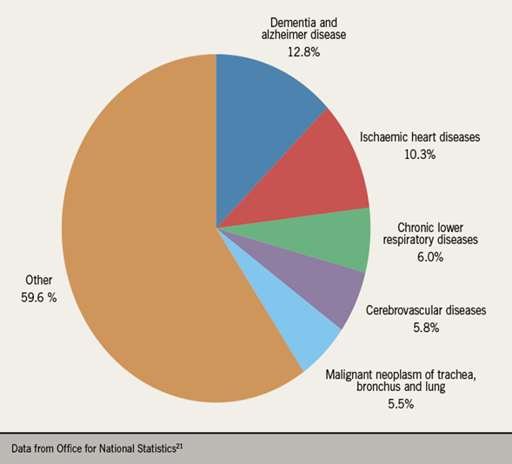

Implications, Influencing Factors, and Professional Collaboration in Heart Disease
Implications of Heart Disease in Communities
Heart disease has wide-ranging effects not only on individuals but also on families and entire communities. (British Heart Foundation, 2025)
Increased healthcare demand: Hospitals and clinics face pressure due to the high number of patients needing long-term treatment, surgeries, and emergency care. (British Heart Foundation, 2025)
Economic burden: Treatment costs, medications, and hospital stays are expensive, placing financial strain on individuals, families, and healthcare systems such as the NHS. (NHS, 2024)
Reduced productivity: People suffering from heart disease may be unable to work or may retire early, reducing workforce productivity.
Impact on families: Family members often take on caregiving roles, which can lead to emotional stress and financial difficulties. (NHS, 2024)
Health inequalities: Communities with lower income or limited access to healthcare are more affected, increasing social inequality.
Overall, heart disease significantly impacts the quality of life and wellbeing of communities.
2. Factors Influencing Health and Wellbeing.
Several factors influence the health and wellbeing of people with heart disease and those around them:
- Physical Factors
Existing conditions such as high blood pressure, diabetes, and obesity (NHS, 2024)
Age and genetic predisposition
Physical inactivity
- Lifestyle Factors
Poor diet (high in fats, salt, and sugar)
Smoking and alcohol consumption
Lack of exercise
- Psychological Factors
Stress, anxiety, and depression can worsen heart conditions
Fear of illness or death may affect mental wellbeing
- Social Factors
Family support or lack of it
Income level and employment status
Education and awareness about health
- Environmental Factors (Centers for Disease Control and Prevention, 2024)
- Living conditions (e.g., overcrowding, pollution)
- Access to healthcare services and facilities
These factors can either improve or worsen the condition, showing that heart disease is influenced by more than just physical health. (Centers for Disease Control and Prevention, 2024)
3. Collaboration Between Healthcare and Social Care Professionals.
Ways to Collaborate Effectively
- Multidisciplinary teams (MDTs): Doctors, nurses, dietitians, physiotherapists, and social workers work together to provide holistic care.
- Clear communication: Sharing patient information and care plans ensures continuity of care.
- Person-centred care: Professionals involve patients in decision-making about their treatment and lifestyle changes. (Public Health England, 2023)
- Care coordination: Linking hospital care with community and home-based services helps patients recover and manage their condition.
- Health education: Professionals work together to educate patients and families about prevention and self-care. (Public Health England, 2023)
Support services: Social workers can help with financial support, housing, and emotional wellbeing.
Benefits of Collaboration.
- Improved patient outcomes and quality of life
- Reduced hospital admissions
- Better management of long-term conditions
- Stronger support systems for patients and families
(NHS, 2024)
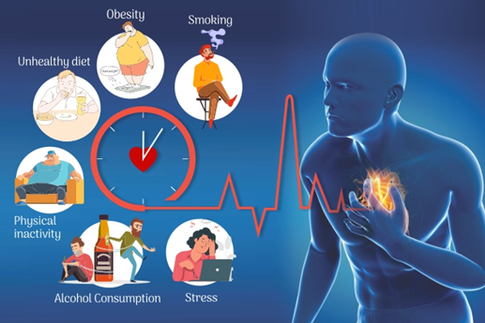

Conclusion
In conclusion, heart disease remains one of the leading causes of death worldwide, yet it is largely preventable through lifestyle changes, early detection, and effective medical intervention. By addressing modifiable risk factors such as poor diet, physical inactivity, smoking, and unmanaged stress, individuals can significantly reduce their chances of developing cardiovascular complications. Public health initiatives, combined with personal responsibility, hold the key to reversing current trends and ensuring healthier futures for generations to come. (World Health Organization, 2023).
Ultimately, the fight against heart disease is not just a medical challenge, it is a societal responsibility. Every healthy choice we make, from the food we eat to the way we manage stress, is a step toward protecting our hearts. Governments, healthcare providers, and communities must work together to promote awareness, improve access to care, and encourage preventive habits. The time to act is now, because every heartbeat matters.
(NHS, 2024)
Heart disease statistics may be measured in numbers, but behind each figure is a life, a family, and a story. Understanding the causes and prevention of cardiovascular illness is not simply about science, it is about preserving moments, relationships, and futures.
(World Health Organization, 2023).



References
World Health Organization (2023) Cardiovascular diseases (CVDs). Available at: https://www.who.int/news-room/fact-sheets/detail/cardiovascular-diseases-(cvds)
British Heart Foundation (2025) UK factsheet: Heart and circulatory disease statistics. Available at: https://www.bhf.org.uk
NHS (2024) Heart disease. Available at: https://www.nhs.uk/conditions/cardiovascular-disease/
Centers for Disease Control and Prevention (2024) Heart disease facts. Available at: https://www.cdc.gov/heartdisease
American Heart Association (2024) Heart disease and stroke statistics update. Available at: https://www.heart.org
Public Health England (2023) Health matters: preventing cardiovascular disease. Available at: https://www.gov.uk
National Institute for Health and Care Excellence (2023) Cardiovascular disease prevention. Available at: https://www.nice.org.uk
Office for National Statistics (2024) Causes of death in the UK. Available at: https://www.ons.gov.uk
Global Burden of Disease Study (2023) Global cardiovascular disease data. Available at: https://www.healthdata.org
European Society of Cardiology (2023) Cardiovascular disease statistics in Europe. Available at: https://www.escardio.org
British Medical Journal (2022) Cardiovascular disease research and reviews. Available at: https://www.bmj.com
National Heart Lung and Blood Institute (2024) Heart disease overview. Available at: https://www.nhlbi.nih.gov
Heart Research UK (2023) Heart disease prevention and lifestyle advice. Available at: https://www.heartresearch.org.uk
Stroke Association (2023) Stroke and cardiovascular disease information. Available at: https://www.stroke.org.uk

