University of Wales Trinity Saint David

Wales Institute of Science and Art



Project Planning

Engineering Management (ACHA5012)

Oska Robertson
2301207
23/10/25

Contents
1. Introduction 3
2. Team Roles 3
3. Group Tasks and Timings 4
4. Personal Tasks 5
5. Project Milestones 6
6. Areas of concern and risk mitigation 6
7. Gantt Charts 6
8. References 8

Introduction

For this project, the team will be working on preparing a 1987 Yamaha FZR 1000^{1.1} for endurance racing. We aim to address current issues with the machines performance by performing routine repairs and maintenance to return the bike to a performance level that it would have possessed when it was built. As well as this, we aim to design and develop some performance improvements for the bike to gain a competitive edge.

As well as focusing on improving the performance of the motorcycle, we also need to ensure the bike complies to the regulations of the endurance series that we intent to enter, otherwise the effort put into the project will be futile. We are currently planning on entering the bike into a no limits^{1.2} category, which will give us much more freedom to institute changes that we see fit, as we only need to comply to ACU rules for safety.^{1.3} Due to the age of the bike we will be able to race in the classic bike category,^{1.4} which can allow further freedom in modification, as the rules are more relaxed.

Team Roles

For this project, I will be taking on the role of ensuring the bike is prepared to race and is in accordance with the regulations of the chosen racing event. I will find and install all necessary parts, as well as ensuring other team members contributions are also legal for racing. For this role, the ideal traits from Belbin’s model would be the monitor evaluator or specialist. The monitor evaluator role will be essential as impartial judgement, and logical viewpoint will be essential to ensure all regulations will be followed correctly.^{2.1} The specialist type is also important as I will need to bring an in-depth knowledge of the regulations.^{2.2}

Daniel will be working towards installing necessary sensors to gain vital telemetry data. He will also be in charge of making sure these components are placed on the bike in a manner that they will avoid damage in the event of a crash.

Moses is filling the role of team leader, as well as working on a new exhaust system. For the exhaust system, he will be primarily looking at the headers and collectors, as well as the wiring of the bike if necessary.

Finn will be in charge of the engine and suspension of the bike. He will start with essential maintenance such as checking valve clearances and then progress onto other modifications for the bike which will result in increased performance on the track.

Group Tasks and Timings

As a group, there are many tasks that require the whole team to complete as they take a significant amount of time and effort, as well as restricting further work until these tasks are completed. Because of this, a strict time schedule needs to be kept ensuring that the project can be completed on time.
The first group task will be the disassembly of the bike. We had to disassemble all of the fairings and bodywork of the bike to access the internal components that need to be worked on. The two main focuses here were removing the suspension and engine from the bike. During disassembly we also noticed that the frame was cracked and will require welding at a later date to ensure the safety of the bike. For this disassembly we allowed ourselves a week between the thirteenth and twenty-first of October.
Next, we had some meetings to decide on the direction of the project once we were able to analyse the current condition of the bike. During this time, we decided which elements of the bike we would each take responsibility of, as well as deciding on timings and coordination. These discussions occurred simultaneously with research and the checking of valve clearances.
The group spent some time in the engine workshop between the 23rd and 29th of October to check the valve clearances. The initial Disassembly went well, but we got stuck when attempting to turn the engine over to align the crankshaft to TDC for correct valve clearances. Once we were able to get it into position and check the valves, we could measure them with feeler gauges and confirmed that the clearances were still correct. After this we reassembled the engine, ready to be reinstalled into the bike.
The next step for the group will be everyone moving on to their individual research and development for their assigned areas of the project. This will also include any CAD designs for the project areas that will require it. For this period, we have allowed the time frame of the 5th of November until the 1st of January.
After this we can consolidate and assess our prototypes for their effectiveness. We have allowed a large amount of time for this section as if there are any issues with the components that arise during the testing stage, we will need time to return to CAD, redesign and reproduce the components to the correct specifications. The timeframe for this will also overlap with the design phase as these sections are partially integrated. We have allowed the time between the 1st of December and 28th of February.
Once prototyping is completed, all of the existing and new components can be installed back onto the bike. During this process we will also need to fix the crack in the frame. We plan for the reassembly of the bike to take a significant amount of time and therefore have left open the period of the 2nd of January until the third of march to make sure this process is completed accurately and on time.
Once the bike is completed, we have also allowed some time for some on track testing to make sure all of the parts are functioning correctly and the bike is race ready. During this time, I will also verify that the bike is legal to race in our chosen series. This will take place between the 8th and 10th of March.
Finally, we have allocated time between the 10th and 24th of march to prepare our presentation for our final viva. This time will be split up between creating group slides, individual slides, and practicing our presentation to ensure it will be able to fit within the allotted time.

Personal Tasks

My area of the project started with researching the rules for our chosen racing series. This proved to be more difficult than initially thought as the rules proved difficult to find. I started my search by visiting the No Limits Racing website^{4.1}. This, however, proved to be fruitless as the website had no easy links to the ruleset. After some further digging I managed to find a 2014 edition of the rules ^{4.2} which after some further searching proved to be the most recent version of the ruleset. These rules also pointed to the ACU rules as these govern all racing in the UK. This took about 2 weeks as I was researching the rules alongside assisting the team with valve clearances as well as discussing future plans for the project. The only resources I needed for this section was the use of my laptop and an internet connection, both of which I already had possession of so no further costs were required. This section took place between the 6th and 29th of October.
After this was completed, I took a break from the project to travel home for Halloween and unfortunately suffered from a sprained ankle shortly after. This led to me missing some time on the project.
Once I returned to the project, I got to work with creating a parts list of the required parts needed to get the motorcycle ready for endurance racing on track. This will include parts such as rain lights, oil sealing and replacing glass components to ensure that they do not cause any hazards on track in the result of a crash or breakage. These parts should cost around £3000, and this section should run from the 6th to 17th of November.
After this we decided to leave some time free for us to work on other projects, as we have four assignments due within a 4-week period between the 17th and 30th of November.
After these assignments have been completed I, as well as the other team members, will switch our focus to preparing for our interim viva presentation. During this time, I will be creating slides and practicing my sections to ensure it is of the correct length and quality necessary. We have allowed the time between the 31st of November and 8th of December to complete this presentation.
After the presentation is complete, we will take a break from the project for the Christmas season and on return to university in January we will begin with the prototyping and building phase of the project.
On return to university, we will start our individual tasks for this project. For me this will include acquiring and designing racing parts such as an oil sealing system, rain lights, wheel release systems and possibly an expanded fuel tank and radiator. This section should be completed by the 15th of February. As well as this, I will be assisting the team with reassembling the bike, and this task will be completed in the same timeframe. I will also need to install my race specific components onto the bike during this timeframe.
After this I can assess my components are working effectively during the track testing phase which will occur between the 8th and 10th of March.
Finally, I can work on my section of the final presentation, which is due on the 24th of March.

Project Milestones
To ensure this project is completed efficiently and on time, we have set a few project gateways and milestones for this project to be completed successfully. The first of these will be the complete disassembly of the bike, which will be completed by the 19th of October. This section will be considered complete when all components are removed from the frame of the motorcycle.
The next two milestones are closely related to each other, and these will be engine reassembly and refitting to the frame of the motorcycle. These tasks should be completed by the 10th of November and 4th of December, respectively.
After this, the following milestones will be getting the engine to run as well as a complete reinstallation of all parts of the motorcycle. These will be completed on the 4th and 14th of December.
The final milestone will be on the 28th of February, and this will be a complete and successful test of the motorcycle on track, confirming the bike will be ready to compete.

Areas of concern and risk mitigation

One area of concern for my project is effectively using the allocated time to complete the project. I have occasionally struggled with making sure projects are completed within the allotted timeframe, which leads to inadequate quality or missed deadlines. To mitigate this risk to the project, I will ensure I stick to the predefined project timeline, objectives and milestones as laid out by the groups Gantt chart to ensure the project is completed on time. Additionally, I will ensure sections are started in a timely manner to ensure the quality of the work does not suffer due to being rushed to completion in a shorter than necessary timeframe.
A second area of concern for this project is the age of the motorcycle. As this bike is an older model, there may be certain issues that arise during testing and building that could make this project more difficult. One example of this that has already arisen is the cracked frame. We plan to avoid this issue by welding the crack to make the frame structurally sound. As well as this, other issues could arise if we find a damaged component in the motorcycle. Typically, this could be fixed by purchasing a replacement for the broken component, but due to this bike being out of production, it could prove difficult to find a commercially available replacement. To mitigate this risk to the project, we will ensure that no component becomes damaged during work, and if a broken part is unable to be replaced by purchasing it from a supplier, we can also manufacture the parts ourself with some time spent in CAD, and produced using Mills, Lathes, or CNC machining.

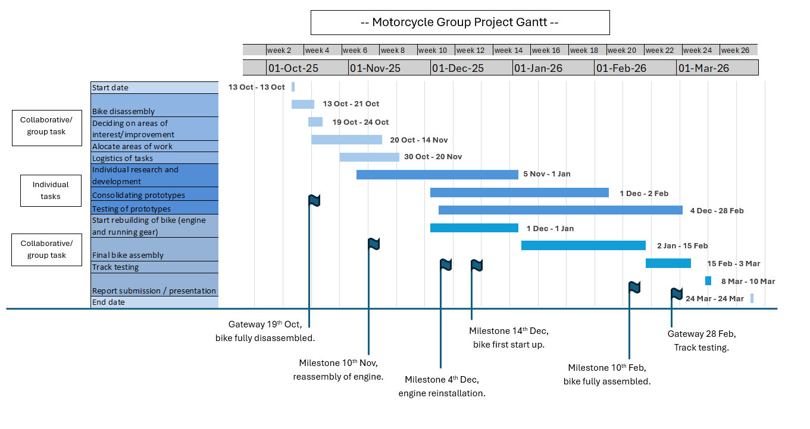
Gantt Charts

References

  - - Yamaha-motor.com. (2025). 1987 FZR1000 - Communication Plaza | Yamaha Motor Co., Ltd. [online] Available at: https://global.yamaha-motor.com/showroom/cp/collection/fzr1000 [Accessed 23 Oct. 2025].
  - 5.2.4 2014 NO LIMITS RACING TECHNICAL REGULATIONS. (2013). Available at: https://nolimitstrackdays.com/media/wysiwyg/nlr-docs/2014_Technical_Rules_NLR_V1_1_.pdf [Accessed 23 Oct. 2025].
  - ROAD RACING STANDING REGULATIONS. (n.d.). Available at: https://www.acu.org.uk/Uploaded/1/Documents/2024%20Paperwork/Handbook/Updated/2024-Road-Racing-Standing-Regulations-Final.pdf [Accessed 23 Oct. 2025].
  - 2024 ACU Classic Enduro Championship Regulations(2024) Available at: https://www.acu.org.uk/Uploaded/1/Documents/2024%20Enduro/2024-ACU-CLASSIC-ENDURO-CHAMPIONSHIP.pdf [Accessed 23 Oct. 2025].
2.1 Belbin (2025). The nine Belbin team roles. [online] Belbin. Available at: https://www.belbin.com/about/belbin-team-roles.
2.2 Belbin (2025). The nine Belbin team roles. [online] Belbin. Available at: https://www.belbin.com/about/belbin-team-roles.
‌4.1 - Nolimitsracing.co.uk. (2025). Home - No Limits Racing 2026. [online] Available at: https://www.nolimitsracing.co.uk [Accessed 23 Nov. 2025].
‌4.2 - 5.2.4 2014 NO LIMITS RACING TECHNICAL REGULATIONS. (2013). Available at: https://nolimitstrackdays.com/media/wysiwyg/nlr-docs/2014_Technical_Rules_NLR_V1_1_.pdf.
‌

