Name Matthew French
Student Number 1905094

Human Evolution and the Origins of Modern Human Behaviour

Practical exercise 2021

Please indicate your response clearly

Looking at faces 1
Look at the following images and then compare them to the list below. Indicate clearly (circle or highlight) the name of the early hominin skull you believe this to be.
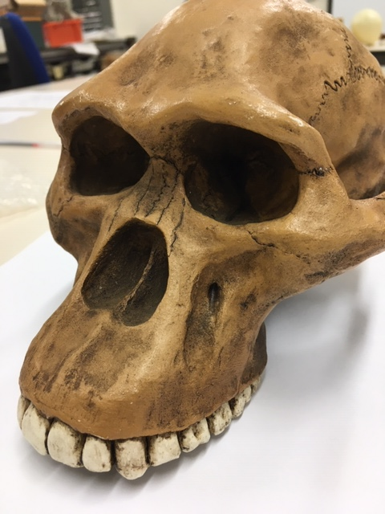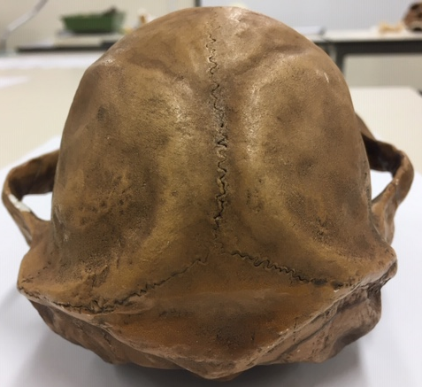

Chimpanzee

Australopithecus afarensis

Australopithecusafricanus

Australopithecus robustus

Homo habilis
Looking at faces 2
Look at the following images and then compare them to the list below. Indicate clearly (circle or highlight) the name of the early hominin skull you believe this to be.
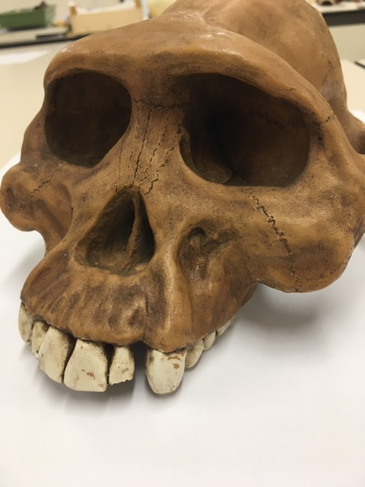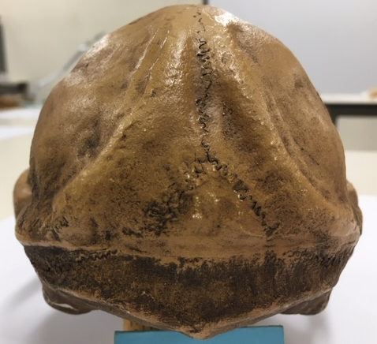

Chimpanzee

Australopithecus afarensis

Australopithecusafricanus

Australopithecus robustus

Homo habilis

Looking at faces 3
Look at the following images and then compare them to the list below. Indicate clearly (circle or highlight) the name of the early hominin skull you believe this to be.
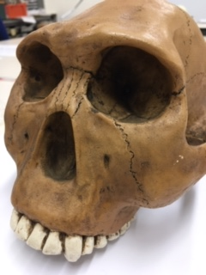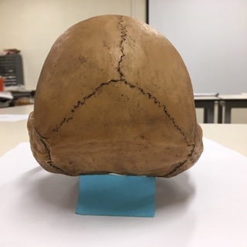

Chimpanzee

Australopithecus afarensis

Australopithecusafricanus

Australopithecus robustus

Homo habilis
Maxilla (upper jaw): Identify the species these belong to
A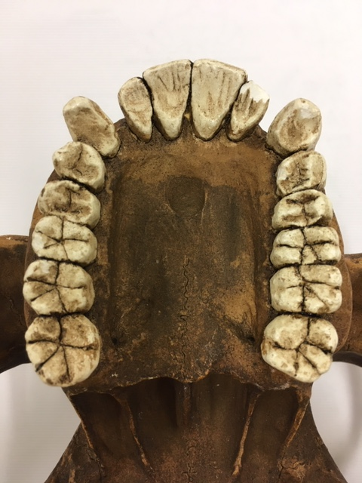B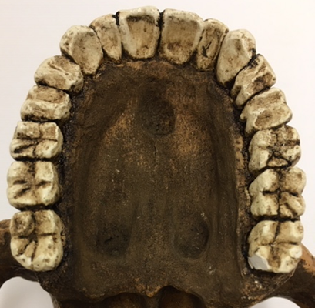
A middle austropithicus afrensis B modern human
Top row left Chimpanzee, Middle Australopithecus afarensis, Right modern human
Lower row Left Australopithecus africanus, Right Australopithecus robustus
Indentify the skull to genus and species level
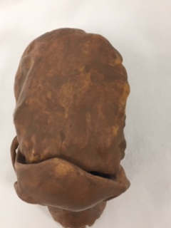
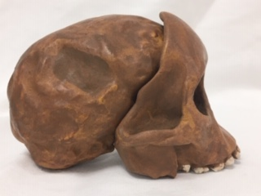
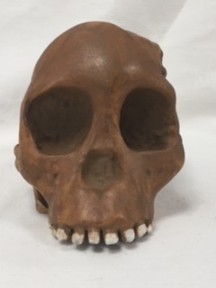
Answer australipithicus aficanus
Indentify the skull to genus and species level
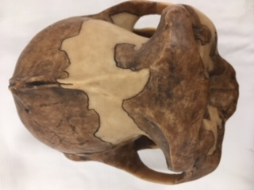
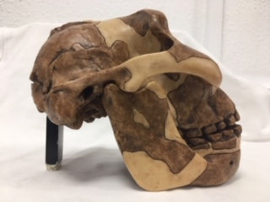
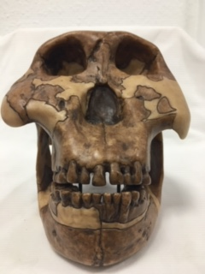
Answer paranthropus boisei
Identify the hominin skull to genus and species level
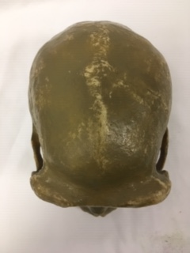

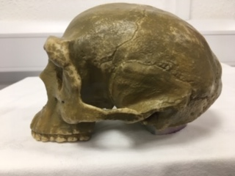

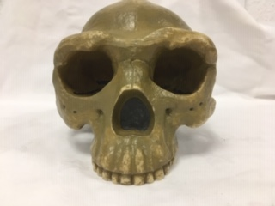
Answer homo erectus
Indentify the skull to genus and species level
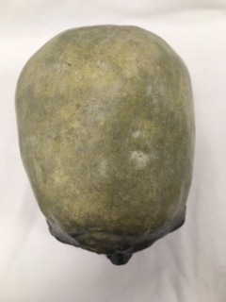
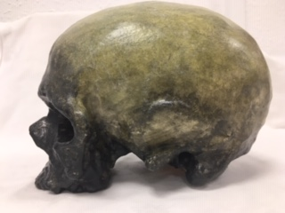
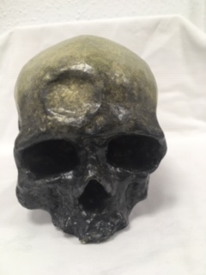
Answer homo sapien
Identify, compare and contrast these two mandibles. Use the illustration below to help if you need to.
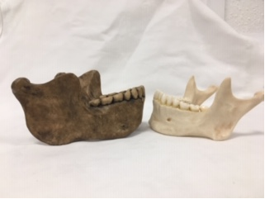
heidelbergensis
Modern Human
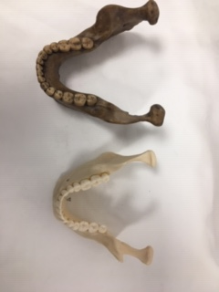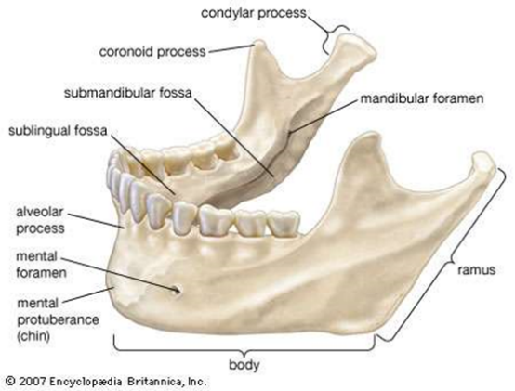

Answer on the left is the jaw of a homo heidelbergensis and on the right is the jaw of a modern human. To start with the heidelbergensis jaw obviously has a far larger ramus and body. This suggests that perhaps the heidelbergensis had a larger bite force as the muscles needed to power a jaw of this size would have to be larger it also suggests that the dood ingested is probably more tough than what modern humans jaws have been developed to eat. Futhermore, the coronoid process which is far less pronounced in the modern day human compared to the heidelbergensis

Stone tools and tool technology: How to tell a stone is worked.
What suggests this has been worked?
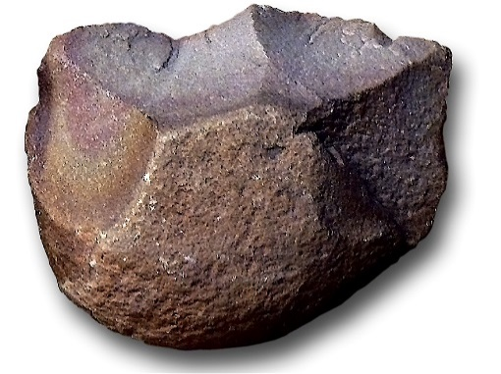
Answer: you can see where the flakes have been removed from the core. Also you can clearly see how the stone has been shaped in order to get that specific edge. You can also see a very slight bulb of pecussion

Features of stone tool flaking: identify features 1-5
4
3
1. striking platform
2.point of percussion
3.bulb of percussion with the eraillure scar
4.fissures
5.ripple marks

Stone tools and tool technology: Stone tools not to scale
Below left: Oldowan Below Right: Acheulean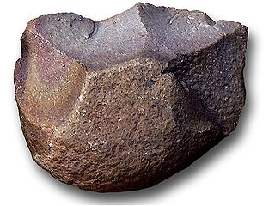 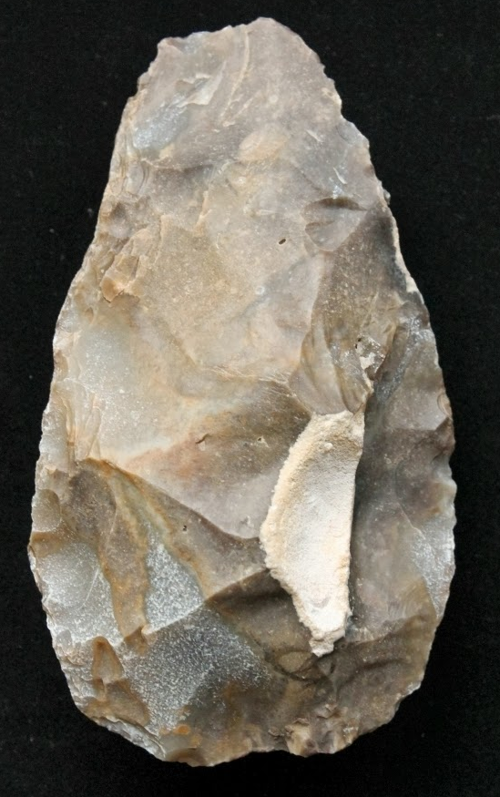
Images taken from https://images.search.yahoo.com

Task: Compare and contrast these two stone tools
The oldowan tool is far more simple in design when compared to the acheulean. As the acheulean has been flaked on both sides rather than just the one side. The edges seem far more refined on the acheulean with a larger cutting edge. Because of the more refined edge on the acheulean It’s probably a more effective tool. The olduwan tool seems like it would be classified as a “chopper” the acheulean tool could also be classed as a “chopper”

