Enterprise and Entrepreneurship- (LCLM 4006)
Certificate in Higher Education
Business Skills for the Workplace
Level 4
Individual Business Plan


Lecturer: Taonga Kaonga Sobere-Snithers

Student’s Name: Llovonne Martin

Student ID: 2428719
Table of contents

- Business overview- page (3-5)

- Legal format and Management Structure- Page (5)

- PESTEL Analysis- Page (6-7)

- Industry/competitor analysis -page (7-9)

- Marketing Strategies-page (10-11)

- Funding and startup expenses-page (11-12)

- Reference List-page (13-14)

Business Plan for Heavenly Moments Luxe Cupcakes


- Business overview
Sweet Moments Luxe Cupcakes is a Birmingham-based artisan bakery that crafts high-quality, locally sourced cupcakes. They offer both classic flavours like vanilla and chocolate, and modern options such as gluten-free, vegan, and seasonal options. Starting from a commercial kitchen, they will use a local delivery service throughout Birmingham and an online ordering platform.
Market Analysis

According to Statista (2024), the UK bakery is strongly, valued at £4.2 billion, with artisanal baked products becoming increasingly popular. Mintel (2023) reports that 62% of UK adults bought sweet bakery goods weekly, showing a sturdy and consistent consumer appetite. Birmingham’s diverse population and vibrant and lively culture make it a suitable place for bakeries owned by a sole trader offering personalised goods and high-quality products that provides modern customer satisfaction.

Market Segmentation

Sweet Moments Luxe Cupcakes will target a variety of key market segments to ensure an effective and focused marketing strategy:
- Individual Consumers – Adults aged 18–45, including families, young professionals, and students who are seeking premium-quality cupcakes for gifting or personal enjoyment.
- Event Clients – Individuals or event planners who needs custom cupcakes for baby showers, weddings, birthdays, and anniversaries. This group values the design, flavour choices, and visual appearance.
- Corporate Clients – Local organisations and businesses buy company -branded cupcakes for events or staff gifting.
- Health-Conscious and Allergen-Sensitive Consumers – Customers who are looking for vegan, gluten-free, or allergen-friendly options. This market segment value high quality alternatives, inclusion, and transparency.
- Local Market Customers – Visitors to events, fairs, and community market, who are interested in unique, locally made goods and loves direct interaction with the business owner(baker).

Sweet Moments Luxe cupcakes stand out by offering allergen friendly options, custom cupcakes and eco friendly packaging. Collaborating with others and taking part in local events helps with boosting the businesses visibility.

Unique Selling Proposition (USP)

The unique power of Sweet Moments Luxe Cupcakes lies in its highlight on customisation, sustainability, and inclusivity. The business allows customers to personalise cupcakes for any occasion, provides allergen-friendly alternatives without settling on taste style, and uses eco-friendly packaging materials.

Feasibility and Growth Potential

Sweet Moments Luxe Cupcakes is both realistic and able to grow over time due to low start up costs and the increasing demand for desserts. Operating as a sole trader provides full creative and functional control, ensuring reliable quality and a customised customer experience. Future growth of the business can extend through catering contracts, new product offerings, and a dedicated retail location in Birmingham.

2. Legal Format and Management Structure

Sweet Moments Luxe Cupcakes will run as a sole trader business, meaning one person manages and owns everything and is entirely responsible for its liabilities and debits (Burns,2022). This structure is great for a small startup because its low administrative costs, simple and flexibility to enable quick decisions. It also allows the owner to keep full control over the business's profits and operations.

Even though the owner is personally accountable for all the debts, the financial threat is low because the company is small and does not need to have a lot of money to startup. Once the business grows, it can become a limited organisation for advanced protection and more funding.

The owner will manage all elements of the business, including customer service, finances, marketing, and baking. Part-time staff may be hired during hectic periods, such as event seasons and holidays, to help with packaging, delivery, and baking. This flexible management process ensures productivity and quality control while keeping excessive costs minimal.
3. PESTEL Analysis

The external atmosphere in Birmingham presents both opportunities and obstacles for Sweet Moments Luxe Cupcakes. The PESTEL framework helps to evaluate these factors and guide to strategic planning and is applied as follows:

- Political: Birmingham City Council offers a range of initiatives and financial support programmes for small businesses, including low-interest startup loans and business grants. The business must also adhere to the Food Standards Agency (FSA) hygiene and Safety laws to ensure legal and applicable standards are met.

- Economic: Even though prices for ingredients are rising and inflation is an issue, Birmingham still has a lot of working families and professionals who are willing to pay for fresh, homemade treats

- Social: Birmingham’s multicultural community offers an opportunity to cater to a wide variety of options, with increasing interest in products that provide specific dietary needs, such as gluten-free, vegan and halal options.

- Technological: The use of digital tools including online delivery platforms, social media, and e-commerce systems, that provides engaging with customers, promoting products and processing orders.

- Environmental: The growing environmental awareness amongst customers encourages businesses to adopt to sustainable eco-friendly packaging. Sweet Moments Luxe Cupcakes aligns with this concept by using eco-friendly packaging and responsibly obtained ingredients.

- Legal: Compliance to allergen labelling laws, food hygiene certification requirements, and employment laws ensures adherence and keeps consumer trust.

Overall, Birmingham’s supportive business settings, cultural diversity, and technological availability make it a strong location for a market bakery like Sweet Moments Luxe Cupcakes.

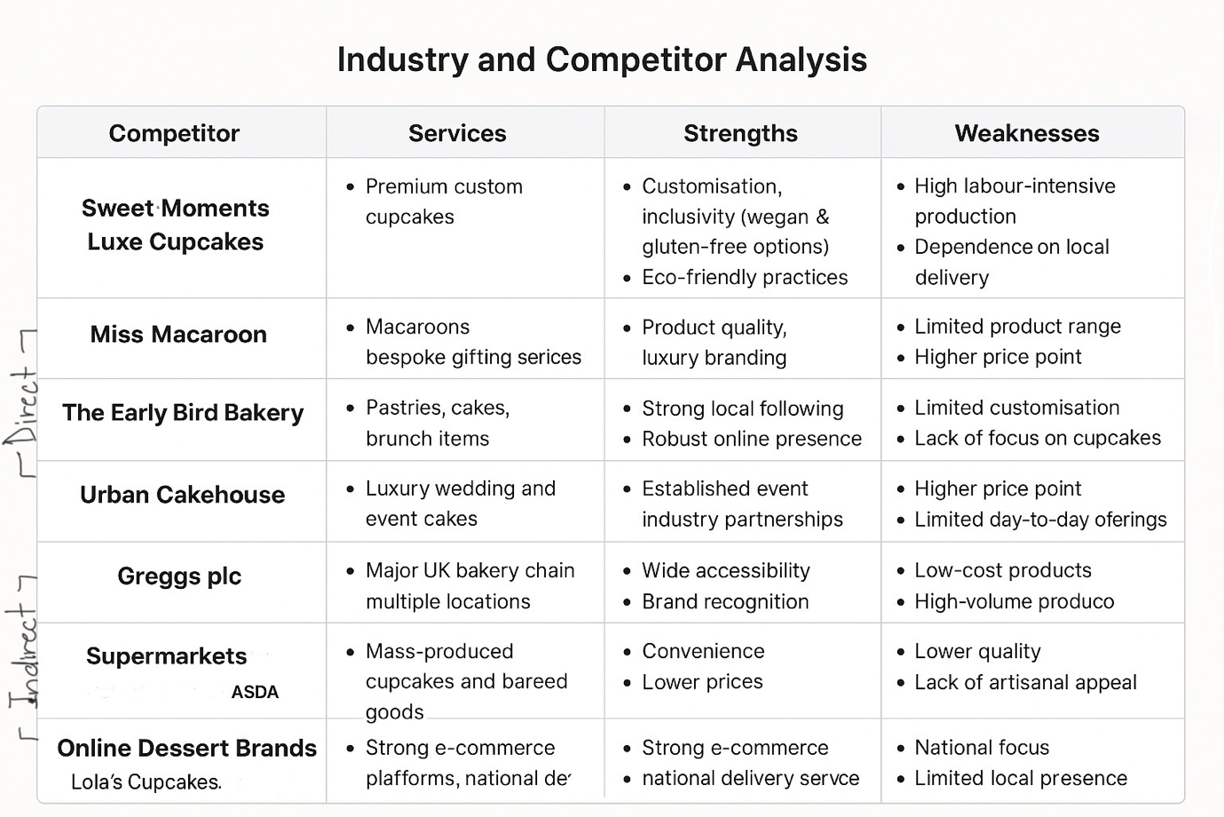
4.Industry/ competitor analysis

Sweet Moment Luxe cupcakes
Services: Premium custom cupcakes
Strengthens: Customisation, Inclusivity (Vegan and gluten-free options), eco friendly practices
Weaknesses: high labour production, dependant on local delivery

Direct:

Miss Macaroon
Services: Macaroons bespoke gifting services
Strengthens: luxury branding, product quality
Weaknesses: higher price point, limited product variety

The Early Bird Bakery
Services: Pastries, Cakes, brunch items
Strengthens: strong local following, strong online presence
Weaknesses: Limited customisation, less focus on cupcakes

Urban Cakehouse
Services: Luxury event and wedding cakes
Strengthens: Established event industry partnerships
Weaknesses: limited daily offerings, greater price point

Indirects:

Greggs
Services: Major UK bakery chain, multiple locations
Strengthens: brand recognition, wide accessibility
Weaknesses: high volume production, low-cost products

Supermarkets
Services: Mass produced cupcakes and baked goods
Strengthens: convenience, lower
Weaknesses: Lack of artisanal appeal, lower quality

Online Dessert Brands:
Services: national delivery, strong e-commerce platforms
Strengthens: national delivery service, strong e-commerce
Weaknesses: Limited local presence, national focus

Competitive Advantage

Sweet Moments Luxe Cupcakes stands out because they are:

* Offer cupcakes for all customers: They customise their cupcakes and provide options that are vegan, gluten-free, and harmless for people with allergies.
* Cares about the environment: Use packaging that is safe for the planet and gets their ingredients from local suppliers.
* They are involved in the community: They are active in Birmingham's local scene, taking part in events, school fairs, markets, and even working with charities.
* Has a strong online presence: They focus on the connection with customers through social media, making sure that they appear in online searches, and offering an easy-to-use online ordering experience.

All these advantages make Sweet Moments Luxe Cupcakes a premium, ethical and community-focused, at home bakery that is a great fit for what consumers in Birmingham are looking forward to today.

5. Marketing Strategies

Sweet Moments Luxe Cupcakes plans to use a marketing strategy that includes the mixture of local community involvement, online activity, and the focus of building its brand to excel in Birmingham’s busy food market.

Digital Marketing:
Sweet Moments Luxe will use TikTok, Instagram, Facebook, and WhatsApp to display their cupcakes, share feedback and give a glance behind the scenes. The website will give customers access to online ordering and the choice to design their own cupcakes. They will also improve their local SEO, targeting terms like ‘custom cupcakes near me’ and ‘Birmingham cupcakes’

Community Marketing:
Taking part in markets, local events, and collaborations with cafés in Birmingham and event planners will help strengthen the brand’s reputation. Partnering with schools for fundraising events or local charities will also enhance the businesses visibility and involvement in the community.

Target Market:
The business is aiming for Birmingham locals wishing the ages of 18-45, event planners and families who enjoy unique, high-quality desserts. These customers value convenience, creativity, and authenticity.

Branding:
Sweet Moments Luxe Cupcakes will present a modern and classy image, using pastel colours and simple designs in its branding. Eco-friendly packaging will also be used to reflect the brand’s care for the environment, which aligns with customer’s expectation in Birmingham.

6. Funding and Startup Expenses

Sweet Moments Luxe Cupcakes will need the estimated cost of £12,000 in its opening funding to cover the essential startup costs in Birmingham. This funding will support ingredient purchases, packaging, baking equipment, marketing, and kitchen rental.

Funding Sources:
- Personal Savings (£5,000)
- Government Start Up Loan (£5,000–£7,000)
- Local business grants available through the West Midlands Growth Hub and Birmingham City Council
Estimated Startup Expenses:
Commercial kitchen rental and deposit: £2,200
Equipment (Tools, oven, mixer): £3,000
Ingredients and eco-friendly packaging: £1,200
Marketing and website: £1,000
Registration, Insurance, certification: £800
Local delivery and transport: £500
Emergency fund: £1,500
Total: £10,000–£12,000
Financial Justification: This funding will allow Sweet Moments Luxe Cupcakes to perform effectively during the first months, supporting product quality and brand recognition. It will also enable sufficient marketing investments for the first few months and an easy launch operation. A projected sales of around 300 cupcakes per week, with a 50% average profit limit. It will aid in sustainable growth and the expectation of generating a sustainable income by the third month of operating.

Reference List
- Burns, P. (2022) Entrepreneurship and Small Business: Start-up, Growth and Maturity. 6th ed. London: Palgrave Macmillan.
- Department for Business and Trade (2024) Business population estimates for the UK and regions 2024. Available at: https://www.gov.uk/government/statistics/business-population-estimates-2024
- Food Standards Agency (2023) Food Hygiene Ratings. Available at: https://www.food.gov.uk/
- Mintel (2023) Sweet Bakery Market Report – UK.
- Statista (2024) Bakery and Confectionery Market in the United Kingdom. Available at: https://www.statista.com/
- Birmingham City Council (2024) Starting a business. Available at: https://www.birmingham.gov.uk/info/50162/business_advice/1506/starting_a_business/2 (Accessed: 26 October 2025).
- Birmingham City Council (2023) Food hygiene rating scheme. Available at: https://www.birmingham.gov.uk/foodhygiene (Accessed: 26 October 2025).
- United Kingdom Government (2024) United Kingdom Food Security Report 2024: Introduction. GOV.UK. Available at: https://www.gov.uk/government/statistics/united-kingdom-food-security-report-2024/united-kingdom-food-security-report-2024-introduction (Accessed: 26 October 2025).
- British Baker (2024) ‘UK bakery consumers increasingly turn to social media for inspiration’. Available at: https://bakeryinfo.co.uk (Accessed: 26 October 2025).
- Mintel (2023) ‘Social media and influencer marketing trends in food and drink’. Mintel Reports. Available at: https://www.mintel.com (Accessed: 26 October 2025).
- Statista (2024) ‘Social media usage in the United Kingdom (UK) – TikTok, Instagram, and Facebook statistics. Available at: https://www.statista.com (Accessed: 26 October 2025).
- Deloitte (2024) ‘Sustainability and consumer behaviour in the UK’. Available at: https://www.deloitte.com/uk (Accessed: 26 October 2025)
- Miss Macaroon (2025) ‘Luxury Macarons Handmade in Birmingham’. Available at: https://missmacaroon.co.uk (Accessed: 26 October 2025).
- The Early Bird Bakery (2025) ‘About Us’. Available at: https://theearlybirdbakery.co.uk (Accessed: 26 October 2025).
- Urban Cakehouse (2025) ‘Wedding and Celebration Cakes Birmingham’. Available at: https://www.urbancakehouse.com (Accessed: 26 October 2025).
- Gregg's plc (2025) ‘Our Story and Products’. Available at: https://www.greggs.co.uk (Accessed: 26 October 2025).
- Lola’s Cupcakes (2025) ‘Order Cupcakes Online’. Available at: https://www.lolascupcakes.co.uk (Accessed: 26 October 2025).

