Michael Oldham (2235684)

Learning in the digital era
Assignment 2: Personal Development Plan (PDP)

Contents
Task 1 – Self Evaluation 2
Task 2 – Personal Development Plan (PDP) 6
Task 3 – Unit 2 topic 4 – Bouncing Forward – Summary 7
Task 4 – Video Presentation 9

Task 1 – Self Evaluation

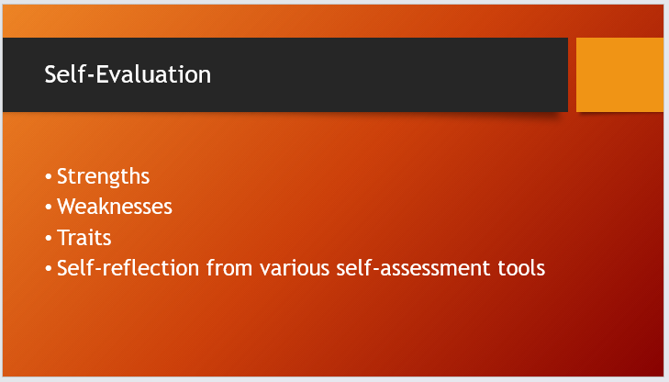
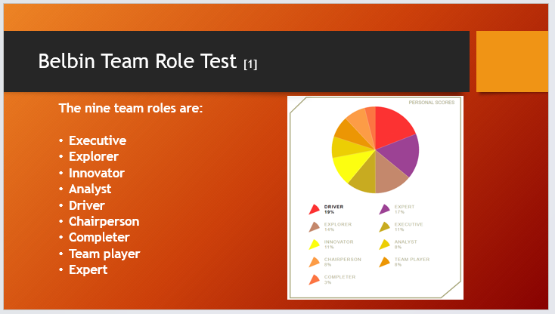
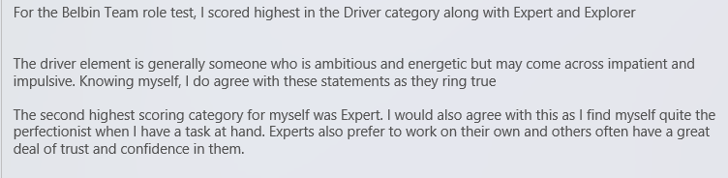
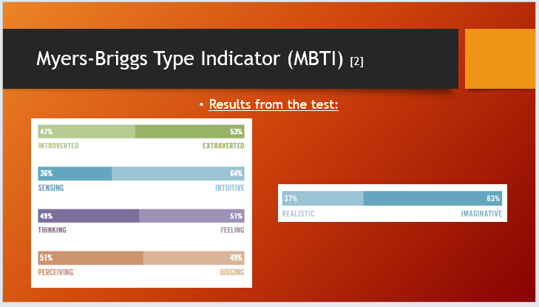
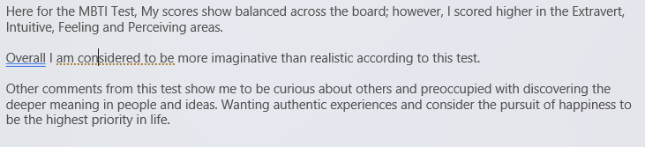
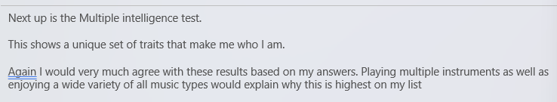
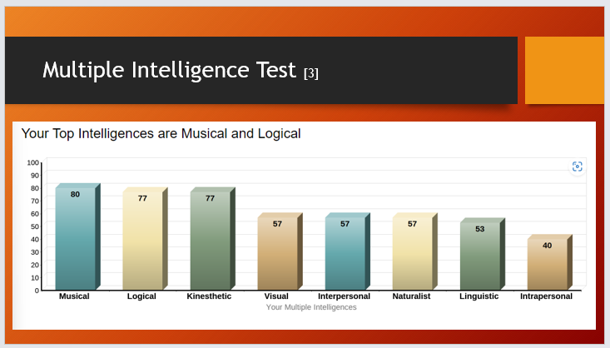

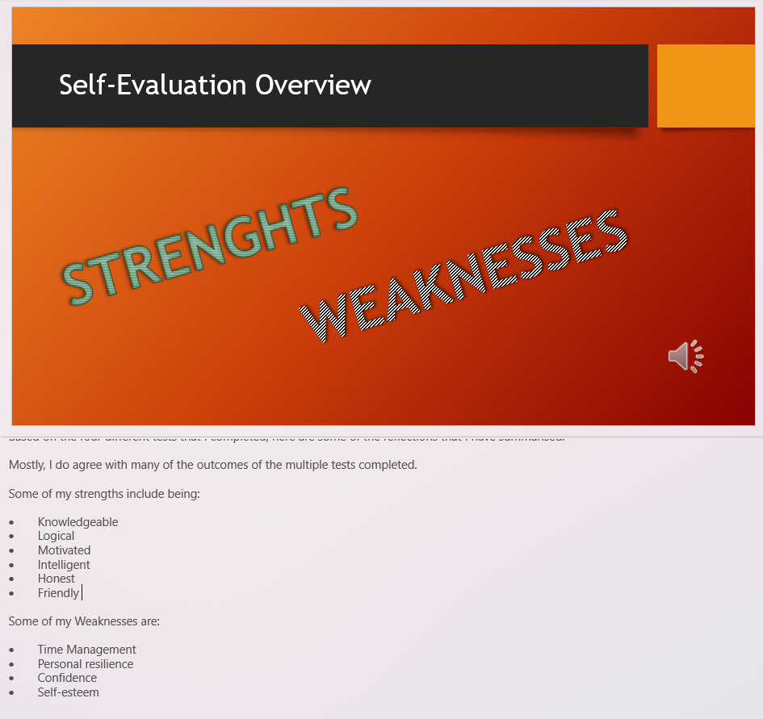
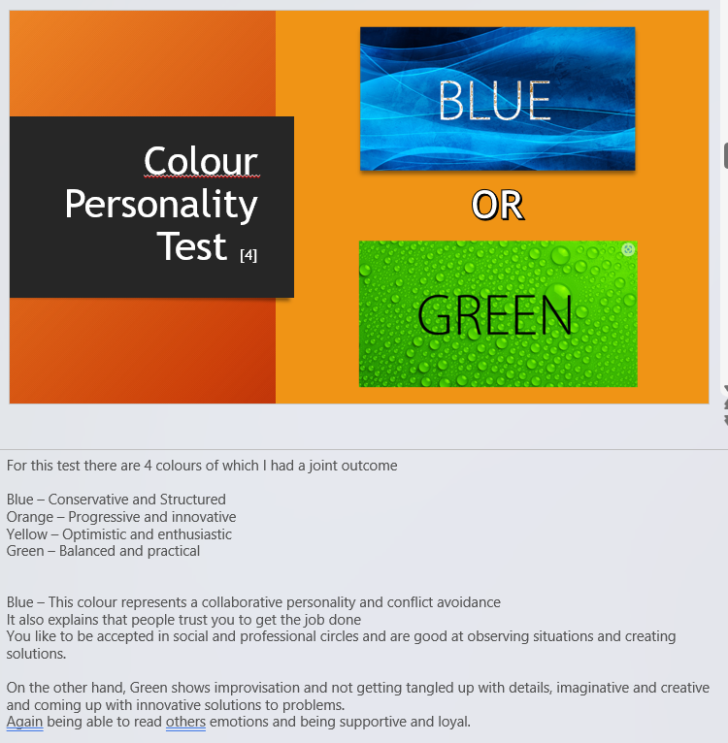

Task 2 – Personal Development Plan (PDP)

Link: Personal Development Plan (PDP)
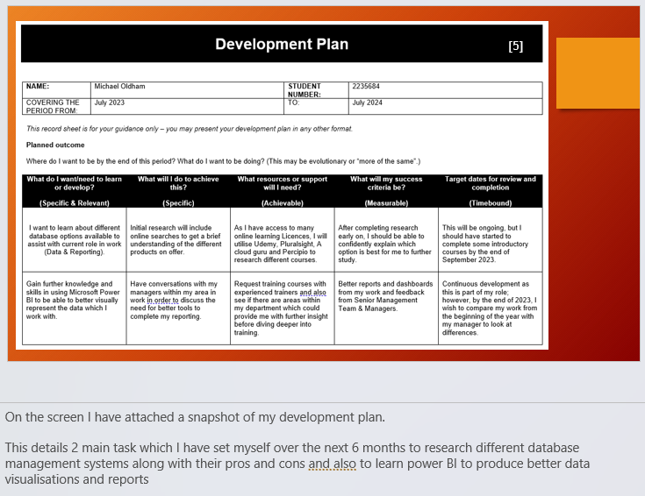

Task 3 – Unit 2 topic 4 – Bouncing Forward – Summary

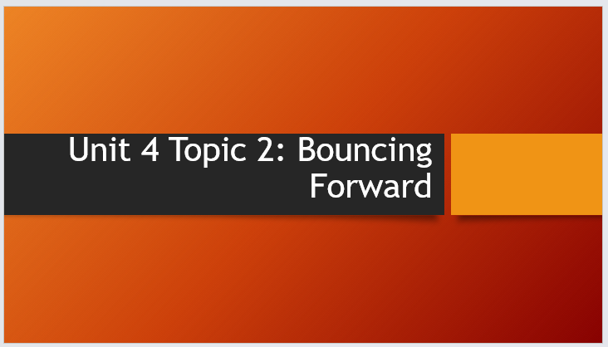

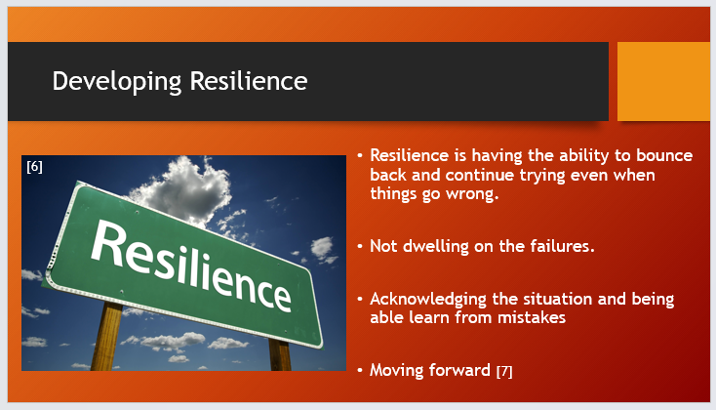

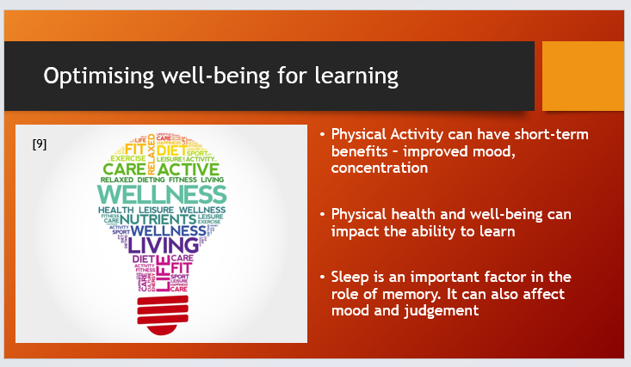
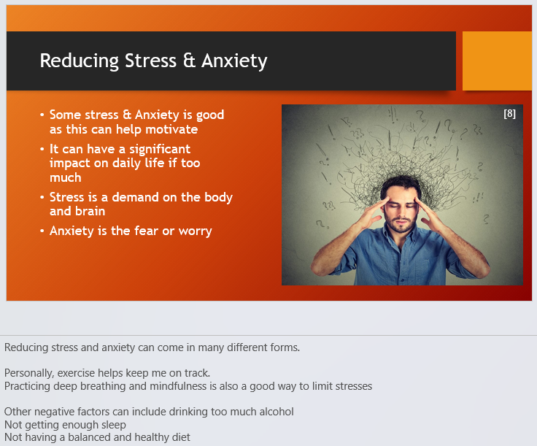

Task 4 – Video Presentation

YouTube link for Presentation: Click here
Link to PowerPoint: Click here
Screenshot:


