Academic and Employability Skills
Module Code: BMSW4001_BIRM
Name of the Student: Cristian Dumitru
Student ID: 2108821
Lecturer’s name: Rebecca Stewart

Task 2: Reflective Report

Executive Summary
This reflective report will reflect on my experience in preparing employability and skill modules using Gibbs's reflective model to assess the weaknesses and the strengths of writing. My learnings during preparing the module mentioned will also be reflected here in this report to understand my development status. I will also prepare a personal development plan using the feedback from the rest quiz. The personal development plan will be focused here to set my objective and to fix action plans to achieve them.

Table of Contents
Task 2: Reflective Report 2
1. Introduction 4
2. Analysation of My Experience of Writing Task 1 Using Gibbs Reflective Model 4
3. Incorporation of Resit Quizzes Feedback in a Personal Development Plan 9
4. Conclusion 11
References 12
Books and Journals 12
Websites 12

1. Introduction
This reflective report will describe my experience in preparing employability and skill modules using Gibbs's reflective model. My learnings during preparing the module mentioned will also be elaborated on here in this report. I will also prepare a personal development plan using the feedback from the rest quiz. Resit quiz refers to the examination which is taken again after one gets unsuccessful in the first attempt. Personal development plans normally are the action plans which help identify the future goals, needed resources to achieve the goals, weaknesses, and strengths along with development required areas. I will describe all the required points here in this reflective report to provide a good idea to the readers.

2. Analyzation of My Experience of Writing Task 1 Using Gibbs Reflective Model
Description of Experiences and Learnings: It happened during preparing for the academic and employability skill module. I have faced many problems and have come to learn many new things regarding employability. These skills refer to some transferable skills which are required by any person and this help to make that person employable (The University of Edinburgh, 2022). Teamwork, reliability, communication., and problem-solving, are the general skills of employability. I have learnt about the motivation factors which are normally required for motivating employees. The challenges of motivating staff also have been recognized by me during preparing module one. It happened during the preparation of the module, and most of the work happened in the university classes (Campbell, 2022). Teachers, students, lecturers, and I were present during preparing the modules. I and other students were finding the importance of motivating factors for employees like pay, additional holiday, awards, recognition, and good working conditions. I was able to identify the challenges of motivating staff. I was there because I was preparing the type of module after getting resit quiz guidance. I want to make the module more effective and get success in preparing the module along with the other students (The University of Edinburgh, 2022).
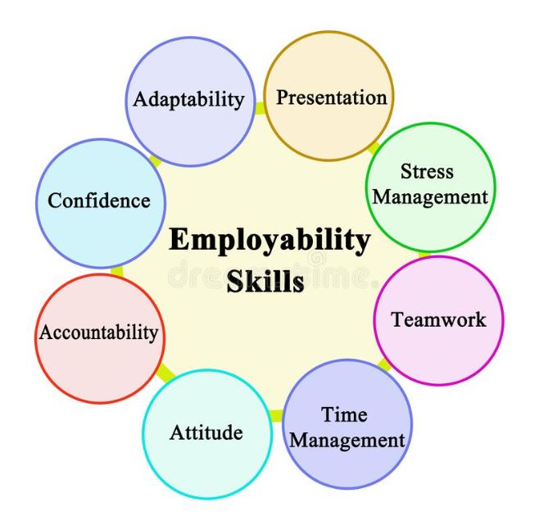
Figure 1: Employability Skills
(Source: Campbell, 2022).

Feelings of Experience and Learning: This part of this report will describe my thinking during the time of making this module and the impacts of these thoughts on making that module. I was thinking during preparing that module that my knowledge is enough to make it. Books and other resources will help me to make this module more potential (University of Queensland, 2019). My thinking before that situation was that I might prepare or learn the topic well. My thinking was negative before preparing the mobile as I was unsuccessful in my first attempt. Data collection and use of pictures may not be perfectly applied by me as I do not have the confidence of using the pictures and data in the right places for any writing. I am now more confident about all the topics which I have presented in task one. I have been able to gather knowledge about diverse types of motivating factors of employees. Now it is also clear that data and pictures were used very prominently and relevant to the topic (Thomson, 2021). All students were nervous to prepare the model because it was stated that task one must be prepared by using appropriate data. Now the other students have come to understand the different pay structures of Zara, ONS and other companies in the UK (University of Queensland, 2019). I am thinking of using more UK-based data in the writings to make them more relevant and impactful. I was thinking during the situation was to use more data from the organizations of the United Kingdom to follow the instruction of the assessment.
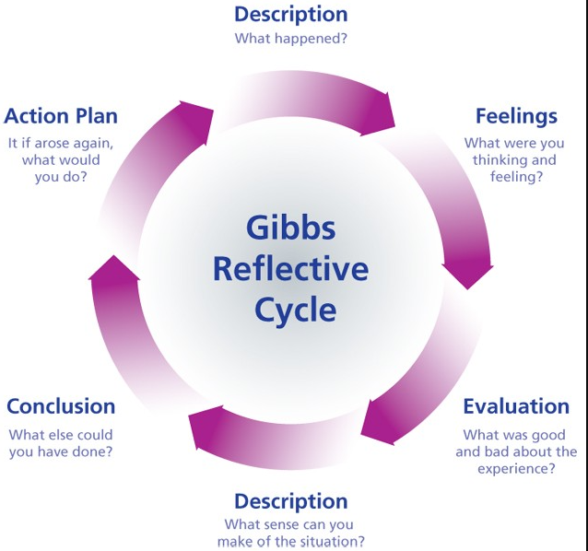
Figure 2: Gibbs Reflective Model
(Source: Glow Scotland, 2022).

Evaluation of Feelings of Experience and Learning: One of the good experiences of the situation was that I was able to reconstruct the assignment once again after being unsuccessful in my first attempt. The use of the official websites has helped to provide all the relevant examples in task one (Glow Scotland, 2022). I was also able to acknowledge the use of different motivating factors which are used by the different companies in the United Kingdom. Virgin Holidays, British Airways, TESCO Plc and many other organizations in this country provide additional holidays to the employees to motivate them (Blogger Crazy, 2018). The bad experience which I faced during preparing for task one was that I was uncomfortable selecting the right images which are more relevant to the topic. The use of numerical data was very hard to use in that assignment because I am not good at research skills. The main thing which has gone well is that the teacher helped me to enhance my research skills, and to find more relevant and prominent data. The thing which did not go well was that the deadline for submitting the academic report was short and for this reason, many important points got missed to mention in the assignment (Master Class, 2021). I and other students worked collaboratively to make the assignments of every student more acceptable. The negative contribution was that many students were not very friendly to working as a team.

Analysis of Feelings of Experience and Learning: Things went well because of some incidents which happened during the preparation of task one. The teachers were extremely helpful because they helped me in many challenging situations which I faced during making the module. Finding the awards and recognition provided by the organization was very hard as the companies do not provide all the detailed data regarding this (Glow Scotland, 2022). Faculties helped to find all the data regarding this along with the names of the awards which were given to the employees. Other students also helped me to make the assignment more potential. The bad thing was that the quality of the writing was hampered because the deadline was very short, and it was very hard to maintain the quality of work. Another bad thing was that many students were not friendly to teamwork or working collaboratively (The University of Edinburgh, 2022). I have understood that I have many weaknesses in writing properly, like researching and searching skills. I tried my best to make the task more perfect than the previous one because the teacher helped me to prepare it. Understanding skills and communication skills helped to understand the situation perfectly by comparing my work with the others (The University of Edinburgh, 2022).

Conclusions of Feelings of Experience and Learning: I have learned many new things like the internal procedures of motivating staff in various companies in the UK. I have learned a lot of data about companies like pay scale, salary structure, holidays, and many more of the companies. Moreover, I am also able to understand the importance of motivating the employees in any organization along with the diverse types of challenges of motivating staff (Blogger Crazy, 2018). I am also able to build my skills in researching, searching and problem solving during preparing the academic report. Live demonstration of the topic, involvement of the teachers, provision of data by the university, and the extension of the deadline may make this situation more positive for all the involved students and teachers (Indeed Editorial Team, 2022). I have poor knowledge in research skills, and this is the main reason for developing just an average quality of writing. I need to develop research skills to understand any topic better and to imply the learning in the writing. I might ask for the help of the other students to create the assignment to make that more potential. I also might have enhanced my reading skills to identify their academic explanation of the motivating factors of the employees (Glow Scotland, 2022).
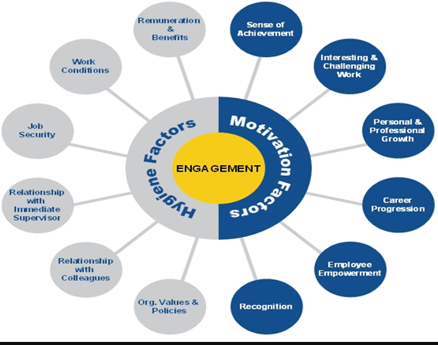
Figure 3: Employee Motivating Factors
(Source: Deirdre, 2022).

Action Plans Conclusions of Feelings of Experience and Learning: I will use many other different skills and techniques if I fall in the same situation the next time. I will increase the research on the topic and collect all the relevant data on the topic to use in the writing. I will also ask for the help of the teachers in the challenging situation of preparing the same assignment in future. I will use an enormous range of numerical data in the next assignment to enhance the quality of my writing (Deirdre, 2022). I will read books, magazines, and journals and use the internet to enhance my research skill. I will also need to increase my communication skills to interact with the teachers for asking help in the future. I may also follow newspapers and government statistical websites to enhance my knowledge of statistical information (Deirdre, 2022). I will surely perform better next time if I can develop all the skills which I have mentioned previously. The motivating factors will be very clear for me if I research the topic. The use of different motivating factors of the organization’s will also be very clear to me. The next projects on the same topic will surely be worked impactfully if I will follow all the mentioned actions differently (Deirdre, 2022).
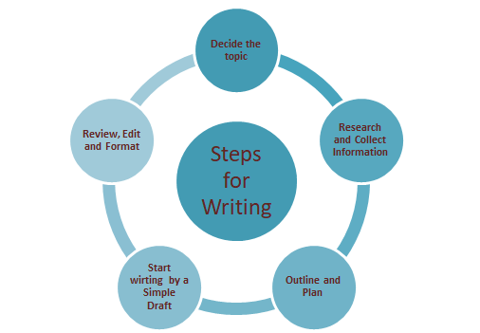
Figure 4: Steps to Develop Writing Skills
(Source: Thomson, 2021).

3. Incorporation of Resit Quizzes Feedback in a Personal Development Plan

Skills | Objectives | Action Plan | Required Resources | Criteria for Success | Targeted Date
Research Skills | The objective is to gather all the knowledge of learning and apply it in the writing (Graham, 2019). | I need to read books, magazines, and journals before starting writing, as I have this suggestion in resit quiz feedback (Indeed Editorial Team, 2022). | Books related to the selected topic will be required along with magazines and journals. | Successful preparation for making the assignment will be the right measurement of it. | September 2022
Communication Skills | It is required to interact with the teachers and the students to ask for help in making the assignment more impactful (Claro, et al., 2018). | I need to talk with the students and the teachers frequently and enhance teamwork to connect witty others. (Thomson, 2021). | I need to execute most of the workings collaboratively and I also may include myself to solve the conflicts. | Interaction with the students and teachers seamlessly will be the accurate measurement of developing these skills. | December 2022
Sentence Structuring Skills | The main objectives of developing this skill are making the assignments flawless and increasing the quality of writing. | I need to develop grammar skills, punctuation and correct spelling making skills more impactfully in the construction of making sentences. | A good grammar tutor, grammar books and practicing making sentences are the main required resources. | Making the perfect sentence with the Grammarly marks above 80% will be the best measure of it (Indeed Editorial Team, 2022). | November 2022
Team Working Skills | Enhancing collaboration, increasing the quality of writing, and building communication skills are its main objectives (Lacerenza, et al., 2018). | Working collaboratively, completing tasks with a friendly mentality, and helping nature make any projecting of other students will give me the scope of building teamwork. | Blogs on communication, YouTube Videos and online courses will be the main resources to develop these skills (Indeed Editorial Team, 2022). | Making projects and assignments with the other students collaboratively will be the best measurement of this skill. | January 2023
Table 1: Personal Development Plan
(Source: Author)

4. Conclusion
This reflective report has described my experience in preparing employability and skill modules using Gibbs's reflective model. My learnings during preparing the module mentioned were also elaborated on here in this report. I have also prepared a personal development plan using the feedback of the rest quiz. My weaknesses and strengths were identified during analyzing the experience and learnings of writing task 1. The faults were also identified in this section along with the improvement areas. PDP plan has provided a suitable recommendation to develop my weak areas or skills. Communication, research, team working, and sentence structuring skills were discussed along with the action plan with the targeted date of accomplishments.

References

Books and Journals
Claro, M., Salinas, Á., Cabello-Hutt, T., San Martín, E., Preiss, D.D., Valenzuela, S. and Jara, I., (2018). Teaching in a Digital Environment (TIDE): Defining and measuring teachers' capacity to develop students' digital information and communication skills. Computers & Education, 121, pp.162-174.
Graham, S., (2019). Changing how writing is taught. Review of Research in Education, 43(1), pp.277-303.
Lacerenza, C.N., Marlow, S.L., Tannenbaum, S.I. and Salas, E., (2018). Team development interventions: Evidence-based approaches for improving teamwork. American psychologist, 73(4), p.517.

Websites
Blogger Crazy, (2018). Developing Writing Skills At B1 And B2 Level. Available at https://bloggingcrazy-annie.blogspot.com/2018/10/developing-writing-skills-at-b1-and-b2.html [Accessed 1 August 2022]
Campbell. M., (2022). Top 5 Skills Employers Look For. Available at https://newmanu.edu/top-5-skills-employers-look-for [Accessed 1 August 2022]
Deirdre, (2022). Employee Engagement Indicator. Available at http://career-engagement.blogspot.com/2011/07/employee-engagement-indicator.html [Accessed 1 August 2022]
Glow Scotland, (2022). Gibbs Reflective Cycle. Available at https://blogs.glowscotland.org.uk/glowblogs/uodsseportfolio/2015/10/25/gibbs-reflective-cycle/ [Accessed 1 August 2022]
Indeed, Editorial Team, (2022). 10 Skills You Need for Team Building (And How to Develop Them). Available at https://in.indeed.com/career-advice/career-development/team-building-skills [Accessed 1 August 2022]
Master Class, (2021). How to Improve Your Research Skills: 6 Research Tips. Available at https://www.masterclass.com/articles/how-to-improve-your-research-skills [Accessed 1 August 2022]
The University of Edinburgh, (2022). Gibbs' Reflective Cycle. Available at https://www.ed.ac.uk/reflection/reflectors-toolkit/reflecting-on-experience/gibbs-reflective-cycle [Accessed 1 August 2022]
Thomson. S., (2021). How to Improve your Communication Skills, with Key Resources. Available at https://virtualspeech.com/blog/improve-communication-skills [Accessed 1 August 2022]
University of Queensland, (2019). Employment-wheel.png. Available at https://uq-urbanplanning.org/employment-wheel/ [Accessed 1 August 2022]

