Trinity Saint David University of Wales
Usability Engineering (ACCA6017)

Author: | Tutor:
Chris Hampton | Prof. Nik Whitehead
2116517@student.uwstd.ac.uk | nicola.whitehead@uwtsd.ac.uk

06/12/2024

Contents
Table of Figures 2
1. Introduction 4
1.1 Abstract 4
1.2 Introduction 4
2. Research 4
2.1 Usability and User experience 4
2.2 Disabilities and Accessibility 5
2.2.1 Colour blindness 5
2.2.2 Dyslexia 6
2.2.3 Physical Disabilities 7
2.2.4 Ethical Game Development 7
3. Personas 8
3.1 Questionnaire 8
3.1.2 Questionnaire Results Analysis 8
3.2 Creating Personas 16
3.2.1 Perona 1 16
3.2.2 Perona 2 17
3.2.3 Perona 3 18
3.2.4 Perona 4 19
4. Storyboard Wireframe 20
5. Prototype Feedback 23
Conclusion 24
References 25
Appendices 27
Appendix 1 - Questionnaire 27
Appendix 2 – Questionnaire Results 29
Appendix 3 – Wireframe flows 33
Wireframe Menu 33
Game Play Screen 34
Appendix 4 – MoSCoW Analysis 35
Appendix 5 - Feedback Questions and Answers 35

Table of Figures
Figure 1- Source: https://enchroma.com/blogs/beyond-color/how-color-blind-see 5
Figure 2 - Source: https://color.adobe.com/create/color-accessibility 6
Figure 3 - Source: https://coolors.co/9d858d-410b13-421820-91171f-edd892 6
Figure 4 - Question 2 - Gender 9
Figure 5 - Source - https://www.hesa.ac.uk/ 9
Figure 6 - Question 3 – Age 9
Figure 7 - Question 4 - Study Status 10
Figure 8 - Question 5 - Study Programme 10
Figure 9 - Question 7 - UWTSD Role 11
Figure 10 - Question 8 - Online Game play 12
Figure 11 - Question 9 - Do not play reasons 12
Figure 12 - Question 11 - Disabilities 13
Figure 13 - Question 12 - Disability Affect 14
Figure 14 - Question 14 - Gaming Device 14
Figure 15 - Question 15 - Interface issues 15
Figure 16 - Question 16 - Technical Issues 15
Figure 17 - Result Persona Capture 16
Figure 18 - Game Glow Diagram 20
Figure 19 - Wireframe - Landing Screen 21
Figure 20 - Settings Menu 21
Figure 21 - International Students 22
Figure 22 - Invite Friends 22
Figure 23 - Game Prompts 22
Figure 24 - Game Play Screen 23
Figure 25 - Lost Game 23

Introduction

Abstract
Zombie Dice is a ‘press your luck’ type of dice game, where a player decides if they want to continue their turn depending on the outcomes they have rolled. Incorporating the fundamental mechanics of Zombie Dice a University of Wales Trinity St David, UWTSD, version will be developed in this project. By designing an engaging user interface, specifically for mobile devices, this research will outline user research and design features for the interface, with a focus on usability to create an immersive gaming experience.

Introduction
This research report aims to give a comprehensive understanding of the usability of a UWTSD themes mobile game based on Zombie Dice. By detailing and producing four personas to gain an understanding into the needs and behaviours of potential users. Each persona is used to outline the main user experience required to ensure that the development of the game aligns with the expectations of the target audience.
Initial wireframe storyboard designs will be used as an initial representation of the user interface, highlighting the flow of the interactions within the game. These will be crucial for the user’s journey in visualisation and directing the development process for the game.
To initiate a final design for the game, a process of collecting feedback from the wireframe storyboard will be collected. This will enable to refine the game interface and enhance the usability to improve engagement for a flawless user experience. Other aspects will be considered for the final designs, such as accessibility for those who may have difficulty participating in games of this nature.

Research

2.1 Usability and User experience
Most games are driven by the user experience (UX). For designers and developers UX is key to ensuring that a user would enjoy playing the game and will return to play further, thus increasing the popularity of the game. This can be achieved by the influences that drive a user to carry on playing a game. By have clear guidance and information will ensure a user has enough knowledge to play and enjoy the game [1].
Mobile puzzle games tend to offer a lower usability level that games classed as Role-Playing game (RPG) adventure style games. This is due to the nature of the game styles and RPG style often has a longer story for a user to play. However, the same design theories can be applied to both. By having key design elements like familiar designs and standardisation throughout the game can ensure the user has a high interactive experience [2].
User acceptance testing is key to ensuring the popularity of a game. Vigorous testing can often miss key errors or usability downfalls as they can be overlooked by designers and developers who know how the software acts. Feedback is the most valuable way in which user experience can be measured [3].
For UWTSD-themed Zombie Dice detailed feedback collection will be used to provide insight into the design and usability of the application. Considerations for the game design will be sought through four personas developed from data collected through questionnaires.

2.2 Disabilities and Accessibility

2.2.1 Colour blindness
Colour blindness or colour vision deficiency (CVD) is surprisingly common among the population. As many as 1 in 12 of the male population is affected by CVD and up to 1 in 200 for females. Within the UK this equates to 4.5% [4] . There is an importance by developers to design games to be accessible to all users. However, through testing there can sometimes be limited availability of colourblind test subjects. Pinheiro et. al. discusses using simulation tools and accessibility guidelines to develop mobile games [5] to make them more accessible to users with disabilities.
Whilst developing applications that can be accessible to users with colour vision deficiency, there also needs to be a consideration for users that aren’t affected by CVD. To have the balance between a normal visioned user and a user with CVD should be considered when designing a game. Through eye-tracking technology it was found that animation was an effective method and yellow was the leading colour for fixation and duration with colourblind test subjects [6].
Software such as the 'Hertfordshire Colour-blind Emulator' (HCBE) can be used by designers to understand the challenges faced by the possible users with CVD. By emulating the major types of CVD an understanding can be gained and incorporated into game design [7].
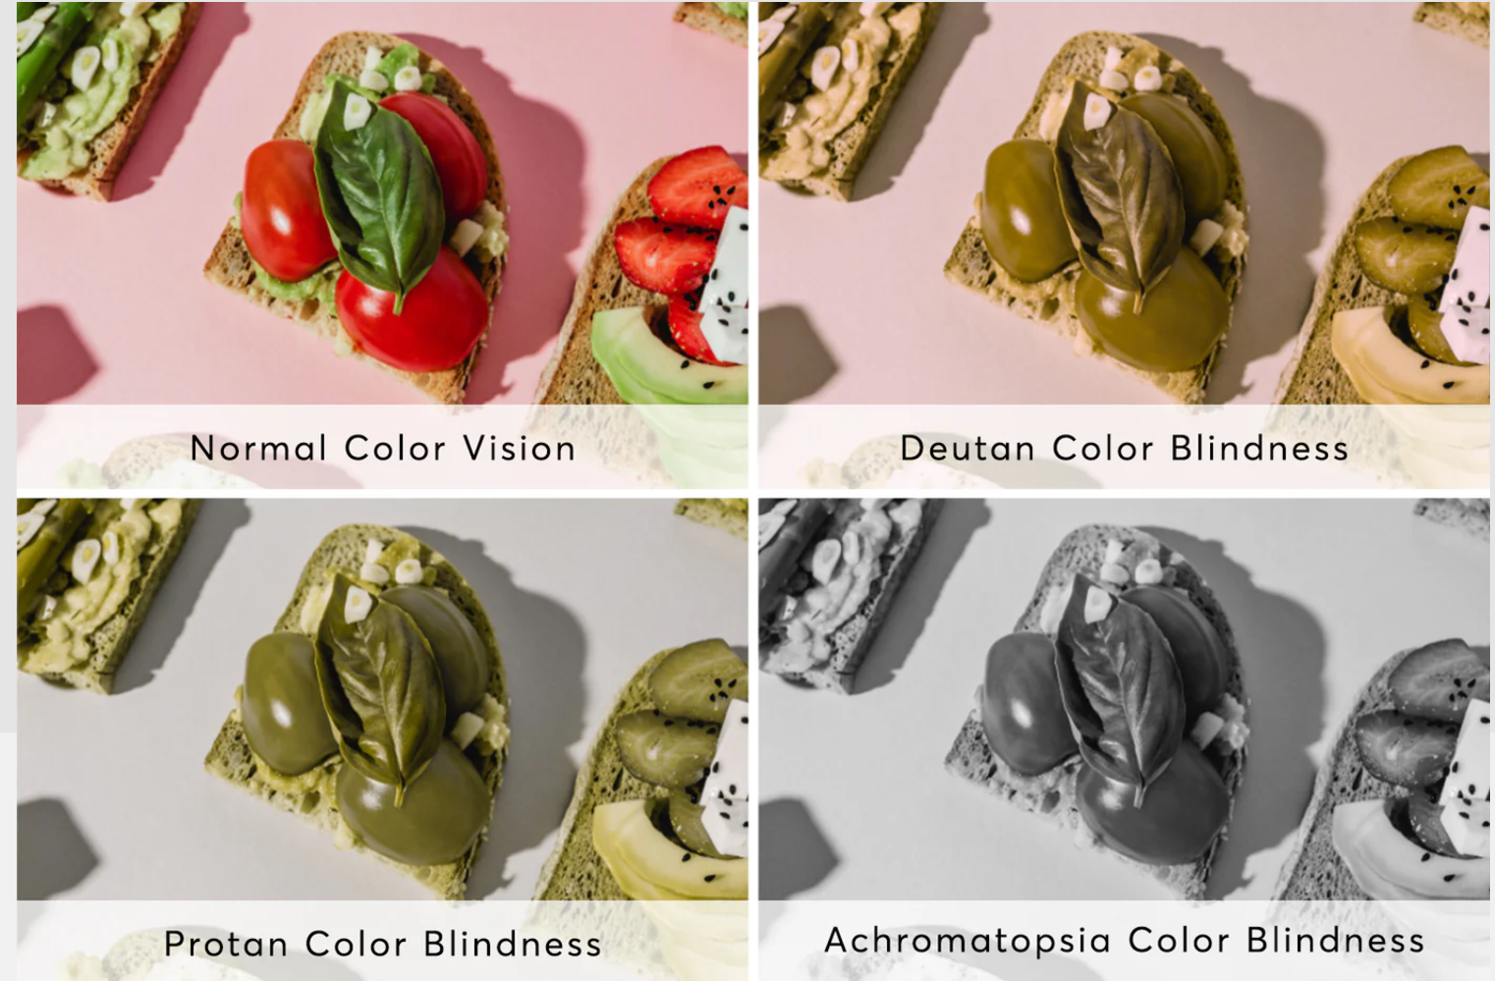
Figure 1- Source: https://enchroma.com/blogs/beyond-color/how-color-blind-see
From the figure above it shows the differences in the types of colour-blindness. The assumption can be that people that are affected by colour-blindness can only see black and white, however, this common misconception shows that the colour range is narrower that a person with normal vision.
Considering the points made above, there needs to be a balance between the colour scheme and the accessibility value attributed to the game design. By using such tools as ‘Adobe Color’ and ‘Coolers’, many different colour palettes can be tested to check to ensure that they are suitable for CVD users.
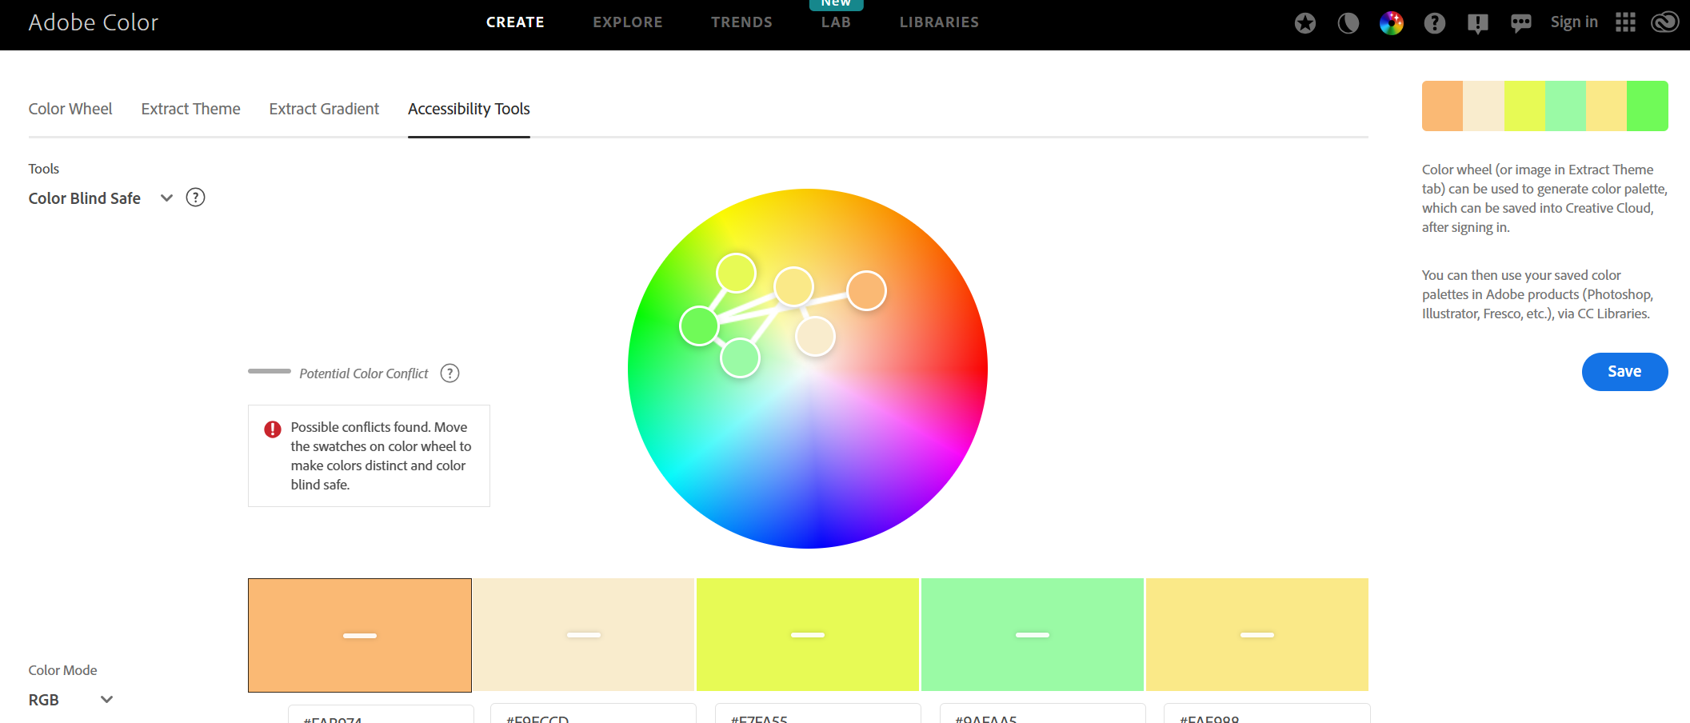
Figure 2 - Source: https://color.adobe.com/create/color-accessibility
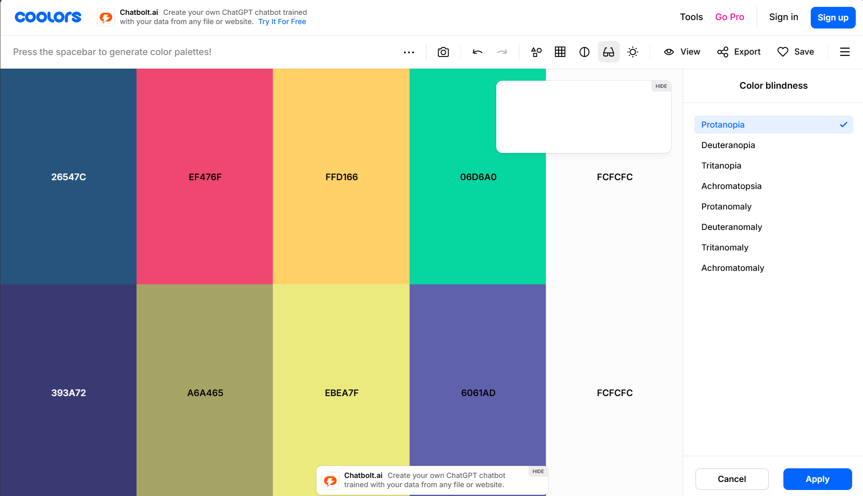
Figure 3 - Source: https://coolors.co/9d858d-410b13-421820-91171f-edd892
When applying these tools and techniques to full colour wireframes these tools will be used to ensure they can ensure users have a good experience with the game. By using animations and yellow colours to highlight important features can add to a more enjoyable experience.

2.2.2 Dyslexia
Dyslexia is a cognitive disorder that affects the abilities to writing, speaking, and reading. According to The British Dyslexia Association it is believed that one in ten individuals suffer from some form of dyslexia [8].
Some common mistakes dyslexic users make can include skipping words that connect sentences, such as a, an, the, etc. Also, the letters in words can sometimes be re-arranged, known as ‘Whole-Word Guesses’. For example, confusing tried with tired. Another example can be reversing letters, such as d for b and p for q [9].
Game designers need to be aware of making applications accessible to users who suffer from dyslexia. Many mobile devices make gaming more accessible to users can lack certain accessibility features and create additional barriers for users [10]. Many studies focus on creating games to aid with teaching and education for dyslexic users there seems to be a lack of accessibility and design guidelines for creating non-educational games that all users can play recreationally.
One accessibility feature that could help dyslexic users can be Text-To-Speech (TTS) functionality within a game. Early TTS software required voice actors to record from a script to assist any users in game dialog [11]. However, as technology has moved on considerably, Artificial Intelligence (AI) is able to assist in creating voice overs and directional commands to users. In addition to using AI generated speech for human to computer interactions, this technology can be used to incorporate other languages and translate the text into a language of choice making the application more accessible to non-native speakers [12].
The functionality of the UWTSD-themed Zombie Dice game will incorporate having a Text-To-Speech option in the final designs to assist any users that may have accessibility issues using a game without these features.

2.2.3 Physical Disabilities
Video and computer games have become an increasing aspect of modern life. According to Ellis et. al. 92 percent of gamers with a physical disability continue to persevere playing computer games despite their physical disabilities [13]. This high percentage can be seen as wholly accepted that computer and online games are accessible for users with physical disabilities, it does not address the need to make games more accessible, relying on the resilience of the individual. Many studies have shown that certain video games can lead to heightened aggressive tendencies shown by the users, however, this is elevated with users that suffer from a physical disability [14].
Research shows that multiplayer gaming is often the key to creating an accessible gaming environment for users with disabilities [15]. By having the ability to converse, play, and socialise within a computer game setting often alleviates the concerns from the user demographic.
For UWTSD-themed Zombie Dice there will be a multiplayer function that allows users to play with friends and family. By creating a low interaction game, i.e. limiting the number of clicks to play the game, it can become more enjoyable and easier to play for those affected by these limitations. As discussed above with Text-To-Speech function this can also crossover with users who have a physical disability.

2.2.4 Ethical Game Development
With the emergence of online games becoming more popular due to the rise in technological advances, so has the increasing negative consequences and risk factors associated with addiction. Addiction to online gaming shows similarities to addiction to other activities, such as alcohol, substance misuse, and gambling [16]. This is especially prevalent in children and teenagers [17].
The main purpose of computer game companies is to make money, and this is done through ensuring that users buy and play the game. Unfortunately, this can lead to creating a highly addictive type of game. Developers need to ensure that there is an ethical consideration when designing the game to ensure that these addictive traits are minimised. This can be done by incorporating a time limit functionality within the game. Although this can go against the ethos of producing games, it can also protect a company from allow addiction to be associated with their product.
Data protection is also an ethical aspect of game development. Developers can use the data gathered from in-play gaming sessions to improve the experience of the user. However, the negatives of collecting data can be used to influence a user’s choice [18]. Any data collected needs to comply with legislation and be used in a proper way that only benefits the user.

Personas
Personas are used to evaluate both game design and user behaviour. This helps to better understand predicted interactions within the game [19]. Personas are used to guide the design process to ensure that the final output meets the intended audiences needs.
A lot of research into personas reference Alan Cooper’s book ‘About Face 2.0: the Essentials of Interactive Design’ in which he describes creating fictional characters based on real user research [20]. Cooper states that a persona is a portrait of an ideal user and are the single most powerful design tool that can be used.

3.1 Questionnaire
To create personas for UWTSD-themed Zombie Dice a survey of 20 people was taken. As this is a UWTSD themed game all responses relate to positions within the organisation.
To build four high level detailed personas the following questions were asked:
Questions
- What is your name?
- What is your gender?
- What is your age?
- Are you currently studying at UWTSD?
- If yes, what graduate scheme are you part of?
- What subject are you currently studying?
- If no, what is your role within UWTSD?
- Do you play computer/online games?
- What is the reason for NOT playing computer/online games?
- How often do you play computer games
- Do you identify as having sensory disabilities (e.g., vision or hearing impairment) or physical disabilities?
- If yes, does your disability restrict or prevent you from playing computer games?
- How does your disability prevent you from playing computer games (e.g., colour vision deficiency, dyslexia, physical restrictions etc.)?
- What device do you primarily use for gaming?
- Describe any issues you've faced with game interfaces or controls in the past?
- How often do you encounter technical difficulties when playing games online?

3.1.2 Questionnaire Results Analysis

Question 2 – Gender
Each participant was asked their gender into 4 categories: -
- Female
- Male
- Non-Binary
- Prefer not to say
The rationale for this question is to ensure that there is even representation within the persona design.
The results showed that 50% of participants identified as male, 45% identified as female and 5% identified as non-binary.
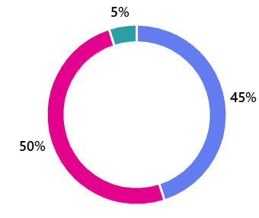
Figure 4 - Question 2 - Gender

With the results there is almost an even split between male and female. This will be added to the persona design.
The Higher Education Statistics Agency (HESA) collect statistics from all higher education facilities in the UK. Considering the results from the questionnaire and the information reviewed on HESA it con be concluded that for the persona design there should be 2 male personas and 2 female persons.
Figure 5 - Source - https://www.hesa.ac.uk/
Persona Design: 2 Male, 2 Female

Question 3 – Age
The analysis of the question for age has been broken down into age range brackets. From the results shown below, almost half of the respondents where aged between 18 to 24. This will align with the consensus of students who attend university and higher education.
The largest represented group of 18-24, to ensure an even spread of age distribution the upper and lower limits will be used to represent to first two personas.
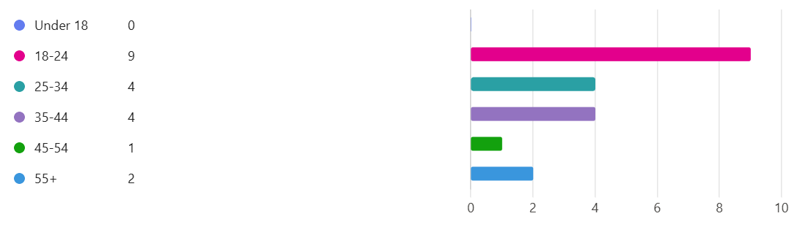
Figure 6 - Question 3 – Age
The next most represented group was 25-34 and 35-44, with four in each group. From this an age will be assigned to a persona from each group. For this we can take the centroid position for each category.
For 25 to 34 group the centre position is 29.5, so one persona will be assigned the age of 29. The same reasoning will be used for age group 35 to 44. This will result in another persona being aged 39 (39.5).
Persona Design: Ages – 18, 24, 29, and 39

Question 4 – Currently studying at UWTSD
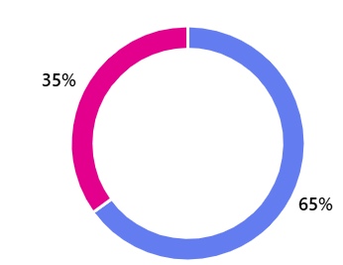
As the respondents where not all students – the question of whether they are currently studying was asked. From the results 65% (13 out of the 20 asked) are currently studying at UWTSD. The remained 35% (7) were made up of faculty, staff, administrators etc.
Figure 7 - Question 4 - Study Status

For the persona design we can calculate 65 percent of the four personas – which results in 2.6. From this it can be deduced that 3 personas are currently studying at UWTSD, and one isn’t.
Persona Design: Study Status – 3 currently studying, 1 not studying

Question 5 – Study Programme
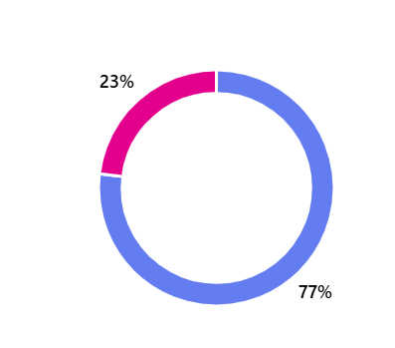
From the 13 respondents, in question 4, who answered ‘Yes’ to currently studying – question 5 was asked what graduate scheme they are part of. Whether its undergraduate or postgraduate.
Figure 8 - Question 5 - Study Programme
Again, using figures from HESA, in the years 2021/2022 there was 12,355 undergraduates for the UWTSD Group and 2,690 postgraduate students. This equates almost 22% of students are postgraduate and almost aligns with the results from the questionnaire.
This results in 77% of the 3 personas should be undergraduates and 23% of the 3 personas should be postgraduate.
With rounding percentage totals results in 2 personas as undergraduate and one as postgraduate.
Personas Design: 2 Undergraduate, 1 Postgraduate

Question 6 – Study Subjects
Question 6 asks respondents to answer with their subject matter that they are studying. This is a free text answer box allowing the user to type their subject. From the results there was a range of answers from computing subjects to engineering subjects. With one of the 13 studying criminology.
There were 8 computing-based answers, 3 engineering based answers and the single criminology answer. To convert these answers into the personas almost 62% were students studying a computing-based subject with just over 23% as engineering students and almost 8% as criminology.
With the 3 personas selected for this cohort it can be realised as 2 of them would be a computing-based studying students and one as an engineering student.
Personas Design: 2 Computing-based students, 1 Engineering based student

Question 7 – Role within UWTSD
The respondents that answered ‘No’ to currently studying a further question of what their role within UWTSD is. The options are listed as:
- Faculty
- Staff
- Parent
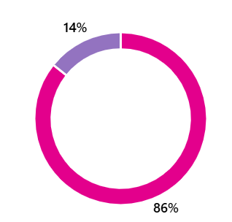
- Administrator
Figure 9 - Question 7 - UWTSD Role
The result shows 86% (6) answered as a staff member and 14% (1) as an administrator. From this the conclusion can be made that most respondents were staff members. This can be applied to the one of the personas.
Persona Design: 1 Staff member

Question 8 – Online Computer Game play
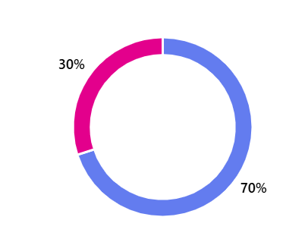
Question 8 asks whether the respondent plays videos games. 70% (14) answered ‘Yes’ and 6 answered ‘No’.
Figure 10 - Question 8 - Online Game play
To apply these results to the personas, it can result in 3 personas already play video games.
Persona Design: 3 currently play computer games, 1 does not play computer games

Question 9 – Reason for not playing Computer Games
The 6 respondents that do not play computer games where asked the reasons why. This question gave multiple responses to the question. The majority said that they lack the interest of playing online computer games.
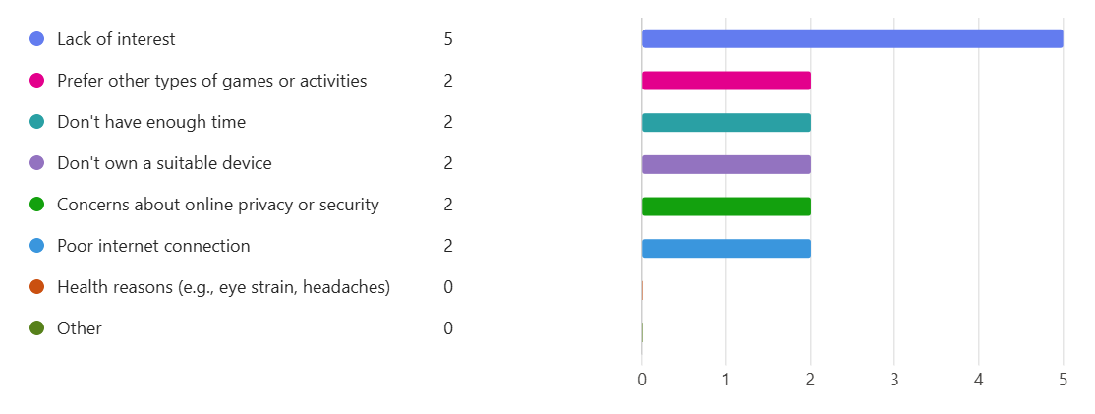
Figure 11 - Question 9 - Do not play reasons
From this it can be concluded that one of the personas does not play computer games due to lack of interest and the preferences to other activities. Although these results can detract from the subject of the personas playing computer games, it can give an insight into how a game can be developed to encourage a user that does not usually play these types of games to, perhaps, change their mind and start playing these types of games.
Persona Design: 1 persona does not play due to lack of interest

Question 10 – Online Computer Game usage
Question 10 outlines how often the respondent plays computer games on a scale of one to ten. The results were (in red):
5 | 8 | 4 | 2 | 4 | 8 | 2 | 3 | 2 | 5 | 3 | 8 | 3 | 4
2 | 2 | 2 | 3 | 3 | 3 | 4 | 4 | 4 | 5 | 5 | 8 | 8 | 8

The green figures represent the results in order. To assign a value to the 3 personas the results can be split into thirds. The figures highlighted in yellow, represented roughly a third slice each, will be assigned to the personas.
Personas Design: 1 has a value of 3, 1 has a value of 4, 1 has a value of 8

Question 11 – Disabilities
Question 11 refers to any disabilities the respondents might have. The categories to answer were:
- No
- Yes, sensory disability
- Yes, physical disability
- Both, sensory and physical disability
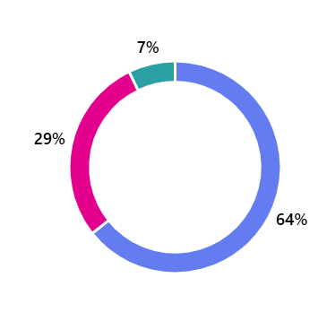
Figure 12 - Question 11 - Disabilities
From the 20 respondents 64% (12) answered ‘No’, 29% (6) answered ‘Yes, sensory disability’ and 7% (2) answered ‘Yes, physical disability’.
To convert these values into the personas, results in 2.56 personas with no disabilities. This equates to 3 as no disabilities and one as having a sensory disability.
Personas Design: 3 No disabilities, 1 has sensory disabilities

Question 12 – Disability Restriction
Those that answered ‘Yes’ to question 11 – 60% answered that their disability affects them when they participate in online games.
For the single persona that has a sensory disability it can be understood that their disability does affect their participation in online games with the result being over 50%.
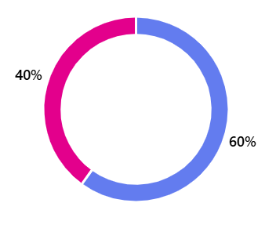
Figure 13 - Question 12 - Disability Affect
Persona Design: 1 has a sensory disability that affects their ability to play online games

Question 13 – Gaming Preventions
Continuing with the accessibility issues faced with the respondents with disabilities, question 13 asks how their disability affects their game participation. The answers had a range of different conditions, but the common theme was due to colour blindness and dyslexia. With colour blindness the most common.
With this considered the single persona suffers from colour blindness.
Persona Design: 1 persona suffers from colour blindness (CVD)

Question 14 – Computer Gaming Devices
To gauge how the respondents play computer games the options for question 14 - What device do you primarily use for gaming?
- Mobile Device
- Tablet
- Computer Desktop/Console
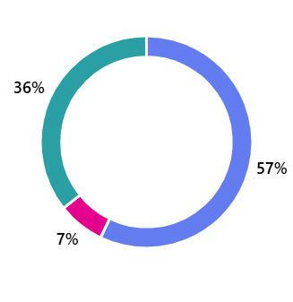
Figure 14 - Question 14 - Gaming Device
From the 13 that answered ‘Yes’ to playing computer games 57% (7) answered Mobile Device, 7% (1) answered ‘Tablet’ and 36% (5) answered ‘Computer Desktop’.
Converting this into our personas this equates to 2 playing computer games via a mobile device and 1 playing computer games on a computer desktop / console.
Persona Design: 2 use a mobile device, 1 use via computer desktop

Question 15 – Interface and Control issues
When asked to describe interface and control issues that users have faced when playing online games, the below word cloud describes the common words used.
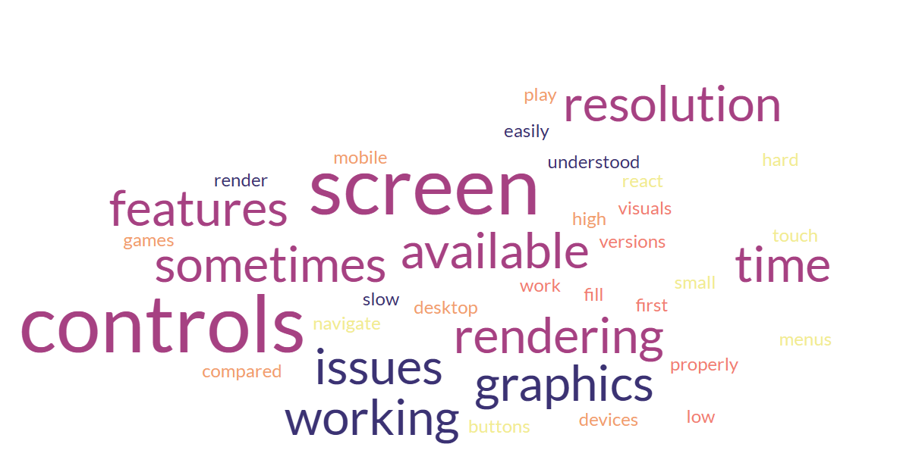
Figure 15 - Question 15 - Interface issues
With the persona design it can be shown that most users have sometimes faced issues with graphics rendering and some features have issues working.
Persona Design: 2 personas have experienced issues with graphics, 1 persona has issues with screen resolutions, 1 persona hasn’t experienced any interface issues

Question 16 – Technical Issues
Question 16 is like question 15 but addresses issues with technical aspects of online gaming.
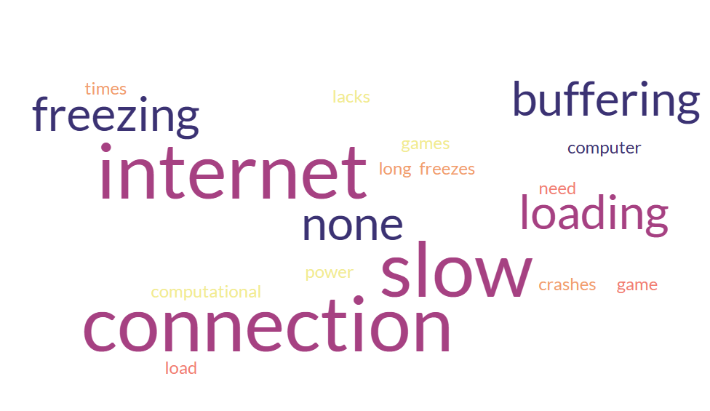
Figure 16 - Question 16 - Technical Issues
Technical issues faced include slow internet connection/buffering/loading. These seems to be common throughout the answers.
Person Design: 3 personas suffered from internet connection issues, 1 persona hasn’t experienced and issues

3.2 Creating Personas
From the results in the questionnaire, they have been collated into a table to produce the 4 personas.
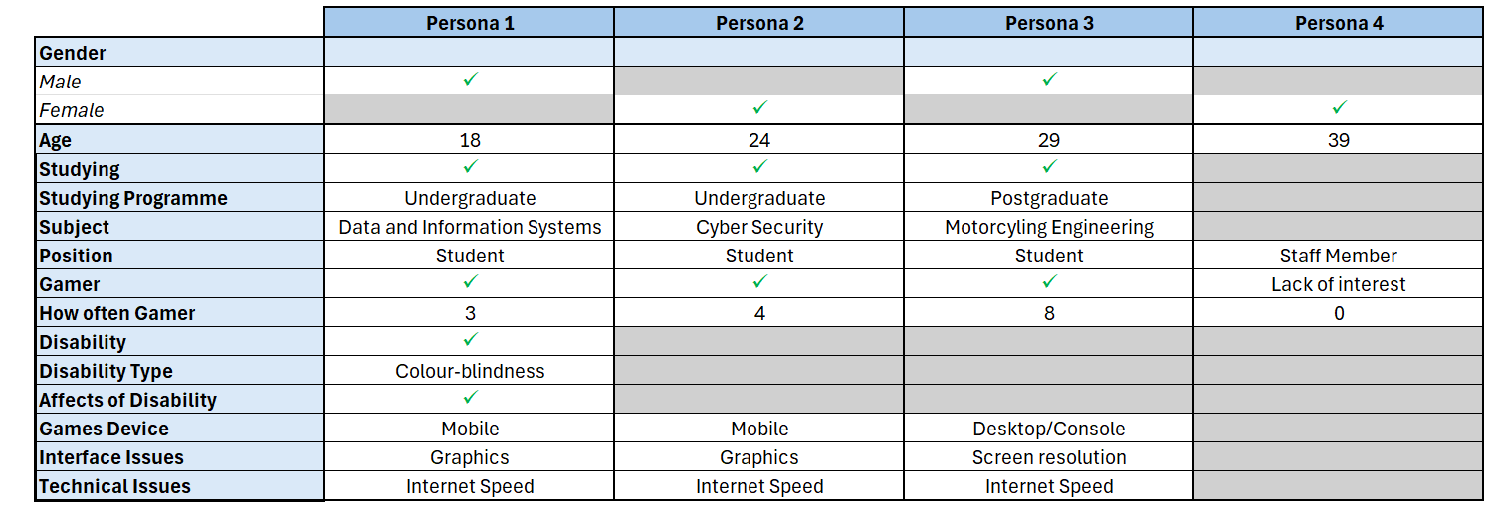
Figure 17 - Result Persona Capture

3.2.1 Perona 1
Persona 1
 | Name: Ethan Walker  Age: 18  Gender: Male  Occupation: Undergraduate Student  Field of Study: Data and Information Systems  Location: Swansea
About Ethan
Ethan is an undergraduate student who lives in Swansea in a student dormitory. He is dependent on his family and part time work for his financial stability whilst studying.

Ethan grew up in a tech-savvy home environment and has always had an interest in computers and technology and influenced his decision to study Data and Information Systems.
His daily routine involves attending lectures, gaming in his free time and working his part-time job on weekends.

Ethan’s motivations and passion for technology hopes he will successfully complete his degree with good grades to secure a job in possibly game development or data analysis.
Ethan sometimes struggles with certain game graphics that aren’t colour-blind friendly and gets frustrated when graphics are not optimised for his condition. He also experiences issues with lagging and buffering during online sessions.

Ethan’s technology preference is to play games on his mobile device due to their portability and is comfortable with new technology due to being tech-savvy. Ethan is active on social media and follows tech and gaming influences and spends his free time exploring tech related videos on YouTube.
Ethan believes that it is important to be inclusive and technology should be accessible for all and advocates for better accessibility features in games and technology. His personality traits included being determined, analytical, creative, and resilient.

A Day in the Life:
Ethan starts his day with lectures and study sessions, takes breaks to play mobile games, and spends evenings catching up on assignments or coding projects. On weekends, he enjoys longer gaming sessions but gets frustrated by slow internet speeds and inaccessible game graphics.

Ethan wishes more games considered colour-blind players like him. It would make the experience so much better.
Recently, Ethan struggled to complete a level in his favourite game due to its poor colour contrast, which led him to research and propose improvements in his classes.

3.2.2 Perona 2
Persona 2
 | Name: Olivia James  Age: 24  Gender: Female  Occupation: Undergraduate student  Field of Study: Cyber Security  Location: Swansea
About Olivia
Olivia is an undergraduate student living in a student house share and is dependent on student financing and part-time work to complete her degree in cyber security.

She is passionate about technology in particular cyber security and hopes her degree will make a meaningful impact on internet safety. Her daily routine includes balancing her time with lectures, studying, gaming and participating in cyber security clubs and events.

Her short-term goals are to excel in her coursework and enhance her gaming skills to secure an internship in the cyber security field. Olivia’s long-term goals include becoming a cyber security analyst with leading tech firms and contributing to a safer internet. She hopes to achieve this through her love for gaming and technology with her desire to solve complex problems and ambition to protect digital spaces.

Olivia finds some mobile games challenging due to the limitations of graphic optimisation and has experienced lag and slow internet speeds that affect her gaming sessions. She finds it demanding with her intense studies and passion for gaming.

She is comfortable to various software and hardware and prefers to play on her mobile device due to their convenience. Her hobbies include gaming, coding and participating in cyber security challenges. This plays into her lifestyle choices and maintains a balance of academia and leisure. She engages in social media forums relating to cyber security and gaming.

Olivia believes in digital safety and inclusivity for games and is analytical, determined and creatives. She advocates for better internet safety and graphic optimisation for mobile games.

A Day in the Life:
Olivia starts her day with lectures and cyber security labs, takes breaks to play mobile games, and spends evenings working on coding projects or participating in cyber security competitions. She often faces challenges with slow internet and graphics issues in her games, but she is proactive in seeking solutions and optimizing her setup.

Olivia believes it’s frustrating when a great game is held back by poor graphics or lag. She wishes developers focused more on these issues.

Recently, Olivia missed out on completing a level in her favourite game due to lag caused by slow internet. This incident motivated her to write a blog post about the importance of optimizing game performance for all users.

3.2.3 Perona 3
Persona 3
 | Name: Alex Morgan  Age: 29  Gender: Male  Occupation: Postgraduate student  Location: Cardiff  Field of Study: Masters in Motorcycling Engineering
About Alex
Alex is completing his masters in motorcycling engineering. For this he is dependent on scholarships, family support and part-time work. He lives alone in an apartment and commutes to campus on his lecture days.

Alex developed his love for motorcycles and engineering from a young age and has led to him pursuing advanced studies in this field. Gaming has always been a significant part of his leisure activities. He balances his time between classes, research and heavy gaming sessions.

He hopes to pass his degree with distinction and optimise his gaming setup to improve his gaming skills. He hopes to land a role with a motorcycling company in design or research and become a prominent figure in the gaming community. He has desire to push the boundaries of engineering and enjoys complex, immersive gaming.

Alex’s challenges when gaming are often games that do not support high-resolution displays. He has experienced connectivity issues when gaming at peak times, leading to frustration. His pain point is sometimes balancing his academic studies with his intense gaming hobby.

Alex’s gaming preferences is on a powerful gaming desktop, but also enjoys mobile games and VR setups. His high-level technological skills have allowed him to combine his studies and his passion into creating engineering simulation tools.

Alex maintains a rigorous schedule to balance his hobbies and studies. He loves to attend gaming and motorcycling events. He follows tech, engineering, and gaming influences and is active on social media.
Alex values innovation and precision in gaming and engineering and believes in continuous improvement and pushing boundaries. He is analytical, competitive, and detail orientated. He advocates for better screen resolution support and improved internet infrastructure.

A Day in the Life:
Alex starts his day with research and classes, spends afternoons working on motorcycle engineering projects, and dedicates his evenings to immersive gaming sessions. He frequently encounters issues with screen resolution and internet speed but remains proactive in seeking solutions and optimizing his setup.

Alex believes a great game can be ruined by poor screen resolution and lag. Developers need to address these issues to keep gamers like him engaged.

Recently, Alex missed a crucial moment in an online game due to internet lag, which motivated him to research better connectivity solutions and share his findings in gaming forums.

3.2.4 Perona 4
Persona 4
 | Name: Dr Emily Carter  Age: 39  Gender: Female  Occupation: University Staff Member (Academic Advisor)  Location: Cardiff
About Emily
Dr Emily has a Pd.D. in Educational Psychology and lives alone in a small apartment. She also enjoys a middle range income.

Dr Emily has been working at the university for over 10 years. She is known for her dedication and ability to connect with students, helping them navigate their academic journeys. Her academic background in psychology provides her with deep insights into student behaviour and motivation.

Her hobbies include reading contemporary fiction, attending local theatre productions, running, and volunteering in community activities. She is seen as being approachable, patient and empathetic. She enjoys learning new things and is described as a great listener and a dependable confidante.

Dr Emily has not been much of a gamer, but she is open minded and curious for new experiences. She could be persuaded to try gaming if it involves social interaction, problem-solving, or strong storytelling elements. She values educational games.

She is proficient with technology and uses it extensively in her work and personal life. She is also highly tech-savvy and finds it easy to navigate new software and tools.

Dr Emily maintains a balanced lifestyle with a mixer of professional and personal activities. She values meaningful interactions and intellectual engagement. Her media consumption involves social media, educational blogs and engaging in education discussions.

She is open to trying new experiences that can add value to her life to enhance her understanding of various topics.

A Day in the Life:
Dr Emily starts her day by reviewing student progress and attending meetings. In the afternoons, she holds advising sessions with students. Evenings are reserved for personal interests like reading, running, or attending local events. Although she hasn’t gamed before, she’s open to trying it if introduced to a game that aligns with her interests and offers a new way to engage intellectually or socially.

Dr Emily always been open to exploring new hobbies. If gaming can offer something more than just entertainment, she’d be interested in giving it a try.

Emily recently attended a seminar on using gamification in education, which piqued her curiosity about the potential benefits of gaming and how it might be applied to her work.

Storyboard Wireframe
The flow diagram shows the high-level structure of the game.
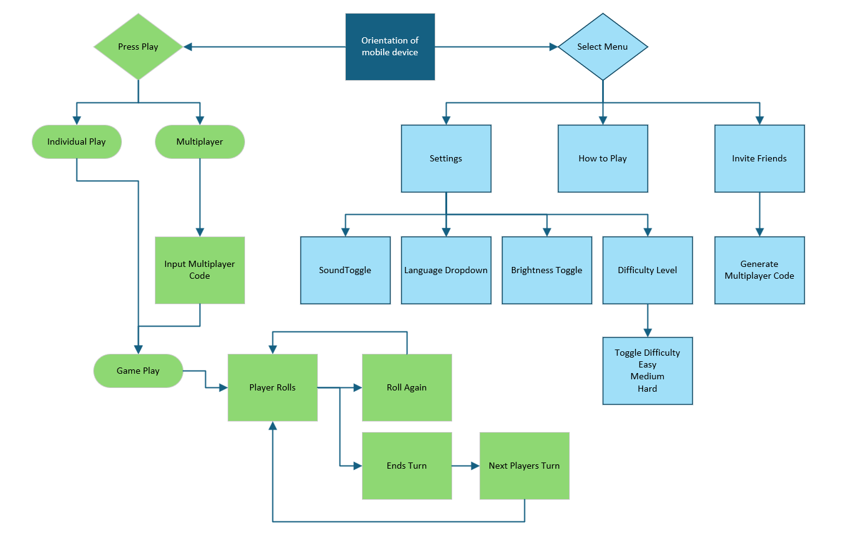
Figure 18 - Game Glow Diagram
The flow diagram shows each option within the menus and the general flow of the game. This will be used as the blueprint for the wireframes.
For the game to be played effectively the user will be prompted to rotate their device to a landscape mode.
The main menu screen will show a menu tab in the top right corner of the screen. This will be a consistent feature on all screens to allow the user familiarity with the menu feature.

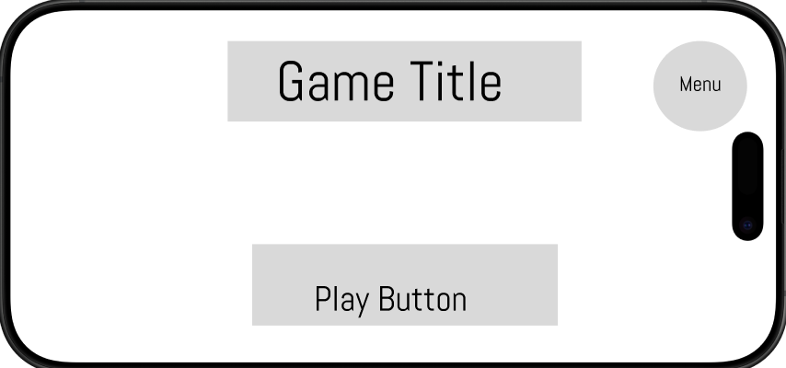
Figure 19 - Wireframe - Landing Screen

By taking the approach of simple interactions and reducing the number of options for the user allows quick game play.
To cater for a wider scope of users a difficulty feature is also within the settings tab. The three components on the dice relate to an action within the game.
For UWTSD-themed Zombie Dice the three features are:
- Pass – you ate your lecturers’ brains and passed the module
- Deadline – the lecturer fought off your zombie attack
- Module Extension – your lecturer escaped your attack and gave you an extension on your assignment
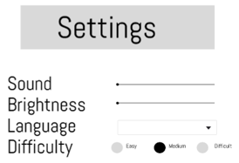
Each of the 13 dice have colours associated with them: Red, Yellow, and Green. Each dice has a risk factor attached – red being high risk and green being low risk. Red dice contain more deadlines and green contains more passes. By toggling the difficulty setting in the settings menu the number of red dice and green dice in play can be altered.
Figure 20 - Settings Menu

The MoSCoW analysis reflected a ‘Must-Have’ of changing the contrast on the game. This can be used to assist users affected by vision conditions.
Another feature in the is the languages settings. According to HESA the number of international students studying in the UK is growing each year. This will accommodate any students who prefer to play the game in the native language.
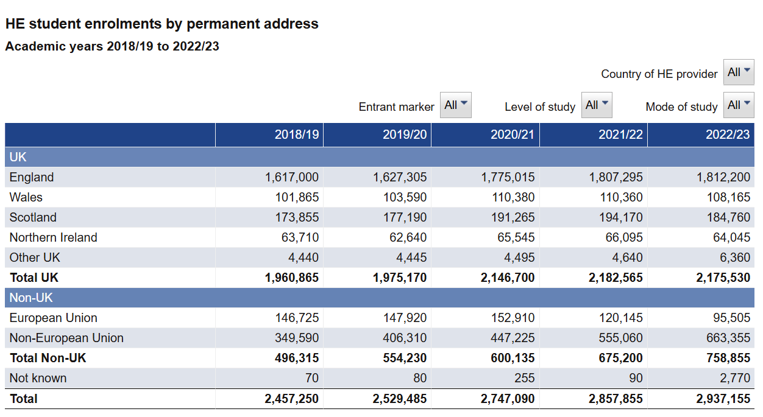
Figure 21 - International Students
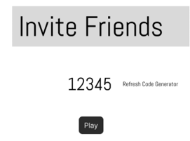
From the MoSCoW analysis there was a need for a multiplayer feature within the game, to allow players to play with there friends. To create an easy to navigate and functional game, a code is generated by a player that can be shared with others for them to join in game play. This allows the players to play the game without having to create an account for supply email addresses that they may not want to share.
Figure 22 - Invite Friends

The game play will feature pop up prompts for users to understand to game play. Popping up at intervals for first time users to direct the game play and navigate features.
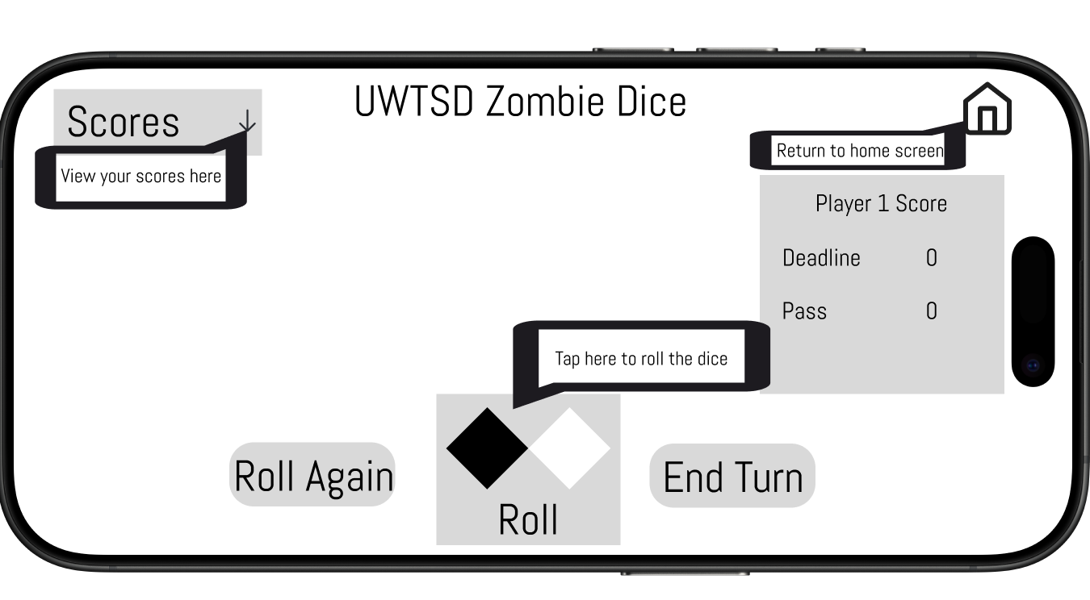
Figure 23 - Game Prompts

Figure 24 - Game Play Screen
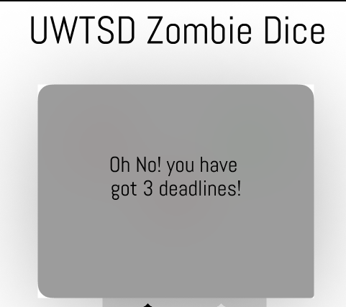
The main features within the game play screen are the players score on the right and other players scores on the left. To prevent the screen being too busy, the scoreboard will be a dropdown allow the player to toggle the scoreboard on and off.
Figure 25 - Lost Game
When a player has rolled three ‘Deadlines’ that means they have lost the game. A popup shown above will let the user know they have lost.

Prototype Feedback
The personas spanned a range of demographics within the university setting. The range of ages and gaming experience was from casual gamers to highly committed gamers, and even a persona that doesn’t game very often or not at all.
By using these personas to influence the game design drives for certain features to be included, removed, and improved upon.
A series of questions were asked to a potential user, in appendix 5, for their feedback to the wireframe diagrams. The feedback was generally of a positive nature and constructive criticism was given.
The main takeaways from the feedback were the general overview and navigation was intuitive and easy to follow. A more personal touch could be given to the players by letting the user input their name. A more of a story could be applied to the wireframes to ensure the player understands what game they are playing.
Things to consider for the full colour feature:
- Input box for the player’s name
- An initial introduction storyline to ensure the players understand the story
- Further expand on the multiplayer feature
- Be able to change the colour theme to be more sympathetic to those with vision difficulties
- Introduce a text-to-speech feature to navigate the user through the game
- More feedback when a player has taken their turn
Using this feedback a more user focused approach can be taken to improve on the usability of the game.

Conclusion
In conclusion, throughout the development of the wireframes it is imperative to understand the target audience. By creating personas there can be a balance created to ensure that the game is hitting the correct points and intended users. While online games can be played by most people there always needs to be accessibility options for those that struggle. By having these inclusivity features can ensure that the experience of gaming is enjoyable and does not exclude any users.

References

[1] | L. a. H. C. a. G. C. Barnett, “First Time User Experiences in mobile games: An evaluation of usability,” Entertainment Computing, 2018.
[2] | C.-L. a. C. J. C.-L. a. D. C.-M. Hung, “Enhancing mobile satisfaction through integration of usability and flow,” Engineering Management Research, 2012.
[3] | H. Korhonen, Evaluating playability of mobile games with the expert review method, Tampere University Press, 2016.
[4] | C. B. Awareness, “About Colour Blindness,” 2022. [Online]. Available: https://www.colourblindawareness.org/colour-blindness/. [Accessed 10 2024].
[5] | M. a. V. W. a. d. G. R. D. T. Pinheiro, “Why Should Red and Green Never Be Seen? Exploring Color Blindness Simulations as Tools to Create Chromatically Accessible Games,” Association for Computing Machinery, vol. 7, 2023.
[6] | Lindkvist, “Assessing Visual Attention Methods in Video Games : A Comparative Study of Effectiveness and Colorblind Accessibility,” 2023.
[7] | A. J. E. D. a. D. S. Colin Egan, “Do you see what I see? - Understanding the challenges of colour-blindness in online learning,” School of Computer Science.
[8] | B. D. Association, “Dyslexia,” British Dyslexia Association, 2024. [Online]. Available: https://www.bdadyslexia.org.uk/dyslexia. [Accessed 11 2024].
[9] | M. Neuropsychology, “5 Common Dyslexia Related Reading Errors,” Minnesota Neuropsychology , 2024. [Online]. Available: https://www.mnneuropsychology.com/articles/common-reading-errors.html. [Accessed 11 2024].
[10] | A. a. V. E. a. C.-C. S. a. L.-M. S. Jaramillo-Alczar, “An approach to accessible serious games for people with dyslexia,” Sustainability, 2021.
[11] | H. a. O. P. A. Engstrom, “Using text-to-speech to prototype game dialog,” Computers in Entertainment (CIE), 2018.
[12] | Y. a. K. A. a. S. C. Kumar, “A deep learning approaches in text-to-speech system: a systematic review and recent research perspective,” Multimedia Tools and Applications, 2023.
[13] | K. a. K. K.-T. Ellis, “Who gets to play? Disability, open literacy, gaming,” Cultural Science Journal, 2019.
[14] | H. J. a. Y. M. a. R. D. a. L. C.-C. Kuo, “Video games and disability—a risk and benefit analysis,” Frontiers in Rehabilitation Sciences, 2024.
[15] | P. a. H. L. a. T. M. Baltzar, “Forced to Choose Silence: Social Gaming with Disabilities,” Simulation & Gaming, 2024.
[16] | C.-H. a. L. G.-C. a. H. S. a. Y. J.-Y. a. Y. M.-J. a. L. W.-C. a. Y. C.-F. a. C. C.-S. Ko, “Brain activities associated with gaming urge of online gaming addiction,” Journal of psychiatric research, 2009.
[17] | D. J. Kuss, “Internet gaming addiction: current perspectives,” Psychology research and behavior management, 2013.
[18] | G. a. G. S. M. Chung, “Data mining the kids: Surveillance and market research strategies in children’s online games,” Canadian Journal of Communication, 2006.
[19] | A. a. D. A. Canossa, “Play-personas: behaviours and belief systems in user-centred game design,” in Human-Computer Interaction--INTERACT 2009: 12th IFIP TC 13 International Conference, Uppsala, Sweden, August 24-28, 2009, Proceedings, Part II 12, Springer, 2009, pp. 510--523.
[20] | A. Cooper, About Face 2.0: the Essentials of Interactive Design.

Appendices

Appendix 1 - Questionnaire
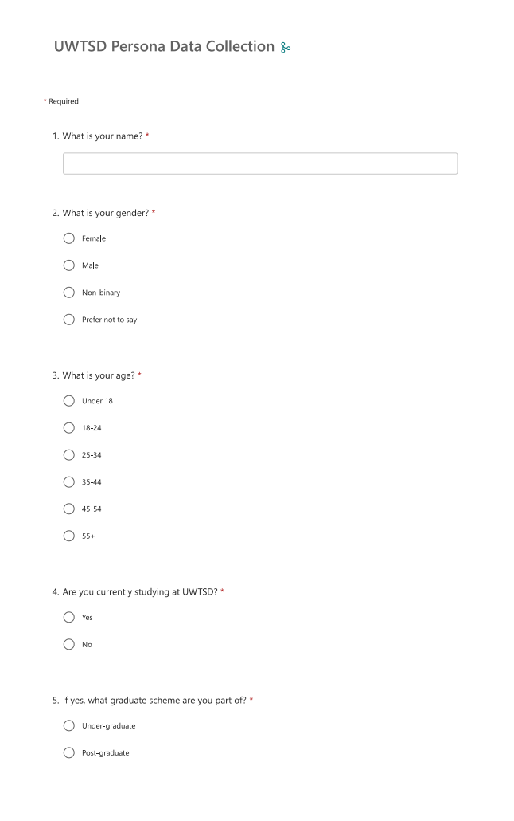
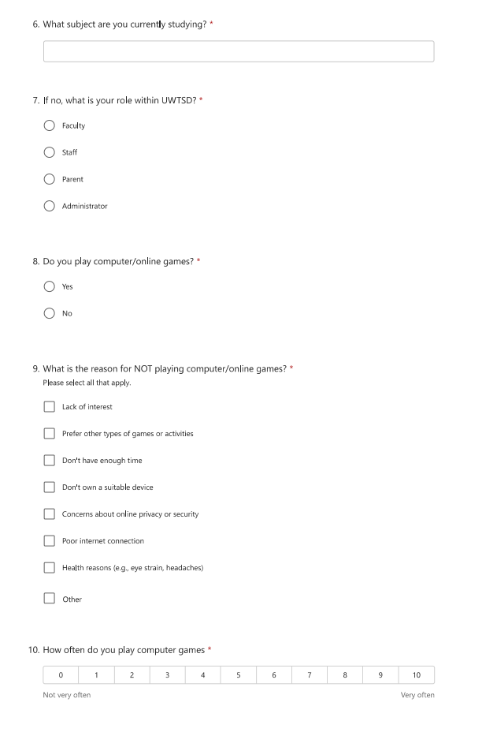
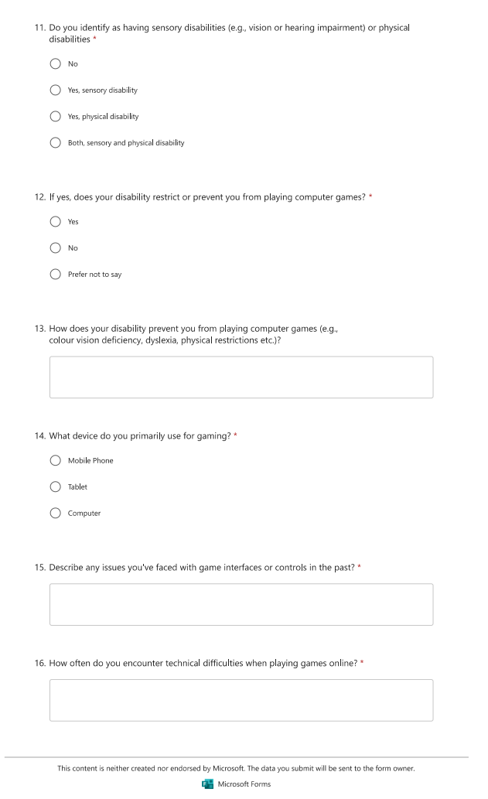

Appendix 2 – Questionnaire Results
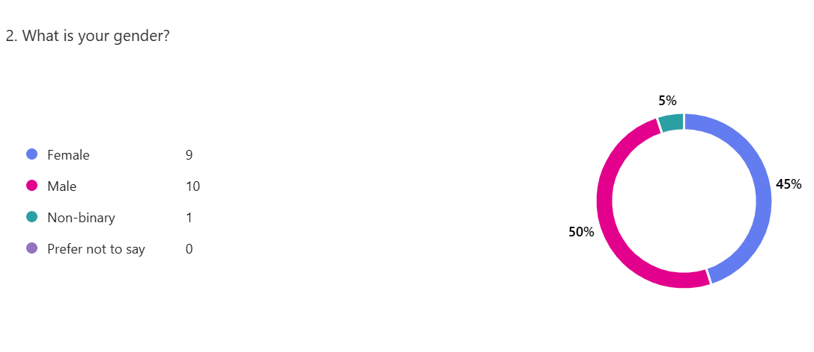
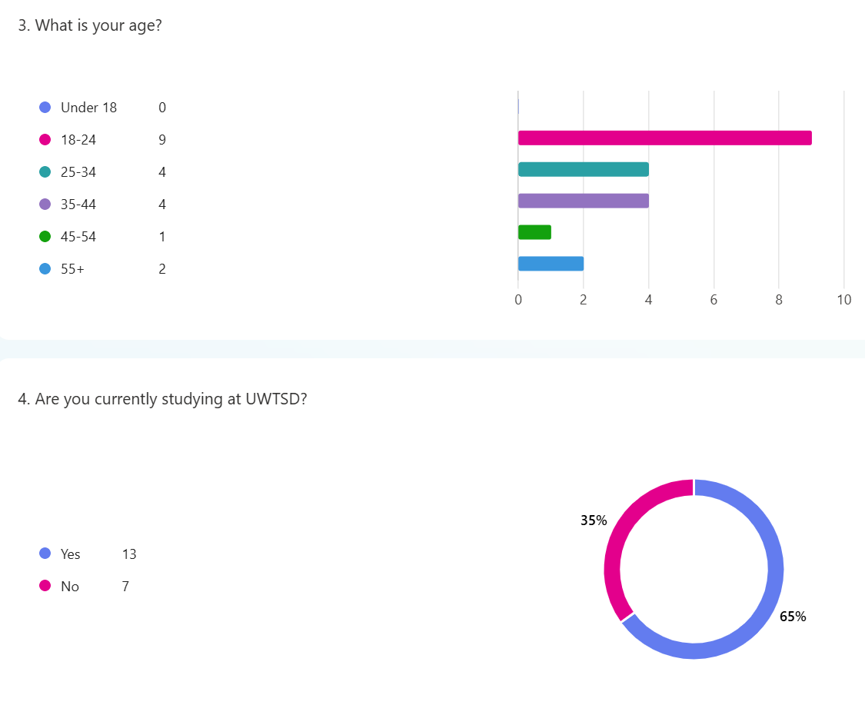
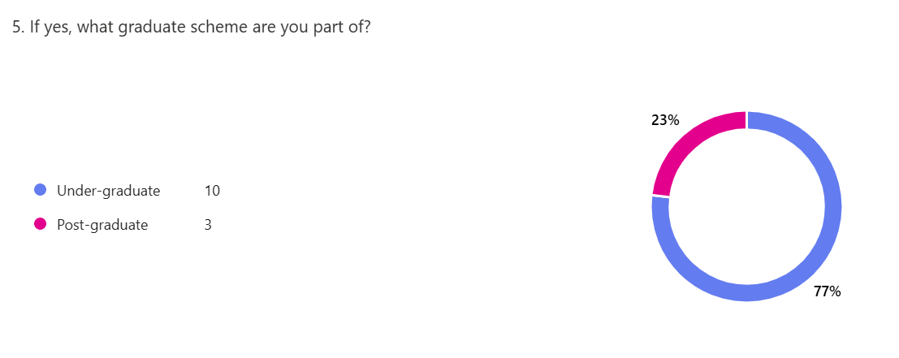
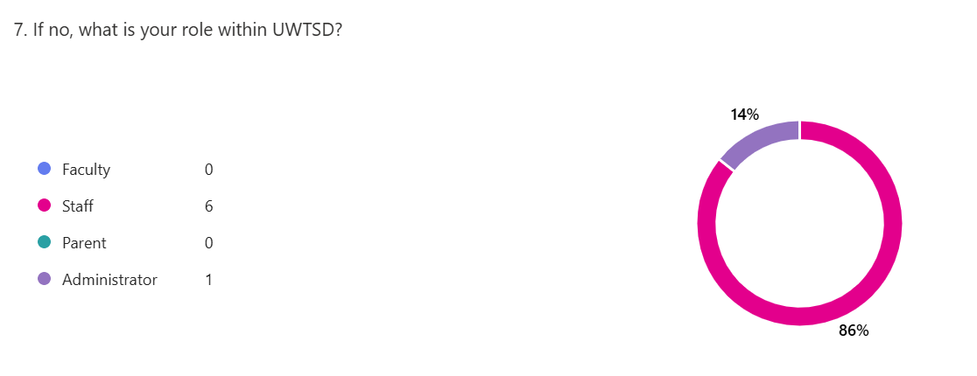
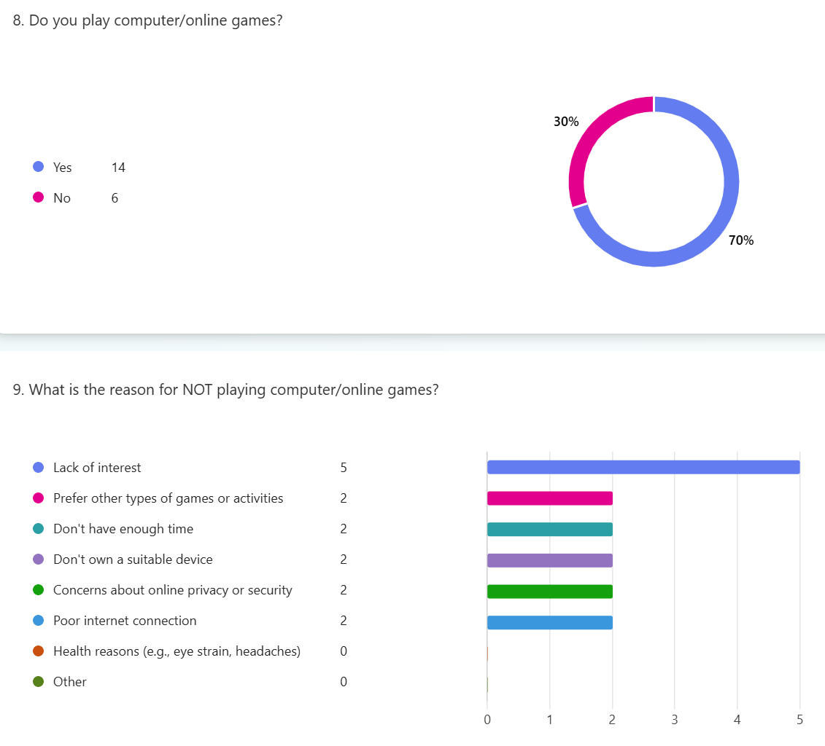
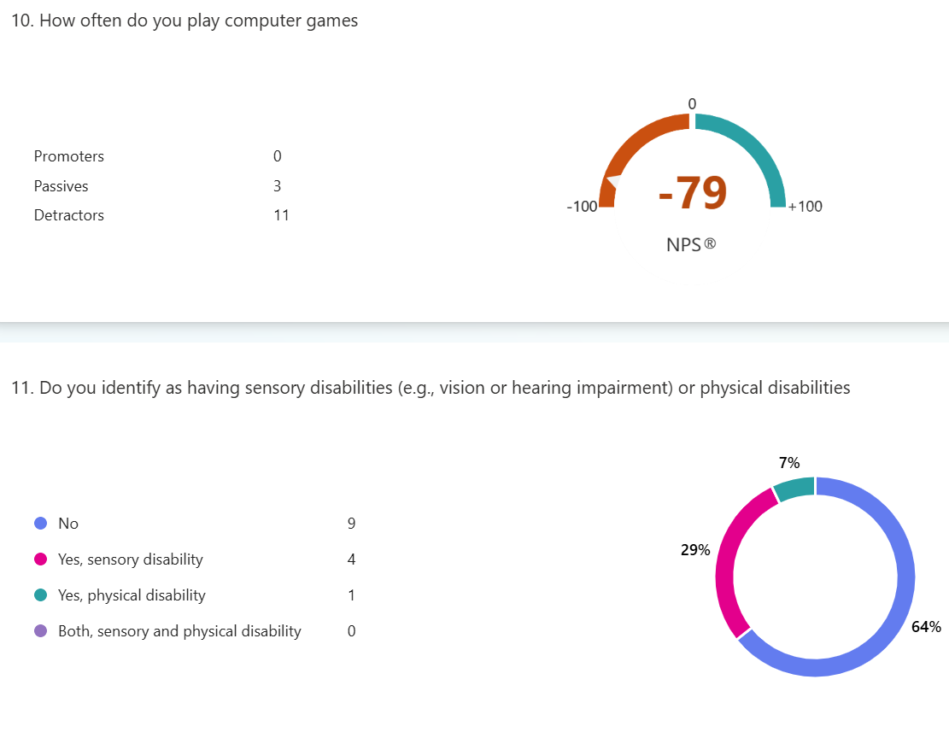
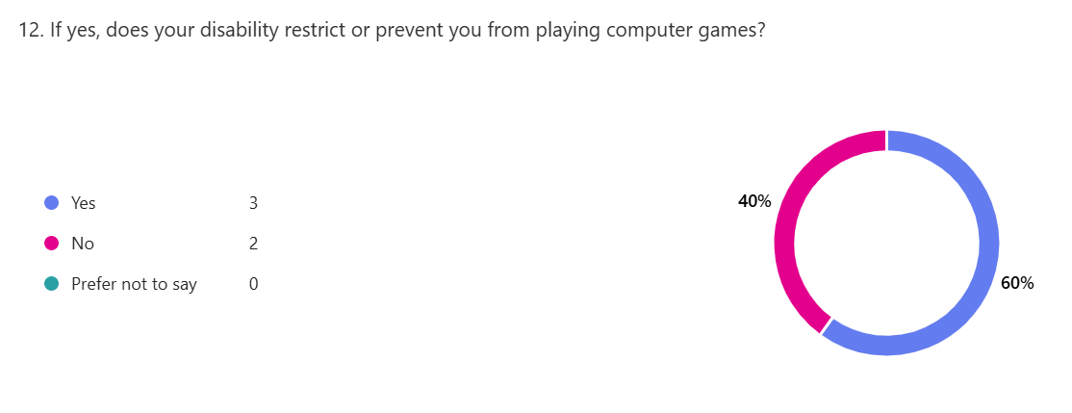
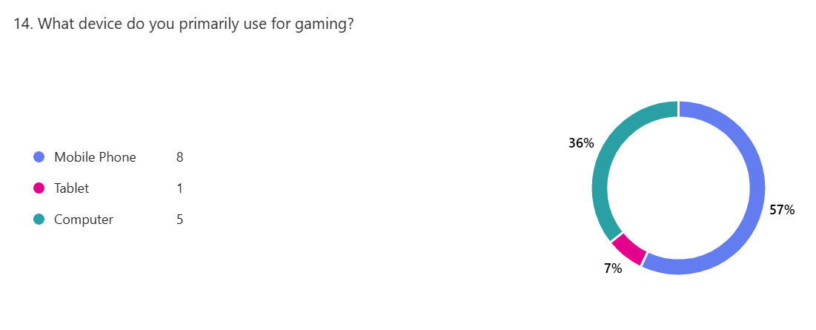

Appendix 3 – Wireframe flows

Wireframe Menu
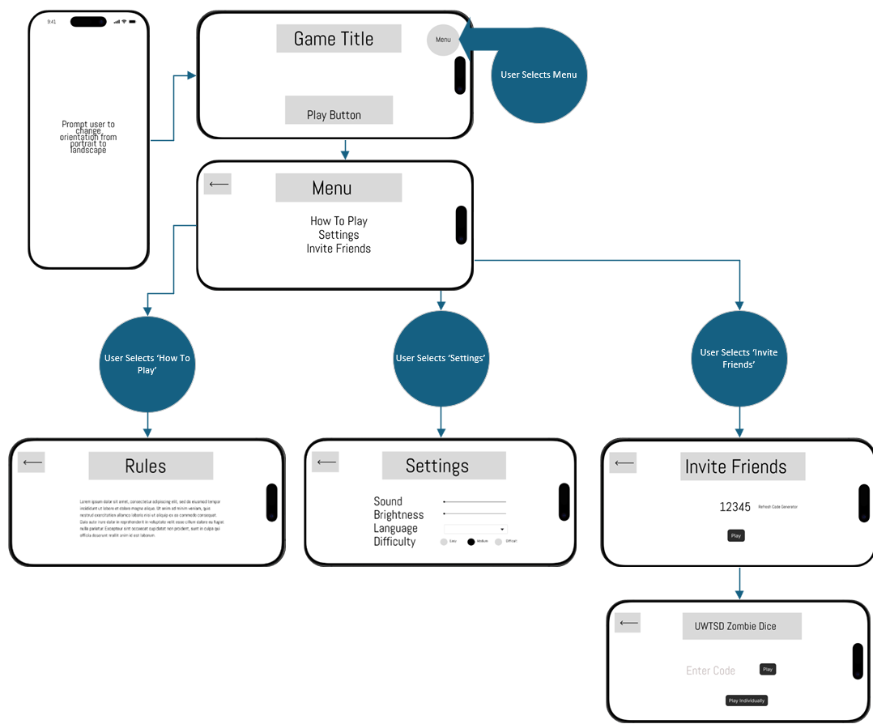

Game Play Screen
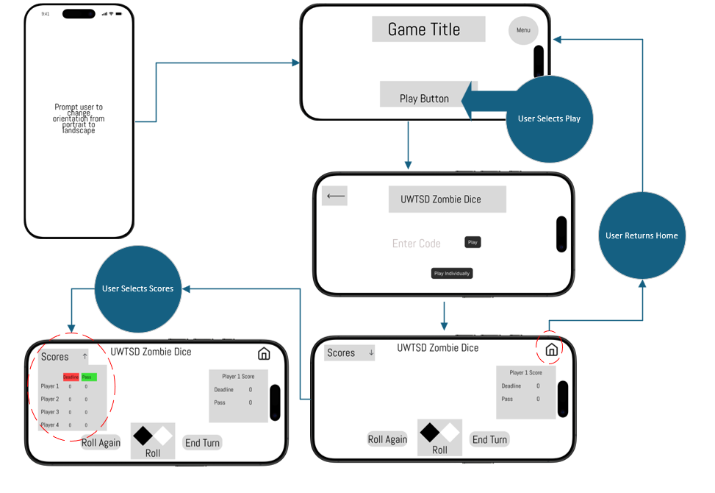
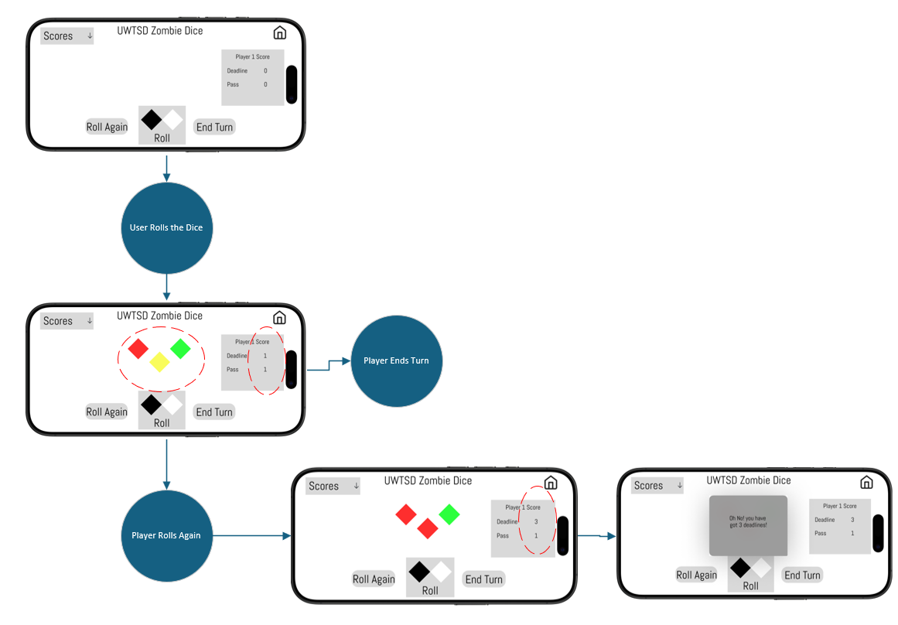

Appendix 4 – MoSCoW Analysis
Must-Have | Should-Have
- Adjustable colour settings to accommodate different types of colour-blindness  - Screen resolution settings to ensure accessibility  - Optimise bandwidth so games can run smoothly on low bandwidth  - Easy to navigate menus and responsive functionality | - Multiplayer options for online and offline game play  - Customisable game themes and control settings
Could-Have | Won’t-Have
- High resolution graphics for user with powerful devices  - Extra levels and storylines for long term user engagement | - Features that will only apply to a niche demographic  - Resource heavy elements that would require significant increase in computing power

Appendix 5 - Feedback Questions and Answers
What were your first thoughts upon using the wireframe?
The initial wireframe was easy to navigate with the menu icon and play button. The layout didn’t look too busy, and it was easy to see where the buttons were.
How easy was it to navigate through the wireframe?
Yes, the menus where self-explanatory and easy to navigate through. By having the back button and home button in opposite corners made it easy to navigate back or to the home page.
Were there any aspects that were confusing or difficult to use?
Somewhat, the concept of the game needed to be explained, but with the pop-up help icons, I think this will alleviate this confusion.
Were there any features you felt were missing?
I would have liked to have a name box to input my name, this would make it feel more personable.
How satisfied are you with the overall experience of using the wireframe?
I think it is a nice feature that I can play with my friends easily. More feedback could be introduced to make the game tell more of a story.
Were there any specific elements you particularly liked or disliked?
I liked how the game was centred around the university themed and believe it could be popular with students and staff at the university. Parts I disliked was how to game only had one level, even though the difficulty could be changed it would be nice to explore further features and levels.
Did you encounter any accessibility issues?
I don’t currently have any issues with accessibility, although I believe it is a good idea to change the brightness for users with sensitive vision.
Do you have suggestions for making the prototype more accessible?
Maybe an option to for text-to-speech. This only wasn’t visible on the wireframes. This would be great for users with difficulties reading or vision issues.
What improvements or changes would you suggest for this prototype?
As stated about the text-to-speech option would be a huge improvement. Also, maybe scope to play with more players and have league tables maybe.

