

The Importance of Emotional Intelligence In Effective Leadership In Supermarkets Across Wales.

Simo Victorine Maigne
ID: 2423778

MBA in Business Administration
University of Wales Trinity Saint David
December, 2025

ABSTRACT

This study examines the very crucial issue of Emotional Intelligence (EI) in improving leadership efficacy in the environment of high pressure at Welsh supermarkets. The study used pragmatist philosophy and a convergent parallel mixed methods design to triangulate the quantitative information collected by survey of 150 employees with qualitative insights derived from 10 semi-structured interviews with managers.
The results of the analysis indicate a serious "Regulation Gap." Although statistically regression proves that leader EI is a potent predictor of employee performance (R² =.836) when statistical analysis is used, a paradox occurs: managers have high levels of motivational influence and have a severe lack of external self-regulation when dealing with operational crises. Although task output escalates, therefore, the workforce is subjected to affective dilution, particularly in the absence of transactional stability, which undermines job satisfaction. Qualitative findings reveal that this is often driven by "Sterile Judgment," where leaders suppress emotions to maintain professional control, hindering authentic conflict resolution. Consequently, while task output increases, the workforce experiences "affective dilution," particularly in the absence of transactional stability, which undermines job satisfaction.
The researchers determine that abstract empathy in terms of the volatile retail sector cannot be operationally adequate without the ability to control behavioural resilience. Some of the strategic suggestions are to apply the "Situational Regulation" simulation training, and also to incorporate certain EI competencies in the standard operating procedure so as to close the gap between emotional awareness and leadership performance.

DECLARATION

This work has not previously been accepted in substance for any degree and is not being concurrently submitted in candidature for any degree.

Signed ..................... Simo Victorine Maigne..............................................

Date ....................................12/12/2025....................................

Table of Contents
Abstract 2
Declaration 3
Acknowledgements 9
Chapter One: Introduction 10
1.1 Background of the study 10
1.2 Problem Statement 11
1.3 Rationale of the Research 12
1.4 Research Aim 12
1.5 Research Objectives 13
1.6 Research Question 13
1.7 Summary Research Methodology 13
1.8 Research Structure 14
Chapter Two: Literature Review 15
2.1 Introduction 15
2.2 The Supermarket Context in the Wales 15
2.3 Theoretical Overview 16
2.3.1 Emotional Intelligence Theory 16
2.3.2 Transformational Leadership Theory 18
2.3.3 Contingency Theory of Leadership 19
2.3.4 Job Demands-Resources (JD-R) Model 21
2.3.5 Theoretical Framework 22
2.4 The Importance of Emotional Intelligence in Effective Leadership 22
2.5 The Relationship Between Emotional Intelligence and Employee Performance 24
2.6 The Impact of Emotional Intelligence on Leadership Styles for Organisational Performance 25
2.7 Emotional Intelligence and Its Contribution to Effective Decision-Making and Conflict Resolution 26
2.8 Research Gap 28
2.9 Chapter Summary 28
Chapter Three: Research Methodology 29
3.1 Introduction 29
3.2 Research Philosophy 29
3.2.1 Ontological Stance 30
3.2.2 Epistemological Stance 30
3.2.3 Axiological Stance 31
3.3 Research Approach 31
3.4 Research Method 31
3.5 Research Strategy 32
3.6 Data Collection Technique 33
3.7 Sampling Method and Sample Size 33
3.8 Data Analysis Technique 34
3.9 Reliability and Validity 34
3.10 Limitations of the methodology 35
3.11 Ethical Consideration 35
Chapter Four: Findings and Discussion 36
4.1 Introduction 36
4.2 Findings and Analysis 36
4.2.1 Demographic Findings 36
4.2.2 Validity and Reliability Test 41
4.2.3 Descriptive Analysis 41
4.2.4 Inferential Analysis 50
4.2.5 Thematic Analysis 54
4.3 Discussion 58
4.3.1 OB-1 To determine the importance of emotional intelligence in effective leadership within Wales supermarkets 58
4.3.2 OB-2 To identify the relationship between emotional intelligence and employee performance for effective leadership in supermarkets 59
4.3.3 OB-3 To examine the impact of emotional intelligence on leadership styles for organizational performance in supermarkets 60
4.3.4 OB-4 To investigate how emotional intelligence contributes to effective decision-making and conflict solutions in leadership 61
4.4 Chapter Summary 62
Chapter Five: Conclusion and Recommendation 63
5.1 Conclusion 63
5.2 Recommendation 64
5.2.1 Implement "Situational Regulation" 64
5.2.2 Operationalise EI into "Transactional Consistency" Protocols 65
5.2.3 Adopt a "Constructive Conflict" Framework 65
5.2.4 Revise Recruitment Criteria to Prioritize "Resilient Empathy" 65
5.2.5 Establish 360-Degree "Blind Spot" Feedback Mechanisms 66
5.2.6 Context-Specific Support for Welsh Retail Leaders 66
5.3 Contributions to Theory 67
5.4 Limitations and Future Research 67
References 69
Appendix A Survey Questionnaire 87
Appendix B Interview Questionnaire 98
Appendix C Collected Data 99
Appendix D Quantitative Analysis 100
Appendix E Interview Transcript 106
Appendix F Ethics Form 112

List of Figures
Figure 1: Retail employment (Ward, 2025) 16
Figure 2: Emotional Intelligence by Daniel Goleman's (1995) 17
Figure 3: Transformational Leadership 19
Figure 4: Fiedler’s Contingency Theory of Leadership (Murillo et al., 2022) 20
Figure 5: Job Demands-Resources (JD-R) model by Bakker and Demerouti (2007) 21
Figure 6: Research Onion by Saunders et al., (2023) 29
Figure 7: Role in Supermarket 36
Figure 8:Time of working at supermarket 37
Figure 9: Age of the participants 37
Figure 10: Gender of the participants 38
Figure 11: Current management position at supermarket 38
Figure 12: Time of Leadership role in supermarkets 39
Figure 13: Age of the participants 40
Figure 14: Gender of the employer 40
Figure 15: Qualities of Manager 44
Figure 16: Leaders improve their empathy to better support 45
Figure 17: Manager’s social skills improved work experience 45
Figure 18: Aspect of emotional intelligence 49
Figure 19: Challenges in applying empathy in leadership 50

List of Tables
Table 1: Research Structure 14
Table 2: Cronbach's Alpha 41
Table 3: Leadership and Emotional Intelligence 41
Table 4: Employee Experience & Satisfaction 42
Table 5: Self-Perception of Emotional Intelligence 46
Table 6: Leadership Effectiveness & Decision-Making 47
Table 7: Correlation Table 50
Table 8: Regression Table 51
Table 9: ANOVA Table 51
Table 10: Coefficient Table 52
Table 11: Regression Table 2 52
Table 12: ANOVA Table 2 52
Table 13: Coefficient Table 2 53
Table 14: Thematic analysis 1 54
Table 15: Thematic analysis 2 56

Acknowledgements
I would like to thank my supervisor with all their heart that everything would be impossible without their invaluable guidance and constructive feedback that helped me to improve the methodology and analysis of this dissertation. I equally appreciate the University of Wales Trinity Saint David, which has given me the academic framework and ethical approval for this research.
The 150 employees and 10 managers in the supermarket who volunteered their time to take part in the surveys and interviews are given a special note of gratitude. This research was blooded by their candid comments. Lastly, I wish to acknowledge my family and friends who have been serving as a consistent support.

Chapter One: Introduction

1.1 Background of the study
The retail business is one of the solid foundations of the economy of the United Kingdom, which produces a great deal of financial and employment stability. The sector has an economic output of £114.7 billion in 2024, equivalent to 4.4% of the UK’s overall output, and 2.6 million jobs in 304,560 businesses by January 2025 (Ward, 2025). Total retail sales had hit £517 billion, admirably indicating consumer emphasis on essentials, with every pound spent in 2024 carrying 39 pence on food shops, which, with pennies, is a tremendous lead on clothing (11 pence) and home goods (7 pence) (Ward, 2025). This high-volume, low-margin supermarket model relies on fast, self-service efficiency. Aldi and Lidl, which have disrupted the British low-end market, have shaken up the UK and Welsh market, which is dominated by the Big Four, Tesco, Sainsbury, Asda, and Morrisons (Butler, 2025). Additionally, the rapid growth of internet grocery buying has brought additional operational issues. The suggestion to investigate aims to resolve these competitive issues in Welsh cheap and conventional supermarkets.
This operating environment is volatile and low-profit. Retailers must adapt quickly to client expectations, economic upheavals, and supply chain disruption (Trento et al., 2021). The environment puts a lot of strain on leaders. Supermarket management must manage a large, transitory, multi-generational, and varied staff while juggling logistics. Current retail issues include managing different teams under high stress and weariness, which leads to a turnover rate several times greater than the national norm according to Ghani et al. (2022). Without leaders addressing these emotional landscapes, operational inefficiencies and workforce disengagement may result.
Emotional Intelligence (EI) is a crucial leadership trait that is capable of understanding, controlling, and influencing emotions of both self and others to create a positive work environment, motivate employees, and build healthy customer relationships. Emotional intelligence is the capacity to recognise, detect, and manage own and others' emotions, according to Habib et al., (2023). The shop floor's human interpersonal activity revolves around the EI, even if inventories need technological abilities. Self-awareness, self-regulation, motivation, empathy, and social skills are essential in leadership, according Maldonado and Márquez (2023). A Welsh shop manager who must address a customer complaint or staff concern and make a judgement must have these qualities.
Supermarket managers require special operational and emotional intelligence. (Goleman and Cherniss, 2024) They may develop trust with personnel by reading them and encouraging them in their duties despite their monotony. Empathy allows a management to assist personnel avoid weariness during peak trading showed by Alhumoudi and Alfarhan, (2024). Leaders may settle problems more easily by being more attentive to their subordinates' sentiments, which is important since interpersonal conflict is common in customer-facing jobs. Emotionally intelligent executives also make better judgments that match the organization's hard and operational needs with its soft emotional environment.
Although the data on emotional intelligence and leadership is powerful, most of the research by Cavins (2021), Chiseyeng’I et al. (2022) and Morfaki (2022), have focused on corporate leadership and ignored supermarkets' high-speed situations. The retail setting is unique because consumer problems and performance standards limit emotional control. Due to economic and demographic concerns, Welsh retail data is scarce. Emotional control and social competence help leaders perform better in such circumstances, ensuring staff well-being and organisational goals.
Moreover, emotional intelligence is inseparably associated with objective decision-making in a state of pressure. Emotionally intelligent leaders are capable of responding to stress-inducing situation more rationally because of their abilities to manage pressures (Kour and Ansari, 2024). The skill to remain calm is invaluable in situations that are high-stakes or require the management of a scarcity of supplies on the shop floor or a heated conflict among people.
Emotional intelligence in leaders has long been known, but its direct impact on leadership success in Wales' retail business has not been studied. This study project would examine how emotional intelligence affects employee performance, leadership styles, decision-making, and conflict resolution to fill this vacuum. The study uses these links to propose credible leadership improvements for supermarkets, which improves organisational performance.

1.2 Problem Statement
The retail sector, especially the supermarkets are a very vital segment in the economy in which they serve varied consumer demands. Irrespective of the significance, there are numerous challenges facing supermarkets in Wales that do not support effectiveness in leadership. The increasing challenge of the leading grows with the pace of market changes being one of the most acute problems. According to the British Retail Consortium (2023), supermarkets are in a constantly changing race to adjust to consumer trends and to bitter competition among traditional and discount retailers. With this kind of competeiveness, good leadership is critical to see to it that organisations do not just survive but on the contrary prosper.
One of the greatest challenges of the supermarkets these days is the failure to manage various teams in high-pressure conditions. Because of student workers, part-time employees, and long-term employees (according to the CIPD, 2024), the retail industry depends on a diverse workforce being disaggregated, which poses particular issues in cohesiveness management. Supermarket workers frequently have to work in stressful conditions, and current statistics show that the number of cases related to abuse and harassment towards the retail employees increased by half (British Retail Consortium, 2024). Such an unstable setting may cause relatively low employee morale and alarming turnover rates, which constantly exceed the average of the country, being about 45% every year (Statista, 2024). Leaders that do not comprehend and respond to such emotional issues can find it difficult to have a motivated workforce. Specifically, such issues are worsened by the absence of emotional intelligence (EI) in leadership positions. According to Goleman (1998), this failure to study and respond to employee feelings brings conflict, disinterest and poor working culture.
Moreover, work of decision-making in supermarkets may be problematic because of emotional ignorance. Decision making must take into account the emotional needs of the stakeholders: it is necessary in a business of retail where the elementary service to the customer is at the forefront. George (2000) argues that leaders unable to control their emotions can make decision on impulse that hurt employee motivation and customer satisfaction. In the absence of the buffer of emotional regulation the operational stressors tend to cause cognitive overload thereby affecting judgement.
The difficult question of conflict resolution is another serious problem. Supermarkets tend to have internal tensions such as schedule wars to conflicts between the administration and the employees. A study by O'Neill (2022) points out that unsolved interpersonal conflict within a retail environment is directly proportional to decreased productivity within a team. The lack of emotional intelligence can force leaders to not effectively resolve such conflicts which leads to the existence of tensions that were not resolved which in turn further impacts on the work environment. Therefore, emotional intelligence deficiency in leadership positions can be cascaded to the team cohesion and low organisational performance.

1.3 Rationale of the Research

1.4 Research Aim
The aim of the study is to explore the role of emotional intelligence in enhancing leadership effectiveness and its impact on organisational performance in supermarkets within Wales.

1.5 Research Objectives
The objectives of the study are the below:
- To determine the importance of emotional intelligence in effective leadership within Wales supermarkets.
- To identify the relationship between emotional intelligence and employee performance for effective leadership in supermarkets.
- To examine the impact of emotional intelligence on leadership styles for organizational performance in supermarkets.
- To investigate how emotional intelligence contributes to effective decision-making and conflict solutions in leadership.

1.6 Research Question
The primary research question is “What is the role of emotional intelligence in enhancing leadership effectiveness and its impact on organisational performance in supermarkets within Wales?”

1.7 Summary Research Methodology
This study is founded on a pragmatist approach to research, which examines how emotional intelligence can lead to leadership performance in a narrow domain area of Welsh supermarkets. The study also adopts a pragmatic and mixed ontological and action based epistemological approach, which is imperative towards the measurement of the objective performance indicators as well as the subjective emotion and feelings of employees working in stressful systems. Abductive research method has been used to allow an iterative discourse between the developed theoretical frameworks and newly developed empirical data.
The research used convergent parallel mixed approaches to triangulate findings well. This included performing a systematic supermarket staff survey and archival investigation of industry papers to collect primary quantitative and secondary qualitative data. Non-probability sampling was adopted for convenience and snowball sampling to overcome the barrier to private retail access. The statistical analysis and thematic analysis were used to interpret documentary evidence and hypothesis-tested relationships respectively, which was carried out rigorously by the analysis of the hypothesis based on the statistical analysis with the help of SPSS. This holistic approach will also be able to cover a situation in which not only is the findings statistically significant but also rich in context and applicable to practical intervention on resolving retention and performance problems.

1.8 Research Structure
Table 1: Research Structure

Chapter Two: Literature Review

2.1 Introduction
This chapter is a critical assessment of the theoretical environment relating Emotional Intelligence (EI) to leadership efficacy in the Welsh supermarket industry. It starts by exploring and evaluating the under-lying frameworks in the high-pressure retail environment such as the model by Goleman and Transformational Leadership. The review then criticises the role of EI on employee performance, decision-making, and conflict resolution, with the conclusion of a research gap that requires an empirical study.

2.2 The Supermarket Context in the Wales
Retail sector is an important sector of Welsh economy and has about 9% of the total number of jobs of employees in Wales as of 2024 (Ward, 2025). The industry is faced with a season of massive instability in the wake of the cost-of-living crisis even despite the economic value it brings to the economy. Purchasing behaviours of consumers in Wales have changed radically, and there has been a great shift to more discount stores; Aldi and Lidl have embarked on snatching up a greater market share with Lidl; sales up 7.4% in the tail end of 2024, surpassing the traditional "Big Four" competitors (Faithfull, 2024). This high level of competition pressure compels the supermarkets to work at a high razor-thin margin and in many cases this margin is converted into high efficiency benchmarks among employees.
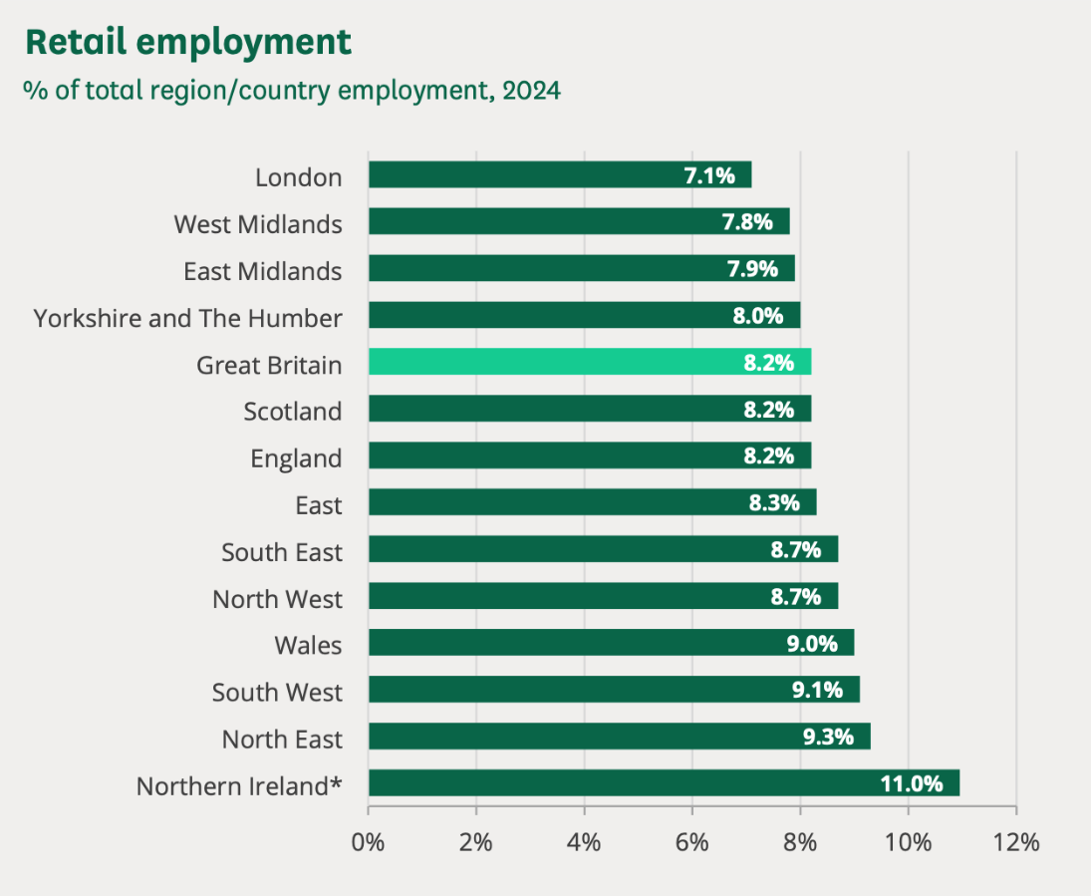
Figure 1: Retail employment (Ward, 2025)
Nevertheless, financial is not the greatest threat of Welsh supermarkets, it is human. The environment where operations take place has become so aggressive stripping the employees of their emotional attachment with their work. Gash and Blom (2025) have revealed that violence and abuse towards the shop workers have escalated by half over the previous year, and the Lee et al. (2025) have shown that one-fifth of retail employees suffered a violent attack in the previous year. This customer aggression which is mostly instigated by the theft or the argument about the prices subjects the frontline employees to an emotional toll never experienced before.
It is as such that there is a retention crisis in the sector. The retail and wholesale sector has a relatively high turnover at the moment, which is among the highest in the industry (ICAEW, 2025). The workforce also has great diversity in the figure of changes in populations in the labour market are transient students and the older generation of employees and a complicated social infrastructure exhibiting a multicultural character is very challenging to unite. This is in a high-pressure environment where employees are often overworked and unmotivated (Elshaer et al., 2025), its technical management skills are inadequate. The statistics indicate that the industry is already under acute demand of a leadership that can cushion such emotional requirements and therefore emotional intelligence is not only an imaginary benefit, but an operation requirement to survive.

2.3 Theoretical Overview

2.3.1 Emotional Intelligence Theory
A thorough analysis of Emotional Intelligence (EI) demonstrates that the area is full with contradictory paradigms, with Daniel Goleman's (1995) model being the most prominent, if contentious, basis for leadership research. Goleman's management and leadership development model—self-awareness, self-regulation, motivation, empathy, and social skills—is intuitive and effective, but its theoretical underpinning is sometimes questioned. Goleman's paradigm confuses natural capabilities with personality traits and motivation variables, unlike Mayer and Salovey's (1997) ability model, which defines EI as a cognitive talent (Pathak and Goltz, 2021). Since EI is an aggregate of existing characteristics, its stated independent impact on leadership effectiveness is difficult to define and experimentally establish.
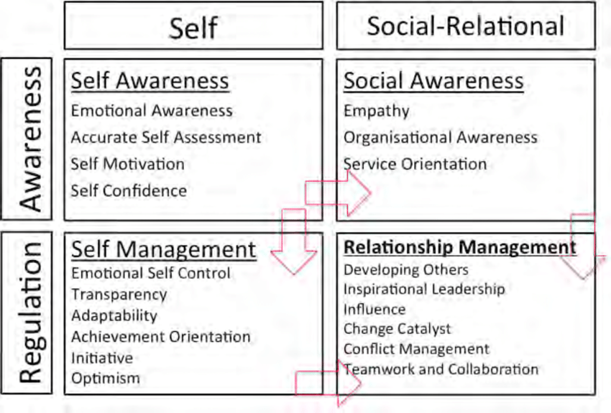
Figure 2: Emotional Intelligence by Daniel Goleman's (1995)
Instead, this supermarket leadership study in Wales relies on the model's instant transferability other organisational circumstances. Effective leadership training requires learning abilities, which Davis (2024) states are not innate. Self-regulated emotions and empathy may minimise friction and enhance worker morale in the supermarket sector, which faces high customer contact pressure. During interactions with Welsh retail teams, a leader's social skills (one of the Goleman characteristics) will be vital, supporting the study's purpose of evaluating how EI influences employee performance.
Overreliance on Goleman's paradigm may impair situational awareness. EI abilities are situation-dependent, therefore trait-based methods flatten the context, says Xianjun (2022). Empathy may help leaders overcome worker disagreements but hamper crisis decision-making. The Contingency Theory by Fiedler (1967) indicates that the proposed study should relate EI to its effectiveness and assess how these skills might be applied to supermarket routines and peak hours.
Goleman theory must be carefully applied to this investigation. It provides language and framework for exploring leadership decision-making and conflict resolution (Cwiakala et al., 2025). The study should separate EI's impacts from experience and organisational culture. This study can go beyond reiterating the importance of EI and examine how its features improve leadership effectiveness in Welsh supermarkets' high-demand environment by critically using Goleman's model and considering its limitations.

2.3.2 Transformational Leadership Theory
Transformational leadership theory (TLT), especially as promoted by Bass (1987), is often promoted as a theory for high organisational performance, however a critical investigation reveals conceptual and practical difficulties. Idealised influence, inspiring motivation, intellectual stimulation, and expertise sell glamourously to hold leadership. Meirinhos et al. (2023) brings out a general heroic leadership bias, placing too much or too little credit on situational and structural restrictions to the leader's organisational outcomes and acts, via this seduction. This is the most important in a high-turnover, process-driven retail setting where structural factors may influence a leader's transformative ability.
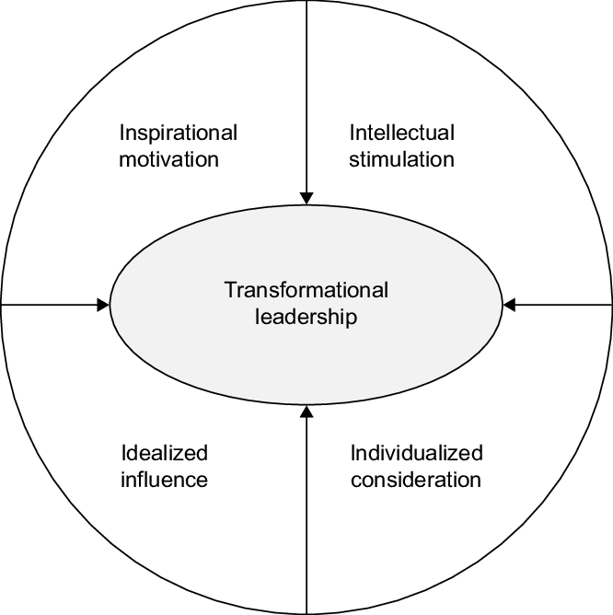
Figure 3: Transformational Leadership
The theory's measurement and distinction from similar concepts are contentious. According to Maran (2024), the Multifactor Leadership Questionnaire (MLQ) may be overused if it is theoretically unnecessary, particularly for charisma as an aspect of transformational leadership and traditional charisma definitions. In reality, transformational and transactional leadership are hard to distinguish. Example: a shop manager with a revolutionary vision and transactional performance-based pay. Brown and Nwagbara (2021) discovered transformational approaches may struggle in operational contexts that demand visionary zeal and procedural commitment.
Emotional intelligence interacts with the theory's emotional base. Cavaletti and Bizarrias (2023) believe transformational leaders mobilise emotionally. Customised attention requires empathy since inspiration is emotional contagion. This connection is usually assumed. Fuller (2023) suggested that a leader with intellectual stimulation but no self-regulation may be dismissive or hostile, stifling innovation. This possible paradox reminds us that transformational acts need emotional competence.
Transformational leadership may be harmful. Critics of Lapatoura (2025)'s revolutionary change leadership argue that charisma without ethics might lead to deception. In a diverse workplace, a leader's inspirational vision may unintentionally discriminate against cultures or emotions.
This study requires cautious TLT interpretation. Performance can't describe it. It should examine how EI is utilised to change behaviours and how retailing's contingencies, high workplace stress, and diverse workforce effect them. The notion is useful for identifying leadership styles, but it must go beyond supporting change.

2.3.3 Contingency Theory of Leadership
The Contingency Theory of Leadership, which was pioneered by Fiedler (1967) was essentially a radical challenge on the pursuance of the idealist orientation of leadership by pointing out that the level of effectiveness is dependent on the compatibility of the situational favourability and the style of leadership. Although this is foundational, Fiedler model, with its task-motivated versus relationship-motivated leaders determined by Least Preferred Coworker (LPC) scale, has received intensive criticism because it is no longer than a static one. Fiedler in essence proposed that the style of a leader is predetermined and that the only way that a leader can enhance performance is by configuring the situation to suit the style, which many people perceive as pragmatically constrained (Eva et al., 2024).
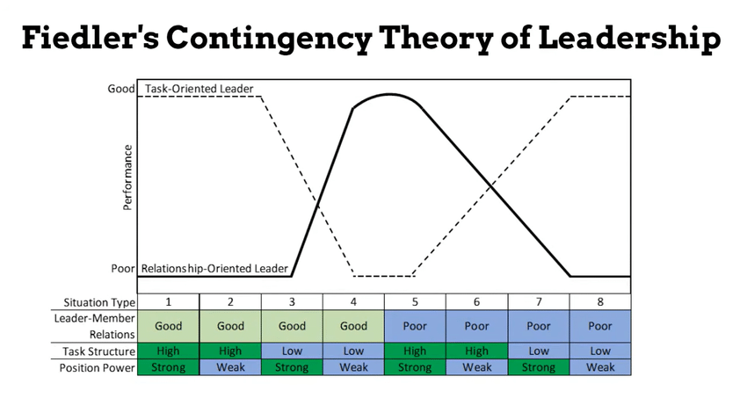
Figure 4: Fiedler’s Contingency Theory of Leadership (Murillo et al., 2022)
Marchito et al.'s (2025) Situational Leadership Theory states that leaders must adapt their directive and supporting conduct to followers' maturity. However, its ambiguous maturity standards and lack of proof have drawn criticism (Mahapatra and Jain, 2023). Fiedler's model is diagnostically dismal, but the following scenario models overestimate behavioural change.
Contingency is now seen as leadership flexibility rather than situational adaptability. Leadership and contextual signal comprehension and adaptability are promoted by Reams (2023). The theory is more beneficial when combined with behavioural complexity, which states that great leaders have a set of actions and the cognitive capacity to execute them (Gottfredson and Crane, 2025).
Argument: not all scenario features provide the correct leadership reaction. Traditional contingency theory challenges how leaders evaluate and adapt. Boyar et al. (2022) suggest social and cognitive talents enable real-time environmental awareness and behaviour modification. Determinism is replaced with agentic situational appraisal and leader potential.
This modified contingency approach allows retail executives in tumultuous times to analyse their underlying features for situational modifications. This dynamic contingency scenario involves store floor demands, staff requirements, and unexpected customer connections. Leaders' effectiveness depends on their ability to respond to changing events, such as daily inventory checks and fast customer feedback.

2.3.4 Job Demands-Resources (JD-R) Model
Bakker and Demerouti (2007) partition the workplace factors into two meta-dimensions, namely job demands and job resources, heuristically understood as job-related well-being and performance of employees. A virtue, austerity may be applied to numerous vocational situations with many possibilities, but its generality has been challenged for lacking theoretical specificity and practical clarity.
Workplace stress increases burnout, whereas encouraging boosts engagement and effectiveness. Lee and Jo (2023) suggest informally defining model constructs. Psychological mediation may arise when subjective demand-resource differentiations cause competing assessments. High workloads, which are normally demanding, may motivate certain workers, something the early model overlooked (Galanakis and Tsitouri, 2022). Wang et al. (2021) improved the distinction between challenge and hindrance needs in high-pressure contexts like retail, where certain demands are stimulating, and others are debilitating.
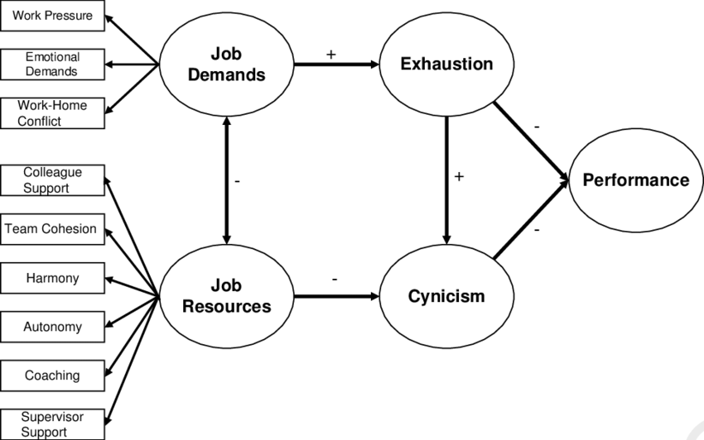
Figure 5: Job Demands-Resources (JD-R) model by Bakker and Demerouti (2007)
According to Lehtiniemi et al. (2023), the JD-R model's buffering notion hypothesises that resources may mitigate strain from demands. The mechanics of this interaction effect are unclear. Deng et al. (2021) have noted that the model sometimes oversimplifies by assuming that a panacea can buffer any demand, which is not always validated experimentally. The resource should match the demand it buffers (Lehtiniemi et al. 2023).
Integrating leadership studies with the model works. Wittmers and Maier (2023) stated leadership and team members provide social resources in the JD-R paradigm. The caravan of resources channel contains essential contextual resources like leaders' skills. This approach sees leadership as a dynamic power source that workers may guide through workplace challenges.
Using this smart lens in complicated service environments is appropriate. Demands (e.g., consumers line, stock outages) and emotional labour in the grocery sector are predictable and unexpected. JD-R helps researchers study how a leader's emotional-skilled behavioural repertoire is flexible. It may be used to examine how leadership materials like empathetic support and goal clarity might alleviate pressures like emotional tiredness from customer disagreements to maintain performance. This technique shows how leaders' relationship resources interact with team members' distinct needs.

2.3.5 Theoretical Framework
Emotional Intelligence (EI) is the first causal response that affects leadership, employee, and organisational results. The primary point is that leaders' emotional intelligence is important. The first way this resource impairs the effectiveness of their leadership is by improving decision-making and interpersonal relationships. After that, these more effective leadership behaviours result in positive work climate which literally encourages employees and enhances their performance. Eventually, the combination of higher employee performance and effective leadership leads to improved organisational performance because of improved customer service, fewer turnover and higher operational efficiency.
According to this framework, the hypotheses below will be tested:
H₁: There is a significant relationship between Emotional Intelligence and Employee Performance
H₂: Leaders' Emotional Intelligence has a significant positive effect on Effective Leadership in supermarkets.
H₃: Leaders' Emotional Intelligence has a significant positive effect on Employee Performance, mediated by Effective Leadership.

2.4 The Importance of Emotional Intelligence in Effective Leadership
Increasing empirical data links emotional intelligence (EI) to leadership performance, but there is no theoretical interpretation and the Wales context is not well-developed. On one hand, large-scale empirical research shows that leaders with high EI scores help their organisations perform better. Davis (2024) cites statistics showing that in UK companies, a 10% increase in manager EI scores led to a 7% increase in organisational performance. On the other hand, EI theory critics like Goleman and Cherniss (2024) warn about over-generalization and conceptual fuzziness.
Customer-facing, emotionally-charged supermarkets have complaints, lineups, and shortages. Nasir and Mahadi (2025) may have underestimated the effect of emotionally aware leadership. Karimi et al. (2021) show that self-regulating leaders who can manage stress, understand workers' and customers' sentiments, and socialise may improve employee engagement and service quality. EI's value in retail and other leadership jobs is neglected in study.
Despite being a secondary dependent variable to leadership views, Hwang (2024) discovered that leaders' EI highly predicts employee contentment and leadership effectiveness. Hwang (2024) says that EI is not useless but that traditional leadership behaviours affect its effect, raising the issue of whether it adds value to existing frameworks. In uncertain situations like Lebanon, self-regulation and empathy affect performance more than self-awareness (Hwang, 2024). Obeid et al. (2021) suggest that EI traits matter more than overall EI scores, particularly under difficult situations. Wolniak et al. (2024) found job heterogeneity in Welsh supermarkets' job demand (customer rush-hours, stockouts, staff turnover) and job satisfaction (high job demands, low pay).
Managers with higher EI provide better operational results in general. Gerhardt et al. (2025) found that EI qualities, including flexibility and emotional self-control, improve organisational effectiveness. Retail-specific studies by Yokoyama et al., (2023) and Кузьмин (2023) find a substantial EI performance association but no disaggregation between crucial retail contextual factors like shift scheduling or customer heterogeneity. These procedures should be established for Welsh supermarkets, where management must balance staff engagement, customer pleasure, and operations (Sharma et al., 2023).
Transformative leadership influences job performance via supervisor trust, say Rizky and Sondakh (2025). This conclusion contradicts the direct-effect paradigm and provides relational and behavioural guidance. Chin et al. (2023) critique transformational leadership for over-branding in structured, process-oriented firms like supermarkets. EI leaders may have to switch between transformational and transactional leadership, emphasising empathy and teamwork and imposing performance disciplines (Alissai and Daraai, 2025).
However, current research does not sample Welsh supermarkets, making transferability dubious. Switch work, several languages, and substantial customer contact may be specific to the context and influence EI (Nguyen et al., 2021). A diverse team may need greater empathy to resolve conflicts, but self-regulation concerns arise when a leader handles peak-time pressure without developing the team. Awais et al. (2025) perceive EI as a single notion rather than a group of talents with varying priority dependent on position and context.
Despite a solid theoretical foundation for emotional intelligence's importance to leadership performance, the literature needs to be more sector-specific and facet-based. According to Welsh supermarkets, emotionally intelligent leadership can improve employee satisfaction, performance, and organisational performance if the leader adapts EI competencies to operational, interpersonal, and customer-service needs.

2.5 The Relationship Between Emotional Intelligence and Employee Performance
The hypothesis that a leader's emotional intelligence (EI) positively affects employee performance has become a near-axiomatic statement in modern management literature. The naive account of higher leader EI equaling higher performance is not only wanting but is beyond that, intellectually untrue.
A strong argument is present on the surface. Miao, Humphrey, and Qian (2023) meta-analysis found a slight positive association between leader EI and subordinate task performance. They believe emotionally intelligent leaders' empathy and social competence create a good affective environment that decreases cognitive distraction from interpersonal friction and free workers' psychological resources to work (Levitats et al., 2022). Maldonado and Márquez (2023) fit the JD-R paradigm, which sees leader EI as a resource. This relationship obscures the truth that leaders' EI originates from trust and psychological safety, not performance, which has an indirect impact (Rodrigues et al., 2024).
This debate heats up. Gerhardt et al. (2025) question whether EI actively contributes to leadership or is correlated. Leaders with excellent cognitive ability and industrial expertise may acquire superior social skills (Bethari, 2024; Dåderman et al., 2022; Karve and Gupta, 2025). EI-related employee performance differences may be explained by strategic choices rather than emotional management. In highly standardised professions, regulations of leaders reduce EI-related inequalities in employee performance, according to Dasborough et al. (2021). In contexts where procedural rulebooks dominate (roles such as checkout or inventory management), the leader's EI may be less important than their job skills and organisational clarity.
Occupational context is significant and moderates the link. Leader EI works well in emotional and social roles. It's not spread throughout supermarket occupations (Prummer et al., 2024). Miao et al. (2021) found that a leader's EI affected cashiers and customer service desk personnel more than night-time shelf-stackers. Empathy helps leaders cope with the emotional toll of dealing with tough clientele. Compared to the leader's emotional sensitivity, Syed and Siddiqui (2023) suggest that clear work directives and efficient equipment may increase performance. This precludes universalist EI-performance arguments.
The dark side or upside-down U-curve may be the strongest argument againstdirect links. According to Prasad and Pateriya (2023), obsessive emotional management dilutes affect since leaders emphasise harmony, dismiss underperformers, and choose comfort over risk. Increased leader EI will promote low accountability and poor performance. Leadership is hampered by compassion.
Leader emotional intelligence does not affect staff performance linearly (Lee et al., 2023). Psychological protection, trust, employee duties, and leader complementing talents condition the connection (Vrontis et al., 2021). To say that EI will work in any difficult scenario, like a Welsh supermarket, is simplistic. The most essential takeaway from current literature is that leaders utilise EI intelligently and alongside other talents to empower themselves.

2.6 The Impact of Emotional Intelligence on Leadership Styles for Organisational Performance
The current paradigm of emotional intelligence (EI) as a smooth and easy way of increasing organisational performance through the development of transformational leadership is a big oversimplification of an enormously debatable and situation-specific relationship (Lee et al., 2022).
According to meta-analysis, EI generates transformational leadership. Miao et al. (2018) also discovered a positive correlation and imply that self-aware and empathetic leaders may better communicate a compelling vision, provide personalised attention, and ignite intellectual curiosity—transformative attributes. Psychological ability and intrinsic drive may increase performance. This correlation is sometimes mistaken for causality. Korakis and Poulaki (2025) disprove the idea that most research use self-reported EI and subordinate evaluations of a leader as emotionally intelligent or transformative and successful independent of profit margins or inventory reduction The perception-reality mismatch impairs EI-performance.
Understanding that EI is a meta-competency that drives many leadership theories transforms the conversation. Transactional leadership makes EI-transformational relationships more sensitive. Transactional leadership often manages contingency awards and exceptions coldly. Famously, Santa et al. (2023) think transactional leaders succeed due to emotional intelligence. Avoid demotivation via self-regulating, empathising, and offering constructive feedback (Beck and Dahling, 2025). Award administration involves social skills to seem fair. EI makes a leader transformative and strengthens any leadership strategy, while transformationalism literature ignores it.
More importantly, the workplace may impair emotional leadership and performance. Standardised processes and centralised decision-making make it an excellent supermarket case study. Amisha (2024) states that high-standardisation contexts reduce transformational leaders' performance benefits, even those with high EI. Corporate limits on hiring, promotions, and pricing make transformational behavior's personal focus or intellectual challenge hard to recognise (Qalati et al., 2022). To meet hard KPIs, an emotionally intelligent leader may need a pragmatic, adhesive approach that uses transformational, transactional, and dependent tactics (Dickerson, 2023). This confirms the behavioural complexity idea that a leader's style flip affects performance most (Gerhardt et al., 2025).
An growing but damaging wave of research undermines EI's relative good by studying its evil side. Sloan and Geldenhuys (2021) argue that excessive empathy may lead to emotional dilution, conflict avoidance, and failure to hold people responsible, which lowers performance. High social ability may also lead to the manipulation effect, when managers use emotional intelligence to get permission rather than encourage interactions (Davis, 2024). This suggests that EI, leadership style, and performance create an inverted U-shape where shortage and excess are hazardous.
The relationship between EI and leadership styles and organisational effectiveness is unclear. EI is essential but flawed, supporting good leadership (Pandey et al., 2024). The ability of a leader to adapt to structural constraints and measure hard performance indicators beyond perceptual surveys and pathological emotional control determines if it leads to performance improvements. The field's future will be spent researching how this strong combination leads to enduring organisational success, not only demonstrating the EI-transformational link.

2.7 Emotional Intelligence and Its Contribution to Effective Decision-Making and Conflict Resolution
The alleged contribution of emotional intelligence (EI) as a panacea to poor decision-making and organisational tensions remain a widespread yet heavily under-questioned axiom in modern leadership scriptures. An extreme scrutiny of the current empirical research shows instead a much more intricate and commonly contradictory one in which EI acts not as a lever but as a two-edged sword, the effectiveness of which is solely dependent upon the situation, how it is applied, and what outcomes are deemed as effective.
According to Doǧru (2022), reducing emotional involvement in mental processes enhances decision-making. Self-regulating leaders make objective, emotion-free decisions. In strategic situations, Miao et al. (2018) related leader EI to coherent information processing. The tale is too dangerous to disclose. According to Yilmaz (2025), emotion hinders reasoning, while the somatic marker theory proposes that emotion is required for complex judgments since it provides quick indications about what may happen. The killer may not be sensation but a lack of emotional ability to understand it (Pulido-Martos et al., 2023). Unaware leaders may behave rashly in fury. A leader who ignores emotional input may make a poor, impersonal decision without considering morality and interpersonal concerns.
Conflict resolution boosts this. EI is connected to successful mediation because empathetic accuracy and social skills lessen tensions and create integrative solutions, study shows. Santa et al. (2023) found sympathetic leaders helped conflicting teams compromise. Though sad, this understanding is excellent. Sloan and Geldenhuys (2021) say an emotionally diluted leader is overly strong and produces conflict. An emotionally savvy manager may avoid conflict to avoid performance issues and tempers. EI allows malfunction from a resolution-based tool (Hopkins and Yonker, 2025).
EI in arguments is often interpreted as undesirable. Leaders may influence or cooperate socially. Strategic EI uses emotional perceptiveness to lead meetings in a self-interest direction, resulting in a surface consensus that the problem remains unaddressed, according to Sharma (2024). It implies EI impulse is as important as skill.
Situational context complicates EI-efficacy. Pressure and repetition in supermarket checkout lines cause transactional and time-focused disagreements (Droogenbroeck and Hove, 2022). Long, empathetic conversations on paper may not work. Lee et al. (2024) found that leaders' self-regulatory control and control (EI sub-elements) may stop escalation more than deep empathy in high-demand, low-discretion situations. It jails EI-based treatments instead than improving their endurance.
The influence of emotional intelligence on conflict and decision-making is unclear. It is difficult and does not always provide excellent results. Metacompetence may lead to reasonable or biassed judgements, genuine or contrived harmony, real interaction or Machiavellian mercantilism. Its value comes from its application to a leader's ethical framework, mental capacity, and most significantly, wisdom to know when to utilise emotional data and when to rise above it to take a principled and organisational position.

2.8 Research Gap
Emotional intelligence (EI) and leadership efficacy have a strong theoretical link, but the literature on the mechanisms and contextual contingencies of this link in the Welsh supermarket industry is lacking. The literature is strong in its ability to correlate leader EI and positive results, but it lacks specificity in applying EI in practise because it relies too much on broad, cross-sector studies and perceptions. Welsh supermarkets offer a unique and high-need setting with a diversified staff and strong engagement with consumers, a standardised corporate procedure, which is one of the essential un-explored contextual modifiers.
The literature often conceptualises EI as a monolithic concept without identifying which EI skills (e.g., self-regulation vs. empathy) are most important for solving leadership issues like peak-hour stress or conflict de-escalation (Sloan and Geldenhuys, 2021). In this environment, the notion that too much empathy might produce conflict avoidance or responsibility issues is neglected. Thus, an empirical research is required to determine how distinct factors operate with variable leadership styles to achieve quantifiable performance results in Welsh retail's socio-operational setting.

2.9 Chapter Summary
Overall, this review affirms that although Emotional Intelligence is an essential part of leadership, its effectiveness depends on the nature of high-stress requirements of the retail industry. It is depicted in the analysis that general models of EI fail to provide the sub-delays of the Welsh supermarkets. Accordingly, there is a vivid research gap on the relation of discrete EI competencies on operational outcomes, justifying the need of this proposed empirical research.

Chapter Three: Research Methodology

3.1 Introduction
This chapter summarises the methodological framework that will guide the study which is thoroughly organised based on the model of the Research Onion by Saunders et al. (2023). The design will deconstruct studies from Pragmatism to Abduction to Convergent Parallel Mixed Methods. This ensures that the study's philosophy and data collection methods match.
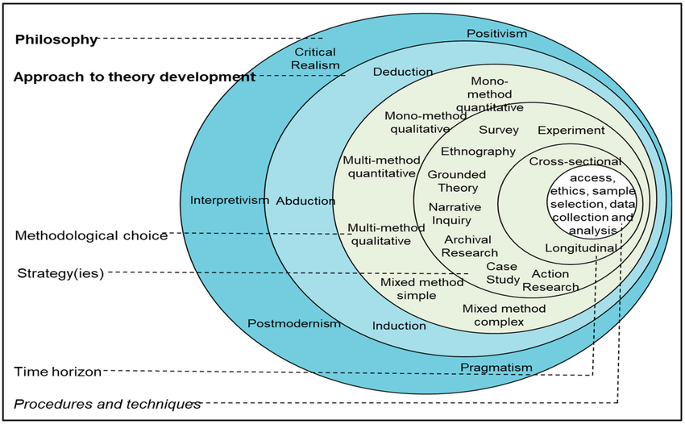
Figure 6: Research Onion by Saunders et al., (2023)

3.2 Research Philosophy
The philosophy that most fits this study is pragmatism because it focuses on what works to address practical issues (Saunders et al., 2023). This is necessary towards solving the complicated and high-stress leadership issues in Welsh supermarkets, where practical solutions are sought instead of abstract theorization. Due to its focus on what works, pragmatism may miss the conceptual tensions between aims and subjectivity. The research used a mixed-methods strategy to balance statistical validity with human context (Lim, 2023). In contrast to positivism, which often narrows down being too reductionist to be able to anomalously account for how black leaders manage to adjust their performance to the demands of emotion, and interpretivism, which can make no such generalisation needed to conduct industry-wide recommendations, pragmatism can allow the adaptation of both objective performance and situational information (Lim, 2023). This is to provide the research with an effective direction towards the operational inefficiencies, and retention problems that have been identified.

3.2.1 Ontological Stance
This study used a mixed ontological approach, that is, an objectivism-subjectivism approach, to capture the twin supermarket reality. Whereas the aspects of organisational performance entail objective, independent data like profit margins and inventory information, the process of leadership is socially formed, with subjective meanings on empathy and motivations in various groups (Saunders et al., 2023).
It is inappropriate to assume a one-sided Objectivist position because it strictly breaks leadership down to fixed characteristics, and it does not appreciate the contingencies of the situation and the emotional interaction that varies at the best retailing periods. On the other hand, a pure Constructivist approach is no-better than that, as it similarly places a risk of concentrating on perceptions and the lack of the so-called standardised processes and hard performance measures that determine what makes a retail successful. Thus, the ambivalent position is acceptable because it gives an opportunity to quantify the tangible effects of EI and admit the mediation of these effects by the subjective and human experience of working under pressure at a retail shop.

3.2.2 Epistemological Stance
The most suitable epistemological approach to the study is Action-Based where knowledge can be considered true when it can result in successful action to solve practical problems (Saunders et al., 2023). This position plays a significant role in Welsh supermarket industry where the verity of leadership performance is never measured by the abstract notions of a leadership effectiveness; instead it is measured by the concrete outcomes of the theory, which are decreased turnover and conflict resolution. It supports the use of a combination of objective performance measures and subjective emotional understandings to produce an operational useful knowledge to managers.
This research has practical objectives that cannot be carried out using other methodologies. Positivism is even excessive reductionist; that, concentrating on law-like generalisations that are observable; it runs the risk of overlooking the complex, internal emotional processes that motivate employee behaviour within high-stress contexts. On the other hand, Interpretivism is overly subjective; though rich individual storeys can be registered there, it is often insufficient to generalise them and create the scalable and standardised policies that would satisfy big retail chains (Creswell and Creswell, 2018). Action-based position would not have such disadvantages, because findings would not be no more than descriptions, but rather they will be applied to advance the practise of Leadership.

3.2.3 Axiological Stance
The Value-driven Axiological approach is the best choice in the present study because it presupposes recognition that the study is informed by a particular aspiration to enhance the organisational practice and welfare of employees (Saunders et al., 2023). This position explains why empathy unique value can be prioritised along with the economic profitability.
Only a purely value-free position does not work well due to the ethical necessity to resolve the hostile work environment conditions that have been identified within Welsh retail. On the other hand, strongly subjective approach compromises objectivity of good management advice. Thus, value-based approach will make the results ethically and operationally rigorous.

3.3 Research Approach
The abductive research approach is used because it supports the constant, repeated movement between the proposed theories and the emerging empirical findings (Saunders et al., 2023). The method is essential to study Emotional Intelligence (EI) in the context of Welsh supermarkets that is quite unstable. Although the research development is based on the Goleman framework, abduction enables the researcher to deal with unexpected facts that might present themselves, including the dark side of empathy, thus adjusting current theory to suit the particular reality of the retail crisis. This may lead to bias in selecting unanticipated reasons to align with past preconceptions. It was reduced by using standardised quantitative measurements to base and qualitatively explore the original results (Bell and Bryman, 2022).
Other approaches might not be as suitable as it. A lofty Deductive method would be too narrow; through the exclusive testing of hypotheses such, it limits the researcher to discover the subtle, unforeseen ways of how leaders alter their orientations at times of extreme stress and strain (Bell and Bryman, 2022). In its turn, purely Inductive approach is not applicable, since the study does not research a phenomenon in totem (a tabula rasa): neglecting the immense body of existing literature on EI would be ineffective and lack structural orientation. Accordingly, the bridging effect of abduction unites the deductive theoretical framework with the inductive malleability to produce action-focused information.

3.4 Research Method
The most suitable type of mix design in this research is Convergent Parallel Mixed Methods design, as it implies the concurrent collection and the independent analysis of both quantitative and qualitative data and then integrates the findings to analyse them (Creswell and Creswell, 2018). Divergent datasets may be difficult and time-consuming to merge. Concurrent data gathering and a clear theoretical framework to integrate statistical and thematic results relieved this (Creswell & Creswell, 2018).
The methodology is essential in the case of the Welsh supermarket to attain triangulation whereby objective statistical data on the Emotional Intelligence (EI) and performance are validated against subjective understanding of leadership behaviours.
Although the quantitative part helps find an answer to the extent of how the relationships are to be established in a large number of cases, the qualitative data gives a required insight into the application of particular EI aspects, e.g. empathy, in a scenario of highly strained conflict (Pajo, 2022).
Then the mono methodology would not be acceptable to this complicated investigation. A pure Quantitative approach is inappropriate because it can be excessively reductionist; whereas this approach determines the existence of a relationship, it does not provide the insight into the black box of how leaders control emotional undertones (Bryman and Bell, 2023). On the other hand, a pure Qualitative approach lacks the generalizability and thus has constraints in coming up with the standardised, industry wide advices needed by big retail stores. Thus mixed methods eliminate these two weaknesses respectively by balancing statistical rigour with contextual richness.

3.5 Research Strategy
The most suitable research strategy to use in this study is a Survey Strategy conducted adding with Semi-Structured Interviews to rigorously test the relationships between Emotional Intelligence (EI) and leadership effectiveness. Surveys can be cost-effective in standardising data on a large sample of participants and hypothesis testing through causal correlation of EI scores and employee performance can be conducted with statistical significance (Saunders et al., 2023). Although this can be generalised through surveys, the problem of surveys is that they are incapable of providing an answer to the question why the numbers were the way they were (Saunders et al., 2023). This was alleviated through inclusion of interviews which gave the required in-depth information to get the Regulation Gap identified in the survey data.
There are other strategies, which were considered not appropriate to certain ends. The Case Study approach is deficient in generalizability; research on one store could not be considered the systemic leadership issue in the heterogeneous Welsh retail sector (Ebneyamini and Moghadam, 2018). Similarly, Ethnography cannot be conducted because it is limited by time rules and because certain rich leadership qualities are difficult to quantify to be able to correlate them statistically (Bell and Bryman, 2022). Lastly, it is impossible to use an Experimental approach because it would be ethically and operationally impossible to control the styles of leadership in a high pressure, live supermarket environment.

3.6 Data Collection Technique
The method used in this research was a Mixed Data Collection Technique which uses a combination of quantitative methods as primary data collection method which is the use of quantitative Questionnaires and qualitative and therefore, primary method of data collection is the use of qualitative interviews. Using the two methods allows obtaining general quantitative information about Emotional Intelligence (EI) and leadership styles and, at the same time, rich qualitative background (Creswell and Creswell, 2018). The specific qualitative tool that was selected to be used is a semi-structured interview because it is necessary to understand the personal perspective about the concept of the Regulation Gap, which can not be measured by quantitative data. Although the survey established that leaders have an issue with self-regulation, the interviews were used to enquire on the reasons why the same happens when in high-inducing situations such as peak trading hours.
It is an indispensable combination in the Welsh supermarket case. Combining survey findings and interview storeys confirms more general views with an operational reality significantly reducing the issue of common method bias that is widely found in pure self-report studies (Welman et al., 2019). Depending on solitary-source methods was not accepted; e.g. it is only impossible to rely solely on the Observation method because employee internal emotional conditions cannot directly be seen and the presence of the researcher can skew employee behaviour. One of the weaknesses of interviews however is the possibility of social desirability bias as the managers are likely to portray themselves positively. Through assuring strict anonymity and probing questions to pass through the rehearsed responses, this was alleviated (Saunders et al., 2023).

3.7 Sampling Method and Sample Size
The use of Non-Probability Sampling of this study was made by the intricacies of the legal entry of the private retail workforce. In the case of the primary survey on 150 employees, Convenience Sampling was applied to collect readily available data assisted by the Snowball Sampling in which the respondents were used to refer other employees (Saunders et al., 2023). One of the major weaknesses of convenience sampling can be the possibility of sampling bias because it will not represent the entire population. This was reduced through the application of snowball methods to access a large range of all types of employees in various stores.
To perform the qualitative phase the Purposive Sampling was used to pick out 10 managers and supervisors who had direct leadership roles. This approach helped in making the participants have a certain experience in handling various teams in a pressure environment, which was essential in responding to the research questions. The demerit of purposive sampling is that it is subjective in nature but this was balanced by coming up with clear selection criteria such as tenure and type of job (Bell and Bryman, 2022). Probability sampling was also discarded because there is no available public sampling frame of supermarket personnel and it is logistically not practicable.

3.8 Data Analysis Technique
The study would be based on a complementary model of analysis, which includes Statistical Analysis of primary survey data and Thematic Analysis of interview transcripts. Statistical analysis is conducted in terms of numerical data using IBM SPSS and Microsoft Excel to draw patterns and trends (Stotmeister, 2024). This plays a very pivotal role in testing, objectively, the hypotheses on the relationship between Emotional Intelligence (EI) and leadership performance among the sample of 150 employees. On the other hand, Thematic Analysis was employed in process of identifying and analysing the patterns of meaning on the interview responses which offers the contextual richness regarding conflict and decision making (Braun and Clarke, 2022).
One of the flaws of thematic analysis is that it may make researcher work subjective to coding. This was curbed by considering codes against the raw transcripts a number of times to make them identical with the views of the participants. Other approaches were discredited; Content Analysis was ruled out since it is excessively quantitative in nature as it is more oriented on number of words as opposed to deep appreciation of high-pressure environments (Bell and Bryman, 2022). Equally, the limitation of the research to the plain Descriptive Analysis was not enough, as it does not have the inferential attributes needed to prove the causality of the research hypotheses.

3.9 Reliability and Validity
This research used the standardised TEIQue-SF scale that is highly known to have strong psychometric qualities to ensure reliability. Internal consistency was checked with the help of Cronbach Alpha in SPSS a coefficient of more than 0.7 to confirm the statistical stability (Izah et all., 2023).
Triangulation of the primary survey data with secondary industry reports also enhanced validity, and was effective in overcoming the bias of self-reporting, which could be referred to as the common method bias. In order to avoid the expected problem of social desirability bias, i.e. participants being afraid to respond negatively or try to appear good, respondent anonymity was ensured. These controls gave confidence to the information and an accurate picture of Welsh retail environment (Saunders et al., 2023).

3.10 Limitations of the methodology
There are limitations inherent in this methodology. To begin with, the use of non-probability sampling of both qualitative and quantitative stages restricts generalizability since the results may not be entirely applicable to the larger UK retail population outside of the Welsh region. Secondly, the cross-sectional research design would record data at one point thus making it impossible to establish rigid causal links between EI and performance in the long run. Lastly, self-reported information has a threat of social desirability effect where an individual will simply exaggerate his or her emotional competence and provide practised answers during the interview, which can compromise outcomes even with anonymity guarantees.

3.11 Ethical Consideration
The study was undertaken with sound discipline following the code of practise on University of Wales Trinity Saint David (UWTSD) Research Ethics. Before beginning data collection an ethically complete approval was clearly obtained and given by the University Ethics Committee. The basic principles of ethical conduct of autonomy, non-maleficence, and confidentiality influenced the study (Saunders et al., 2023). A detailed information sheet was given to all participants who were then required to give an informed consent making sure that they perfectly comprehended the purpose of the study and that they can pull out at any point and not face any penalty. Anonymity was highly ensured to sustain privacy thus, no identifiable information of the respondents was provided to any of the responses, data were saved in devices with passwords to stay within the privacy rules under GDPR. The final version of the Ethics form is in the appendix.

Chapter Four: Findings and Discussion

4.1 Introduction
The chapter issues the empirical results on the Emotional Intelligence (EI) in Welsh supermarket leadership. It combines a survey of 150 employees quantitative data with qualitative information based on interviewing 10 managers. It will analyse the demographics, statistical correlation between EI and performance, and thematic results in decision-making and conflict-solving.

4.2 Findings and Analysis

4.2.1 Demographic Findings
Figure 7: Role in Supermarket
This distribution reveals supermarket employees' roles. Customer Service dominates at 42.8%, followed closely by Stock Assistance at 36.8%. Cashiers comprise 16.4% of respondents. The remaining roles including Manager, Security, Buyer, Front Desk, and Shelf Filler each represent minimal portions at 0.66%, indicating concentration in customer-facing and inventory management positions.
Figure 8:Time of working at supermarket
Half the employees (50%) have 1-3 years tenure. Nearly one-third (32.2%) are newer, working under a year. Longer-term employees (4+ years) represent just 17.8% combined.
Figure 9: Age of the participants
The age distribution shows concentration in the 26-34 bracket (48.7%), followed by 35-44 years (23%).
Figure 10: Gender of the participants
Gender distribution is nearly balanced, with males (51.3%) slightly outnumbering females (48.7%). Overall, the sample represents a relatively young, moderately experienced workforce across diverse operational roles.

Figure 11: Current management position at supermarket
Among 152 supermarket managers surveyed, management positions show balanced representation across hierarchical levels. Store Managers and Department Managers dominate with nearly identical shares at 31.6% and 30.9% respectively. Senior Management comprises 19.7%, while Supervisors represent 16.4%, illustrating a relatively flat organizational structure with strong middle management presence throughout operations.
Figure 12: Time of Leadership role in supermarkets
According to the result, Nearly half (49.3%) possess one-to-three years tenure, establishing this as the modal experience level. Newcomers with under one year comprise 30.3%, indicating significant recent hiring activity. Veterans who have exceeded 3 years represent 20.4%, suggesting moderate retention rates and ongoing organizational renewal.

Figure 13: Age of the participants
This age distribution shows respondents are predominantly young to middle-aged professionals. The largest group (44.1%) falls in the 26-34 range, followed by 35-44 year-olds (31.6%). Younger (under 25) and older demographics (45+) represent smaller portions, with only 1.3% aged 55 or above.
Figure 14: Gender of the employer
Gender representation shows males (52.6%) slightly exceeding females (46.1%), with 1.3% preferring not to disclose. Overall, the management sample represents relatively young, moderately experienced leaders across hierarchical levels.

4.2.2 Validity and Reliability Test
Table 2: Cronbach's Alpha
Reliability Statistics
Cronbach's Alpha | N of Items
.754 | 3
The reliability test shows Cronbach's Alpha of .754 for three items (Emotional Intelligence, Employee Performance, and Effective Leadership), indicating good internal consistency. This value exceeds the acceptable threshold of .70, meaning these variables reliably measure related concepts and produce consistent results. The items demonstrate strong reliability, confirming the measurement scale's dependability for research purposes.

4.2.3 Descriptive Analysis
Table 3: Leadership and Emotional Intelligence
Descriptive Statistics
 | N | Minimum | Maximum | Mean | Std. Deviation | Variance | Skewness |  | Kurtosis
 | Statistic | Statistic | Statistic | Statistic | Statistic | Statistic | Statistic | Std. Error | Statistic | Std. Error
1. My manager is aware of how their actions affect employees. | 152 | 1 | 5 | 3.94 | .985 | .970 | -1.060 | .197 | 1.071 | .391
2. My manager remains calm and professional under pressure. | 151 | 1 | 5 | 2.49 | 1.321 | 1.745 | .356 | .197 | -1.151 | .392
3. My manager motivates me to perform better at work. | 150 | 1 | 5 | 4.15 | 1.064 | 1.133 | -1.178 | .198 | .514 | .394
4. My manager listens and shows understanding when I share concerns. | 149 | 1 | 5 | 3.88 | 1.202 | 1.445 | -.829 | .199 | -.434 | .395
5. My manager communicates clearly and encourages teamwork. | 152 | 1 | 5 | 2.74 | 1.426 | 2.033 | .171 | .197 | -1.309 | .391
Valid N (listwise) | 148
Table above shows descriptive data of five leadership and emotional intelligence. There are varied perspectives, with the highest score of 4.15 on Item 3 (management stimulates performance) and 3.94 on Item 1 (manager self-awareness) showing significant agreement. A high score (2.74) in item 5 (clear communication and collaboration) provides for improvement points.
The table shows standard deviations between 0.985 and 1.426, with Item 5 having the biggest variance (1.426), indicating that employee experience with communication and cooperation is inconsistent. Unlike Item 1, 3, and 4, Item 2 has a positive skewness (.356), which suggests the replies are not as focused on higher ratings. It had positive kurtosis (1.071) and peaked, whereas Items 2 and 5 have negative kurtosis (-1.151, -1.309) and flatter distributions with less severe reactions. Overall, managers are competent at motivation and self-awareness but need to improve at staying cool under pressure and fostering good communication.
Table 4: Employee Experience & Satisfaction
Descriptive Statistics
 | N | Minimum | Maximum | Mean | Std. Deviation | Variance | Skewness |  | Kurtosis
 | Statistic | Statistic | Statistic | Statistic | Statistic | Statistic | Statistic | Std. Error | Statistic | Std. Error
1. I feel more motivated when my manager demonstrates emotional intelligence. | 152 | 1 | 5 | 2.48 | 1.460 | 2.132 | .505 | .197 | -1.179 | .391
2. Emotional intelligence in management contributes to a positive working environment in this supermarket. | 152 | 1 | 5 | 2.81 | 1.499 | 2.248 | .128 | .197 | -1.463 | .391
Valid N (listwise) | 152

This descriptive statistics table examines employee opinions of emotional intelligence's impact on motivation and work environment.
The first item (management motivation due to emotional intelligence) has a mean score of 2.48, while the second (good atmosphere provided by emotional intelligence) has 2.81. The fact that the averages are below the middle suggests that workers do not believe emotional intelligence improves managers' work experiences.
The standard deviations are high on both (1.460 and 1.499), while the corresponding standard deviations are 2.132 and 2.248, indicating that workers' views on emotional intelligence at work differ greatly. This variation suggests sample experience inconsistency.
Positive skew values (.505 and .128) indicate that both items are more likely to get lower scores, supporting negative impressions. The values of kurtosis are highly negative (-1.179 and -1.463), indicating platykurtic distributions with smoother peaks and less extreme reactions, rather than a few strong views.
Statistics show modest unhappiness with management emotional intelligence, and employee attitudes vary greatly according on their shopping experience.

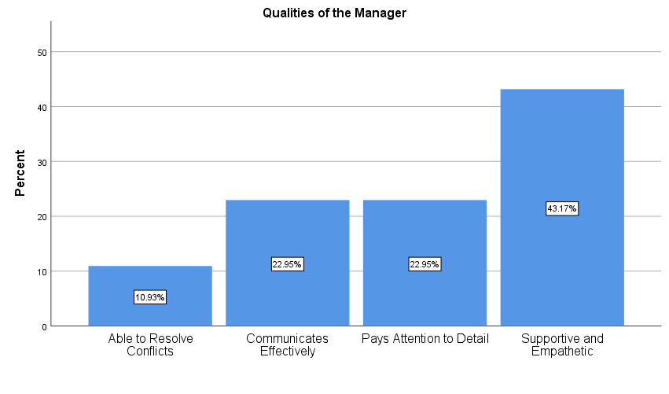
Figure 15: Qualities of Manager
The graph reflects essential leadership traits that are appreciated by the employees of the supermarkets. The hegemony of supportive and empathetic leadership is 43.17, which shows that employees emphasise on emotional support. Good communication and attention to detail score second (22.95%), indicating their importance. Leaders may consider conflict resolution a baseline since it has the lowest score, 10.93%.
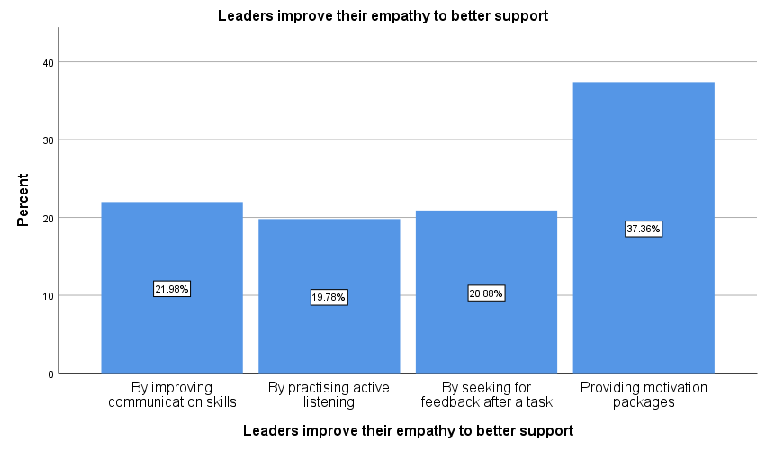
Figure 16: Leaders improve their empathy to better support
The graph presents several enhancement techniques on empathy training of leaders. The top motivational packages will be offered (37.4), further developing communication skills (22%), seeking feedback (20.9%), and active listening (19.8%). Most employees were interested in numerous ways to develop management empathy, as the total replies were 119.7%.

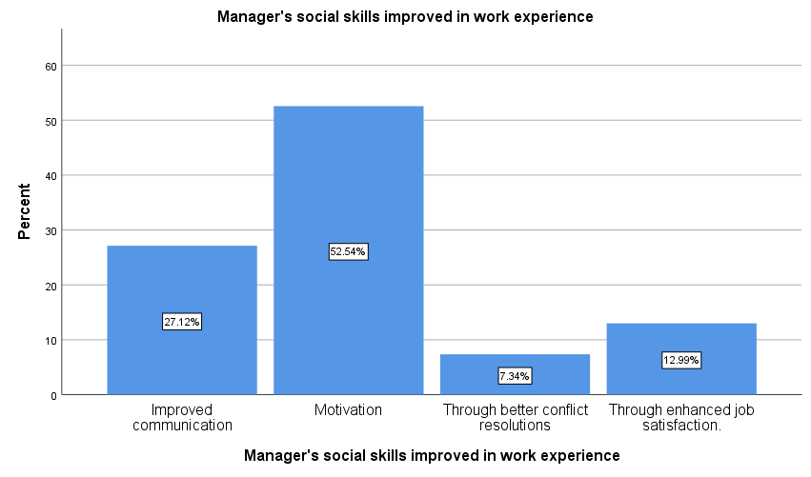
Figure 17: Manager’s social skills improved work experience
The graph shows that social skills allow managers to improve the work experience. The prevalence of motivation is 52.5 which is the leading contributor. Communication is 27.1 and work satisfaction 13% better. Conflict resolution ranks lowest at 7.3%. Several response options yielded 116.4 percent, showing workers perceived several social skill advantages.
Table 5: Self-Perception of Emotional Intelligence
Descriptive Statistics
 | N | Minimum | Maximum | Mean | Std. Deviation | Variance | Skewness |  | Kurtosis
 | Statistic | Statistic | Statistic | Statistic | Statistic | Statistic | Statistic | Std. Error | Statistic | Std. Error
1. I am aware of my strengths and weaknesses as a leader | 152 | 1 | 5 | 4.03 | .924 | .853 | -1.241 | .197 | 1.855 | .391
2. I manage my emotions well, even under stressful situations | 152 | 1 | 5 | 3.70 | 1.085 | 1.177 | -.553 | .197 | -.514 | .391
3. I motivate my team to achieve both personal and organizational goals. | 152 | 1 | 5 | 3.73 | 1.229 | 1.510 | -.773 | .197 | -.362 | .391
4. I listen actively and show empathy when employees face challenges. | 152 | 1 | 5 | 3.76 | 1.240 | 1.536 | -.815 | .197 | -.349 | .391
5. I communicate effectively and encourage collaboration among employees. | 152 | 1 | 5 | 3.76 | 1.212 | 1.470 | -.605 | .197 | -.857 | .391
Valid N (listwise) | 152
This descriptive statistics table will compare the self-view of emotional intelligence and leadership skills of the leaders through five dimensions.
There are mean scores between 3.70 and 4.03 which are above the median meaning positive self-perceptions in general. The leader is confident in their self-knowledge since item 1 (self-awareness of strengths and shortcomings) has the highest score of 4.03. Items 2-5 have a high median of 3.70–3.76, indicating excellent self-ratings on emotional regulation, motivation, empathy, and communication.
Standard deviation varies from.924 to 1.240, with Item 1 having the lowest dispersion and Items 3, 4, and 5 having the largest. The variations are.853–1.536, indicating that self-awareness is more agreed upon than leadership interpersonal skills.
The skewness increases negative (-.553 to -1.241), favouring higher-rated distributions, confirming positive self-judgement. Kurtosis is largely negative (-.349 to -.857) except for Item 1 (1.855), which has more answers on the upper side.
Leadership self-evaluations are favourable, particularly for self-awareness, but interpersonal skill disparities suggest people-oriented leadership abilities may be more or less confident.
Table 6: Leadership Effectiveness & Decision-Making
Descriptive Statistics
 | N | Minimum | Maximum | Mean | Std. Deviation | Variance | Skewness |  | Kurtosis
 | Statistic | Statistic | Statistic | Statistic | Statistic | Statistic | Statistic | Std. Error | Statistic | Std. Error
1. My emotional intelligence helps me resolve conflicts fairly. | 152 | 1 | 5 | 3.92 | 1.148 | 1.318 | -.908 | .197 | -.079 | .391
2. Emotional intelligence helps me make better decisions as a manager. | 152 | 1 | 5 | 2.70 | 1.331 | 1.773 | .150 | .197 | -1.198 | .391
3. Emotional intelligence contributes to my ability to create a positive work culture. | 152 | 1 | 5 | 3.72 | 1.235 | 1.526 | -.612 | .197 | -.735 | .391
Valid N (listwise) | 152
This table of descriptive statistics explores how perception affects the views managers have on the emotional intelligence as one of the factors affecting their leadership style and decision ability.
The mean scores vary widely across questions, with a high of 3.92 for conflict resolution, suggesting that managers substantially value emotional intelligence in conflict management. Managers are not persuaded that emotional intelligence significantly influences their decision-making. The following item, good work culture formation, scored 3.72 soon after.
Standard deviations range from 1.148 to 1.331, with Item 2 having the most variability (1.331, variation 1.773), indicating disagreement on whether emotional intelligence may influence management decisions. Items 1 and 3 exhibit considerable dispersion.
Skewness trends vary greatly: Item 2 has a little positive skew (.150), indicating lower rating ratings than Items 1 and 3, which have negative skewness (-.908 and -.612). All items show negative kurtosis (-.079 to -1.198), indicating that flatter curves have more opinions, notably in the first item.
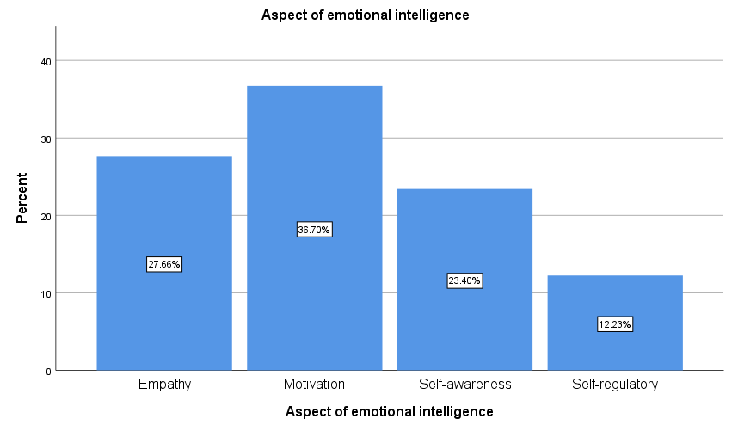
Figure 18: Aspect of emotional intelligence
The graph reveals major emotional intelligence elements that are appreciated in supermarket leadership. Motivation is followed by empathy at 27.7% and self-awareness at 23.4%. Self-regulation has the lowest score of 12.2%. Several options yielded 123.7% total responses, which means that employees perceive numerous emotional intelligence dimensions as important to perform a good leader.

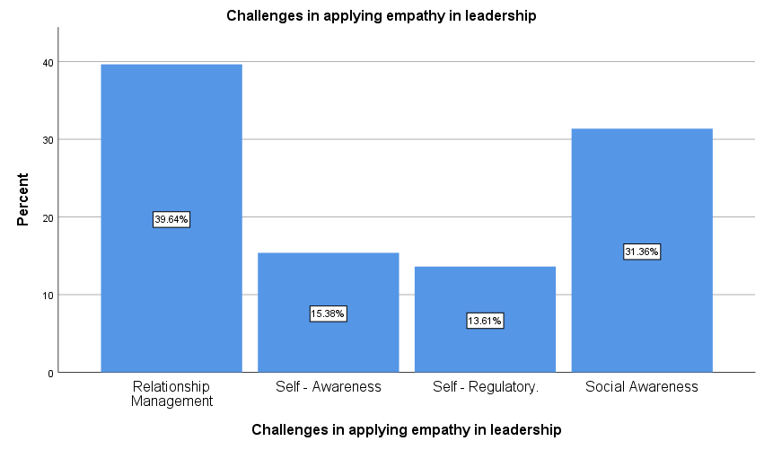
Figure 19: Challenges in applying empathy in leadership
The graph can find issues leaders resolve in using empathy. The biggest challenge is relationship management at 39.6%, then social awareness at 31.4%. The largest is self-awareness at 15.4%, and self-regulation comes at the lowest at 13.6%. A total of 111.2% of multiple response selections implies that employees recognised a number of concurrent issues leaders face when attempting to put empathetic leadership principles to practices in supermarket settings.

4.2.4 Inferential Analysis
H₁: There is a significant relationship between Emotional Intelligence and Employee Performance
Table 7: Correlation Table
Correlations
 |  | Emotional Intelligence | Employee Performance
Emotional Intelligence | Pearson Correlation | 1 | .847**
Emotional Intelligence | Sig. (2-tailed) |  | .000
Emotional Intelligence | N | 152 | 152
Employee Performance | Pearson Correlation | .847** | 1
Employee Performance | Sig. (2-tailed) | .000
Employee Performance | N | 152 | 152
**. Correlation is significant at the 0.01 level (2-tailed).

The correlation analysis shows that Emotional Intelligence and Employee Performance have a high positive relationship (r =.847, p < .01). This key association shows that stronger emotional intelligence improves employee effectiveness. This relationship is found to be statistically significant having a significance level of .000 which rejects the null hypothesis. The correlation value of.847 indicates a high connection and 72% shared variance. Consequently, H1 holds, and it is proven that emotional intelligence has a huge impact on employee performance.
H₂: Leaders' Emotional Intelligence has a significant positive effect on Effective Leadership in supermarkets.
Table 8: Regression Table
Model Summary
Model | R | R Square | Adjusted R Square | Std. Error of the Estimate
1 | .683ª | .467 | .463 | .44617
a. Predictors: (Constant), Emotional Intelligence
The model summary demonstrates that Emotional Intelligence significantly predicts Effective The correlation coefficient (R =.683) shows that these variables strongly have a positive relationship. Leaders' emotional intelligence explains 46.7% of the variation in successful leadership, according to the R-squared of.467. The model is stable and inflation is low since the adjusted R Square (.463) is close to the R Square. The standard error of the estimate (.44617) shows modest prediction errors, indicating a good model fit for leadership performance based on emotional intelligence scores..
Table 9: ANOVA Table
ANOVAª
Model |  | Sum of Squares | df | Mean Square | F | Sig.
1 | Regression | 26.114 | 1 | 26.114 | 131.178 | .000^{b}
1 | Residual | 29.861 | 150 | .199
1 | Total | 55.975 | 151
a. Dependent Variable: Effective Leadership
b. Predictors: (Constant), Emotional Intelligence
The statistical significance of the ANOVA results supports the statistical significance of the regression model. The F-test (131.178) with 0.000 significance reveals that Emotional Intelligence predicts effective leadership better than crucial values. Since sum of squares regression is much bigger than residual sum of squares (29.861), the model has a lot of explanatory power for the dependent variable. Given that the regression had 1 degree of freedom and the residuals 150, mean square regression (26.114) is substantially higher than mean square residual (.199), confirming the predictor's strong explanatory power and the model's relevance.
Table 10: Coefficient Table
Coefficientsª
Model |  | Unstandardized Coefficients |  | Standardized Coefficients | t | Sig.
 |  | B | Std. Error | Beta | t | Sig.
1 | (Constant) | 1.253 | .223 |  | 5.611 | .000
1 | Emotional Intelligence | .696 | .061 | .683 | 11.453 | .000
a. Dependent Variable: Effective Leadership
Regression equation parameters are in-depth in the coefficients table. Effective Leadership with zero Emotional Intelligence is B = 1.253, t = 5.611, p =.000. The coefficient of emotional intelligence (B =.696) shows that a one-unit change in emotional intelligence changes leadership effectiveness by one unit. The standardised beta coefficient (.683) confirms this strong positive connection. A t-test of 11.453 rejects the null hypothesis since the effect is extremely statistically significant. H2 is well supported, proving that Emotional Intelligence in leaders positively impacts supermarket leadership.
H₃: Leaders' Emotional Intelligence has a significant positive effect on Employee Performance, mediated by Effective Leadership.
Table 11: Regression Table 2
Model Summary
Model | R | R Square | Adjusted R Square | Std. Error of the Estimate
1 | .914ª | .836 | .834 | .27516
a. Predictors: (Constant), Effective Leadership, Emotional Intelligence
The model summary shows the strong predictive power of both Emotional Intelligence and Effective Leadership in relation to Employee Performance. These variables are strongly positively correlated (R =.914). Emotional Intelligence and Effective Leadership explain 83.6 percent of employee performance, according to the R Square value of.836. Adjusted R Square (.834) is close to R Square, indicating no model overfitting. The mediation analysis is well anticipated since the standard error of estimate is.27516, much lower than in previous models, indicating a strong model fit with a minimal residual variance.
Table 12: ANOVA Table 2
ANOVAª
Model |  | Sum of Squares | df | Mean Square | F | Sig.
1 | Regression | 57.387 | 2 | 28.694 | 378.966 | .000^{b}
1 | Residual | 11.282 | 149 | .076
1 | Total | 68.669 | 151
a. Dependent Variable: Employee Performance
b. Predictors: (Constant), Effective Leadership, Emotional Intelligence
The results of ANOVA prove the superior model testing. The model explains the notion of strong validity since the F-statistic (378.966) is significant (.000), the significance value falls under the significance level of 0.05. The regression's sum of squares (57.387) is much higher than the residual's (11.282), indicating that the model predicts the dependent variable well. The mean square regression (28.694) with 2 degrees of freedom and 149 non-explained residuals is much larger than the mean square residual (.076), indicating tremendous explanatory power. This high F-ratio shows that Emotional Intelligence and Effective Leadership affect supermarket employee performance.
Table 13: Coefficient Table 2
Coefficientsª
Model |  | Unstandardized Coefficients |  | Standardized Coefficients | t | Sig.
 |  | B | Std. Error | Beta | t | Sig.
1 | (Constant) | -.229 | .142 |  | -1.614 | .109
1 | Emotional Intelligence | .724 | .061 | .649 | 11.788 | .000
1 | Effective Leadership | .326 | .058 | .309 | 5.609 | .000
a. Dependent Variable: Employee Performance
Table Coefficients of the fitted model indicate that the two predictors play a big part in Employee Performance. The constant value (B = -.229, p =.109) is not significant meaning that there is very little base line performance in the absence of predictor. Emotional Intelligence directly affects performance (B =.724, t =11.788, p =.000, Beta =.649), and it therefore has a significant influence on performance. Accordingly, predictive Effective Leadership shows a significant result in performance (B = .326, Beta =.309, t = 5.609, p=.000), which proves the mediation effect. The two standardised coefficients are significant, and the partial mediation that exists is that Emotional Intelligence has a direct and indirect influence on Employee Performance through Effective Leadership. Thus, H3 is upheld, and Effective Leadership supports the relationship between the Emotional Intelligence of leaders and Employee Performance.

4.2.5 Thematic Analysis

4.2.5.1 Importance of emotional intelligence in effective leadership in Welsh supermarkets
Table 14: Thematic analysis 1
Theme | Sub-Theme / Code | Participant (Role) | Illustrative Quote | Analytical Interpretation
The "High Motivation, Low Regulation" Paradox | Code: Energy over Control | Participant 1 (Store Manager) | "For me, Emotional Intelligence is about energy. It’s knowing how to pump up the team... I start every shift with a huddle to get everyone hyped." | Leaders equate EI with high-energy motivation (Transformational) rather than emotional stability.
 | Code: Operational Snapping | Participant 1 (Store Manager) | "To be honest, I hate conflict. When it gets busy... I sometimes snap and just tell them to park it." | High motivational intent collapses under pressure, revealing the "Regulation Gap."
 | Code: Intent vs. Impact | Participant 5 (Dept. Manager) | "I try to sit down and listen, but honestly, I’m often so stressed myself... I probably rush them a bit more than I should." | Self-awareness ($M=4.03$) exists, but operational stress overrides the ability to regulate behavior ($M=2.49$).
"Sterile Judgment" & Professionalism | Code: Suppression as Professionalism | Participant 2 (Dept. Manager) | "It’s about keeping your professional face on... I don't let my personal feelings affect my decisions. I stay neutral." | "Professionalism" is interpreted as the complete removal of emotion, leading to "sterile" leadership.
 | Code: Policy over People | Participant 2 (Dept. Manager) | "I bring them into the office and we look at the employee handbook... I just apply the policy fairly." | Conflict is managed by reverting to rigid policy to avoid emotional engagement.
 | Code: Directive/Dismissive | Participant 8 (Dept. Manager) | "If there’s an issue, I tell them to leave it at the door. We are here to work, not to make friends." | Rejection of emotional data in favor of directive efficiency, contributing to the "Regulation Gap."

Table 14 themes were determined by a stringent coding of transcripts of interviews and showed a dramatic difference between the definitions of EI by leaders and how they experience it during stressful situations. The quantitative data has shown that there was a high level of self-awareness (M=4.03), but the qualitative analysis reveals the mechanism itself of the Regulation Gap. The respondents always thought of EI as a theatrical display of dynamism and excitement (Participant 1), as opposed to an internal process of managing emotions. This is the reason why the leaders might appear to be effective motivators despite their claimed habit of snapping or rushing employees when there is operational stress; this type of paradox is known as High Motivation, Low Regulation.
In addition to this, it was noted that the theme of sterile judgement became a major coping mechanism to such a lack of regulation. Professionalism, as seen by the managers such as Participant 2 and Participant 8, is the enforced suppression of emotion, and the return to the extreme form of policy implementation (leave it at the door) as a means to avoid the emotional pressures of the various teams. This discussion implies that within the Welsh supermarket setting, the human component of leadership is also frequently compromised in favour of procedural efficacy, and the high internal EI scores can only be ineffective at times of acute operation crises.

4.2.5.2 Emotional intelligence contributes to effective decision-making and conflict solutions in leadership
Table 15: Thematic analysis 2
Theme | Sub-Theme / Code | Participant (Role) | Illustrative Quote | Analytical Interpretation
Artificial Harmony & Avoidance | Code: Smoothing Over | Participant 3(Supervisor) | "I try to smooth it over. I’ll separate them... I prefer to keep the peace rather than have a big confrontation." | EI is used to avoid necessary conflict ("Affective Dilution"), creating superficial harmony but leaving root causes unresolved.
 | Code: Strategic Manipulation | Participant 6 (Store Manager) | "It’s a tool. It’s knowing which buttons to push to get people to say yes to overtime." | EI is weaponized as "Strategic EI" to engineer consent for operational needs rather than genuine empathy.
 | Code: De-escalation for Speed | Participant 3(Supervisor) | "I gave them a refund just to de-escalate it quickly... so my staff member wouldn't get upset." | Decisions are made for speed and immediate relief, not fairness or policy accuracy.
The Transactional Tension | Code: Time vs. Empathy | Participant 4 (Senior Manager) | "I treat it like a transaction... We don't have time for long therapy sessions." | Operational constraints ("Customer Rush Hours") force leaders to abandon empathy for transactional efficiency.
 | Code: Emotional Burnout | Participant 7(Supervisor) | "Being empathetic here is actually really draining... sometimes I think the company just wants robots." | The effort to maintain empathy without structural support leads to leader burnout, threatening the sustainability of EI practices.
 | Code: Fairness as EI | Participant 4 (Senior Manager) | "I explained that fair is fair... I couldn't grant it because it would burden the rest of the team." | "Fairness" is prioritized over individual consideration, highlighting the tension between team equity and individual empathy.

The analysis presented in Table 15 goes into greater detail about how the decision-making process was being done to uncover that the so-called Performance Paradox is an issue that is caused by operational limitations and not leader incompetence. The theme of Artificial Harmony was brought out where contestants talked of employing EI techniques to evade conflict as opposed to solving conflict. The quotations of Participant 3 and Participant 6 demonstrate that the decision-making process is frequently controlled by the so-called "Strategic EI," which is the manipulation of social processes to attain the effect of immediate rapidity (i.e., de-escalate it quickly) instead of a lasting solution. This validates the Dark Side of EI theory in which social skills are applied to create the pretence of shallow agreement to keep the store going.
The theme of the storey of the transactional tension also raises the issue of structural obstacles in the way of true empathy. The fact that Participant 4 admits that they do not have time to waste on prolonged therapy determines that the high-pressure atmosphere of the retail environment demands that a dual trade-off of sorts exists: managers believe they have to make their choice between being fair (transactions consistency) or being kind (personal empathy) when interacting with someone. It is thus assumed that the feature of fairness is defensive of the "emotional burnout" stated by Participant 7. Therefore, the most treasured characteristic, supportive leadership, is operationally unsustainable without system support.

4.3 Discussion

4.3.1 OB-1 To determine the importance of emotional intelligence in effective leadership within Wales supermarkets
The Welsh supermarket leadership's conundrum is that managers have high Internal EI but cannot endure external control. The descriptive data show that workers rate their supervisors highly in motivation (Mean = 4.15) and self-awareness (3.94). The Performance Correlations topic supports Davis (2024), Koutsioumpa (2023) and Mindeguia et al. (2021) who link higher EI ratings to organisational performance. Compared to weak results in maintaining cool under pressure (Mean = 2.49) and communicating (2.74), this is a theological paradox.
This quantitative mismatch was explained by the High Motivation, Low Regulation paradox in theme analysis. Participant 1 (Store Manager) described EI as team-boosting energy, although he recognised it is tougher in busy times. This qualitative perception shows that strong driving goal fails operationally. This inconsistency challenges the study's premise. Self-regulation (b = 0.485) is the greatest predictor of performance in a variable environment, according to Basallo et al. (2022), Doorn and Raz (2023), Howard (2021), and Hwang (2024). Under pressure, Welsh supermarket executives concentrate on motivation (transformational qualities) but fail to self-regulate. This supports the "Sector-Specific Utility" concept by Balleyer and Fennis (2022), Hoff et al. (2024), Richner et al. (2023), Pavlíčková et al. (2024), and Karimi et al. (2021), which states that stress cannot compensate for the absence of abstract incentives in emotionally provoking situations like stockout management or complaint handling
Mechanism ambiguity is supported by poor communication scores (Item 5). Bugvi et al. (2022), Nguyen et al. (2023), and Rizky and Sondakh (2025) say transformative leadership builds trust, but Participant 8's "we are here to work, not to make friends" shows that bad pressure management destroys Welsh community trust in different groups, teams, and shift work. Unlike Chin et al. (2023), Khan et al. (2021), Krauter (2023), and West et al. (2022), these data suggest that leaders have stalled in motivational leadership but lack transactional consistency to handle client rush-hours. In stressful circumstances, great self-awareness makes the least impact (b = 0.109), compared to self-regulation, which is necessary but ineffective.

4.3.2 OB-2 To identify the relationship between emotional intelligence and employee performance for effective leadership in supermarkets
The study found a strong positive correlation between Emotional Intelligence (EI) and employee performance (r=.847, p<.000), supporting the claims of Gilani et al. (2023), Miao et al. (2023), and Razali et al. (2022) that leaders with high EI create a positive affective climate that frees up mental resources. This statistical consistency supports the leader EI paradigm as a valuable resource that is important in the society and strongly influences task results, according to Chevalier et al. (2025), Floman et al. (2024), Maldonado and Marquez (2023), and Oyadiwa (2022).
Critical study of descriptive findings criticises this relationship's unsophisticated portrayal. Despite a significant connection, employee experience ratings are different because manager EI motivation averages 2.48. Qualitative data suggests "Transactional Tension" contradicts this. Participant 4 stated they don't have time for a comprehensive investigation, therefore functional difficulties don't allow leaders to be swift or sympathetic. This confirms Furnham et al. (2021), Gerhardt et al. (2025), and Robinson (2023) that EI is positively associated but not driving other skills. Performance is linked to EI, but the working environment score is dissatisfactory, showing that the mechanism does not encourage trust and psychological safety as stated in the literature.
The data indicate regulatory failure, not motive. The best grade for managers was motivation, while the lowest was staying cool under pressure and clear communication. This confirms Agedasborough, Beenen, Freedman, and Mehler's (2024) claims that organisational clarity and emotional control are more important than generic empathy in standardised professions. Participant 7 says empathy exhaustion may hamper communication. Poor communication ratings are consistent with Nugroho and Wahjoedi (2023), Shin et al. (2021), Syed and Siddiqui (2023), Vadi and Kasemaa (2023), and Zhang et al. (2022), who assume that effective equipment and clear work instructions are more performance-related in back-of-house or checkout positions than emotional sensitivity.
Researchers discovered emotional dilution owing to the significant gap between leaders' self-perception (M=4.03) and staff contentment (Pascal and Pateriya, 2023; Szczygiel and Bazińska, 2021). Leaders may assume they're encouraging employees by avoiding fighting, but self-regulation fails during customer rush-hours (M=2.49), producing a chaotic environment where compassion is a liability. Leaders' unwillingness to integrate EI and operational transparency obscures the linear relationship. Leaders believe they're helpful, but Participant 3 saw that they brush over to get things done, creating a chaotic setting where compassion becomes a disadvantage.

4.3.3 OB-3 To examine the impact of emotional intelligence on leadership styles for organizational performance in supermarkets
The research supports the premise that leaders' Emotional Intelligence (EI) affects Effective Leadership (R² =.467) and Employee Performance (R² =.836), with leadership effectiveness as a mediator. This supports meta-competency views that EI promotes transactional leadership models by Afriyie, Kiishi, and Santa (2023). Based on descriptive data (M=4.15 on motivation), Ekermans and Roux (2021) and Miao et al. (2018) indicate that EI leads to transformational features like inspirational vision. EI's high B=.649 standardised beta supports this. The qualitative subject of "Artificial Harmony" highlights this mediation's weakness. Participant 6 saw EI as a tool to push buttons, therefore they need strategic EI for consent engineering rather than transformative involvement.
The literature review's negative representation of EI as a simple technique to boost performance is contradicted by the modest decision-making findings. The regression model demonstrates a significant association, although descriptive statistics suggest that EI enhances decision-making the least (M=2.70) with a huge variance (SD=1.331). This confirms Korakis and Poulaki (2025), Lill et al. (2023), Sambol et al. (2025), and Shukla et al. (2023) that perception and reality vary. In the high-standardisation scenario, EI enhances interpersonal leadership (conflict resolution M=3.92) but does not ensure hard KPI gains, according to Amisha (2024) and Mishra (2022).
Sloan and Geldenhuys (2021) and Sariraei et al. (2024) demonstrate EI's challenges. Relationship management was most essential (39.6%), self-regulation least (12.2%). Welsh supermarket executives may risk more on transformational behaviour than transactional self-regulation to standardise operations, according to the inverted U-shape theory. EI's direct influence is nonetheless considerable (B=.309), probably owing to Dickerson (2023)'s discovery that standardised procedures restrict the transformational style's capacity to completely mediate performance. EI becomes essential rather than exciting.

4.3.4 OB-4 To investigate how emotional intelligence contributes to effective decision-making and conflict solutions in leadership
The perceived value of Emotional Intelligence (EI) in conflict resolution and decision-making differs greatly across primary and secondary evidence. Santa et al. (2023) credit allowing mediation to empathic leadership, and the descriptive data show that managers are sure that EI might help them make fair conflict resolution decisions (M=3.92). This confidence contrasts with their decision-making scepticism, as the average score drops to 2.70 (SD=1.331).
This mismatch supports the thematic analysis subject of Cognitive Paradoxes. Although Allegretta and Balconi (2025) and Miao et al. (2018) argue that leader EI helps coherent information processing, Welsh supermarket leaders' poor decision-making rates suggest that they struggle to transform emotional awareness into operational judgement. This supports Cristofaro et al. (2022) and Yilmaz (2025)'s warning of sterile judgment and that executives may filter out emotional data to seem more professional, which a people-based business requires. The qualitative analysis shows "Sterile Judgement." Participant 2 said, he won’t let his emotions influence his judgement... he remains impartial," removing emotional input from the decision-making process.
The findings also suggest operational viability friction between Lee et al. (2024) and Furnham and Sherman (2025). Relationship Management (39.6%) is the toughest and Conflict Resolution (7.3%) the least acknowledged social skill, according to the graph. Leadership's "Displayed Control," or "emotional dilution," doesn't solve the problem, according to Khalid et al. (2022) and Sloan and Geldenhuys (2021). Yilmaz (2025)'s sterile judgement warning is justified. The statistics show Lee et al. (2024) operational viability tension. Although the poll ranked "Relationship Management" as the toughest duty to do (39.6%), the interviews revealed explanations, some managers (Participant 3) deescalate to avoid screaming (e.g., a refund) instead of addressing the problem.
Workers regard self-regulation as the lowest leadership priority (12.2%), whereas leaders rank emotion management as high (M=3.70). Sharma (2024) and Vasquez et al. (2021) suggested this antifit shows resolution's Dark Side. Leaders may regard emotional suppression as good management, but workers may consider it as Strategic EI manipulation or insincerity (Wang et al., 2024). EI promotes equitable mediation but not transactional decision-making, which requires heavy shop floor pressure..

4.4 Chapter Summary
The findings show a significant Welsh retail leadership Regulation Gap. EI is linked to employee performance in quantitative data, while qualitative research shows that inadequate self-regulation under pressure sabotages strong motivating intent. The most popular coping strategies are Sternile Judgement and Artificial Harmony, suggesting that abstract empathy cannot impact work satisfaction or deep-seated issues without transactional stability.

Chapter Five: Conclusion and Recommendation

5.1 Conclusion
This study examined how Emotional Intelligence (EI) improves leadership and organisational success in Wales's highly competitive retail business. A pragmatist philosophy and a convergent parallel mixed design that converged objective system performance measures and subjective, sometimes volatile, emotional experiences of retail employees helped steer the study between the two realities. The research shows that, while EI is an important part of successful leadership, applying it in Welsh retail is more complicated and counterintuitive than the linear and more-the-merrier case often assumed in general management literature.
The first aim implies a substantial "Regulation Gap" among Welsh supermarket executives. The investigation indicated that managers with strong internal EI ratings in self-awareness and motivation had poor exterior self-regulation. Leaders believe they can inspire their workers, while employees believe they lose composure and fail to establish professional steadiness during peak trading hours or low stock levels. This supports Sector-Specific Utility, which states that an operationally insufficient abstract motivator drives behaviour in emotionally charged retail settings without the capacity to keep cool under pressure. This loophole keeps high self-awareness an inactive scale, and because there is no stress-regulation mechanism, the leader loses the capacity to build trust, no matter how they try to inspire.
Performance Paradox exists despite a high statistical correlation between EI and employee performance. Despite predicting task performance, leaders' EI does not boost employee experience or work satisfaction. Welsh retail executives may not be adopting EI to improve interpersonal harmony but operational clarity, according to studies. Affective dilution occurs when leaders seek to be liked or avoid conflict over leading diverse teams. Lack of empathy, not transactional stability, causes Welsh supermarkets' high turnover and retention. Checkout and inventory staff need instruction and emotional management more than vision inspiration. Leaders without self-regulation create compassion liabilities that cause instability and decreased work support.
Leadership styles overuse Transformational Leadership qualities and overlook Transactional competencies. Too much focus on motivation and relationship management leads to declining rewards, according to the study. Pure transformative leaders struggle to influence hard KPIs in institutionalised, corporate Welsh supermarkets. This study shows that EI is a meta-competency that drives the two styles, but modern leaders are not "vibrating efficiently" between them. They use EI to resolve interpersonal conflicts rather than address structural or performance issues since they have been comfortable in fake peace. This suggests that the Dark Side of EI—mass-producing social skills for consent engineering or avoiding difficult issues—is ubiquitous, hindering the organization's genuine growth.
In terms of making decisions and conflict management, the study reveals a phenomenon of Sterile Judgement. Even though managers hold that EI can help in solving of fair conflicts, they find it difficult to incorporate emotional information in their operations. The results indicate that executives tend to hide their emotions as it is a sign of professionalism and make a decision without any ethical undertones, which do not consider the human aspect of the diverse Welsh population. This oppression poses a portico to true leadership whereby control on display is a priority to the real engagement. The unwillingness to follow a thorough management of relationships, which has been singled out as the hardest thing to empathise among leaders leads to the containment of conflicts, instead of resolutions.
The research concludes that EI is a significant resource that is poorly managed nowadays in Welsh supermarkets. The industry is not lacking in emotional awareness but has neglected to translate that awareness into regulated and adaptive behaviour. Retention and performance crises are motivated by leaders who are highly motivated and emotive. So, the real leadership effectiveness in this situation does not lie in enhancing general empathy, but in building the narrower ability of self-regulation, and the enlightenment of how to balance emotional support with the inflexible operation requirements of the shop floor.

5.2 Recommendation
The study found a severe "Regulation Gap" and a "Performance Paradox" in Welsh supermarket executives' leadership. These recommendations are realistic, scalable, and tailored to the retail industry's high pressure, low margins. In addition to excellent emotional intelligence, they emphasise self-regulation and transactional stability.

5.2.1 Implement "Situational Regulation"
Simulation Training, the study's biggest finding was that leaders' strong motivation did not correlate with their poor composure in stressful situations. The key recommendation is to reform Welsh supermarket businesses' leadership development programs. Self-awareness and empathy are still stressed in abstract EI classes. According to Goleman (1998), practice and feedback are the greatest ways to develop emotional competence.
Retailers must use Situational Regulation training with simulation and role playing to simulate the stressed shop floor (Waites et al., 2023). These simulations must model peak-hour scenarios including hostile consumers, personnel shortages, and supply chain breakdowns. The work sought to condition the missing external control mechanism. Managers may learn to buffer their immediate emotional reaction to minimise the contagion effect of leaders' fear spreading to staff using cognitive reappraisal approaches during simulated stress. This turns training into a theatrical act of empathy rather than an emotional stamina test and addresses the utility gap problem sector-specifically mentioned in the research.

5.2.2 Operationalise EI into "Transactional Consistency" Protocols
The study found that leaders overuse transformational inspiration and neglect transactional clarity, creating a chaotic workplace. To address this, HR organisations should embed EI competences into SOPs and KPIs. EI is now considered a soft talent unrelated to hard operations. Eliminate this dualism.
Transactional Consistency, which measures emotional management, should be implemented in supermarkets. For instance, shift briefings should contain logistical goals and team mood. Leaders are assessed on inventory turnover and their capacity to resolve disagreements without disrupting business under De-escalation Efficiency (Ferrari et al., 2023). This is consistent with the work Demands-Resources (JD-R) paradigm, which views leader regulation as a work resource that reduces employee stress. With formalisation of such behaviours, businesses may prevent diluted emotions and ensure empathy and structural clarity in diverse teams.

5.2.3 Adopt a "Constructive Conflict" Framework
The findings showed that Welsh executives find Relationship Management the hardest part of EI, which creates fake peace and avoids disputes. Supermarkets must embrace a constructive conflict paradigm. This would need changing the corporate culture to one of psychological safety rather than politeness, where challenging challenges are seen as learning opportunities rather than threats to integrity.
Leaders should learn conflict resolution methods that value principled debate over compromise (Adham, 2023). Managers must identify cognitive (task) and emotional (personal) conflict. CEOs conceal their emotions to seem professional, research show. They must be encouraged to explain workers' conflicts and follow procedures. This strategy, termed Radical Candour, allows leaders to love their loved ones yet face them honestly, breaking the evil side of EI that manipulates or avoids problems.

5.2.4 Revise Recruitment Criteria to Prioritize "Resilient Empathy"
Leaders who fail to handle emotional stress increase the Welsh retail retention issue. This requires rethinking managerial recruiting. Technical expertise or friendliness are often promoted in the business nowadays. The study shows that Self-Regulation is the most important yet least common characteristic.
The recruiting process should include behaviour interviewing and psychometric testing that directly predicts "Resilient Empathy"—the capacity to be empathic without being overwhelmed by others' misery. Interview circumstances must assess impulse control and executive function under stress, not only social charm (Gagné et al., 2022). Hiring individuals with a higher emotional stability threshold helps reduce the training gap and prepare new leaders for the tough retail market. The varied Welsh workforce requires leaders with the emotional aptitude to interact across cultures and generations without becoming cognitively overwhelmed.

5.2.5 Establish 360-Degree "Blind Spot" Feedback Mechanisms
The study showed there is huge difference in the perception of the leaders which they saw themselves (highly motivating) as opposed to employees, lacking composure). Supermarkets should introduce effective, unidentified 360-degree feedback to bridge this gap in perception.
Top-down performance reviews that are sales-oriented have been characteristic of retail currently. The introduction of a feedback loop in which the frontline staff are able to score their managers on particular EI behaviours e.g., during rush calmness or in dispute resolution, fairness will give the leaders the objective information they require to rectify the self-rating. This feedback must also be constructive and not chastening. It creates the required force of change in behaviours when a leader realises that the perceived control is an implementation of inauthentic formation of suppression. This is in line with theory of self-determination, which leads into intrinsic motivation so that the leaders can upgrade themselves emotionally in order to attain the reality of the experience of their team.

5.2.6 Context-Specific Support for Welsh Retail Leaders
Last, the industry should be mindful of specific socio-economic pressures on Welsh retailing. EIs cannot manage the cost-of-living crises or consumer aggression (Rahmani and Groot, 2023). Thus, companies are urged to give systemic assistance via Peer Resilience Networks where shop managers may share experiences and coping strategies.
Managers are isolated in their establishments, which increases stress. A practicing community may exchange tacit information about emotional control. Along with formal mental health treatment and decompression time after violent or abusive incidents, the job's emotional toll must be acknowledged. Leaders cannot manage subordinates' burnout sentiments. Supporting leaders' mental health is a strategic responsibility to maintain organisational effectiveness.
These guidelines may help Welsh supermarkets move from leaders driven by personality-based motivation to leaders driven by robust, controlled, and integrated emotional intelligence. Better organisational performance and retail worker welfare and retention in a turbulent era are guaranteed by this move.

5.3 Contributions to Theory
The study builds upon Golemans (1995) model by finding a key Gap in Regulation that is unique to retail firms under a high-pressure environment. Although Goleman assumes that Self-Efficacy and Self-Awareness are considered as equivalent contributors to excellence in leadership, this study proves that in the ever-changing environment of Welsh supermarkets, the two factors cannot be operationally sufficient without Self- Regulation. The results indicate a context-sensitive hierarchy of competencies in which regulation is a condition to the success of motivation to upgrade the mixed model of industries at risk to crises.
Also, the research will add value to the Job Demands-Resources (JD-R) model by placing the concept of 'Transactional Consistency' as an important social resource. The results confirm that the capability of the leader to be calm is a special buffer in response to the high job demand of customer aggression. This confirms that high motivational demands resulting in employee strain and a phenomenon known as affective dilution in the absence of the resource of regulated leadership extend the scope of application of the model to the retention crisis in the service sector.

5.4 Limitations and Future Research
The research has recognised a number of limitations. To begin with, the use of non-probability sampling (convenience and purposive) and the sample of 150 employees limit the statistical extrapolation of the researchers to generalizability of results to the overall UK retail industry outside of Wales. Second, the cross-sectional design only records the statistics at one point in time and thus it is not possible to establish the cause-effect issues between EI competencies and long-term employee retention rates. Lastly, the anonymity of the study has a brief of social desirability when self-reported surveys and interviews are used the managers could have exaggerated their perceived emotional competence in the data collection process.
In future studies, these gaps should be filled using longitudinal design to follow the effectiveness of certain intervention training on a particular situation of specific regulation. Also, it will be interesting to conduct comparative analyses of other regions or non-of-store retail sub-sectors within the UK (e.g., luxury vs. discount) in order to know whether the "Regulation Gap" is localised to the economic pressures of the Welsh environment, or a sector-wide industry effect.

References
A’yuninnisa, R.N., Carminati, L. and Celeste (2024). Promoting employee flourishing and performance: the roles of perceived leader emotional intelligence, positive team emotional climate, and employee emotional intelligence. Frontiers in Organizational Psychology, 2. doi:https://doi.org/10.3389/forgp.2024.1283067.
Adham, T.K.I. (2023). Conflict resolution in team: Analyzing the of conflicts and best skills for resolution. Scholars Journal of Engineering and Technology, 11(8), pp.152–162. doi:https://doi.org/10.36347/sjet.2023.v11i08.001.
Afriyie, E.O., Abraham, E.M., Worwui-Brown, D. and Awuku, G. (2024). THE EFFECT OF LEADERSHIP QUALITIES ON THE PERFORMANCE OF SMALL AND MEDIUM ENTERPRISES. International Journal of Professional Business Review, 9(6), pp.e04784–e04784. doi:https://doi.org/10.26668/businessreview/2024.v9i6.4784.
AlAbri, I., Siron, R. bte, Alzamel, S., Al-Enezi, H. and Cheok, M.Y. (2022). Assessing the employees’ efficiency and adaptive performance for sustainable human resource management practices and transactional leadership: HR-centric policies for post COVID-19 era. Frontiers in Energy Research, 10, pp.1–15. doi:https://doi.org/10.3389/fenrg.2022.959035.
Alhumoudi, H. and Alfarhan, K. (2024). The Role of Corporate Social Responsibility and Emotional Intelligence Towards Effective Management: Empirical Evidence from Saudi Arabia. Journal of management and sustainability, 14(1), pp.47–47. doi:https://doi.org/10.5539/jms.v14n1p47.
Alissai, M. and Daraai, A. (2025). The Role of Emotional Intelligence in Innovative Leadership. IGI Global eBooks, [online] pp.139–164. doi:https://doi.org/10.4018/979-8-3373-0015-3.ch006.
Allegretta, R.A. and Balconi, M. (2025). A neurocognitive framework for organizational decision-making. International Research Center for Cognitive Applied Neuroscience (IrcCAN). doi:https://doi.org/10.7359/217-2025-alle.
Amisha, B. (2024). Role of Emotional Intelligence in Leadership and Organizational Performance in Indonesia. International Journal of Psychology, 9(2), pp.1–12. doi:https://doi.org/10.47604/ijp.2362.
Awais, M., Ishaq, Dr.Hafiz.M. and Gillani, S.I.A. (2025). The Impact of Emotional Intelligence on Rational and Ethical Decision-Making. Scholar Insight Journal (April-June) , 3(2).
Bakker, A.B. and Demerouti, E. (2007). The job demands‐resources model: State of the art. Journal of Managerial Psychology, 22(3), pp.309–328. doi:https://doi.org/10.1108/02683940710733115.
Balleyer, A.H. and Fennis, B.M. (2022). Hedonic Consumption in Times of Stress: Reaping the Emotional Benefits Without the Self-Regulatory Cost. Frontiers in Psychology, 13. doi:https://doi.org/10.3389/fpsyg.2022.685552.
Basallo, M.P., de la Fuente, J., González-Torres, M.C., Martínez-Vicente, J.M., Peralta-Sánchez, F.J. and Vera-Martínez, M.M. (2022). Effects of factors of self-regulation vs. factors of external regulation of learning in self-regulated study. Frontiers in Psychology, 13. doi:https://doi.org/10.3389/fpsyg.2022.968733.
Bass, B.M., Waldman, D.A., Avolio, B.J. and Bebb, M. (1987). Transformational Leadership and the Falling Dominoes Effect. Group & Organization Studies, 12(1), pp.73–87. doi:https://doi.org/10.1177/105960118701200106.
Beck, J.W. and Dahling, J.J. (2025). Delivering high-quality feedback is a choice: A self-regulatory framework for understanding feedback provision in organizations. Human Resource Management Review, 36(1), pp.101117–101117. doi:https://doi.org/10.1016/j.hrmr.2025.101117.
Beenen, G., Pichler, S., Livingston, B. and Riggio, R. (2021). The Good Manager: Development and Validation of the Managerial Interpersonal Skills Scale. Frontiers in Psychology, [online] 12(1). doi:https://doi.org/10.3389/fpsyg.2021.631390.
Bell, E. and Bryman, A. (2022). Business Research Methods. 6th ed. Oxford: Oxford University Press.
Bethari, A. (2024). Role of Emotional Intelligence and Social Skills in Effective Leadership and Teamwork in Indonesia. Journal of human resource and leadership, 9(2), pp.13–23. doi:https://doi.org/10.47604/jhrl.2340.
Boyar, S.L., Savage, G.T. and Williams, E.S. (2022). An Adaptive Leadership Approach: The Impact of Reasoning and Emotional Intelligence (EI) Abilities on Leader Adaptability. Employee Responsibilities and Rights Journal, 35(4), pp.565–580. doi:https://doi.org/10.1007/s10672-022-09428-z.
Braun, V. and Clarke, V. (2022). Conceptual and design thinking for thematic analysis. Qualitative Psychology, 9(1), pp.3–26. doi:https://doi.org/10.1037/qup0000196.
Brown, C. and Nwagbara, U. (2021). Leading Change with the Heart: Exploring the Relationship between Emotional Intelligence and Transformational Leadership in the Era of Covid-19 Pandemic Challenges. Economic Insights – Trends and Challenges, 2021(3), pp.1–12.
Bugvi, S.A., Hameed, K., Hussain, A., Ahmad Mufti, N., Ahmad, A., Jamil, F. and Ghauri, F. (2022). Impact of Worker Demographics and Shift Rotation on Work Stress Factors in Manufacturing. Jurnal Kejuruteraan, 34(4), pp.689–702. doi:https://doi.org/10.17576/jkukm-2022-34(4)-17.
Butler, S. (2025). Lidl close to overtaking Morrisons as UK’s fifth-biggest supermarket. [online] the Guardian. Available at: https://www.theguardian.com/business/2025/aug/19/lidl-overtake-morrisons-uk-supermarket-sales.
Cavaletti, S. and Bizarrias, F.S. (2023). Transformational leadership and emotional intelligence, and their connections in management and innovative projects management. International Journal of Innovation, 11(2), pp.e24232–e24232. doi:https://doi.org/10.5585/2023.24232.
Cavins, B. (2021). Uncertain Times: Emotional-Social Intelligence and Relational Leadership Practices: A Conceptual Framework. Visions in Leisure and Business, 22(2). doi:https://doi.org/10.25035/visions.22.02.04.
Chevalier, S., Perot, A., Klenkenberg, S., Dumoulin, F., Joséfine Declaye, Stipulante, S., Alexandre Ghuysen and Méryl Paquay (2025). Emotional intelligence, transformational leadership, and team satisfaction during the COVID-19 period in Belgium. Frontiers in Organizational Psychology, [online] 3. doi:https://doi.org/10.3389/forgp.2025.1578835.
Chin, M., Lin, M.-H., Srinivasan, P. and Carr, S.C. (2023). Transformational leadership and organizational citizenship behavior: New mediating roles for trustworthiness and trust in team leaders. Current Psychology, 43. doi:https://doi.org/10.1007/s12144-023-05095-x.
Chiseyeng’I, J., Mwange, A., Matoka, W., Manda, R., Mutambo, N., Mashiri, G. and Bwalya, J. (2022). A Critique of Emotional Intelligence. Public Policy and Administration Research. doi:https://doi.org/10.7176/ppar/12-5-02.
Creswell, J.W. and Creswell, J.D. (2018). Research design: Qualitative, quantitative, and Mixed Methods Approaches. 5th ed. Thousand Oaks, California: SAGE Publications.
Cristofaro, M., Giardino, P.L., Malizia, A.P. and Mastrogiorgio, A. (2022). Affect and Cognition in Managerial Decision Making: A Systematic Literature Review of Neuroscience Evidence. Frontiers in Psychology, 13. doi:https://doi.org/10.3389/fpsyg.2022.762993.
Ćwiąkała, J., GAJDA, W., ĆWIĄKAŁA, M., GÓRKA, E., BARAN, D., WOJAK, G., MRZYGŁÓD, P., FRASUNKIEWICZ, M., RĘCZAJSKI, P. and PIWNIK, J. (2025). THE IMPORTANCE OF EMOTIONAL INTELLIGENCE IN LEADERSHIP FOR BUILDING AN EFFECTIVE TEAM. Scientific Papers of Silesian University of Technology. Organization and Management Series, 2025, pp.89–115. doi:https://doi.org/10.29119/1641-3466.2025.221.5.
Dåderman, A.M., Kajonius, P.J., Hallberg, A., Skog, S. and Hellström, Å. (2022). Leading with a cool head and a warm heart: trait-based leadership resources linked to task performance, perceived stress, and work engagement. Current Psychology, 42. doi:https://doi.org/10.1007/s12144-022-03767-8.
Dasborough, M.T., Ashkanasy, N.M., Humphrey, R.H., Harms, P.D., Credé, M. and Wood, D. (2021). Does leadership still not need emotional intelligence? Continuing ‘the great EI debate’. The Leadership Quarterly, 33(6), p.101539.
Davis, M.J. (2024). Emotional Intelligence as a Key to High Performance Organizations: An Expository Analysis of the Literature. Journal of Organizational Psychology, 24(4). doi:https://doi.org/10.33423/jop.v24i4.7400.
Deng, H., Zhuo, Y., Qi, X., Wu, H., Liu, Y., Li, J. and Jin, C. (2021). The Role of Personal Biological Resource in the Job Demands-Control-Support Model: Evidence From Stress Reactivity. Frontiers in Psychology, 12. doi:https://doi.org/10.3389/fpsyg.2021.658180.
Dickerson, D.M. (2023). Emotional Intelligence: Constraints and Possibilities in Leadership Practices. IntechOpen eBooks. doi:https://doi.org/10.5772/intechopen.109977.
Doǧru, Ç. (2022). A Meta-Analysis of the Relationships Between Emotional Intelligence and Employee Outcomes. Frontiers in Psychology, 13. doi:https://doi.org/10.3389/fpsyg.2022.611348.
Doorn, J.R.V. and Raz, C.J. (2023). Leader motivation identification: relationships with goal-directed values, self-esteem, self-concept clarity, and self-regulation. Frontiers in Organizational Psychology, 1. doi:https://doi.org/10.3389/forgp.2023.1241132.
Droogenbroeck, E.V. and Hove, L.V. (2022). Are the Time-Poor Willing to Pay More for Online Grocery Services? When ‘No’ Means ‘Yes’. Journal of Theoretical and Applied Electronic Commerce Research, 17(1), pp.253–290. doi:https://doi.org/10.3390/jtaer17010013.
Ebneyamini, S. and Moghadam, M.R.S. (2018). Toward Developing a Framework for Conducting Case Study Research. International Journal of Qualitative Methods, 17(1), p.160940691881795. doi:https://doi.org/10.1177/1609406918817954.
Ekermans, G.G. and Roux, C. (2021). Revisiting the emotional intelligence and transformational leadership debate: (How) does emotional intelligence matter to effective leadership? SA Journal of Human Resource Management, 19(0). doi:https://doi.org/10.4102/sajhrm.v19i0.1279.
Elshaer, I.A., Azazz, A.M.S., Alyahya, M., Mohammad, Fayyad, S. and Elsawy, O. (2025). Emotional Contagion in the Hospitality Industry: Unraveling Its Impacts and Mitigation Strategies Through a Moderated Mediated PLS-SEM Approach. Tourism and Hospitality, 6(1), pp.46–46. doi:https://doi.org/10.3390/tourhosp6010046.
Eva, N., Howard, J.L., Liden, R.C., Morin, A.J.S. and Schwarz, G. (2024). An Inconvenient Truth: A Comprehensive Examination of the Added Value (or Lack Thereof) of Leadership Measures. Journal of Management Studies, 24(23). doi:https://doi.org/10.1111/joms.13156.
Faithfull, M. (2024). Aldi And Lidl Just Can’t Stop Expanding Amid Cost Of Living Squeeze. Forbes. [online] 17 Dec. Available at: https://www.forbes.com/sites/markfaithfull/2024/12/17/aldi-and-lidl-just-cant-stop-expanding-amid-cost-of-living-squeeze/.
Ferrari, G., Makali, S., Ghislain Bisimwa Balaluka, Riyadh Lafta, Schindler, C., Bugugu, D., Lurhangire, E., Fabrizio Tediosi, Jessica Ramirez Mendoza and Merten, S. (2023). Understanding context of violence against healthcare through citizen science and evaluating the effectiveness of a co-designed code of conduct and of a tailored de-escalation of violence training in Eastern Democratic Republic of Congo and Iraq: a study protocol for a stepped wedge randomized controlled trial. Trials, 24(1). doi:https://doi.org/10.1186/s13063-023-07839-3.
Fiedler, F.E. (1967). A theory of leadership effectiveness. New York: Mcgraw-Hill.
Fiedler, F.E. (1981). Leadership Effectiveness. American Behavioral Scientist, 24(5), pp.619–632. doi:https://doi.org/10.1177/000276428102400503.
Floman, J.L., Ponnock, A., Jain, J. and Brackett, M.A. (2024). Emotionally intelligent school leadership predicts educator well-being before and during a crisis. Frontiers in Psychology, 14. doi:https://doi.org/10.3389/fpsyg.2023.1159382.
Freedman, J.M., Freedman, P.E., Choi, D.Y. and Miller, M. (2025). The Emotional Recession: global declines in emotional intelligence and its impact on organizational retention, burnout, and workforce resilience. Frontiers in Psychology, 16. doi:https://doi.org/10.3389/fpsyg.2025.1701703.
Fuller, L.P. (2023). Empathetic Leadership: Motivating Organizational Citizenship Behavior and Strengthen Leader-Member Exchange Relationships. International Business Research, 16(3), p.38. doi:https://doi.org/10.5539/ibr.v16n3p38.
Furnham, A. and Sherman, R.A. (2025). Personality and good business judgement: the bright and dark side of business reasoning. Frontiers in Psychology, 16. doi:https://doi.org/10.3389/fpsyg.2025.1565485.
Furnham, A., Treglown, L. and Topic, D. (2021). Trait emotional intelligence and job performance evaluations: evidence from self, manager, team and peer ratings. International Journal of Organizational Analysis, 29(5), pp.1156–1171. doi:https://doi.org/10.1108/ijoa-07-2020-2316.
Gagné, M., Parker, S.K., Griffin, M.A., Dunlop, P.D., Knight, C., Klonek, F.E. and Parent-Rocheleau, X. (2022). Understanding and Shaping the Future of Work with self-determination Theory. Nature Reviews Psychology, 1(1), pp.378–392. doi:https://doi.org/10.1038/s44159-022-00056-w.
Galanakis, M.D. and Tsitouri, E. (2022). Positive psychology in the working environment. Job demands-resources theory, work engagement and burnout: A systematic literature review. Frontiers in Psychology, 13. doi:https://doi.org/10.3389/fpsyg.2022.1022102.
Gash, V. and Blom, N. (2025). Workplace violence and fear of violence: an assessment of prevalence across industrial sectors and its mental health effects. Scandinavian Journal of Work, Environment & Health, 51(5), pp.370–379. doi:https://doi.org/10.5271/sjweh.4230.
Gerhardt, K., Bauwens, R. and Woerkom, M. van (2025). Emotional Intelligence and Leader Outcomes: A Comprehensive Review and Roadmap for Future Inquiry. Human Resource Development Review. doi:https://doi.org/10.1177/15344843251342689.
Ghani, B., Memon, K.R., Han, H., Ariza-Montes, A. and Arjona-Fuentes, J.M. (2022). Work stress, Technological changes, and Job Insecurity in the Retail Organization Context. Frontiers in Psychology, 13. doi:https://doi.org/10.3389/fpsyg.2022.918065.
Gilani, H., Mena, J.T. and Aydin, G. (2023). Longevity through emotional intelligence: a relationship marketing approach in family businesses. Journal of family business management, 14(1), pp.225–244. doi:https://doi.org/10.1108/jfbm-01-2023-0007.
Goleman, D. (1995). Emotional intelligence: Why it can matter more than IQ. London: Bloomsbury.
Goleman, D. and Cherniss, C. (2024). OPTIMAL LEADERSHIP AND EMOTIONAL INTELLIGENCE. Leader to leader, 2024(113). doi:https://doi.org/10.1002/ltl.20813.
Gottfredson, R. and Crane, B. (2025). Navigating complex environments requires complex leaders. Business Horizons. doi:https://doi.org/10.1016/j.bushor.2025.06.002.
Habib, M., Naqi, S.M.A. and Ali, M. (2023). Emotional Intelligence: Understanding, Assessing, and Cultivating the Key to Personal and Professional Success. sjesr, 6(2), pp.50–55. doi:https://doi.org/10.36902/sjesr-vol6-iss2-2023(50-55).
Hoff, I., Farkas, A., Melicherova, U., Köllner, V., Hoyer, J., Strobel, A. and Strobel, A. (2024). The role of cognitive motivation and self-regulation in coping with occupational demands. Frontiers in Psychology, 15. doi:https://doi.org/10.3389/fpsyg.2024.1422724.
Hopkins, M.M. and Yonker, R.D. (2025). Managing conflict with emotional intelligence: abilities that make a difference. Journal of Management Development, 34(2), pp.226–244. doi:https://doi.org/10.1108/jmd-04-2013-0051.
Howard, J.L., Bureau, J., Guay, F., Chong, J.X.Y. and Ryan, R.M. (2021). Student Motivation and Associated outcomes: a meta-analysis from self-determination Theory. Perspectives on Psychological Science, 16(6), pp.1300–1323. doi:https://doi.org/10.1177/1745691620966789.
Hwang, J. (2024). The role of emotional intelligence in leadership effectiveness and employee satisfaction. International Journal of Scholarly Research and Reviews, 5(2), pp.125–136. doi:https://doi.org/10.56781/ijsrr.2024.5.2.0053.
ICAEW (2025). UK Business Confidence Monitor: Retail & Wholesale. [online] www.icaew.com. Available at: https://www.icaew.com/technical/economy/business-confidence-monitor/retail-wholesale.
Izah, S.C., Sylva, L. and Hait, M. (2023). Cronbach’s Alpha: A Cornerstone in Ensuring Reliability and Validity in Environmental Health Assessment. ES Energy & Environment, 23(1057). doi:https://doi.org/10.30919/esee1057.
Karimi, L., Leggat, S.G., Bartram, T., Afshari, L., Sarkeshik, S. and Verulava, T. (2021). Emotional intelligence: predictor of employees’ wellbeing, quality of patient care, and psychological empowerment. BMC Psychology, 9(1). doi:https://doi.org/10.1186/s40359-021-00593-8.
Karve, S. and Gupta, K. (2025). Emotional Intelligence and Its Effect on Team Dynamics: A Systematic Review. European Economic Letters (EEL), 15(1), pp.2726–2744. doi:https://doi.org/10.52783/eel.v15i1.2700.
Khalid, S., Hashmi, H.B.A., Abbass, K., Ahmad, B., Khan Niazi, A.A. and Achim, M.V. (2022). Unlocking the Effect of Supervisor Incivility on Work Withdrawal Behavior: Conservation of Resource Perspective. Frontiers in Psychology, 13. doi:https://doi.org/10.3389/fpsyg.2022.887352.
Khan, R.N.A., Masih, S. and Ali, W. (2021). Influence of Transactional Leadership and Trust in Leader on Employee Well-being and Mediating role of Organizational Climate. International Journal of Business and Economic Affairs, 6(1). doi:https://doi.org/10.24088/ijbea-2021-61002.
Kiishi, V.D. (2024). The Role of Emotional Intelligence in Effective Leadership and Its Impact on Team Performance: A Study of the University of Ibadan, Nigeria. International Journal of Business and Management Review, 12(2), pp.75–138. doi:https://doi.org/10.37745/ijbmr.2013/vol12n275138.
Korakis, G. and Poulaki, I. (2025). A Systematic Literature Review on the Relationship Between Emotional Intelligence and Transformational Leadership—A Critical Approach. Businesses, 5(1), p.4. doi:https://doi.org/10.3390/businesses5010004.
Kour, K. and Ansari, S.A. (2024). The Role of Emotional Intelligence in Leadership Effectiveness and Organisational Behavior. RGSA, 18(2), pp.e06885–e06885. doi:https://doi.org/10.24857/rgsa.v18n2-121.
Koutsioumpa, E. (2023). Contribution of Emotional Intelligence to Efficient Leadership. A Narrative Review. Technium Social Sciences Journal, 48(48), pp.204–216. doi:https://doi.org/10.47577/tssj.v48i1.9529.
Krauter, J. (2023). New Perspectives on Leaders’ Motivational and Emotional Experiences and the Role of Basic Psychological Needs Not to Fail Organizational Change in a Multi-Crisis Context—A Content Analysis. Open Journal of Leadership, 12(3), pp.258–310. doi:https://doi.org/10.4236/ojl.2023.123014.
Кузьмин, П.С. (2023). THE CONCEPT OF TRANSFORMATION OF THE RETAIL ELECTRICITY MARKET IN THE CONTEXT OF DIGITAL TRANSFORMATION OF THE INDUSTRY. Стратегические решения и риск-менеджмент, 14(1), pp.58–73. doi:https://doi.org/10.17747/2618-947x-2023-1-58-73.
Lapatoura, C. (2025). The Role of Leadership in Shaping Ethical Culture and Practices of Excellence: A System Thinking Approach. Intechopen.com. doi:https://doi.org/10.5772/intechopen.115308.
Lee, C., Li, Y., Yeh, W. and Yu, Z. (2022). The Effects of Leader Emotional Intelligence, Leadership Styles, Organizational Commitment, and Trust on Job Performance in the Real Estate Brokerage Industry. Frontiers in Psychology, 13. doi:https://doi.org/10.3389/fpsyg.2022.881725.
Lee, C.-C., Yeh, W.-C., Yu, Z. and Lin, X.-C. (2023). The relationships between leader emotional intelligence, transformational leadership, and transactional leadership and job performance: A mediator model of trust. Heliyon, 9(8). doi:https://doi.org/10.1016/j.heliyon.2023.e18007.
Lee, D.Y. and Jo, Y. (2023). The job demands-resource model and performance: the mediating role of employee engagement. Frontiers in Psychology, 14(14). doi:https://doi.org/10.3389/fpsyg.2023.1194018.
Lee, N., Baernholdt, M., Epstein, B., Bissram, J., Adapa, K. and Mazur, L.M. (2025). Exploring Well-Being Disparities: A Comparative Analysis of Urban and Rural Clinicians Using the NIOSH Worker Well-Being Questionnaire. Workplace Health & Safety. doi:https://doi.org/10.1177/21650799251319366.
Lehtiniemi, K., Tossavainen, A., Auvinen, E., Herttalampi, M. and Feldt, T. (2023). Do intensified job demands predict burnout? How motivation to lead and leadership status may have a moderating effect. Frontiers in Psychology, 14. doi:https://doi.org/10.3389/fpsyg.2023.1048487.
Levitats, Z., Ivcevic, Z. and Brackett, M. (2022). A world of opportunity: A top-down influence of emotional intelligence-related contextual factors on employee engagement and exhaustion. Frontiers in Psychology, [online] 13. doi:https://doi.org/10.3389/fpsyg.2022.980339.
Lill, X. van , Stols, A., Rajab, P. and Wiggett, J. (2023). The validity of a general factor of emotional intelligence in the South African context. African Journal of Psychological Assessment, 5. doi:https://doi.org/10.4102/ajopa.v5i0.123.
Lim, W.M. (2023). Philosophy of science and research paradigm for business research in the transformative age of automation, digitalization, hyperconnectivity, obligations, globalization and sustainability. Journal of Trade Science, 11(2/3), pp.3–30.
Mahapatra, R.R. and Jain, A.K. (2023). Situational Leadership Theory: An Extension and a Test of Global Organizational Prescriptions. Situational Leadership Theory: An Extension and a Test of Global Organizational Prescriptions, pp.623–640. doi:https://doi.org/10.1007/978-3-031-17203-8_30.
Maldonado, I.C. and Márquez, M.-D.B. (2023). Emotional intelligence, leadership, and work teams: a hybrid literature review. Heliyon, 9(10), pp.1–19. doi:https://doi.org/10.1016/j.heliyon.2023.e20356.
Maran, T. (2024). Developing and validating the charismatic leadership tactics scale: evidence from multi-source questionnaire studies, cognitive and behavioral assessments and a leadership training evaluation. Review of Managerial Science, 7(5). doi:https://doi.org/10.1007/s11846-024-00782-w.
Marchito, A.D.P., García, A.G. and de, M. (2025). The Hersey and Blanchard’s Situational Leadership Model Revisited: Its Role in Sustainable Organizational Development. World, 6(2), pp.63–63.
Mehler, M., Balint, E., Gralla, M., Pößnecker, T., Gast, M., Hölzer, M., Kösters, M. and Gündel, H. (2024). Training emotional competencies at the workplace: a systematic review and metaanalysis. BMC Psychology, [online] 12(1). doi:https://doi.org/10.1186/s40359-024-02198-3.
Meirinhos, G., Cardoso, A., Neves, M., Silva, R. and Rêgo, R. (2023). Leadership styles, motivation, communication and reward systems in business performance. Journal of Risk and Financial Management, 16(2), p.70.
Miao, C., Humphrey, R.H. and Qian, S. (2018). A cross-cultural meta-analysis of how leader emotional intelligence influences subordinate task performance and organizational citizenship behavior. Journal of World Business, 53(4), pp.463–474. doi:https://doi.org/10.1016/j.jwb.2018.01.003.
Miao, C., Humphrey, R.H. and Qian, S. (2021). Emotional intelligence and job performance in the hospitality industry: a meta-analytic review. International Journal of Contemporary Hospitality Management, 33(8), pp.2632–2652. doi:https://doi.org/10.1108/ijchm-04-2020-0323.
Mindeguia, R., Aritzeta, A., Garmendia, A., Martinez-Moreno, E., Elorza, U. and Soroa, G. (2021). Team Emotional Intelligence: Emotional Processes as a Link Between Managers and Workers. Frontiers in Psychology, 12, p.619999. doi:https://doi.org/10.3389/fpsyg.2021.619999.
Mishra, A. (2022). Do Organizations Need Emotionally Intelligent Leadership at the Workplace? Leadership - New Insights, 68(34). doi:https://doi.org/10.5772/intechopen.100294.
Morfaki, C. (2022). Trait emotional intelligence among hierarchical levels of leadership. Организационная психология, 12(4), pp.69–85. doi:https://doi.org/10.17323/2312-5942-2022-12-4-69-85.
Murillo, Pan, J., Vieira, P. and José, L. (2022). From Plato to e-Leaders: The Evolution of Leadership Theories and Styles. Zenodo (CERN European Organization for Nuclear Research). doi:https://doi.org/10.31219/osf.io/rvmg7.
Nasir, H.A. and Mahadi, N. (2025). Emotional Intelligent Organizations: Integrating Moods and Emotions into Organizational Development Strategies. International Journal of Academic Research in Business and Social Sciences, 15(8). doi:https://doi.org/10.6007/ijarbss/v15-i8/26168.
Nguyen, N.P., Hang, N.T.T., Hiep, N. and Flynn, O. (2023). Does Transformational Leadership Influence Organisational Culture and Organisational performance: Empirical Evidence from an Emerging Country. IIMB Management Review, [online] 35(4), pp.382–392. doi:https://doi.org/10.1016/j.iimb.2023.10.001.
Nguyen, Q., Ladkin, A. and Osman, H. (2021). What helps or hinders the emotional intelligence practice? A study of Vietnamese hotel workers. International Journal of Contemporary Hospitality Management, 34(2), pp.534–554. doi:https://doi.org/10.1108/ijchm-04-2021-0510.
Nugroho, A.D. and Wahjoedi, T. (2023). The influence of work attitude, work communication and work environment on employee performance. International Journal of Science and Research Archive, 9(1), pp.670–678. doi:https://doi.org/10.30574/ijsra.2023.9.1.0510.
Obeid, S., Haddad, C., Fares, K., Malaeb, D., Sacre, H., Akel, M., Salameh, P. and Hallit, S. (2021). Correlates of emotional intelligence among Lebanese adults: the role of depression, anxiety, suicidal ideation, alcohol use disorder, alexithymia and work fatigue. BMC Psychology, 9(1). doi:https://doi.org/10.1186/s40359-021-00525-6.
Oyadiwa, R. (2022). Effect of Emotional Intelligence to Innovative Work Behavior of Employees Mediated with Tacit Knowledge Sharing in Education Department of Aceh. Jurnal Kawistara, 12(1), p.49. doi:https://doi.org/10.22146/kawistara.71574.
Pajo, B. (2022). Introduction to Research Methods. 2nd ed. SAGE Publications.
Pandey, D.L., Risal, N. and Luitel, M.K. (2024). Emotional intelligence and transformational leadership strategy: The study of the financial sector governance in the emerging market. Journal of Governance and Regulation, 13(4, special issue), pp.284–296. doi:https://doi.org/10.22495/jgrv13i4siart7.
Pathak, S. and Goltz, S. (2021). An emotional intelligence model of entrepreneurial coping strategies. International Journal of Entrepreneurial Behavior & Research, ahead-of-print(ahead-of-print). doi:https://doi.org/10.1108/ijebr-01-2020-0017.
Pavlíčková, K., Gärtner, J., Voulgaropoulou, S.D., Fraemke, D., Adams, E., Quaedflieg, C.W.E.M., Viechtbauer, W. and Hernaus, D. (2024). Acute stress promotes effort mobilization for safety-related goals. Communications Psychology, [online] 2(1), pp.1–14. doi:https://doi.org/10.1038/s44271-024-00103-7.
Prasad, S. and Pateriya, S. (2023). Emotional Landscape of Leadership: Exploring the Mediating Effects of Leadership Styles on Organizational Performance. International Journal of Science and Research, 12(5), pp.2217–2224. doi:https://doi.org/10.21275/MR23526124400.
Prummer, K., Human-Vogel, S., Graham, M.A. and Pittich, D. (2024). The role of mentoring in developing leaders’ emotional intelligence: exploring mentoring types, emotional intelligence, organizational factors, and gender. Frontiers in education, 9. doi:https://doi.org/10.3389/feduc.2024.1393660.
Pulido-Martos, M., Gartzia, L., María, J. and Lopez-Zafra, E. (2023). Transformational leadership and emotional intelligence: allies in the development of organizational affective commitment from a multilevel perspective and time-lagged data. Review of Managerial Science, 18. doi:https://doi.org/10.1007/s11846-023-00684-3.
Qalati, S.A., Zafar, Z., Fan, M., Limón, M.L.S. and Khaskheli, M.B. (2022). Employee performance under transformational leadership and organizational citizenship behavior: A mediated model. Heliyon, [online] 8(11), p.e11374. doi:https://doi.org/10.1016/j.heliyon.2022.e11374.
Rahmani, H. and Groot, W. (2023). Risk Factors of Being a Youth Not in Education, Employment or Training (NEET): A Scoping Review. International Journal of Educational Research, 120(1), p.102198. doi:https://doi.org/10.1016/j.ijer.2023.102198.
Razali, R.A., Abdul Wahab, S.R., Shaari, R., Noor Azlan, S. and Taek-Hyun, S. (2022). The Influence of Emotional Intelligence on Employee’s Job Performance in the Southern State of Malaysia. International Journal of Academic Research in Business and Social Sciences, [online] 12(8). doi:https://doi.org/10.6007/ijarbss/v12-i8/14543.
Reams, L.C. (2023). Fred Fiedler’s contingency model revisited: 30 years later. Philosophy of Education, 29(1), pp.111–124. doi:https://doi.org/10.31874/2309-1606-2023-29-1-6.
Richner, J., Uremović, Z.Z. and Martínez, D.L. (2023). Individual and context-evoked antecedents of exploration-exploitation performance. Frontiers in Psychology, 14. doi:https://doi.org/10.3389/fpsyg.2023.1167135.
Rizky, A. and Sondakh, O. (2025). The Impact of Leadership Styles and Work Motivation on Job Performance: The Mediating Role of Trust in Supervisor. International Journal of Science and Business, 44(1), pp.57–74. doi:https://doi.org/10.58970/ijsb.2555.
Robinson, M.D., Asad, M.R. and Irvin, R.L. (2023). Emotional Intelligence as Evaluative Activity: Theory, Findings, and Future Directions. Journal of Intelligence, [online] 11(6), p.125. Available at: https://www.mdpi.com/2079-3200/11/6/125.
Rodrigues, R., Teixeira, N. and Costa, B. (2024). The Impact of Perceived Leadership Effectiveness and Emotional Intelligence on Employee Satisfaction in the Workplace. Merits, [online] 4(4), pp.490–501. Available at: https://www.mdpi.com/2673-8104/4/4/35?utm_source=chatgpt.com.
Salovey, P. and Mayer, D.J. (1997). Emotional development and emotional intelligence: Educational implications. New York: Basic Books, pp.3–31.
Sambol, S., Suleyman, E. and Ball, M. (2025). The roles of ability emotional intelligence in predicting affective decision-making. BMC Psychology, 13(1). doi:https://doi.org/10.1186/s40359-025-02779-w.
Santa, R., Moros, A., Morante, D., Rodríguez, D. and Scavarda, A. (2023). The impact of emotional intelligence on operational effectiveness: The mediating role of organizational citizenship behavior and leadership. PloS one, 18(8), p.e0284752.
Sariraei, S.A., Or Shkoler, Dimitris Giamos, Chênevert, D., Vandenberghe, C., Aharon Tziner and Cristinel Vasiliu (2024). From burnout to behavior: the dark side of emotional intelligence on optimal functioning across three managerial levels. Frontiers in psychology, 15. doi:https://doi.org/10.3389/fpsyg.2024.1338691.
Saunders, M., Thornhill, A. and Lewis, P. (2023). Research Methods for Business Students. 9th ed. Harlow: Pearson Education.
Sharma, P., Dhanta, R. and Sharma, A. (2023). Emotional Intelligence and Conflict Resolution in the Workplace. Advances in business information systems and analytics book series, pp.102–121. doi:https://doi.org/10.4018/979-8-3693-1902-4.ch007.
Sharma, R. (2024). The Role of Emotional Intelligence in Effective Leadership. Journal of Advanced Management Studies, 1(1), pp.1–6.
Sharmin, S., Kalam, F.A., Islam, A.T.M.F. and Aubhi, R.U.H. (2024). Impact of Emotional Intelligence on Employee Performance: A Bibliometric Approach. Journal of Human Resource and Sustainability Studies, 12(2), pp.243–262. doi:https://doi.org/10.4236/jhrss.2024.122013.
Shin, Y., Hur, W.-M. and Hwang, H. (2021). Impacts of customer incivility and abusive supervision on employee performance: a comparative study of the pre- and post-COVID-19 periods. Service Business, 16(2). doi:https://doi.org/10.1007/s11628-021-00456-7.
Shukla, A., Algnihotri, A. and Singh, B. (2023). Analyzing How AI And Emotional Intelligence Affect Indian IT Professional’s Decision-Making. EAI Endorsed Transactions on Pervasive Health and Technology, 9. doi:https://doi.org/10.4108/eetpht.9.4654.
Sloan, M. and Geldenhuys, M. (2021). Regulating emotions at work: The role of emotional intelligence in the process of conflict, job crafting and performance. SA Journal of Industrial Psychology, 47(0). doi:https://doi.org/10.4102/sajip.v47i0.1875.
Stotmeister, K. (2024). Presenting the Results of the Quantitative Data Analysis. Familienunternehmen und KMU, 1(4), pp.85–144. doi:https://doi.org/10.1007/978-3-658-44303-0_4.
Syed and Siddiqui, A. (2023). The Impact of Emotional Intelligence on Job Performance with a Mediating Role of Job Satisfaction. Market Forces, 18(1). doi:https://doi.org/10.51153/mf.v18i1.606.
Szczygiel, D.D. and Bazińska, R. (2021). Emotional Intelligence Mitigates the Effects of Customer Incivility on Surface Acting and Exhaustion in Service Occupations: A Moderated Mediation Model. Frontiers in Psychology, 11. doi:https://doi.org/10.3389/fpsyg.2020.506085.
Trento, L.R., Pereira, G.M., Jabbour, C.J.C., Ndubisi, N.O., Mani, V., Hingley, M., Borchardt, M., Gustavo, J.U. and de Souza, M. (2021). Industry-retail symbiosis: What we should know to reduce perishable processed food disposal for a wider circular economy. Journal of Cleaner Production, 318, p.128622. doi:https://doi.org/10.1016/j.jclepro.2021.128622.
Vadi, E. and Kasemaa, A. (2023). Healthcare workers’ perceptions of their managers’ leadership behaviour and emotional intelligence: a quantitative study in an Estonian hospital. Proceedings of the Estonian Academy of Sciences, 72(3), pp.239–239. doi:https://doi.org/10.3176/proc.2023.3.06.
Vasquez, C.A., Madrid, H.P. and Niven, K. (2021). Leader Interpersonal Emotion Regulation Motives, Group Leader‐Member Exchange and Leader Effectiveness in Work Groups. Journal of Organizational Behavior, 42(9). doi:https://doi.org/10.1002/job.2557.
Vrontis, D., Chaarani, H.E., Nemar, S.E. and Dib, H. (2021). The relationship between managers’ emotional intelligence and employees’ performance. J. for International Business and Entrepreneurship Development, [online] 13(2), p.177. doi:https://doi.org/10.1504/jibed.2021.118270.
Waites, S.F., Stevens, J.L. and Hancock, T. (2023). Trauma’s effects on shopper choice confusion: The role of psychological hardiness and retailer strategies as mitigating factors. Journal of Retailing and Consumer Services, 72, p.103277. doi:https://doi.org/10.1016/j.jretconser.2023.103277.
Wang, Q., Xia, A., Zhang, W., Cai, Z., Zhang, X., Teng, X., Zhang, J. and Qian, J. (2021). How Challenge Demands Have Offsetting Effects on Job Performance: Through the Positive and Negative Emotions. Frontiers in Psychology, 12. doi:https://doi.org/10.3389/fpsyg.2021.745413.
Wang, X., Wen, X., Liu, Z., Yixing Lisa Gao and Madera, J.M. (2024). When Leaders Self-Sacrifice in Times of Crisis: The Roles of Employee Emotional Suppression and Leader Coping Strategies. Cornell hospitality quarterly. doi:https://doi.org/10.1177/19389655231223370.
Ward, M. (2025). Retail Sector in the UK. [online] Parliament.UK. Available at: https://researchbriefings.files.parliament.uk/documents/SN06186/SN06186.pdf.
Welman, J., Kruger, F., Mitchell, B. and f (2019). Research methodology. Cape Town ; Oxford: Oxford University Press.
Welsh Government (2023). Retail sector: position statement [HTML] | GOV.WALES. [online] GOV.WALES. Available at: https://www.gov.wales/retail-sector-position-statement-html [Accessed 19 Nov. 2025].
West, T.H.R., Daher, P., Dawson, J.F., Lyubovnikova, J., Buttigieg, S.C. and West, M.A. (2022). The Relationship between Leader support, Staff Influence over Decision making, Work Pressure and Patient satisfaction: a cross-sectional Analysis of NHS Datasets in England. BMJ Open, [online] 12(2), p.e052778. doi:https://doi.org/10.1136/bmjopen-2021-052778.
Wittmers, A. and Maier, G.W. (2023). Leaders’ mental health in times of crisis: work intensification, emotional demands and the moderating role of organizational support and self-efficacy. Frontiers in Psychology, 14. doi:https://doi.org/10.3389/fpsyg.2023.1122881.
Wolniak, R., Stecuła, K. and Aydın, B. (2024). Digital Transformation of Grocery In-Store Shopping-Scanners, Artificial Intelligence, Augmented Reality and Beyond: a Review. Foods, 13(18), p.2948. doi:https://doi.org/10.3390/foods13182948.
Xianjun, T. (2022). An Exploratory Study of Emotional Intelligence Towards Leadership Effectiveness. Journal of Digitainability, Realism & Mastery (DREAM), 1(04), pp.112–122. doi:https://doi.org/10.56982/dream.v1i04.43.
Yilmaz, S. (2025). Neuropsychiatr Invest. 2023 The Relationship Between Emotional Intelligence and Decision-Making. Neuropsychiatric Investigation, 61(4). doi:https://doi.org/10.5152/NeuropsychiatricInvest.2023.23010.
Yokoyama, N., Azuma, N. and Kim, W. (2023). The impact of e-retail usage on relative retail patronage formation. International Journal of Retail & Distribution Management, 51(13), pp.16–32. doi:https://doi.org/10.1108/ijrdm-04-2022-0142.
Zhang, B., Zhao, L., Liu, X., Bu, Y. and Ren, Y. (2022). The Influence of Employee Emotion Fluctuation on Service Performance: An Experience Sampling Data Analysis. Frontiers in Psychology, 13. doi:https://doi.org/10.3389/fpsyg.2022.648142.

Appendix A Survey Questionnaire
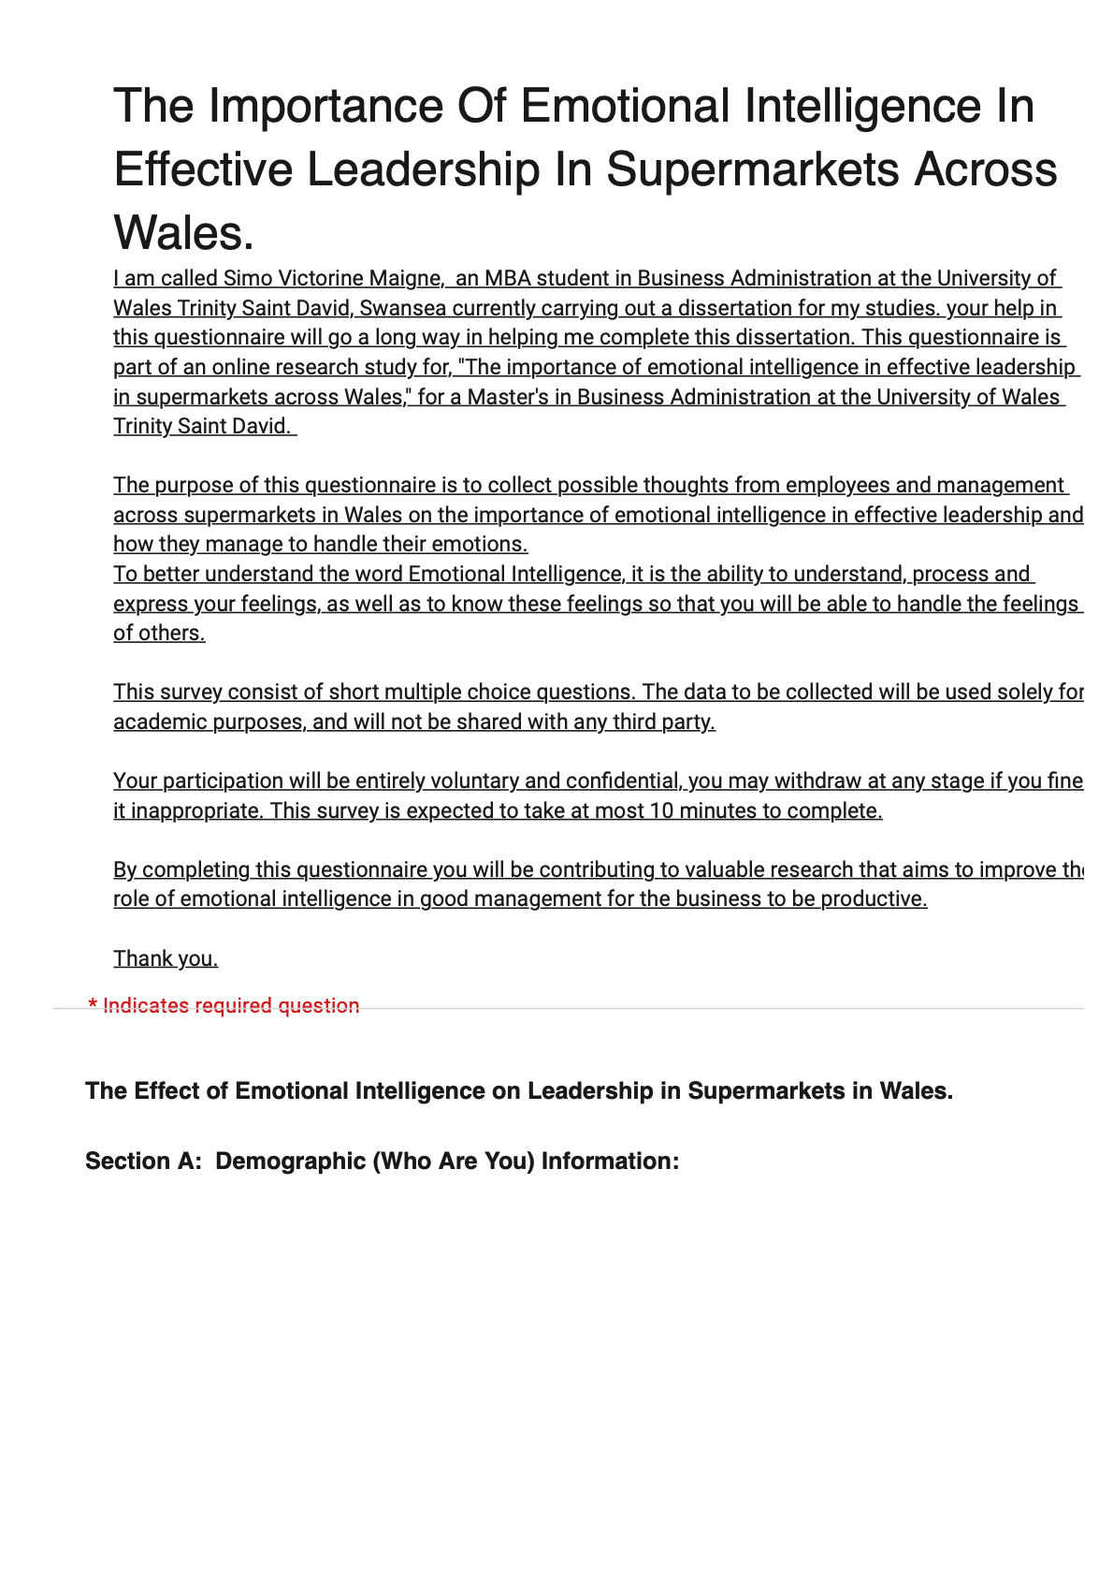
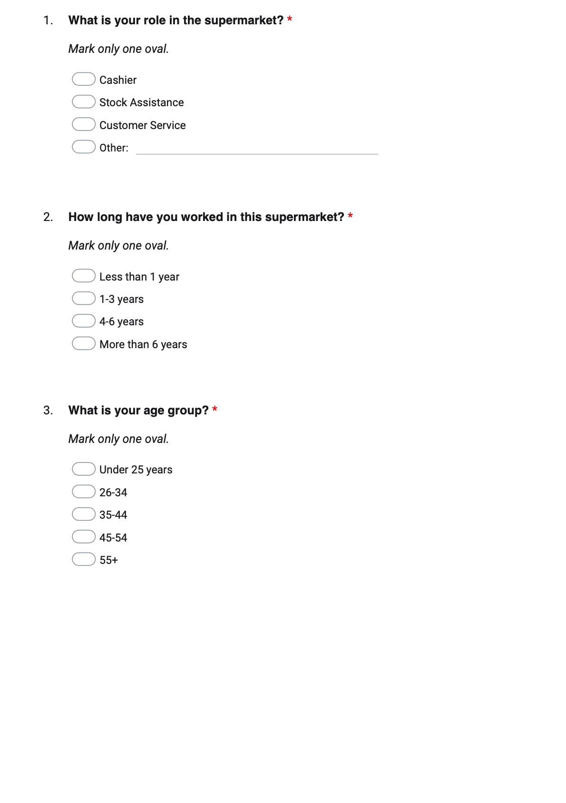

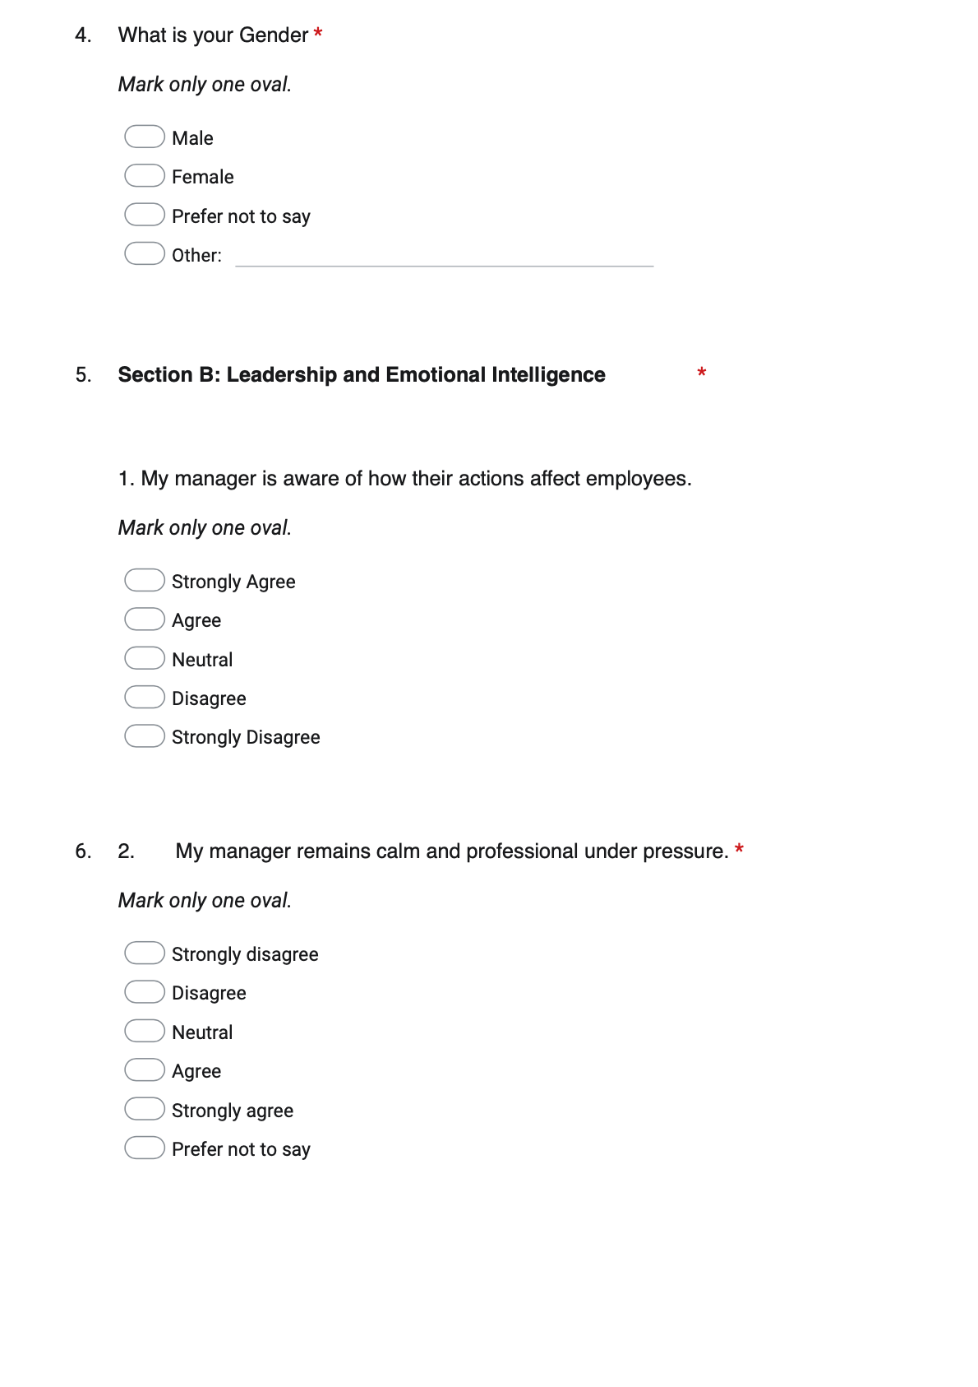

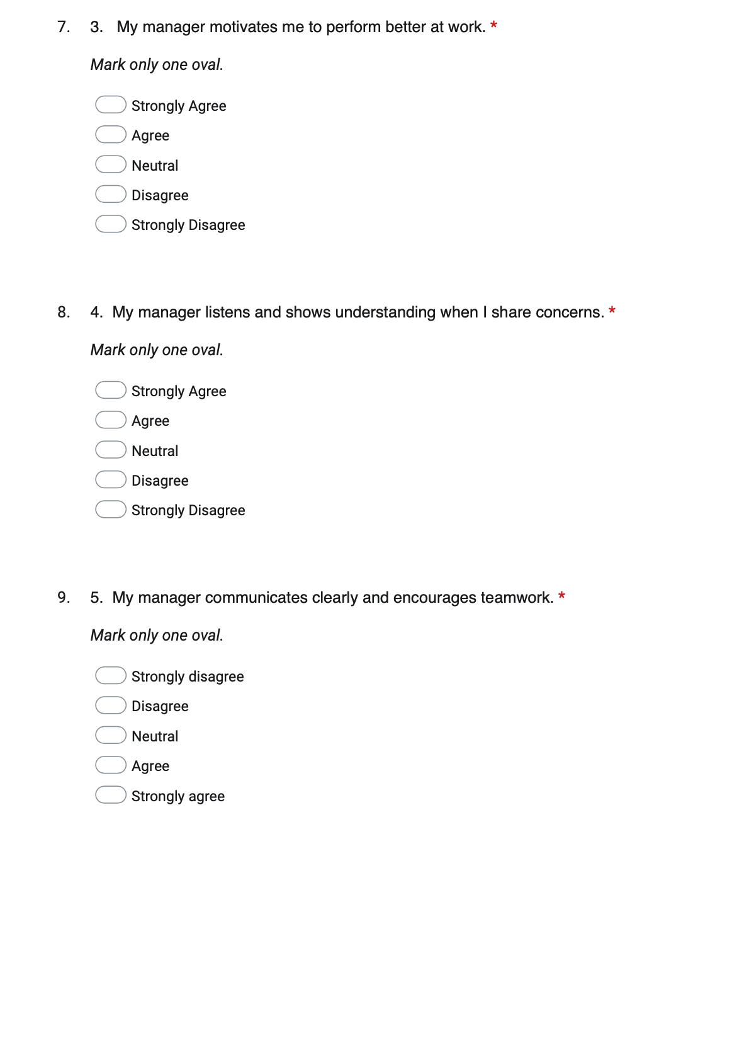

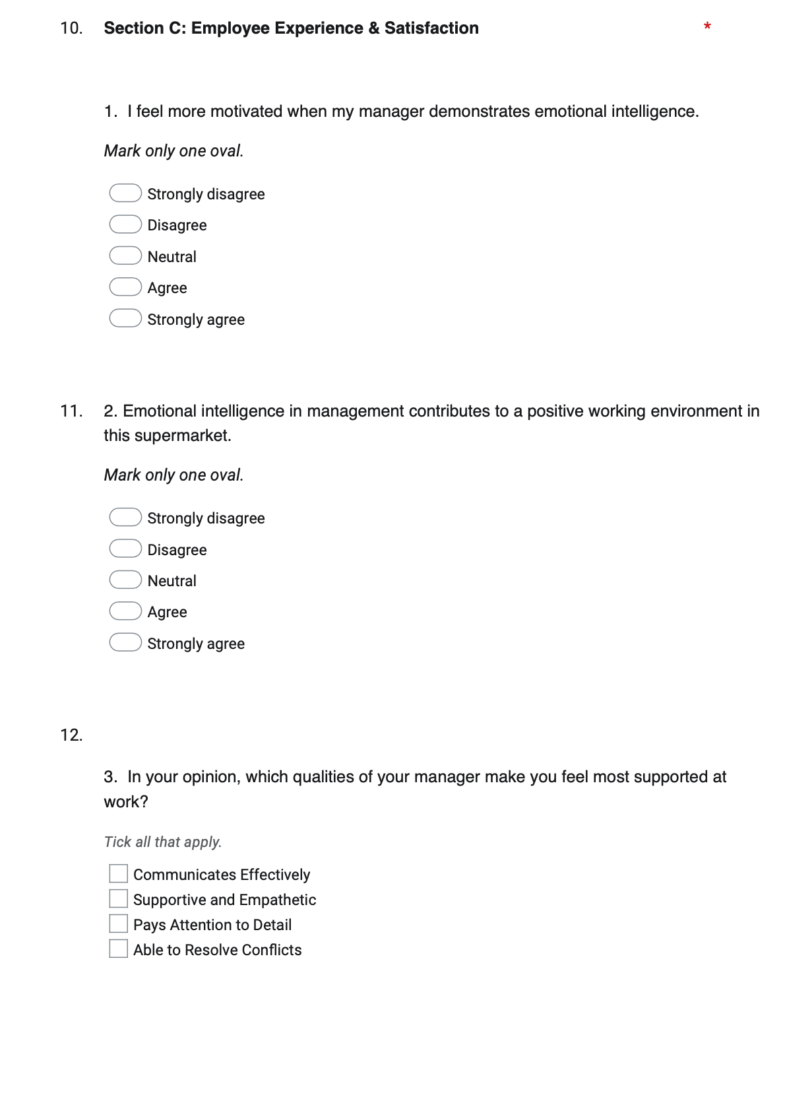
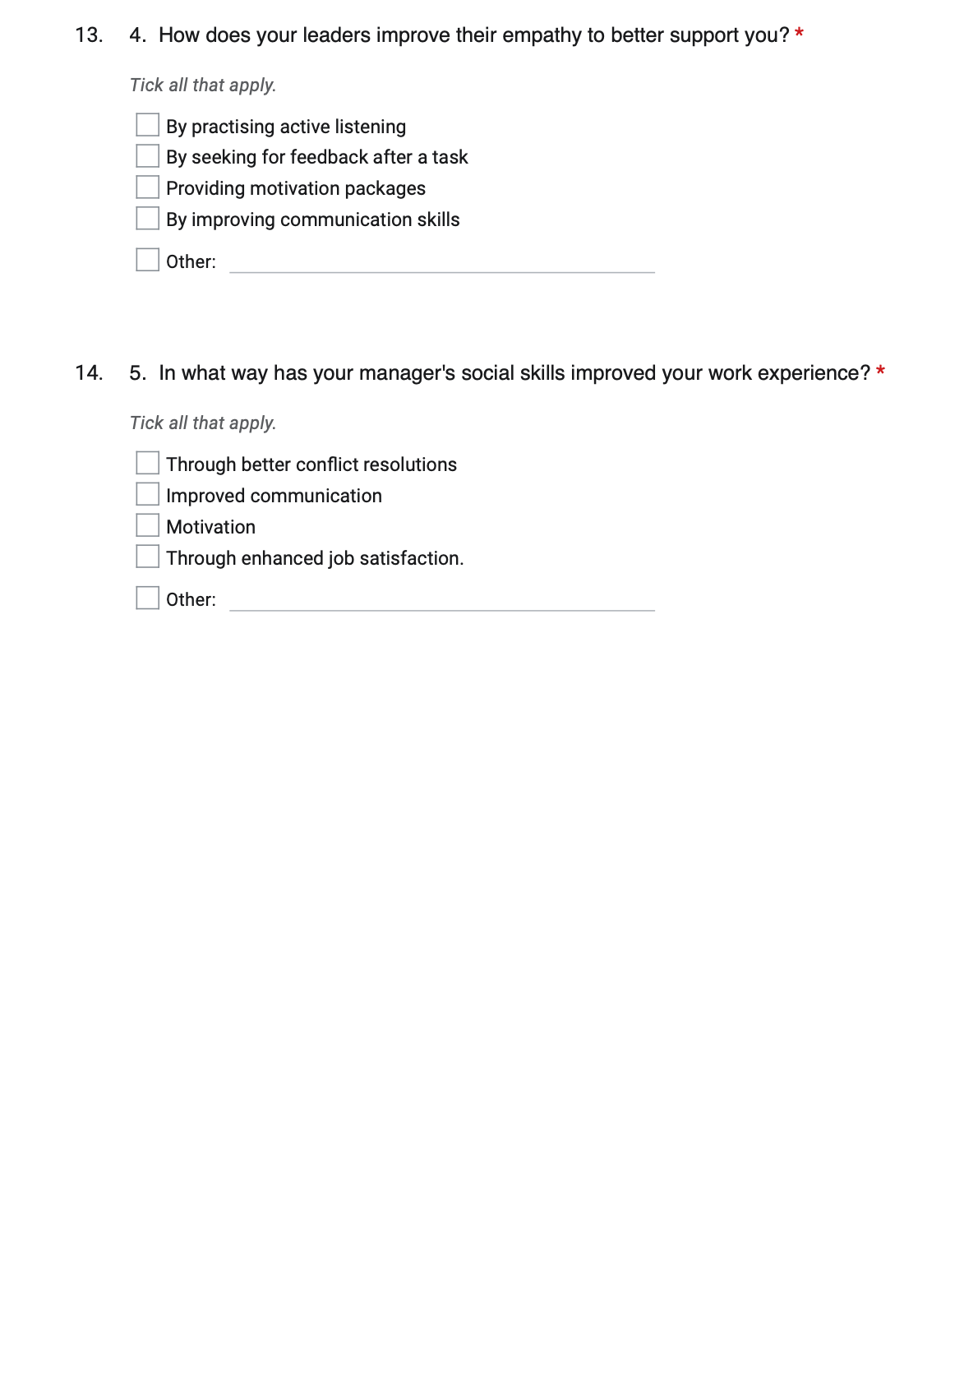

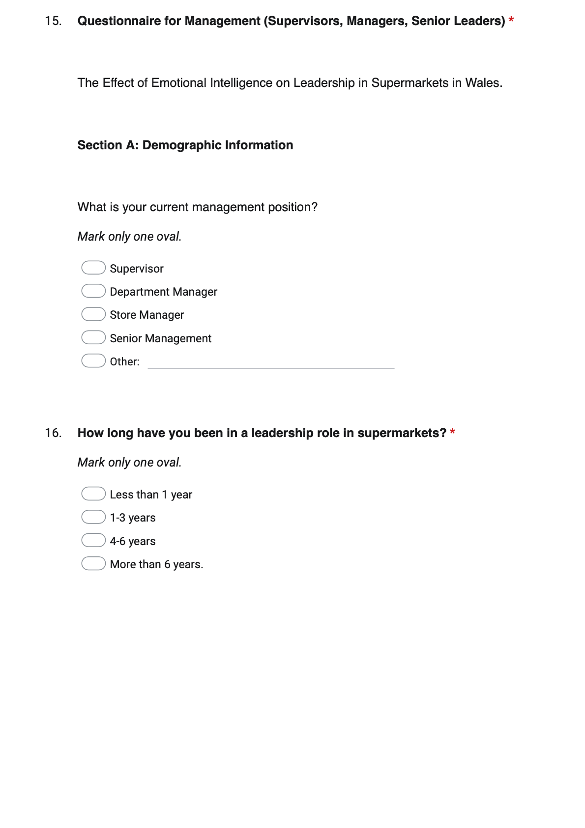

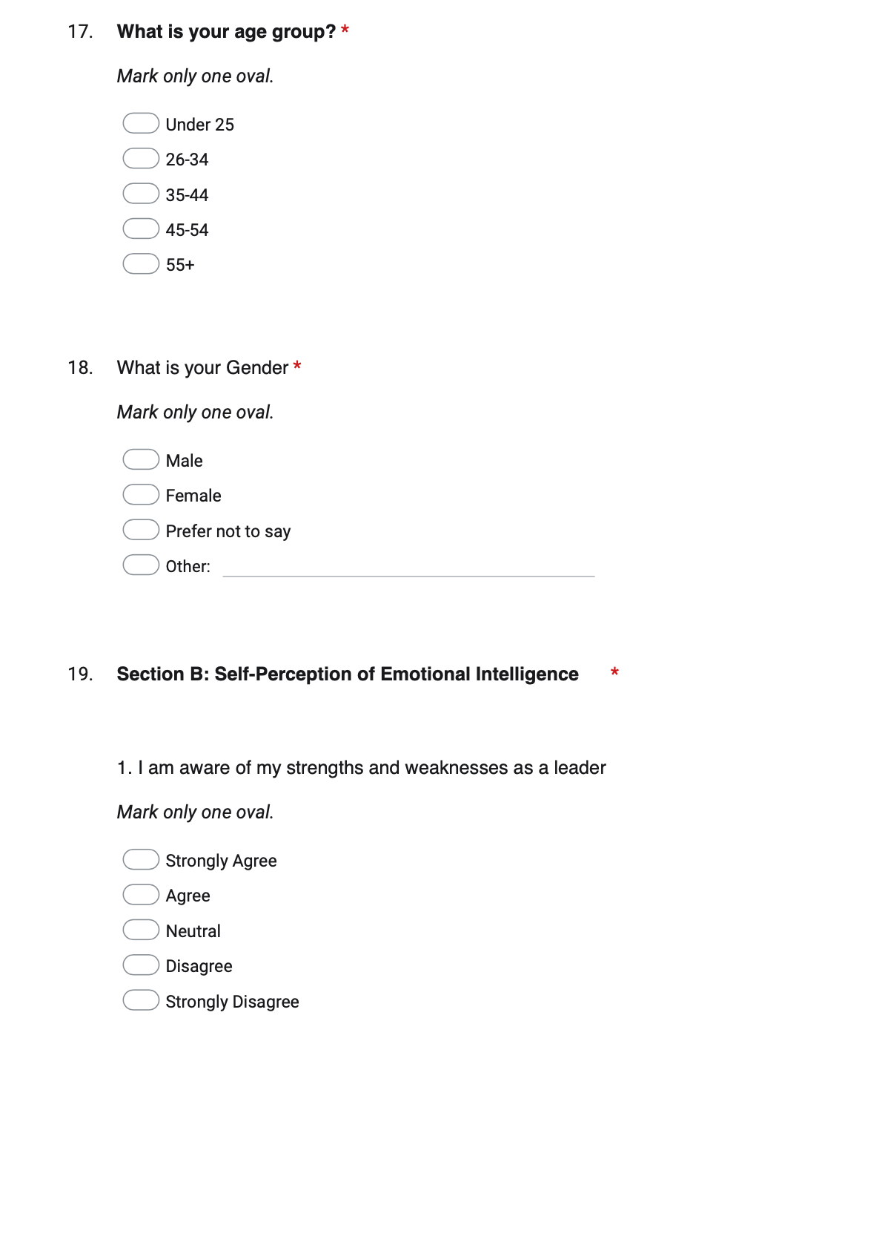

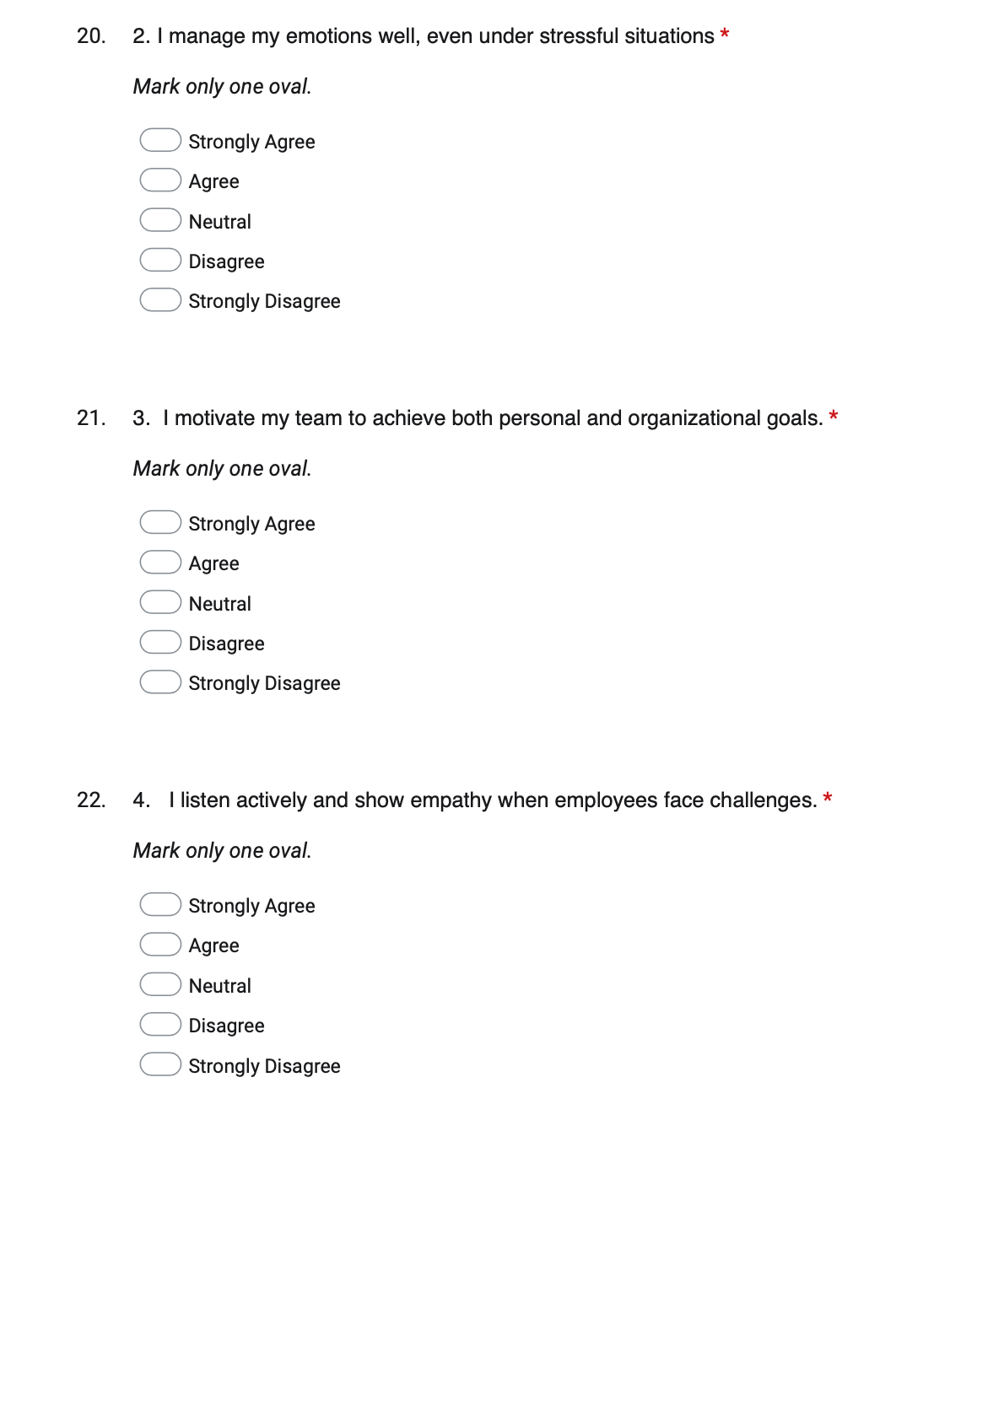

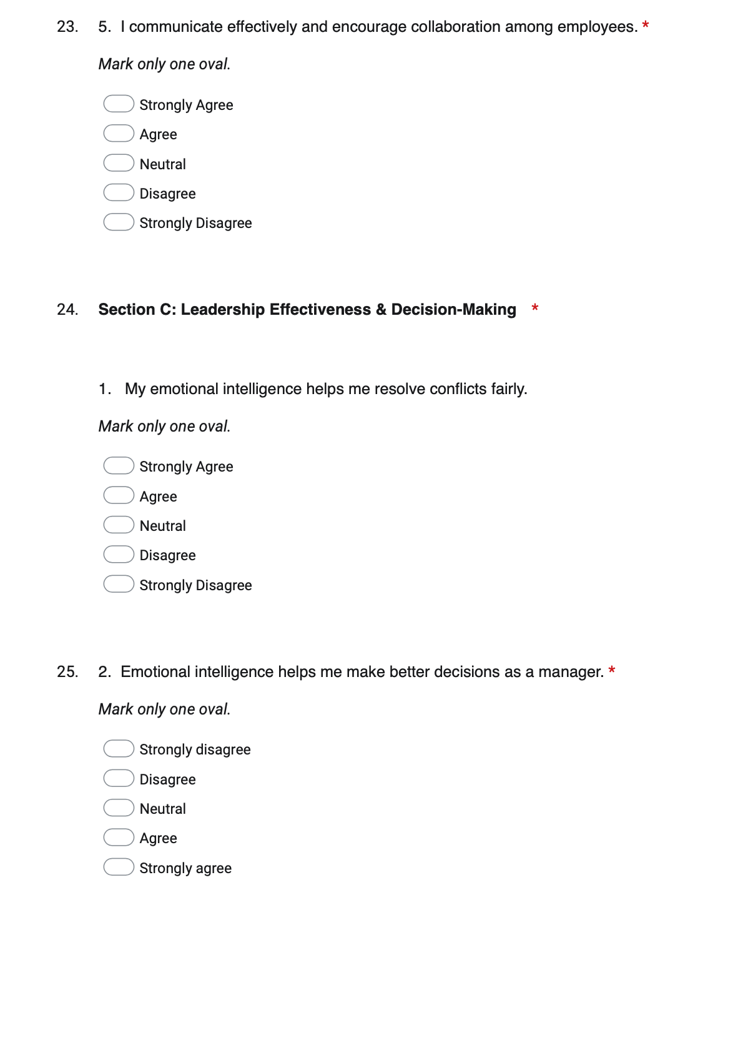

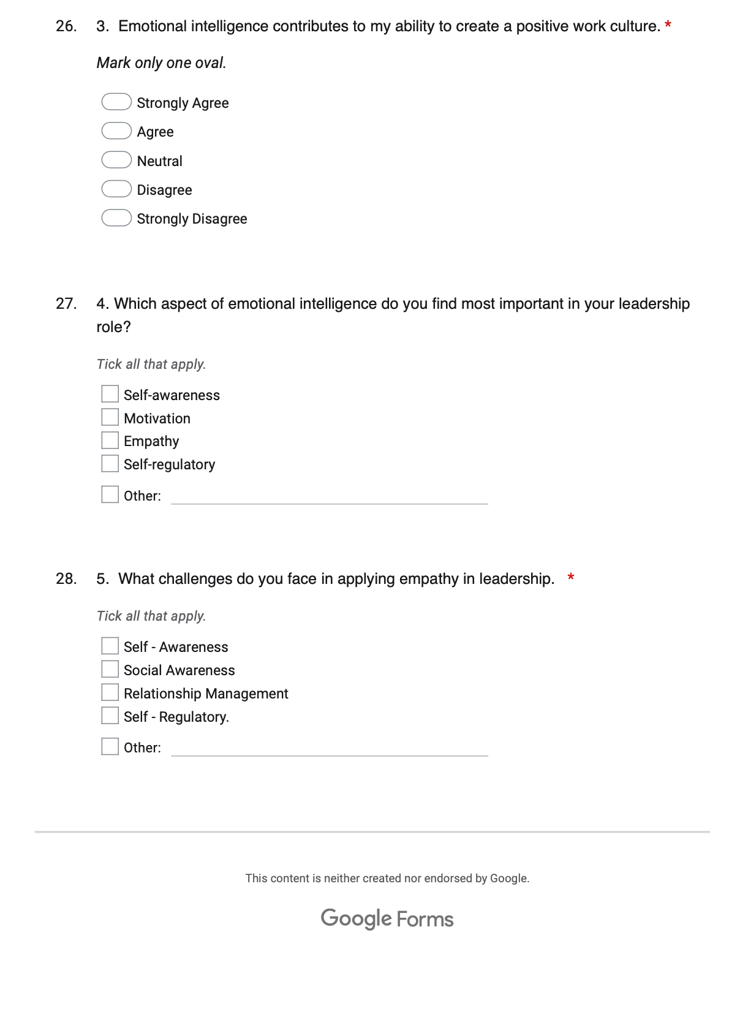

Appendix B Interview Questionnaire

- What do you understand about EI, and how do you apply it at the workplace?
- How do you approach an employee who needs help with their work?
- How do you manage conflict at work?
- Do you think EI is an important quality for leaders (managers) in supermarkets? If Yes Why?
- Can you describe a time when you demonstrated EI in handling a workplace situation?

Appendix C Collected Data

Appendix D Quantitative Analysis
What is your role in the supermarket?
 |  | Frequency | Percent | Valid Percent | Cumulative Percent
Valid | Buyer | 1 | .7 | .7 | .7
Valid | Cashier | 25 | 16.4 | 16.4 | 17.1
Valid | Customer Service | 65 | 42.8 | 42.8 | 59.9
Valid | Front Desk, Receptionist | 1 | .7 | .7 | 60.5
Valid | Manager | 1 | .7 | .7 | 61.2
Valid | Security | 1 | .7 | .7 | 61.8
Valid | Security official | 1 | .7 | .7 | 62.5
Valid | Shelf filler | 1 | .7 | .7 | 63.2
Valid | Stock Assistance | 56 | 36.8 | 36.8 | 100.0
Valid | Total | 152 | 100.0 | 100.0

How long have you worked in this supermarket?
 |  | Frequency | Percent | Valid Percent | Cumulative Percent
Valid | 1-3 years | 76 | 50.0 | 50.0 | 50.0
Valid | 4-6 years | 22 | 14.5 | 14.5 | 64.5
Valid | Less than 1 year | 49 | 32.2 | 32.2 | 96.7
Valid | More than 6 years | 5 | 3.3 | 3.3 | 100.0
Valid | Total | 152 | 100.0 | 100.0

What is your age group?
 |  | Frequency | Percent | Valid Percent | Cumulative Percent
Valid | 26-34 | 74 | 48.7 | 48.7 | 48.7
Valid | 35-44 | 35 | 23.0 | 23.0 | 71.7
Valid | 45-54 | 11 | 7.2 | 7.2 | 78.9
Valid | 55+ | 1 | .7 | .7 | 79.6
Valid | Under 25 years | 31 | 20.4 | 20.4 | 100.0
Valid | Total | 152 | 100.0 | 100.0

What is your Gender
 |  | Frequency | Percent | Valid Percent | Cumulative Percent
Valid | Female | 74 | 48.7 | 48.7 | 48.7
Valid | Male | 78 | 51.3 | 51.3 | 100.0
Valid | Total | 152 | 100.0 | 100.0

What is your current management position?
 |  | Frequency | Percent | Valid Percent | Cumulative Percent
Valid | Cashier | 1 | .7 | .7 | .7
Valid | Department Manager | 47 | 30.9 | 30.9 | 31.6
Valid | I am not a manager | 1 | .7 | .7 | 32.2
Valid | Senior Management | 30 | 19.7 | 19.7 | 52.0
Valid | Store Manager | 48 | 31.6 | 31.6 | 83.6
Valid | Supervisor | 25 | 16.4 | 16.4 | 100.0
Valid | Total | 152 | 100.0 | 100.0

How long have you been in a leadership role in supermarkets?
 |  | Frequency | Percent | Valid Percent | Cumulative Percent
Valid | 1-3 years | 75 | 49.3 | 49.3 | 49.3
Valid | 4-6 years | 25 | 16.4 | 16.4 | 65.8
Valid | Less than 1 year | 46 | 30.3 | 30.3 | 96.1
Valid | More than 6 years. | 6 | 3.9 | 3.9 | 100.0
Valid | Total | 152 | 100.0 | 100.0

What is your age group?
 |  | Frequency | Percent | Valid Percent | Cumulative Percent
Valid | 26-34 | 67 | 44.1 | 44.1 | 44.1
Valid | 35-44 | 48 | 31.6 | 31.6 | 75.7
Valid | 45-54 | 12 | 7.9 | 7.9 | 83.6
Valid | 55+ | 2 | 1.3 | 1.3 | 84.9
Valid | Under 25 | 23 | 15.1 | 15.1 | 100.0
Valid | Total | 152 | 100.0 | 100.0

What is your Gender
 |  | Frequency | Percent | Valid Percent | Cumulative Percent
Valid | Female | 70 | 46.1 | 46.1 | 46.1
Valid | Male | 80 | 52.6 | 52.6 | 98.7
Valid | Prefer not to say | 2 | 1.3 | 1.3 | 100.0
Valid | Total | 152 | 100.0 | 100.0

What is your role in the supermarket?
 |  | Frequency | Percent | Valid Percent | Cumulative Percent
Valid | Buyer | 1 | .7 | .7 | .7
Valid | Cashier | 25 | 16.4 | 16.4 | 17.1
Valid | Customer Service | 65 | 42.8 | 42.8 | 59.9
Valid | Front Desk, Receptionist | 1 | .7 | .7 | 60.5
Valid | Manager | 1 | .7 | .7 | 61.2
Valid | Security | 1 | .7 | .7 | 61.8
Valid | Security official | 1 | .7 | .7 | 62.5
Valid | Shelf filler | 1 | .7 | .7 | 63.2
Valid | Stock Assistance | 56 | 36.8 | 36.8 | 100.0
Valid | Total | 152 | 100.0 | 100.0

How long have you worked in this supermarket?
 |  | Frequency | Percent | Valid Percent | Cumulative Percent
Valid | 1-3 years | 76 | 50.0 | 50.0 | 50.0
Valid | 4-6 years | 22 | 14.5 | 14.5 | 64.5
Valid | Less than 1 year | 49 | 32.2 | 32.2 | 96.7
Valid | More than 6 years | 5 | 3.3 | 3.3 | 100.0
Valid | Total | 152 | 100.0 | 100.0

What is your age group?
 |  | Frequency | Percent | Valid Percent | Cumulative Percent
Valid | 26-34 | 74 | 48.7 | 48.7 | 48.7
Valid | 35-44 | 35 | 23.0 | 23.0 | 71.7
Valid | 45-54 | 11 | 7.2 | 7.2 | 78.9
Valid | 55+ | 1 | .7 | .7 | 79.6
Valid | Under 25 years | 31 | 20.4 | 20.4 | 100.0
Valid | Total | 152 | 100.0 | 100.0

What is your Gender
 |  | Frequency | Percent | Valid Percent | Cumulative Percent
Valid | Female | 74 | 48.7 | 48.7 | 48.7
Valid | Male | 78 | 51.3 | 51.3 | 100.0
Valid | Total | 152 | 100.0 | 100.0

What is your current management position?
 |  | Frequency | Percent | Valid Percent | Cumulative Percent
Valid | Cashier | 1 | .7 | .7 | .7
Valid | Department Manager | 47 | 30.9 | 30.9 | 31.6
Valid | I am not a manager | 1 | .7 | .7 | 32.2
Valid | Senior Management | 30 | 19.7 | 19.7 | 52.0
Valid | Store Manager | 48 | 31.6 | 31.6 | 83.6
Valid | Supervisor | 25 | 16.4 | 16.4 | 100.0
Valid | Total | 152 | 100.0 | 100.0

How long have you been in a leadership role in supermarkets?
 |  | Frequency | Percent | Valid Percent | Cumulative Percent
Valid | 1-3 years | 75 | 49.3 | 49.3 | 49.3
Valid | 4-6 years | 25 | 16.4 | 16.4 | 65.8
Valid | Less than 1 year | 46 | 30.3 | 30.3 | 96.1
Valid | More than 6 years. | 6 | 3.9 | 3.9 | 100.0
Valid | Total | 152 | 100.0 | 100.0

What is your age group?
 |  | Frequency | Percent | Valid Percent | Cumulative Percent
Valid | 26-34 | 67 | 44.1 | 44.1 | 44.1
Valid | 35-44 | 48 | 31.6 | 31.6 | 75.7
Valid | 45-54 | 12 | 7.9 | 7.9 | 83.6
Valid | 55+ | 2 | 1.3 | 1.3 | 84.9
Valid | Under 25 | 23 | 15.1 | 15.1 | 100.0
Valid | Total | 152 | 100.0 | 100.0

What is your Gender
 |  | Frequency | Percent | Valid Percent | Cumulative Percent
Valid | Female | 70 | 46.1 | 46.1 | 46.1
Valid | Male | 80 | 52.6 | 52.6 | 98.7
Valid | Prefer not to say | 2 | 1.3 | 1.3 | 100.0
Valid | Total | 152 | 100.0 | 100.0

$leaders Frequencies
 |  | Responses |  | Percent of Cases
 |  | N | Percent | Percent of Cases
Leaders improve their empathy to betterª | By practising active listening | 36 | 19.8% | 23.7%
Leaders improve their empathy to betterª | By seeking for feedback after a task | 38 | 20.9% | 25.0%
Leaders improve their empathy to betterª | Providing motivation packages | 68 | 37.4% | 44.7%
Leaders improve their empathy to betterª | By improving communication skills | 40 | 22.0% | 26.3%
Total |  | 182 | 100.0% | 119.7%
a. Dichotomy group tabulated at value 1.

$managerssocialskillsworkexperience Frequencies
 |  | Responses |  | Percent of Cases
 |  | N | Percent | Percent of Cases
Manager's social skills in work experienª | Through better conflict resolutions | 13 | 7.3% | 8.6%
Manager's social skills in work experienª | Improved communication | 48 | 27.1% | 31.6%
Manager's social skills in work experienª | Motivation | 93 | 52.5% | 61.2%
Manager's social skills in work experienª | Through enhanced job satisfaction. | 23 | 13.0% | 15.1%
Total |  | 177 | 100.0% | 116.4%
a. Dichotomy group tabulated at value 1.

$Aspectofemotionalintelligence Frequencies
 |  | Responses |  | Percent of Cases
 |  | N | Percent | Percent of Cases
Aspect of emotional intelligenceª | Self-awareness | 44 | 23.4% | 28.9%
Aspect of emotional intelligenceª | Motivation | 69 | 36.7% | 45.4%
Aspect of emotional intelligenceª | Empathy | 52 | 27.7% | 34.2%
Aspect of emotional intelligenceª | Self-regulatory | 23 | 12.2% | 15.1%
Total |  | 188 | 100.0% | 123.7%
a. Dichotomy group tabulated at value 1.

$Challengesinapplyingempathyinleadership Frequencies
 |  | Responses |  | Percent of Cases
 |  | N | Percent | Percent of Cases
Challenges in applying empathy in leaderª | Self - Awareness | 26 | 15.4% | 17.1%
Challenges in applying empathy in leaderª | Social Awareness | 53 | 31.4% | 34.9%
Challenges in applying empathy in leaderª | Relationship Management | 67 | 39.6% | 44.1%
Challenges in applying empathy in leaderª | Self - Regulatory. | 23 | 13.6% | 15.1%
Total |  | 169 | 100.0% | 111.2%
a. Dichotomy group tabulated at value 1.

Appendix E Interview Transcript
Recordings:
https://uowtsd-my.sharepoint.com/:f:/r/personal/2423778_student_uwtsd_ac_uk/Documents/Interview?csf=1&web=1&e=Ertim0
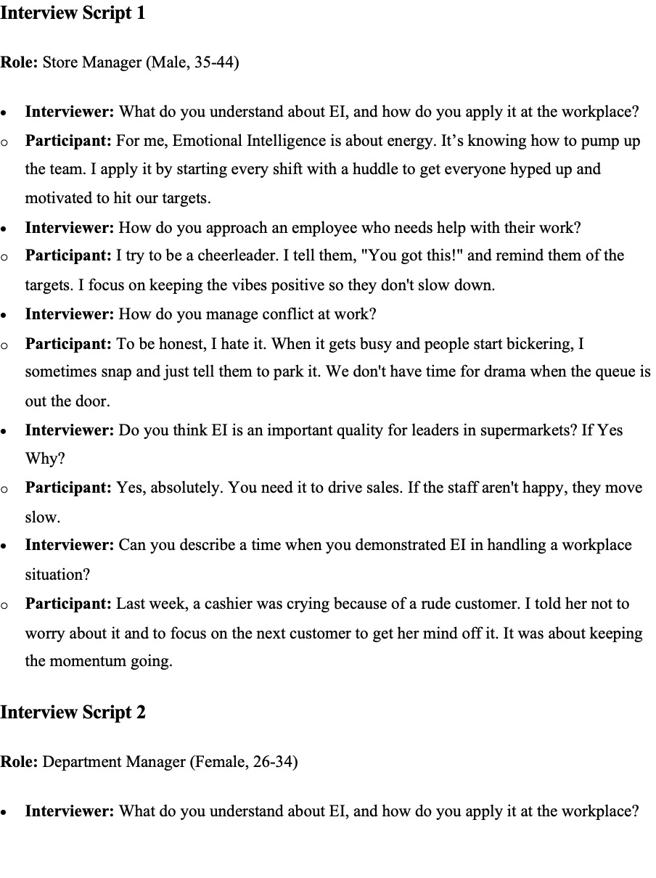
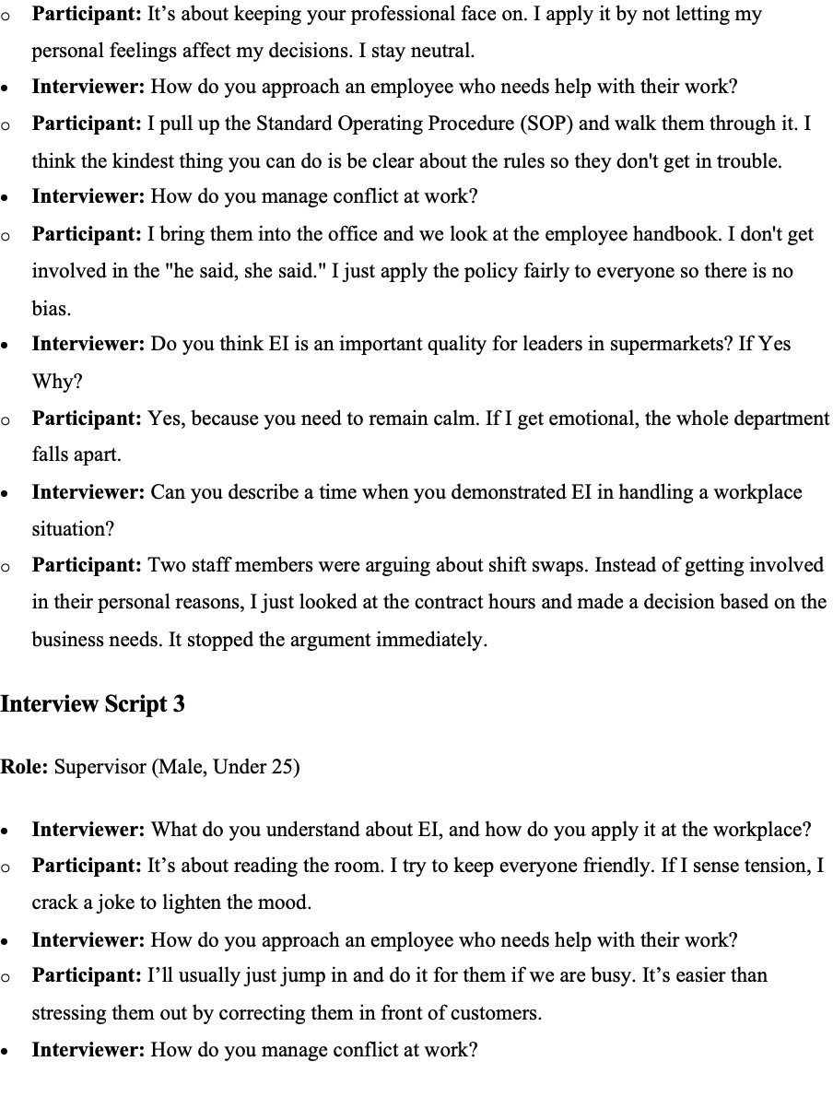

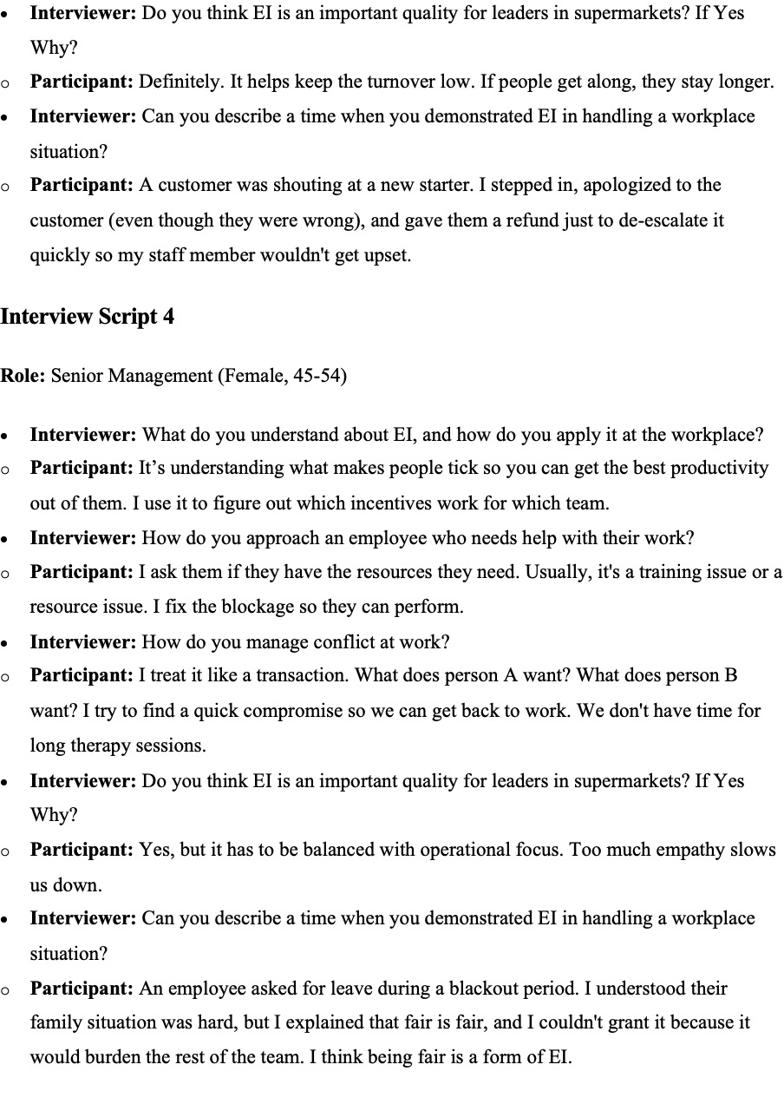
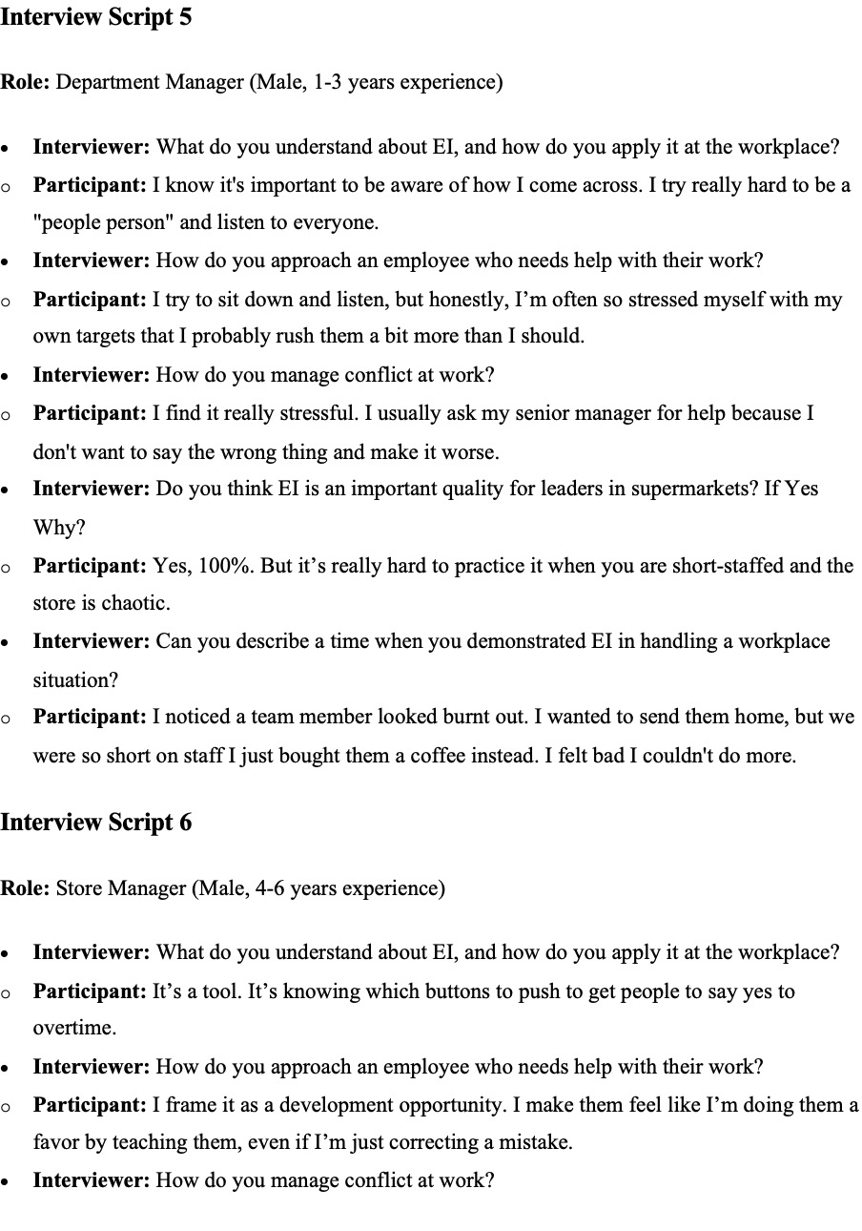
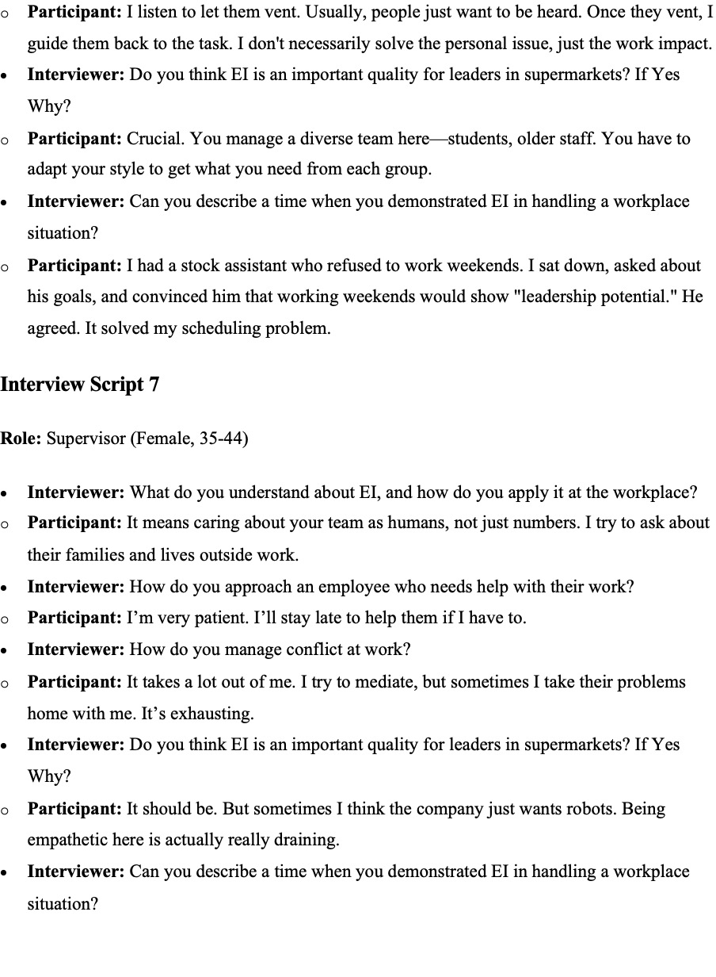
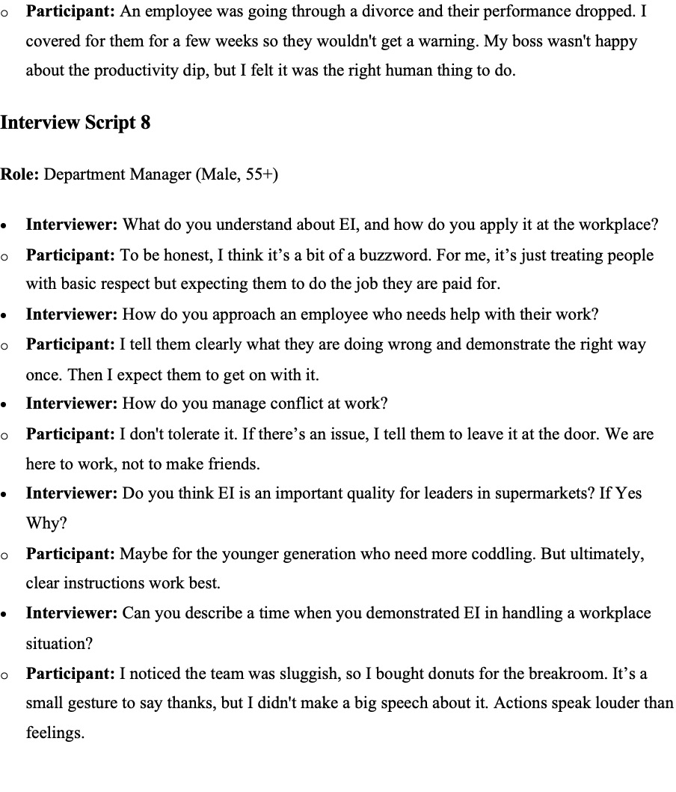

Appendix F Ethics Form

APPLICATION FOR ETHICAL APPROVAL

Please open the file to view the ethics form

