INTERVIEW AND ASSESMENT PROCESS
Supplementary notes
Valentin Gotsev
Student number: 1912864

1. Phone interview –
According to Jacobs, D. (2014) there are two types of phone interview scheduled and unscheduled. Interviewed Area Manager Paveley (2020) states that Amazon practice is to give scheduled phone interviews when there is high interest. The interview lasts between 20 and 40 minutes. According to him and Smith (2013) the most frequently asked questions on the phone interview are:

Paveley (2020), Smith (2013)
The conclusion of Smith (2013) article in Forbes is that these questions are asked to get better understanding of the interviewee self-awareness and personality. These questions give more information if the candidate is really interested in the position and thinks about the position in long-term. They are essential to get better understanding of the person that is interviewed by the Company.
.

2.Assessment process

2.1 Numeracy test - In an advert for a Learning Manager on the Amazon.jobs (2020) website it is stated that the responsibilities of Amazon Learning Managers are to take a data driven approach to understand performance issues and take action to improve the quality of training. One of the essential qualifications in this advertisement is that the candidate must have data skills and understand different methods of learning. Interviewed Area Manager Paveley (2020) states that the Numeracy test lasts half an hour, contains 20 questions and interviewees have little more than a minute to answer every question.

2.2Case Studies – According the London school of Economics and Political science (n/d) companies are using this type of interview to assess the candidate’s ability to analyse and find effective solutions to different problems. During the interview of Paveley (2020) Amazon Management must know how to communicate effectively with their associates. To assess their ability amazon requires candidates to solve a case study based on a difficult associate case and indicate how would they deal with it.

3.Interview process

3.1 Panel interview - According to Doyle (2019) a panel interview is conducted by a group of people who ask the candidate or the candidates different questions. Anderson (2017) explains that while he had worked in Amazon he had the opportunity to interview a lot of people, he says that they assigned specific principles to each interviewer in the process to get a better picture of how likely the candidate is the leader that they are looking for. Paveley (2020) states that senior management ask the questions and HR records the answers.
3.2 Leadership principles – Anderson (2017) also states that Amazon wants to create leadership culture based on leadership principles. According to amazon.jobs (n/d) the future leads must follow and possess 14 leadership principles:
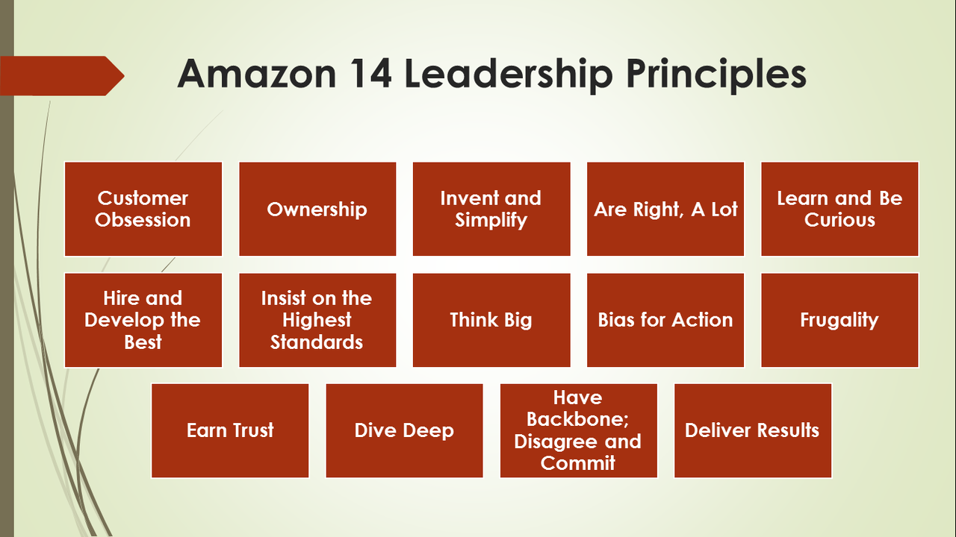
Alawi, B. S. (2018)

3.3 Behavioural questions - According to Scupi, J. (2017) the Amazon leadership principles-based questions are behavioural they can start with: ‘’Tell me about time…’’, ‘’ Give me an example of….’’ Etc. Scupi, J. (2017) also states that no matter what role you take in amazon even technical Amazon wants those principles to be embedded in your life. The interviewed manager in Amazon Paveley, T. (2020) states that Learning, and Development manager interview could contain questions like :

Paveley (2020), Scupi, J. (2017)

According to Murphy (2014) the behavioural questions are asked to assess the future candidate on their previous experience. Murphy (2014) also states that these questions are asked to see situations where the interviewee have failed or confronted and how would they have dealt with them. The interviewed Paveley (2020) states that the longer the answers and the more principles embedded in the answers shows that the candidates possess solid experience.

5 Reference list

- Alawy, S. (2018). Amazon leadership principles. Available: https://www.linkedin.com/pulse/amazon-leadership-principles-sayed-bader-alawi-msc-pmp-1d. Last accessed 08/10/2020.
- Anderson, D. (2017). Interviewing at amazon - Leadership principles. Available: https://medium.com/@scarletinked/are-you-the-leader-were-looking-for-interviewing-at-amazon-8301d787815d. Last accessed 02/03/2020.
- (anon.). (n/d). Leadership principles. Available: https://www.amazon.jobs/en/principles. Last accessed 1/03/2020.
- (anon.). (2020). Learning Manager. Available: https://www.amazon.jobs/en/jobs/890711/learning-manager?fbclid=IwAR1u-sgDm-DTvOZ1UzRiD5YvYpE9rffzKworVCoj9qoF16plvaHRb9glV4g. Last accessed 1/03/2020.
- Doyle, A. (2019). Panel Interview Questions Answers and Tips. Available: https://www.thebalancecareers.com/panel-interview-questions-and-answers-2061158. Last accessed 02/03/2020.
- Jacobs, D.. (2014). How To Ace A Phone Interview. Available: https://www.forbes.com/sites/deborahljacobs/2014/05/27/how-to-ace-a-phone-interview/#49abdf662617. Last accessed 13/03/2020.
- Paveley, T. (2020) ‘’Amazon Learning Manager interview process’’ Interviewed by Valentin Gotsev, 1th of March 2020
- Scupi, J. (2017). How to interview at Amazon using the Leadership Principles. Available: https://www.linkedin.com/pulse/how-interview-amazon-using-leadership-principles-jennifer-scupi. Last accessed 03/03/2020.
- Smith, J. (2013). How to ace the 50 most common interview questions. Available: https://www.forbes.com/sites/jacquelynsmith/2013/01/11/how-to-ace-the-50-most-common-interview-questions/#a35b1934624d. Last accessed 02/03/2020.

