Lecturer: Efua Adams

Marketing Fundamentals

(LCBB4004_BIRM)

Student : Ina Stancheva 2010542

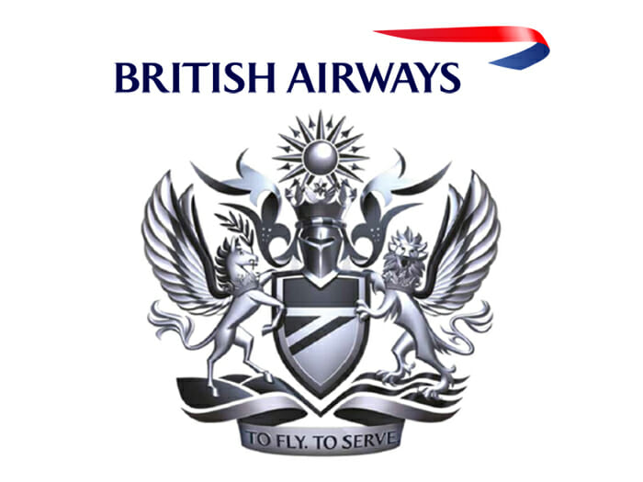

Introduction
Marketing communication is a complicated part of an organization's marketing efforts. It includes advertising, direct communication, packaging, branding, sales presentation, trade shows, and pricing of the product or services. Communication refers to the interaction between two or more people where they share some information and topic. It is a set of tools and techniques to deliver a clear message to the potential and target audience. In the middle of marketing communications of a marketing mix which consist of seven Ps. These Ps consist of price, promotion, place, product, people, physical evidence, and company process. This overall marketing mix allows the customers to understand and knowing of the brand and company. British Airways is the largest flag career airline in the UK. It was founded in the year 1974. the parent company of British Airways is the International airline's group. IAG is the world's largest airline group in terms of annual revenue. The destinations which it covers around 183 places all over the world. This blog covers the company's marketing mix and covers what promotional strategies the company uses during the introduction of a new service. It tells how a brand communicates with its customers and makes plans accordingly (Bolsen and Shapiro, 2018).

Importance of Marketing mix in improving communication structure in British Airways
The blogs revolve around the importance of communication in an organization and how it helps the organization achieve its goals and objectives. Communication plays a vital role in every organization's functioning as it helps top-level managers communicate the organization's goals and objectives to employees of an organization. Communication help employees of the organization in understanding their roles and responsibilities. Practical communication help in understanding the vision and mission of the organization. Blogs are based on the organization British Airways. It covers information about the importance of communication in British Airways and what changes have to be deal in its communication structure, which helps the organization achieve its goals and objectives. The marketing mix is explained as a process in which several components include implementing an effective marketing plan in an organization in relevance with communication (Buluş, Atan and Sarıkaya, 2017). There are 7P's included in the marketing mix, which is mentioned below with relevance to communication in British Airways: 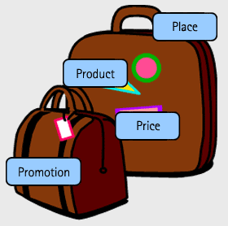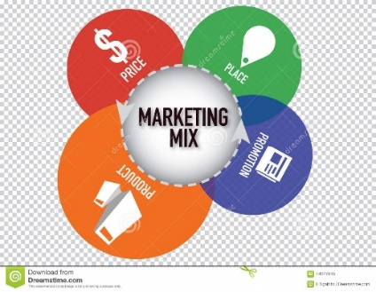

Product

Every organization focuses on making innovation in their products, satisfying their consumers, and engaging new customers. In this phase, the product's planning and the manager focus on the comprised attributes of the product. Communication plays a vital role in the planning and developing of any product as top-level management decides about the type and detail of the product and communicates instructions to employees and managers. Our focus in British Airways on providing services that can satisfy our consumers, and top-level managers decide about the nature of service and benefit of service to organization and consumer. Top-level managers communicate with organization managers, helping them understand service attributes and character and effectively and efficiently. Top-level managers can provide personal space for consumers with no interruptions, best food, entertainment system, etc. British Airways makes service users, helping make the enjoyable flight for consumers (Deep, Salleh and Othman, 2019.). Using our business class your journey will make you relaxed and comfotable untill you arrive in a right place which you chose. 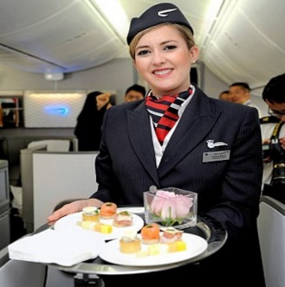

Price

The price of a product or service depends on its quality and value; the consumer pays only for its value and quality. Organizations decide on costs based on competitor pricing as a competitor could be selling the same product or service to consumers at lower prices. British Airways focuses on using this strategy as we offer different travel classes such as economy class, business class, and first-class. This helps our customers in picking type they want to travel according to their need and preference. Top-level people decide pricing in an organization and communicate pricing strategy to lower-level managers in the organization, which further communicate it to employees. Communication plays a vital role in understanding strategies related to pricing and product as effective communication help in implementing strategy in an organization (Hassell and Cotton, 2017).

Place

The place is explaining as delivering the product to consumers and different ways it can be possible. The site also discusses where goods are manufactured and how they are distributed to customers. British Airways relies on the marketing of its travel facilities through travel companies. British Airways focuses on reaching out to more customers by using a different model. Top-level managers concentrate on implementing strategies related to reaching out to consumers by other models and understanding their needs and wants. Communication helps lower-level managers understand goals and objectives through which product is provided and focus on implementing suitable strategies. Communication also helps in understanding the needs of customers. 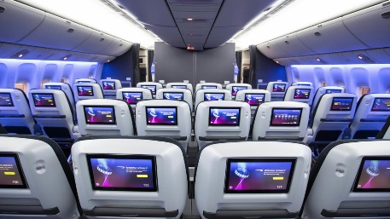

Promotion

Promotion help organization in spreading awareness about product or services offered by the organization to its consumers. Promotion helps consumers understand the attributes of the product and help consumers identify a product, helping to complete their needs and wants. Promotion help organization in promoting brand name and help in enhancing the goodwill of organization among consumers. Promotion of product and services help in increasing clients base of an organization. British Airways focuses on promoting products and our services through effective plans and strategies. Top-level managers focus on communicating their strategies and plan related to product promotion and effectively implementing strategies in an organization (Kalogiannidis, 2020.).

Process

The process is explained as service and product by the organization and helps understand processes produced here and then. British Airways consumers have an opinion about customer services based on food, services related to their satisfaction. Here in our company we try to put a process to make services effective and efficient. The process makes sure that standards for services should meet customers' expectations. Communication plays a vital role in the transmission of measures to successfully introduce procedures in the enterprise's workings. British Airways make sure that the quality of food we are provide should meet customer expectations, which helps retain consumers and help attract new consumers (Stachova, Stacho and Vicen, 2017).

Physical Evidence

Physical Evidence is explaining about product or service that is sold and provided by an organization. Physical Evidence is considered Evidence about when consumer experiences about product or service and helps the clients experience and perceive it. It helps create an image about products and services and allows customers to determine product and service quality. It helps in engaging consumers with the organization. 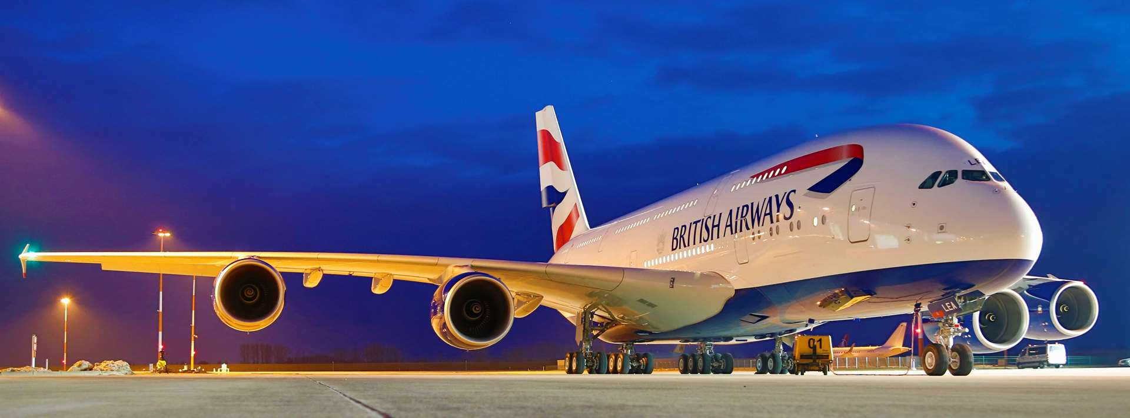 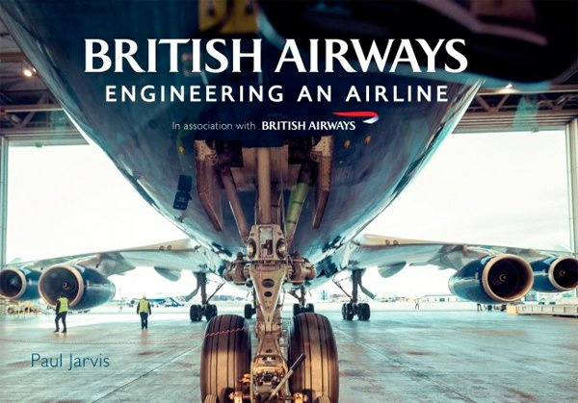

People

People play a vital role in every organization's functioning as products and services are delivered to people, which helps the organization boost its revenues and maximize its productivity and profitability. British Airways focuses on providing appropriate training to our staff, which helps in dealing with our clients effectively, creating the right image in front of our customers. Our company is concentrate on treating our employees with respect and focus on providing luxurious services to them, which leads to boosting revenues for an organization (Villa, Gonçalves and Odong, 2017). 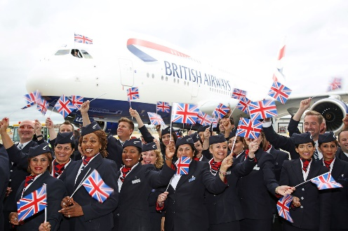

CONCLUSION

All that customers need is British Airways services—making the journey comfortable, enjoyable, safety and unusual.
For more information don't hesitate to visit:

www.britishairways.com/

REFERENCES
Books and Journals
Bolsen, T. and Shapiro, M. A., 2018. The US news media, polarization on climate change, and pathways to effective communication. Environmental Communication. 12(2). pp.149-163.
Buluş, M., Atan, A. and Sarıkaya, H. E., 2017. Effective Communication Skills: A New Conceptual Framework and Scale Development Study. International Online Journal of Educational Sciences. 9(2).
Deep, S., Salleh, B. M. and Othman, H., 2019. Study on problem-based learning towards improving soft skills of students in effective communication class. International Journal of Innovation and Learning. 25(1). pp.17-34.
Hassell, M. D. and Cotton, J. L., 2017. Some things are better left unseen: Toward more effective communication and team performance in video-mediated interactions. Computers in Human Behavior. 73. pp.200-208.
Kalogiannidis, S., 2020. Impact of Effective Business Communication on Employee Performance. European Journal of Business and Management Research. 5(6).
Stachova, K., Stacho, Z. and Vicen, V., 2017. Efficient involvement of human resources in innovations through effective communication. Business: Theory and Practice. 18. p.33.
Villa, S., Gonçalves, P. and Odong, T. V., 2017. Understanding the contribution of effective communication strategies to program performance in humanitarian organizations. Journal of Humanitarian Logistics and Supply Chain Management.
Yap, J. B. H., Abdul-Rahman, H. and Chen, W., 2017. Collaborative model: Managing design changes with reusable project experiences through project learning and effective communication. International Journal of Project Management. 35(7). pp.1253-1271.

