

Masters of Business Administration
Dissertation Proposal
Module code: LCMB7035

The Impact of Digital Marketing on customer satisfaction in the UK Market- A analysis of TESCO

Supervisor Name: Tushara Balendran

Student Name: Durjoy Kumar Kundu
Student ID: 2503600

Submission Date: 17th July, 2026

Table of Contents

1. Introduction 2
2. Research Background and Rationale 2
3. Research Aim 2
4. Research Objectives 3
5. Research Questions 3
6. Literature Review 4
7. Research Gap 6
8. The RACE Framework 6
9. Methodology 9
10. Research Onion 9
Choices 10
Data Collection and Analysis 11
11. Research Ethics 13
12. Resource and Planning 14
References 15

1. Introduction
Digital marketing has become an important factor in improving customer engagement, loyalty, and business performance in the modern retail sector. The use of digital channels such as social media, mobile apps, email marketing, and personalised platforms has changed how businesses communicate with customers. Understanding the connection between digital marketing and customer satisfaction is essential for maintaining competitiveness (Kotler and Keller, 2016). Tesco PLC has adopted digital transformation strategies to improve customer experiences through data-driven and personalised marketing (Tesco PLC, 2025). This study explores the impact of digital marketing on customer satisfaction in the UK retail industry.

2. Research Background and Rationale
The UK retail sector has undergone significant digital transformation, with the COVID-19 pandemic accelerating online shopping adoption and digital customer engagement (Chaffey et.al, 2022). Retailers increasingly invest in digital marketing strategies including social media, mobile applications, and personalised loyalty programmes to enhance customer experiences and remain competitive (Kotler and Keller, 2016). Research indicates that effective digital marketing improves customer engagement, satisfaction, and loyalty through personalised shopping experiences (Nanta et al., 2025). Tesco has embraced this transformation through its Clubcard loyalty programme and data-driven personalised marketing (Tesco PLC, 2025; Reuters, 2026). However, there remains limited understanding of how different digital marketing strategies collectively influence customer satisfaction. This research will identify digital marketing practices with the greatest impact on customer satisfaction and long-term loyalty (James and Cooper, 2015), helping Tesco refine its strategies and maintain competitive advantage in the UK retail market.

3. Research Aim
The main aim of this research is to investigate the impact of digital marketing on customer satisfaction at Tesco in the UK market, examining the mechanisms and pathways through which digital marketing activities influence customer satisfaction outcomes.

4. Research Objectives
This study aims to achieve the following objectives:
- To investigate the current digital marketing strategies implemented by Tesco.
- To determine the current opportunities and challenges of Tesco implementing digital marketing.
- To analyse the impact of digital marketing on customer satisfaction.

5. Research Questions
The proposed research will address the following questions:
- What are the current digital marketing strategies implemented by Tesco?
- What are the current opportunities and challenges of Tesco implementing digital marketing?
- What are the impact of digital marketing on customer satisfaction?

6. Literature Review
Digital Marketing in the Retail Context
Digital marketing uses digital platforms to promote products, enhance brand awareness, and improve customer relationships. Retail businesses now use websites, social media, apps, email, and personalised content as part of integrated strategies (Chaffey, 2022). Tesco has strengthened its digital approach through online services, Clubcard data, and AI-based personalisation (Adobe, 2026). These activities support customer satisfaction and engagement (Nanta et.al,2025).
Personalisation and Customer Satisfaction
Personalisation is an important part of digital marketing because it improves customer experience and retention through customised recommendations and targeted promotions (Ologunebi, 2023). Relationship marketing factors such as trust, communication, commitment, and customer care also play a key role in building long-term loyalty (Mollah, 2014; James and Cooper, 2015). Tesco supports personalisation through its Clubcard loyalty programme, which serves over 24 million UK households by offering personalised rewards and recommendations (Reuters, 2026). Tesco has further strengthened this approach by combining AI with Clubcard data to deliver more relevant customer experiences (Adobe, 2026).
Current Opportunities and Challenges of Tesco Implementing Digital Marketing
Tesco's digital marketing creates many opportunities by using Clubcard data and artificial intelligence to deliver personalised offers and improve customer engagement (Tesco PLC, 2026). Its online platform, Tesco.com, has also increased online sales and customer spending (Fairlie, 2004). Social media, especially Facebook, helps expand Tesco's reach and marketing effectiveness (Stankizai et.al, 2024), while digital marketing improves customer satisfaction (Nanta et al., 2025). However, Tesco faces challenges in setting marketing goals, selecting suitable platforms, identifying target audiences (Stankizai and Ali, 2024), and ensuring that digital marketing supports trust, service quality, and long-term customer loyalty (Mollah, 2014; James and Cooper, 2015).
Research Objectives
Research objectives are clear and specific statements that explain what a research study aims to achieve (Saunders et al., 2019). Clearly written research objectives help the researcher choose suitable research methods, data collection techniques, and data analysis methods, while keeping the study focused and ensuring the research questions are answered effectively (Bryman and Bell, 2022).
To investigate the current digital marketing strategies implemented by Tesco:
This objective aims to examine the digital marketing strategies used by Tesco to promote its products and engage customers through Tesco.com, mobile apps, social media, email marketing, and the Clubcard programme (Stankizai and Ali, 2024). It also explores Tesco's use of artificial intelligence for personalised marketing (Reuters, 2026). Understanding these strategies helps evaluate their effectiveness and shows how Tesco has adapted to digital changes in the retail industry (Chaffey and Ellis-Chadwick, 2022).
To determine the current opportunities and challenges of Tesco implementing digital marketing:
This objective aims to evaluate the main opportunities and challenges of Tesco's digital marketing. Opportunities include to provide personalised offers, improve customer engagement, increase satisfaction, and boost online sales through Tesco.com and social media platforms (Nanta et al., 2025). Challenges include setting clear marketing goals, selecting suitable platforms, identifying target audiences, and building long-term customer trust and loyalty beyond reward programmes (Mollah, 2014; James and Cooper, 2015).
To analyse the impact of digital marketing on customer satisfaction at Tesco:
This objective examines how Tesco's digital marketing strategies influence customer satisfaction and overall shopping experiences. It explores the impact of personalised marketing, artificial intelligence on customer engagement and satisfaction (Ologunebi, 2023). The study also considers the role of trust, communication, and customer care in strengthening customer relationships, while assessing whether Tesco meets the changing expectations of UK consumers (Kotler and Keller, 2016; Tesco PLC, 2025).

7. Research Gap
Although many studies have examined digital marketing and customer satisfaction in the retail sector, there is limited research that provides a complete understanding of how different digital marketing strategies work together to influence customer satisfaction. Previous studies have focused on individual areas such as online platforms (Fairlie, 2004), relationship marketing (James and Cooper, 2015), social media (Stankizai and Ali, 2024), and loyalty programmes (Mollah, 2014). However, limited research has examined the combined impact of digital channels, loyalty programmes, and AI-driven personalisation on customer satisfaction (Adobe, 2026). Therefore, this study addresses the research gap by providing a holistic investigation of Tesco's digital marketing strategies and their collective impact on customer satisfaction, offering integrated insights that current fragmented research does not provide.

8. The RACE Framework
The RACE Framework is a digital marketing model that divides marketing activities into four stages: Reach, Act, Convert, and Engage (Chaffey, 2023). It provides a simple and structured way to understand how digital marketing strategies support the customer journey, from creating awareness to building long-term customer relationships (Smith, 2020). Applying the RACE Framework helps analyse how organisations use different digital channels to attract, engage, convert, and retain customers in a competitive market.

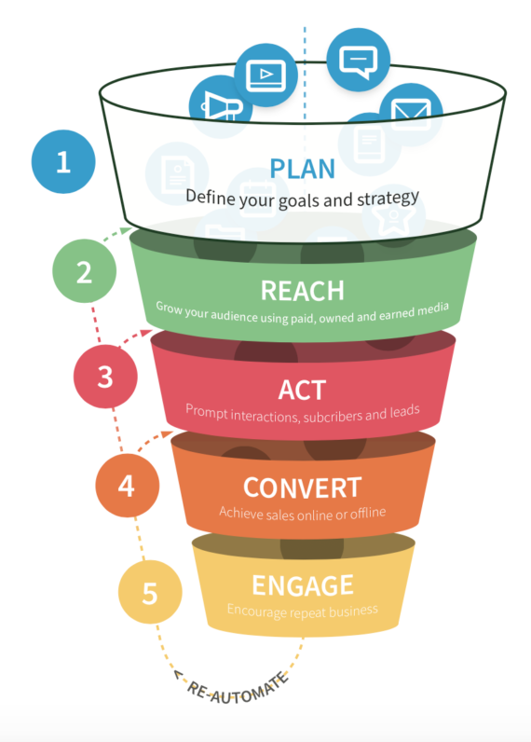

Fig: 01 The RACE Framework (Smith,2020)

Advantages of Using the RACE Framework
1. Structured Analysis of Customer Journey
The RACE Framework provides a systematic approach to examine Tesco's digital marketing strategies across four distinct stages: Reach, Act, Convert, and Engage; supporting a comprehensive evaluation of how each stage influences customer satisfaction (Chaffey, 2023; Smith, 2020).
2. Clear Identification of Strategic Gaps
The framework helps identify strengths and weaknesses in Tesco's digital marketing implementation across different customer journey phases, allowing to identify areas requiring improvement and strategic refinement (Smith, 2020).
3. Data-Driven Evaluation Framework
The RACE Framework promotes the use of data and analytics to assess marketing effectiveness, supporting measure the impact of Tesco's digital marketing on customer satisfaction using measurable metrics and performance indicators (Smith, 2020).
Disadvantages of Using the RACE Framework
1. Potential Oversimplification of Complex Relationships
The RACE Framework may oversimplify the complex, non-linear relationship between digital marketing activities and customer satisfaction, potentially overlooking indirect influences and emotional factors affecting customer loyalty (Mollah, 2014).
2. Limited Focus on Emotional and Relational Aspects
The framework primarily addresses functional marketing activities and may inadequately capture relationship marketing factors such as trust, communication, and customer care, which significantly impact customer satisfaction at Tesco (James and Cooper, 2015).
3. Risk of Disjointed Analysis
Segmenting Tesco's digital marketing into Reach, Act, Convert, and Engage phases may create a disjointed approach, potentially overlooking the interconnected nature of marketing activities and failing to capture the unified customer experience (Smith, 2020).

9. Methodology
Research methodology is a systematic process that guides how a research study is planned, conducted, and analysed to answer research questions and produce reliable findings (Dawson, 2017). It includes selecting appropriate research designs, data collection methods, and analysis techniques. This study follows the research onion framework which provides a clear structure for choosing research philosophy, approach, methodology, data collection, data analysis, time horizon, and research tools to ensure a well-organised research process (Saunders et al. 2019).

10. Research Onion
The research onion framework, provides a comprehensive and systematic structure for designing and executing research projects. The research onion is particularly valuable for business research, as it guides researchers through the complex process of selecting appropriate methods for collecting and analysing data (Saunders et al., 2019). For this study investigating the impact of digital marketing on customer satisfaction at Tesco, the research onion ensures a logical and justified methodological framework, from philosophical foundations through to data collection and analysis techniques.

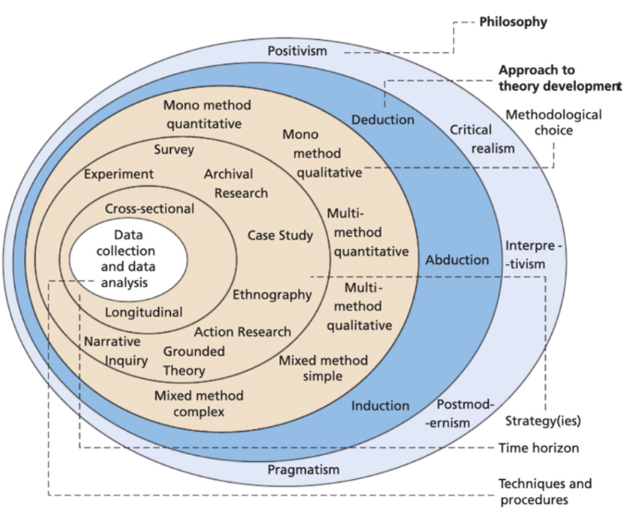

Fig: 02 The Research Onion (Saunders et al., 2019)

Choices
Quantitative Research
Quantitative research involves collecting and analysing numerical data to measure variables, identify patterns, and test relationships (Bryman, 2022). It commonly uses surveys and questionnaires to gather data from a large number of participants, allowing findings to be generalised to a wider population (Smith, 2017). This approach provides reliable and objective results through statistical analysis, making it suitable for business and marketing research (Saunders et al., 2019).
Qualitative Research
Qualitative research focuses on understanding people's experiences, opinions, and behaviours through detailed data collection methods such as interviews, focus groups, and observations (Saunders et al., 2019). It helps explore the reasons and meanings behind human behaviour and is useful for studying complex issues (Bryman,2022). However, because it usually involves small samples, its findings cannot be easily generalised to a wider population (Saunders et al., 2019).
Mono Method Quantitative
For this research, a mono-method quantitative approach will be applied, which includes a methodology that exclusively relies on quantitative data and analytical techniques for investigation (Creswell, 2014). Within the field of digital marketing and customer satisfaction, this strategy involves utilising a range of quantitative methods, including surveys, to evaluate the influence of digital marketing activities on customer satisfaction (Creswell, 2014). The mono method quantitative approach is appropriate for this study as it enables the collection of measurable and statistically analysable data from a significant number of Tesco customers, allowing for objective assessment of the relationship between digital marketing strategies and customer satisfaction (Saunders et al., 2019).
Time Horizons- Cross-Sectional
A cross-sectional time horizon involves collecting data from participants at a single point in time to examine a research problem or identify relationships between variables (Creswell, 2014). This approach provides a snapshot of the situation during the period of data collection and is widely used in business and social science research (Zeqiri et. al, 2025). For this study, data will be collected once from the selected participants to examine the research objectives. A cross-sectional approach is appropriate because it is time-efficient and suitable for studies with limited research duration (Saunders et al., 2019).

Data Collection and Analysis
Sampling
Sampling is the process of selecting a smaller group of people from a larger groups to take part in a research study. The selected sample is used to collect data and draw conclusions about the wider population (Saunders et al., 2019).
Sample Size
This study will collect data from 50 participants who will be the students from different Universities in UK. This sample size is suitable for quantitative research and allows the researcher to carry out statistical analysis and draw meaningful conclusions (Saunders et al., 2019).
Sample Type
Sampling is an essential research technique that entails the selection of a smaller group from a larger population, considering demographic factors such as age, gender, income, and education, as well as geographic location (Groves et al., 2011). Participants for this study will be Tesco customers from both genders, aged between 18 and 50, residing across the United Kingdom. This age range represents the most active users of digital platforms and online shopping services. Participants will include regular Tesco shoppers with experience using Tesco.com, the mobile application, and the Clubcard programme, ensuring a representative sample of Tesco's diverse customer base across different regions (Saunders et al., 2019).
Sampling Method
This study will use a non-probability sampling method to select participants for the research. In non-probability sampling, participants are chosen based on their availability and willingness to take part in the study rather than through random selection (Saunders et al., 2019). This method is appropriate because it allows the researcher to collect data quickly and efficiently from individuals who meet the study criteria. Although the findings may not be fully generalisable to the entire population, non-probability sampling is widely used in business and marketing research, especially when there are time and resource limitations (Saunders et al., 2019).
Data Collection Method
Data will be collected through an online questionnaire developed using Microsoft Forms, Microsoft Excel. The survey will include 10 closed-ended questions. Participants will complete the survey within approximately 10 minutes. The questionnaire will be shared through online platforms and email invitations to collect responses from a diverse group of participants.
Analysis of Data
Quantitative data analysis will be conducted using Microsoft Excel to organise, analyse, and present numerical data effectively. Data analysis involves applying statistical techniques to interpret information and identify patterns, relationships, and trends within the collected data (Saunders et al., 2019). Microsoft Excel provides useful functions for managing datasets and creating visual representations using graphs and charts.

11. Research Ethics
Research ethics refers to the principles and guidelines that ensure research is conducted responsibly while protecting participants’ rights, privacy, and wellbeing (Smith and Johnson, 2015). In any research study, ethical practices such as obtaining informed consent, maintaining confidentiality, and ensuring voluntary participation are essential. Participants will be informed about the research purpose and how their data will be used before taking part. All collected information will be kept secure and anonymous, with data handled according to relevant protection policies. The research will also ensure that participants are not exposed to any harm or discomfort during the study (Bryman and Bell, 2015).

12. Resource and Planning
A Gantt progress chart helps researchers monitor project activities, manage deadlines, identify potential challenges, and ensure timely communication when adjustments are required (Geraldi, 2012). It provides a clear visual representation of the research timeline, showing the planned sequence and duration of different tasks. Developing a Gantt Chart improves research organisation by supporting effective planning, coordination, and completion of project activities within the required timeframe.

Fig: 03 Personal Gantt Chart (Self-Created)

References

Adobe (2026) 'Beyond Marketing: How Tesco is Using Creativity, AI, and Personalisation to Rewrite the Customer Experience Rulebook', Adobe for Business, 8 February. Available at: https://business.adobe.com/uk/blog/perspectives/tesco-rewrites-cx-rulebook (Accessed 10/07/2026)
Bell, E., Harley, B. and Bryman, A., 2022. Business research methods. Oxford university press.
Chaffey, D. and Ellis-Chadwick, F. (2022) Digital Marketing: Strategy, Implementation and Practice. 8th edn. Harlow: Pearson.
Creswell, J.W. (2014) Research Design: Qualitative, Quantitative, and Mixed Methods Approaches. 4th edn. Sage Publications.
Fairlie, R. (2004) 'Tesco.com: Defining the online shopping experience for the UK consumer', Interactive Marketing, 5(4), pp. 1-5.
Geraldi, J. and Lechter, T., 2012. Gantt charts revisited: A critical analysis of its roots and implications to the management of projects today. International Journal of Managing Projects in Business, 5(4), pp.578-594.
Groves, R.M., Fowler Jr, F.J., Couper, M.P., Lepkowski, J.M., Singer, E. and Tourangeau, R., 2011. Survey methodology. John Wiley & Sons.
James, A. and Cooper, B. (2015) 'The Impact of Relationship Marketing on Customer Loyalty at Tesco Plc, UK', International Journal of Engineering Economics, 5(3), pp. 95-102.
Kotler, P., 2016. Marketing management (15th global ed.). England: Pearson, p.803.
Mollah, M.A.S. (2014) 'The Impact of Relationship Marketing on Customer Loyalty at Tesco Plc, UK', European Journal of Business and Management, 6(3), pp. 1-35.
Nanta, T.M., Noermijati, N., Rohman, F. and Hussein, A.S., 2025. The effect of digital touchpoint usage experience on customer loyalty mediated by digital engagement and customer satisfaction. Businesses, 5(1), p.3.
Ologunebi, J., 2023. An analysis of customer retention strategies in e-commerce fashion business in the UK: A case study of Primark. Available at SSRN 4628521.
Reuters (2026) 'Tesco partners with Adobe to ramp up AI-driven personalised marketing', Yahoo Finance Available at: https://www.reuters.com/business/media-telecom/tesco-partners-with-adobe-ramp-up-aidriven-personalised-marketing-2026-04-13/. (Accessed on 10/07/2026).
Stankizai, I.U. and Ali, H. (2024) 'The Influence of Social Media Platform Marketing on the Global Reach and Performance of the UK Retail Sector Organisation: A Case Study on Tesco Plc', Journal of Social Media Marketing, pp. 1-20.
Saunders, M., Lewis, P. and Thornhill, A. (2019) Research Methods for Business Students. 8th edn. Pearson.
Smith, J. (2020) 'Applying the RACE Framework to Digital Marketing Strategies', Journal of Digital Marketing, 10(2), pp. 45-58.
Smith, J. and Johnson, R. (2015) Understanding Research Ethics: A Comprehensive Guide. Harvard University Press.
Tesco PLC, (2025) Annual Report and Financial Statements 2025. Available at: https://www.tescoplc.com/investors/reports-results-and-presentations/annual-report-2025
(Accessed on 29 June 2026)
Tesco PLC, (2026). Adobe & Tesco enter strategic AI partnership to personalise experiences and reward loyalty for Tesco’s customers. Available at: https://www.tescoplc.com/adobe-tesco-enter-strategic-ai-partnership-to-personalise-experiences-and-reward-loyalty-for-tesco-s-customers/ (Accessed on 10/07/2026)
Yoruk, D.E. and Radosevic, S. (2000) 'International Expansion and Buyer-Driven Commodity Chain: The Case of Tesco', ESRC One Europe or Several? Programme, Working Paper, University College London.
Zeqiri, J., Koku, P.S., Dobre, C., Milovan, A.M., Hasani, V.V. and Paientko, T., 2025. The impact of social media marketing on brand awareness, brand engagement and purchase intention in emerging economies. Marketing Intelligence & Planning, 43(1), pp.28-49.

