
Data Handling & Business Intelligence
LCBB5014
_{HELGA BARROS}
_{ID NUMBER:2246034}
_{LCBB5014}
Table of Contents
Introduction 3
Understanding Business Intelligence Concepts 3
Business Intelligence Applications 4
Common Business Intelligence Tools 4
Use in the Finance Industry 5
Use in the Retail Industry 5
Use in the Healthcare Industry 5
Use in the Manufacturing Industry 6
Popular Business Intelligence Platforms 6
Real-World Examples or Case Studies 6
Case Study 1: Amazon and Customer Insights 6
Case Study 2: Starbucks and Store Operations 7
Case Study 3: NHS and Patient Care 7
Case Study Insights 7
Benefits and Challenges of Business Intelligence 8
Key Benefits of Business Intelligence 8
Main Challenges of Business Intelligence 8
Ways to Overcome the Challenges 9
Conclusion 9
References 10

Introduction
Business Intelligence helps businesses understand data and make better decisions quickly. It collects, stores, and analyses data to support future business planning. Many companies now use data every day to manage risks and improve results. Business Intelligence gives useful insights to help business leaders choose smart actions. This report explains how Business Intelligence supports modern businesses in different industries. It shows the main parts of Business Intelligence, such as data collection and data analysis tools. The report also shows how different sectors use Business Intelligence in daily operations (Jourdan, Rainer and Marshall, 2008). Some examples include healthcare, retail, finance, and manufacturing businesses. The report also presents real examples of companies using Business Intelligence to improve work and save money. These examples will show how Business Intelligence helps increase revenue and reduce problems. The report will then explain the many benefits of using Business Intelligence tools in any organisation. Next, the report will explain the common problems faced during the Business Intelligence setup. Some issues include data problems, cost issues, or a lack of skilled staff. The report ends with a short summary and recommendations for future improvements. Businesses must use Business Intelligence well to stay strong and competitive in today’s market.

Understanding Business Intelligence Concepts
Business Intelligence means using data to make business decisions with a better understanding. It collects, stores, and studies business information to help improve future actions. Many businesses use it to track progress, see trends, and reduce risks. It also supports better planning by using facts instead of guessing.
The first part of Business Intelligence is data collection from daily business work. Data can come from sales, customers, websites, or suppliers (Ranjan, 2009). Businesses gather this data from many sources, including computers, phones, or customer systems. Good data collection is important for strong Business Intelligence results.
After collection, the data goes to a data warehouse. A data warehouse is a system where all collected data is kept safely. This warehouse organises the data into clear and useful forms. The stored data can be used later for reports or analysis. It also helps reduce errors in future reports.
The next step is data mining. This means finding useful patterns or links in the data. Data mining tools help find hidden trends and unusual changes in performance (Chen, Chiang and Storey, 2012). These insights help managers know what is working and what must be improved. Data mining also helps in customer studies and future planning.
Data visualisation is another important part of Business Intelligence. It presents data using charts, graphs, and dashboards. These tools help users understand large data quickly and clearly. It makes reports easier for non-technical people to read and use. Visuals also help spot good or bad trends faster. Analytics and reporting tools are also key parts of Business Intelligence. These tools create reports about sales, customer actions, or stock levels. Reporting tools give real-time updates and help managers act fast when problems arise. Many companies use dashboards to view key results every day.
Business Intelligence has changed over time. In the past, it only gave simple reports. Today, it includes smart systems that use Artificial Intelligence. These smart tools can learn from data and give better predictions (Oliveira, Thomas and Espadanal, 2014). AI-based Business Intelligence helps companies react quickly in fast-changing markets. Modern Business Intelligence connects past, present, and future data. It helps answer what happened, why it happened, and what may happen next. This full view of data supports better business thinking and planning. Companies that understand Business Intelligence well can grow faster and make better choices.

Business Intelligence Applications
Business Intelligence has many tools that help businesses manage data more effectively. These tools support smart decisions, better planning, and stronger business control (Moss and Atre, 2003). Many industries use Business Intelligence to improve services and reduce waste. Each application helps in different ways depending on the business needs.

Common Business Intelligence Tools
Dashboards are visual tools that show key data on one screen. Managers use dashboards to check daily performance and spot problems quickly. Dashboards save time because all important results appear clearly in one place.
Reporting tools are used to create regular updates about business activities. These reports can show sales numbers, customer trends, or costs (Watson, 2009). Reports help leaders compare past and current performance. Fast reports also help in responding to sudden problems.
Data mining tools study large amounts of data to find patterns. These tools help find links between sales, customer actions, or market changes. Managers use data mining to know what customers want and how to meet those needs.
Predictive analytics tools help predict future results using past data. These tools are useful for planning, budgeting, and stock control. Businesses use predictive analytics to reduce risks and prepare better for future changes.

Use in the Finance Industry
Banks and financial companies use Business Intelligence to check customer risks and spending habits. Dashboards help banks monitor daily transactions and detect fraud early. Data mining helps find customers who may stop using bank services (Chen et al., 2014). Finance managers use predictive tools to guess future profits and losses. Reports help in checking the performance of loans and credit services. Business Intelligence also supports customer satisfaction by studying service feedback.

Use in the Retail Industry
Retailers use Business Intelligence to understand buying habits and improve product sales. Dashboards show which items sell best and which need offers. Reports help in comparing sales across shops, cities, or periods (Baars and Kemper, 2008). Retailers also use data mining to group customers by age, gender, or location. Predictive tools help in planning sales, restocking, or launching new products. Business Intelligence helps retailers give the right product to the right customer.

Use in the Healthcare Industry
Hospitals use Business Intelligence to track patient care, cost, and treatment success. Dashboards help doctors view patient data quickly and make fast decisions. Reports help check the performance of each hospital unit or doctor (Delen and Demirkan, 2013). Data mining tools help find common health issues in certain areas. Predictive analytics helps plan patient services during flu seasons or emergencies. Business Intelligence also helps improve patient safety and reduce waiting times.

Use in the Manufacturing Industry
Manufacturers use Business Intelligence to control production, reduce waste, and save costs. Dashboards help managers track machines and daily output. Reports show which products are made on time or face problems (Ramakrishnan, Jones and Sidorova, 2012). Data mining helps find reasons behind late delivery or damaged goods. Predictive tools help plan machine repairs or future demand. Business Intelligence also improves worker safety by showing risk trends clearly.

Popular Business Intelligence Platforms
Power BI is a popular tool made by Microsoft. It helps create reports and dashboards with easy visuals. Many companies use it for sales and stock reports.
Tableau is known for strong visual tools and fast data handling. It helps users find insights without technical knowledge (Isik, Jones and Sidorova, 2013).
SAP BI is used by large companies for full data control. It combines reporting, planning, and analytics in one system.

Real-World Examples or Case Studies
Many companies have improved decisions and performance using Business Intelligence tools. Real examples show how different organisations use Business Intelligence to increase results, save costs, and support growth.

Case Study 1: Amazon and Customer Insights
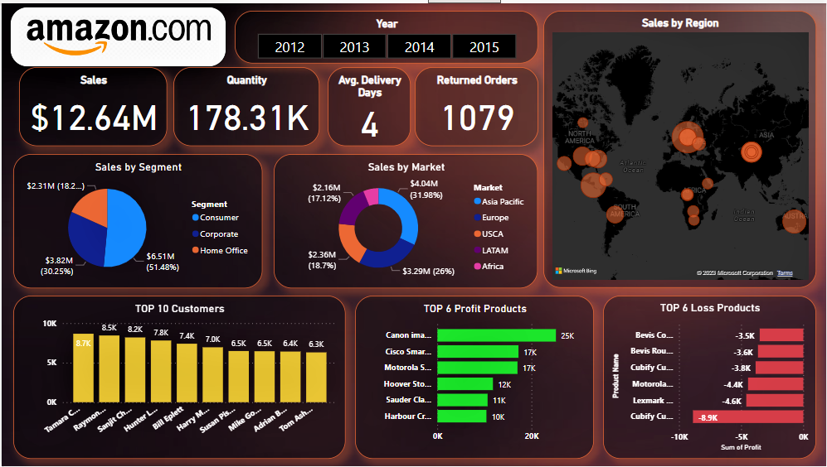
Figure: Amazon and Customer Insights
Source: (Delen and Demirkan, 2013)
Amazon uses Business Intelligence to study customer behaviour and improve shopping experiences. It collects huge data from website clicks, product views, and past orders. The company uses this data to recommend new items to each user.
Predictive tools help Amazon guess what a customer may want to buy next. Dashboards help managers track best-selling items across countries and age groups (Yeoh and Koronios, 2010). Reports help the company plan new product offers or remove low-selling items.
Business Intelligence helped Amazon raise customer satisfaction and increase total sales quickly. The system also reduced delays by improving warehouse stock levels. Amazon now leads global e-commerce by using smart Business Intelligence tools daily.

Case Study 2: Starbucks and Store Operations
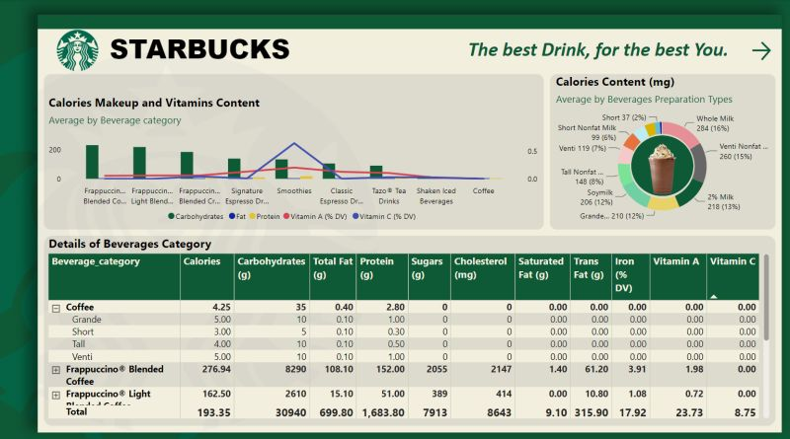
Figure: Starbucks and Store Operations
Source: (Chen et al., 2014)
Starbucks uses Business Intelligence to improve store planning and customer loyalty. The company collects data from mobile apps, loyalty cards, and store visits. Reports help track buying trends based on customer age, time, or location.
Dashboards give managers real-time updates on daily sales and supply needs. Predictive analytics help Starbucks choose the best new store locations (Popovič et al., 2012). Business Intelligence also supports targeted marketing based on local preferences and behaviours.
With Business Intelligence, Starbucks increased repeat visits and lowered waste in stores. Customer experience became more personal, and profits grew in many locations.

Case Study 3: NHS and Patient Care
The UK National Health Service (NHS) uses Business Intelligence to improve patient care and services. Hospitals use dashboards to monitor wait times and treatment results in real-time.
Data mining tools help find disease trends across different areas and patient groups. Reporting tools help share updates with doctors, managers, and policy teams (Jourdan, Rainer and Marshall, 2008). Predictive tools support planning during high-pressure times, like flu season or winter months. Business Intelligence helped the NHS reduce patient delays and improve emergency service response. It also supports better use of doctors and health budgets.

Case Study Insights
All three companies used Business Intelligence to solve different business problems. Each one collected good data and turned it into useful actions. They used dashboards, reports, and predictive tools to support smarter decisions. These examples show that Business Intelligence can improve results in any industry.

Benefits and Challenges of Business Intelligence
Business Intelligence gives many strong benefits to different types of businesses. It also brings some key challenges that must be managed carefully for success.

Key Benefits of Business Intelligence
The first benefit is improved decision-making through real-time and accurate data access. Managers can act quickly when reports or dashboards show performance issues or changes.
Business Intelligence also helps reduce waste and save money in daily operations. Reports and alerts help spot delays, errors, or slow products earlier than usual (Negash, 2004).
It supports better customer understanding by analysing feedback, habits, and buying trends. Marketing teams can then create better plans for each customer group.
Another benefit is a competitive advantage through faster planning and stronger business control. Companies that use Business Intelligence well often grow faster than others in the market.

Main Challenges of Business Intelligence
One major challenge is poor data quality from different or old sources. Bad data can lead to wrong insights and poor decisions.
Another problem is the high cost of Business Intelligence tools and skilled staff. Smaller businesses may struggle to buy systems or train workers (Ranjan, 2009).
There is also a gap in knowledge for using advanced tools and understanding results. Staff must learn how to use dashboards, reports, and predictive models clearly.
Privacy is another challenge, as customer data must be stored and used carefully. Rules like GDPR must be followed to avoid legal and trust issues.

Ways to Overcome the Challenges
Businesses can reduce costs by starting small and growing tools step by step. Staff training should be regular to build strong Business Intelligence knowledge across departments (Wixom, Ariyachandra and Douglas, 2011). Data quality can improve by using checks, filters, and clear collection methods. Following privacy laws also builds trust with customers and avoids legal trouble.

Conclusion
Business Intelligence plays a very important role in modern business operations. It helps businesses use data to make faster and smarter decisions daily. This report explained key Business Intelligence concepts and their use across different industries. It also described how companies apply Business Intelligence tools to gain better results. Real-life examples showed that Business Intelligence improves customer service, planning, and cost control. Tools like dashboards, reports, and predictive models support smart choices based on real data. The report also discussed key benefits, such as better performance, lower risks, and happier customers. But there are also challenges, such as poor data quality and high setup costs. Some organisations also struggle with privacy risks or lack trained staff to use the tools (Chen, Chiang and Storey, 2012). To fix these problems, businesses should focus on small steps, staff training, and good planning. Looking ahead, Business Intelligence will keep growing with real-time data and smart systems. Tools that use Artificial Intelligence will make decisions even faster and more accurately. Self-service platforms will also help more people use Business Intelligence without technical skills. Businesses must use these trends to stay strong and grow in a changing world.

References
Baars, H. and Kemper, H.G., (2008). Management support with structured and unstructured data—An integrated business intelligence framework. Information Systems Management, 25(2), pp.132–148. https://doi.org/10.1080/10580530801941140
Chen, H., Chiang, R.H. and Storey, V.C., (2012). Business intelligence and analytics: From big data to big impact. MIS Quarterly, 36(4), pp.1165–1188. https://doi.org/10.2307/41703503
Chen, Y., Wang, Y., Nevo, S., Jin, J., Wang, L. and Chow, W.S., (2014). IT capability and organisational performance: The roles of business process agility and environmental factors. European Journal of Information Systems, 23(3), pp.326–342. https://doi.org/10.1057/ejis.2013.4
Delen, D. and Demirkan, H. (2013). Data, information and analytics as services. Decision Support Systems, 55(1), pp.359–363. https://doi.org/10.1016/j.dss.2012.05.044
Isik, Ö., Jones, M.C. and Sidorova, A., (2013). Business intelligence success: The roles of BI capabilities and decision environments. Information & Management, 50(1), pp.13–23. https://doi.org/10.1016/j.im.2012.12.001
Jourdan, Z., Rainer, R.K. and Marshall, T.E., (2008). Business intelligence: An analysis of the literature. Information Systems Management, 25(2), pp.121–131. https://doi.org/10.1080/10580530801941124
Moss, L.T. and Atre, S. (2003). Business intelligence roadmap: The complete project lifecycle for decision-support applications. Journal of Data Warehousing, 8(1), pp.1–20.
Negash, S. (2004). Business intelligence. Communications of the Association for Information Systems, 13(1), pp.177–195. https://doi.org/10.17705/1CAIS.01315
Oliveira, T., Thomas, M. and Espadanal, M., (2014). Assessing the determinants of cloud computing adoption: An analysis of the manufacturing and services sectors. Information & Management, 51(5), pp.497–510. https://doi.org/10.1016/j.im.2014.03.006
Popovič, A., Hackney, R., Coelho, P.S. and Jaklič, J., (2012). Towards business intelligence systems success: Effects of maturity and culture on analytical decision making. Decision Support Systems, 54(1), pp.729–739. https://doi.org/10.1016/j.dss.2012.08.017
Ramakrishnan, T., Jones, M.C. and Sidorova, A., (2012). Factors influencing business intelligence (BI) data collection strategies: An empirical investigation. Decision Support Systems, 52(2), pp.486–496. https://doi.org/10.1016/j.dss.2011.10.009
Ranjan, J., (2009). Business intelligence: Concepts, components, techniques and benefits. Journal of Theoretical and Applied Information Technology, 9(1), pp.60–70. https://doi.org/10.5281/zenodo.1057765
Watson, H.J. (2009). Tutorial: Business intelligence–past, present, and future. Communications of the Association for Information Systems, 25(1), pp.487–510. https://doi.org/10.17705/1CAIS.02539
Wixom, B.H., Ariyachandra, T. and Douglas, D.E., (2011). State of business intelligence in academia: 2010 data. Communications of the Association for Information Systems, 29(1), pp.299–312. https://doi.org/10.17705/1CAIS.02916
Yeoh, W. and Koronios, A. (2010). Critical success factors for business intelligence systems. Journal of Computer Information Systems, 50(3), pp.23–32. https://doi.org/10.1080/08874417.2010.11645450

