In essay format (in 2,500 words) critically evaluate the forces and concepts that shape our perception of landscape
Introduction
What is landscape? A word what is subjective to everyone, it was originally used to describe a form of art (Stilgoe, 2015). For an artist it is up to their own interpretations on how they paint a landscape, this can be influenced by both internal and external forces that change one’s interpretation (Doherty & Waldheim, 2016). J. B. Jackson 1984 refers to it as something different to everyone, in the book ‘The Word Itself’ refers to it as ‘something which we think we understand; and yet to each of us it seems to mean something different’ and how we can interpret the surface in which we can comprehend at a glance (Jackson, 1984). A nuance in the landscape is ‘landscape ecology’ this is described as ‘how landscape structure affects the abundance and distribution of organisms’ (Fahrig, 2005, p. 3). This essay is going to investigate the importance in connecting to the landscape, this is firstly going to be accomplished by gathering information about the history of how we perceived the landscape. Secondly looking at recent contemporary issues such as COVID-19 and how it tested our relationship with landscape. Thirdly I will look at how humans are treating the environment and how we and governments are talking it. Lastly, I will give my own perspective upon the landscape.
History of our perceptions of landscape:
Plato (428-347 BC) said that “landscapes and trees have nothing to teach me – only people in the city can do that” however even though Plato is reckless in his viewpoints towards nature, he still isn’t naive towards the forces of nature, as he later writes how nature is heavenly and with a hellish geography (Zalta & Nodelman, 2003). For them they had a philosophy of gods are directly linked to nature and that gods had their own place in nature this resulting in forests becoming a sacred place. Even then Plato created the link between human interference and changes in the environment and the cycles in which the landscapes evolve. He explained that Athena had unfertile ground because of natural hazards and deforestation from humans, Aristotle (384-322 BC) backed this up by saying that everything has a goal like an acorn wanting to become a tree however, if you disturb this frequently you therefore change the natural timeline of nature. These perceptions upon environment influenced the Romans and how they perceived the landscape and nature.
When the Romans invaded Britain around 43 AD, they came into an landscape that was already manipulated by humans. Their perception upon the landscape was of a military standpoint, they took over pre-existing settlements as the Romans had similar needs upon the landscapes as the previous pre-historic settlers such as they built on high ground for defence, near water sources and forests for food and transport (Rogers, 2008). Roman’s use of water was specifically important for them for ritual uses as they believed that water showed mastery over nature as it had the ability to control the uncontrollable (Purcell, 1996). Roman Britin became incresaing relient upon water ways for trade, making tidal harbours in london and southampton to accomidate for forty to fifty foot long dug out fessles made out of oak to show power and wealth. They also used coricals made out of leather and wicker as a mode of smaller transport for both inland and sea (Collingwood & Linton, 1936), these were used to susteain a living of trading. Now in modurn society in Carmarthen, Wales there is a coricle club that still practces this traditional method of transport (Edwards, 2024). When the Roman invaded Julius Caesar Wrote about these skin coverd boats when travelling the coast line seeing people hunting. The Romans ended up living side by side with natives learning there skills. this is apparent in a poam called ‘Pais Dinogod’ done by Y Gododdin in the 7th century when translated it reads ‘he would kill a fish in his coracle, as a lion kills an animal’ (Edwards, 2024).
With the fall of Roman Empire, the Latin Christian culture became prevelent they changed the outlook upon the landscape and the wildness was a place of demods and where the devil resides. This ecpecally happed as the fall of the Roman Empire left vast spaces of once groomed landscape to overgrown wilderness, it was said to be the result of the devil taking over to tempt people in to distract them from Gods work. For medivle society there was a fear of uncultivated land so it came down to the monistaries to transform these godless landscaped to Gods vision of paradise. However this wasn’t true for all as monistries in Irland had monks who seekd a life style in the wilderness as a place of solitude to live along side these spirirts and to gain respect to Gods creation (Schouten, 2005).
Moving through time into the 19th century of the Romantic Movement showed a rebellion upon the industrial revolution, aristocrats and political norms; where cottage industries, older techniques and traditions from middle and ancient history was being left behind. The Romantics found beauty and the divine mystery in nature and wild places which was left untouched by humans (Diep, 2020). For the Romantics it was the connection between art, science, and faith for example, art would show interpretations of truth, science provided altera narratives and faith to show the sublime between these artforms (Diep, 2020). Nature and the natural world proved to be this altera, uncontrollable power that could disrupt the powers and the order of the world that was the result of enlightenment period where wealth split people and the aristocrats dictated (Galitz, 2000).

Theory of Landscape perceptions:

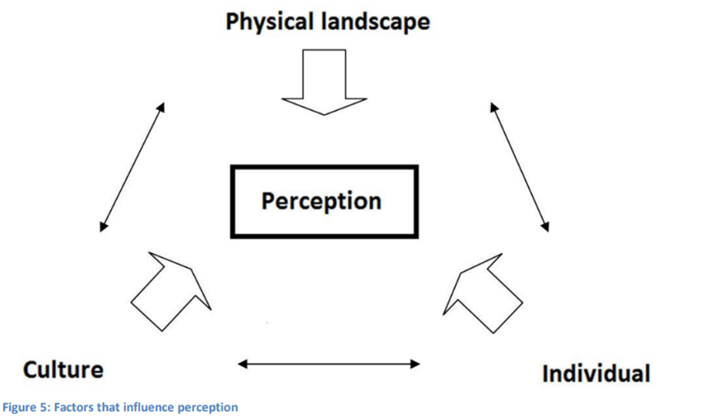
Figure 1: factors that influence perception.

Our perception is influenced by multiple factors as shown in figure one. They all interlink and affect each other; physical landscape means something is real and literal such as a tree is real. Individual is something personal like how you walk through the landscape and how we interact with it such as changing landscapes like gardens this also effects the physical landscape like changing ecosystems and habitats. Lastly culture is how we may use the land like farming such as farming communities with their ways of doing things, this may change individual perceptions as it may change how you walk through a field or how noisy you are around livestock. This derives from Jacobs (2006) theory of landscape divides into three different realities: Matterscape, Powerscape and Mindscape. Our perception upon landscape is always going change through external and internal thoughts and ideologies whether that’s the news, new jobs, education, age, gender, or location within the world; our perceptions are always changing, and everyone’s perception is “no two persons see the same reality” (Tuan, 1974, p. 5)
Landscape evolves around interactions between a person and nature this means that everyone has a different preference, people chose their public space in accordance with the preference for static or dynamic activities (Li, et al., 2021). The government must cater and collect this information to manipulate landscape to cater for everyone’s perception and preference. This preference is subject to lots of variables such as your culture, gender, age etc this will all change your preference and perception as we still have routes within the landscape and surviving around and using it however, we are becoming further away from it (Falk, 2020).
A sense of place in relation to the landscape is important for people this links Jacobs (2006) theory of landscapes as it builds a meaning to a landscape in which people walk through. If people build a sense of place, they are more likely to look after it especially for those in early years of education (6-11yrs of age) (Chawla, 2020). Merging past and present has become a popular leisure activity with heritage sites evoking fascination in people as they are feeling more connected to their ancestors and their roots (Aitchison, et al., 2000). The National Trust was created in 1896 for places of historic interest and natural beauty it was to maintain and manage gardens and houses to ‘set aside beautiful parts of Britain for the public and posterity, and to provide sitting rooms for the poor in the countryside’ (University of Liverpool, 2024). The National Trust was also one of the first organisations to be concerned about the environmental and social welfare in the England and Wales around that time, to have this organisation focusing on preserving landscape and heritage provides people with a strong sense of place that boosts better wellbeing and environmental appreciation which therefor provokes a strong willingness to preserve the landscape that we are in (Williams, 2018).
However, this influx of people wanting to be out in the landscape and the natural environment has been increasing in recent years, COVID-19 showed that people became more connected to nature and the landscape local to them. This was a result of the restrictions that withheld people from going out to nature, therefore causing people to feel nature was a novelty this meaning, when restrictions lifted everyone felt the internal wellbeing benefits of nature (Friedman, 2021; Barrable & Booth, 2020). While more people where visting national parks and protected areas was this a good thing for the landscaspe? With parks facing financial cuts and footfall increasing massivly it has placed parks in the worst condistions sinse 2013 (O'Brien, 2021). This was due to the influx of people coming in without being educated on how their actions my effect the landscape, as reports of groupes of people lighting fires and leaving litter was on an increse, increased foot fall meant high rates of foot path erosion thus causing problems with dranage (Gatens, 2021). As mentioned prevelously these damages may be a result of a lack of education this could be a result of the demographic and socio-economic staus, as during covid local parks were closed so people were travling further to the country side and national parks.
With taking stuwardship of our envronment and landscape we need to think and act sustainably. Going on holiday to other countries across the world is unsustainable with transport and holiday resorts being founded on ussally unsustainable foundations. So what is sustainable tourisum? The UN World Tourism Organiszation (UNWTO) describes it as “Tourism that takes full account of its current and future economic, social and environmental impacts, addressing the needs of visitors, the industry, the environment and host communities” (UN Tourisum, 2024). However Burns (2006) argues that we can not compehend what damages we may be doing as we cant see it directly happening such as damges to coral reaths or corrupting communities through the money we are spending (Jones, 2006, as cited in, Fennell & Cooper, 2020).
So what dose sustainable tourism aim to accomplish and how dose it affect our perception of landscape and others perceptions? The World Commission on Environment and Development (WCED), the Brundtland Report 1987 Our Common Future (Brundtland, 1987, p. 43) defies sustainable development as development that “meets the needs of the present without compromising the ability of future generations to meet their own needs”. This report also adresses the need of all couties to co-operate and work together as sustainabilty is a not something that one nation can handle alone. This report has shaped all the next stagergies to takle sustainabilty. With the recent being the 17 goals of sustainable development (United Nations, 2015), as shown in figure 2:
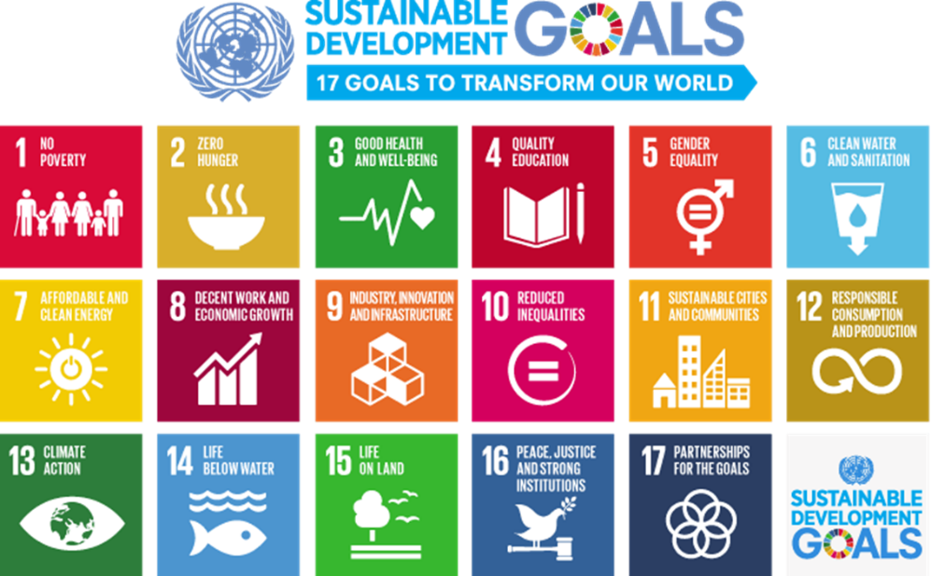
Figure 2: The UN sustainable development goals (United Nations, 2015)

It can be argued that all the goals link to how we interact with the landscape in a balanced and fair way. As it’s not just humans who perceive landscape, but all living organism perceives and afford the environment around them (Baker, 2005). However, to many countries who are just going through their industrial revolution, feels unfair as most of the western countries has benefited from an industrial revolution fuelled from fossil fuels and not sustainable fuels for the landscape (European Environment Agency, 2017).
If this balance was to be affected substantially humans would suffer greatly through climate changes and soil infertility. Humans since the industrial revolution has seen them selves to be at the centre of the earth due to the influx of people moving from the countryside to cities sore the decrease of nature connectivity and appreciation as they only sore the power that humans can do but couldn’t see the effects that it can do to the balance the world needs. Rachel Carson was one of the first people to notice nature is a network of ‘interconnections and interdependence and that humans are a part of that’ (Baum, 2007). The Book authored by Carson, called ‘Silent Spring’ (1962) was a huge turning point, in how we are affected from our own actions and is still highly regarded today as a turning point for environmentalism. Her study investigates Dichlorodiphenyltrichloroethane also known as DDT this chemical is used as an insecticide and was spread using sprayers, through the research Carson made it was discovered that these chemicals could travel through the environment such as water ways, and through the food chain, for example insects feed on crops, and then birds feed upon the insects. These chemicals were shown to build up in people and accumulate in fat tissues, DDT also was shown to transfer genetically from the mother to their offspring. This book scrutinised heavily when released with mixed opinions about the findings however many world leaders saw it seriously such as President John F Kennedy who then after a couple congressional hearing limited the use of pesticides due to the harm it can do to the environment and body. This book acted as a catalyst for the environmental movement, and it spread internationally and was the prompt for the creation of the U.S. Environmental Protection Agency that then led to the overall ban of DDT in 1972. This is an example on how we can change the fabric of nature.
My perception on landscape has changed throughout my life cause, I grew up in a little village in the countryside close to woodlands, rivers and fields, this was an ultimate playground to develop interpersonal relationship with the landscape and nature around myself, linking back to Jacobs (2006) and figure 1 this enhanced my understanding about the physical environment and how it interacts with me. From the age of 13 I Volunteered at a Saxon village gaining knowledge and practice in traditional craft like woodwork and forging this experience enabled me to gain knowledge on previous cultural history and how to use the land sustainably. This cemented a strong sense of place that led to a strong willingness to try and help the environment and try and spread ideas using the outdoor landscape to inspire and build strong senses of place in people. Personally, my preference of landscape is somewhere untouched like the mountains however this is getting rarer as people are accessing these areas without the knowledge or understanding of how your footsteps can change how the landscape and nature interacts with each other.
In conclusion there has been an undulating trend through history with how people perceive landscape for example in ancient history with Greek philosophy they worship and nourished the landscape it was holy and all powerful however later in the Roman empire it was feared if it was wild therefor appointing monasteries make it back to god’s sacred land. This trend happens all the way through history because of humans being afraid of the unknown, we can see this in modern times and the threat of climate change, we are afraid to change little bit of our lives for something that seems unobtainable as you can’t see a visual change in the physical landscape. However, it is possible to change thoughts on a global scale as shows from the Rachel Carson case study where she speaks out about the landscape is a network of interconnections and interdependences this is also backed up from the documentary ‘The Biggest Little Farm’ (2019) where they successfully created a farm that needed little upkeep as nature did it. Education about how the landscape works and where humans fit into the network, Fredrik Steiner (2002 p. 86) founder of such organisations like Steiner schools and the Duke of Edinburgh Reward and Outward-bound; described landscapes as ‘dynamic entities defined by their interacting parts and their integrative whole’, and Steiner schools are based on the pedgogie of respect for the environment and biulding a sense of place within the network of the landscape.
Word count: 2749

References
Aitchison, C., Macleod, N. & Shaw, S., 2000. Leisure and tourism landscapes social and cultural geographies. London: Routledge.
Baker, M., 2005. landfullness in Adventure-Based Programming: Promoting Reconnection to the Land. Journal of Experiential Education, 27(3), pp. 267-276.
Barrable, A. & Booth, D., 2020. Increasing nature connection in children: A mini review of interventions. Front. Phychol, 11(492).
Baum, R., 2007. letter from Editor-in-Chief of Chemical & Engineering News, s.l.: Chemical & Engineering News.
Brundtland, G., 1987. Report of the World Commission on Environment and, s.l.: World Commission on Environment and.
Carson, R., 1962. Silent Spring. New York: Fawcett Crest.
Chawla, L., 2020. Childhood nature connection and constructive hope: A review of research on connecting with nature and coping with environmental loss. People and Nature, 2(3), pp. 619-642.
Collingwood, R. & Linton, J., 1936. Roman Britain and the English Settlements. Oxford: Oxford University Press.
Diep, V., 2020. The Romantic Landscape: A search for material and immaterial truths through scientific and spiritual representations of nature. Athens journal of humanities & arts, 7(2), pp. 137-168.
Doherty, G. & Waldheim, 2016. Introduction: What is landscape?. In: G. Doherty & C. Waldheim, eds. Is Landscape...? Essays on the Identity of Landscape. Oxon: Routledge, pp. 1-9.
Edwards, A., 2024. The Carmartehn Coracle, Carmarthen: Carmarthen Coracle & Netsmen's Association; People Collection Wales.
European Environment Agency, 2017. Perspectives on transitions to sustainability, Luxembourg: Publications office of the Euroupean Union .
Fahrig, L., 2005. When is a Landscape perspective important. In: J. Wiens & M. Moss, eds. Issues and perspectives in landscape ecology. Cambridge: Cambridge University Press, pp. 3-10.
Falk, J., 2020. Landscape Preference. Encyclopedia of Evolutionary Psychology.
Fennell, D. & Cooper, C., 2020. Sustainable Tourism Principles, Contexts and Practices. Bristol: Channel View Publications.
Friedman, S., 2021. Understanding changes to children's connection to nature during the COVID-19 pandemic and implications for child well-being. people and nature, 4(1), pp. 155-165.
Galitz, C., 2000. "Romanticism" in Helibrunn timeline of art history. New Yourk: The Metropolitan Museum of Art. [Online]
Available at: https://www.metmuseum.org/toah/hd/roma/hd_roma.htm
[Accessed 04 April 2024].
Gatens, K., 2021. The Sunday Times, National parks at crisis point: how the pandemic is taking its toll. [Online]
Available at: https://www.thetimes.co.uk/article/national-parks-at-crisis-point-how-the-pandemic-is-taking-its-toll-vc5tj5bk7
[Accessed 07 April 2024].
Jackson, J., 1984. The Word itself. 3 ed. New Haven: Yale University Press.
Jacobs, H., 2006. The production of mindscapes: a comprehensive theory of landscape experience, Wageningen: thesis.
Jones, F., 2006. Open Road, Clear Conscience; Mother Jones. [Online]
Available at: https://www.motherjones.com/politics/2006/07/open-road-clear-conscience/
[Accessed 08 April 2024].
Li, K., Zhai, Y., Dou, L. & Liu, J., 2021. A Preliminary Exploration of Landscape Preferences Based on Naturalness and Visual Openness for College Students With Different Moods. Sec. Environmental Psychology, Volume 12.
O'Brien, P., 2021. State of UK Public parks 2021, s.l.: Association for Pulic Srvice Eellence (apse).
Purcell, N., 1996. Rome and the management of water: environment, culture and power. In: G. Shipley & J. Salmon, eds. Human Landscapes in Classical Antiquity; Environment and Culture. London: Routledge, pp. 180-212.
Rogers, C., 2008. Religiouse place and its interaction with urbanization in the Roman era. Journal of Social Achaeology, 8(37).
Schouten, 2005. Mirror of nature. The Image of nature in a cultural-historical perspective. Plant Ecology and Nature Conservation; KNNV publishing house.
Steiner, F., 2002. Human ecology: Following nature's lead. Washington DC: Island Press.
Stilgoe, J., 2015. What is Landscape. Cambridge, Massachusetts: The MIT Pess.
The Biggest Little Farm. 2019. [Film] Directed by J Chester. Universal City, CA: Universal Pictures Home Entertainment.
Tuan, Y., 1974. Topophilia a study of environmental perception, attitudes, and values. New York: Columbia University Press.
UN Tourisum, 2024. Sustainable development. [Online]
Available at: https://www.unwto.org/sustainable-development#:~:text=%22Tourism%20that%20takes%20full%20account,the%20environment%20and%20host%20communities%22
[Accessed 08 April 2024].
United Nations, 2015. Department of Economic and Social Affairs, Sustainable Development, The 17 Goals. [Online]
Available at: https://sdgs.un.org/goals
[Accessed 08 April 2024].
University of Liverpool, 2024. The history and role of the national trust. [Online]
Available at: https://pcwww.liv.ac.uk/~sinclair/algy399_site/national_trust.html#:~:text=O%20n%2012th%20January%201895,the%20poor%20in%20the%20countryside.
[Accessed 6 April 2024].
Williams, A., 2018. Place is special when we do a bit of research. Horizons , Volume 82, pp. 14-17.
Zalta, E. & Nodelman, U., 2003. Plato's Ethics: An Overview, Stnaford: The metaphysics Research Lab Department of Philosophy.

