“The Age of Lloyd George – The Liberal Party and British Politics, 1890-1929”
Kenneth O. Morgan

The book analyses the successes and decline of the Liberal Party and the involvement of Lloyd George during the period 1890-1929. The text is not only aimed at students of modern history, for whom it provides a succinct overview of a period which fundamentally changed the nature of British politics, but also the lay person who is sufficiently interested to engage with the detail. Through his concise style and clarity of analysis, the author, Professor Sir Kenneth O Morgan, is highly effective in infusing the topic with energy and at times drama. The book, published in 1971, is unusual in that it consists of an extended essay together with original documents which inform the analysis. It is structuralist in nature but has a strong internationalist element centring on Lloyd George. It is fair to conclude that the author, based on the text and other published works, is sympathetic to the aims of left leaning politics to alleviate social and economic injustices.
Organised into five chapters, the book covers the shift from the traditional liberal beliefs of the Gladstonian period to new liberalism which saw the party in power under Asquith 1905-15, the challenges of the 1915-18 government period, the Lloyd George Coalition 1918-22 and the decline of the party 1923-29. Across these chapters, the author draws out a number of themes relating to the fortunes of the party and the political dominance of Lloyd George.
The book clarifies developments leading to the Liberal Party in 1903 formally adopting a shift in policy from traditional Liberal Party beliefs in free trade, imperialism, Irish independence, temperance and the disestablishment of the church in Wales to new liberalism based on social reform. The author, as do Thompson and Searle, views the 1890s as a period which unleashed new ideas for the Liberals rather than a time writhen with divisions during which the party struggled to win working class support. Concerns over the conduct of the Boer War marginalised traditional liberal imperialists which helped the party unite over policy and regain moral authority. This unity, the author stresses, was based on local democratic concerns about monopoly and privilege rather than Gladstonian preoccupations such as free trade and Irish independence. As noted by Searle, links and alliances with the Labour Party and socialism were opened through new liberalism and, in the author’s view, were key to the Liberal landslide victory of 1906, notwithstanding Conservative failings during the previous ten years. Dutton concurs but suggests caution regarding over exaggerating the importance of links with Labour.
Whether the Liberal Party had lost its ideological base and middle class values in 1906 being thus doomed to be replaced by the Labour Party is debatable. Thompson and Pelling regarded the conflict between Asquith and Lloyd George in 1916 as the occasion rather than the cause of the demise of the party. Morgan, and likewise Searle, refute this view and concurs with Wilson considering the party, despite internal upheaval, to be in a healthy state at that juncture. Lloyd George recognised the significance of the shift in electorate support in 1906 and pushed for social changes such as the old age pension and free school meals but in other respects, the author believes, his views on aspects such as temperance, land reform and church disestablishment remained faithful to traditional liberal beliefs which did little to consolidate the party’s position and fulfil the expectations of its new demographic. Campbell-Bannerman was too cautious fearing divisions within the party so recently united and although the appointment of Asquith as Prime Minister and Lloyd George as Chancellor in 1908 is seen by Morgan, as well as Searle and Dutton, to have created opportunities to shift priorities, Asquith provided little leadership as regards reform. Others within the cabinet, with the exception of Churchill, who was a strong advocate of economic and social liberty, were not responsive to pressures for change thus already setting Lloyd George apart from his party.
Morgan and Dutton regard Lloyd George’s radical budget of 1909 as ground breaking. Constructed to finance social reform through licensing duties and taxation of unearned income, it was true to traditional Liberal values and preserved free trade, underlining Lloyd George’s belief in his party. The crisis it created through its rejection by the House of Lords, the elections of 1910 and, in effect, the ending of the House of Lords veto is seen by Morgan to mark a turning point in the transformation of the Liberal Party which also opened the way for the National Insurance Bill 1911. Searle agrees with the author that 1911 was a crucial juncture in the development of social policy, although the 1911 election was the last in which a party other than Labour or Conservative won a majority marking a highly important event in 20th century British politics.
The miners’ national stoppage of 1912, over a minimum wage, Churchill’s military intervention following the Tonypandy riots and the creation of the Triple Alliance of miners, railwaymen and dockers in 1914 created immense class pressures in Morgan’s view, and likewise Dutton, which threatened the cohesion of British society making the demise of the Liberal Party inevitable. This compounded the fact that the party was losing support in its heartland - working class and nonconformist chapel areas where congregations were in decline. The party’s continuing preoccupation with Irish nationalism and the Welsh Church, the author believes, distracted from social reforms. Further, despite the social benefit, the taxation element of the National Insurance Bill was not wholly popular with the working classes. Morgan argues like others, that at this point, the party was still viable as Labour fared worse in bi-elections due to militancy. Further, Lloyd George’s 1914 budget was clearly aimed at supporting further social improvements as had the people’s budget of 1909.
Not surprisingly, the impact of the First World War as a cause of Liberal decline is not fully resolved in the book because, as both Searle and Adleman concluded, the path of politics should war not have broken out can only be surmised. In this respect Dutton regards the social and political challenges the party faced between 1911 and 1914 to be unrelated events as opposed to symptoms of a failing party. Asquith’s failures in prosecuting the early phases of the First World War are demonstrated by Morgan, and reflected by Alderman, to in effect, have created the circumstances which irrevocably split the Liberal party linking its demise even more directly with the political fortunes of Lloyd George. The crisis of 1915, due to the resignation of the First Sea Lord following clashes with Churchill, according to Morgan, but more complex causes according to Dutton, resulted in Asquith remodelling the Liberal administration through bringing in Conservative ministers. According to Morgan, Lloyd George turned down a Conservative offer to be prime minister and also refutes Koss’s assertions that Lloyd George had been conspiring with the opposition. Dutton confirms the author’s view that the crisis of 1915 isolated Liberal ministers from the back benches and the country and that Lloyd George became increasingly isolated from his party associating more with Balfour and Conservative ministers than his own party.
The author’s coverage of the events leading to Asquith’s resignation in 1916 and Lloyd George’s appointment as Prime Minister clearly demonstrate Lloyd George’s leadership qualities, commitment to his beliefs and his pragmatic approach to his own party. His actions in forcing Asquith to introduce conscription through the Military Service Act 1916 enhanced his status according to Morgan but aligned him further with the Conservatives thus isolating him from his party. Although Morgan expresses the view that Lloyd George neither encouraged nor plotted to remove Asquith for his incompetent execution of the war, he was in the vanguard of persuading Asquith to establish a War Committee. Alderman, reviewing the debate, likewise concludes there to be little evidence of collusion in 1916, as does Crosby, but recognises the desire to be Prime Minister is not an ignoble ambition for a politician of genius. Although Morgan concludes that Lloyd George, despite his status, was in a politically weak position because of his isolation from his party, he accepted the premiership in 1916, when Bonar Law declined, bringing a fundamental change to the country. According to the author, he was a Prime Minister without a party relying on the Conservatives and was personally the main agent of change in British politics, having brought to an end, if only temporarily, the old class-based conflict between Liberals and Unionists creating an aligned government based on authority. His isolation was underlined by his reliance on his Garden Suburb group of private advisers. The election of 1918, according to Morgan, reinforced the rift between Asquith’s traditional Liberals and Lloyd George’s coalitionists. The latter, by dint of the coalition, leaned to the political right, and oddly so according to Dutton when the pre-war preoccupations of the two men are considered, resulting in Asquith failing to attract the support of the reformers thus strengthening the Labour Party. The author argues that the Liberal Party was only kept alive in post-war politics through the unpredictable influence of Lloyd George and although the 1918 election marked the end of the Liberal Party as major force the book does not fully explain the details of the causation. Dutton for example considers wider factors such as significant changes in the electorate in 1918.
Morgan clearly demonstrates, as does Crosby, the history of the Liberal Party and British politics to be closely linked to the personality and beliefs of Lloyd George. Highly pertinent is the demonstration by the author that the beliefs and policies of the Liberal Party evolved within the broad parameters of liberalism as a political philosophy but, whilst Lloyd George had firm liberal beliefs, his priorities did not always accord with party dogma. Lloyd George’s beliefs were firmly based on the non-conformism, nationalism, temperance and social inequalities of his Welsh roots and the narrative of the text shows him to be true to those beliefs. As confirmed by Dutton, the coalition manifesto of 1918 was fundamentally liberal. The extent to which Lloyd George was responsible for the decline of the Liberal Party is debatable but Morgan sees him and his followers, particularly during his period as Prime Minister, as scapegoats and victims of the nation decline of the liberal ethic and the overall decline of Britain in the 21st century. Alderman and Grigg support this view considering Asquith’s pride and stubbornness in refusing Lloyd George’s offers to join his government as the main reason for splitting the party.
The overriding picture Morgan, and Grigg, convey of Lloyd George is a pragmatist with social insight, vision and exceptional leadership skills. He mobilised the county councils against Balfor’s Education Act in 1902, urged his cabinet colleagues to dissolve parliament when the Lords rejected his Education Bill 1906 and Licensing Bill 1908 and stressed the urgency of social reform. His people’s budget of 1909 broke with traditional budgetary policy and appealed both to workers and middle class free traders, and clearly set him out as the leader of the radical wing of the party. Morgan and likewise Crosby, view his National Insurance Bill 1911 as immensely complex and politically challenging underlining his political skills in achieving a compromise between state socialism and the laissez-faire liberalism, and in effect setting the foundations for the welfare state. The author draws attention to the exceptional manner Lloyd George dealt with the city following the declaration of war in 1914 and his war budget of 1914 impressed even hardened economists confirming him to be an outstanding minister. The author shows Lloyd George to be instinctively drawn to coalitions and the notion of collaboration which would surmount sectional and party conflicts. Even during the crises following his people’s budget he proposed such an approach, which Balfour was strangely supportive of, but party politics were too ingrained. Only the First World War created the circumstances to give such a proposal credibility and his natural leaning to executive power stood him and the country well.
A major strength of this book is that it strikes a balance between the texts cited above which focus on the history and decline of the Liberal Party and biographical works centred specifically on Lloyd George. As such it provides a well-considered overview of a key period of social and political change in Britain whilst opening avenues for further reading. The book is succinctly written whilst probing some events in depth. Particularly useful is the attention given to historical aspects which are debatable or inconclusive. The overarching message of the book is that the decline of the Liberal Party was the consequence of social changes and unpredictable occurrences to which the party, despite the broad nature of liberalism, failed to adapt. Lloyd George’s farsightedness, political shrewdness, determination and pragmatism regarding Liberal Party policies enabled him to adapt and provide leadership at times of crisis. Despite his farsightedness however, his recurring isolation from his party greatly diminished his ability to ensure its survival as a dominant political force. In the words of Aneurin Bevan:
Even the most superabundant personal qualities are irrelevant if not associated with great mass machines (political parties).

Bibliography
P. Adleman, The Decline of the Liberal Party 1910-1931 (London and New York: Longman 1995).
T.L. Crosby, The unknown Lloyd George (London and New York: Tauris 2014).
D. Dutton, A History of the Liberal Party Since 1900 (Basingstoke: Palgrave Macmillan 2013).
J. Grigg, Lloyd George the People’s Champion 1902-1911 (London: Penguin Books 2002).
J. Grigg, Lloyd George War Leader (London: Allen Lane 2002), p. 358.
S. E. Koss, Nonconformity in modern British Politics (London: Harper Collins 1975).
K.O Morgan, The Age of Lloyd George The Liberal Party and British Politics 1890-1929 (London: George Allen and Unwin 1983).
H. Pelling, Popular Politics and Society in Late Victorian Britain (London: Macmillan 1968).
G.R. Searle, The Liberal Party Triumph and Disintegration 1886-1929 (Basingstoke: Palgrave 2001).
P. Thompson, Socialists, Liberals and Labour: the struggle for London 1885-1914 (London: Routledge 1967).
R. Toye, Lloyd George and Churchill Rivals for Greatness (London; Pan Macmillan 2008).
T. Wilson, The Downfall of the Liberal Party 1914-1935 (London: Faber and Faber 1966).

An Analysis of the Austro-Hungarian Declaration of War by Franz Joseph I on 28th July 1914

The progenitor of World War I, the Austria-Hungarian declaration of war on Serbia was published on July 28th, 1914 in French and German in a special edition of the Weiner Zeitung, the official publication used by the government for its formal announcements (Figure 1). It essentially follows the same format used in earlier Austrian declarations of war against Piedmont-Sardinia in 1859 and Prussia in 1866. Though as Commander-in-Chief of the Armies Franz Joseph I is the mouth-piece, the Declaration is the result of the culmination of policies produced by ‘interactions of factions and lobbies’ within principally the Viennese foreign and war ministries.

The tone of the Declaration is patrician, measured and defensive. Three themes dominate. The first is the inevitability of a war that the empire has been forced into: ‘Providence....has decreed’. This can be linked directly with a cultural ‘deepening readiness for war, particularly amongst European elites’ and the prevalent acceptance that a social Darwinist struggle for primacy was unavoidable between powers. European states had all become increasingly militarised, paradoxically not for war but for maintenance of the peace, on the basis of the deterrent value of a ‘perception of power’. The second, vital for the first formal aggressor, is that war with Serbia is justified on the grounds of ‘incessant provocations’: Serbia is blamed as the progenitor of violence ‘unrestrained passion and the bitterest of hate’. A third theme of pacifism runs through the Declaration: ‘long years of peace’, ‘love of peace’, ‘tranquillity’ and bellicose imagery is minimal. War as a protection of the peace was very much a product of the times: in 1914, it was a military axiom that attack was the only effective means of defence, though both the Emperor and his heir were avowedly non-belligerent: ‘My policy is a policy of peace!’; ‘the duty of the government [is] to preserve peace’. The assassinations are referred to only obliquely: a ‘fruitful success [that] wounded me and my loyal peoples’ and are not promoted as a reason for war.

This is truth from the Austrian perspective. The examples given of Austrian beneficence and stability and Serbian provocation have validity – Austria-Hungary was generally judged to be well-governed, radical nationalism was present but not wide-spread, Austria had given Serbia past support both economically and politically and Serbian atrocities against other ethnic groups were constantly reported back to many foreign ministries. There were genuine security threats along its border with Serbia, a league of Balkan nations headed by Serbia might well become hostile to Austria-Hungary and the growing influence of France and Russia in the Balkans was deeply unsettling for Austria-Hungary. Additionally, though not a casus belli, the murder of the Habsburg heir when the emperor was eighty-three was bound to be seen as an attack on the empire. So the Declaration is essentially defensive, or, as Taylor puts it, ‘an extreme diplomatic manoeuvre’. The Declaration is also highly selective, as any piece of propaganda tends to be. The document is a mismatch between national and imperial visions of an imperial Fatherland and ethnic realities. The empire comprised at least ten ethnic groups and ethnic tensions were exacerbated by nationalism – which was routinely suppressed by the authorities. There had not been ‘long years of peace’ – troops were frequently mobilised along Austria’s south-eastern borders, and the annexation of Bosnia-Herzegovina, described as an extension of ‘Sovereign rights’, was bitterly resented by Slavs within and outside Austria-Hungary and Russia. The ‘assistance’ given by the empire masked an economic stranglehold on the Serbian economy which created wide dissatisfaction. Finally, the ultimatum referred to in the Declaration (‘just and moderate demands’) was couched in a way that Serbian refusal was guaranteed.

The public address given by Kaiser Wilhelm on the 6th August 1914 (Figure 2) is in stark contrast to the Austrian Declaration. Although both Declarations were drafted by others, the respective characters of the two emperors are apparent: Franz Joseph, the ‘supreme bureaucrat’ carefully marshalling his grievances and justifications, and Kaiser Wilhelm, a swaggering, quixotic bombast who needed careful management by his ministers. There are superficial similarities in that both are written in florid black Gothic script, and both pose as the peaceful ‘attacked nation’ forced to defend itself. But whereas the Austrian document is scrupulous in its list of justifications, Wilhelm’s Declaration is impenetrable and unfocussed (even allowing for the vagaries of Google Translate). Aggressor, ally and the casus belli are unspecified, the pace is hurried and cajoling and the text is peppered with Wagnerian grandiosity. It was at least partially ghost-written by a Protestant theologian, Adolf von Harnack, which, together with the somewhat manic language frequently used by the Kaiser, gives an air of crusading religiosity: ‘Forward with God who will be with us as he was with our Fathers.’ By contrast, Catholic Franz Joseph uses much more measured language: ‘I am fully conscious of...my responsibility before the Almighty’. In contrast again, in just two sentences the Declaration of War issued by the British government on 12th August in the Supplement to the London Gazette is a model of brevity and clarity (Figure 3) – the only justification needed was that the neutrality of Belgium had been breached.

Both Austrian and German Declarations were propaganda designed for public consumption. The Austrian Declaration is a war against Serbia alone and allies and potential enemies are not mentioned (though Austria-Hungary did not make its final move until it was assured of German support), so did it expect it to remain a localised conflict? Certainly there was an appreciation by Viennese ministers that the situation could escalate into pan-European conflict, given the complex alliances between European powers – which is why justifications are carefully presented. Analyses by various ministries suggested that a European conflict might be protracted. But Austrian insecurities and well-founded concerns that Serbian irredentist activities threatened the existence of the empire led her to take a gamble on a short, decisive campaign against a smaller adversary. She had good grounds for supposing strong-arm tactics might work: the Austrian ultimatum of 17th October 1913 demanding Serbian troop removal in eight days or Austria-Hungary would deploy ‘proper means to ensure the realisation of its demands’ was successful. Concomitantly, the cost of maintaining peace-time troop mobilisations increased the empire’s financial problems, making a forceful solution to the Balkan problem more attractive. We view the Declaration from the perspective of two world wars and global nuclear threat but the 1914 Austrian perspective was coloured instead by the fairly recent Franco-Prussian and Austro-German wars, both of which lasted months, not years. The Austria-Hungarian Declaration of War is therefore a defensive attempt to protect the empire, but Clark’s counterfactual analysis of the empire in 1914 indicates that although the state had internal problems, it was not in terminal decline.

Appendix:

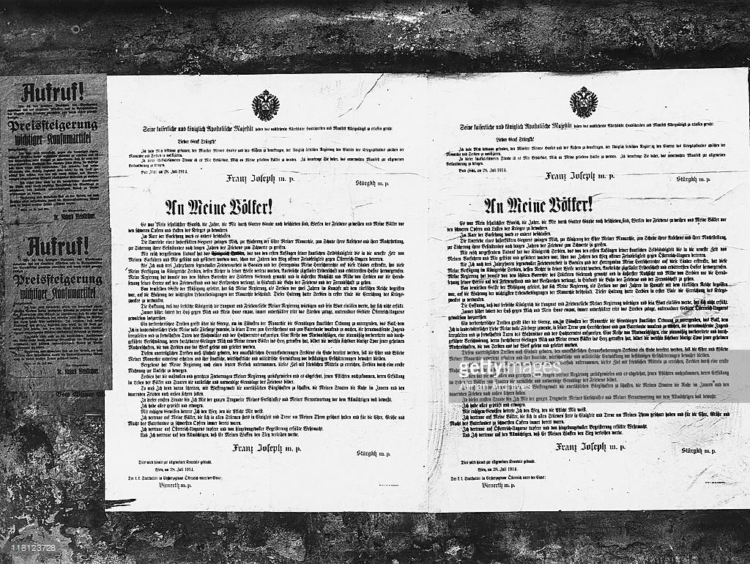

Figure 1: Original transcript of the Declaration of War by the Austro-Hungarian Empire with English translation

To my peoples!
It was my fervent wish to consecrate the years which, by the grace of God, still remain to me, to the works of peace and to protect my peoples from the heavy sacrifices and burdens of war. Providence, in its wisdom, has otherwise decreed. The intrigues of a malevolent opponent compel me, in the defence of the honour of my Monarchy, for the protection of its dignity and its position as a power, for the security of its possessions, to grasp the sword after long years of peace.

With a quickly forgetful ingratitude, the Kingdom of Serbia, which, from the first beginnings of its independence as a State until quite recently, had been supported and assisted by my ancestors, has for years trodden the path of open hostility to Austria-Hungary. When, after three decades of fruitful work for peace in Bosnia and Herzegovina, I extended my Sovereign rights to those lands, my decree called forth in the Kingdom of Serbia, whose rights were in nowise injured, outbreaks of unrestrained passion and the bitterest hate. My Government at that time employed the handsome privileges of the stronger, and with extreme consideration and leniency only requested Serbia to reduce her army to a peace footing and to promise that, for the future, she would tread the path of peace and friendship. Guided by the same spirit of moderation, my Government, when Serbia, two years ago, was embroiled in a struggle with the Turkish Empire, restricted its action to the defence of the most serious and vital interests of the Monarchy. It was to this attitude that Serbia primarily owed the attainment of the objects of that war.

The hope that the Serbian Kingdom would appreciate the patience and love of peace of my Government and would keep its word has not been fulfilled. The flame of its hatred for myself and my house has blazed always higher; the design to tear from us by force inseparable portions of Austria-Hungary has been made manifest with less and less disguise. A criminal propaganda has extended over the frontier with the object of destroying the foundations of State order in the southeastern part of the monarchy; of making the people, to whom I, in my paternal affection, extended my full confidence, waver in its loyalty to the ruling house and to the Fatherland; of leading astray its growing youth and inciting it to mischievous deeds of madness and high treason. A series of murderous attacks, an organized, carefully prepared, and well carried out conspiracy, whose fruitful success wounded me and my loyal peoples to the heart, forms a visible bloody track of those secret machinations which were operated and directed in Serbia.

A halt must be called to these intolerable proceedings and an end must be put to the incessant provocations of Serbia. The honour and dignity of my monarchy must be preserved unimpaired, and its political, economic, and military development must be guarded from these continual shocks. In vain did my Government make a last attempt to accomplish this object by peaceful means and to induce Serbia, by means of a serious warning, to desist. Serbia has rejected the just and moderate demands of my Government and refused to conform to those obligations the fulfilment of which forms the natural and necessary foundation of peace in the life of people and States. I must therefore proceed by force of arms to secure those indispensable pledges which alone can insure tranquillity to my States within and lasting peace without.

In this solemn hour I am fully conscious of the whole significance of my resolve and my responsibility before the Almighty. I have examined and weighed everything, and with a serene conscience I set out on the path to which my duty points. I trust in my peoples, who, throughout every storm, have always rallied in unity and loyalty around my throne, and have always been prepared for the severest sacrifices for the honour, the greatness, and the might of the Fatherland. I trust in Austria-Hungary's brave and devoted forces, and I trust in the Almighty to give the victory to my arms.

FRANZ JOSEPH mppria

Figure 2: Original transcript of ‘Call to Arms’ with English translation
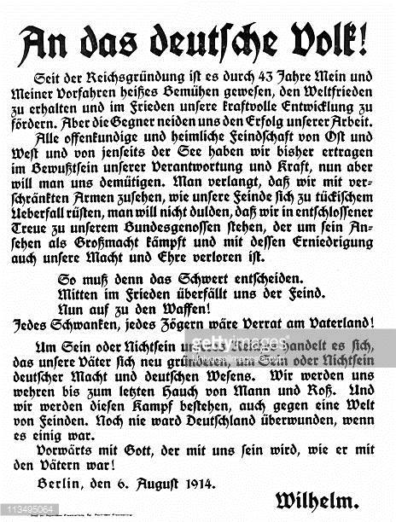

Since the founding of the Reich, through 43 years of my ancestors and me, it has been a difficult task to keep the world at peace and to promote our mighty development in peace. But our enemies envy our success.
We have endured much, manifestly and in secret, from our enemies from East and West and from beyond the sea.
But now we must humble ourselves. We must stand with folded arms, as our enemies prepare themselves to treacherously attack us; we will remain faithful to our ally, who fights for his reputation as a great power and with his humiliation our power and honour is lost.

So now the sword must decide. In the midst of peace, the enemy attacks. So rise up! To arms! Any dithering, any hesitation would be treason to the Fatherland........ It is a matter of being or not-being. We will defend ourselves to the last breath of man and horse. And we will fight this battle against a world of enemies. Never was Germany overcome. Forward with God, who will be with us as he was with our Fathers.

Figure 3: Declaration of War

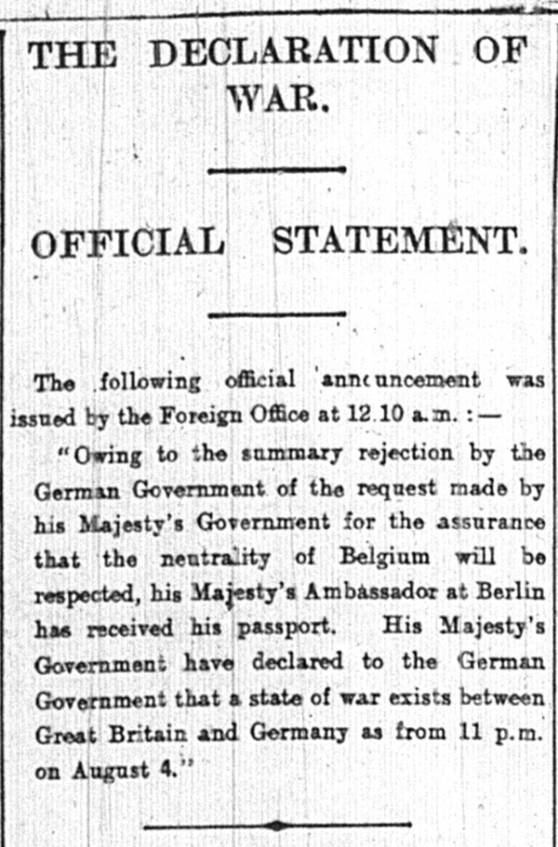

Word count 1192

Bibliography
A.J.P. Taylor, The First World War: An Illustrated History (London: Penguin Press, 1963).
C. Clark, The Sleepwalkers: How Europe went to War in 1914 (London: Penguin Press, 2013).
Gutenberg [online]. Available: https://www.gutenberg.org/files/16331/16331-h/16331-h.htm Accessed on [10/11/2017].
I. Armour, ‘The Roots of Sarajevo: Austria-Hungary and Serbia, 1867-81’, History Today, vol. 38 (1988).
The Spectator [online]. Available: https://archive.spectator.co.uk/issue/7th-may-1859. Accessed on [10/11/2017].
The World of the Habsburgs [online]. Available: http://www.habsburger.net/en/chapter/franz-joseph-supreme-bureaucrat Accessed on [10/11/2017].

For example, British Empire Ministers: Lloyd George (London: Purnell Book Services 1974), Labour People: Leaders and Lieutenants Hardie to Kinnock (London: Faber and Faber 2010), Britain Since 1945: the People’s Peace (Oxford and New York: Oxford University Press 2010).
P. Thompson, Socialists, Liberals and Labour: the struggle for London 1885-1914 (London: Routledge 1967)
G.R. Searle, The Liberal Party Triumph and Disintegration 1886-1929 (Basingstoke: Palgrave 2001), pp. 26-45.
G.R. Searle, The Liberal Party Triumph and Disintegration 1886-1929 (Basingstoke: Palgrave 2001), p. 69.
D. Dutton, A History of the Liberal Party Since 1900 (Basingstoke: Palgrave Macmillan 2013), pp. 18-19.
D. Dutton, A History of the Liberal Party Since 1900 (Basingstoke: Palgrave Macmillan 2013), pp. 35-36.
P. Thompson, Socialists, Liberals and Labour: the struggle for London 1885-1914 (London: Routledge 1967), pp. 179.
H. Pelling, Popular Politics and Society in Late Victorian Britain (London: Macmillan 1968), pp.110-118.
G.R. Searle, The Liberal Party Triumph and Disintegration 1886-1929 (Basingstoke: Palgrave 2001), pp. 2-3, 86-87.
T. Wilson, The Downfall of the Liberal Party 1914-1935 (London: Faber and Faber 1966), pp.15-19.
G.R. Searle, The Liberal Party Triumph and Disintegration 1886-1929 (Basingstoke: Palgrave 2001), pp. 94-95.
D. Dutton, A History of the Liberal Party Since 1900 (Basingstoke: Palgrave Macmillan 2013), pp. 20-21.
D. Dutton, A History of the Liberal Party Since 1900 (Basingstoke: Palgrave Macmillan 2013), p. 21.
G.R. Searle, The Liberal Party Triumph and Disintegration, 1886-1929 (Basingstoke: Palgrave 2001), p. 1. pp. 67-68.
D. Dutton, A History of the Liberal Party Since 1900 (Basingstoke: Palgrave Macmillan 2013), p. 24.
H. Pelling, Popular Politics and Society in Late Victorian Britain (London: Macmillan 1968), p. 13.
G.R. Searle, The Liberal Party Triumph and Disintegration 1886-1929 (Basingstoke: Palgrave 2001), pp. 86-87.
P. Adleman, The Decline of the Liberal Party 1910-1931 (London and New York: Longman 1995), p. 7.
G.R. Searle, The Liberal Party Triumph and Disintegration, 1886-1929 (Basingstoke: Palgrave 2001), p. 87.
P. Adleman, The Decline of the Liberal Party 1910-1931 (London and New York: Longman 1995), p. 6.
D. Dutton, A History of the Liberal Party Since 1900, (Basingstoke: Palgrave Macmillan 2013), pp. 34-35.
P. Adleman, The Decline of the Liberal Party 1910-1931 (London and New York: Longman 1995), pp. 6 – 22.
D. Dutton, A History of the Liberal Party Since 1900 (Basingstoke: Palgrave Macmillan 2013), pp. 57-58.
S. E. Koss, Nonconformity in modern British Politics (London: Harper Collins 1975).
D. Dutton, A History of the Liberal Party Since 1900 (Basingstoke: Palgrave Macmillan 2013), p. 60.
T.L.Crosby, The unknown Lloyd George (London and New York: Tauris 2014), pp. 212-214.
P. Adleman, The Decline of the Liberal Party 1910-1931 (London and New York: Longman 1995), p. 22.
T.L.Crosby, The unknown Lloyd George (London and New York: Tauris 2014), p. 217.
D. Dutton, A History of the Liberal Party Since 1900 (Basingstoke: Palgrave Macmillan 2013), pp. 65-67.
D. Dutton, A History of the Liberal Party Since 1900 (Basingstoke: Palgrave Macmillan 2013), p. 71.
T.L.Crosby, The unknown Lloyd George (London and New York: Tauris 2014), pp 110-149.
D. Dutton, A History of the Liberal Party Since 1900 (Basingstoke: Palgrave Macmillan 2013), p. 69.
P. Adleman, The Decline of the Liberal Party 1910-1931 (London and New York: Longman 1995), pp. 22-23.
P. Adleman, The Decline of the Liberal Party 1910-1931 (London and New York: Longman 1995), pp. 22-23.
J. Grigg, Lloyd George War Leader (London: Allen Lane 2002), p. 358.
J. Grigg, Lloyd George the People’s Champion 1902-1911 (London: Penguin Books 2002), pp.94-131.
T.L.Crosby, The unknown Lloyd George (London and New York: Tauris 2014), pp. 214-118.
R. Toye, Lloyd George and Churchill Rivals for Greatness (London: Pan Macmillan 2008), p. 9. Citing Aneurin Bevan’s speech to parliament in 1945 following the death of Lloyd George.
The multi-ethnic diversity of the Empire required translations into Hungarian, Czech and Slovenian.
The Spectator [online]. Available: https://archive.spectator.co.uk/issue/7th-may-1859. Accessed on [10/11/2017].
C. Clark, The Sleepwalkers: How Europe went to War in 1914 (London: Penguin Press, 2013), p. 469.
Clark, ibid., p. 183.
Clark, ibid., p. 237.
A.J.P. Taylor, The First World War: An Illustrated History (London: Penguin Press, 1963), p. 17.
Taylor, ibid., pp.13-65.
Franz Joseph exclamation in a clash was Conrad von Hōtzendorf, cited by Clark, The Sleepwalkers: How Europe went to War in 1914, p. 105.
Franz Ferdinand to Hōtzendorf, cited by Clark, ibid., p. 117.
Clark, The Sleepwalkers: How Europe went to War in 1914, p. 71.
Austria loaned money to keep the Serbian economy afloat in the 1880-90s and supported Serbian ambitions in Macedonia. Massacres were routinely reported during the Balkan wars e.g. Skopje and Prizren. Clark, ibid., pp. 3-64 and p. 112-3.
France made multiple loans to Serbia who used them primarily for armaments; Russia was a focus for pan-Slavic nationalism.
Clark, The Sleepwalkers: How Europe went to War in 1914, p. 49.
Taylor, The First World War: An Illustrated History, pp.13-65
I. Armour, ‘The Roots of Sarajevo: Austria-Hungary and Serbia, 1867-81’, History Today, vol. 38 (1988), available at www.historytoday.com (Accessed: 29th October 2017)
Gutenberg [online]. Available: https://www.gutenberg.org/files/16331/16331-h/16331-h.htm Accessed on [10/11/2017].
The World of the Habsburgs [online]. Available: http://www.habsburger.net/en/chapter/franz-joseph-supreme-bureaucrat Accessed on [10/11/2017]
Clark, The Sleepwalkers: How Europe went to War in 1914, pp. 168-241.
Imperial Foreign Minister Count Aehrenthal repeatedly urged restraint on Italy in North Africa because of possible consequences in the Balkans so the possibilities of a domino effect following hostilities was understood, Clark, ibid., p. 246.
French, German, British and Russian decision-makers independently concluded that a continental war might be long-lasting. Clark, ibid., p. 561.
Clark, ibid., p. 288.
Clark, ibid., p. 357.
Clark, ibid., p. 73.
The Times correspondent Henry Wickham Steed wrote in 1913 that there no reason why ‘the Habsburg monarchy should not retain its rightful place in the European Community’, cited by Clark, ibid., p. 77
Getty Images [online]. Available: http://www.gettyimages.com/detail/news-photo/an-meine-volker-poster-with-a-message-from-by-emperor-franz-news-photo/118123728. Accessed on [9/11/2017].
Gutenberg [online]. Available: https://www.gutenberg.org/files/16331/16331-h/16331-h.htm Accessed on [9/11/2017].
Foreign Office, Notice of State of War Between Great Britain and Austria-Hungary, August 12, 1914, Supplement to the London Gazette no. 28868 (August 13, 1914): 6375, Available online at https://www.thegazette.co.uk/London/issue/28868/ supplement/6375/data.pdf

