STUDENT NAME: Valentina Somnik
STUDENT CODE: 2020147

Table of Contents
Introduction 2
The principles of Sustainability 2
Case Study 1: Punta Cana Hurricane Recovery 3
Natural disasters 3
Climate change 4
Punta Cana: Sustainable Tourism Development 6
Conclusion 7
References 8

Introduction

The principles of Sustainability

To begin, "sustainability" refers to the capacity and effort required to exist indefinitely.In other words, this is in direct connection with Earth's biosphere and human civilization.UCLA, 2021) To put it another way, sustainability means being able to live a good life, or at least a decent life, while also making changes. The only important thing to keep in mind is not putting the future of future generations in jeopardy.To put it simply, it involves talking about taking care of the world.Sustainability actually focuses on three main areas, each of which encompasses almost everything when taken as a whole rather than in discrete parts that pertain to a single aspect.The economy, society, and the environment are the three main areas that sustainability is referring to.In point of fact, these aspects are mentioned when it was mentioned that sustainability is about each person satisfying their own needs without compromising the ability of subsequent generations to satisfy their own needs, such as protecting the environment.Grant, 2020) Sustainability, on the other hand, refers to continuously maximizing the benefits of tourism for natural reserves, society as a whole, and the economy at the same time as attempting to reduce costs.When all three pillars of sustainable tourism are taken into consideration and worked on for the benefit of visitors while safeguards are maintained, the result is sustainable tourism (UNWTO, 2021).

In addition, when it comes to the development of sustainability and tourism, it is very accurate to state that tourism has increased significantly over the past few years, along with the hospitality industry, which is closely related, and transportation, which facilitates travel. This fact makes sustainability a barrier to the tourism industry's future because of the enormous amount of waste produced—35 million tons—and environmental damage (UNEP, 2021).

Case Study 1: Punta Cana Hurricane Recovery
The most famous and famous resorts of the Dominican Republic were selected. Punta Cana is he one of the most popular vacation spots due to its high visitor numbers and popularity. People love this area for its beauty and the numerous gorgeous strategically placed beaches. In addition, Punta Cana Resort has plenty of natural accommodation and is 'green' as far as the eye can see, proving its eco-friendliness. (Punta-Cana, 2021)
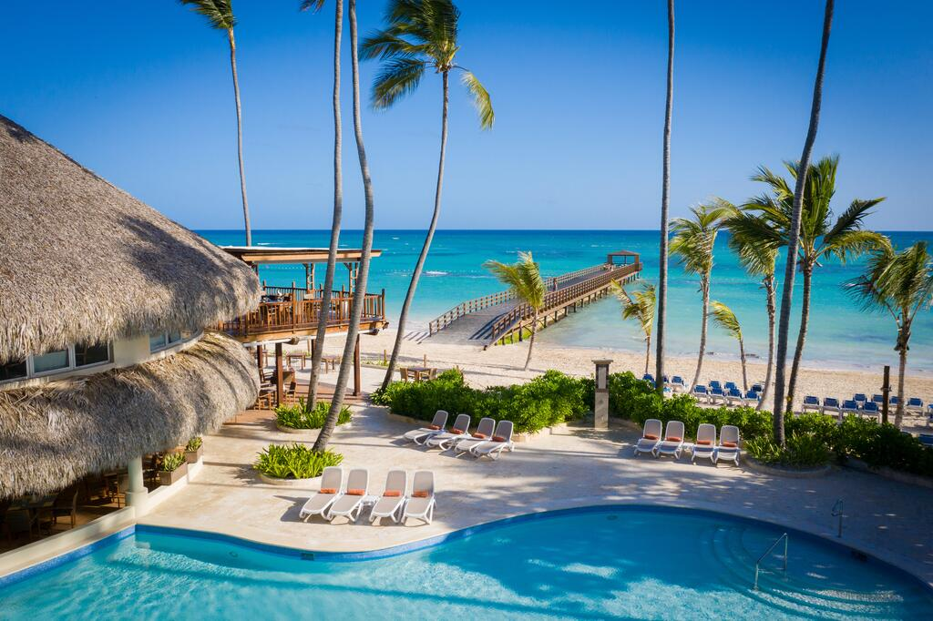

Natural disasters
Although this vicinity exudes elegance, beauty, and a feel of tranquility, it additionally faces demanding situations added on via way of means of the have an effect on of nature, which has a substantial have an effect on on tourism and its sustainability.In the prolonged duration of 2017, whilst the Punta Cana hotel commenced to be more and more more famous and it was a fascination factor for extra individuals, the Dominican Republic had to confront now no longer one, but tropical storms, named Irma and Maria and that they precipitated some severe harms.In addition, the harm became now no longer confined to the places that have been destroyed—many homes and different varieties of homes have been damaged—however additionally to the hurricanes' substantial wide variety of fatalities—15—and lacking persons—20—that precipitated concern.Even aleven though the vicinity became in a horrific situation, they wanted a number of assist to get again on their feet. One supply of "income" became tourism, which became significantly declining.Dominica's tourism has suffered due to the 2 hurricanes, which extended the country's struggling and made it extra tough to recover. As a result, fewer humans have been courageous sufficient to journey there on the time due to the fact they commenced to worry what may show up in the event that they have been there.However, they have been capable of paintings matters out, or even the president of the resort affiliation withinside the Dominican Republic reassured the general public that the typhoon had no impact at the country, inspiring them to disregard any poor thoughts.In addition, the those who have been there on the time truely persuaded others to desert their doubts and make a reservation, and as a result, tourism have become sustainable yet again and the vicinity recovered. (Holpuch, Fishwick, 2017)
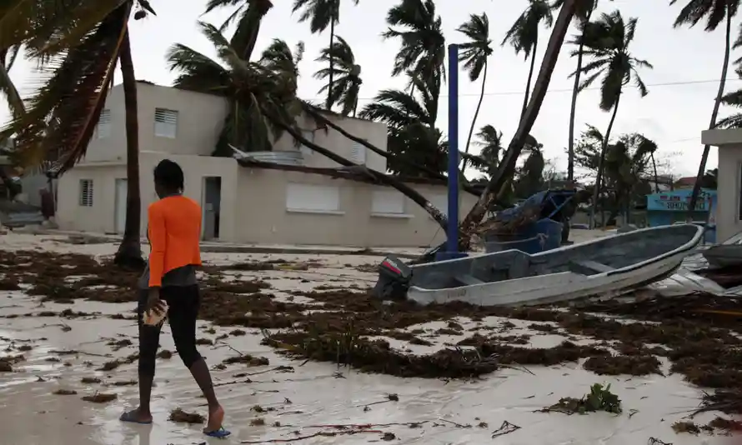

Climate change
Today, Punta Cana is the Caribbean's fastest-growing tourist destination, bringing many benefits to the region as a whole. It receives a record 1.6 million visitors annually, a number that can change at any time, but it is more likely to rise than fall.Kheel, 2020) The three pillars of sustainability—the economy, society, and environment—can be described in detail in this section. They are also referred to as profit, people, and planet—the 3Ps.
1.Economy, profit—this refers to the fact that a company, in this instance the Punta Cana resort, exerts a great deal of effort and experiments with strategies to sustainably expand the economy. The primary objective is to generate profits, which necessitates effective resource management with care and accountability. Circular Ecology, 2021) It is common knowledge that Punta Cana is crucial to the Dominican economy and development.
2.People, society—this is concerned with the well-being of humans by preserving peace and a certain level of goodness for the community over an extended period of time. AS a society, it is expected to take reasonable actions that will benefit the nation. Regarding the hurricanes, people worked well together, and the nation was able to recover quickly enough to continue its sustainability after its fall.
3. Environmental Circulation, 2021)The terms "environmental," "planet," and "flora and fauna" refer to the well-being of the planet. The rapid expansion of Punta Cana's natural attractions, such as the beaches, sea grass, and coral reef habitat, contributed significantly to environmental concerns.
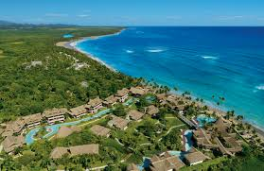

In fact, according to relevant data, Punta Cana focused more on the economy and the environment than on society. On the other hand, the economy comes first, these he three things work in tandem, but sometimes one is left out. It is entirely possible that increased tourism will reduce the quality of life of those who live there, and changes that will directly affect them will emerge as a result of "overtourism."Teel, 2019) tourism leaders We have many tools and strategies that can help us to better manage sustainable tourism and sustainable development. An example is Richard Butler's The Traveler's Life his cycle model, which consists of his six stages.
Exploration, participation, growth, integration, stagnation and finally decline.
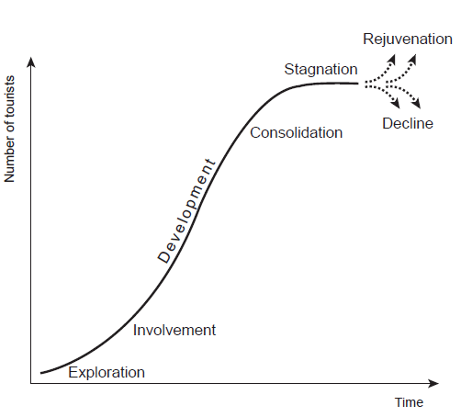

The fact that Punta Cana is currently in the development stage suggests that the city is still expanding and that some of its benefits are beginning to materialize. When Punta Cana was just an idea many years ago, they were already in the research and participation phase. However, due to the impact of overtourism and its negative effects, Punta Cana is likely to enter a period of stagnation. However, this can easily be avoided with good sustainability and development practices, so the decline stage seems well advanced. (Punta Cana Resort & Club, 2021)

Punta Cana: Sustainable Tourism Development
The selected region has many homes from the mid-century era, however this best provides to the stylish life-style it suggests.There are a number of elegant lodges and locations to play golfing withinside the Punta Cana area.Despite supplying a totally opulent life-style, this region is touted as being low priced and exceptional to stay in, that is exactly why it's miles on many humans's "desire listing" lists.People are curious about the possibility to stay a existence of opulence at an inexpensive cost, now no longer to say the metropolis's dawn and sundown views.Hochberg, 2019) As a result, a number of travelers are going to Punta Cana, that is called the "Golf Capital of the World," to get that movie-like enjoy of gambling tennis and prevailing gold.In this instance, it's miles the obligation of tourism managers and people in fee to each sell and preserve tourism.
Reducing stable waste and recycling are additives of the Punta Cana improvement and sustainability plan, which sooner or later ends in the metropolis turning into a zero-waste community.Punta Cana have become a international chief in reusing water as a part of its improvement, which additionally protected water conservation and its effectiveness in presenting potable water to the population.The metropolis is without a doubt a renewable strength metropolis due to an amazing approach, so the listing of strength conservation measures can cross on.When those are connected to tourism, it's miles proven that humans are inclined to pay greater for greater peace and quiet, in addition to for nature, that is any other gain of Punta Cana as it has city forestry and greater inexperienced homes which can be meant to enhance air quality (Raimi, 2016)
All this makes it an attraction for tourists, which draws about one million visitors a year. Additionally, they are working on proactive and sustainable transport strategies for the benefit of sustainable tourism development. However, the Centers for Disease Control and Prevention (CDC) recommends 150 minutes of walking or other physical activity per week. Raimi, 2016) To meet this requirement, they use natural gas to ensure clean transportation. However, 92% of the country's residents drive alone, and the strategy aims to encourage people to use public transport to further reduce their carbon footprint. This strategy is also beneficial for tourists as it prioritizes public transport.

Conclusion
In the end, the report showed that sustainability in tourism and its growth is a very complicated topic that covers many important areas.With the assistance of the destinations chosen, it was demonstrated that there are numerous steps to take and regulations to abide by in order to be sustainable and avoid the decline stage, from which it is difficult to escape.The travel industry is persistently developing, and the partners needs to make the proper strides and choices to keep a specific security, as well as to develop, to create.

References



