

Course Title: MBA - International Business
Term 1

Module Name: Human Capital Management
Module Code: LCMB7023

Student Name: Hitarth Girishbhai Sorathiya
Student ID: 2506577

Lecturer’s Name: Dr. Gladius Kulothungan
Word Count: 2747/2500

The impact of Labour Market Global Transformation on HRM and IHRM Strategy in Digital Era

Abstract

In the capturing of the essence for the capabilities that is dynamic also the understanding of what they can with how it was actually to be support in the innovative technology with the change of the technology. Although the unfold of the capabilities for the dynamic with the facilitate of the technology that will change throughout the managerial strategic for the decision-making, resource that reconfiguration with the learning that is continuous with that subsequently aim to comprehensive the framework that used to be provides an integrative perspective on how the capabilities that is dynamic in the support of the management in a change of technological. However, the proliferation for the stakeholders of non-state, while making the concept of the international business that use to be increasingly in the complex.

Table of Contents
Abstract 2
Introduction 4
1. Technological Advancements and Implication for HRM and IHRM strategies 5
1.1 AI and Automation Reshaping Labour Markets 5
1.2 Implication of HRM 6
1.3 Implication of IHRM 6
2. HR Professionals Challenges and Key Demographic & Geopolitical Factor 6
2.1 Demographic Factor 6
2.2 Geopolitical Factor 7
2.3 Challenges for HR Professionals 7
3. Organization Address Skill Gap and Talent Shortages in Sectors 8
3.1 Addressing Skill Gap 8
3.2 The Talent Shortages in Sectors 10
4. The Current Capability’s and Strengths & Weaknesses 10
4.1 Working on Current Capability’s 10
4.2 Strength and Weaknesses 12
4.2.1 Strength 12
4.2.2 Weaknesses 13
Conclusion 14
Reference 15
Appendix 18

Introduction
The better understanding with the benefit which is substantially in the scholars of the management that must be in the research for the international the HR which is human resource management in the context of understanding by the HRM in the context of organizations. Managerial implications and the Practical were having a very deeper understanding for the retention of effective strategies in the top also the middle-level in the manner that could be assist Human Resources Management and automation also the Augmented Reality or the Virtual Reality, the major complement of an ongoing development of workforce the purpose is used to make the efforts (Hunt, Tourish and Hargie, 2000). While, the each of those capabilities that must be necessary condition of the growth of a sustainability in current economy of the world the characterized that is increasing in the advancement of the technological also the globalization of business. In that capabilities that are dynamic view of emerged in the approach that is in the centre by the addressing for the central question of the firms in the cope with the change in technological (Wigert, Dellenmark and Bry, 2013).

1. Technological Advancements and Implication for HRM and IHRM strategies

1.1 AI and Automation Reshaping Labour Markets
The fastest advancement of the AI and the technologies of the automation were transforming or reshaping the labour markets that is around the world, while in the prompting of the both optimism and the concern. The research is used to be seeks to the analysation is critically in the implications of economic to AI with that the automation in the reshaping and the transformation in labour market, is used to focusing on the potential to their disrupt in the structures of the traditional employment, and the influence productivity, with that it either alleviates or exacerbate of the economic inequality (Zubair, 2024).
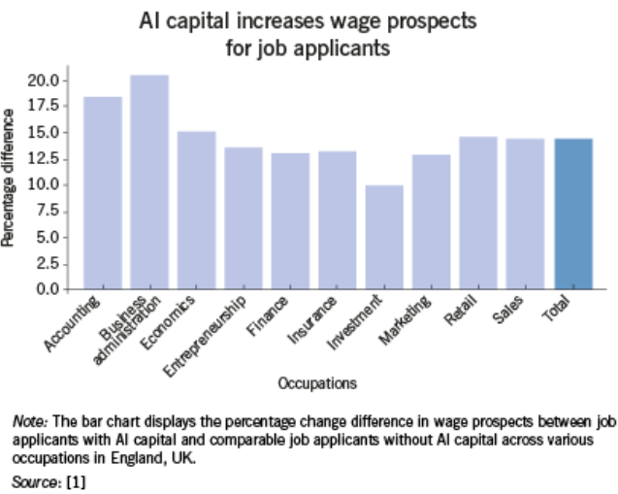
Figure: AI & Labour Market Outcome
Source: (Drydakis, 2025)

The method of examining the historical patterns of the disruptions for technological disruptions, while alongside the data which is contemporary, in that the purpose of the research is to assess in either those technologies that will provide as the means of the enablement in the economic or it is a catalyst for the economic inequality (Zubair, 2024). The major objective to give the understanding of the completely understood of opportunities also challenge that is presented in the transformations of AI-driven, in the along with the policy is recommended for the actionable to be managing all those inclusive is ensuring the growth, transition, with the cultivating the workforce to be equipped in the demands for the era of Artificial Intelligences. The major research used to be explored the impacts of the AI and automation technology that upon the working on the structures of the system with that the transformations of employment in the labour markets or the readiness of employee to the adjust (Yolusever, 2025).

1.2 Implication of HRM
The detailed in the implications that is explain the major advanced of the Human Resource Management to be analytics also the AI that can facilitate in the transition the toward personalized the HRM. However, by emerging in the concept of the HRM personalization, in which it used to be referred of the programs the human resource management which is HRM also to the practices that can be vary all across the individuals within a company or the organization (Yolusever, 2025).

1.3 Implication of IHRM
The research for the implication of IHRM, the agenda of this field for an international human resource management which is clear. In the well understanding with aid which is significantly in the scholars of the management that must be in this research of the IHRM in context of understanding the human resource management in this context of the company also in the environment. IHRM that must be researched in concept for the economic changing with conditions in the business. The dynamics between the both of the regional also the global business which of the firm that it operates must give in the serious consideration (Yolusever, 2025).

2. HR Professionals Challenges and Key Demographic & Geopolitical Factor

2.1 Demographic Factor
The key important demographic factors used to be affecting in the labour market with their movement must be lead in the significant changes of the economically share of active the population. The detailed describes that will impact of the demographic individual elements on the labour market that is through the research with the generalization of the several scientific literatures of this field (Hovy, 2015). The major focus is the demographic factor, in the work also the issues of the family, that is pension also health of the patterns, the technical replaces, and the adjustment of the less unemployment in the international, with the main plight for the workers of less in skilled. It is many profitable in approach than the other activities for marketing, like as the price that might cuts and also programs the promotional activity. As the experience industry, and the business of hospitality that should be pursue the market of share gains, that is rather than the growth of the market gains (Hovy, 2015).

2.2 Geopolitical Factor
The Globalization, is very hyper-competition between the both multinational enterprises with the escalation for the stakeholders of the non-state, while building the concept for the international business that use to be increasingly in the complex. The Politico-economic of the countries, with the postures in the several issues that is in the global forums to be keep in the altering the concept. The Despite of the symbiotic relationship, with that the both the Relations of International and the Business International to have the scholars to the geopolitical concept for the global business, while it has been explicitly the analysed. There is also have the evidence that is all the MNEs do to be indeed the Globalization factor it is varying the degrees, formulating strategy, but there are no frameworks that are conceptual in either the discipline that can be facilitate like an analysis (Hovy, 2015).

2.3 Challenges for HR Professionals
This is a major informative is general literature research that was tries to be in the look of a recent and the relevant of the publications while the major impact of pandemic on Human Resources Management and the before the post-COVID they have more on HRM challenges. The major purpose for this research has to be explore the major challenges of the Human Resources Management to be retention with the effective of the retention strategies in the top also the middle of the level of supervisor. The main motivation for this research the HR managers is also facing the difficulties to retaining the managers as the result for the ineffective strategies for retention (Publication, 2021).
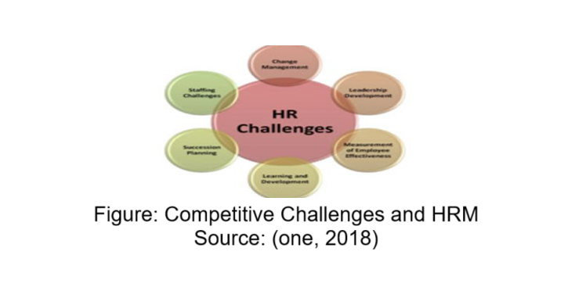
The exploratory factor to be analysis to be conducted in the comparisons group. While, the main findings of the Results that revealed the leadership with the performance management that practices the considered that is effective strategies retention for the top also the middle-level in managers. Managerial implications and the Practical were having a very deeper understanding for the retention of effective strategies in the top also the middle-level in the manner that could be assist Human Resources Management, HR professionals which can be retaining the employees. Contribution for this research will adds the insights for the HR Management or HR professionals, the line managers with the leaders to the organisations or the company to be retention of regarding challenges also the effective retention strategies managers (Publication, 2021).

3. Organization Address Skill Gap and Talent Shortages in Sectors

3.1 Addressing Skill Gap
The addressing talent shortages have becoming very crucial for company and the organisational sector for the success of a current business changing climate. In the skill gaps, it is mention to the variation for the capability which is compulsory also skills which is held, in the obstruct to be very productivity also the creativity. In this research that major examined of the of the methods for the efficiently to be the skill to addressing the deficiencies from the customised initiatives of training, with the integration of the technology, also the cultivating of the lifelong of learning mindset (Publication, 2021). While, this research is used to be surveys with the case studies that happens across in the various sectors, also to be identify in the main initiatives skills of initiatives. The major examined is efficacy for the options of remedial with that assessed in their influence for the competitiveness and the productivity. The major results that will be highlighted on the need of the strategic planning personnel also the ongoing development of skill for the adapt of changing the demands of market with the organisational of maintain the resilience (Collins, 2021).
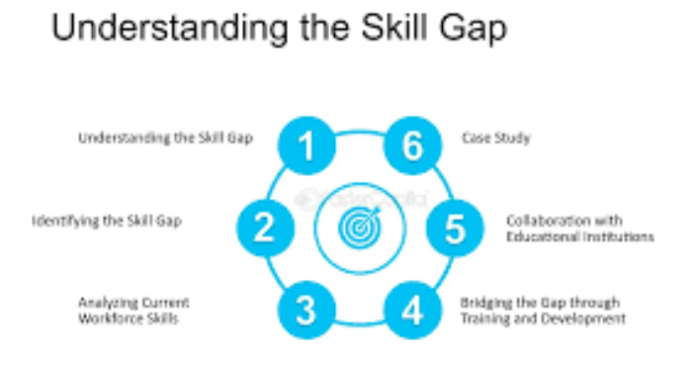
Figure: Skill Gap Identification
Source: (Skill, 2025)

The evolving of the business landscape, in the organisations sector that face those major constant challenges for the competitiveness maintaining, enhancing productivity, and fostering innovation. While, one of the major issues that pressing in the skill gap of the persistent within a workforce (Collins, 2021). The skill gaps, that used to be defined as a disparity for the required of skills for the job and the major skills has possessed by the employees, that may be hinder organisational sectors performance and the growth potential is in limit. Addressing those gaps was crucial for the organisations sector to be proposing to agile remain and very responsive to the demands of market. The major importance of the closing gaps of skill that have been very underscored in the recent researches, which of these highlights are the correlation of a workforce that is skilled and the success of an organisational (Braun et al., 2024).

3.2 The Talent Shortages in Sectors
The integrating technology with the automation that can be alleviate the talent shortages of carrying out the duties is repetitive, while the enabling the staff of concentrate on many of the intricate also the operations of innovative. However, the nevertheless of this necessitates of using the approaches of the supplementary to be enhance skills of the personnel, also the enabling to them for the collaborate the proficiently with the emerging of the technology. This research that will explore the two paradigms of the feasibility for all the technical Industry (Braun et al., 2024).
The automation also the Augmented Reality or the Virtual Reality, the major accompaniment of an in process development of workforce the purpose is used to make the efforts and the optimize of a desirability workplace by the core of the catalysing to the manufacturing processes that used to be enhancing the effectively of a onboarding, learning, with the professional empire of all the promising to be the capabilities among in process talent shortage also the track that is towards the packaging of an advanced (Braun et al., 2024).

4. The Current Capability’s and Strengths & Weaknesses

4.1 Working on Current Capability’s
The reflecting on the current capability of the of the strength and the weakness are the international context, communication, focusing on technologies, leadership, teamwork and the self-directed learning. The research that clears the capability of a dynamic perspective the globally context. There are three essential ingredients are learned to get the capabilities of the dynamic capability there is the capability possession, capability deployment, and capability upgrading also it increasingly in the fundamental of the global expansion with the operations of global. While, the every of those ability that is compulsory condition for the growth of a sustainability in current economy of the world the characterized that is increasing in the advancement of the technological also the globalization of business (Cetindamar, Phaal and Probert, 2009).
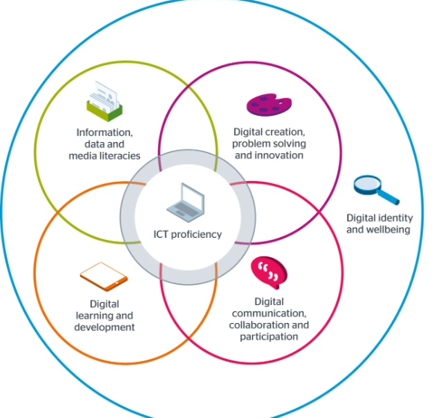
Figure: Capability in the technologies
Source: (Beetham, 2017)

The capabilities that are dynamic view of emerged in the approach that is in the centre by the addressing for the central question of the firms in the cope with the change in technological. The major capturing of the essence for the capabilities that is dynamic also the understanding of what they can with how it was actually to be support in the innovative technology with the change of the technology, however, has formerly posed in the exacting challenge (Cetindamar, Phaal and Probert, 2009). I analyse to these major three concepts of the unfold of the capabilities for the dynamic with the facilitate of the technology that will change throughout the managerial strategic for the decision-making, resource that reconfiguration with the learning that is continuous. I subsequently aim to comprehensive the framework that used to be provides an integrative perspective on how the capabilities that is dynamic in the support of the management in a change of technological, that is the developments toward the transformation of a digital, and the new ICTs also the systems of cyber physical. Finally, it is future discuss the research that’s directions were based on the major findings of our framework and the synthesis (Pagano, 2009).

4.2 Strength and Weaknesses

4.2.1 Strength

Technological Adaptability: Now certain about my ability to use digital platforms to carry out research, work, and communicate. As an example, the work on group projects in Microsoft Teams and Google Workspace helped me build virtual teamwork management skills, which are becoming particularly necessary in the field of in IHRM (Olander, Hurmelinna-Laukkanen and Heilmann, 2015).
Communication and Interpersonal: The case studies and HCM discussions have enabled me to interact with people in various domains better. This practice has taught me to exercise cultural sensitivity and emotional intelligence when engaging in conversations, which are essential human resource skills in the international human resource management (Olander, Hurmelinna-Laukkanen and Heilmann, 2015).
Teamwork and Collaboration: Group work has also honed my team work skills. Now I have a more profound awareness of the dynamics of the team and the value of shared leadership, inclusivity and respect towards each other in the pursuit of shared objectives (Gant, 2004).
Leadership and Initiative: Having completed leadership practices and presentations, I am now confident in my leadership abilities to work in small teams and make decisions based on data. The knowledge of the concepts of leadership theories in HCM, including transformational and situational leadership, has allowed me to discover my inherent preference toward a participative leadership style (Gant, 2004).

4.2.2 Weaknesses

Strategic Thinking: Though I have already gained a proper vision of operational HR functions, my strategic perspective is yet to be reinforced, in particular, the ability to match HRM strategies with long-term business objectives. This I intend to improve by applying case-based learning and internships with strategic HR positions (Oh et al., 2017).
Self-Directed Learning: Though I am active in task accomplishment, I occasionally lack the ability to stick to long term learning agenda. I’ll respond to this by developing a well-organized self-education plan through the use of online education resources like LinkedIn Learning and Coursera to continuously refresh my level of knowledge in HR (Oh et al., 2017).
Future Growth: Action Plan. In the future, I would like to combine both my academic experience in HCM with practice. To establish cross-cultural relationships, I’ll use my communication and teamwork strengths, as well as concentrate on the development of strategic and analytical skills. Professional growth workshops, international internships, and AI-focused HR analytics tools can help me be a more competent and internationally adaptable employee (Dobbin and Sutton, 1998).
Overall, my knowledge about Human Capital Management has helped me change my perception about the workplace where I felt that employees were resources, but could now see them as crucial assets towards sustainable growth. This consciousness will inform my path towards becoming an internationally competent HR practitioner who is competent to negotiate the challenges of the contemporary labour market (Dobbin and Sutton, 1998).

Conclusion
The research used to be explored the impacts of the AI and automation technology that upon the working on the structures of the system with that the transformations of employment in the labour markets or the readiness of employee to the adjust. While, the concept of company also in the environment. International human resource management that must be researched in the concept of the economic changing with the conditions of the business. However, the focus is the demographic factor, in the work or the issues of the family, that is health and support of the design, the technical replaces, and the adjustment the less unemployment in the international also retention of effective strategies in the top also middle-level in the manner that could be assist Human Resources Management, HR professionals which can be retaining the employees. The international expansion with the operations of global.

Reference

Beetham, H. (2017). Designing for digital capabilities in the curriculum: what’s new? [online] Jisc Building Digital Capability Blog. doi: https://digitalcapability.jiscinvolve.org/wp/2017/10/31/designing-for-digital-capabilities-in-the-curriculum-whats-new/.

Braun, G., Rikala, P., Järvinen, M., Hämäläinen, R. and Stahre, J. (2024). Bridging Skill Gaps : A Systematic Literature Review of Strategies for Industry. [online] Advances in Transdisciplinary Engineering. doi: https://jyx.jyu.fi/jyx/Record/jyx_123456789_94425.

Cetindamar, D., Phaal, R. and Probert, D. (2009). Understanding technology management as a dynamic capability: A framework for technology management activities. Technovation, [online] 29(4), pp.237–246. doi: https://doi.org/10.1016/j.technovation.2008.10.004.

Collins, M. (2021). Ensuring a More Equitable Future: Addressing Skills Gaps through Multiple, Nuanced Solutions. [online] ERIC. doi: https://eric.ed.gov/?id=ED612639.

Drydakis, N. (2025). Artificial intelligence and labor market outcomes. IZA World of Labor. [online] doi: https://doi.org/10.15185/izawol.514.

Hovy, D. (2015). Demographic Factors Improve Classification Performance. [online] Association for Computational Linguistics, pp.752–762. doi: https://aclanthology.org/P15-1073.pdf.

Hunt, O., Tourish, D. and Hargie, O.D.W. (2000). The communication experiences of education managers: identifying strengths, weaknesses and critical incidents. International Journal of Educational Management, 14(3), pp.120–129. doi: https://doi.org/10.1108/09513540010322393.

one, T. intact (2018). Competitive Challenge and HRM. [online] theintactonedoi: https://theintactone.com/2018/04/16/hrm-u1-topic-5-competitive-challenge-and-hrm/.

Pagano, A. (2009). The role of relational capabilities in the organization of international sourcing activities: A literature review. Industrial Marketing Management, [online] 38(8), pp.903–913. doi: https://doi.org/10.1016/j.indmarman.2009.02.007.

Publication, I. (2021). CHALLENGES TO HR PROFESSIONALS DUE TO COVID - 19 PANDEMIC. IAEME PUBLICATION. [online] doi: https://doi.org/10.34218/IJM.12.3.2021.027.

Skill, F. (2025). Skill Gap Identification: Addressing Needs with Open Position Ratio - FasterCapital. [online] FasterCapital. doi: https://fastercapital.com/content/Skill-Gap-Identification--Addressing-Needs-with-Open-Position-Ratio.html [Accessed 31 Oct. 2025].

Wigert, H., Dellenmark, M.B. and Bry, K. (2013). Strengths and weaknesses of parent–staff communication in the NICU: a survey assessment. BMC Pediatrics, [online] 13(1). doi: https://doi.org/10.1186/1471-2431-13-71.

Yolusever, A. (2025). AI AND AUTOMATION: RESHAPING THE LABOR MARKET. Biga İktisadi ve İdari Bilimler Fakültesi Dergisi, 6(1), pp.63–85. doi: https://doi.org/10.70754/biibfd.1594580.
Zubair, S. (2024). AI-Driven Automation: Transforming Workplaces and Labor Markets. Frontiers in Artificial Intelligence Research, [online] 1(3), pp.373–411. doi: https://sprcopen.org/FAIR/article/view/46.

Dobbin, F. and Sutton, J.R. (1998). The Strength of a Weak State: The Rights Revolution and the Rise of Human Resources Management Divisions. American Journal of Sociology, 104(2), pp.441–476. doi: https://doi.org/10.1086/210044.

Gant, L.P. (2004). The weakest link strategic management of human capital. Performance Improvement, 43(8), pp.25–29. doi: https://doi.org/10.1002/pfi.4140430808.

Oh, H., Seo, D., Yoo, S. and Kim, J. (2017). Analysis of strengths and weaknesses in the National Human Resource Development systems of BRICS. Human Resource Development International, [online] 20(4), pp.268–281. doi: https://doi.org/10.1080/13678868.2017.1285523.

Olander, H., Hurmelinna-Laukkanen, P. and Heilmann, P. (2015). Human resources – strength and weakness in protection of intellectual capital. Journal of Intellectual Capital, 16(4), pp.742–762. doi: https://doi.org/10.1108/jic-03-2015-0027.

Appendix

Figure: AI & Labour Market Outcome
Source: (Drydakis, 2025)

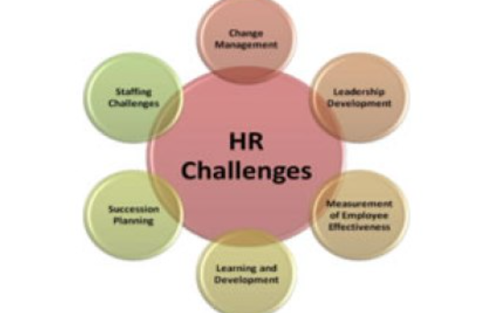
Figure: Competitive Challenges and HRM
Source: (one, 2018)

Figure: Skill Gap Identification
Source: (Skill, 2025)

Figure: Capability in the technologies
Source: (Beetham, 2017)

