Question – apply a range of critical theory’s, identify, discuss, and evaluate an artwork of your own choosing.
By Kesia Tucker
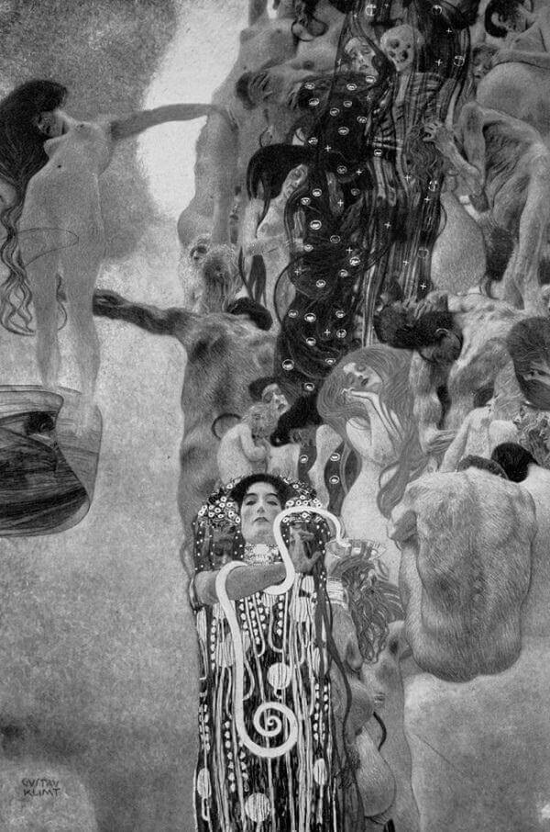
So why have I decided to talk about Gustav Klimt ‘Medicine’ in this essay?
Well, the first book I picked up while in my fine art reading room was a book on the secession, the book was facing out front first, like it wanted to be looked over. I was drawn to the cover (as usual). Apon reading a bit further I came across Klimt’s work and remembered how taken my mum was with his work when I was younger. It was then I decided at some stage I would like to dig a little deeper and when this opportunity arose it seemed the perfect time. I’m still struggling to fully understand critical theory and its endless depths. I believe I am getting somewhere though, and I am just going to try to keep it simple. I have been pulling from semiotics which is the theory and study of signs, symbols and form within critical theory. I have also tried to touch appoint some things I feel important to know in understanding Klimt’s journey.
I have chosen to look at medicine because I like the symbolism of Hygeia Greek goddess of health and for the way he has depicted the cycle of life and death within this painting. Medicine was an oil painting commissioned by the university of Vienna to be part of a series for their ceiling murals in the great hall in the 1890s. This series were all over 13 feet tall, I can’t find specific measurements, but this gives an idea of scale and the impact these would have had on the great hall. Klimt had to rent suitable studio spaces just to work on them. The great sizes of the paintings added to the feeling of God like power and the composition of this piece would have been spectacular.
The painting consists of a river of bodies at all stages of life, men, women, baby’s, pregnant women, youthful people, older ones, some of the faces it seems like death would suit them better. A symbolic depiction of what I believe to be death himself is painted as a skeleton floating among the people in the river of life, shrouded in his dark translucent cloak with what I believe to be a golden block pattern to show his royalty as the god of the underworld. Then off to the left-side u see a figure of a women connected to the river by her own arm, youthful and healthy she seems. A man’s arm connects the women in a cycle with a baby at her feet representing the birth of life. She and the baby being off to the side in this Colome of light has a feel to it like a gift from the heavens, a light in the dark, the birth of medicine perhaps.
Furthermore, Hygeia herself expresses who she is through symbolism, her effects, the serpent (the Aesculapian snake), the cup (the cup of Lethe) and mistletoe in her hair representing renewal all indicate her as being Hygiea the daughter of the god of medicine from Greek mythology. The designs on her gown and headdress are more aesthetic and fun. With her back to the river of life, the gold and the vivid red of her robes suggests blood with golden medicine running through it and gives a very dramatic but still warm feeling to her. In general, I believe this piece has a mix of styles drawing from a few of Klimt’s previous paintings/sketches of women. To pulling from themes such as archaic Greek mythologies and a Japanese style of block printing patterns. I really love the messages and symbolism in this painting and wished it survived in all its glory filled splendour today. Unfortunately, this series along with most of Klimt’s work was demolished by fire at the end of the second world war by the Nazis in May 1945. A few black and white photos and a coloured section of Hygeia is the only known surviving coloured version of this painting and hints to its beautiful, lavish golds, reds and orange hues.
In addition, this quote found in (‘medicine’ by Gustav Klimt. Storkovich, T. 2003.) Is a perfect depiction of the semiotics in this paintings based on symbolic meaning to what medicine really is, and that is, in the end medicine won’t stop the inevitable death that befalls us all in the end. ‘Medicine is testimony of a man’s struggle to break away from parturition and death, the suffering in life, the finality of death and the unwillingness to accept the idea that every birth is a death sentence.’ I think Klimt’s interpretation of medicine has many depths and I can see the time taken and the throughs he must have gone over Klimt’s brother died while he was painting this series and I believe this contributed to his work and his mood comes through in the paintings especially through medicine. I can see why the faculty didn’t go for his idea as its rather a dark side of medicine in the sense that you’re just prolonging the inevitable and he’s not celebrating the miracle of being able to have death wait for you a while longer. But having said that I believe it works well and is a piece full of hidden meanings for those that take the time to look.
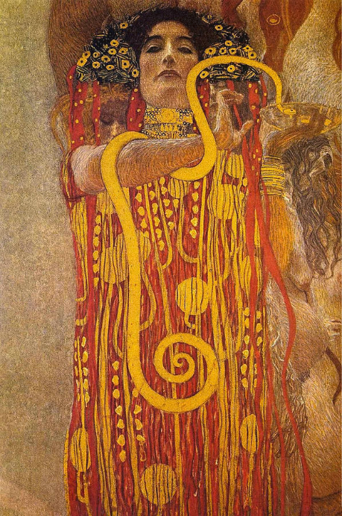
Medicine is a piece that resides second in The University paintings series along with philosophy (1899-1907) being the first and jurisprudence (1899-1907) being the last. As said in Essential Klimt these works ‘represents Klimt’s fall from grace’ (Payne L, 2000, p94) as they were surrounded by controversy as to whether they depicted the right symbolism. It is said that their colour palette was something of a marvel, philosophy being a ‘marine-green colour harmony-like ‘dreaming’’ said pro-Klimt critic Ludwig Hevesi as mentioned in (Payne L, 2000, p94), Medicines palette being made up of reds, warm hues, blacks and gold and jurisprudence largely being made up of gold and black. Klimt displayed this series at his 18th secession exhibition in 1903 after he finished his last painting in the series Jurisprudence.
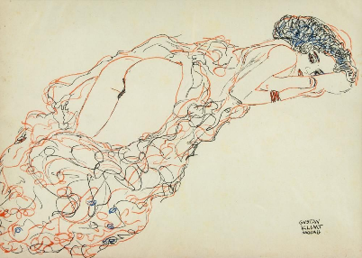
Let’s go back to looking at medicine and her appearance, it’s interesting seeing the full black and white version for the shading and really helps to see where emphasis is given, shading in the river of life gives a lovely feeling of flow, tumbling movement, while the lighter parts give a feeling of hope, light in the dark and what I would imagen to be a warm candlelight orange in the original. The black and white version has an overall lightness that feels like it could go on and on. In contrast to seeing the coloured section of Hygeia, giving hints to the colour palate. The movement in his tones and shading is unreal and makes the painting come alive. Most of his work is very bold but is built up of smaller movements and direction of little lines or longer ones particularly in how he gets this underwater effect with women’s long flowing hair. He takes his time and feels in no need to rush his master pieces.
To conclude, I believe his paintings to be tasteful, colourful and have a royal feel to them mainly given by the gold theme that moved through a lot of his work including medicine. Compared to some of his sketches which I can understand why people especially of Klimt’s time would be seen theses as more pornographic or of an erotic nature. But in Klimt’s times people where still rather constricted, less vibrant, following a more modest way of life and Klimt’s bohemian ideas rocked that boat for a lot of people but for just as many disapproved of his work there were those that idolized him, supported his ideals and believed in a free world to paint beautiful women and enjoy the things life has to offer. He was so world widely known for the controversy that it furthered his fame but landed him in court on occasions. But he thrived and was a very desirable painter, for people to judge, be for or against the movement, or the artist and the art itself with its notes of gold and art Nouveau décor. Moreover, I find it really interesting as people today can see life/figure drawing to be old fashioned, I’m most intriguing how things change over time and how different things capture the eye of the beholder and how the beholder captures there subject and the way they display this so you can look through their eyes even though a long time has passed by.
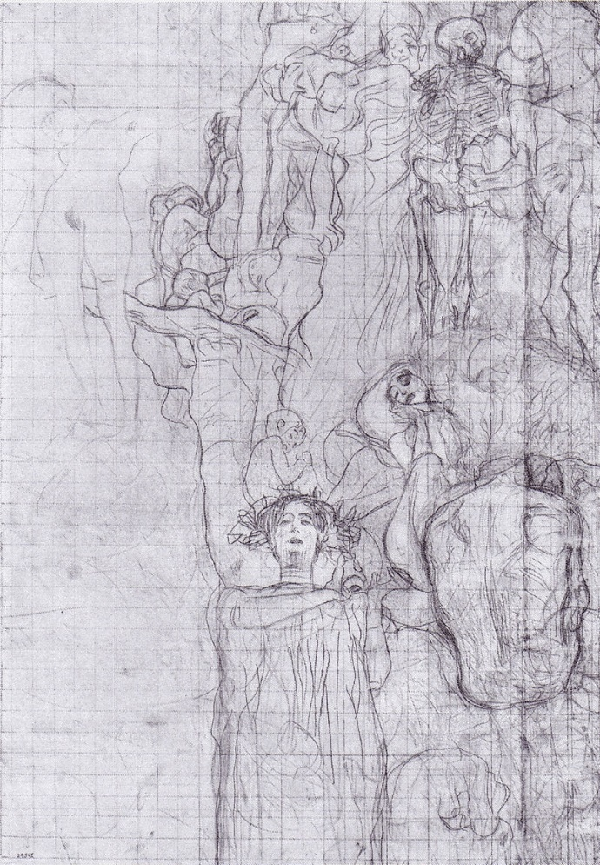
Reference list/ bibliography

Book- A, D’alleva. (2005) Methods & theories of art history. London: Laurence king publishing ltd.
Book - Partsch, S. (2008) Gustav Klimt Painter of Women. London: Prestel Verlag.
Book – Payne, L. (2000) Essential Klimt. Bath: Paragon.
Book –R, Waissenberger. (1977) Vienna, Succession. London: academy editions.
Article – Florman, L. (1990) ‘Gustav Klimt and the precedent of ancient Greece’ [online]the art bulletin. 72, 310-326 Accessed Oct 6. 2023.
Article – Morowitz, L. (2016) ‘hail the hero Klimt!’ nazi aesthetics in Vienna and the 1943 Gustav Klimt retrospective.’[online] oxford art journal. 39, 107,129 Accessed Oct 20. 2023.
Article – Marlowe-Storkovich, T. “‘Medicine’ by Gustav Klimt.” Artibus et Historiae, vol. 24, no. 47, 2003, pp. 231–52. JSTOR, https://doi.org/10.2307/1483769. Accessed 7 Dec. 2023.
Article - Topp, L (2008), Klimt. Liverpool [online] The Burlington Magazine, Vol. 150, No. 1265, Collectors and Collecting pp. 562-563 (2 pages) Accessed: 9 Oct. 2023.
Article – Warlick, M. (1992), Mythic Rebirth in Gustav Klimt's Stoclet Frieze: New Considerations of Its Egyptianizing Form and Content [online] The Art Bulletin, Vol. 74, No. 1 pp. 115-134 (20 page) Accessed 11 Oct. 2023.
Images
https://en.wikipedia.org/wiki/Klimt_University_of_Vienna_Ceiling_Paintings#/media/File:Klimt_-_%C3%9Cbertragungssskizze_der_Medizin.jpeg
https://www.gustav-klimt.com/Medicine.jsp
https://images.fineartamerica.com/images/artworkimages/mediumlarge/3/2-medicine-gustav-klimt.jpg
https://www.bing.com/images/search?view=detailV2&ccid=Tr5vKOHo&id=36E06F257BEB2F3E196136C55ACEBC1DC2D3F263&thid=OIP.Tr5vKOHomYexIrNwrgYwcAHaFQ&mediaurl=https%3a%2f%2fi.pinimg.com%2foriginals%2fa4%2f19%2fab%2fa419ab3b89e4f2fb0e26a455dd6879ba.jpg&cdnurl=https%3a%2f%2fth.bing.com%2fth%2fid%2fR.4ebe6f28e1e89987b122b370ae063070%3frik%3dY%252fLTwh28zlrFNg%26pid%3dImgRaw%26r%3d0&exph=710&expw=1000&q=Gustav+Klimt+Sketches&simid=608024991555079062&FORM=IRPRST&ck=2D3866B555EB508293DD8B3FADCF4502&selectedIndex=45&itb=0&ajaxhist=0&ajaxserp=0

