

BEng (Hons) Electrical and Electronics Engineering

Automated Window Shades Solution

By

Jennifer Hill

Potential Supervisor:

Gary Jones

October 2024

Contents
Introduction 2
Key Developments 3
Key Trends 3
Technologies 3
Research Gap 3
Problem Statement 3
Project Aim 4
Project Objectives 4
Expected Outcomes 4
Project Design 5
Data Collection Methods and Objectives 5
Develop and Prototype Shading System 5
Specialist Development Methods and Techniques 6
1. PLC Programming: Programming the Siemens PLC to operate with precise, real-time responsiveness to sensor data, ensuring the system can dynamically adjust shading based on environmental inputs. 6
2. Motor Calibration: Ensuring the motor’s movement corresponds accurately to shade positioning commands from the PLC, particularly for gradual adjustments based on light and UV intensity. 6
3. System Testing and Tuning: Iterative testing of the system within a controlled environment to calibrate sensors, refine the PLC program, and validate system responsiveness. 6
Risk Management Process 6
1. Technical Risks: 6
2. Health and Safety: 6
3. Legal Compliance: 6
Ethical Implications 6
Environmental and Societal Impact 7
Data Analysis and Evaluation Methods 7
References 8

Introduction

Managing over exposure to uncontrolled brightness and ultraviolet (UV) rays can have damaging effects to workers welfare, machinery and materials in commercial and industrial applications as well as making the environments difficult to temperature control which leads to increased cooling costs. There is an increasingly growing demand for energy efficiency technologies especially with the integration of advanced window systems, sunlight control and automated shading.

An ‘Automated Window Shades Solution’ can integrate with already exciting building management systems with real life control over brightness and UV exposure. Controlling natural light use doesn’t just improve energy efficiency but increases the longevity of the UV sensitive equipment. The system will be particularly useful to the electronics, pharmaceuticals, catering and automotive industries, as well as warehouses for product storage.

The development of automated shading systems that adapt to the environmental conditions is essential. Automated window shades have been evolving in the past decade with technological advancements for Smart Building Systems, energy efficiency and individuals’ well-being.

Key Developments

- Smart building control to adapt to the indoor and outdoor environments with the goal to reduce the use for HVAC (Heating, Ventilation, and Air Conditioning) and lighting systems and reach sustainability goals and cut down on energy consumption.

- Improvement in control of the systems to allow for more specific positions and movement for better performance. As well as remote and automatic control based on real time data with IoT connectivity.

- Exterior shading devices are a key development in the market because they are more effective at blocking solar heat compared to internal shades, especially in hot climates where most energy is used on cooling systems

- Natural light optimisation to help reduce energy consumption negating the sole need for artificial lighting and visual comfort. There’s also been research on mental health, productivity and natural light in the workplace, especially with mental health initiatives in the workplace on the rise.

Key Trends

- Smart and Connected Systems: Systems that can be controlled remotely or automatically adjust based on real-time data is a growing trend.

- Adaptable for Comfort: Increased demand for customized indoor environments has made automated shading systems more appealing, especially in office and commercial spaces where comfort and productivity are important.

Technologies

The development of adaptive and automated shading systems is driven by several key technologies:

- IoT (Internet of Things): Monitoring the environment and shading systems with apps and integrated management systems.

- Sensors: To adjust based on conditions such as sunlight intensity and temperatures with sensors

- Sustainable Materials: The use of recyclable materials

Research Gap

There have been many studies and developments in automated shading systems, but a gap seems unexplored:

Commercial and Industrial Applications: Many studies look at domestic applications, with less thought on commercial and industrial buildings, where energy consumption and light management is more complicated.

Problem Statement

There is notable gap in scalability, particularly in large commercial and industrial buildings. Existing systems are primarily designed for residential or small-scale commercial use, where the complexity of light and energy management is less challenging.

Project Aim

To program a scalable automated window shades system able to be used in commercial and industrial buildings.

The aim of this project is to develop and program an Automated Window Shading System that can to adapt and incorporate into commercial and industrial buildings.

Project Objectives

- To analyse the current applications in commercial and industrial settings and apply scalability and adaptability:

  - Conducting a thorough literature review.
  - Reviewing existing studies and market trends.

- To design and develop a scalable automated window shading system:

  - Creating a prototype system capable of adapting to both small and big buildings.

- To implement and evaluate the system's performance in terms of adaptation to different environments:

  - By conducting trials and gathering data metrics including temperature, and UV readings.

- To assess the system’s overall precision of the window shades in the created conditions:

- By conducting performance tests and analysing the movements when environmental preferences are selected.

Expected Outcomes

Prototype of the Automated Window Shading System: A functional, scalable prototype of an automated window shading system designed to adapt and integrate into large commercial and industrial buildings.

Project Design

Using Siemens PLC (Programmable Logic Controller) and a motor to control window shades in commercial and industrial environment. The PLC will process input signals from the sensors (light, temperature and UV) to adjust the shades, for enhancing light and temperature control.

Main Components:

- PLC: The Siemens PLC will operate as the control unit, receiving data from sensors and controlling motor actions based on programmed logic. The Siemens PLC is the most suitable as its used in a wide range of applications as well as being relatively inexpensive compared with other brands.

- Siemens Simatic HMI Display:

- To seamlessly integrate with the Siemens PLC using TIA Portal software.
- Easy to use and customisable user interface to tailor to the needs of specific users
- Durable and industrial grade design which makes them reliable and resistant in most environments.
- Can monitor real-time data to control locally or remotely the parameters directly.

- Sensors:

- Brightness Sensor: for managing the brightness levels in the environment for worker comfort.

- UV Sensor: for managing sunlight exposure to prevent the temperature rising.

- Temperature sensor: to analyse the temperature to analyse environment accurately and prevent high temperatures.

- Motor: The Stepper Motor moves in small increments and so perfect for precise and controlled movement that are usually measured in degrees. They have high torque and low speeds which allows them to hold positions firmly which makes them very reliable.
The stepper motor can attach to the linkage arm of the window shades used for the purposes of this project.

Data Collection Methods and Objectives

Develop and Prototype Shading System

Sensor data (light intensity, UV, temperature) and operational data from the PLC will be collected to validate the shading system’s responsiveness and functionality. To ensure the system responds accordingly to environmental changes.

Specialist Development Methods and Techniques

- PLC Programming: Programming the Siemens PLC to operate responsively to the sensor data, making sure the system can adjust shading based on data inputs.

- Motor Calibration: Confirming the motor’s movement respond accurately to shade movement commands from the PLC, particularly for specific adjustments based on light and UV intensity.

Risk Management Process

Technical Risks:
- Motor malfunction, leading to system failure.
- Mitigate by performing regular calibration and programmed failsafe’s in the PLC to stop if sensor data becomes invalid.

Health and Safety:
- Potential harm if the motorised shades malfunction.
- Mitigate by incorporating an emergency stop function.

Ethical Implications

- Safety Considerations: The design must prioritise safety, with failsafe mechanisms for shade control and motor operation.

Note: An ethics form will be submitted to address these concerns formally and ensure compliance with institutional standards.

Environmental and Societal Impact

- The project will help to reduce future energy consumption and supporting sustainability goals.

- Societal Impact: Improving UV protection and light control will positively impact future workers' health and productivity, making the workplace safer and more comfortable.

Data Analysis and Evaluation Methods

Comparative Analysis: Compare pre- and post-implementation data. i.e. temperatures, UV and brightness to assess the shading system’s ability.

Resources Required

- TIA Software to program the PLC system

Estimated Project Development Chart

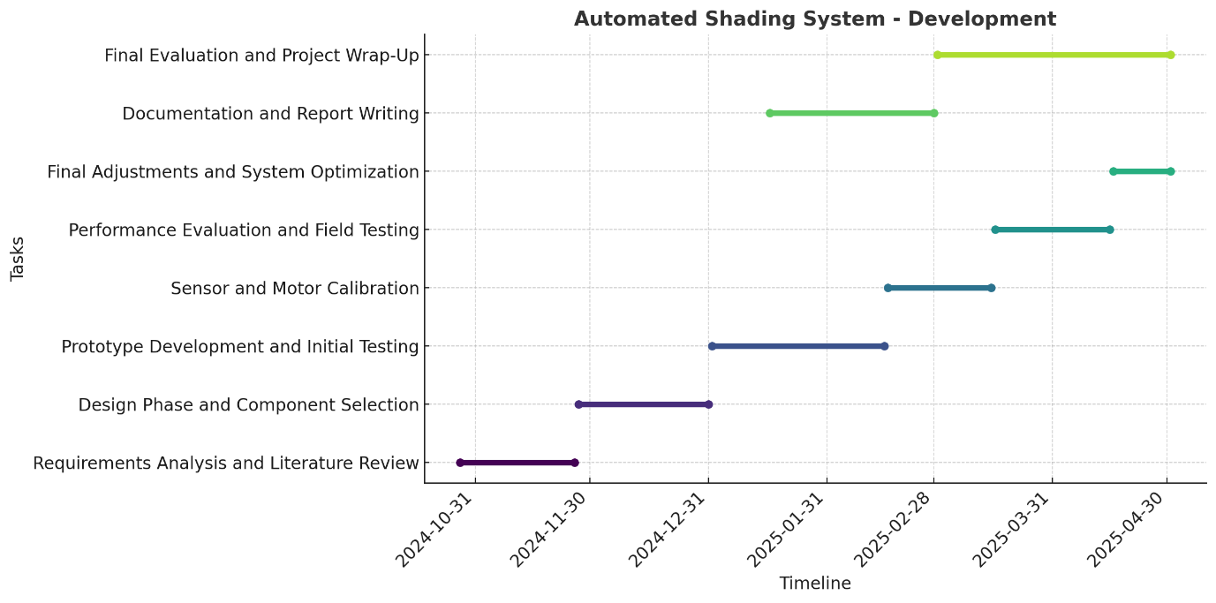

References

https://escholarship.org/content/qt5mq2p25x/qt5mq2p25x.pdf

