STUDENT NAME: FATOU CUBA
STUDENT ID: 2421797
MODULE CODE: BMHP5014

Part 1
MindConnect UK: An AI-Powered Mental Health Support Platform for Young Adults Innovation Overview

Mental health issues are one of the major public health problems in the United Kingdom, especially for young adults aged 18 to 25 years. Anxiety, depression, stress and social isolation are all at unprecedented levels and have put an unprecedented strain on the National Health Service (NHS), universities and community health services. While the NHS has increased the availability of psychological therapies services and launched a number of digital mental health services, many young people still face long wait times, restricted access to professional psychological help and stigma and cost concerns. This is why there is a pressing need for innovative, technology-enabled solutions that work alongside the current health and care system and enhance early intervention for mental health issues (NHS England, 2023).

MindConnect UK is suggested to be a novel artificial intelligence (AI) driven mental health support system tailored for supporting the mental health of young adults within the United Kingdom. The platform isn't meant to take the place of healthcare professionals but rather to complement the NHS mental health services with personalized digital support, initial mental health self-screening, ongoing emotional surveillance, and evidence-based self-management tools. The platform leverages artificial intelligence, machine learning and mobile health (mHealth) technologies to detect signs of psychological distress at an early stage and provide the user with the right support, based on their specific needs.

The app would also enable the user to fill out a confidential mental health self-assessment with validated psychological screening tools like the PHQ-9 and the Generalised Anxiety Disorder Scale (GAD-7). AI algorithms would read users' answers, monitor their behavioural patterns and track their mood to provide individualised wellbeing recommendations based on these, such as mindfulness exercises, self-help tools based on cognitive behavioural therapy (CBT), guide users through stress management and even signpost users to NHS Talking Therapies or emergency crisis services if relevant. Importantly, all high-risk cases, including indications of self-harm or suicidal ideation, would be first referred to qualified healthcare professionals, rather than allowing AI to operate as a final decision maker (Topol, 2019; NHS England, 2023).

The proposed innovation is aligned with the growing digitalisation of healthcare in the UK, and the NHS Long Term Plan which calls for the use of digital technologies to enhance patient access, improve service efficiency and deliver personalised healthcare services (NHS England, 2019). AI has shown great promise in enhancing healthcare accessibility, aiding early diagnosis, and alleviating administrative burdens for healthcare providers. Recent studies show that AI enabled digital mental health interventions can enhance symptom monitoring, engagement with patients and continuity of care, and help healthcare professionals prioritize patients who might need immediate clinical attention ( Ng et al., 2022).

In addition, MindConnect UK aims to help tackle inequalities in mental health care by offering a free, safe and easy-to-use platform, which is accessible 365 days a year, 24 hours a day. Psychological distress happens when many young people are not available for routine health care services at conventional hours, and help is not readily available. Continuous availability promotes help-seeking behaviours and provides people with an opportunity to take greater responsibility for their mental wellbeing before it becomes serious. This preventative strategy resonates with the existing public health agenda that prioritises early intervention, health promotion and patient-centred care (World Health Organization 2022).

The innovation also drives interdisciplinary cooperation between healthcare professionals, the universities, local authorities and digital technology developers. All clinical governance would be overseen by healthcare practitioners and universities and community organisations could explore how this platform could enhance and reinforce student wellbeing services and ensure appropriate referrals. This would mean that technological innovation is ethically responsible and clinically effective and meets the needs of service users.

In summary, MindConnect UK is a pioneering healthcare technology solution that leverages AI with clinical supervision to improve mental health care for young adults. Combining digital innovation with evidence-based psychological care, the platform can help to enhance patient experiences, alleviate pressure on mental health services in the NHS and ensure fair access to quality mental health care in the United Kingdom.

An issue and gaps in health and social care will be developed.An issue and gaps in health and social care will be constructed.

Psychological distress is one of the most important types of illness affecting young adults worldwide and the prevalence of psychological distress has risen considerably in the United Kingdom during the last decade. Increased anxiety disorders, depression, self-harm, feelings of loneliness and emotional stress are found among university students and young professionals, especially after the COVID-19 pandemic. The need for mental health services has significantly increased, placing significant strain on services and leading to longer wait times for assessment and treatment, as reported by NHS England (2023).

Although funding for mental health services has been ongoing, there are still some gaps in the existing health and social care system. Limited availability of qualified mental health service providers is one of the biggest challenges. Fewer people are referred for specialist care in time because of shortage of staff in psychiatry, psychology and mental health nursing. This often means that mental health issues can escalate to a point where suitable treatment is not available, leading to hospital admissions, lower educational results and poorer long-term health outcomes (Health Foundation, 2024).

The other significant issue is accessibility. A number of young adults face obstacles to accessing professional help such as stigma, the perception of limited confidentiality, financial accessibility and lack of knowledge of services. Geographical inequalities in the provision of health services may present further difficulties for people living in deprived or rural areas. This means that many young people try to work through their psychological issues themselves until they get so bad that emergency support is needed (McGorry et al., 2022).

Over the last couple of years a number of digital mental health services have grown in size, although there is still a large number of services that are not clinically validated, not integrated with the NHS system or overseen by professionals. There are many mental health apps on the market that give general information about mental health without a specific evaluation or referral process, which reduces their clinical utility and may cause a delay in accessing the appropriate care. The quality of the different digital mental health technologies (THTs) has been a concern due to the lack of quality standards, as well as the lack of regulation and protection of sensitive health data within them (Torous et al., 2021).

The use of AI can offer great potential to solve some of these healthcare issues. AI systems can process vast amounts of patient-generated data and detect patterns of behavior that could indicate poor mental health, and assist healthcare providers in streamlining triage workflows. However, issues of ethical principles of algorithmic bias, transparency, accountability and patient privacy should be handled sensitively. There is a need for robust clinical governance, human oversight and adherence to national guidance and regulation on AI, such as the UK General Data Protection Regulation (UK GDPR), the Data Protection Act 2018 and NHS Digital guidance on artificial intelligence (Department of Health and Social Care, 2022).

MindConnect UK has been created to meet these identified gaps, it is not meant to replace any existing health care services. The platform integrates AI-enabled early screening and continuous wellbeing monitoring, while streamlining workflows with NHS referral pathways, fostering early intervention and assisting healthcare providers to manage the growing demand on their services. The innovation also helps to achieve digital inclusion by making available an evidence-based resource for mental health, accessible to anyone and usable without revealing their location or socioeconomic status.

MindConnect UK can help to enhance individual wellbeing and population health outcomes by expanding preventative mental health care and helping to connect digital with professional health and wellbeing services.

Target Audience and Impact

MindConnect UK is intended for young adults (18-25 years) such as university students, apprentices, young professionals, and those moving onto independent adulthood. This population is vulnerable to experiencing significant psychological distress from academic challenges, financial uncertainty, employment difficulties, and evolving social relationships and significant life changes. Three-quarters of mental health problems emerge before age 25, underscoring the need to identify and respond to them early (Kessler et al., 2021). MindConnect UK aims to offer early and accessible mental health interventions to this age group, before the onset of more serious clinical states.

Besides young adults, the innovation is likely to have an impact on a broad sector of the health and social care community. AI-powered screening and referral tools will help healthcare providers, such as general practitioners, mental health nurses, psychologists and NHS Talking Therapies practitioners, to streamline services and prioritise patients needing immediate intervention. Another advantage for universities and higher education institutions will be the better wellbeing support for their students, better retention of students and better support with local NHS services. Emotional and financial pressures can be reduced for families and carers, as young adults get earlier help and interventions.

The potential of MindConnect UK goes beyond patient outcomes and reaches into the health and social care system as a whole. Early detection of mental health issues can help minimize the severity of the illness, enhance recovery rates and lower the need for emergency mental health care. Greater access to evidence-based digital support could also help to close health inequalities, as digital support may be available to people who would otherwise have limited or no access to traditional services, because it is free and confidential. In addition, the platform holds the potential to contribute to the NHS focus on person-centred and digitally enabled healthcare, with self-management, mental health literacy and suitable referrals to healthcare professionals. In summary, MindConnect UK can have a positive impact on psychological wellbeing, efficiency of services and benefit the common good, through making mental health services more accessible, equitable and sustainable in the United Kingdom.
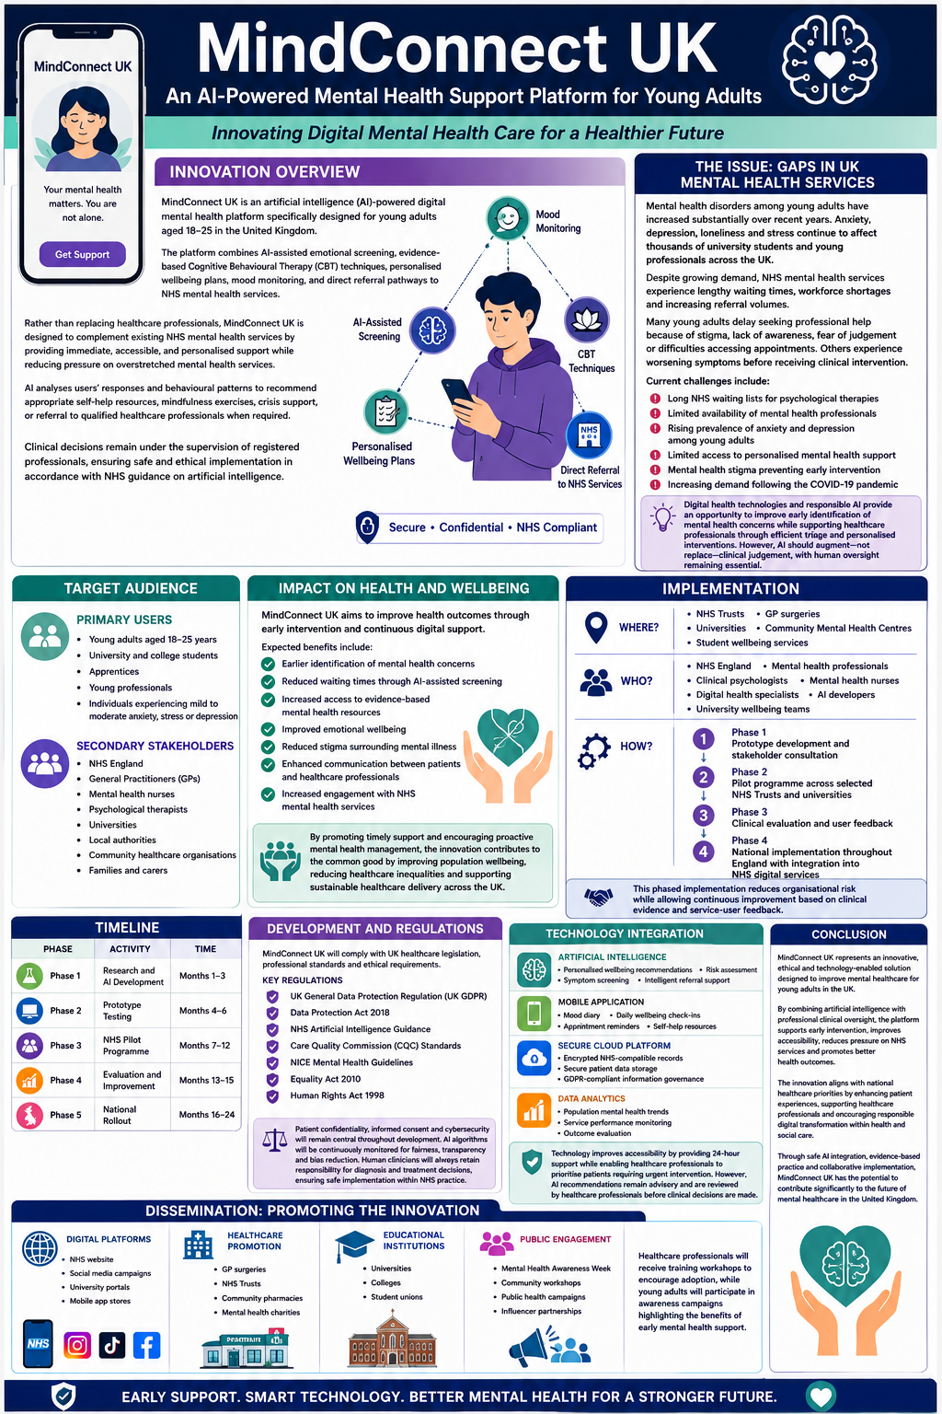
Reference
Cipriani, A., Singh, I., Desai, G. and Tomlinson, A. (2022) ‘Building trust in artificial intelligence and new technologies in mental health’, Evidence-Based Mental Health, 25(2), pp. 45–46. Available at: https://doi.org/10.1136/ebmental-2022-300489.
Department of Health and Social Care (2022) Data saves lives: Reshaping health and social care with data. London: DHSC.
Health Foundation (2025) AI in health care: What do the public and NHS staff think? Available from the Health Foundation.
Karyotaki, E., Efthimiou, O., Miguel, C., et al. (2021) ‘Internet-based cognitive behavioural therapy for depression: A systematic review and individual patient data network meta-analysis’, JAMA Psychiatry, 78(4), pp. 361–371.
National Institute for Health and Care Excellence (2022) Depression in adults: Treatment and management (NG222).
National Institute for Health and Care Excellence (2022) Medicines associated with dependence or withdrawal symptoms: Safe prescribing and withdrawal management (NG215).
NHS England (2019) The NHS Long Term Plan.
NHS England (2023) NHS Mental Health Implementation Plan 2019/20–2023/24.
NHS England Digital (2026) Artificial intelligence guidance for health and care professionals. Available via NHS Digital guidance.
O'Dell, B., Stevens, K., Tomlinson, A., Singh, I. and Cipriani, A. (2022) ‘Building trust in artificial intelligence and new technologies in mental health’, Evidence-Based Mental Health, 25(2), pp. 45–46.
Torous, J., Bucci, S., Bell, I.H., et al. (2021) ‘The growing field of digital psychiatry: Current evidence and the future of apps, social media, chatbots and virtual reality’, World Psychiatry, 20(3), pp. 318–335.

Part 2
Implementation
Adopting MindConnect UK will require a multi-agency and staged approach, that will involve NHS England, Integrated Care Boards (ICBs), general practitioners (GPs), universities, community mental health services, software providers and mental health professionals. The main aim is to provide the platform as a way of supporting, not replacing, face-to-face mental health services in the NHS. The NHS Long Term Plan highlights the importance of digitally-enabled health care, making health care more accessible and relieving pressure on over-stretched services (NHS England, 2019). The Department of Health and Social Care (2022) also reports that digital innovations can be used to improve the quality of services, service outcomes and efficiency of services provided safely using health data.
The development process would start with software engineers, cyber security specialists and artificial intelligence (AI) experts working side by side with clinical psychologists, psychiatrists and mental health nurses to create the app for six months. All assessment tools, such as the Patient Health Questionnaire (PHQ-9) and the Generalised Anxiety Disorder Scale (GAD-7), would be evidence-based and clinically suitable in the context of healthcare used. This would also be the time for the platform to be thoroughly tested as part of the security process to ensure it adheres to the cybersecurity and information governance practices and standards of the NHS (Department of Health and Social Care, 2022; NHS England Digital, 2026).
Once software development was complete, MindConnect UK would be trialled in a number of NHS Trusts and University wellbeing services in England. The pilot programme will be run for six months to assess usability and patient satisfaction, as well as referral accuracy and clinical effectiveness. This process will be continuous before it is widely implemented with user feedback. If the platform was successful it would be implemented in NHS Talking Therapies, GP surgeries, community mental health teams and universities and colleges. The healthcare professionals would be responsible for managing referrals and starting clinical interventions as necessary and young adults would use the application through secure NHS login authentication. The NICE (2022) guidance states that there is a need for coordinated care pathways and for people with depression and/or a heightened risk of self-harm to be routinely monitored and referred to specialist services, thus reinforcing the need to incorporate digital mental health technologies into current services.
Timeline
The MindConnect UK rollout would be planned over a 24-month period with key milestones to minimise organisational risk and provide for continued monitoring and improvement.
The stakeholder consultation, which would include NHS England, would happen concurrently with the University wellbeing teams, health care professionals and young adults – in Months 1-3. The service gaps would be identified in the needs assessments and software developers would start designing the AI-based application. Planning for cyber security and clinical governance also would be put in place and ethical approval granted at this stage.
The simulated patient data would be used from Months 4-6 during the course of prototype development and usability testing. Clinical professionals would assess the accuracy of mental health screening with AI and software developers would improve the performance of the system, based on user feedback.
From Months 7-12 the innovation would be tried out in various NHS Trusts and Universities. Continuous monitoring of clinical outcomes, referral rates, patient engagement and users' satisfaction would be used to assess effectiveness. Training should be provided to healthcare workers on the AI system, offering them clinical supervision.
The outcomes of the pilot programme will be leveraged to make enhancements to the system in Months 13-18, to further cyber security and enhance interoperability with the NHS digital environment. Finally the platform, which had been successfully piloted at a local level, would be introduced nationally in England at a phased level to GP surgeries, community mental health and universities in Months 19-24. Ongoing monitoring, annual audits and patient feedback would help to sustain and enhance the services (NHS England, 2023).
Development and Regulations
To keep patients safe and ensure public confidence, the development of MindConnect UK needs to abide by the healthcare legislation, ethical principles and professional standards in the UK. Due to the sensitive health information being handled, compliance with the UK General Data Protection Regulation (UK GDPR) and Data Protection Act 2018, is essential to the platform. The regulations mandate that medical institutions gain informed consent, use data in a lawful way and put in place strong cybersecurity protocols to safeguard personal patient information (Department of Health and Social Care, 2022).
The innovation would also comply with the guidance from NHS England Digital on the responsible use of AI in health and social care. Organisations should involve Information Governance Leads, Data Protection Officers, and Caldicott Guardians in the implementation of AI technologies, fostering responsible and ethical data utilization, transparency, and accountability, the guidance recommends. Moreover, the healthcare professionals should remain in the driver's seat and realize that AI is not a substitute for their expertise, but rather a tool that can assist them in making decisions. Organisations are also urged to keep a close eye on AI systems for any potential risks to patient safety, inappropriate outputs, and algorithmic bias.
The platform would also adhere to the guidance of the NICE Guideline NG222, which outlines evidence based interventions, person centred care, regular risk assessments and rapid referral for anyone with a depression or suicidal thoughts. NICE also highlights the need to reduce stigma, engage patients in decision making and deliver coordinated care via multidisciplinary teams, which are all part of the design of MindConnect UK.
Other regulatory compliance considerations would include meeting the Fundamental Standards of the Care Quality Commission (CQC), the Equality Act 2010 and the Human Rights Act 1998. They are legislative documents that ensure that the innovation is equality and access promoting, that is, it respects confidentiality, person centred care and it respects the dignity and rights of the service users.
Technology Integratio
At the heart of MindConnect UK is technology: Artificial intelligence, mobile health technologies, cloud computing and secure digital communication all rolled into one. The answers to the validated mental health questionnaires would then be submitted to AI which would monitor changes in behavior, and be able to identify early signs of anxiety, depression or emotional stress. These would then be used to make recommendations for individual interventions that could be delivered on the platform such as cognitive behavioural therapy (CBT) based exercises, mindfulness exercises, stress management techniques and refer to NHS Talking Therapies if appropriate.
The app would also feature patient-provider messaging, customised wellbeing plans, reminder notifications for appointments and mood tracking. It would enable patients to access their health records anywhere, anytime as it would be stored in the cloud and Only Hospital Staff with approval could login into it. Data Analytics also would enable health care organisations to monitor the demand for services, predict future trends in mental health and evaluate the effectiveness of interventions.
These technical benefits do not come, however, without the need for responsible human oversight of the use of AI. At times, AI systems can generate inaccurate or conflicting results (NHS England Digital, 2026), and clinical decisions must always be made in consultation with healthcare practitioners, after checking AI-suggestions. By doing so, technology can enhance the provision of health services while not compromising the safety of patients, transparency or responsibility of the practitioner.
The Innovation is spreading across the state.
To facilitate the spread of MindConnect UK amongst healthcare professionals, young adults and the wider community, successful dissemination is essential to encourage wider adoption. Digital marketing and healthcare promotion/public engagement programmes would then form part of a concerted communication strategy.
The innovation will be promoted first via NHS England, GP surgeries, Integrated Care Boards and University wellbeing services. Healthcare premises, schools and community groups/centres would be used to promote awareness of the platform through the use of posters, QR codes and information leaflets. Healthcare providers would receive mental health technology training through structured workshops and ongoing professional development to enhance their competency and confidence in mental health technologies powered by AI.
Digital dissemination would consist of social media campaigns for young adults on Instagram, Facebook, TikTok, and LinkedIn with patient testimonials, videos about the brain and mental health and mental health awareness campaigns. This could be strengthened and extended through effective partnerships with charities such as Mind and YoungMinds and encourage the taking of early help, leading to greater trust in the public. Universities would also embed MindConnect UK into induction programmes, wellbeing programmes and mental health awareness programmes to ensure for optimal engagement of young adults.
Finally, annual evaluation reports will be submitted to NHS England, government and healthcare commissioners to help plan for future funding and national implementation, based on the outcomes for patients, the quality of referrals and the effectiveness of enhanced services.
Conclusion
MindConnect UK is an innovative, person centred, evidence-based service to improve mental health services for young adults in the UK. It combines AI functionality with human clinical management to enable early intervention, access and enhanced communication amongst health care professionals and service users. The innovation is in line with the strategic agenda of the NHS Long Term Plan and has the potential to help the NHS become a digitally-enabled service, as well as reduce the pressure on already stretched mental health services.
Furthermore, the innovation will be ethical, safe and clinically effective, as this will follow the UK legislation, NICE guidance and NHS information governance standards. By using AI in a continuous manner, working across many disciplines, and responsibly, we believe that MindConnect UK can play a major role in enhancing mental health outcomes, in reducing inequalities in health and social care and in significantly
Reference
Department of Health and Social Care (2022) Data saves lives: Reshaping health and social care with data. London: DHSC.
Karyotaki, E., Efthimiou, O., Miguel, C. et al. (2021) ‘Internet-based cognitive behavioural therapy for depression: A systematic review and individual patient data network meta-analysis’, JAMA Psychiatry, 78(4), pp. 361–371.
National Institute for Health and Care Excellence (2022) Depression in adults: Treatment and management (NG222).
NHS England (2019) The NHS Long Term Plan.
NHS England (2023) NHS Mental Health Implementation Plan 2019/20–2023/24.
Torous, J., Bucci, S., Bell, I.H. et al. (2021) ‘The growing field of digital psychiatry: Current evidence and the future of apps, social media, chatbots and virtual reality’, World Psychiatry, 20(3), pp. 318–335.
World Health Organization (2022) World Mental Health Report: Transforming Mental Health for All.
NHS England Digital (2026) Artificial intelligence guidance for health and care professionals.
Topol, E. (2019) The Topol Review: Preparing the healthcare workforce to deliver the digital future.

