Solomon Lopez.
1914083.
Changemakers: Creativity and Value Creation.
Dr Azora Hurd.
BMHP5014_BIRM.
E-portfolio that addresses task one and two.

Contents
Task one…………P3
Task two…………………P5
References……………………….P6

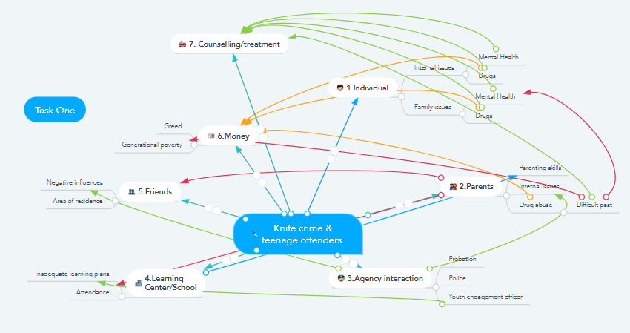
(Mindmeister, 2021).

My idea in the above mind map relates to knife crime and teenage offenders, selecting those most at risk and identifying how they can be assisted to further offending.
- Individual – This would be highlighting the most at risk individuals and looking at issues such as mental health and drug use as causes for offending. Drug use has been linked to money as if money is an issue the use of drugs will continue to help make the situation worse.
- Parents/carers – Engaging with parents to highlight issues they may have such as mental heath and drug abuse which they may also need support for to help support their teenage child. Parenting skills has been linked with learning centre.
- Agency interaction – Highlighting what other agencies may be needed to help support the teenager and/or parent. Identifying concerns other agencies may have concerning the teenager and/or parent.
- Learning centre/school – Understanding what learning plans are in place to support the teenager and if changes are needed for it to be effective. This was linked with parents as if needed sourcing parenting skills courses may be needed.
- Friends – Identifying friends that may be at risk and need of intervention through other agencies and learning centre. Identifying not only those at risk but those may pose a threat.
- Money – Understanding how the young person budgets their money. Identifying if they must support parents due to generational poverty or greed being an issue. Money is linked to drug use as this may be the source of money issues.
- Counselling – Counselling may be an option due to drug abuse or mental health issues. This was linked to parents as counselling may also be needed for them in order to help them support their young person.

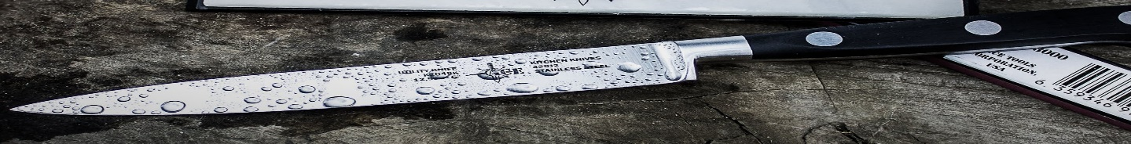
Task two
www.innovativeprogrammes.com/offending/teen

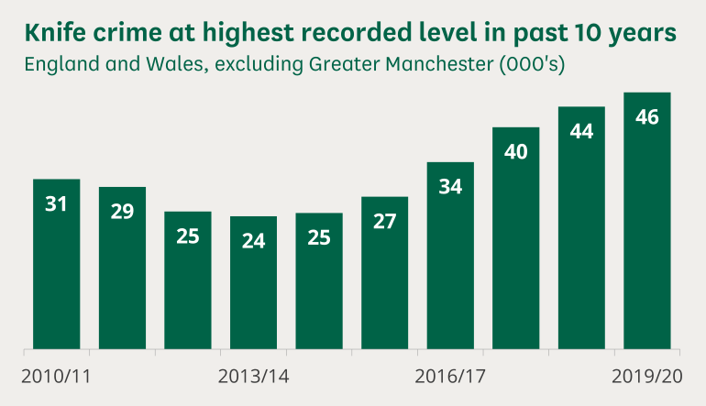
Knife Crime & Teenage Intervention Programme
S.Lopez 1914083
“Knife crime is a persistent and worrying concern, especially as it impacts particularly upon young people and the disadvantaged, and various remedies have been tried over the years” (Kirk-Wade. E, 2020).
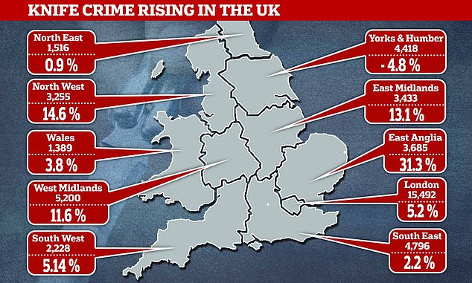
The knife and intervention programme came about after looking at the numbers of young people carrying knives and wanting to understand the different aspects that may be involved to explain this. In the year ending June 2019, there were 22,306 disposals given for possession of a knife or offensive weapon. Juveniles (aged 10-17) were the offenders in 20% of cases (Kirk-Wade. E, 2020). The 20% is who this programme is targeted towards. This programme aims to address the many issues and factors that may cause the most serious youth offending. Participants in the programme will be the most at risk and be referred by either youth offending services, police, or social services. The youth justice system was created to rehabilitate the youngest offenders, but with cuts to public services causing some of the most vulnerable, young offenders slipping through the gaps it is failing – 76 % of children who serve custodial sentences go on to reoffend (Longfield. A, 2020). Youth offending services are currently stretched, this programme aims to bridge the gap between multiple agencies and establishments to offer a complete individualised support plan for each individual young person. We will engage with the young people on the programme addressing aspects such as education, drug use, friends, external agencies etc to get a better understanding of the individual young person’s needs. Young people associated with gangs or recently released from prison are particularly at risk. The programme will liaise with the youth offending service to identify those due for release that may be at risk and as such eligible for the programme. Agencies such as youth offending services and probation offer young people a level of support but this will differ as the programme will aim to liaise with their school or learning centre, monitor drug use, engage with parents/carers, friends, other external agencies those with the worst offending records and tailor 1-2-1 plans for that young person with a increased level of interaction. Those delivering the programme will have a background in either the youth offending services or probation. They will have an in-depth knowledge of the needs and challenges each young person may face and have the adequate skills to deal with issues as they arise.

References
Kirk-Wade, E., Allen, G. (2020) knife crime statistics (illus.). Available at: https://commonslibrary.parliament.uk/research-briefings/sn04304/ (Accessed: 15 February 2021).
Kirk-Wade, E., Allen, G. (2020) Knife crime statistics. Available at: https://commonslibrary.parliament.uk/research-briefings/sn04304/ (Accessed: 15 February 2021).
Longfield, A. (2020) Children’s Commissioner: The youth justice system is failing too many children – it’s time for a complete overhaul. Available at: https://www.politicshome.com/thehouse/article/childrens-commissioner-the-youth-justice-system-is-failing-too-many-children--its-time-for-a-complete-overhaul (Accessed: 14 February 2021).
Mindmeister. (2021) mindmap (illus.). Available at: https://www.mindmeister.com/1767660099# (Accessed: 17 February 2021).
SOS Global. (2020) knife crime (illus.). Available at: http://www.sosglobal.org/parents/parents-carers-knife-crime/ (Accessed: 15 February 2021).
Wright, J. (2020) Bloodiest year on record: Knife crime soars by 7% to its highest ever level in England and Wales with 45,627 offences recorded in 2019 - as robbery also rockets by 12% (illus.). Available at: https://www.dailymail.co.uk/news/article-8248449/Children-believe-transgender-face-restrictions-protect-reassignment.html (Accessed 17 February 2021).

