BMMB7013 STRATEGIC MANAGEMENT
Student Name: Gurleen kaur
Student ID: 2216066

Executive Summary:
The study entails a detailed evaluation, analysis and discussions about reshaping of the strategic direction of a chosen organisation. In this report, the chosen organisation is Walmart. Walmart Inc. is an American Multinational retail company that runs a huge chain of hypermarkets, discount departmental stores, and grocery stores within the United States of America. Its headquarter is situated in "Bentonville, Arkansas". The present study discusses different ways of delivering "innovative consumer care services", ensuring future resilience and sustainable competitive advantages against the backdrop of the pandemic. Thus the current report mainly focuses on a thorough strategic analysis of Walmart Inc. by undertaking a range of internal and external analyses and a critical evaluation of the strategic alternatives for personalised customer service.
Table of Contents
Introduction: 3
Strategic Analysis of Walmart 4
External analysis: 4
PEST analysis: 4
Porter’s five forces analysis: 6
Internal analysis: 8
SWOT analysis: 8
VRIO analysis: 9
Inference from the above two analyses: 11
Stakeholder analysis: 12
Critical Evaluation of the strategic options 12
Porter's Generic Strategies: 13
Bowman's Strategy Clock: 14
Ansoff’s Matrix 17
An Ansoff matrix analysis for Walmart is explained below 17
Conclusion: 21
Reference list: 22

Introduction:
The study carries out a thorough evaluation, analysis and discussions about the reshaping of the strategic direction of the chosen organisation, Walmart. It is to be noted that Walmart Inc. is an American Multinational retail corporation that tends to operate a vast chain of hypermarkets, discount departmental stores, and grocery stores within the United States of America headquartered in "Bentonville, Arkansas" (Walton, 2012). It can be said that Walmart Supercentres tend to offer customers one-stop solutions and shopping experiences by combining the grocery stores with bakeries, fresh produce, deli, and dairy products and also electronic goods, toys, apparel, as well as home furnishing (Walmart.com, 2023). Walmart mainly aims to make all the days easier for busy families run with utter discipline and enhance the culture and become more digital and also trust "competitive advantages". Price leadership has been a cornerstone of Walmart's business strategy and model (Bamidele-Sadiq et al., 2022).
Here, this report explores new ways of delivering "innovative consumer care services", ensuring future resilience and sustainable competitive advantages against the backdrop of the pandemic. Thus the current report mainly sheds light on a detailed strategic analysis of the chosen organisation by undertaking various internal and external analyses as well as a critical evaluation of the strategic alternatives for more "personalised customer services" (Bamidele-Sadiq et al., 2022). In addition, the wider implications of the proposed strategies have also been considered in various organisational areas, and a crisp justification will be provided for the recommended strategies with the help of appropriate theoretical frameworks and techniques.



Strategic Analysis of Walmart

External analysis:

PEST analysis:
Political factors: It is to be noted that Government support for cyber securities and smooth operations of the e-commerce industry tend to work in favour of Walmart (Walmart.com, 2023). Moreover, since Walmart is a multinational business, the political stability of the developed countries tends to work in favour of the business (Mounika et al., 2021). Moreover, governmental encouragement towards online retail businesses further tends to pose immense competition in front of Walmart, as a large number of foreign businesses have been making their way to the online retail business industry. Moreover, Walmart, via its functioning, had become potentially influential within state politics (Alsharari, 2021). For instance, they have increased the legal ages for "Gay Rights" and "Gun Licences" to impress customers and potential consumers in 2018. Above all, they have asked the workers to contribute to the Republicans (Bamidele-Sadiq et al., 2022).
Economic factors: Taxes remain a constant challenge for Walmart as they are ever-changing, especially within Asian countries (Volpe and Boland, 2022). However, in developing countries, economic stabilities tend to pose vast growth opportunities for Walmart, as establishing businesses within these markets is smoother when the countries' economies are stable and affluent (Asperti, 2020). Also, it is worth noting that Walmart primarily operates within the USA, which has a potentially stable economic structure. In addition, the continued growth of the developing nations and reduced unemployment rates within the United States are some of the major economic factors that further pose significant opportunities for Walmart (Mounika et al., 2021). For example, the rapid economic growth of countries like India further makes it easier for businesses like Walmart.
Social factors: It is important to note that the rising tendencies of online shopping and increased consumerism would tend to benefit the organisation. Affordable prices of the products sold by Walmart and its diverse product range are what make the company popular amongst all sorts of people (Ramadani, 2020). Moreover, since maintaining a healthy lifestyle is the new trend on digital and social media platforms, Walmart's health-friendly products add to the business's advantages regarding social factors (Garcia, 2020). However, it is important to note that the shifts in living styles are another reason behind the shifts in the demands of various goods and therefore, the organisation needs to determine how to run their business accordingly (Shanshan, 2020). Additionally, enjoying diverse cultural spectrums and showing respect to all kinds of people is trendy (Bratton and Boak, 2020). The factors here thus potentially influence the market and hence are considered a critical external factor that Walmart must consider (Shanshan, 2020).
Technological analysis: Since Walmart has been focusing on expanding its e-commerce business sector, it can be said that technological advancement is another crucial factor affecting Walmart's business. Technological innovation, automation, effective change and wider technical awareness are the most important factors that tend to help organisations intelligently plan their future (Volpe and Boland, 2022). Thus, Walmart can significantly employ automation technologies to save time and resources (Piórkowska, 2021). Moreover, smartphones are used by an immense number of people around the world, which has facilitated a tech-savvy consumer circle. Hence, it should be noted that to increase its consumer base, Walmart must be tech-savvy as well (Ramadani, 2020).
For example, with the new Walmart mobile application, the consumer experience has been enhanced as they no longer need to carry physical checklists but can mark the things they need on the app. Moreover, aligning with the "profit-maximising and competition-based theory", it can be said that the main goal of a business is to keep increasing its long-term profits and generating sustainable competitive advantages for increasing business sustainability (Volpe and Boland, 2022). It can thus be said that MNCs like Walmart need to consider their massive data and thus leverage advanced technologies to increase business sustainability (Karpenko, 2019). Technological advancements such as the emergence of business analytics, big data and the growing usage of mobile devices amongst customers are some opportunities for Walmart in terms of technological factors (Chen, 2020).

Porter’s five forces analysis:
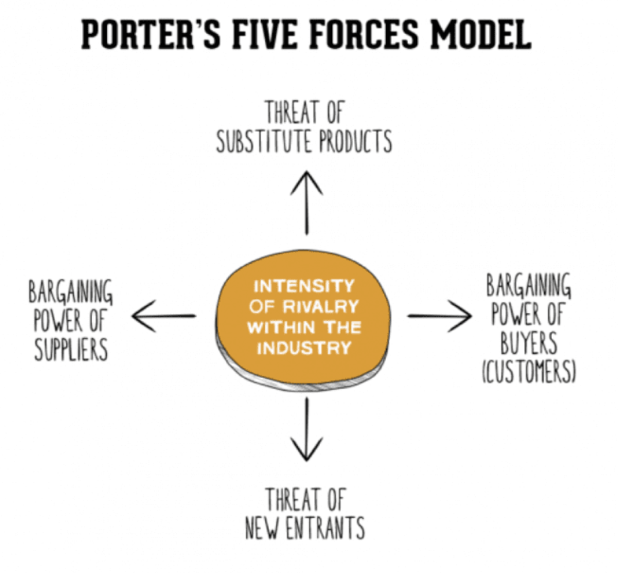
Figure: Porter's 5 Forces model
Source: Smart Insights (2022)
Threats from new entrants (LOW): Since Walmart is a giant retail company and invests potentially in marketing product development, distribution and sales (Bamidele-Sadiq et al., 2022). Thus, in the case of new entrants, they would need a huge amount of capital investments to match up to the level of Walmart (Toma et al., 2020). Moreover, outperforming Walmart's relationship with its suppliers and customers is utterly difficult for any newbie in the market, and hence the threats from new entrants for Walmart are low.
Bargaining power from buyers (MODERATE): Walmart tends to deal with several small buyers regularly, which tends to disseminate the buying powers of the buyers. Contrary to popular belief, customers tend to exert moderate power on Walmart (Ahn and Chung, 2022). This is because the low price approach of the store and the conveniences are difficult to be found anywhere else. However, the switching costs of Walmart's buyers are low and hence the bargaining power of the buyers of Walmart can be considered as moderate.

Bargaining power of suppliers (LOW): It should be noted that Walmart tends to buy products from a wide range of suppliers. For these producers, Walmart is a buyer with a huge customer base and great buying volumes; hence, it can be said that for these suppliers, Walmart is a highly powerful buyer. Thus, the suppliers always ensure that they successfully cater to the needs and demands of Walmart (Burbach, 2021). For example, the suppliers of Walmart tend to build their stores near Walmart to cater to their convenience. The potential strong brand identity, huge customer base, large-scale market share and great reputation of Walmart make it a potential buyer, reducing its switching costs. Thus, if the suppliers cannot meet their needs, they can switch to other suppliers within a click time (Neebe, 2020). These factors further weaken the bargaining potential of the suppliers and their bargaining potential is low.
Threats from substitutes (LOW): Walmart offers various goods and categories of products, from groceries to various household appliances. Thus, with this wider range, there is no potential substitute for Walmart as it is highly unlikely that a product is better available somewhere else than Walmart (Bratton and Boak, 2020). Thus, the products and all the substitutes would probably be available within Walmart (Mounika et al., 2021). Therefore, it can be said that Walmart worries about rivals who may attract customers with the same sort of diversity, such as Amazon. Yet, since this concern is a matter of industry rivalry and not of substitution, it can be said that the threats from substitutes for Walmart are Low.
Industry rivalries (MODERATE): It should be noted that US retail is highly competitive, with a constant 4% industry growth and a market size of approximately 5 trillion dollars (Bratton and Boak, 2020). However, in the case of Walmart, the company does not face any challenge or threat from small-scale market players such as Sears and so on but from giant market players such as Amazon, Costco, Target and The Kroger (Saif, 2020). However, it is also to be noted that the "competitive advantages", "economies of scale", and "effective price strategies" are some of the advantages of Walmart against its competitors. Therefore, it can be said that the industry rivalries for Walmart are moderate.
Inference from the above two analyses:
From the above PEST analysis, it can be said that Walmart enjoys political stability within its home country and most of its host countries, which smooths its business operations. However, ever-changing taxes and foreign market competition are some of the challenges for Walmart (Saif, 2020). Also, the economic development of the developing nations, decreasing unemployment in the US and increasing buying potential further pose opportunities for Walmart. Technological advancements are one of the most advantageous factors for Walmart as with cutting-edge technologies, the company can reduce its resource consumption, optimise time and also increase consumer experience and satisfaction (Piórkowska, 2021). Increased digitisation and a tech-savvy customer base further mandate it for Walmart to leverage advanced technologies.
Furthermore, from Porter's five forces analysis, it can be said that the main challenges Walmart faces are from industry rivalry and buying power of consumers (Gupta, 2020). Hence it can be said that Walmart should constantly strive towards strengthening its capacities in association with the various existing players. To do that, the organisation must further invest in automating its internal processes to enhance its supply chains and develop its human resources (Nilufer, 2020).

Internal analysis:

SWOT analysis:

Strengths  - Strong brand identity and market reputation are one of the major strengths of Walmart, being the largest retailer in the world and having unmatched scales of operations.  - Cost leadership strategy is another strength of Walmart.  - Walmart combines an advanced distribution system and a well-managed information system.  - They have a solid international presence. | Weaknesses  - Overdependence on the sales from the American market  - Potentially criticised employment policies that result in more significant turn-over and compromised customer services  - Low wages, inadequate wages and poor healthcare services for the employees are some of the issues that are publicly criticised.
Opportunities:  - Walmart can enhance and expand its Marketplace and its "Walmart Fulfilment Services (WFS)" to accommodate the increasing number of small retailers.  - Increasing varieties of advanced robotic technologies and other automation tools further tend to pose various opportunities for Walmart.  - Walmart can also adopt "Augmented Reality (AR)" and "Virtual Reality (VR) to enhance their shopping experiences.  - The e-commerce market is rapidly growing, so they have tremendous opportunities in this field. | Threats  - The company faces new laws and regulations regarding food, product safety, employee wages, work benefits, etc.  - Changing lawsuits might tend to damage the brand reputation of the business.  - Growing cybersecurity risks further poses threats of data breaches.

VRIO analysis:

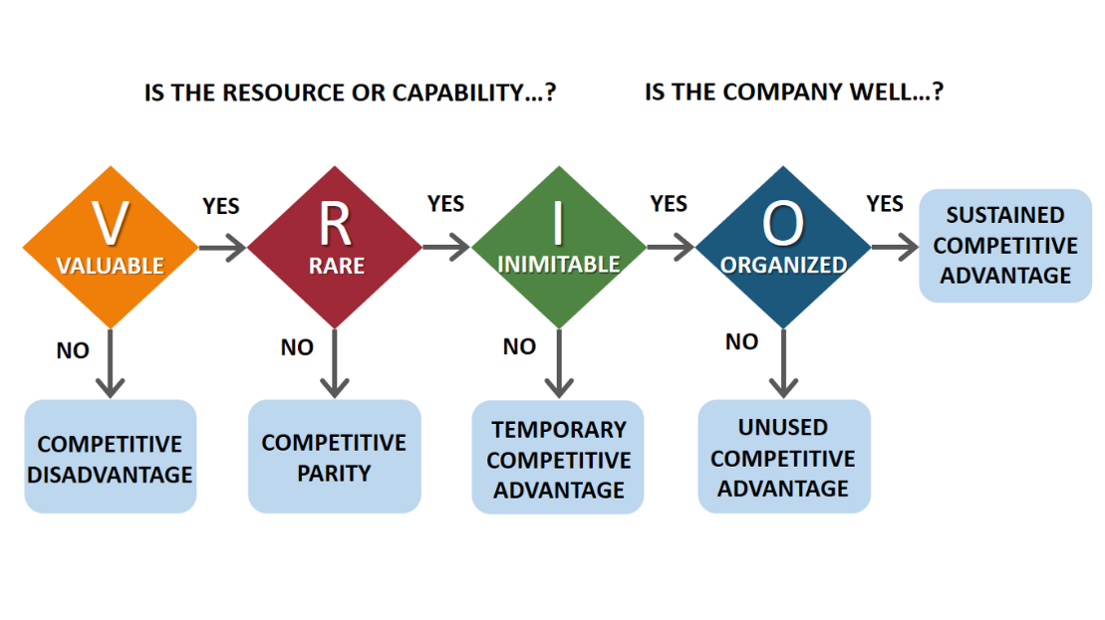
Figure: VRIO framework
Source: Reogma (2023)
Competencies/Resources | Valuable | Rarity | Imitable | Organisation | Competitive Advantage
Ease of accessibility to the large-scale consumer base | Yes | No | No | No | Competitive neutrality
Diverse product lines | Yes | No | No | No | Competitive neutrality
Broad private label brands | Yes | Yes | No | No | Short-term Competitive Advantage
High-potential delivery networks | Yes | Yes | No | No | Short-term Competitive Advantage
Strong brand value | Yes | Yes | Yes | Yes | Sustainable competitive advantage
Highly efficient inventory management systems | Yes | Yes | Yes | Yes | Sustainable competitive advantage
Vast e-commerce operations | Yes | Yes | Yes | Yes | Sustainable competitive advantage
Data mining and data analytics capabilities | Yes | Yes | Yes | Yes | Sustainable competitive advantage

Inference from the above two analyses:
It is to be noted that being a retail business, Walmart needs a workforce that does not necessarily require highly specialised expertise and hence easy accessibility to skilled human resources is considered to be a short-term competitive advantage for the business. Also, the company's diverse product line, the private label brands, and the package delivery network are the resources that do not provide a long-term competitive advantage to Walmart (Rose, 2023). Whereas, their competencies such as strong brand value, efficient inventory management systems, large-scale e-commerce operation and data analytics/mining capabilities tend to contribute to the long-term or sustainable competitive advantage for the company as these are valuable, rare, non-imitable, and organised to leverage (Taylor, 2022). For example, Walmart's brand reputation and market recognition are so high that for any newcomer or small-scale business, it is not imitable and is also a rare competency as not many businesses enjoy such high brand value. It is organised as Walmart uses their brand in their value chain to compete against its rivals (Jin et al., 2021).
Furthermore, from the SWOT analysis, it can be said that the main strengths of Walmart include their strong brand identity, cost-leadership strategies to attract all types of consumers, advanced distribution system, a well-managed distribution system and strong international presence. In addition, it is to be noted that some of the potential weaknesses of Walmart include overdependence on sales, poor working conditions and employment, stressed employees, high employee turnover and poor work culture and wage systems (Wijsenbeek et al., 2023). Again, the main opportunities include scopes to expand in other international countries and advancements in technologies like robotics, AR, VR and so on that can enhance customer satisfaction and a rapidly growing e-commerce market. However, some of the threats include increasing cyber risks, changing lawsuits, and high employee turnover for poor working conditions and employee management systems (Mrozek, 2022).

Stakeholder analysis:
The following are the main stakeholder groups considered in Walmart’s corporate social responsibility strategy, arranged according to the company’s priorities:

Mendelow’s Matrix for Stakeholder Mapping
Observers  - Government  - Politicians | Key Players  - Employees  - Investors  - Consumers  - Suppliers
Crowd  - Common people | By-standers  - NGO  - Environmentalists  - Labour Unions

From the above matrix, it can be said that the politicians and the government are the observers and thus, they have a high impact but a low influence on the company (Dong, 2023). Again, the employees, consumers, suppliers and investors are the key players, and hence they have a high impact and strong influence on the company. The common people are considered as a crowd as they have low impact and low influence on the business and the NGOs, environmentalists and labour unions are considered as bystanders as they have low impact and high influence on the overall business of Walmart (He et al., 2021).

Critical evaluation of the strategic options

Porter's Generic Strategies:
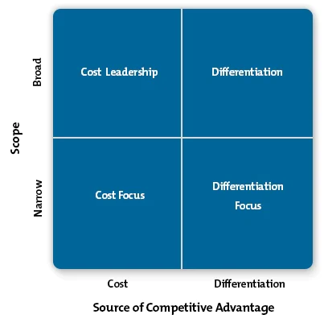
Figure: Porter’s Generic Strategy
Source: IMGIX (2023)
Porter's Generic Strategies for Walmart are discussed below:
Cost leadership strategy: This strategy involves increasing profits by minimising costs and charging "industry average prices". This strategy is primarily adopted by Walmart at present, which entails charging low prices whilst still making reasonable profits on all sales as the business and operational costs are reduced (Bamidele-Sadiq et al., 2022). Store locations, efficient management and the use of technology tend to help the business to attain an "economy of scale" and have cost leadership within the retail market (Park, 2022). One of Walmart's most significant competitive strategies is its inimitable supply chain. Walmart also constantly implements technological solutions to improve supply efficiency and reduce costs (Woong and Goh, 2021).
Differentiation: This is a type of strategy by which an organisation tends to differentiate itself from the other goods and services from those of the competitors. It is here to be noted that the main objective is to be unique (Walton, 2012). An organisation might use "creative ads", "distinctive features of products", "greater product qualities", "optimal performance", and so on (Woong and Goh, 2021). In order to adopt this strategy, Walmart needs to innovate their product line vigorously to be unique from the other competitors (Guven et al., 2021).
Focus: Focus is a competitive strategy focusing on specific regional markets or buyer groups. In order to adopt this strategy, Walmart primarily needs to select a particular segment within the industry and needs to curate the strategies for serving the segments to the exclusions of others (Park, 2022). It is to be noted that focus strategy can be of 2 types, that is, "differentiation focus" and "cost focus". In focus, Walmart needs to seek a "cost advantage" within the target segment" and while in differentiation focus, it needs to differentiate its target market segment (Walton, 2012). It is to be noted that both variants of the focus strategy tend to rest on differences between the "target segment" and "other segments" within the industry (Wijsenbeek et al., 2023).

Bowman's Strategy Clock:
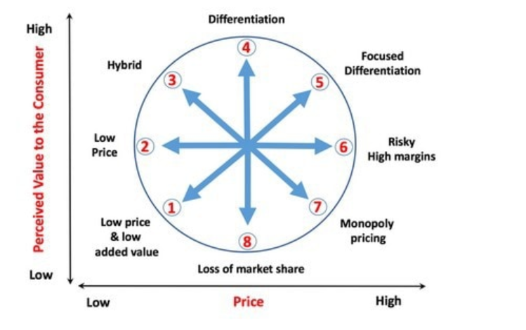

Figure: Bowman’s Strategy Clock
Source: (CreativeAdviser, 2019)
Strategic position | Inference
1. Low Price and Low-Value Added | In this strategy, the prices and the product or service values are very low and hence are considered the most competitive strategy (Jin et al., 2021).
2. Low Price | This strategy entails providing the customers with products or services at lower prices than the competition's prices. The businesses that use this strategy tend to focus mainly on quantity rather than quality and minimise product costs to sell them at the lowest possible price (Taylor, 2022).
3. Hybrid | This strategy is all about combining low prices and product differentiation, and the businesses tend to make tiger goods/services highly valued within the market and for the customers. Since the prices are low, it makes the products highly competitive (Piórkowska, 2021).
4. Differentiation | This strategy entails making the goods/services different and unique from the other competitors, generally by offering the same product category but with different and unique features (Neebe, 2020).
5. Focused differentiation | The strategy entails a combination of high price and high value. The businesses using this strategy tend to produce highly valued and distinguished products/services and sell them at the highest possible prices and hence it requires a lot of effort and value efforts to make this strategy successful (Ahn and Chung, 2022).
6. Risky High Margins | The strategy entails low value and high prices, and the businesses using this strategy usually offer low-valued goods/services but sell them at high prices. Hence, this strategy tends to work only for businesses with a very strong brand name (Volpe and Boland, 2022).
7. Monopoly Pricing | This strategy is used by businesses when in a market, there is only one business that tends to control the services/products and also their prices as there is no competition (Mounika et al., 2021). However, the businesses using this strategy should be aware of the market as all monopolies are temporary and come to an end and new businesses in the market keep on emerging (Ramadani, 2020).
8. Loss of Market Share | This strategy is about exiting a market or being in a declining state (Mounika et al., 2021). This strategy is generally used when businesses end up losing their consumers and become less profitable and thus are forced to reduce product prices (Mounika et al., 2021).

From the above strategy, it is to be noted that at present, Walmart uses Strategy 2- that is, the low-cost strategy. In other words, the model tends to rely on the idea that the consumers prefer buying the items at lower prices instead of waiting for "sales" or "speciality discount offers" (Bamidele-Sadiq et al., 2022). In order to attain this, Walmart obtains little margins from every unit of product sold and trades them off in return for greater overall profit resulting from increased volumes or sales (Alsharari, 2021). Furthermore, Walmart tends to spend heavily on technologies that further help them to minimise operational and business costs. Moreover, the location of the stores, effective management and the use of technologies tend to help the company attain the "economy of scales" and hence they are known for their "low cost strategy" within the retail industry (Walmart.com, 2023).

Ansoff’s Matrix
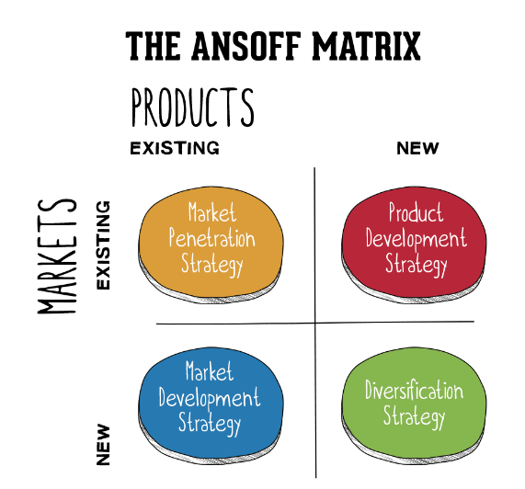

Figure: Ansoff Matrix
Source: (SmartInsights, 2022)

An Ansoff matrix analysis for Walmart is explained below:
Market Penetration: The market penetration strategies of Walmart were adopted when the company newly entered the market and helped the business with its continuous growth. Its promise of everyday low price (EDLP) had drawn the attention of many customers who had helped the company penetrate the market further. Some of the market penetration strategies often adopted by Walmart include "final black friday deals” and various other special offers and deals.
Market development: It goes without mentioning that Walmart is one of the greatest retailers in the world. From the United States of America, the company has expanded to a large number of countries like Canada, Mexico, China, India and Chile. Apart from that, Walmart also beholds “equity investments in Japan, Brazil and the United Kingdom. However, the market development strategy had failed within Japan and Germany as Walmart had been unsuccessful in understanding the market aspects of the countries.
Product development strategies: It is to be noted that Walmart tends to offer a vast range of products and also possesses private label brands and also tends to invest heavily in R&D. By September 2020, the business launched some free assembly and new private labelled lines of women's and men's clothing. Moreover, it is also worth noting that new product development is not the main growth focus for Walmart.
Diversification Strategies: Offering new services and products within completely new markets is definitely a risky strategy. However, the company has applied the strategy many times and has been successful. For example, Walmart introduced its financial services and data monetisation services to different international markets and gained huge success. It is to be noted that Walmart, being a "risk-aware organisation, does not hesitate to try new things. They are also focusing on exploring new things such as websites, stores, and massive reach for going beyond retailing and exploring the opportunities in the fields of ads, healthcare, technologies and many more.
Final recommendations:
From the external and the internal analysis of Walmart, it can be said that the key issues include "inadequate working conditions for the employees", "non-resilient employee management programs", and increasing digital disruptive trends and high competition from giant retail players like Amazon, CostCo, Target and The Kroger. Therefore, it can be said that in order to make the company prepared against futuristic pandemics such as Covid-19, it can be said that the business should adopt some strategic changes to increase its resilience. Here, referring to Drucker's theory, the business leaders like that of Walmart need to go for "Spirit of Performance" by displaying greater levels of moral as well as ethical integrity within the actions focusing on the results, empowering employees, and going beyond "financial obligations" to the stakeholders and by working towards the common good (Zeng, 2019). This approach would help Walmart to increase its business resilience even during times of challenges and hence, need to strengthen it's Corporate Social Responsibilities (CSRs) and should adopt more sustainable business operations (Bratton and Boak, 2020).
During the Covid-19 pandemic, one of the main challenges was working conditions and many companies have provided remote working facilities (Work from home facilities) to the employees, taking into consideration the health and safety of the company.
It is to be noted that when the company thinks about their employees, it tends to motivate them, further increase their tenacity and dedication towards their work, and empower them. Here, referring to "Mayo's management theory", it can be said that the employees can be motivated potentially by various relational factors like camaraderie, attention, and so on rather than "monetary factors" or "environmental factors" (Burbach, 2021). Thus, some of the recommendations for Walmart in terms of its increasing its workforce resilience and motivation to reduce employee turnover is to enable the following:
- Hybrid work opportunities to facilitate better work-life balance to the employees
- Taking care of the salary package, following the minimum wage laws, and abiding by all the labour laws established by the countries where they run their business (Volpe and Boland, 2022).
- Conduct employee engagement programs such as rewards, games, promotions, appraisals, and so on to motivate employees (Volpe and Boland, 2022).
- Allow medical reimbursements, sick leaves and other monetary allowances to support during tough times such as a pandemic. Referring to the " Scientific Management Theory", it is important to remember that, as per Taylor, money is considered to be the key incentive for working and leads to effective collaboration between the employees and motivates them and hence Walmart should provide adequate wages along with other allowances to their employees (Taylor, 2022).
- Furthermore, to address the threats and weaknesses identified from the SWOT analysis, it can be said that the biggest weaknesses of the business include overdependence on sales, poor employment policies, and poor wage systems (Bamidele-Sadiq et al., 2022). Therefore, it is recommended that they take adequate steps to keep their employees motivated and increase their brand reputation by introducing proper wage systems and employing innovation and diversifying services to reduce overdependence on sales (Alsharari, 2021).
- Referring to Porter's 5 forces analysis, it can be said that the biggest threat lies with market competition and buyers’ bargaining power (Alsharari, 2021). Therefore, it is recommended that Walmart employ innovative and advanced technologies to enhance consumer experience and outperform its competitors (Bratton and Boak, 2020). Moreover, aligning with the current situation of the pandemic, they should also expand their e-commerce operations so as to keep up with the market competition.
- From the stakeholders' analysis, it can be said that to satisfy the key players, they need to focus on employee engagement and motivation, customer satisfaction, and diversifying revenue streams to earn more revenues to satisfy the investors and suppliers (Walmart.com, 2023). Furthermore, they should also undertake environmentally sustainable business operations and comply with the different laws and legislations as set by the governments of different countries.
Strategic choices:
From the analysis, some of the most important strategic choices for Walmart are recommended below:
- Referring to Porter's Generic strategy analysis, it is recommended to Walmart that, though they are currently using a cost leadership strategy, they must not forget to maintain their perceptions of quality and must be able to adapt to market changes rapidly. Generally, cost leaders are slow to adapt to market changes. Hence, it is important for Walmart to focus on research and development to learn about the latest market changes and should be able to adjust accordingly (Walton, 2012).
- From Bowman's strategy clock, it was seen that Walmart is currently in Position 2, which is the low-price strategy. It is important to note that Walmart should try residing in Position 3, which is the hybrid strategy (Bratton and Boak, 2020). This strategy, as discussed earlier, entails making the products/services unique and different from the other rivals, mostly by offering the same categories of products but with different and unique features (Walton, 2012). For example, in the case of Walmart, they can sell the same categories of grocery or food products but with better quality, higher nutrition content and greater value for money.
- Furthermore, referring to the Ansoff matrix, it is recommended to Walmart that they undertake a diversification strategy. As discussed earlier, the company must be able to diversify its product lines and should also try exploring new countries and places so as to increase its market share and expand its revenue channels (Bamidele-Sadiq et al., 2022). Since Walmart is technologically rich and also they are risk aware, it is highly likely that with a diversification strategy, it can be able to deal with a crisis situation such that of a pandemic, as it would have enough revenue sources to deal with such downturns or crises (Toma et al., 2020).

Conclusion:
From the entire analysis, evaluation and discussion, it can be said that Walmart, though it is a highly successful business, also tends to face a number of challenges and threats. Therefore, the paper conducted a thorough internal and external analysis followed by a detailed strategic analysis; it can be said that Walmart must primarily focus on constant innovation and diversification of its products and services and should also seek to expand its business to different countries and cities. Moreover, they should revise their employment policies and focus more on employee motivation. Furthermore, more investments are required in research and development as these tend to strengthen the company's risk management capabilities. In addition to that, it is also suggested to Walmart expanding on e-commerce operations can also be utterly helpful for the business, taking into consideration the current trends and preferences.

Reference list:
Ahn, D.Y. and Chung, H., 2022. Format blurring: how the advent of the Walmart Supercenter has changed the US grocery industry. Economic Research-Ekonomska Istraživanja, 35(1), pp.1285-1305.
Alsharari, N.M., 2021. Management accounting practices and e-business model in the US Walmart corporation. Accounting and Finance Innovations, 3.
Asperti, N., Vedovati, G. and Vuerich, L., 2020. Enterprise risk management in Walmart and Target. Available at SSRN 3581698.
Bamidele-Sadiq, M., Popoola, O., Lawal, GO and Awodiji, T.O., 2022. The importance of decision tree analysis on strategic management practice: Evidence from retail industries in the US. Journal of Marketing and Consumer Research, 87, pp.87-04.
Bratton, J. and Boak, G., 2020. Strategic Management, Innovation and Leadership. Organisational Leadership, 35.
Burbach, C., 2021. Walmart Strategic Analysis. Digital Commons.
Chen, X., 2020. Corporate Social Responsibility Analysis of Walmart in China. In 2020 International Conference on Economic Management and Social Science. https://www. clausiuspress. com/conferences/LNEMSS/ICEMSS2020/20ICEMSS003. Pdf.
CreativeAdviser., 2019, May 9. How to leverage Bowman's clock in marketing for IFAS. Retrieved April 11, 2023, from https://creativeadviser.co.uk/financial-marketing/bowmans-clock/
Dong, R., 2023. Wal-Mart's Financial Analysis. Highlights in Business, Economics and Management, 5, pp.312-316.
Garcia, G.J.V. and Red, E.R., 2020. Information Systems Utilisation of an Organization: The Case of Walmart Inc. College of Computer and Information Science.
Gupta, A.D., 2020. Strategic human resource management: Formulating and implementing HR strategies for a competitive advantage. CRC Press.
Guven, H., Guven, E.T.A. and Akkaya, B., 2021. The Status of the Retail Sector During and After the Covid-19 Outbreak: What Should Strategic Managers Do?. EMERGING TRENDS AND STRATEGIES FOR INDUSTRY 4.0: DURING AND BEYOND COVID-19, p.47.
He, Z., Ding, Y. and Liu, W., 2021, September. The States Quo of Walmart and Challenges and Opportunities of Their Online Transformation in China Based on SWOT Analysis. In 2021 International Conference on Financial Management and Economic Transition (FMET 2021) (pp. 353-359). Atlantis Press.
IMGIX (2023). The end-to-end visual media solution. imgix. (n.d.). Retrieved April 11, 2023, from https://imgix.com/
Jin, Y., Xu, W. and Zheng, N., 2021, September. Analysis of COVID-19’s Investment in Corporate Value. In 2021 International Conference on Financial Management and Economic Transition (FMET 2021) (pp. 146-152). Atlantis Press.
Karpenko, L., Mykola, I., Onyshko, S., Chunytska, I. and Starodub, D., 2019. Blockchain as an innovative technology in the strategic management of companies. Academy of Strategic Management Journal, 18, pp.1-6.
Mounika, S., Sahithi, Y., Grishmi, D., Sindhu, M. and Ganesh, P., 2021. Walmart Gross Sales Forecasting Using Machine Learning. Journal of Advanced Research in Technology and Management Sciences (JARTMS), 3(4), pp.22-27.
Mrozek, M., 2022. Walmart Inc. in light of COVID-19 pandemic: the financial assessment. Catallaxy, 7(1), pp.23-32.
Neebe, K., 2020. Sustainability at Walmart: Success over the long haul. Journal of Applied Corporate Finance, 32(2), pp.64-71.
Nilufer, N., 2020. Critical assessment on business strategy from aviation to retail industry during COVID-19 Pandemic: A Walmart Case. International Journal of Business Ecosystem & Strategy (2687-2293), 2(2), pp.8-14.
Park, G., 2022. Analysis of Management Strategies of Various Multinational Companies that have Adapted and Grown Simultaneously during the Corona Pandemic Era. Available at SSRN 4203490.
Piórkowska, K., Witek-Crabb, A., Lichtarski, J.M., Wilczyński, M. and Wrona, S., 2021. Strategic thinkers and their characteristics: toward a multimethod typology development. International Journal of Management and Economics, 57(4), pp.313-330.
Ramadani, V., Memili, E., Palalić, R., Chang, E.P., Ramadani, V., Memili, E., Palalić, R. and Chang, E.P., 2020. Strategic management in the family businesses. Entrepreneurial Family Businesses: Innovation, Governance, and Succession, pp.43-53.
Reogma., 2023. WP-content uploads: What it is and how to upload files in WordPress. Hostinger Tutorials. Retrieved April 11, 2023, from https://www.hostinger.com/tutorials/wordpress-content-uploads
Rose, N., Rowe, F. and Dolega, L., 2023. How consumer behaviours changed in response to COVID-19 lockdown stringency measures: A case study of Walmart. Applied Geography, p.102948.
Saif, M., 2020. Corporate strategy of Walmart.
Shanshan, L., 2020. ANALYSIS OF WALMART’S INTERNATIONAL MARKETING STRATEGY. Редакционная коллегия, p.411.
Smart Insights., 2022, November 25. Digital marketing strategy advice - smart insights digital marketing. Retrieved April 11, 2023, from https://www.smartinsights.com/
Smart Insights., 2022. Digital marketing strategy advice - smart insights digital marketing | Smart Insights. Available at: https://www.smartinsights.com/ (Accessed: April 11, 2023).
Taylor, J.B., 2022. The Effect of the COVID-19 Pandemic on Online Shopping at a Traditional Ground Retailer: Walmart, Inc from the Customer Perspective (Doctoral dissertation, Trident University International).
Toma, S.G., Grădinaru, C., Săseanu, A.S. and Ghiță, S.I., 2020. Viable Business Models in Global Retailing: The Case of Walmart.
Volpe, R. and Boland, M.A., 2022. The Economic Impacts of Walmart Supercenters. Annual Review of Resource Economics, 14, pp.43-62.
Walmart.com., 2023. “Save money. live better” | Home Page. Available at: https://www.walmart.com/ (Accessed: April 11, 2023).
Walton, S., 2012. Case Study: Walmart. Strategic International Management, 67.
Wijsenbeek, M.S., Moor, C.C., Johannson, K.A., Jackson, P.D., Khor, Y.H., Kondoh, Y., Rajan, S.K., Tabaj, G.C., Varela, B.E., van der Wal, P. and van Zyl-Smit, R.N., 2023. Home monitoring in interstitial lung diseases. The Lancet Respiratory Medicine, 11(1), pp.97-110.
Woong, J.Y. and Goh, S.H., 2021. Supply chain risk management strategies in the face of covid-19. In Conference on Industrial Engineering and Operations Management Singapore (pp. 7-11).
Zeng, Z., 2019. Different functions between leadership and management in today's enterprises. The Frontiers of Society, Science and Technology, 1(3), pp.33-35.

