THERMOFLUID MECHANICS

  - Heat Exchanger Laboratory Analysis
HND Y1-Mechanichal Engineering
Naeem Noor
Student No: Noo17838267
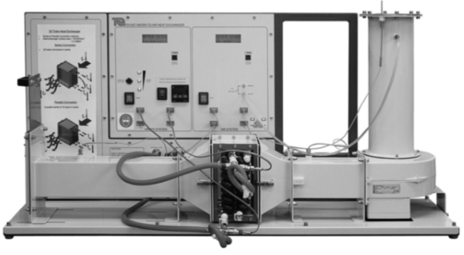

Water to Air Heat Exchanger (TD 1007 User Guide)

Contents
Summary: 2
Introduction to Heat Exchangers: 2
Types of Heat exchanger: 3
Parallel-flow and counterflow 3
Cross flow 3
Shell-and-tube 3
Compact heat exchanger 4
Heat exchanger (32 tubes): 4
How does a heat exchanger work? 4
Experiment No.1: 5
The Effect of Varying Water Flow Rate: 5
Procedure: 5
Experiment 1 Results: 6
Experiment 1 Charts: 6
Chart 1 6
Chart 2 7
Chart 3 7
Experiment 2 The Effect of Varying Air Flow Rate: 8
Procedure: 8
Experiment 2 Charts: 8
Chart 1 8
Chart 2 9
Chart 3 10
Experiment 3 - Effect of Varying Temperature (Driving Force): 10
Procedure: 10
Result Analysis: 10
Experiment 3 Charts: 10
Chart 1 10
Chart 2 11
Chart 3 12
Discussion: 12
References: 13

Summary:
Thermofluid Mechanics is one on my first year HND Mechanical Engineering Course modules, to achieve this module I am required to carry out a heat exchanger laboratory experiment where I will work on a water to air heat exchanger, carry out practical experiment, collect results, record temperatures and using the results for the further calculations (i.e. working the heats emitted, heat loss, specific heats, internal energy, masses and efficiencies etc).

Introduction to Heat Exchangers:
Heat exchanger is a device which allows heat from a fluid or a gas to pass to a second fluid which can be another fluid or gas without the two fluids having to mix together or came into contact with directly. Heat exchangers are used in both cooling and heating processes (Ahmed T. Al-Sammarraie & Kambiz Vafai, 2017)
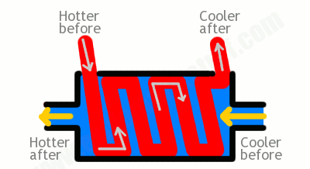
https://www.explainthatstuff.com/how-heat-exchangers-work.html
The above picture shows basic heat exchanger and how it works.
Central heating in buildings are examples of heat exchanger. In central heating the furnace (boiler) heats up the hot water in radiators in various rooms of building. The process involves burning the natural gas making a line of hot gas jets that fire upwards over water flowing through a network of pipes. While the water pumps through the pipes it absorbs the heat energy and heats up, in this process losses of heat take place. Heat is a form of energy, heat transferred from one body to another if the two bodies have different temperature.
“Energy can neither created nor destroyed but can only transfer from one form to another” (Richard Feynman, 1970)
Heat exchanger is one of very important topic in engineering sector as it transfers heat from a hot to a cold fluid. In many real life situations, we usually need to either increase or decrease the temperature of a fluid. In general, any process which involve cooling, heating, condensation, boiling or evaporation will require a heat exchanger.

Types of Heat exchanger:

Heat exchangers are used to transfer heat between at least two streams of fluid or from one medium to another. Heat exchangers can be categorized depending on their flow arrangement plus the construction features.

Parallel-flow and counterflow:
In this parallel type of heat exchangers, the two fluids go into the system at the same terminal; flow in parallel to one another to the other end. While in counter flow heat exchangers, the fluids enter the exchanger from opposite side. The counter current design is the most efficient (Engineers Edge, LLC).

Cross flow
In cross flow heat exchanger, the fluids travel perpendicular to one another through the exchanger (Engineers Edge, LLC).

Shell-and-tube
In shell and tube heat exchanger consists of two set of tubes; one set of the tubes contains the fluid that must be either heated or cooled. The second fluid runs over the tubes that are being heated or cooled so that it can either provide the heat or absorb the heat (Engineers Edge, LLC).

Compact heat exchanger
Compact heat exchangers are characterized by a large heat transfer surface area per unit volume of the exchanger, resulting in reduced space, weight, support structure and footprint, energy requirements and cost, as well as improved process design and plant layout and processing conditions. (Kays and London, 1998).
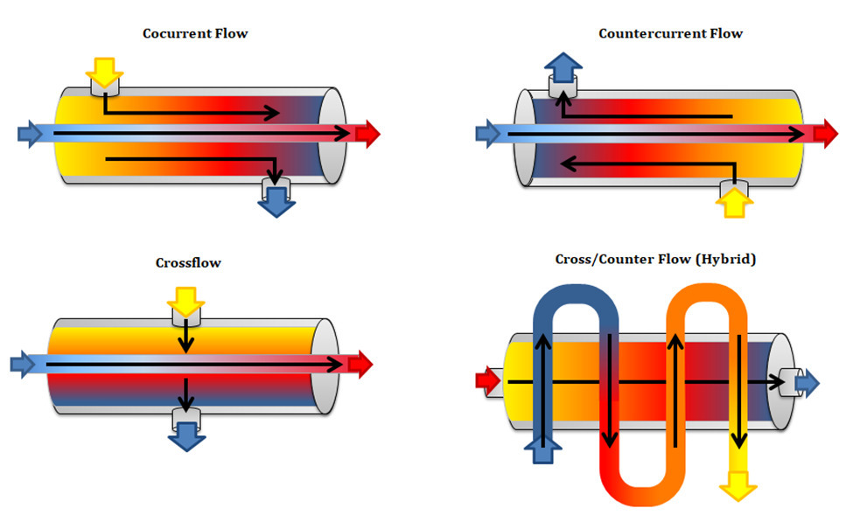
https://www.thomasnet.com/articles/process-equipment/understanding-heat-exchangers/

Heat exchanger (32 tubes):
This heat exchanger has two tube bundles of 16 tubes. Water which is heated to a set temperature passes through the tubes from the bottom to the top across the working section and air passes through the tube’s bundles at the right angles. These heat exchangers have the additional benefits of the two sets of tubes, which you can connect in series or parallel. In series mode, it allows the use of a third thermo couple at midpoint in the water flow. The upstream bundle is that nearest the fan.

How does a heat exchanger work?
As we are working with the heat exchanger and in parallel connection, below are a figure which gives you an idea that how the water is flowing across all the tubes and how the air is passing across the tubes. And in this process how the temperature loss occurs and how the temperature is gained. Baffles are used to support the tubes for structural rigidity, inhibiting tube vibration and bending.
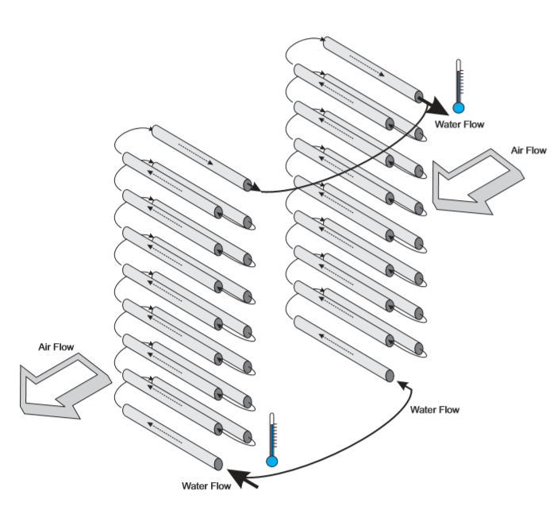

Experiment No.1:

The Effect of Varying Water Flow Rate:
The aim of this experiment is to demonstrate that how the different water flow rate affects the performance of the heat exchanger for a given fixed flow rates and the water temperature.

Procedure:
To begin the experiment we connected the standard 32 tubes heat exchanger, connected it parallel flow and set a heater tank temperature of 60°C in my table the temperature is 60.8°C. Water was entered from the bottom of the heat exchanger and exits from the top. Here we noted the ambient air pressure. Orifice and its diameter being checked.
Fan was switched on and the side valve was used to set the airflow to give an orifice pressure drop of 250 Pa.
NOTE (+/- 5Pa is negligible)
Now switch on the pump and use the hand operated water supply valve to set the water flow to a 2.25 L/minute.
NOTE (+/- 0.01L/min is negligible)
Now allow at least for five minutes for the heat exchanger temperature to stabilize and record all the reading.
The whole procedure was repeated at different lower water flow rates which are 1.75, 1.25, 0.75 and 0.25L/min.

Experiment 1 Results:
Below is the table of experiment with all the reading and all the results. Table is created in excel which we were required to do.
Table is present in excel as I could not fit in the word document!

Experiment 1 Charts:
Chart 1 is plotted on the heat emitted by the exchanger and the power absorbed into the air. As the water mass flow rate increases, the heat emitted will reach to constant level.

Note negative values were ignored.
Chart 2 this graph is plotted on air, water and the mean temperature efficiencies. The results show that, as the water mass flow increases, the efficiency of the exchanger will be reduced due the fact that the heat emitted/absorbed will reduced.

Chart 3 this graph is plotted on the overall heat transfer coefficient U.
It is clear from the experimental results that raising the mass flow rate will results in increase in heat transfer coefficient or improved the heat transfer across the heat exchanger.

Note negative values were ignored.

Experiment 2 The Effect of Varying Air Flow Rate:

Aim for this experiment is to show that how different air flow affects the performance of the heat exchangers for a given fixed water flow and temperature.

Procedure:
Make sure that the connection is set to the parallel flow and set the heat exchanger temperature at 60° C. Water will enter from the bottom of the exchanger and find its way out from the top.
Now check and write down the air pressure. Also check the diameter of the orifice.
Now switch on the fan and use the slide valve to set the airflow to give a orifice pressure drop of 250 Pa.
Note: (+/- Pa is negligible)
Now switch on the pump and use the hand operated water supply valve to set the flow to 0.25 L/minute.
Note (+/- 0.01 L/minute is negligible)
Allow the heat exchanger to stabilize for at least 5 minutes, then record all the readings.
We are required to repeat the procedure for lower air flow rates of 200, 150, 100, and 50 Pa pressure drop.

Results Analysis:
Table is present in excel.

Experiment 2 Charts:
Chart 1 is plotted on the heat emitted by the heat exchanger and the heat absorbed by the air. As the air mass flow rate increase (double), the heat emitted to the fluid by the exchanger was slightly improved or enhanced while the heat absorbed by the air was reduced.

Chart 2 this graph is plotted on air, water and the mean temperature efficiencies.
The results show that increasing air mass flow rate on overall efficiencies will have small effects

Chart 3 this graph is plotted on the overall heat transfer coefficient U.
The experimental results show that doubling the air mass flow rate will improved the
Heat transfer coefficient by nearly 25%

Experiment 3 - Effect of Varying Temperature (Driving Force):
Aim for this experiment is to show how different hot water supply temperatures affect the performance of the heat exchanger for a given fixed water flow.

Procedure:
Procedure for this experiment include to first check the connection if its parallel and this time set the tank temperature at 45°C. And just like the previous experiments water will enter from the bottom of the heat exchanger and will leave from the top of the exchanger.

Result Analysis:
Again, the results table is in excel.

Experiment 3 Charts:
Chart 1 is plotted on the heat emitted by the heat exchanger and the heat absorbed by the air. The results show that there is a considerable dropped in emitted heat by the exchanger at water mass flow rate of 0.087 and 0.11 kg s⁻¹ or fluctuate while the heat emitted by the exchanger to the air is level off. It could be systematic error caused by other factors.

Chart 2 this graph is plotted on air, water and the mean temperature efficiencies.
The results also show that there is considerable dropped in temperature efficiency or fluctuation by the exchanger at water mass flow rate of 0.087 and 0.11 kg s-1 while the temperature efficiency in the case of air is slightly decline with water mass flow rate. It could be systematic error too caused by other factors.
.

Chart 3 this graph is plotted on the overall heat transfer coefficient U.
The results also show that there is fluctuation in the heat mass transfer coefficient by the exchanger with water mass flow rate. Also, it could be systematic error caused by other factors.

Discussion:
In experiment 3 the results appear different from expected value this may be due to systematic errors. Many factors could lead to systematic error, these factors include calibration of equipment and improper equipment use. Other external factors could affect our results, for example, the change in temperature, pressure, light between taking results.
Random error is another type of error could affect our reading this could be eliminated by taking many measurements where error happened and average the results.
In experiment one and two the results appear to be the expected value. And in experiment three the results are very different from the expects it could be several reasons, it could be heat exchanger error or manual error.
Now we all are facing pandemic situation from COVID-19 and because of this we were not allowed to perform the experiment in the university laboratory. Instead we had to use results from the previous students who performed the experiment.
Even though we did not perform the experiment, but I think I have learnt a lot from it that how the heat exchanger work and I am sure it will be beneficial for me in my practical field. I learnt how to make tables in excel and how to create the chats using the values in the table. And much more information in regard to the heat exchangers.

References:
Ahmed T. Al-Sammarraie & Kambiz Vafai (2017) Heat transfer augmentation through convergence angles in a pipe, Numerical Heat Transfer, Part A: Applications, 72:3, 197-214, https://dx.doi.org/10.1080/10407782.2017.1372670
Richard Feynman (1970). The Feynman Lectures on Physics Vol I. Addison Wesley. ISBN 978-0 -201-02115-8.
Kays, W. M., and A. L. London, 1998, Compact Heat Exchangers, reprint 3rd ed., Krieger Publishing, Malabar, FL.

https://www.explainthatstuff.com/how-heat-exchangers-work.html
https://www.explainthatstuff.com/how-heat-exchangers-work.html
https://www.thomasnet.com/articles/process-equipment/understanding-heat-exchangers/
https://www.engineersedge.com/heat_transfer/parallel_counter_flow_designs.htm
https://www.academia.edu/20253273/Heat_Exchanger_Lab_Experiment_Chemical_Engineering
https://www.studocu.com/en-gb/document/the-university-of-hull/fluid-dynamics/coursework/heat-exchanger-lab-report-final/7115188/view

