The Impact of Diversity, Equity and Inclusion (DEI) Initiatives on Employee Perceptions and Job Satisfaction in the UK Tourism and Hospitality Sector: A Quantitative Survey Study
Md Rakibul Hasan
Student Number: 2438287
MBA Business and Management (Level 7)
University of Wales Trinity Saint David
Supervisor: Kathryn Flynn
2025 – 2026

Declaration
This dissertation is a submission towards the award of the MBA (Level 7) in Business and Management at the University of Wales Trinity Saint David.
I certify that this dissertation is an original work by myself and has not been previously submitted for a degree or qualification at this or any other university or college. All information has been sourced with references, and any work from other sources has been cited appropriately using Harvard referencing.
Signed: ............................................................
Name: Md Rakibul Hasan
Student Number: 2438287
Date: ............................................................

Acknowledgements
I would like to thank my supervisor, Kathryn Flynn, for her guidance, patience and constructive feedback during this research. She has supported me greatly in developing this dissertation’s direction and quality.
I would also like to express my thanks to all tourism and hospitality workers who took the time to fill in the survey and give their opinions, without which this study would not have been possible. Finally, I would like to thank my family and friends for their continual encouragement and support throughout my studies.

Abstract
This dissertation investigates the relationships between employee perceptions of diversity, equity and inclusion (DEI) efforts, perceived inclusion and inclusive leadership with regard to job satisfaction in the United Kingdom (UK) tourism and hospitality industry. While many hospitality businesses are focusing on DEI as a workforce priority, there is inconsistent evidence that it positively affects employee outcomes, the data are primarily international, and the evidence relied on was not necessarily based on employee experience. The study took a positivist, deductive and quantitative approach, with primary data collected using a cross-sectional online survey of eligible and quality-controlled UK hospitality workers (n = 159), analysed using reliability analysis, descriptive statistics, Pearson correlation, multiple linear regression, one-way ANOVA and chi-square tests in IBM SPSS Statistics (version 27). The internal consistency was very good for all four measurement scales. All three predictors were positively and highly related to job satisfaction and together accounted for about 75 per cent of the variance in job satisfaction (R² = .749). All three hypotheses were supported: DEI perceptions, perceived inclusion and inclusive leadership each significantly and positively predicted job satisfaction, with inclusive leadership the strongest predictor. The scores of frontline workers were found to be significantly lower than those of supervisory and managerial workers. The results suggest that the real-world application of inclusive leadership, not just the presence of policy, is the biggest driver of improved satisfaction and has direct implications for retention in a sector with an ongoing skills deficit. The study provides much needed evidence on the hospitality industry in the UK and offers practical suggestions for enhancing the effectiveness of DEI and retention.
Keywords: diversity, equity and inclusion; perceived inclusion; inclusive leadership; job satisfaction; tourism and hospitality; United Kingdom.
Table of Contents
Declaration 2
Acknowledgements 3
Abstract 4
Chapter One: Introduction 8
1.1 Background to the Research 8
1.2 Research Problem and Focus 9
1.3 Research Aim and Objectives 11
1.4 Research Questions and Hypotheses 11
1.5 Significance of the Study 12
1.6 Structure of the Dissertation 12
Chapter Two: Literature Review 14
2.1 Introduction and Chapter Overview 14
2.2 Diversity, Equity and Inclusion: Conceptual Foundations 14
2.3 Legislative and Post-Brexit Context 15
2.4 Distinctive Characteristics of the Hospitality Workforce 16
2.5 DEI in Tourism and Hospitality: Empirical Evidence 17
2.6 Perceived Inclusion and Employee Outcomes 19
2.7 Inclusive Leadership 20
2.8 Job Satisfaction in Hospitality 21
2.9 Theoretical Framework 22
2.10 Conceptual Framework and Hypotheses 24
2.11 Research Gap and Chapter Summary 25
Chapter Three: Research Methodology 26
3.1 Introduction 26
3.2 Research Aim and Objectives 26
3.3 Research Rationale 26
3.4 Research Philosophy 27
3.5 Research Approach and the Research Onion 28
3.6 Research Design and Strategy 29
3.7 Questionnaire Design and Data Collection 29
3.8 Population and Sampling 30
3.9 Data Analysis 31
3.10 Reliability and Validity 33
3.11 Research Ethics 33
3.12 Summary 34
Chapter Four: Data Analysis and Findings 35
4.1 Introduction 35
4.2 Data Screening and Response Profile 35
4.3 Demographic Profile of Respondents 35
4.4 DEI Actions Reported by Respondents 41
4.5 Reliability of Measurement Scales 41
4.6 Descriptive Statistics of the Constructs 42
4.7 Correlation Analysis 44
4.8 Multiple Regression Analysis 45
4.9 Job Satisfaction by Job Level (ANOVA) 47
4.10 Association Between Job Level and Diversity Training 48
4.11 Group Differences by Respondent Type 48
4.12 Discussion and Critique of Findings 50
4.13 Summary of Findings 52
Chapter Five: Conclusions and Recommendations 53
5.1 Introduction 53
5.2 Summary of Key Findings 53
5.3 Discussion and Conclusions 54
5.4 Recommendations for Practice 55
5.5 Contribution of the Study 57
5.6 Limitations of the Study 57
5.7 Recommendations for Future Research 58
5.8 Concluding Remarks 58
References 60
Appendix A: Research Questionnaire 70
Appendix B: UWTSD Ethics Approval Form (PG2) & Response Data 73

Chapter One: Introduction

1.1 Background to the Research
Tourism and hospitality is one of the most demographically diverse sectors, as well as one of the largest employers, in the United Kingdom (Baum et al., 2016). The sector is heavily reliant on women, young people, ethnic minority workers and migrant workers, especially in the more basic and less well-paid jobs (Robinson et al., 2019). This diversity provides genuine commercial momentum for the sector but also places it at risk of ongoing pay and progression inequalities, and of inequalities of treatment in the day to day workplace (Baum et al., 2016). Many hospitality employers are moving beyond a compliance approach to diversity, equity and inclusion (DEI) and towards a broader focus on diversity as a workplace priority.
DEI is defined as a group of practices that aim to broaden representation, provide equal opportunity, and help everyone feel included and empowered to participate fully in the organisation (Roberson, 2006). Diversity is the combination of identities in the workforce, equity is the fair treatment of people that takes account of their different starting points, and inclusion is the feeling of belonging and being valued on the basis of those identities (Roberson, 2006). This study focuses on the lived experience of DEI, not just the presence of a policy, in order to avoid the false impression of a diverse organisation in which many employees may nonetheless feel excluded.
These are important workforce issues because of the economic impact of the sector. Tourism and hospitality provides a large number of jobs in the United Kingdom and is a significant source of employment, especially for those entering the labour force and those looking for flexibility in their work (Baum et al., 2016). The employee experience is customer facing, so there is a close relationship between the quality of that experience and the quality of the service provided; an employee’s perception of fairness and inclusion is therefore an ethical issue as well as a business one, since employees who do not feel included are more likely to leave and more expensive to replace (Robinson et al., 2019). The point is reinforced by the nature of the workforce, which includes a high proportion of young people, women, part-time workers, and workers from a diverse range of national and ethnic backgrounds, many of whom are in lower paid and less secure jobs (Robinson et al., 2019).
The Equality Act 2010 is the UK law that frames workplace DEI and imposes positive duties on employers to tackle barriers to fair treatment across nine protected characteristics (Equality Act 2010). However, legal compliance is only a beginning, because employees’ experiences of DEI are more about whether they are treated fairly every day than about the words in a policy (Nishii, 2013). Moreover, longer-term studies of the industry indicate that, despite the presence of equality legislation for many years, women and ethnic minority staff continue to be under-represented in higher-paid and higher status positions, suggesting that formal equality does not necessarily lead to real equality (Baum et al., 2016). This has become a more pressing issue owing to recent developments in the labour market: the UK’s exit from the European Union reduced hospitality’s access to the migrant workers on which it has historically depended, and this has affected the diversity of frontline teams (CIPD, 2021). Employee retention is therefore a crucial focus for managers, given the labour shortage and high levels of staff turnover (ONS, 2023).
Job satisfaction is at the heart of this study, as it is closely related to the outcomes most important to hospitality employers. Happy employees mean happy employees, who not only will remain with the company longer, but are better at their frontline customer service job and less likely to leave the organisation, whilst employees who are unhappy are more likely to leave the organisation (Dorta-Afonso et al., 2020). There are two theoretical concepts that help to explain how DEI could affect satisfaction. According to this theory, social exchange theory, when the employer treats employees fairly and inclusively, employees will have positive attitudes towards the employer (Blau, 1964). Climate for inclusion theory expands the discussion to include that climate is not as important as the felt sense of inclusion rather for staff (Nishii, 2013).
It is very expensive to lose workers. High turnover rates are expensive to recruit and train, negatively impact service continuity and diminishes staff's experience to offer top-notch customer service (Robinson et al., 2019). It is a competitive need, not a goodwill one, to maintain happy and loyal employees, as the shortage of staff is already a problem in the sector (CIPD, 2021). DEI initiatives would need to be demonstrated as providing a beneficial way to improve satisfaction to be more than an ethical and legal responsibility under the Equality Act 2010, but also to be a valuable tool in addressing one of the biggest operational challenges facing the sector.

1.2 Research Problem and Focus
While interest in DEI has risen rapidly, there is not yet enough evidence that it actually yields positive employee outcomes. Studies undertaken in countries other than the UK indicate that diversity management can improve job satisfaction, but not always through the lens of employees’ felt sense of inclusion, as in the case of Dorta-Afonso et al. (2020). A more recent study suggests that perceived inclusion may be the stronger link between DEI practice and satisfaction (Song et al., 2024), and that the actions of the immediate manager may influence whether DEI initiatives are actually realised on the ground (Kim et al., 2024). Many studies simply focus on whether a policy exists, rather than on the employee experience of that policy (Nishii, 2013); the evidence that does exist from other countries is not widely applied to the United Kingdom hospitality context, and these relationships have not been explored together in this setting (Liu et al., 2025).
Hospitality is a distinctive environment in which studying these questions takes on a different meaning. Jobs are often temporary and precarious, turnover rates are high, and a large proportion of migrant and overseas workers are employed in the industry (Robinson et al., 2019). Many employees’ working hours are long and unsocial, pay is often low, and much of the workforce is engaged on a part-time or casual basis, which places a particular strain on the employment relationship and makes its perceived quality especially significant (Baum et al., 2016). Managers’ openness and availability, together with whether their employees feel included in the organisation, are therefore likely to be particularly relevant in this sector, where the immediate supervisor is the primary point of contact with the organisation and the person through whom fairness and inclusion are experienced (Kim et al., 2024). This study therefore assesses employee perceptions directly and examines how far job satisfaction is predicted by DEI perceptions, perceived inclusion and inclusive leadership.
Considering the three constructs together rather than separately enables a comparison of their relative importance and provides a greater understanding of which has the greatest practical leverage for the employer. The focus of the present research is integrated, which aligns with previous research that tended to consider DEI, inclusion or leadership separately, and addresses calls for more integrated evidence in the tourism and hospitality context (Liu et al., 2025).
It is important to note that the study is concerned not with the presence of DEI provision but with its felt effect. Many organisations today have equality policies and implement diversity initiatives, but having such policies and programmes does not ensure that staff feel included or treated fairly (Nishii, 2013). The study quantifies perceptions and compares them with job satisfaction to see whether these programmes are achieving the outcomes that matter to employees and employers, rather than assuming that they are.
While diversity, equity and inclusion is a wide subject, this study takes inclusion, the felt experience of being valued and able to participate, as its main lens, and treats perceptions of diversity, equity and inclusion, and inclusive leadership, as dimensions that enable inclusion. This emphasis runs throughout the dissertation and serves as the basis for the argument that inclusion – not diversity or policy per se – is more closely related to employee outcomes (Nishii, 2013; Shore et al., 2011).

1.3 Research Aim and Objectives
This study seeks to explore the relationship between employee perceptions of diversity, equity and inclusion strategies, perceived inclusion and inclusive leadership, and job satisfaction in the tourism and hospitality industry in the United Kingdom. To achieve this aim, the objectives of the research are to:
- Describe the DEI dimensions most relevant to the UK tourism and hospitality sector and the context in which they operate.
- Explore how employees’ perceptions of DEI efforts are correlated with job satisfaction.
- Examine the relationship of perceived inclusion and inclusive leadership with job satisfaction.
- Assess the combined ability of DEI perceptions, perceived inclusion and inclusive leadership to predict job satisfaction.
- Suggest best practice actions, based on evidence, to support the effectiveness of DEI in the hospitality sector and improve employee retention.
The study is limited to employees in the UK tourism and hospitality sector only and does not compare it with other sectors or generalise beyond it. It focuses on employees’ perceptions (what they think) rather than on organisational documents or managerial reports (what they are told), because perception is most directly related to attitudes and behaviour in the workplace (Nishii, 2013). Within DEI, particular attention is given to the inclusion dimension, with diversity and equity treated as part of the broader context in which inclusion is experienced.

1.4 Research Questions and Hypotheses
The study is guided by three research questions. First, is there a correlation between employee perceptions of DEI initiatives and job satisfaction in UK hospitality organisations? Second, does perceived inclusion lead to job satisfaction? Third, is inclusive leadership predictive of job satisfaction? Drawing on social exchange theory (Blau, 1964) and climate for inclusion theory (Nishii, 2013), three hypotheses are formulated:
- H1: There is a positive relationship between employee perceptions of DEI initiatives and job satisfaction.
- H2: Job satisfaction is positively predicted by perceived inclusion.
- H3: Job satisfaction is positively influenced by inclusive leadership.
These hypotheses create a model in which DEI perceptions, perceived inclusion and inclusive leadership act as independent predictors of the dependent variable, job satisfaction. Testing the three predictors together, rather than independently, enables the study to identify their relative importance and fill the integration gap found in the literature (Liu et al., 2025).

1.5 Significance of the Study
Academically, this study is among the first to investigate perceptions of DEI, perceived inclusion, inclusive leadership and job satisfaction together in a UK hospitality setting, which was highlighted as a research gap in the field of inclusive leadership (Liu et al., 2025); it also addresses the call to measure perceived inclusion as employees experience it, rather than as it is stated in organisational policy (Nishii, 2013). The study is guided by social exchange theory (Blau, 1964) and climate for inclusion theory (Nishii, 2013), extending these to a challenging service environment that has been little explored in relation to employee perceptions of DEI.
Practically, the findings are intended to help hospitality managers focus scarce resources on those practices most likely to enhance satisfaction and retention during a challenging period of constrained labour supply (CIPD, 2021). Evidence to inform training, management development and inclusion activities will help focus them on the areas most likely to make a difference, rather than wasting limited resources on a broad spectrum of initiatives of unknown effectiveness, while the industry adjusts to a reduced supply of overseas labour and ongoing recruitment challenges.

1.6 Structure of the Dissertation
The dissertation is organised into five chapters. Chapter One introduces the background, problem, aim, objectives and hypotheses. Chapter Two provides a comprehensive review of the literature on DEI, inclusion, leadership and job satisfaction, and aims to pinpoint the research gap. Chapter Three explains and justifies the research methodology. Chapter Four presents and discusses the findings. Chapter Five draws conclusions, offers recommendations and notes the limitations of the study.

Chapter Two: Literature Review

2.1 Introduction and Chapter Overview
This chapter offers a summary of the theoretical and empirical work that underpins the study of the relationship between DEI practices and job satisfaction in UK hospitality. Building on the aim and objectives in Chapter One, it defines the DEI constructs, places them in the UK legislative and post-Brexit context, explores the hospitality workforce and reviews sector-specific evidence, and then examines in turn perceived inclusion, inclusive leadership and job satisfaction. It ends by summarising the theoretical framework, conceptual model and hypotheses, and research gap for the study.

2.2 Diversity, Equity and Inclusion: Conceptual Foundations
Diversity, equity and inclusion are often used together but are conceptually distinct. Diversity is the difference in terms of demographics and identities; equity is an equitable distribution of resources and opportunities that takes into account individual circumstances; and inclusion is the positive feeling of being valued and able to participate fully (Roberson, 2006). It is important to distinguish between them in this study, since it is possible to have a diverse organisation in which employees do not feel included in practice.
Conflating diversity and inclusion has resulted in programmes to meet representation targets while overlooking the personal experience of employees, as Roberson (2006) points out. Shore et al. (2011) extend this by stating that belonging – being accepted as a member of a group – is a necessary condition for real inclusion, as is uniqueness – being recognised for one’s unique contribution; non-discriminatory displays of difference without the opportunity for individual expression can thus be counterproductive to inclusion. In line with this, Nishii (2013) provides evidence that the quality of how DEI is put into practice within an organisation – not the presence of DEI policy – is what matters for outcomes; therefore, this study does not measure actual DEI policy but rather what employees perceive as the quality of implementation.
Another theme is the distinction between merely being present in an organisation and genuinely being included in it. Shore et al. (2011) suggest that inclusion is realised when both belonging (as an accepted member of a group) and uniqueness (maintaining an individual identity) are met; when only belonging is valued, uniqueness is suppressed and this results in assimilation; and when belonging is not valued, uniqueness is retained and this leads to exclusion. This reiterates that inclusion is not automatic in a diverse organisation, but a different psychological experience which organisations must actively foster (Roberson, 2006; Nishii, 2013).
This framework offers another reason for the lack of effectiveness of formal diversity programmes in enhancing employee outcomes. According to Roberson (2006), many programmes in organisations focus on improving the representation of particular groups and less on the day-to-day environments in which employees feel valued. Nishii (2013) has performed empirical tests of this concern, finding that the advantages of diversity can only be achieved if there is a culture of inclusion, and that diversity may even exacerbate conflict in the absence of inclusion. These contributions make the study’s focus on measuring perceived inclusion directly, and not by proxy through diversity or the language of formal policies, seem warranted.
This distinction between diversity and inclusion is echoed in the broader literature. Integrative reviews suggest that diversity involves representation, whereas inclusion involves “felt” experiences of belonging, being accepted and valued by the group, and that these two are interdependent if the benefits of diversity are to be realised (Shore, Cleveland and Sanchez, 2018; Garg and Sangwan, 2021; Mor Barak, 2017). There is meta-analytic evidence that it is a climate of inclusion and not diversity that is consistently linked to positive employee and organisational outcomes (Mor Barak et al., 2016), and that employee perceptions of the diversity climate predict employee responses to their organisation (McKay and Avery, 2015).

2.3 Legislative and Post-Brexit Context
Before looking at the UK policy context, it is useful to clarify the difference between equality and equity. While equality means that everyone receives the same treatment, equity means that treatment and resources are adjusted to take into consideration the varying starting points and obstacles of different employees, a distinction that is growing in recognition as a key component of effective DEI practice (Roberson, 2006). Workplace obligations in the UK are based on the Equality Act 2010, which sets out nine protected characteristics: gender, race, age and disability, amongst others, and places positive duties on employers to do what can be done to eliminate barriers to fair treatment.
For hospitality employers, legal compliance is a bare minimum rather than a strategy. Compliance has not led to equity: the review by Baum et al. (2016) continues to report under-representation of women and ethnic minorities in senior positions. This has grown more acute since Brexit, which has lowered the supply of EU workers and affected the diversity of frontline jobs (CIPD, 2021), against a longer period of precarity in which marginalised workers are increasingly exposed to flexible, low-wage work (Robinson et al., 2019). In light of ongoing labour shortages and turnover (ONS, 2023), studying DEI and employee outcomes in the UK hospitality sector is both timely and important.
The UK context is distinctive in a further respect. The Equality Act 2010 covers a wide range of protections, but the law appears to be a minimum rather than a maximum standard, as pay and progression inequalities have persisted (Baum et al., 2016). Meanwhile, the shortage of EU labour following Brexit has led employers to intensify their competition for a more restricted pool of labour, making a strong business case for keeping the diverse staff they already have (CIPD, 2021). Learning about DEI in this particular national context will therefore help to answer questions which evidence from other countries cannot fully answer.
The specifically UK context has attracted growing research. Following the end of free movement, the labour market in the sector has become re-regulated and the number of EU nationals employed in the sector has fallen sharply (Alberti and Cutter, 2022; Cusimano, Donegani and McKay, 2025; Migration Observatory, 2023, 2025; Portes, 2023). The evolving situation of EU nationals (Barnard, Fraser Butlin and Costello, 2022) and ongoing skills shortages have been reported by researchers and policy organisations (CIPD, 2023; Equality and Human Rights Commission, 2018).

2.4 Distinctive Characteristics of the Hospitality Workforce
Hospitality presents a distinctive operating context for DEI. Employment is typically seasonal and precarious, with a high proportion of women in frontline positions and high turnover rates (Baum et al., 2016; Robinson et al., 2019). Seasonal contracts do not ensure continuity for inclusion initiatives, low-paid and part-time roles tend to be held by women, and a reliance on overseas workers brings issues of cultural inclusion and post-Brexit uncertainty to the fore (CIPD, 2021). These characteristics set the sector apart from other, more established and professionalised sectors and make it worth studying as a distinctive context.
A further feature of the sector is the strong influence of the immediate supervisor. The frontline manager is the primary point of contact between the employee and the organisation, and the person through whom the organisation’s fairness, recognition and inclusion are experienced on a day-to-day basis (Kim et al., 2024). This focus on sector specificity calls for DEI in the hospitality context to be treated as an empirical context in its own right rather than generalised from other sectors, and sets the stage for the inclusive leadership model tested in this study.
Within this workforce, inequities are not evenly distributed. Women are still over-represented in frontline roles and under-represented in management, and ethnic minority and migrant workers are similarly over-represented in frontline roles and under-represented in management (Baum et al., 2016; Robinson et al., 2019). These patterns highlight that the groups most affected by the quality of inclusion are typically the least involved in organisational decisions, further emphasising the need for research into the lived experience of employees, and not the formal definition of DEI as written by organisations.
The precarious character of the job in hospitality is not a new phenomenon. Recent evidence confirms that the pandemic exacerbated existing issues of insecurity, low pay and high turnover, rather than causing them, and that existing UK evidence shows low pay, in-work poverty and reliance on migrant workers (IER, 2023; Baum et al., 2020; Chaichi et al., 2024). These circumstances make retention a constant management challenge (Mohsin, Lengler and Kumar, 2018) and also shape the conditions in which DEI is experienced.
Gender inequality is a particularly well-documented feature of the sector. Although women make up more than half of the workforce, they are over-represented in low-paid frontline jobs and under-represented in senior management (Kokkranikal et al., 2024; Russen, Dawson and Madera, 2021; World Tourism Organization, 2019). Research has found gender pay gaps and progression barriers (Costa et al., 2023; Adib and Guerrier, 2003), with mentoring recognised as one solution (Dashper, 2020; Mooney, Harris and Ryan, 2016). Reviews note that, until recently, there was little research on diversity in the hospitality HR field (Madera et al., 2017).

2.5 DEI in Tourism and Hospitality: Empirical Evidence
Empirical research on DEI in hospitality has expanded quickly. Dorta-Afonso et al. (2020) conclude that diversity management has a positive impact on job satisfaction in hotels in Spain, but mostly in terms of organisational commitment rather than perceived inclusion. Song et al. (2024) address this issue more directly, finding that a perceived climate of inclusion is strongly linked to satisfaction and retention, as does Nishii (2013). Robinson et al. (2019), however, add a critical note: the contributions of frontline employees are often undervalued, leaving dissatisfaction and turnover among those DEI is designed to serve.
These outcomes are shaped by concrete mechanisms: recruitment and promotion, training, the provision of resources and managerial support. Resourcing DEI provision and embedding it in day-to-day management practice is linked to employees reporting more recognition, fairness and a positive culture, all of which positively affect employee satisfaction (Nishii, 2013; Song et al., 2024). If commitment is only a policy, that is, a formal statement, regardless of its purpose, the sense of belonging is reduced. Management behaviours and practices that enable or hinder inclusion therefore play a key role in the effectiveness of DEI in the hospitality sector; and although the field has grown rapidly, few examples of comprehensive DEI work in the UK have been found (Liu et al., 2025).
The mechanisms through which DEI shapes outcomes merit attention. Perceptions of fairness in recruitment and promotion are closely related to trust (Nishii, 2013); training can open up a progression path but requires reinforcement in daily practice; and reporting routes indicate that the organisation values fairness. Across all of these mechanisms, the actual existence of a formal measure is less important than whether it is felt by employees to be genuine and applied consistently (Song et al., 2024). In hospitality, delivery is more complex: first, high employee turnover makes it difficult to maintain continuity in delivery; second, casual contracts may restrict the time available to develop a sense of inclusion; and third, shift working means that much of the delivery is at team level (Baum et al., 2016; Robinson et al., 2019), making the immediate manager’s role even more critical (Kim et al., 2024).
The hospitality context complicates the delivery of these mechanisms. High turnover can break the continuity of training and mentoring; seasonal and casual contracts give limited time for inclusion to develop; and the fragmented, shift-work nature of the work affects the employee experience at team level rather than organisational level (Baum et al., 2016; Robinson et al., 2019). These features help illustrate the role of the immediate manager as the place where DEI lives or does not (Kim et al., 2024).
Although empirical DEI research in hospitality has developed, it remains relatively young (Manoharan and Singal, 2017; Kalargyrou and Costen, 2017). Some initial work focused on the relationship between diversity climate and job satisfaction among hotel managers (Madera, Dawson and Neal, 2013), while subsequent studies have explored formal and informal diversity-management efforts within an organisation, such as efforts to foster diversity among disabled employees and ethnically diverse employees (Manoharan, Gross and Neal, 2014; Manoharan, Neal and Gross, 2019; Kalargyrou and Volis, 2014). Recent research tackles the subject of age diversity and the field’s agenda for the future (Shum et al., 2023; Madera, Manoharan and Singal, 2023; American Hotel and Lodging Association Foundation, 2023).

2.6 Perceived Inclusion and Employee Outcomes
Perceived inclusion is the employee’s feeling of being accepted, valued and respected in the workplace (Shore et al., 2011). It is distinct from both diversity (workforce composition) and DEI policy (organisational intent). Nishii (2013) indicates that positive attitudes among employees are linked to a climate of inclusion, the perceived climate of fairness and belonging within the organisation. Employees’ experiences of inclusion are related to greater satisfaction, greater commitment and a lower intention to leave (Song et al., 2024).
In the current research, perceived inclusion is therefore treated not only as a consequence of a diversity policy but also as a major predictor of job satisfaction. This is because, as argued, inclusion is a distinct psychological experience with its own implications for employees’ feelings about work (Shore et al., 2011; Nishii, 2013). The sense of being truly included may be a particularly significant determinant of job satisfaction, and of the likelihood of staying, for employees in a demographically diverse but at times precarious hospitality workforce.
There's more to the benefits of perceived inclusion than satisfaction—it has been linked to retention as well. When workers feel a part of the organisation, they are more likely to stay; when they feel excluded, they are more likely to disengage and to leave (Song et al., 2024). This relationship is of commercial and ethical interest in the hospitality industry, where labour turnover tends to be high and replacement costs are high (Dorta-Afonso et al., 2020). This sense of belonging may then be one of the more tangible levers that employers can pull to make their workforce less volatile, particularly for frontline workers who are most at risk of leaving and most are employed.
It is important to note that perceived inclusion is not synonymous with job satisfaction; although it is associated with job satisfaction. Perceived inclusion relates to feeling accepted and valued in the workplace, while job satisfaction relates to overall evaluations of the job and the workplace. An employee may feel included but not satisfied with the wages and/or working conditions, or satisfied with the content of the job but socially excluded. This conceptual separation is reflected in the operationalization of the variable as a predictor of satisfaction, instead of measuring inclusion itself, and allows for the analysis of the contribution of inclusion to satisfaction (Shore et al., 2011).
There is strong evidence of the relationship between inclusion, engagement and retention. Inclusive climates are associated with greater engagement and lower turnover intention (Ashikali et al., 2021; Saks, 2006; Kahn, 1990), and, at the organisational level, turnover is associated with lower performance (Park and Shaw, 2013). Meta-analysis in the field of hospitality finds that satisfaction and commitment are important factors in predicting turnover intention (Park and Min, 2020), and that quality of working life, training and career satisfaction all contribute to retention (Kim et al., 2017; Cavus, Zirzakiran and Tokgoz, 2025; Mowday, Porter and Steers, 1982).

2.7 Inclusive Leadership
Inclusive leadership has emerged as a significant influence in the DEI–outcomes literature. Carmeli, Reiter-Palmon and Ziv (2010) describe three behavioural dimensions – openness, accessibility and availability – that convey a sense of inclusion and foster psychological safety in which employees can share their ideas. Randel et al. (2018) build on this and define inclusive leadership as the behaviours that enable employees to feel included in the group while still feeling unique, and assert that it works best when viewed as authentic rather than performative: when employees perceive insincerity, they discount inclusive behaviours.
Recent hospitality-specific evidence supports the importance of inclusive leadership. Kim et al. (2024) demonstrate that inclusive leadership positively shapes the interaction between diversity climate and organisational outcomes such as satisfaction and retention. The frontline supervisor is frequently the first point of contact for the employee in hospitality, and the same formal DEI initiatives can yield very different results depending on the daily inclusive behaviours of frontline managers (Kim et al., 2024). In the model tested here, inclusive leadership is therefore treated as a direct predictor of job satisfaction, in addition to perceptions of DEI and perceived inclusion.
A key reason inclusive leadership matters is its effect on psychological safety, the collective perception that one can express oneself without fear of negative consequences (Carmeli, Reiter-Palmon and Ziv, 2010). By being open, available and accessible, managers allow employees to express their views and opinions, helping to foster inclusion and engagement; these behaviours succeed only where they are considered genuine, as Randel et al. (2018) add. For the hospitality sector, which has a high number of junior, precarious employees, a manager’s ability to listen and treat staff with real respect can be particularly significant for how included, and consequently how satisfied, staff feel (Kim et al., 2024).
The structure of hospitality work gives the immediate manager an unusually high level of influence on the employee experience. Frontline staff are often employed on flexible contracts, are geographically distant from head office and are large in number, so the role of the supervisor is central to enacting organisational values. Within this context, a manager’s day-to-day behaviour can be a significant driver of whether the organisation is perceived by employees as inclusive, which is why inclusive leadership is likely to be especially predictive of satisfaction (Carmeli, Reiter-Palmon and Ziv, 2010; Kim et al., 2024).
A substantial and rapidly growing literature now addresses inclusive leadership in its own right. Leadership inclusiveness has been argued to create psychological safety (Nembhard and Edmondson, 2006), which has provided the basis for an increasing number of systematic reviews that aim to clarify what inclusive leadership behaviour entails and how it operates across levels of analysis (Korkmaz et al., 2022; Nishii and Leroy, 2022; Roberson and Perry, 2022). Empirical research validates the link between inclusive leadership and an inclusive climate within diverse teams (Ashikali, Groeneveld and Kuipers, 2021), as well as the relationship between inclusive leadership and positive employee behaviours such as organisational citizenship (Kuknor et al., 2023), and measures of inclusive leadership are now available (Al-Atwi and Al-Hassani, 2021).

2.8 Job Satisfaction in Hospitality
Job satisfaction is the positive emotional state that results from evaluating one’s job and experiences at work. It is an important variable in organisational behaviour, as it has been consistently associated with outcomes that are significant to the employer, such as performance, engagement and intention to leave the organisation (Dorta-Afonso et al., 2020). Job satisfaction is an appropriate outcome measure for a study focused on the workforce impacts of DEI, in an industry where turnover is persistently high and service delivery requires the discretionary effort of frontline employees (Robinson et al., 2019).
The classic work motivation theories can provide some insight into why DEI experiences can lead to satisfaction. According to Herzberg's (1966) two factor theory, hygiene factors can lead to dissatisfaction and motivators can lead to satisfaction; basic fairness and non-discrimination can be considered as hygiene factors and authentic recognition and belonging can be considered as motivators. A sense of belonging and the feeling of being valued is also a necessary component of motivation, according to Maslow's (1943) hierarchy of needs, and in the absence of that, even if pay and working conditions are satisfactory, employees can be unhappy. These stories again make it clear that perceived inclusion and inclusive leadership is a critical aspect of satisfaction, not an optional one.
This focus on job satisfaction is also consistent with previous research demonstrating that it is related to organisational performance. Satisfied employees provide better customer service, have higher levels of organisational commitment and lower intention to quit, and dissatisfaction is a good predictor of intention to quit (Dorta-Afonso et al., 2020). In a customer service-oriented business, the attitude and discretionary effort of the frontline staff are critical factors in providing a quality service, which is linked to job satisfaction (Robinson et al., 2019). The satisfaction construct is therefore, directly relevant to the hospitality employer, and will be the dependent variable in this study.
Job satisfaction is among the most researched constructs in organisational research (Locke, 1976; Spector, 1997; Judge et al., 2017). Despite methodological criticism (King, 1970), Herzberg’s two-factor theory is still used and has received increasing empirical support in hospitality settings (Lundberg, Gudmundson and Andersson, 2009; Chien et al., 2020). Job satisfaction has been consistently found to be related to performance (Katebi et al., 2022) and, through affective commitment, to lower turnover (Koo et al., 2020; Meyer and Allen, 1991); for this reason, it is considered a key dependent variable here.

2.9 Theoretical Framework
Two organisational theories provide the primary foundation for the study. Social exchange theory (Blau, 1964) suggests that employee perceptions of fairness and inclusion in the organisation influence their attitudes and engagement, and that this reflects a perceived commitment on the part of the organisation. Such a mechanism often applies in the hospitality industry’s interpersonal service environment, where valued employees are more inclined to put in extra effort (Dorta-Afonso et al., 2020).
This does not fully account for the experience of inclusion and can be complemented by climate for inclusion theory (Nishii, 2013). This holds that the effects of formal policy on individual outcomes occur through employees’ collective perception of a culture of inclusion in the organisation, and so perceived inclusion was included as an additional predictor in this study. The two organisational theories operate at the group and organisational level, whereas Herzberg (1966) and Maslow (1943) provide individual-level psychological explanations for the importance of inclusion and recognition in satisfaction. Together, these perspectives inform a model in which DEI perceptions, perceived inclusion and inclusive leadership all contribute to job satisfaction.
Social exchange theory can also be used to anticipate the relative strength of the three predictors. Because the immediate manager is the most visible and frequent representative of the organisation in the hospitality setting, inclusive leadership sends employees the clearest and most direct signals of organisational commitment to fairness and inclusion, and is therefore likely to prompt the strongest reciprocal response (Blau, 1964; Kim et al., 2024). Perceptions of DEI and perceived inclusion operate at a more organisational level and may be perceived less directly. This logic anticipates the finding, presented in Chapter Four, that of the three constructs inclusive leadership is the strongest predictor of job satisfaction.
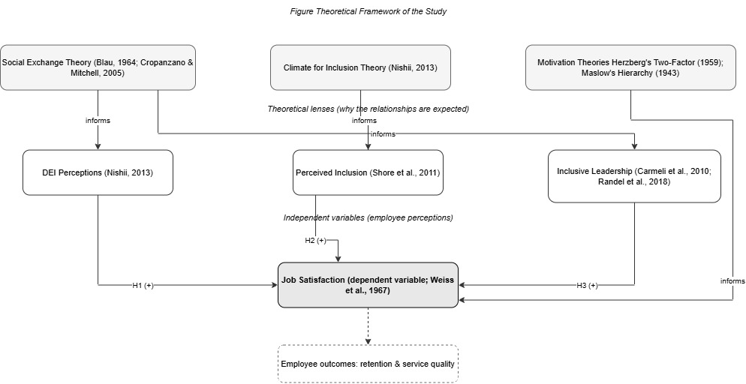
Figure 2.1: Theoretical framework of the study (Social Exchange, Climate for Inclusion and motivation theories underpinning the three predictors of job satisfaction).
These theoretical foundations are themselves well established. According to the norm of reciprocity (Gouldner, 1960), social exchange is grounded in a set of expectations of reciprocated treatment from others, and is closely related to perceived organisational support (Eisenberger et al., 1986; Rhoades and Eisenberger, 2002), since the other party is expected to return positive attitudes for positive treatment. Organisational justice theory is an important factor in triggering such exchange (Colquitt, 2001; Colquitt et al., 2001). Inclusion matters for wellbeing and engagement at the individual level, because of the need to belong (Baumeister and Leary, 1995) and the conditions for psychological safety (Edmondson, 1999), and at the group level because of social identity theory (Tajfel and Turner, 1979).

2.10 Conceptual Framework and Hypotheses
Drawing the literature together, this study adopts a model that positions three related but distinct constructs as direct predictors of job satisfaction. DEI perceptions relate to the perceived fairness and authenticity of an organisation’s DEI provision, perceived inclusion relates to how far employees feel they belong and are valued, and inclusive leadership relates to the everyday behaviours of the immediate manager. The dependent variable is job satisfaction. By testing each predictor alone and in combination, the study provides evidence on the relative importance of the three predictors and addresses the integration gap noted in the literature (Liu et al., 2025). On this basis, three hypotheses are formulated:
- H1: Employee perceptions of DEI initiatives are positively associated with job satisfaction.
- H2: Perceived inclusion is positively related to job satisfaction.
- H3: Job satisfaction is positively predicted by inclusive leadership.
In this model, job satisfaction is the dependent variable, and the three predictors are treated as conceptually independent but correlated antecedents. The three constructs are not necessarily independent but are, rather, highly connected with one another, as indicated in the literature: inclusive leadership is likely to foster perceived inclusion, and both fall within the broader DEI context. The model therefore determines whether each construct uniquely influences satisfaction when the others are controlled for, as the multiple regression presented in Chapter Four will test.
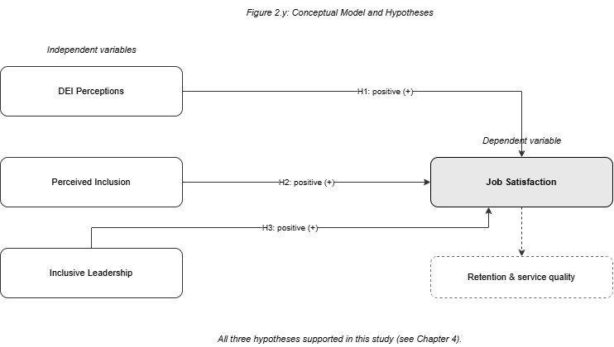
Figure 2.2: Conceptual model and hypotheses (H1–H3: DEI perceptions, perceived inclusion and inclusive leadership as direct predictors of job satisfaction).

2.11 Research Gap and Chapter Summary
The literature establishes that the felt experience of inclusion, and not policy, is the key link to positive outcomes, while both DEI and perceived inclusion are associated with positive outcomes. Three gaps, however, have not been sufficiently addressed in prior work: first, these constructs have not been studied together in a single UK hospitality model; second, much of the evidence was gathered outside the UK and may not transfer to the UK’s legal and post-Brexit context; and third, many studies are designed to determine whether policies exist, not how they are experienced by employees.
This chapter has reviewed the conceptual, contextual, empirical and theoretical literature and developed a conceptual framework to test the direct impact of DEI perceptions, perceived inclusion and inclusive leadership on job satisfaction in UK hospitality. The study seeks to address the gaps identified above by directly assessing employee perceptions and by testing the three predictors in combination. The research methodology used to test the resulting hypotheses is explained and justified in the next chapter.

Chapter Three: Research Methodology

3.1 Introduction
This chapter outlines and defends the research methodology adopted to examine the link between employee perceptions of DEI, perceived inclusion and inclusive leadership and job satisfaction in the UK tourism and hospitality industry. It explains the philosophical stance taken, the research approach and design, the design of the data-collection instrument, the sampling process, the data-analysis techniques used in IBM SPSS Statistics, and the measures taken for reliability, validity and ethical integrity. The chapter is organised around the research onion model, which begins with the philosophical layer and moves down to the core level of data collection and analysis techniques (Saunders, Lewis and Thornhill, 2023).

3.2 Research Aim and Objectives
Clear aims and objectives are essential to the development of any research design, as they specify the exact aim the research is intended to achieve and the criteria used to measure its success (Saunders, Lewis and Thornhill, 2023). By setting them out explicitly, they help to focus the research, guide the selection of methods, and facilitate evaluation and replication. To this end, the aim and objectives set for this study are restated below.
This study was designed to examine the relationships between employee perceptions of DEI initiatives, perceived inclusion and inclusive leadership, and job satisfaction among employees in the UK tourism and hospitality industry. The objectives were to:
- Explain the key dimensions of diversity, equity and inclusion most relevant to the UK tourism and hospitality workforce and their context.
- Explore the connection between employee perceptions of DEI efforts and satisfaction at work.
- Discuss the relationship of perceived inclusion and inclusive leadership with job satisfaction.
- Assess the combined ability of DEI perceptions, perceived inclusion and inclusive leadership to predict job satisfaction.
- Suggest evidence-based recommendations to support the effectiveness of DEI practices and staff retention in hospitality businesses.

3.3 Research Rationale
The research was designed to produce evidence that is systematic, transparent and open to scrutiny. A quantitative, theory-testing design was suitable because the aim was to test hypotheses derived from existing theory rather than to develop new theory (Bell, Bryman and Harley, 2022). Structured measurement was both feasible and desirable, since the constructs under investigation (DEI perceptions, perceived inclusion, inclusive leadership and job satisfaction) are well developed in the literature and have established measurement scales (Nishii, 2013). The validity and reliability of the study depend on the use of previously validated scales, a clear and repeatable data-collection process and the analysis used to address the research questions (Hair et al., 2010).
A quantitative design also brought practical advantages. It allowed data to be collected efficiently from a geographically dispersed population, generated information that could be readily summarised for a non-specialist audience, and enabled the relationships between constructs to be tested using well-known statistical tests whose assumptions and limitations are well documented (Hair et al., 2010). The approach was feasible within the timeframe of the dissertation and suitable for testing the hypotheses.

3.4 Research Philosophy
Research philosophy refers to the set of assumptions a researcher holds about the nature of knowledge and the means by which it is produced (Saunders, Lewis and Thornhill, 2023). The approach of this study was positivist. A positivist approach assumes that social phenomena can be objectively observed and measured, and that knowledge about them can be advanced by testing hypotheses against empirical data (Bell, Bryman and Harley, 2022). It was appropriate here because the constructs were predefined, measurable and drawn from established theory, and because the study sought to test whether they were related to one another across a large sample rather than to investigate individual lived experience. Interpretivism was considered but not adopted, because it treats reality as socially constructed and is typically studied qualitatively, which did not fit the measurable and generalisable research questions of the study (Saunders, Lewis and Thornhill, 2023).
This positivist stance shaped every subsequent decision in the research. It supported the use of a structured instrument with fixed response options and established, previously validated scales, and the use of statistical analysis to test relationships across a large number of respondents. It also positioned the researcher as an outsider observing and attempting to capture an external reality, rather than engaging in dialogue with the researched, as is common in interpretivist research (Bell, Bryman and Harley, 2022). This provides the link between reasoning and practice that unites the study.

3.5 Research Approach and the Research Onion
Two broad approaches to theory development exist. A deductive approach is “top-down”, moving from established theory to specific hypotheses and then to the data collected to test them, whereas an inductive approach is “bottom-up”, moving from observations to new theory (Saunders, Lewis and Thornhill, 2023). This study adopted a deductive, top-down approach. All three hypotheses – DEI perceptions (H1), perceived inclusion (H2) and inclusive leadership (H3) – were specified before the data were analysed and relate directly to the research aim and objectives set out in section 3.2, reflecting social exchange theory (Blau, 1964) and climate for inclusion theory (Nishii, 2013). Empirical data were then gathered to test them.
The research onion, developed by Saunders, Lewis and Thornhill (2023), is a widely used framework that highlights the decisions that must be made when designing research, beginning with the outer philosophy and moving to the inner layers of data-collection and analysis techniques. Its value is that it helps the researcher to make each methodological choice deliberately and in a logical sequence, so that the inner choices follow from the outer ones. Applied to this study, the onion runs from a positivist philosophy, through a deductive approach, a mono-method quantitative choice, a survey strategy and a cross-sectional time horizon, to the data collection and analysis at its core. This path is illustrated in Figure 3.1, in which the layers used in this study are highlighted.
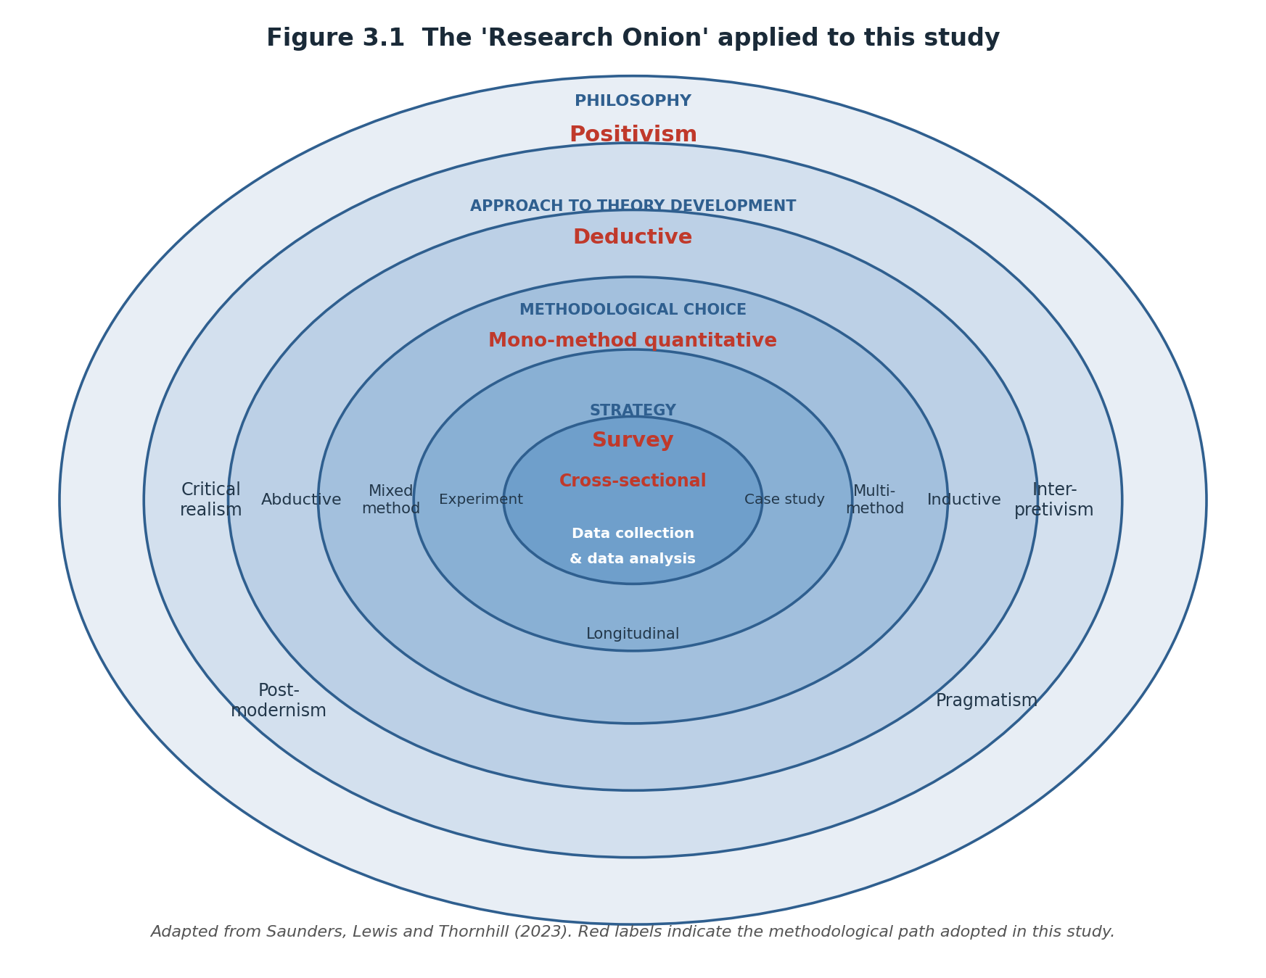
Figure 3.1: The research onion applied to this study (adapted from Saunders, Lewis and Thornhill, 2023).

3.6 Research Design and Strategy
The study used a mono-method quantitative design, relying on a single quantitative data source (Saunders et al., 2023). A survey was chosen because surveys collect standardised, comparable data from a large and geographically dispersed population at reasonable cost (Veal, 2011). A cross-sectional time frame was used, with data gathered at a single point in time, corresponding to the scope and timeframe of a master’s dissertation. The survey was online and self-administered, to minimise interviewer bias and allow respondents to complete it in their own time and place while reducing the cost of nationwide distribution; its anonymity also encouraged honest responses on a sensitive topic (Veal, 2011).

3.7 Questionnaire Design and Data Collection
A structured, self-administered online questionnaire was used for primary data collection through Microsoft Forms. The questionnaire measured four constructs using items adapted from previously validated scales: perceptions of DEI were measured with items adapted from Nishii (2013); perceived inclusion with items based on Shore et al. (2011); inclusive leadership with behavioural items adapted from Carmeli, Reiter-Palmon and Ziv (2010); and job satisfaction with items from the short-form Minnesota Satisfaction Questionnaire (Weiss et al., 1967). The use of established scales was appropriate because they have already been tested for reliability and validity, increasing confidence that they measure what they are intended to measure and allowing comparison with previous studies (Bell, Bryman and Harley, 2022). Each item was adapted to ensure that it related directly to the respondent’s own organisation and the UK hospitality environment.
A brief portfolio of demographic information was also gathered on the subject about the respondent, to describe and compare the categories. The instrument was structured into specific parts with each having a clear question. The sections included an eligibility screening question, a demographic section, a multiple response question asking the respondent's organisation about the DEI actions it provides, four sets of four Likert statements (one set for each construct with statements rated on a five-point scale from strongly disagree to strongly agree), and an optional open comment. This resulted in a tightly focused instrument, consisting of approximately twenty rating items, along with some demographic data, estimated to take ten to fifteen minutes to complete; long enough to provide multiple indicators of each construct, but short enough to avoid the problem of low completion rates often seen with lengthy on-line surveys (Hair et al., 2010). To avoid respondents scrolling back, the response scale was repeated at the beginning of each rating section. The questionnaire was pre-tested with a small sample of professionals involved in the hospitality industry to check the understandability of the items and relevance to jobs in the hospitality sector (Saunders, Lewis and Thornhill, 2023). An empty version of the final questionnaire can be found in Appendix A.
The form of the questionnaire was selected purposefully. The positivist, deductive study called for the use of a structured questionnaire with fixed-response items to allow for the generation of standardised, numerical data that would be suitable for comparison between respondents and data analysis, as these would facilitate statistical analysis (Bell, Bryman and Harley, 2022). Closed Likert items were used to consistently measure the four constructs and the multiple-response question and open comments provided context but were not extensive. This was done on purpose to minimize respondent fatigue and drop-out in busy hospitality employees' online surveys (Veal, 2011).

3.8 Population and Sampling
The target population comprised employees of UK tourism and hospitality organisations, with particular emphasis on the food and beverage sub-sectors (restaurants, bars and pubs), hotels and events, which accounted for the bulk of the sample and represented the frontline, customer-facing jobs at the heart of the study. A non-probability approach combining purposive and snowball sampling was used. Purposive sampling was appropriate because participants had to meet specific criteria, namely working in the UK hospitality industry and being aged 18 or over, while snowball sampling was used as initial respondents were asked to recommend others who met the study’s requirements (Bell, Bryman and Harley, 2022). The survey was distributed online, primarily through LinkedIn and hospitality-industry groups, which provided an efficient and cost-effective way to reach a geographically dispersed group of employees, albeit with a bias towards more digitally active employees. Data were gathered over about six and a half weeks, between 1 July and 15 August 2026. A total of 209 responses were received. These were then screened for eligibility and data quality: 22 respondents indicated that they were not currently employed in the sector; 23 gave identical answers to every rating item, a sign of careless responding; and a further 5 multivariate outliers were removed, resulting in 159 valid responses (Tabachnick and Fidell, 2019). The eligibility screening question at the beginning of the questionnaire was used to ensure that respondents were working in the sector at the time of the survey, and the response profile is presented in full in Chapter Four. The 159 observations in the analytic sample were sufficient for descriptive, comparative and regression analysis, according to the guideline of ten to fifteen observations per predictor for a three-predictor regression (Hair et al., 2010).
The non-probability nature of the sampling approach is acknowledged as a deliberate trade-off. Probability sampling of the UK hospitality sector would have been impracticable within the confines of a master’s dissertation, since there is no definitive list of the population from which a sample could be drawn. Purposive and snowball sampling were effective for reaching eligible respondents, but did not ensure representativeness, because people contacted through professional digital networks may not be representative of the broader workforce. This limitation is revisited in the interpretation of the results and in the conclusion.

3.9 Data Analysis
All data were analysed using IBM SPSS Statistics (version 27). Responses were exported from Microsoft Forms and prepared for analysis. Each variable was then coded numerically, with the five-point Likert responses ranging from one to five and the other categorical variables entered as numbered categories with descriptive value labels; in the Variable View, each variable was assigned the appropriate measurement level (scale for the Likert and composite variables, ordinal for ranked categories such as age and length of service, and nominal for unordered categories such as gender and sub-sector). The data were also examined for completeness and any obvious errors were corrected before analysis, so that the results are based on clean, correctly specified data (Hair et al., 2010).
The analysis followed a clear sequence. First, frequency analysis (Analyze → Descriptive Statistics → Frequencies) described the sample, and descriptive statistics (Analyze → Descriptive Statistics → Descriptives) summarised the four construct scores. Second, the internal consistency of each multi-item scale was examined using Cronbach’s alpha (Analyze → Scale → Reliability Analysis), with values of 0.70 or higher considered acceptable (Hair et al., 2010). Each scale was then combined into a composite (mean) score for use in the subsequent analysis.
Third, Pearson correlation (Analyze → Correlate → Bivariate) was used to assess the strength and direction of the relationships among the constructs. Finally, and most importantly, multiple linear regression (Analyze → Regression → Linear) was conducted to determine whether DEI perceptions, perceived inclusion and inclusive leadership together predicted job satisfaction, and to provide the R-squared statistic and collinearity diagnostics (tolerance and VIF). A one-way ANOVA (Analyze → Compare Means → One-Way ANOVA) was then used to compare job satisfaction by job level, and a chi-square test of independence (Analyze → Descriptive Statistics → Crosstabs) was used to explore the relationship between job level and diversity training. Results are presented in tables and charts – a bar chart for the demographic profile, a scatterplot to check the regression assumptions, and a means plot for the group comparison – so that they are clear and easily understood.
Microsoft Excel was used alongside SPSS for the initial organisation and cleaning of the exported data, with SPSS used for all statistical testing and for producing the charts and supporting summaries reported in Chapter Four. Presenting the results both numerically and graphically was a deliberate decision, taken to ensure that they are transparent and accessible to readers who may not be specialists in statistics, in line with good practice on the clear communication of quantitative results (Saunders, Lewis and Thornhill, 2023).
The analytical procedures followed standard guidance for quantitative research and for the use of SPSS (Field, 2018; Pallant, 2020; Creswell and Creswell, 2018), with thresholds for reliability, multicollinearity, outlier screening and effect size drawn from established sources (Nunnally and Bernstein, 1994; Tabachnick and Fidell, 2019; Cohen, 1988). Single-source, self-reported data posed a risk of common method bias, which was addressed and reduced by using anonymous and neutrally worded items (Podsakoff et al., 2003).

3.10 Reliability and Validity
Reliability refers to the consistency of a measure – whether it produces the same result on repeated use – and validity refers to whether it actually measures what it claims to measure (Saunders, Lewis and Thornhill, 2023). Both matter equally, since only findings supported by reliable and meaningful measures can be trusted. Reliability was supported by using established scales and was tested statistically against the 0.70 threshold applied by Hair et al. (2010). Content and construct validity were supported by adapting previously validated scales and piloting the instrument before distribution.
Two limitations should be acknowledged. First, although the 159 analysable responses were deemed sufficient, the sample is small relative to the very large number of hospitality employees in the UK, so the results are limited in their representativeness and cannot be generalised to the sector as a whole. Second, because the data were self-reported and gathered through the researcher’s connections, there is a possibility of bias, both in the researcher’s selection of participants and in socially desirable responding. These risks were minimised through the anonymity of the survey, neutral question wording and the use of conventional, transparent data-analysis procedures; they cannot be eliminated, and are acknowledged here in the interests of transparency.

3.11 Research Ethics
Research ethics matter because research must benefit knowledge while protecting those who take part; otherwise harm can be done and the credibility of the findings compromised (Saunders, Lewis and Thornhill, 2023). Before any data were collected, ethical approval was granted for this study in accordance with the University of Wales Trinity Saint David’s ethics application (PG2) form, and the study was conducted in line with the University’s Research Ethics and Integrity Code of Practice. Participation was not compulsory, and informed consent was obtained through a clear information statement at the start of the questionnaire, which explained the purpose of the study and confirmed that continuing to answer indicated ongoing consent. No personally identifying information was gathered, so responses were anonymous, and all data were kept securely on password-protected University systems in accordance with the Data Protection Act 2018. A copy of the approved ethics form is included in the appendices.

3.12 Summary
This chapter has justified a positivist, deductive, mono-method quantitative methodology, applied through a cross-sectional online survey of UK hospitality workers that yielded 159 analysable responses after screening, which were then analysed using descriptive statistics, reliability analysis, correlation, multiple regression, ANOVA and chi-square tests in IBM SPSS Statistics. It has described the measurement of the constructs, the sampling process, the reliability and validity of the measures, and the ethical considerations. The results are presented in the following chapter.

Chapter Four: Data Analysis and Findings

4.1 Introduction
The results from the primary survey data are presented in this chapter, which is divided into two parts. The first (Sections 4.2 to 4.11) presents the results in tables and figures, as outlined in Chapter Three: data screening and descriptive profiling, reliability, correlation, multiple regression, a group comparison, a test of association and comparisons across respondent types. The second (Section 4.12) critically reviews these results in the context of the literature, the theoretical framework and the aims of the study. IBM SPSS Statistics (version 27) was used for all analyses.

4.2 Data Screening and Response Profile
A total of 209 responses were received and screened at three stages. First, 22 respondents who indicated on the screening question that they were not currently working in a hospitality role in the UK were excluded as ineligible, leaving 187. Second, 23 respondents were removed for giving the same answer to every one of the sixteen rating items, a recognised check for careless responding, leaving 164. Third, a further 5 multivariate outliers were identified by a Mahalanobis distance test (p < .001) and removed. This produced a final analytic sample of 159 valid responses, used throughout this chapter. Ethnic background was an optional question, and the three respondents who did not report it are treated as missing only for that variable.

4.3 Demographic Profile of Respondents
The composition of the sample was described using frequency analysis. The demographic profile is summarised in Tables 4.1 to 4.7 and the accompanying charts.
Table 4.1: Gender of respondents
Gender | Frequency | Percent
Male | 99 | 62.3
Female | 48 | 30.2
Non-binary | 5 | 3.1
Prefer not to say | 7 | 4.4
Total | 159 | 100.0
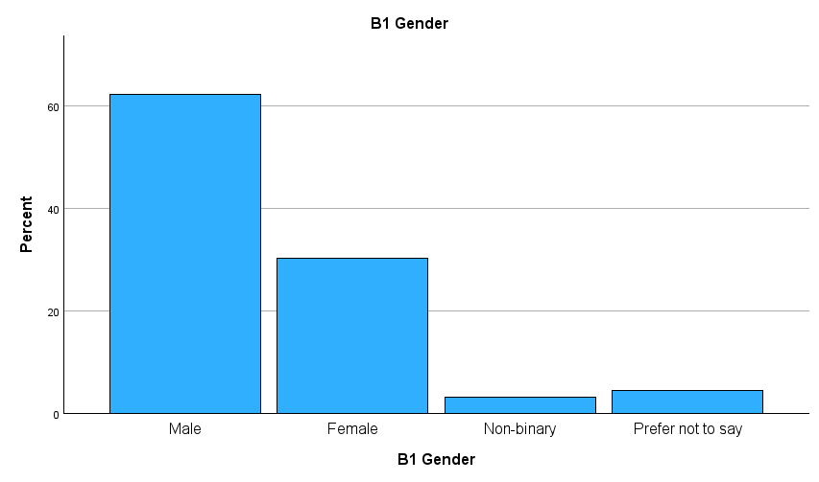
Figure 4.1: Gender of respondents
The majority of the sample were male (62.3%), followed by female (30.2%), with small proportions non-binary (3.1%) or preferring not to say (4.4%).
Table 4.2: Age group of respondents
Age group | Frequency | Percent
18–29 | 61 | 38.4
30–39 | 58 | 36.5
40–49 | 33 | 20.8
50–59 | 3 | 1.9
60 and above | 4 | 2.5
Total | 159 | 100.0
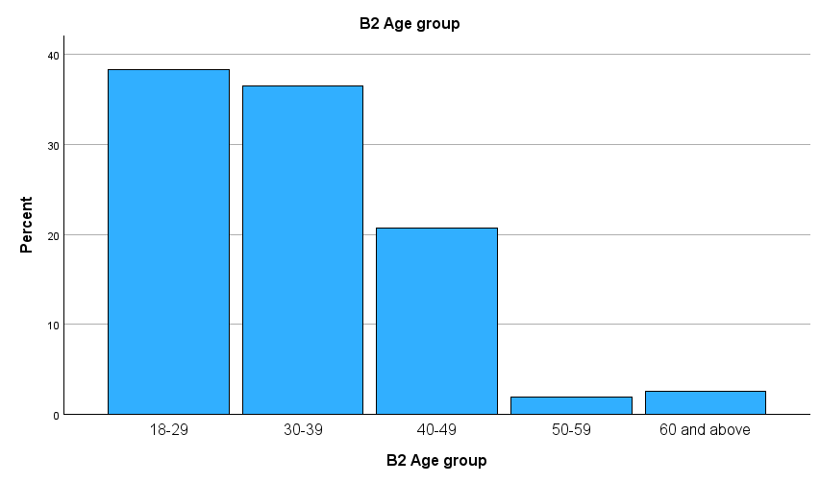
Figure 4.2: Age group of respondents
The age distribution was skewed towards younger employees, with approximately 75% aged under 40. This is in line with the recruitment strategy outlined in Chapter Three, where the survey was advertised on professional digital networks that tend to reach a younger, digitally active cohort (Baum et al., 2016); it is therefore not interpreted as a reflection of the sector as a whole.
Table 4.3: Employment type
Employment type | Frequency | Percent
Full-time | 57 | 35.8
Part-time | 86 | 54.1
Seasonal or Casual | 16 | 10.1
Total | 159 | 100.0
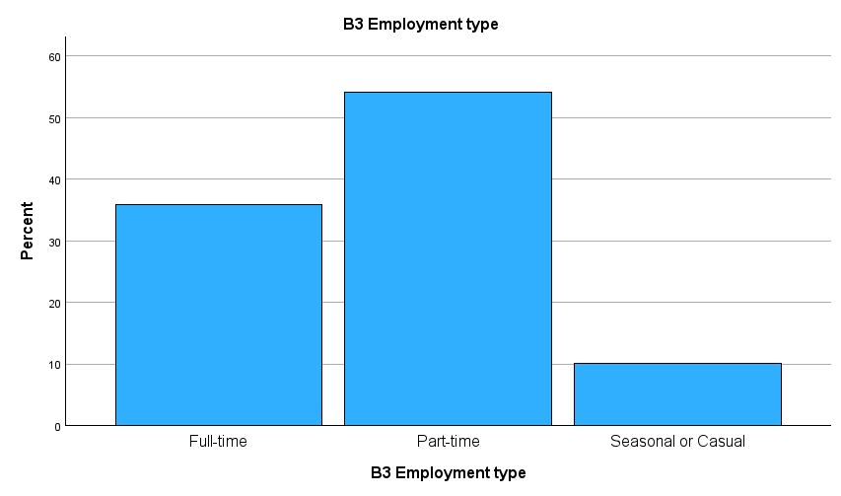
Figure 4.3: Employment type
Table 4.4: Job level
Job level | Frequency | Percent
Frontline staff | 42 | 26.4
Supervisory staff | 75 | 47.2
Managerial staff | 42 | 26.4
Total | 159 | 100.0
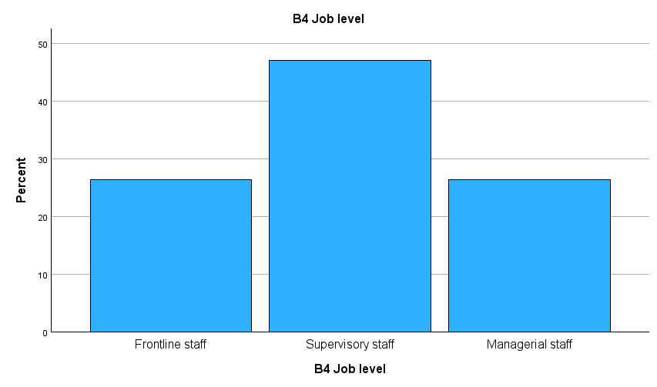
Figure 4.4: Job level
The hospitality sector was also a flexible one with the majority of respondents working part-time (54.1%) and approximately half holding a supervisory position (47.2%). Frontline (26.4%) and managerial (26.4%) workers represented about a quarter of the sample each.
Table 4.5: Length of service
Length of service | Frequency | Percent
Less than 6 months | 25 | 15.7
6 months to 2 years | 59 | 37.1
2 to 5 years | 48 | 30.2
5 to 10 years | 16 | 10.1
More than 10 years | 11 | 6.9
Total | 159 | 100.0
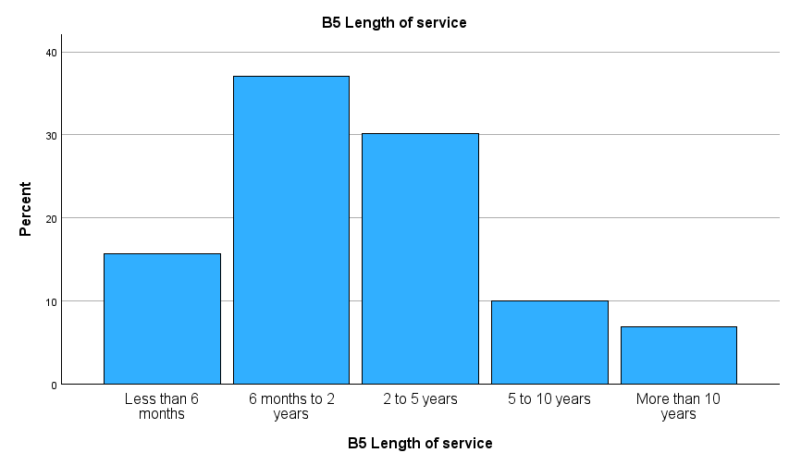
Figure 4.5: Length of service
Table 4.6: Ethnic background
Ethnic background | Frequency | Valid percent
White | 31 | 15.1
Asian / Asian British | 74 | 36.1
Black / Black British | 48 | 23.4
Mixed / Multiple | 28 | 13.7
Other | 17 | 8.3
Prefer not to say | 7 | 3.4
Total (valid) | 205 | 100.0
Missing | 4 | –
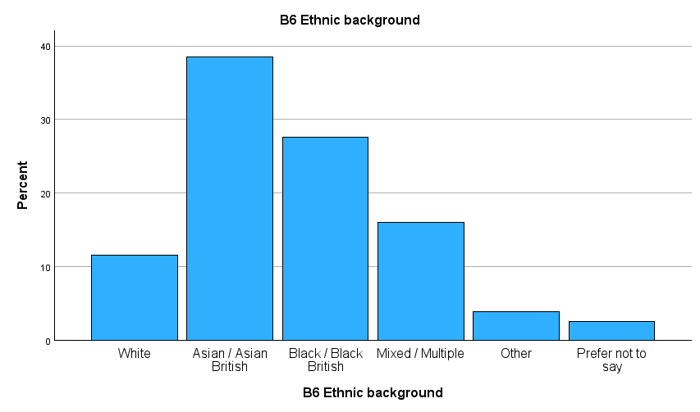
Figure 4.6: Ethnic background
The sample was ethnically diverse with the highest percentage identifying as Asian or Asian British (38.5% of valid responses), 27.6% identifying as Black or Black British, 16.0% identifying as Mixed or Multiple, and 11.5% as White. This diversity is similar to that of the workforce on the front lines of hospitality service (Robinson et al., 2019).
Table 4.7: Hospitality sub-sector
Sub-sector | Frequency | Percent
Hotels / Accommodation | 26 | 16.4
Restaurants / Food service | 55 | 34.6
Bars / Pubs | 30 | 18.9
Events / Catering | 24 | 15.1
Travel / Tourism services | 12 | 7.5
Other | 12 | 7.5
Total | 159 | 100.0
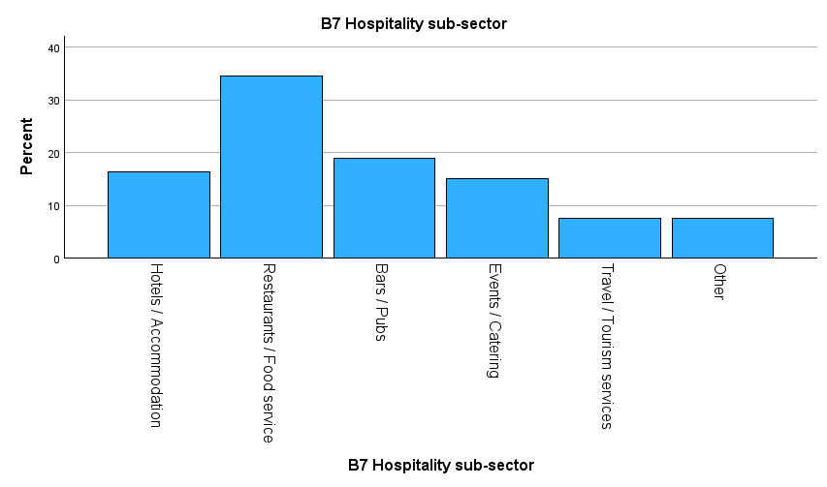
Figure 4.7: Hospitality sub-sector
Most respondents worked in restaurants and food service (34.6%), followed by bars and pubs (18.9%) and hotels and accommodation (16.4%).
Taken as a whole, the sample describes a relatively younger, ethnically diverse, part-time workforce, weighted towards supervisory roles and drawn mainly from the restaurant, bar and hotel sub-sectors. This profile broadly aligns with the frontline hospitality workforce described in the literature (Baum et al., 2016; Robinson et al., 2019), although the concentration of younger and more senior respondents reflects the digital recruitment channel and limits how far the results generalise to the sector as a whole.
The demographic profile is itself informative. The sample was predominantly male (62.3%), whereas the broader hospitality sector is dominated by women, who make up approximately 60% of the workforce yet are underrepresented in the supervisory and managerial positions well represented in this sample (Kokkranikal et al., 2024; Russen, Dawson and Madera, 2021). This is not a reflection of the frontline composition of the sector but a result of the LinkedIn recruitment channel and men’s over-representation in the senior roles sampled, and it should be borne in mind when generalising. The sample was also concentrated among younger (around 75% aged under 40) and part-time (54.1%) employees, reflecting the youthful, flexible nature of the workforce (Baum et al., 2016; Robinson et al., 2019). As Section 4.11 shows, younger workers rated DEI provision significantly less favourably, which matters when interpreting the high mean scores below.

4.4 DEI Actions Reported by Respondents
Respondents were asked to select all the DEI actions their organisation currently provides. The most commonly reported were mentoring or career development (64.2%) and employee networks (63.5%), followed by a written DEI policy (50.9%) and a discrimination-reporting route (46.5%). Flexible working and diversity training were each reported by around a quarter, while a minority reported none (7.5%) or were unsure (17.0%), suggesting that although many organisations have some provision, awareness of the specific measures in place is uneven.
Table 4.8: DEI actions reported (multiple response, n = 159)
DEI action provided | Respondents | Percent
Mentoring / career development | 102 | 64.2
Employee networks or support groups | 101 | 63.5
Written DEI or equality policy | 81 | 50.9
Discrimination reporting route | 74 | 46.5
Flexible working arrangements | 45 | 28.3
Diversity or inclusion training | 37 | 23.3
Not sure | 27 | 17.0
None of the above | 12 | 7.5

4.5 Reliability of Measurement Scales
Before composite scores were introduced, the internal consistency of each four-item scale was evaluated using Cronbach’s alpha. As shown in Table 4.9, all four scales exceeded the 0.70 threshold by a wide margin (Hair et al., 2010), indicating excellent reliability, and no scale would have been improved by deleting an item. The composite (mean) scores were therefore deemed appropriate for the analysis that follows.
Table 4.9: Reliability of measurement scales
Construct (items) | No. of items | Cronbach's alpha
DEI perceptions (C2–C5) | 4 | .894
Perceived inclusion (D1–D4) | 4 | .906
Inclusive leadership (E1–E4) | 4 | .921
Job satisfaction (F1–F4) | 4 | .916

4.6 Descriptive Statistics of the Constructs
Table 4.10 reports the descriptive statistics for the four composite scores. The mean scores were all above the mid-point of the five-point scale, with DEI perceptions the highest (M = 4.19) and perceived inclusion the lowest (M = 3.95). Each of the four distributions was negatively skewed, with responses falling towards the more positive (higher) end of the scale. This mild ceiling tendency is noted as a feature of the data and reiterated in the limitations.
The relatively high mean scores are themselves informative. Overall, they suggest broadly positive attitudes among the employees who responded towards their organisations’ DEI provision, their own inclusion, their managers and their jobs. This may partly reflect the profile of those who chose to respond, but it also suggests that dissatisfaction in this sample is concentrated among a minority, and the analysis below helps to highlight where it is most likely to be found, most notably among frontline staff.
Table 4.10: Descriptive statistics for the composite scores (n = 159)
Construct | Mean | SD | Skewness | Kurtosis
DEI perceptions | 4.19 | 0.80 | −2.42 | 5.50
Perceived inclusion | 3.95 | 0.90 | −1.36 | 1.05
Inclusive leadership | 4.02 | 0.95 | −1.68 | 1.84
Job satisfaction | 4.01 | 0.93 | −1.56 | 1.59
Figures 4.8 to 4.11 present the distribution of each composite score. In every case the responses cluster towards the upper end of the scale, with a tail extending towards lower values, confirming the negative skew reported above. This mild ceiling pattern is common in self-report attitude data and is noted again among the limitations.
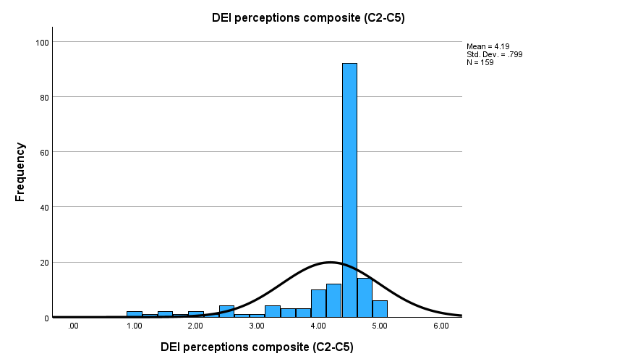
Figure 4.8: Distribution of the DEI perceptions composite
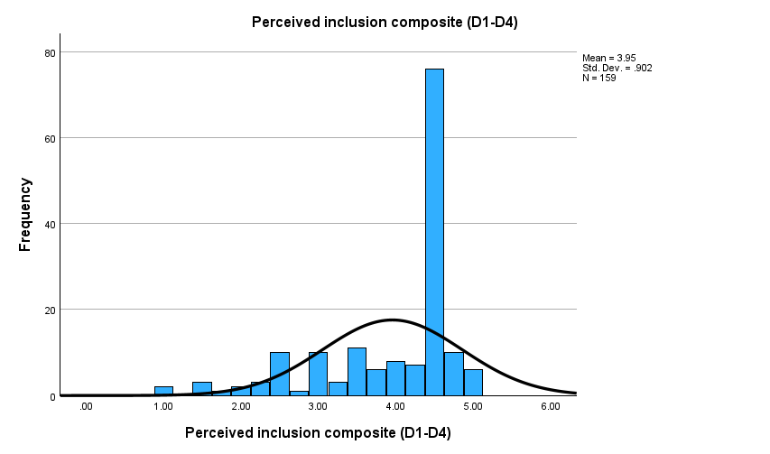
Figure 4.9: Distribution of the perceived inclusion composite
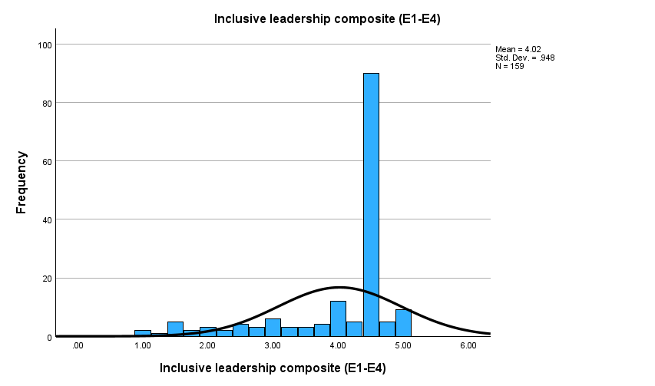
Figure 4.10: Distribution of the inclusive leadership composite
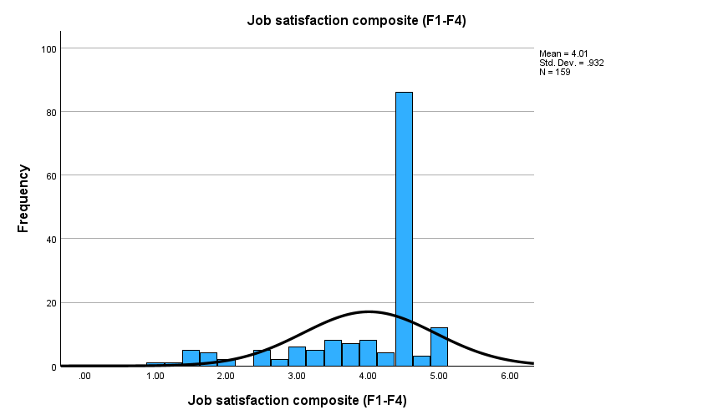
Figure 4.11: Distribution of the job satisfaction composite

4.7 Correlation Analysis
Pearson correlations were computed to explore the relationships between the four constructs (Table 4.11). Each correlation was positive, strong and statistically significant (p < .001). Job satisfaction was most strongly correlated with inclusive leadership (r = .849), followed by perceived inclusion (r = .752) and DEI perceptions (r = .726). The predictors were also highly correlated with one another (r = .683 to .778), which is examined further through the collinearity diagnostics in the regression below.
Table 4.11: Correlation matrix (Pearson r, n = 159)
 | DEI | Inclusion | Leadership | Satisfaction
DEI | 1
Inclusion | .683** | 1
Leadership | .771** | .778** | 1
Satisfaction | .726** | .752** | .849** | 1
** Correlation is significant at the 0.01 level (2-tailed).
The strong, positive correlations provide initial support for the hypotheses and suggest that employees who perceive stronger DEI provision, greater inclusion and more inclusive leadership also tend to report higher job satisfaction. The particularly strong correlation between inclusive leadership and job satisfaction (r = .849) foreshadows the regression result below. The high inter-correlations among the three predictors are to be expected, given the conceptual relationships between inclusive leadership, felt inclusion and perceptions of DEI provision.

4.8 Multiple Regression Analysis
Multiple linear regression was conducted to test if DEI perceptions and perceived inclusion and inclusive leadership as a combination predicts job satisfaction. The results of the model are significant, F(3, 155) = 153.83, p < .001, and produced a strong model of the variance in job satisfaction, R² = .749, adjusted R² = .744, accounting for approximately 75% of the differences in job satisfaction between respondents (Table 4.12).
Table 4.12: Regression model summary and ANOVA
Statistic | Value
R | .865
R² | .749
Adjusted R² | .744
Std. error of the estimate | .472
F (3, 155) | 153.83
Sig. (p) | < .001
All three predictors contributed positively and significantly as shown in Table 4.13. Inclusive leadership was the strongest predictor (β = .585, p < .001), followed by perceived inclusion (β = .203, p = .002) and DEI perceptions (β = .137, p = .036). Collinearity diagnostics was satisfactory, with all VIF values below five (2.6 to 3.5), and tolerance values exceeding 0.20, which means that the predictors are correlated but not at a level that would be a problem for the model (Hair et al., 2010).
Table 4.13: Regression coefficients (dependent variable: job satisfaction)
Predictor | B | Std. error | β | t | Sig. | VIF
(Constant) | .200 | .205 | – | 0.976 | .330 | –
DEI perceptions | .160 | .075 | .137 | 2.119 | .036 | 2.57
Perceived inclusion | .209 | .068 | .203 | 3.093 | .002 | 2.65
Inclusive leadership | .575 | .074 | .585 | 7.790 | < .001 | 3.48
The scatterplot of the standardised residuals against the standardised predicted values (Figure 4.12) demonstrated a fairly even distribution of the points around zero with no particular trend, as expected if the model is linear and variances are constant, although a few cases with large residuals were identified, as described above.
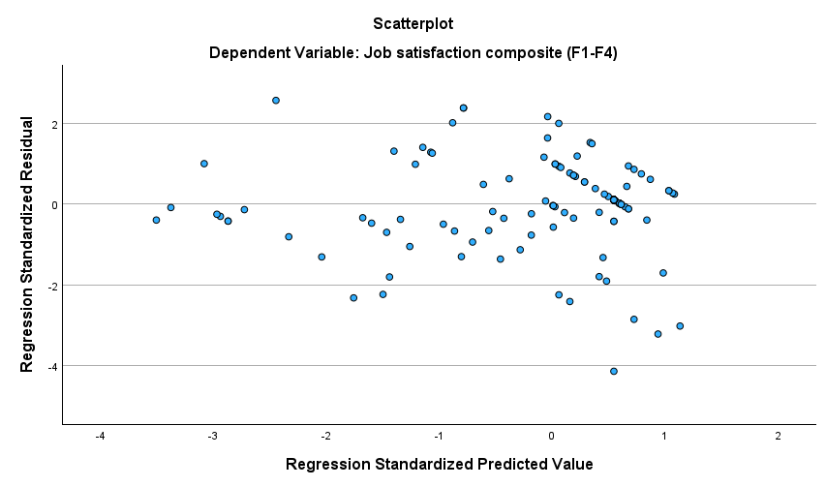
Figure 4.12: Scatterplot of standardised residuals (regression)
These results support all three hypotheses: DEI perceptions (H1), perceived inclusion (H2) and inclusive leadership (H3) each positively and significantly predicted job satisfaction, with inclusive leadership the most influential. This is in line with research that suggests that managers’ everyday behaviors, such as their approachability, listening and valuing employees, can drive felt inclusion, not just policy-based DEI initiatives (Carmeli, Reiter-Palmon and Ziv, 2010; Kim et al., 2024). Perceived inclusion as an independent pathway to positive outcomes not just a result of diversity policy confirms that inclusion is a distinct pathway to positive outcomes, rather than merely a by-product of diversity policy (Nishii, 2013; Song et al., 2024). The pattern is clear from social exchange theory: When employees feel that they are being treated fairly and equitably and leaders are treating them well, they respond positively with more positive attitudes (Blau, 1964).
In terms of practical significance, the explanatory power of the model is noteworthy. With an R² of .749, about three-quarters of the variation in satisfaction of these employees is explained by their perception of DEI and inclusion and leadership. This result is not unique to compensation but indicates that the emotional sense of belonging and of being a leader is a significant, not insignificant, factor in satisfaction for this sample and should be considered to be a factor that can be changed.

4.9 Job Satisfaction by Job Level (ANOVA)
The one-way ANOVA was used to determine if there was any significant difference in satisfaction with the job between the three job levels. There was a statistically significant difference between groups, F(2, 156) = 5.28, p = .006 (Table 4.14). Frontline staff reported the lowest level of job satisfaction (M = 3.62) while supervisory staff (M = 4.15) and managerial staff (M = 4.15) reported higher levels of satisfaction, but not very different from one another (Figure 4.13). A Tukey post hoc test confirmed that those working in the frontline were significantly less satisfied than those working in supervisory or managerial positions (p = .008 and p = .022 respectively). There was no significant difference between the satisfaction of the supervisory and managerial (p = 1.000).
Table 4.14: Job satisfaction by job level (one-way ANOVA)
Job level | n | Mean | SD
Frontline staff | 42 | 3.62 | 1.19
Supervisory staff | 75 | 4.15 | 0.78
Managerial staff | 42 | 4.15 | 0.79
Total | 159 | 4.01 | 0.93
ANOVA: F(2, 156) = 5.28, p = .006.
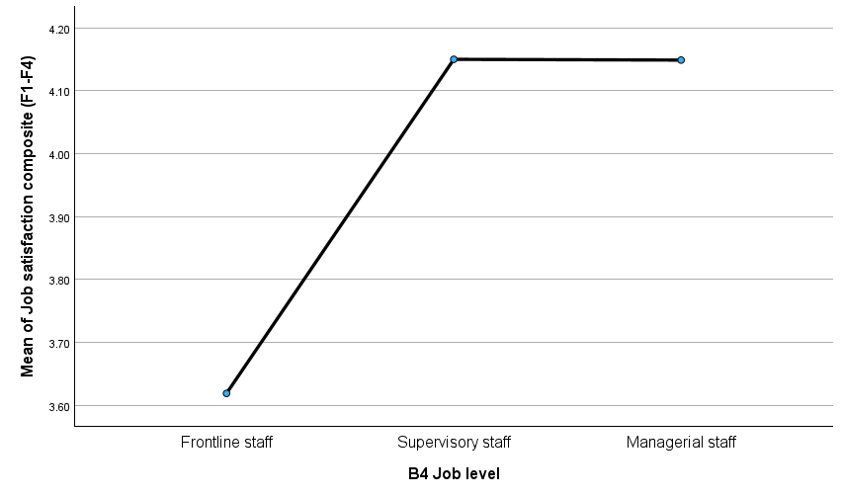
Figure 4.13: Mean job satisfaction by job level
This means that the most frontline workers are also the least satisfied group of workers, and the impact on turnover is clear (Dorta-Afonso et al., 2020). This lower satisfaction occurs at the frontline of the sector, where much of the diversity is also found (Robinson et al., 2019), meaning in those areas where DEI and inclusive leadership efforts are most needed. This discovery reinforces the message of the regression: the opportunity to increase the satisfaction and retention of frontline workers is likely to be the biggest through their supervisors' experience of inclusion (CIPD 2021).
The association between job level and diversity training was not statistically significant.Job level and diversity training were not significantly associated.

4.10 Association Between Job Level and Diversity Training
A chi-square test of independence was used to determine if diversity training was provided across job levels (Table 4.15). There were not significant differences in proportions reporting training by job level, either between frontline and supervisory staff (26.2% each, χ²(2) = 1.70, p = .428) or between frontline and managerial staff (26.2% each, χ²(2) = 1.00, p = .605). Thus, no significant differences in access to diversity training across levels of job position were found within this sample.
While this specific association is not important, in light of the above finding that frontline staff were not the most satisfied, the following pattern is noteworthy: that other groups reported more access to training than frontline staff. It implies that the lack of formal training provision may not be a driving factor in explaining the lower satisfaction of frontline employees, but rather the quality of inclusion and leadership in day-to-day work. It further suggests that the quality of daily inclusion and leadership may explain the lower satisfaction of frontline employees as evidenced by the results of the regression analysis.
Table 4.15: Job level by provision of diversity training
Job level | Training provided | Not provided | Total
Frontline staff | 11 (26.2%) | 31 | 42
Supervisory staff | 15 (20.0%) | 60 | 75
Managerial staff | 11 (26.2%) | 31 | 42
Total | 37 | 122 | 159
Chi-square: χ²(2) = 0.85, p = .654.

4.11 Group Differences by Respondent Type
One way ANOVA was used to explore the difference in perceptions among each of the four composite scores across gender, age group, hospitality sub-sector and employment type to determine if there was a difference. The results are summarized in table 4.17 and only the statistically significant differences are discussed below.
Table 4.17: Differences in construct scores by respondent type (one-way ANOVA, N = 159)
Grouping | DEI perceptions | Perceived inclusion | Inclusive leadership | Job satisfaction
Gender (M/F/Other) | F(2,156)=1.43, p=.242 | F(2,156)=0.24, p=.789 | F(2,156)=1.46, p=.235 | F(2,156)=0.56, p=.574
Age group | F(4,154)=3.44, p=.010* | F(4,154)=0.75, p=.558 | F(4,154)=1.56, p=.189 | F(4,154)=1.93, p=.108
Sub-sector | F(5,153)=2.99, p=.013* | F(5,153)=3.23, p=.008* | F(5,153)=1.56, p=.175 | F(5,153)=2.12, p=.066
Employment type | F(2,156)=1.12, p=.328 | F(2,156)=0.98, p=.378 | F(2,156)=1.25, p=.289 | F(2,156)=0.05, p=.956
* significant at p < .05.
There are three patterns of interest. First, we found that there were no significant gender difference on any construct between male and female respondents and other respondents regarding their DEI perceptions, inclusion, leadership and satisfaction. This is significant because of the male-dominated sample and literature that focuses on gendered inequality (Kokkranikal et al., 2024) and the felt experience of inclusion was equal across gender for these respondents, although representation in senior roles may have been different. Second, perceptions of DEI provision differed by age (p = .010): younger workers (18–29) rated provision less favourably than those aged at or over 30 years (M = 4.33–4.50; Figure 4.14), which aligns with findings that younger generations feel the employer's DEI initiatives are being reviewed more critically (Madera, Manoharan and Singal, 2023). Third, perceptions of DEI and perceived inclusion were significantly different across sub-sector (p = .013 for perceptions of DEI and p = .008 for perceived inclusion); however, perceived inclusion was not significantly different across any sub-sector grouping, and inclusive leadership was not significantly different across sub-sector groupings, suggesting it had a strong effect across all sub-sector groupings.
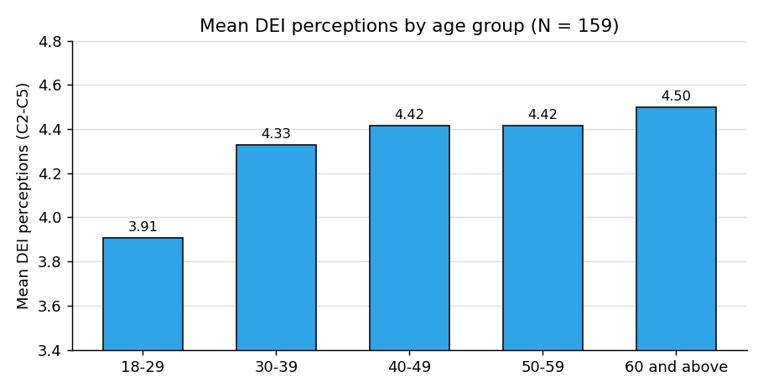
Figure 4.14: Mean DEI perceptions by age group (younger employees rate DEI provision less favourably).

4.12 Discussion and Critique of Findings
The statistical results were given in the previous sections, which are now summarized and critically evaluated in the light of literature, the theoretical framework and the aims of the research. Overall, the findings give an understandable and theoretically supported explanation of the impact of inclusion on job satisfaction in hospitality in the UK and fulfil all the objectives of the study.
The first goal was to explore the relationship between DEI perceptions and job satisfaction. The results confirmed the hypothesized H1, as perceptions of DEI significantly and positively predicted satisfaction (β = .137, p = .036). This is consistent with social exchange theory (Blau, 1964; Cropanzano and Mitchell, 2005): employees' reciprocation to positive attitudes toward fair and inclusive treatment. It also reveals that satisfaction is not merely about meeting the legal minimums of the Equality Act 2010; satisfying people is achieved only when DEI is seen as authentic and is applied systematically (Nishii, 2013; Mor Barak, Luria and Brimhall, 2022). The modest weight of DEI perceptions compared to leadership indicates that formal provision has less impact than how inclusion is being put into practice on a day-to-day basis.
The second goal was to focus on perceived inclusion and inclusive leadership. Both significantly predicted satisfaction (inclusion β = .203, p = .002; leadership β = .585, p < .001) supporting H2 and H3, and the study's core variable, the inclusion variable, was the strongest predictor, with leadership the strongest predictor, the mechanism most closely related to outcomes. This is in line with the literature, where inclusive leaders build psychological safety and belonging that create the conditions for formal DEI to feel like inclusion (Carmeli, Reiter-Palmon and Ziv, 2010; Edmondson, 1999; Baumeister and Leary, 1995; Kim et al., 2024). This dominance of leadership reflects the fact that employee's immediate manager is the prime source of contact with the organisation (Korkmaz et al., 2022; Nishii and Leroy, 2022) and this is the reason why this construct was the one that did not differ between the groups of respondents.
The third was to test the joint predictive power of the three constructs. When combined, they accounted for 75% of the variance in job satisfaction (R² = .749), a significant number that suggests that the felt experience of DEI, inclusion and leadership is a key, if not primary, factor in job satisfaction. The study directly addresses the integration gap suggested in recent reviews (Liu et al., 2025), and the gap to investigate inclusion as it is experienced by employees and not as it is declared as policy (Nishii, 2013).
Generally high mean scores (all with a value greater than 3.8 on a five point scale) require interpretation rather than being reported as is. They are in part dependent on the profile of the respondents (a digitally engaged, relatively older, self-selected sample) and on a relatively mild positive response tendency shared in self-report data (Podsakoff et al., 2003). When reading along with the group comparisons, however, there are noteworthy differences in the averages, with lower perceptions of DEI and satisfaction focused among frontline and younger workers. It is important to know, therefore, the value of the analysis is to pinpoint the areas where the felt sense of inclusion is the weakest, and therefore where managerial attention will need to be focused.
The results of a disparity in satisfaction between frontline and supervisory and managerial staff, and between younger and older employees, can be interpreted through motivation theory and the context of the sector. According to Herzberg's two-factor theory (Herzberg, Mausner and Snyderman, 1959) and Maslow's hierarchy of needs (Maslow, 1943), when higher-order needs for recognition and belonging are not satisfied, even when the basic conditions are satisfied, satisfaction will suffer, as in precarious front line jobs (Robinson et al., 2019). Frontline jobs are the largest and are most vulnerable to turnover (Park and Min, 2020), so it is likely that inclusive leadership and a true sense of inclusion will have the greatest impact on these positions, and sub-sector differences indicate that DEI is not felt uniformly across the industry.
Reviewing the various sections of the questionnaire in turn – the DEI actions reported, DEI perceptions, perceived inclusion, inclusive leadership and job satisfaction, and the demographic and group comparisons – the analysis has addressed all of the study’s research objectives and both research questions. The theme is that the benefits of DEI for employees are not about the policies, it's about the inclusion in practice, most importantly through frontline leadership. These findings have been used to draw conclusions and make recommendations in Chapter Five.

4.13 Summary of Findings
Analysis yielded consistent and clear results. The four scales were highly reliable and the three predictors were significantly and positively related with satisfaction. All three predictors were significant with inclusive leadership being most significant and the regression model explained approximately 75% of the variance in satisfaction; all three hypotheses were supported; (Table 4.16). There was a significant difference between the satisfaction of frontline and supervisory/managerial staff, with the latter being more satisfied, but no significant difference was found between the provision of diversity training by job level. The findings are discussed in Chapter Five.
Table 4.16: Summary of hypothesis testing
Hypothesis | Result
H1: DEI perceptions positively predict job satisfaction | Supported (β = .137, p = .036)
H2: Perceived inclusion positively predicts job satisfaction | Supported (β = .203, p = .002)
H3: Inclusive leadership positively predicts job satisfaction | Supported (β = .585, p < .001)

Chapter Five: Conclusions and Recommendations

5.1 Introduction
In this final chapter, the results of the study are summarised and their significance and implications are discussed. It starts with a summary of the key findings in the context of the research questions and goals set in Chapter One. It then discusses the implications of findings based on the literature and recommends some practical suggestions for the hospitality organisations, and the contribution of the study. The chapter ends with a discussion of the study's shortcomings and suggestions for future research as well as some concluding thoughts.

5.2 Summary of Key Findings
The purpose of this study is to investigate the relationship between employee perceptions of DEI initiatives, perceived inclusion and inclusive leadership and employee job satisfaction in the UK tourism and hospitality sector. The results in IBM SPSS Statistics were clear and consistent after analysing the responses that were provided in the survey (159). The measurement scales were very reliable and all three predictors were positively and strongly correlated with job satisfaction. The overall regression model was highly significant (R²=0.75), and all three predictors were significant in the model.
The answers to the research questions are positive. Perceptions of DEI significantly predicted satisfaction (supporting the first question and H1) as did perceived inclusion (supporting the second question and H2) and inclusive leadership (supporting the third question and H3). In addition to the hypotheses, results showed that, compared to supervisory and managerial employees, frontline employees were significantly less satisfied and that provision of diversity training was not different between these job levels. The results answered questions related to the study's aim to explore the relationship between DEI perceptions and satisfaction, the relationship between perceived inclusion, inclusive leadership and satisfaction, and the combined predictive power of the three constructs.
The results also have a definite message of awareness. While many organisations were implementing more than one measure, a significant minority reported that they did not know what specific DEI measures were being provided and/or were not providing any. This indicates that there may be a correlation between an awareness gap and the lack of action in DEI efforts as people are only able to take action if they are aware of what they are doing. The results of the pattern are clues to what organisations do and how clearly and consistently they communicate.
Taken together, the results paint a consistent picture. There are high levels of correlations between the scales and between the predictors and satisfaction, which suggests reliability of the measures, but also that all three predictors uniquely contribute when measured together. That these results are consistent across the various analyses leads to the overall finding that perceptions of DEI, perceived inclusion and inclusive leadership are all relevant to job satisfaction in the UK's hospitality sector.

5.3 Discussion and Conclusions
The key takeaway is that inclusion is more about the lived reality of inclusion than it is about formal DEI provision. The most significant predictor was inclusive leadership, consistent with the theory that only good formal commitments will be followed through if supported by inclusive behaviours exhibited by immediate managers (Carmeli, Reiter-Palmon and Ziv, 2010; Kim et al., 2024). Perceived inclusion is an independent pathway to positive outcomes, thereby emphasizing the importance of inclusion as a unique aspect of diversity policy beyond just its consequences (Nishii, 2013; Song et al., 2024). This aligns with social exchange theory (Blau, 1964) that states that employees who are fairly and inclusively treated return with more satisfaction.
The result of frontline workers being the least satisfied group is especially significant for the sector. Frontline staff are the largest, most stressed group in hospitality, and have the greatest demographic diversity (Robinson et al., 2019). The lower satisfaction levels signify a risk of losing these talents and are where inclusive management is most likely to make a difference. In the study, the authors found that DEI in the UK hospitality sector is not a policy issue, but a practice issue, and that the most common way this happens is through frontline leadership.
The conclusions are in line with the theoretical framework. The centrality of inclusive leadership and perceived inclusion is in line with climate for inclusion theory (Nishii, 2013) which proposes that the formal provision for inclusive leadership indirectly affects outcomes through the felt experience of employees; the direction of the relationships is consistent with social exchange theory (Blau, 1964); and the lower satisfaction of frontline staff is consistent with Herzberg (Herzberg, Mausner and Snyderman, 1959) and Maslow (1943) which suggest that the unmet needs for recognition and belonging help to depress satisfaction even when basic conditions are met.

5.4 Recommendations for Practice
The results lead to some practical recommendations. First, inclusive leadership demonstrated the greatest association with satisfaction, suggesting that fostering inclusive behaviours at the frontline and supervisory level – as opposed to having a written policy alone – should be a priority, as this can be done through training, coaching and expectations. Second, as felt inclusion was an important factor of satisfaction on its own, organisations should pay attention to the day to day experience of working there, actively listening and responding to employee voice, recognising employee achievements and ensuring that the day-to-day treatment reflects the commitment expressed.
Third, as the third group reported the lowest satisfaction, this group should be targeted specifically including making sure inclusion initiatives reach frontline staff and are not limited to supervisory and managerial levels. Fourth, given that in some instances the respondents were not aware of the specific measures that an organisation was taking in relation to DEI, organisations should make their DEI provision more visible, enabling employees to know what is available for their support. Together and separately they should enhance satisfaction and therefore help to retain the workforce in a sector that has been plagued by a long labour shortage (CIPD, 2021).
Lastly, organisations should not see measurement as a one-off, but an ongoing measurement process. Employee perceptions of inclusion and leadership may be gathered on a regular basis, anonymously gathered, and then acted upon in a way that is clearly visible to all employees, which would enable the employer to detect issues early and focus their efforts accordingly. The least contented and most diverse group is frontline staff, so breaking down such measurement by role level would be more effective to focus inclusion efforts on those levels of staff where satisfaction is lower, not those where it is higher.
Managers may also be given incentives for inclusive behaviour, for example, by organisations recognizing and rewarding inclusive behaviour as part of their job evaluation and promotion process. Inclusive leadership as a metric turned out to be the most important predictor of satisfaction, therefore making it a part of the selection, development and retention of managers would help it become a routine expectation instead of an optional quality, and would align the incentive to managers with the outcomes sought by the organisation.

Lessons from overseas practice
A significant proportion of the evidence of what works in DEI in the hospitality sector is from outside the UK, meaning employers can find good and bad examples of DEI practice elsewhere. Some of the most common examples of good practice can be found in large international hotel chains, where some are linking leaders' pay and career progression to certain DEI metrics and have employee resource groups (ERGs) and mentoring programmes (American Hotel and Lodging Association Foundation, 2023; Manoharan, Madera and Singal, 2024). The implications of this research for these connect to the implications from this study: accountability for inclusive behaviour highlights the importance of inclusive leadership, and mentoring and networks speak to the felt aspects of inclusion and to the progression barriers experienced by women and frontline staff (Dashper, 2020; Kalargyrou and Volis, 2014). Something that is missing from the UK at present, in terms of leadership diversity, could be implemented by employers in the UK.
International experience can also provide lessons learned for cautionary and worst practice. First, the recent backlash against DEI in the United States, which has seen many companies remove their public DEI commitments, illustrates the fragility of commitments when they are not built into the everyday management, and how they can be rescinded. This is representative of the studies main finding that symbolic policy will likely have less staying power than inclusion through regular day-to-day management. Second, the wider literature has also shown ‘diversity without inclusion': where organisations have more diversity but not different experiences for members and, therefore, do not reap the benefits of diversity (Nishii, 2013; Roberson, 2006; Mor Barak, Luria and Brimhall, 2022). The government, therefore, urges UK employers to implement representation targets as a first step, not a final goal.
Theory-based recommendations
Recommendations may also be based on the theoretical framework of the study. Social exchange theory (Blau, 1964; Cropanzano and Mitchell, 2005) suggests that employees' reciprocation to fair and inclusive treatment occurs more readily when such treatment is consistently provided rather than on a sporadic basis. According to the theory of climate for inclusion (Nishii, 2013), the felt inclusion needs to be measured rather than assumed; then it needs to be acted. Herzberg's two factor theory (Herzberg et al., 1959) and Maslow's hierarchy (Maslow, 1943) suggest that the workplace ought to be concerned with ‘motivators’ like recognition and belonging and ‘hygiene’ factors like fair pay: the latter were found to be most closely associated with satisfaction, specifically amongst the frontline and younger employees.

5.5 Contribution of the Study
The study is a modest but meaningful contribution. It is conceptual, theoretically, as it offers rare UK hospitality evidence of the relationship between DEI perceptions, perceived inclusion and inclusive leadership and their prediction of job satisfaction, building on the idea that inclusion should be measured as perceived by employees (Nishii, 2013) and recent empirical research (Liu et al, 2025). In practice it provides the evidence to hospitality managers on where they should invest limited resources - into daily inclusive leadership, but also into the sense of inclusion, not just policy.
The study is also practically and methodologically valuable as an illustration of how sound and meaningful evidence can be provided on DEI and employee outcomes through the use of a clear, easy-to-understand conceptual framework, and commonly available software and scales. It has gone to great lengths to carefully screen the data, test the reliability of the scales and present the analysis openly, making it a model for other practitioners for use and making it a model for student researchers. It's important this is accessible as it reduces the barriers for the hospitality industry which is largely made up of small to medium-sized organisations to engage in evidence-informed DEI practice.
The results also have implications for policy-makers and sector organisations who are interested in the quality of the hospitality industry's occupations. The study highlights the significance of the informal nature of the job, and the need to focus on how jobs are managed at the frontline, which is where the majority of employee experience takes place and is likely to be where the most gains in satisfaction and retention can be realised if the sector is to enhance the quality of jobs.

5.6 Limitations of the Study
The results must be considered in the context of some restrictions. It cannot be causally concluded because of the cross-sectional design, as it is still possible that more satisfied employees have a more positive view on their organisations. All information is self reported, and comes from the same source, therefore there is potential for common method bias; the distribution is slightly negatively skewed, indicating a possible response bias. The sample size of 159 is small compared to the UK's hospitality sector, and being a non-probability sample sourced via professional digital channels may be skewed towards younger, more connected and more senior staff. Results are therefore to be interpreted as a reflection of the respondents and not the sector as a whole.
Another constraint relates to measuring DEI provision. Respondents responded without reference to documents, and therefore, the actions they cited may not have been all implemented or some may have been under-reported. Furthermore, the responses tend to be skewed toward the positive end of the rating scales, which is not unusual in surveys, but could have limited the range that could be analyzed. The general conclusions are coherent, robust, and theoretically sound, although these caveats should be noted and highlight the need for cautious interpretation and replication with larger and more representative samples.

5.7 Recommendations for Future Research
The restrictions indicate possible avenues for further research. The causal direction of the relationships between inclusion, leadership and satisfaction would be furthered by a longitudinal study. A bigger, random sample would provide more representativeness and generalizability. Qualitative interviews could be used in a mixed methods approach to gain a deeper understanding of the statistical relationships and to enrich the lived experience of the relationships. Future research should also differentiate the constructs of DEI, investigate the role of perceived inclusion and inclusive leadership as mediators and/or moderators (using appropriate methods), and add other measures like turnover intention and job performance.
Further research may also benefit from comparisons between organisations of varying size and size of sector – for instance, large hotel chains might be nearer to managers and have greater resources than small, independent restaurants. Comparative work of this type would enable the generalisation of the findings of this study to a broad range of varying contexts that can be found within the hospitality industry and provide specific guidance to employers in diverse contexts.

5.8 Concluding Remarks
The aims of this dissertation have been to explore the links between DEI perceptions, perceived inclusion, inclusive leadership, and job satisfaction of UK tourism and hospitality employees. It identified that all three predictors positively impact satisfaction, with inclusive leadership being the top predictor, and frontline staff being the least satisfied predictor. The overall takeaway is that DEI works for employees, and that's done largely by those who interact with them directly in their day-to-day work—particularly frontline leaders. A decision and an investment in the real world, everyday inclusion is not only an ethical decision, it is a practical approach to a more satisfied and stable workforce in an industry that requires a diverse workforce, but can't keep it.

References
Adib, A. & Guerrier, Y. (2003) ‘The interlocking of gender with nationality, race, ethnicity and class: The narratives of women in hotel work’, Gender, Work & Organization, 10(4), 413-432. Available at: https://doi.org/10.1111/1468-0432.00204
Al-Atwi, A.A. & Al-Hassani, K.K. (2021) ‘Inclusive leadership: Scale validation and potential consequences’, Leadership & Organization Development Journal, 42(8), 1222-1240.
Alberti, G. & Cutter, J. (2022) ‘Labour migration policy post-Brexit: The contested meaning of regulation by old and new actors’, Industrial Relations Journal, 53(5), 430-447. Available at: https://doi.org/10.1111/irj.12382
American Hotel & Lodging Association (AHLA) Foundation (2023) Diversity and Inclusion in the U.S. Hotel & Lodging Industry. Washington, DC: AHLA Foundation.
Ashikali, T., Groeneveld, S. & Kuipers, B. (2021) ‘The role of inclusive leadership in supporting an inclusive climate in diverse public sector teams’, Review of Public Personnel Administration, 41(3), 497-519. Available at: https://doi.org/10.1177/0734371X19899722
Barnard, C., Fraser Butlin, S. & Costello, F. (2022) ‘The changing status of European Union nationals in the United Kingdom following Brexit: The experience of the EU Settlement Scheme’, Social & Legal Studies, 31(3), 365-388.
Baum, T., Kralj, A., Robinson, R.N.S. and Solnet, D.J. (2016) ‘Tourism workforce research: A review, taxonomy and agenda’, Annals of Tourism Research, 60, pp. 1–22. Available at: https://doi.org/10.1016/j.annals.2016.04.003
Baum, T., Mooney, S.K.K., Robinson, R.N.S. & Solnet, D. (2020) ‘COVID-19's impact on the hospitality workforce - new crisis or amplification of the norm?’, International Journal of Contemporary Hospitality Management, 32(9), 2813-2829. Available at: https://doi.org/10.1108/IJCHM-04-2020-0314
Baumeister, R.F. & Leary, M.R. (1995) ‘The need to belong: Desire for interpersonal attachments as a fundamental human motivation’, Psychological Bulletin, 117(3), 497-529. Available at: https://doi.org/10.1037/0033-2909.117.3.497
Bell, E., Bryman, A. and Harley, B. (2022) Business Research Methods. 6th edn. Oxford: Oxford University Press.
Blau, P.M. (1964) Exchange and Power in Social Life. New York: Wiley.
Carmeli, A., Reiter-Palmon, R. and Ziv, E. (2010) ‘Inclusive leadership and employee involvement in creative tasks in the workplace’, Journal of Creative Behavior, 44(3), pp. 175–195. Available at: https://doi.org/10.1002/j.2162-6057.2010.tb01314.x
Cavus, A., Zirzakiran, F. & Tokgoz, L. (2025) ‘Shaping career satisfaction: The influence of professional training and expectations in winter hotel employees’, SAGE Open, 15(1). Available at: https://doi.org/10.1177/21582440241310903
Chaichi, K., Zawawi, D., Abdul Aziz, Y. & Leong, M.K. (2024) ‘Uncovering the hidden intangible factors of hotel employees' turnover intention during COVID phenomenon’, Management and Labour Studies. Available at: https://doi.org/10.1177/0258042X241244577
Chien, G.C.L., Mao, I., Nergui, E. & Chang, W. (2020) ‘The effect of work motivation on employee performance: Empirical evidence from 4-star hotels in Mongolia’, Journal of Human Resources in Hospitality & Tourism, 19(4), 473-495. Available at: https://doi.org/10.1080/15332845.2020.1763766
CIPD (2021) Labour Market Outlook: Focus on Hospitality. London: Chartered Institute of Personnel and Development. Available at: https://www.cipd.org/uk/knowledge/reports/labour-market-outlook/
Cohen, J. (1988) Statistical Power Analysis for the Behavioral Sciences. 2nd edn. Hillsdale, NJ: Lawrence Erlbaum.
Colquitt, J.A. (2001) ‘On the dimensionality of organizational justice: A construct validation of a measure’, Journal of Applied Psychology, 86(3), 386-400. Available at: https://doi.org/10.1037/0021-9010.86.3.386
Colquitt, J.A., Conlon, D.E., Wesson, M.J., Porter, C.O.L.H. & Ng, K.Y. (2001) ‘Justice at the millennium: A meta-analytic review of 25 years of organizational justice research’, Journal of Applied Psychology, 86(3), 425-445. Available at: https://doi.org/10.1037/0021-9010.86.3.425
Costa, C., Seyitoglu, F., Malta, A. & Martins, A. (2023) ‘Gender inequality and work-life balance in tourism and hospitality labour in Portugal’, Tourism and Hospitality Management, 29(4), 623-626.
Creswell, J.W. & Creswell, J.D. (2018) Research Design: Qualitative, Quantitative, and Mixed Methods Approaches. 5th edn. Los Angeles: Sage.
Cropanzano, R. & Mitchell, M.S. (2005) ‘Social exchange theory: An interdisciplinary review’, Journal of Management, 31(6), 874-900. Available at: https://doi.org/10.1177/0149206305279602
Cusimano, A., Donegani, C.P. & McKay, S. (2025) ‘Changing labour migration flows after Brexit: An analysis of UK survey and administrative data’, Work, Employment and Society. Available at: https://doi.org/10.1177/09596801241268291
Dashper, K. (2020) ‘Mentoring for gender equality: Supporting female leaders in the hospitality industry’, International Journal of Hospitality Management, 88, 102397. Available at: https://doi.org/10.1016/j.ijhm.2019.102397
Data Protection Act 2018, c.12. London: The Stationery Office. Available at: https://www.legislation.gov.uk/ukpga/2018/12/contents
Dorta-Afonso, D., González-de-la-Rosa, M., García-Rodríguez, F.J. and Romero-Domínguez, L. (2020) ‘Hospitality diversity management and job satisfaction: The mediating role of organisational commitment’, International Journal of Hospitality Management, 91, 102698. Available at: https://doi.org/10.1016/j.ijhm.2020.102698
Edmondson, A. (1999) ‘Psychological safety and learning behavior in work teams’, Administrative Science Quarterly, 44(2), 350-383. Available at: https://doi.org/10.2307/2666999
Eisenberger, R., Huntington, R., Hutchison, S. & Sowa, D. (1986) ‘Perceived organizational support’, Journal of Applied Psychology, 71(3), 500-507. Available at: https://doi.org/10.1037/0021-9010.71.3.500
Equality Act 2010, c.15. London: The Stationery Office. Available at: https://www.legislation.gov.uk/ukpga/2010/15/contents
Equality and Human Rights Commission (2018) Is Britain Fairer? The state of equality and human rights. London: EHRC.
Field, A. (2018) Discovering Statistics Using IBM SPSS Statistics. 5th edn. London: Sage.
Garg, S. & Sangwan, S. (2021) ‘Literature review on diversity and inclusion at workplace, 2010-2017’, Vision, 25(1), 12-22. Available at: https://doi.org/10.1177/0972262920959523
Gouldner, A.W. (1960) ‘The norm of reciprocity: A preliminary statement’, American Sociological Review, 25(2), 161-178. Available at: https://doi.org/10.2307/2092623
Hair, J.F., Black, W.C., Babin, B.J. and Anderson, R.E. (2010) Multivariate Data Analysis. 7th edn. Upper Saddle River, NJ: Pearson.
Herzberg, F. (1966) Work and the Nature of Man. Cleveland, OH: World Publishing Company.
Herzberg, F., Mausner, B. & Snyderman, B.B. (1959) The Motivation to Work. 2nd edn. Wiley, New York.
Institute for Employment Research (2023) Work, wages and employment in the UK hospitality sector (REWAGE Evidence Paper). University of Warwick.
Judge, T.A., Weiss, H.M., Kammeyer-Mueller, J.D. & Hulin, C.L. (2017) ‘Job attitudes, job satisfaction, and job affect: A century of continuity and of change’, Journal of Applied Psychology, 102(3), 356-374. Available at: https://doi.org/10.1037/apl0000181
Kahn, W.A. (1990) ‘Psychological conditions of personal engagement and disengagement at work’, Academy of Management Journal, 33(4), 692-724. Available at: https://doi.org/10.5465/256287
Kalargyrou, V. & Costen, W. (2017) ‘Diversity management research in hospitality and tourism: Past, present and future’, International Journal of Contemporary Hospitality Management, 29(1).
Kalargyrou, V. & Volis, A.A. (2014) ‘Disability inclusion initiatives in the hospitality industry: An exploratory study of industry leaders’, Journal of Human Resources in Hospitality & Tourism, 13(4), 430-454. Available at: https://doi.org/10.1080/15332845.2014.888508
Katebi, A., Hossain, M.H., Ali, H., Amir, B. & Salehi, M. (2022) ‘The relationship between 'job satisfaction' and 'job performance': A meta-analysis’, Global Journal of Flexible Systems Management, 23(1), 21-42.
Kim, M., Kim, J. and Wang, Y. (2024) ‘Effects of inclusive leadership on diversity climate and organisational outcomes in hospitality’, Behavioral Sciences, 14(6), 491. Available at: https://doi.org/10.3390/bs14060491
Kim, T.T., Karatepe, O.M., Lee, G., Lee, S., Hur, K. & Xijing, C. (2017) ‘Does hotel employees' quality of work life mediate the effect of psychological capital on job outcomes?’, International Journal of Contemporary Hospitality Management, 29(6), 1638-1657. Available at: https://doi.org/10.1108/IJCHM-04-2016-0224
King, N. (1970) ‘Clarification and evaluation of the two-factor theory of job satisfaction’, Psychological Bulletin, 74(1), 18-31.
Kokkranikal, J. et al. (2024) ‘Too many barriers to overcome? Career challenges of women in the UK hospitality industry’, International Journal of Tourism Research, 26(4). Available at: https://doi.org/10.1002/jtr.2726
Koo, B., Yu, J., Chua, B.L., Lee, S. & Han, H. (2020) ‘Relationships among emotional and material rewards, job satisfaction, burnout, affective commitment, job performance, and turnover intention in the hotel industry’, Journal of Quality Assurance in Hospitality & Tourism, 21(4), 371-401.
Korkmaz, A.V., van Engen, M.L., Knappert, L. & Schalk, R. (2022) ‘About and beyond leading uniqueness and belongingness: A systematic review of inclusive leadership research’, Human Resource Management Review, 32(4), 100894. Available at: https://doi.org/10.1016/j.hrmr.2022.100894
Kuknor, S., Bhattacharya, S., Sharma, B.K. & Bhattacharya, S. (2023) ‘Organizational inclusion and OCB: The moderating role of inclusive leadership’, FIIB Business Review. Available at: https://doi.org/10.1177/23197145231183859
Liu, S., Li, M. and Kim, W.G. (2025) ‘Diversity, equity and inclusion research in tourism and hospitality: A bibliometric analysis’, International Journal of Contemporary Hospitality Management. Available at: https://doi.org/10.1108/IJCHM-11-2024-1638
Locke, E.A. (1976) The nature and causes of job satisfaction. in Dunnette, M.D. (ed.) Handbook of Industrial and Organizational Psychology. Chicago: Rand McNally.
Lundberg, C., Gudmundson, A. & Andersson, T.D. (2009) ‘Herzberg's two-factor theory of work motivation tested empirically on seasonal workers in hospitality and tourism’, Tourism Management, 30(6), 890-899. Available at: https://doi.org/10.1016/j.tourman.2008.12.003
Madera, J.M., Dawson, M. & Neal, J.A. (2013) ‘Hotel managers' perceived diversity climate and job satisfaction: The mediating effects of role ambiguity and conflict’, International Journal of Hospitality Management, 35, 28-34. Available at: https://doi.org/10.1016/j.ijhm.2013.05.001
Madera, J.M., Dawson, M., Guchait, P. & Belarmino, A.M. (2017) ‘Strategic human resources management research in hospitality and tourism: A review of current literature and suggestions for the future’, International Journal of Contemporary Hospitality Management, 29(1), 48-67.
Madera, J.M., Manoharan, A. & Singal, M. (2023) The future of diversity, equity, and inclusion research in hospitality. in The Routledge Handbook of DEI Management in the Hospitality Industry. London: Routledge.
Manoharan, A. & Singal, M. (2017) ‘A systematic literature review of research on diversity and diversity management in the hospitality literature’, International Journal of Hospitality Management, 66, 77-91. Available at: https://doi.org/10.1016/j.ijhm.2017.07.002
Manoharan, A. et al. (2023) ‘Disability employment in the hospitality industry: A systematic literature review’, Cornell Hospitality Quarterly. Available at: https://doi.org/10.1177/19389655231214744
Manoharan, A., Gross, M.J. & Sardeshmukh, S.R. (2014) ‘Identity-conscious vs identity-blind: Hotel managers' use of formal and informal diversity management practices’, International Journal of Hospitality Management, 41, 1-9.
Manoharan, A., Madera, J.M. & Singal, M. (eds.) (2024) ‘The Routledge Handbook of Diversity, Equity, and Inclusion Management in the Hospitality Industry’, Routledge, Abingdon, ISBN 9781032259260.
Manoharan, A., Sardeshmukh, S.R. & Gross, M.J. (2019) ‘Informal diversity management practices and their effectiveness in the context of ethnically diverse employees in hotels’, International Journal of Hospitality Management, 82, 102226. Available at: https://doi.org/10.1016/j.ijhm.2019.05.003
Maslow, A.H. (1943) ‘A theory of human motivation’, Psychological Review, 50(4), pp. 370–396. Available at: https://doi.org/10.1037/h0054346
McKay, P.F. & Avery, D.R. (2015) Diversity climate in organizations: Current wisdom and domains of uncertainty. Research in Personnel and Human Resources Management (Emerald).
Meyer, J.P. & Allen, N.J. (1991) ‘A three-component conceptualization of organizational commitment’, Human Resource Management Review, 1(1), 61-89. Available at: https://doi.org/10.1016/1053-4822(91)90011-Z
Migration Observatory (2025) EU citizens in the UK labour market. University of Oxford (COMPAS).
Mohsin, A., Lengler, J. & Kumar, B. (2018) ‘Exploring the antecedents of intentions to leave the job: The case of luxury hotel staff’, International Journal of Hospitality Management, Vol. 73.
Mooney, S.K., Harris, C. & Ryan, I. (2016) ‘Long hospitality careers - a contradiction in terms?’, International Journal of Contemporary Hospitality Management, 28(11), 2589-2608. Available at: https://doi.org/10.1108/IJCHM-04-2015-0143
Mor Barak, M.E. (2017) Managing Diversity: Toward a Globally Inclusive Workplace. 4th edn. Sage, Thousand Oaks, CA.
Mor Barak, M.E., Lizano, E.L., Kim, A., Duan, L., Rhee, M.-K., Hsiao, H.-Y. & Brimhall, K.C. (2016) ‘The promise of diversity management for climate of inclusion: A state-of-the-art review and meta-analysis’, Human Service Organizations: Management, Leadership & Governance, 40(4), 305-333. Available at: https://doi.org/10.1080/23303131.2016.1138915
Mor Barak, M.E., Luria, G. & Brimhall, K.C. (2022) ‘What leaders say versus what they do: Inclusive leadership, policy-practice decoupling, and the anomaly of climate for inclusion’, Group & Organization Management, 47(4), 840-871. Available at: https://doi.org/10.1177/10596011211005916
Mowday, R.T., Porter, L.W. & Steers, R.M. (1982) Employee-Organization Linkages: The Psychology of Commitment, Absenteeism, and Turnover. Academic Press, New York.
Nembhard, I.M. & Edmondson, A.C. (2006) ‘Making it safe: The effects of leader inclusiveness and professional status on psychological safety and improvement efforts in health care teams’, Journal of Organizational Behavior, 27(7), 941-966. Available at: https://doi.org/10.1002/job.413
Nishii, L.H. (2013) ‘The benefits of climate for inclusion for gender-diverse groups’, Academy of Management Journal, 56(6), pp. 1754–1774. Available at: https://doi.org/10.5465/amj.2009.0823
Nishii, L.H. & Leroy, H. (2022) ‘A multi-level framework of inclusive leadership in organizations’, Group & Organization Management, 47(1), 24-54. Available at: https://doi.org/10.1177/10596011221111505
Nunnally, J.C. & Bernstein, I.H. (1994) Psychometric Theory. 3rd edn. New York: McGraw-Hill.
ONS (2023) Labour Force Survey. London: Office for National Statistics. Available at: https://www.ons.gov.uk/employmentandlabourmarket/peopleinwork/employmentandemployeetypes/bulletins/uklabourmarket/
Pallant, J. (2020) SPSS Survival Manual. 7th edn. Maidenhead: Open University Press.
Park, J. & Min, H.K. (2020) ‘Turnover intention in the hospitality industry: A meta-analysis’, International Journal of Hospitality Management, 90, 102599. Available at: https://doi.org/10.1016/j.ijhm.2020.102599
Park, T.-Y. & Shaw, J.D. (2013) ‘Turnover rates and organizational performance: A meta-analysis’, Journal of Applied Psychology, 98(2), 268-309. Available at: https://doi.org/10.1037/a0030723
Podsakoff, P.M., MacKenzie, S.B., Lee, J.-Y. & Podsakoff, N.P. (2003) ‘Common method biases in behavioral research: A critical review of the literature and recommended remedies’, Journal of Applied Psychology, 88(5), 879-903. Available at: https://doi.org/10.1037/0021-9010.88.5.879
Portes, J. (2023) The impact of Brexit on the UK labour market: An early assessment. UK in a Changing Europe.
Randel, A.E., Galvin, B.M., Shore, L.M., Ehrhart, K.H., Chung, B.G., Dean, M.A. and Kedharnath, U. (2018) ‘Inclusive leadership: Realizing positive outcomes through belongingness and being valued for uniqueness’, Human Resource Management Review, 28(2), pp. 190–203. Available at: https://doi.org/10.1016/j.hrmr.2017.07.002
Rhoades, L. & Eisenberger, R. (2002) ‘Perceived organizational support: A review of the literature’, Journal of Applied Psychology, 87(4), 698-714. Available at: https://doi.org/10.1037/0021-9010.87.4.698
Roberson, Q. & Perry, J.L. (2022) ‘Inclusive leadership in thought and action: A thematic analysis’, Group & Organization Management, 47(4), 755-778.
Roberson, Q.M. (2006) ‘Disentangling the meanings of diversity and inclusion in organisations’, Group and Organization Management, 31(2), pp. 212–236. Available at: https://doi.org/10.1177/1059601104273064
Robinson, R.N.S., Martins, A., Solnet, D. and Baum, T. (2019) ‘Sustaining precarity: Critically examining tourism and hospitality labour’, Journal of Sustainable Tourism, 27(7), pp. 1008–1025. Available at: https://doi.org/10.1080/09669582.2018.1538230
Russen, M., Dawson, M. & Madera, J.M. (2021) ‘Gender diversity in hospitality and tourism top management teams: A systematic review of the last 10 years’, International Journal of Hospitality Management, 95, 102942. Available at: https://doi.org/10.1016/j.ijhm.2021.102942
Saks, A.M. (2006) ‘Antecedents and consequences of employee engagement’, Journal of Managerial Psychology, 21(7), 600-619. Available at: https://doi.org/10.1108/02683940610690169
Saunders, M.N.K., Lewis, P. and Thornhill, A. (2023) Research Methods for Business Students. 9th edn. Harlow: Pearson.
Shore, L.M., Cleveland, J.N. & Sanchez, D. (2018) ‘Inclusive workplaces: A review and model’, Human Resource Management Review, 28(2), 176-189. Available at: https://doi.org/10.1016/j.hrmr.2017.07.003
Shore, L.M., Randel, A.E., Chung, B.G., Dean, M.A., Holcombe Ehrhart, K. and Singh, G. (2011) ‘Inclusion and diversity in work groups: A review and model for future research’, Journal of Management, 37(4), pp. 1262–1289. Available at: https://doi.org/10.1177/0149206310385943
Shum, C., Ghosh, A., Zhang, Y. & Chiu, Y. (2023) Age diversity in the hospitality workplace. in Manoharan, A., Madera, J.M. & Singal, M. (eds.) The Routledge Handbook of DEI Management in the Hospitality Industry. London: Routledge.
Song, H.J., Lee, C.K. and Lee, S.K. (2024) ‘Perceived inclusion climate and leadership diversity in hospitality’, International Journal of Contemporary Hospitality Management, 36(13), pp. 77–96. Available at: https://doi.org/10.1108/IJCHM-09-2023-1378
Spector, P.E. (1997) Job Satisfaction: Application, Assessment, Causes, and Consequences. Sage, Thousand Oaks, CA.
Tabachnick, B.G. & Fidell, L.S. (2019) Using Multivariate Statistics. 7th edn. Boston: Pearson.
Tajfel, H. & Turner, J.C. (1979) An integrative theory of intergroup conflict. in Austin, W.G. & Worchel, S. (eds.) The Social Psychology of Intergroup Relations. Monterey, CA: Brooks/Cole.
Veal, A.J. (2011) Research Methods for Leisure and Tourism: A Practical Guide. 4th edn. Harlow: Pearson Education.
Weiss, D.J., Dawis, R.V., England, G.W. and Lofquist, L.H. (1967) Manual for the Minnesota Satisfaction Questionnaire. Minneapolis: University of Minnesota.
World Tourism Organization (UNWTO) (2019) Global Report on Women in Tourism (2nd edition). Madrid: UNWTO.

Appendix A: Research Questionnaire
Participant Information and Consent
You are invited to take part in an academic research study exploring how diversity, equity and inclusion (DEI), inclusion and leadership relate to job satisfaction among employees in the UK tourism and hospitality sector. The study is conducted as part of an MBA dissertation at the University of Wales Trinity Saint David.
Taking part is entirely voluntary. The questionnaire is anonymous and confidential, takes under 10 minutes to complete, and asks no questions that could identify you. Because responses are anonymous, it will not be possible to withdraw your data once you have submitted the questionnaire. Your data will be stored securely and used only for academic purposes, in line with the Data Protection Act 2018 and GDPR. By continuing to the questions below, you confirm that you are aged 18 or over, that you have read this information, and that you consent to take part.
Section A – Eligibility
A1. Are you currently employed in a tourism or hospitality organisation in the UK, and are you aged 18 or over? ☐ Yes ☐ No
(If “No”, the survey ends here. Thank you for your interest.)
Section B – About You
B1. Gender: ☐ Male ☐ Female ☐ Non-binary ☐ Prefer not to say
B2. Age group: ☐ 18–29 ☐ 30–39 ☐ 40–49 ☐ 50–59 ☐ 60 and above
B3. Employment type: ☐ Full-time ☐ Part-time ☐ Seasonal or Casual
B4. Job level: ☐ Frontline staff ☐ Supervisory staff ☐ Managerial staff
B5. Length of service: ☐ Less than 6 months ☐ 6 months to 2 years ☐ 2 to 5 years ☐ 5 to 10 years ☐ More than 10 years
B6. Ethnic background (optional): ☐ White ☐ Asian / Asian British ☐ Black / Black British ☐ Mixed / Multiple ☐ Other ☐ Prefer not to say
B7. Which best describes your hospitality sub-sector? ☐ Hotels / Accommodation ☐ Restaurants / Food service ☐ Bars / Pubs ☐ Events / Catering ☐ Travel / Tourism services ☐ Other
Section C – Diversity, Equity and Inclusion (DEI)
C1. Which of the following DEI actions does your organisation currently provide? (Select all that apply.) ☐ Diversity or inclusion training ☐ A written DEI or equality policy ☐ Employee networks or support groups ☐ Mentoring or career development for underrepresented staff ☐ A clear way to report discrimination or unfair treatment ☐ Flexible working arrangements ☐ None of the above ☐ Not sure
For the following statements, please indicate your level of agreement (1 = Strongly disagree, 2 = Disagree, 3 = Neutral, 4 = Agree, 5 = Strongly agree).
C2. My organisation has clear diversity, equity and inclusion policies. 1 2 3 4 5
C3. Recruitment and promotion in my organisation are fair and free from bias. 1 2 3 4 5
C4. My organisation provides adequate DEI training and guidance. 1 2 3 4 5
C5. My organisation’s stated DEI commitments are reflected in everyday practice. 1 2 3 4 5
Section D – Inclusion at Work
(1 = Strongly disagree … 5 = Strongly agree)
D1. I feel a sense of belonging at my workplace. 1 2 3 4 5
D2. My ideas and contributions are valued at work. 1 2 3 4 5
D3. I feel comfortable being myself at work. 1 2 3 4 5
D4. I am treated with respect by my colleagues and my organisation. 1 2 3 4 5
Section E – Your Manager (Inclusive Leadership)
(1 = Strongly disagree … 5 = Strongly agree)
E1. My immediate manager is approachable. 1 2 3 4 5
E2. My immediate manager listens to my views. 1 2 3 4 5
E3. My immediate manager actively supports inclusion. 1 2 3 4 5
E4. My immediate manager makes me feel valued. 1 2 3 4 5
Section F – Job Satisfaction
(1 = Strongly disagree … 5 = Strongly agree)
F1. Overall, I am satisfied with my job. 1 2 3 4 5
F2. I feel recognised for the work I do. 1 2 3 4 5
F3. I am satisfied with my working environment. 1 2 3 4 5
F4. I would recommend my organisation as a good place to work. 1 2 3 4 5
Section G – Final Comments
G1. Is there anything else you would like to add about DEI, inclusion or your job satisfaction? (Optional) __________________________________________
Scale sources: DEI perceptions adapted from Nishii (2013); perceived inclusion from Shore et al. (2011); inclusive leadership from Carmeli, Reiter-Palmon and Ziv (2010); job satisfaction from the short-form Minnesota Satisfaction Questionnaire (Weiss et al., 1967). Thank you for your participation.

Appendix B: UWTSD Ethics Approval Form (PG2) & Response Data

