Amina Bibi 1807446
Module: Changemakers: Creativity and Value Creation
Module code: BMHP5014_BIRM
Lecturer Dr Azora Hurd

Table of contents

1 Introduction…………………………………………………………
2 Mind map………………………………………………………………
3 Blog ……………………………………………………………………
4 References……………………………………………………………

Introduction

In this e portfolio will be looking at autism and its awareness around it. based on an existing national project which I will demonstrate my active role. I will be creating two artefacts which will be mind map to brainstorm my idea and a blog to advertise my idea and interact with my targeted group which is parents and their children from aged 18months.i will be introducing a support group to enable to help parents with diagnosis of autism and have the right professionals involved in their child’s life for future development. This is an existing project which I felt that there is a gap in society.

Mind map

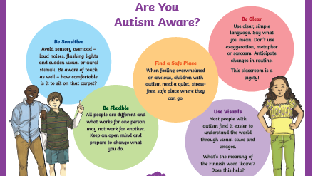
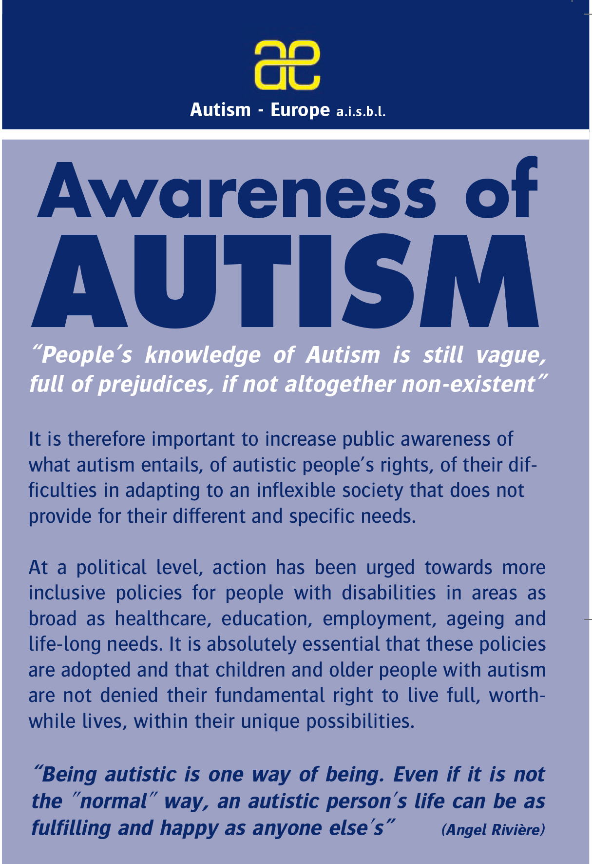
Targeted groups parents who have children with autism research in austim 1558-1567 (Rose et al., 2022)

2
1 A Local support group in the area
(Keenan M2013).

Autism support group with Amina

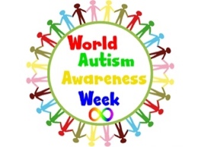

3 Awareness logo
4 Signs and symptoms
(World Autism Awareness Day | Autism Speaks, 2022)

What is autism

Autism is a disability that has a board range of conditions characterized by challenges with social skills and behaviors speech language and communication.
The previous slide mind map has ideas which support autism awareness and autism week. In order make people aware that there is support out there and help.

How is autism diagnosed
Diagnosing autism can be very difficult because there is no form of medical medicine or bloods test to find out if a person has autism or to diagnosis. However, doctors and health professions look at the child’s or persons development history. The can however sometimes detect these issues around 18months.
The main types of symptoms that can detect autism are
Avoiding eye contact
Delayed speech and communicating with others.
Relies on routines and order.
Gets frustrated and upset to minor changes.
Unexpected reactions.
Difficulty understanding others emotions or reactions.

Where to get support

Nhs.co.uk
letting family and friends know that you or someone you know may have or have autism can be a real help and they may know of professionals or help that you may not be aware of to help.
National charities
These are available to parents adults children and young people with autism for help and support regarding their disability and help which is available to them.

Image 1 Awareness autism

Image one shows awareness of autism it works hard in order to make the disability aware to wider people has loads of information for people to be aware of autism and make them know that having this disability does not mean you can live a normal healthy life.

Image 2 Are you autism aware.
Image 2 shows you basic strategies to use with people or children diagnosed with autism to help with daily living. For example, be sensitive and avoid sensory overload. Find a safe place when overwhelmed children’s people with autism like to be alone and play in a quiet and safe place.
Use clear and simple words to get point across and for people children with autism to understand clearly and simply. People or children with autism will be unaware for sarcasm and exaggeration use avoid using this as they may not understand as a normal person will. Avoid changes to routine.

Image 3
World autism awareness week.
A logo that is designed to have a week all about autism around the country to make people aware of autism and have people thinking of autism and people who suffers from it.

Image 4
Key facts of autism.
Autism is limited response of social integration and eye contact
Repetitive speech and behaviour and play.
Has difficulty in understanding other people’s feelings and expressing their own.


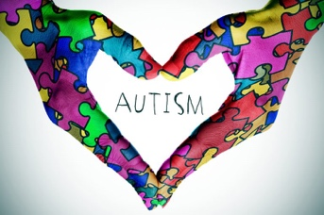

(Autism awareness/ puzzle polycotton; fat quarter, 2022)
(Autism no puzzle, nothing wrong with us - Altogether Autism, 2022)

Blog

My name is Amina Bibi my blog is based on Autism support group for families with children who are diagnosed or in process of a diagnoses of autism. We have a local autism group service which is in our area in the community room on 11 Lea Road B7 4QA.
My support group is open to all parents who suspect or have a diagnosis for their child with autism. From the ages of 18months. This support group can give you an idea as to what sign and symptoms to look out for or what ideas and structure you as parents can get in place to help your child every day. This support group also helps you with forms for diagnosis or the process in order to get a diagnosis. The session will be held on every Monday at 1pm in the allocated location. This is a WALK IN SERVICE so no sign up is needed and everyone is welcome.

I am very passionate about this topic as I have my own child diagnosed with autism aged 6.

At the beginning when my child was 18months I suspected a few things that I thought as a parent would get better over time as he grow up.
However, these things for example;
guiding me to what he wanted instead of using words or communication to ask me what he wanted.

Playing with specific car toys and putting them in order and lines.

Getting frustrated when routines would change or when things will be out of place or order.

interfering with his play when not on his terms.

These things would frustrate my child and make him really upset when this would happen.

As time went by my child joined nursery settings at this time, I thought things will improve he would learn to communicate and have a routine that he would follow but deep down I suspected something was wrong but as a very in denial mother I just didn’t want to hear it and wanted things to be normal.

As time went on my child wasn’t improving in fact things were getting worse this is when other health professionals got involved and together, we had meetings which we suspected autism. From this I had to accept it and only wish and get the help and support he needed from other professionals. I started routines that would suit him I gave him mother and son time, family time and from this my child has become intelligent in school and is achieving what he should be and that makes me a proud mother. He has one to one support and other help and extra time for activities during school.

The following link gives you information on autism awareness and help which is available to families. https://www.autism.org.uk
This web page gives you information on autism education, diagnosis which will help you on diagnosis support on education and what help is available.

This webpage will also help you on what is autism and what help is also available to you. It support families like yourselves with the diagnosis process and support groups.
https://www.childautism.org.uk

Cost of this group will be free of charge to parents and will be government funded.

Refreshments will be provided during the 1 hour for our parents.
This is a opportunity for parents to come forward and discuss any issues and help they are unaware of during this time as myself and other members will be able to help you get the correct support you need for your child to develop and achieve we will get the correct professionals which you need in order to get the support you need for child to achieve,

you can follow me on Facebook and twitter to see what he achieves next.
My child can achieve is our Facebook page



You can contact myself or my team on 0800564675 option 2
Local community address is 11 Lea Road B7 4QA.

References
Autism.org.uk
NHs.co.uk
https://www.autismspeaks.org/world-autism-awareness-day
https://autismawareness.com
https://www.autism.org.uk/advice-and-guidance/topics/diagnosis
https://www.cdc.gov/ncbddd/autism/signs.html
https://www.webmd.com/brain/autism/symptoms-of-autism
https://www.rozascraftshop.co.uk/autism-awareness-fat-quarter

