Benin Bronzes
Reflect on the significance of the Benin Bronze within the cultural context of the Yoruba as well as the post-colonial context today.

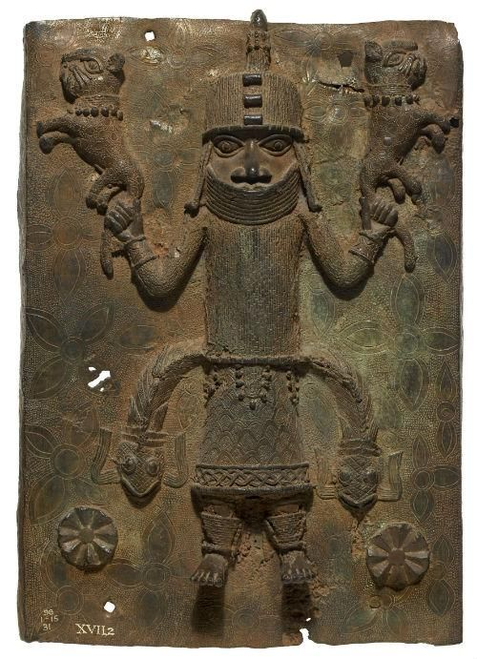
Introduction
‘The 'Benin Bronzes' are a group of sculptures which include elaborately decorated cast relief plaques, commemorative heads, animal and human figures, items of royal regalia, and personal ornaments’. Originating from the Kingdom of Benin, now known as Nigeria, these pieces date back to the 13th to 16th centuries. While these bronzes are primarily associated with the Edo people of Benin, their artistic and symbolic elements intersect with broader Yoruba mythological traditions, with historical, political, religious and spiritual significance. However, their significance extends beyond their cultural and historical roles. In 1897, during the British Punitive Expedition, ‘British troops occupied and ransacked the royal palace. They looted between 3000 and 5000 objects of immense cultural value from the palace compounds and other sites.’ This specific piece was a victim of the expedition, it shows the Oba (king); sacrificing leopards as part of a ceremony said to ‘strengthen his mystical powers’ .Today, the Benin Bronzes have been central to debates on restitution, as African nations seek to reclaim their stolen heritage from Western institutions. This essay will explore the significance of the Benin Bronzes within the Yoruba religion, while also analyzing their role in the post-colonial context, particularly in the context of restitution and the decolonisation of museum collections.

The Cultural significance of the Benin Bronzes
‘The Yoruba faith is commonly seen as one of the principal components of the syncretic pool known as the African traditional religions.’ It is still widely celebrated throughout Nigeria and Brazil through elements such as dance, music, food and clothing.
The Yoruba religion contains a variety of stories with no specific central authority and with many localised adaptations. However, the creation myth broadly stays the same throughout. Oduduwa is described often as the creator God, founder of the Yoruba people. Lfe is seen as being the place of creation. And Obatala is described as the creator of the human body, by forming the body from clay.
The Benin Bronzes served several key functions including political, religious, social and artistic visual expression. The Bronzes were used to reinforce the authority of the Oba and the centrality of the Benin monarchy. Kathryn Gunsch, curator for the arts of Africa and Oceania Museum, suggests ‘The plaques were additionally commissioned by the obas to help shore up their power by reminding members of the court of their place, rank, and proper etiquette.’ Many of the plaques and sculptures depict past nobles, Obas and warriors, serving as historical records and legitimising the ruling dynasty. Many of the Bronzes had spiritual significance, particularly in religious ceremonies honoring ancestors and deities. ‘During court ceremonies, chiefs and other title holders often wore a single brass pendant, usually in the shape of a head.’ This explains why the Yoruba religion is often described as an integrated cosmology; these pieces could be seen as a gift or sacrifice to the deities so rewards can be given in return. The Bronzes reflected the identity of Benin by portraying significant figures, courtly life and military achievements, while also preserving oral traditions by visually representing historical narratives. Barbara Plankensteiner pointed out that ‘in Edo, the language spoken in Benin, 'to remember'-sa-e-y-ama-means literally 'to cast a motif in bronze' Therefore it is the act of castIng itself that captures history.’
Beyond the immediate functions, the Bronzes show the technical prowess of Benin’s artists.
‘The artworks have since become a powerful symbol of Africa’s decades-long struggle to restore the cultural heritage seized under colonial regimes.’
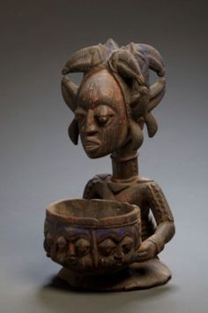
This Benin Bronze plaque seen in picture one, is a significant example of the artistry and cultural symbolism of the Kingdom of Benin. In this particular piece, it shows the Oba wearing elaborate regalia, including a beaded necklace and a distinctive helmet or crown, which are markers of high status in the Benin court. The Oba’s stance is frontal, a characteristic feature of the Benin Bronzes that emphasizes authority and power. The facial features are stylised, with wide eyes and a strong nose. The Oba is holding leopards, which were associated with kingship, power and control in Benin iconography. The skirt-like garment and leg adornments suggest ceremonial attire, reinforcing the high status of the figure. Additionally, the surrounding circular designs in the background, suggest symbolic representations of power, divine legitimacy or cosmological order, illustrating visually the power the Oba held. The figure’s formal stance and regalia share similarities with Yoruba depictions of Orisha (deities) (reference for picture)

The impact of colonialism and the looting of the Benin Bronzes
The looting of the Benin Bronzes is one of the most significant examples of colonial plunder, reflecting the broader impact of European imperialism on African cultural heritage. The encounter between the kingdom of Benin and the British Empire culminated in the 1897 British Punitive Expedition, which resulted in the looting of thousands of Benin Bronzes. This event had both immediate and long-term consequences for Benin’s cultural heritage, its people and resulted in global debates on restitution and colonialism.

The British atrocity at Benin City was a crime against humanity that
mapped directly onto the three principal elements of the 1899 Hague
Convention: the indiscriminate attack on human life in which tens of
thousands died; the purposeful and proactive destruction of an ancient
cultural, religious and royal site; and the looting of sacred artworks

Dan Hicks thus explains the brutality of the expedition by emphasising how it disregarded many Convention principals. He further explains that the British were instructed to ‘destroy all towns’ on their routes. The looting of the Benin Bronzes resulted in the loss of sacred objects that held deep religious and historical significance to the Edo people. The Bronzes functioned as courtly archives, depicting a long line of Obas, historical events and religious ceremonies. Their loss disrupted the transmission of historical knowledge within the kingdom and reinforced colonial narratives that dismissed African societies as lacking important history. This cultural loss continues to impact the identity and heritage of Benin’s people. After the looting, the Bronzes were sold to American and European museums, for example the British Museum, the ethnological Museum of Berlin and the Metropolitan Museum of Art in New York. Their presence in these institutions continues to raise ethical concerns about ownership and the role of museums in perpetuating colonial legacies.

The Benin Bronzes in the post-colonial context
In the post-colonial era, the Bronzes have become a symbol of colonial violence, cultural loss and the struggle for restitution. Scholars like Dan Hicks and Benedicte Savoy have argued that colonial looting was not simply an act of military conquest but also a violence that sought to redefine African heritage through Western lenses.
The decolonisation of museum spaces involves more than the return of objects; it also argues the importance of re-centering the narratives around the original creators and their descendants.
In recent years, some institutions such as the University of Aberdeen and the Smithsonian in Washington have begun returning Benin bronzes to Nigeria. However, debates continue over the logistics of repatriation and where these artefacts should be housed as valuable objects of cultural heritage. Paul Wood argues in his article on repatriation, specifically regarding the Benin Bronzes, that

There is a real danger that if works were returned to Benin in the present political and economic situation, they would be lost: either through physical decay or through various forms of theft, looting, etc.

Where this is a possibility, an argument could be made that funding opportunities can be put in place such as donations that can help museums in Nigeria cover the costs of looking after the artefacts. It can be argued it is morally unjust to harbour artifacts because institutions like the British museum may have better resources, when financial support could instead be given to African countries to help look after these pieces and protect their culture. Holding on to these objects continues to perpetuate the damage caused by colonialism.

Conclusion
The Benin Bronzes represent far more than just artistic pieces; they serve as profound cultural, historical and spiritual records of the Benin Kingdom. Their craftsmanship and use in royal and religious ceremonies highlight the deep connection between art and government in pre-colonial African societies. In the post-colonial context, the legacy of the Bronzes has shifted from this symbol of royalty and authority to contested objects of restitution and historical justice. Their forceful removal during the British Punitive Expedition of 1897 highlights the violent disruptions of colonialism, which not only stripped the Benin Kingdom of its sacred artifacts but also reinforced Eurocentric narratives that dismissed African Civilisations. Today, the global discourse surrounding the return of the bronzes reflects broader efforts to decolonise museums and to challenge the legacies of imperialism. It also shows the ongoing struggle for African nations to reclaim their heritage and cultures.

Bibliography

Adepeju Oti; Oyebola Ayeni. (2013). Yoruba Culture of Nigeria. [Online]. Cross-Cultural Communication. Available at: https://core.ac.uk/download/pdf/236297908.pdf [Accessed 1 March 2025].

Alicja Zelazko. (2024). Benin Bronzes. [Online]. Britannica. Available at: https://www.britannica.com/place/Benin-historical-kingdom-West-Africa [Accessed 5 March 2025]

Barbara Plankensteiner. (2007).(article) Benin- Kings and Rituals. Vienna: Winter. P.3. Available at: https://www-jstor-org.ezproxy.uwtsd.ac.uk/stable/20447858?sid=primo&seq=3

Benedicte Savoy, Susanne Meyer-Abich. (2022). Africa's Struggle for Its Art. Princeton: Princeton University Press. Available at: https://www.jstor.org/stable/j.ctv20hcs1p

Benjamin Sutton. (2025). Long in Exile, the Looted Benin Bronzes Tell the Story of a Mighty African Kingdom. [Online]. Artsy. Available at: https://www.artsy.net/article/artsy-editorial-chico-da-silvas-mystical-paintings-enchanting-art [Accessed 13 March 2025].

Claude Clark. (N/A). EARTH METROPOLIS AFRICAN ART. [Online]. EarthMetropolis. Available at: https://www.earthmetropolis.com/Earth/yoruba.html [Accessed 9 March 2025].

Dan Hicks. (2020). The Brutish Museums: The Benin Bronzes, Colonial Violence and Cultural Restitution. London: Pluto Press. Pg.111-114. Available at:https://www-jstor-org.ezproxy.uwtsd.ac.uk/stable/j.ctv18msmcr

Linda St. Thomas. (2022). Smithsonian Returns 29 Benin Bronzes to the National Commission for Museums and Monuments in Nigeria. [Online]. Smithsonian. Available at: https://www.si.edu/newsdesk/releases/smithsonian-returns-29-benin-bronzes-national-commission-museum [Accessed 10 March 2025].

Paul Wood. (2020)(article). Display, Restitution and World Art History: The Case of the ‘Benin Bronzes’. Visual culture in Britain. P.20. Available at: https://research-ebsco-com.ezproxy.uwtsd.ac.uk/c/onvpsy/viewer/pdf/rzhfzjp4ff

The British Museum. (N/A). Benin Bronzes. [Online]. The British Museum. Available at: https://www.britishmuseum.org/about-us/british-museum-story/contested-objects-collection/benin-bronz [Accessed 1 March 2025].

The Communications Team. (2021). University to return Benin bronze. [Online]. University of Aberdeen. Available at: https://www.abdn.ac.uk/news/14790/ [Accessed 10 March 2025].

National Museums Scotland. (N/A). The British raid on Benin 1897. [Online]. Small Print National Museums Scotland. Available at: https://www.nms.ac.uk/discover-catalogue/the-british-raid-on-benin-1897 [Accessed 1 March 2025].

https://www.britishmuseum.org/about-us/british-museum-story/contested-objects-collection/benin-bronzes
https://www.nms.ac.uk/discover-catalogue/the-british-raid-on-benin-1897
https://www.britishmuseum.org/about-us/british-museum-story/contested-objects-collection/benin-bronzes
https://core.ac.uk/download/pdf/236297908.pdf
https://www.britannica.com/art/Benin-Bronzes
https://www.britannica.com/art/Benin-Bronzes
The Brutish Museums: The Benin Bronzes, Colonial Violence and Cultural Restitution- Dan Hicks, Page 114
The Brutish Museums: The Benin Bronzes, Colonial Violence and Cultural Restitution- Dan Hicks, Page 111
Benedicte Savoy, Susanne Meyer-Abich. (2022). Africa's Struggle for Its Art. Princeton: Princeton University Press.
https://www.abdn.ac.uk/news/14790/
https://www.si.edu/newsdesk/releases/smithsonian-returns-29-benin-bronzes-national-commission-museums-and-monuments
https://research-ebsco-com.ezproxy.uwtsd.ac.uk/c/onvpsy/viewer/pdf/rzhfzjp4ff?route=details
https://www.earthmetropolis.com/Earth/yoruba.html
https://www-jstor-org.ezproxy.uwtsd.ac.uk/stable/20447858?sid=primo&seq=3
https://www.artsy.net/article/artsy-editorial-chico-da-silvas-mystical-paintings-enchanting-art

