

Front Wheel Wake Management through Aerodynamic Front Wing Development on a F399 Single Seater Sprint Car:
Research Proposal.
John Michael Hughes
P146322
University of Wales Trinity Saint David
Major Project including Research Methods & Professional Development
MSc Motorsport Engineering
Chris House & Tim Tudor
ACFA7004
12/1/20


Contents

List of Figures 2
1.0.0 Introduction 3
1.1.0 The Purpose 3
1.2.0 Objectives 4
2.0.0 Research Context 5
2.1.0 A Brief Look at Wing Theory 6
2.2.0 Wheel Aerodynamics (Bluff Body) 10
2.3.0 Other Aerodynamic Devices & Considerations 12
2.3.1 End Plates 12
2.3.2 Barge Boards 13
3.0.0 Research Questions 14
3.1.0 Understanding the Current State 14
3.1.1 The Baseline 14
3.2.0 Development 14
3.3.0 Computational Difficulty 15
4.0.0 Research Methods 16
4.1.0 Computational Fluid Dynamics 16
4.1.1 Ansys Simulation 16
4.1.2 OpenFoam (Helyx - OS) 17
4.2.0 Wind Tunnel (MIRA) 17
4.2.1 C2 Open Loop 1/12 Scale 18
4.3.0 Wool Tufts & Flow Visualisation Paint 18
4.4.0 Pitot Sensor Array 19
5.0.0 Evaluation 20
6.0.0 References 21

List of Figures
Figure 1 - SBD Ltd Dallara F399 5
Figure 2 - SBD Dallara Front Wing & Front Wheel Assembly 6
Figure 3 - Front Wing Geometry & Wheel Interaction (Vortex) (Nakagawa & Hojo, 2014) 6
Figure 4 - SBD F399 Front Wing Profiles 6
Figure 5 - F399 Velocity Contours (Left 15.42° & Right 20.42°) 8
Figure 6 - SBD F399 Front Wheel Pressure Contours 10
Figure 7 - Open Wheel Wake Formation (Velocity) (Ramesh, 2018) 10
Figure 8 - SBD F399 Front Wheel (Left - Side View, Right - Front View) 11
Figure 9 – Red Bull Racing Rear Wing End Plate (Piola & Somerfield, 2016) 12
Figure 10 - Front Wing End Plate Air Flow Vector (Harish, 2019) 12
Figure 11 - SBD F399 Barge Board Design Iteration 13
Figure 12 - Streamlines (Velocity) Showing Barge Board Area (Ravelli & Savini, 2018) 13
Figure 13 - C2 Open Loop Wind Tunnel 18
Figure 14 - SBD F399 Wool Tuft Testing 18
Figure 15 - Flow Visualisation Paint applied to a rear wing 19
Figure 16 - 2014 Lotus F1 Car with Aero Rake (Scarborough, 2014) 19

Graph 1 - F399 Front Wing AoA Pressure Plots 7
Graph 2 - F399 Front Wing Assembly AoA Pressure Plots 8

Equation 1 - Lift Force (N) 9

1.0.0 Introduction
Understanding the importance of a vehicles aerodynamic characteristics has become a crucial aspect of modern automotive design and even more so in open wheel racing vehicles (Park, 2015) (Mears & Dominy, 2004). It has been stated that due to the complex flow fields produced by the rotating mass of a wheel, together with the associated complex geometry, the overall drag implication contributes up to 25% of the overall drag force produced by the vehicle (Schuetz, 2016). However, this value has been estimated to be between 35% – 50% for open wheel race cars (James, et al., 2014), therefore, any reduction in these values has the potential to improve the performance characteristics of both the vehicle handling, and the engine emissions, as a result of the increased efficiency through a reduction in the resistive force.
It has long been perceived that the accurate computational modelling of wheel wake formation is complex and still considered to be not fully understood by many within the automotive aerodynamics field (Yu, et al., 2018). Wind tunnel tests can be conducted, however, these are costly procedures due to their power consumption and the need for either a manufactured scale model or the completed vehicle, with the addition that many wind tunnels do not permit the use of deforming tyres (Knowles, 2005). This being the case, great efforts are now being directed towards computational modelling techniques (CFD) in an effort to accurately predict the wake formations produced and left by the wheel and their impact on the overall performance of the vehicle. However, this technique still carries significant complications with respect to tyre deformation with an applied force, and the proximity the of the wheel and tyre assembly to the ground, thus the representation of the tyre contact patch is still under debate.
The front wing assembly of modern open wheel race cars produces 30% of its overall downforce, which is located in close proximity to the front wheels of the vehicle. It is as a result of this, that it has been acknowledged that the wing assembly must have an impact on the aerodynamic behaviour of the front wheels, therefore the front wing may also be used as a controlling device in addition to the benefits it provides by producing the frontal vertical force required (Diasinos, et al., 2014).

1.1.0 The Purpose
The purpose of this research is to examine how a front wing assembly interacts with a rotating front wheel on an open wheel race car.
As stated in chapter 1.0.0, the wheels on any road going vehicle produce a vast amount of aerodynamic drag force. As a consequence, this increases a vehicles total rolling resistance, thus requiring more fuel to overcome it. As a greater fuel consumption is required, more fuel mass is needed, which will then increase the vehicles total mass and add to the rolling resistance. All of these factors will then contribute towards an increase in the produced exhaust emissions (Soofastaei, et al., 2015).
This is also relevant when such environmental issues are now pushing vehicle manufacturers towards electrification. Standard gasoline has an energy content of 47.5MJ/Kg, which is far superior to that of a lithium-ion battery, which only holds 0.3MJ/Kg (Schlachter, 2012). Despite efforts being made into battery technology, these figures cannot be ignored. If a switch is made to electric cars, the total mileage range maybe affected by the considerable resistances imposed. This would require electric vehicles to recharge more frequently to that of a gasoline car. As a consequence, entire electric infrastructures would then need to be reconsidered.
Due to the complexity of computationally modelling the aerodynamic effects of a rotating wheel, both practical and mathematical modelling research methods have to be utilised for the purposes of validation.
Many attempts to accurately model a rotating wheel have been conducted, with the result that many have been discounted or left unproven. In 1969, Morelli attempted to examine the aerodynamic characteristics of a rotating wheel but opted to leave a gap between the underside of the wheel and the ground surface. Adopting this method allowed for further investigation into the lift force generated by a wheel, however, it neglects the interaction between a wheel and ground, and therefore does not accurately represent the true aerodynamic behaviour.
If the front wing can be used as a controlling device for the generated wheel wake, a study to examine whether it can reduce the generated drag force is required. However, it may be found that the reduction in drag may be as a consequence of the reduction in frontal downforce (Diasinos, et al., 2014). It may, therefore, be beneficial to use the wing to protect any aerodynamic devices rearward of the front wheels from the detrimental effects of the turbulent eddies within the wake produced. Such areas will include the floor and rear wing.

1.2.0 Objectives
The objective is to advance understanding on whether a rotating wheel can be truly modelled using modern, but limited techniques, and use the potential interaction of a front wing to control the turbulent wake field. A simplification of this maybe required due to complexities of such a task.
Using this data, a front wing concept will be developed, designed, manufactured and installed on an open wheel race car, with the final goal being to improve the performance of the vehicle.

2.0.0 Research Context
As the front wheels produce large areas of turbulent wake, they have the capability to disrupt any on-set free stream air flow towards the rear of the vehicle. This results in destabilising any aerodynamic devices, causing an increase in the resistive drag force and a reduction in the overall produced downforce, which makes the car less aerodynamically efficient, and disturbs vehicle handling (Heyder-Bruckner, 2011) and increases fuel consumption.
Steve Broughton Developments Ltd provide internal combustion engine development and electronic control unit services to many customer race teams, while also competing with a Formula 3 Dallara F399 (Figure 1) race car in the British Sprint Championship (SBD Motorsport Ltd, 2019), which will be the main focus vehicle of this project.
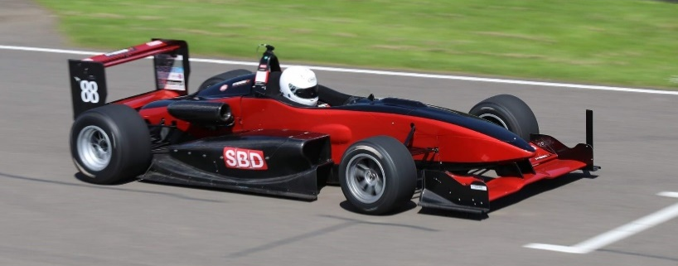
Figure 1 - SBD Ltd Dallara F399
The British Sprint Championship functions as a time trial rather than a circuit race (where multiple cars compete on the circuit at once). The sprint championship consists of cars trying to complete a single lap in the fastest possible time, one at a time (www.britishsprint.org/, 2019). It is for this reason that the performance of the vehicle is critical, as peak performance has to be reached rapidly, otherwise valuable seconds could be lost over the course of a single lap. Depending on the event, drivers have 3 timed laps available to achieve the fastest possible time for their vehicle, after which an average for the times is taken, with the fastest produced being the event winner.
Due to this, the area consisting of the front wing and front wheel has been chosen to be studied and developed. Figure 2, illustrates the proximity in which the front wing and front wheel exist, and it can be observed that the distance between the two assemblies is kept to a minimum. It is, therefore, assumed that the wheel will have an impact on the performance of the wing, and the wing will influence the aerodynamics of the wheel.

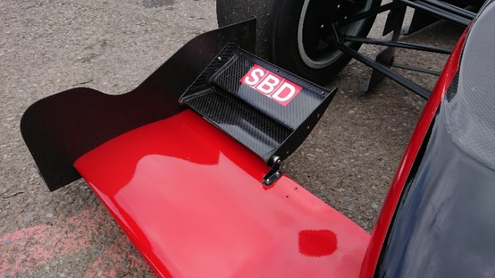
Figure 2 - SBD Dallara Front Wing & Front Wheel Assembly
This idea has also been put forward by others, (Nakagawa & Hojo, 2014), who point out that front wing geometry has a large impact on the formation and shape of the wheel wake through the use of vortex formation as illustrated in Figure 3.
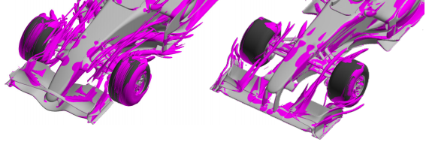
Figure 3 - Front Wing Geometry & Wheel Interaction (Vortex) (Nakagawa & Hojo, 2014)
However, it is not stated whether the results displayed in Figure 3, use rotating wheel geometries.

2.1.0 A Brief Look at Wing Theory
There are several different theories behind how a wing generates its vertical force (a downwards or upwards vector depending on the orientation of the wing), although the principle behind all of them is that the wing must generate a pressure differential between its upper and lower surfaces (McBeath, 1998).
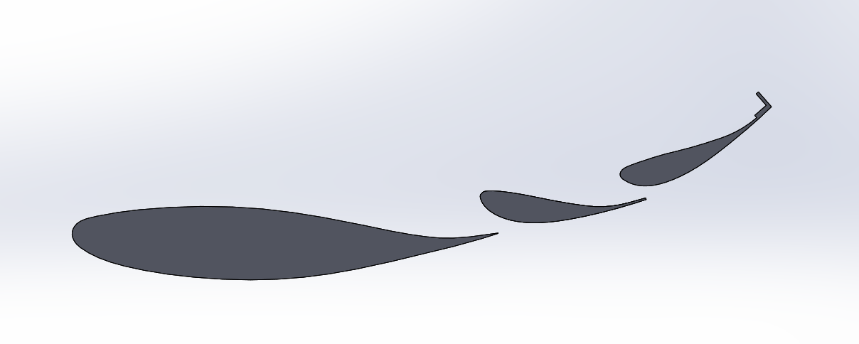
Figure 4 - SBD F399 Front Wing Profiles
The above figure (Figure 4) illustrates the wing profiles currently employed as part of the F399 front wing assembly. As indicated, the assembly utilises a multi-element geometry which allows the
re-energisation of the boundary layer that forms over the surfaces of the assembly, due to fluid viscosity. This also reduces the chances of early onset boundary separation, which can cause a reduction in vertical force and an increase in drag force (pressure drag) (Kachare, 2017).
As a result of this arrangement, greater angles of incidence can be achieved, which have the effect of maximising the generated vertical force. This is because, as the incidence angle is increased, the pressure differential between the upper and lower surfaces also increases. This phenomenon is illustrated in Graph 1.
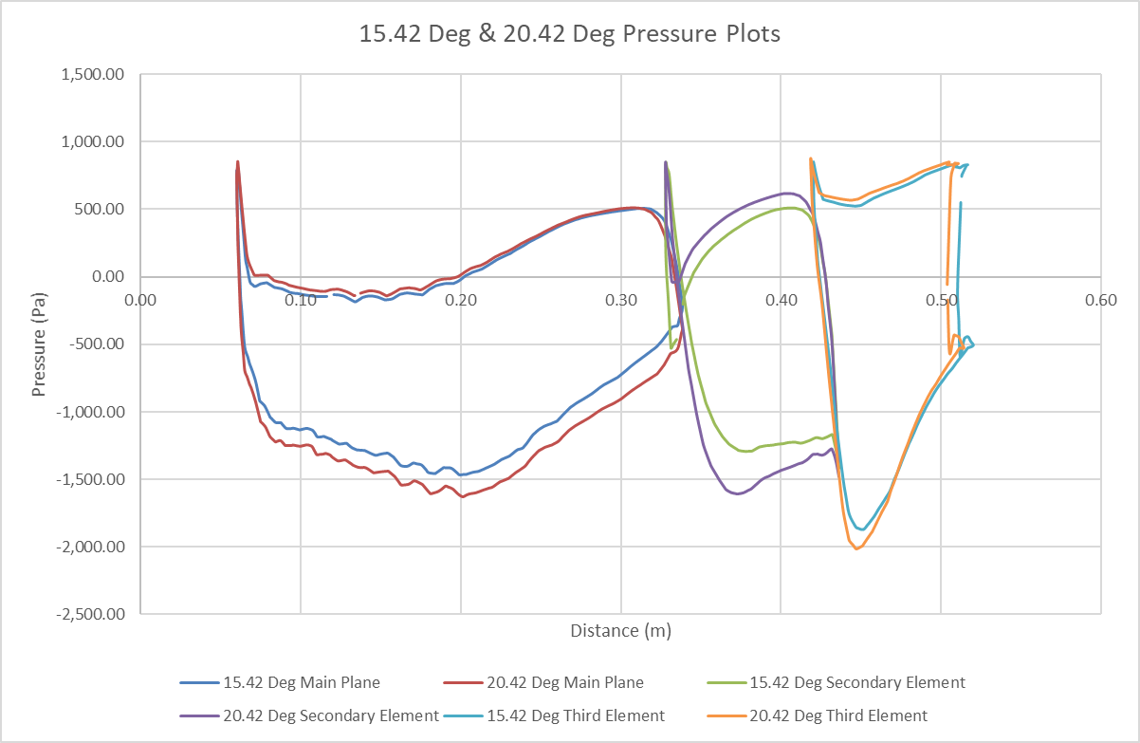
Graph 1 - F399 Front Wing AoA Pressure Plots
Graph 1 illustrates that as the incidence angle of the second and third wing elements is increased, the pressure differential between the surfaces also increases, thus generating more downforce.
The same characteristic can also be seen when the entire assembly has an angle increase, as indicated in Graph 2.
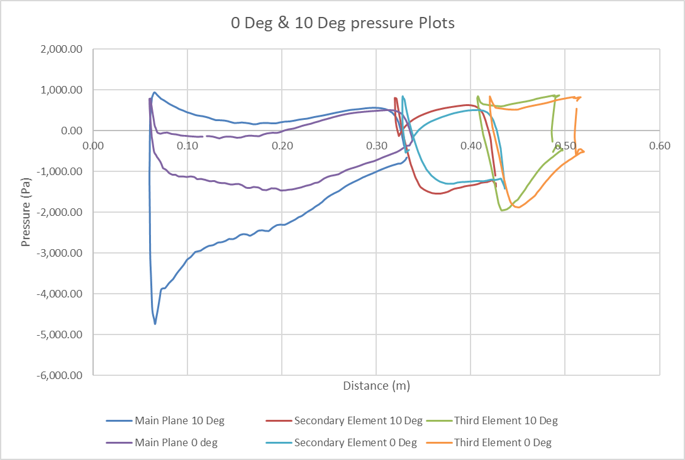
Graph 2 - F399 Front Wing Assembly AoA Pressure Plots
However, in this case it is noticeable that the main element generates the greatest differential in pressure. It is through this, that the overall distribution of pressure (centre of pressure) can be altered, thus changing the aerodynamic characteristics of the wing (Bhargava, et al., 2017) and therefore the handling characteristics of the entire vehicle.
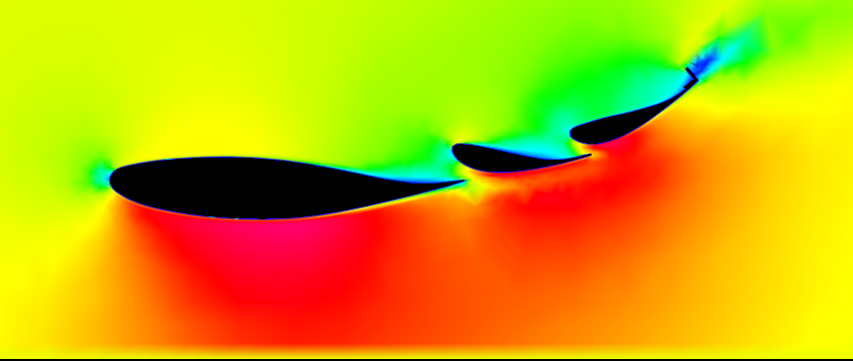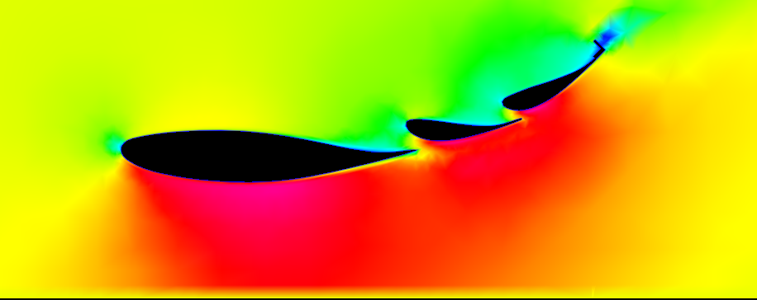
Figure 5 - F399 Velocity Contours (Left 15.42° & Right 20.42°)
Bernoulli’s equation states, that with a decrease in pressure, the velocity must increase (Hall, 2015). As illustrated in Figure 5, as the angle of the second and third elements increases, the velocity across the lower surface increases, causing the pressure to decrease, which produces a greater pressure differential and more vertical force. The reason for this velocity increase stems from the continuity of mass, therefore as a result of the increased expansion, the pressure decreases (Fanchi, 2002). This phenomenon is also present, and is to be considered when determining the height of the wing from the ground (ground effect) (McBeath, 1998).

The measure of the lift force produced from a wing can be calculated using the following equation:
$$Force=\frac{1}{2}ρ Cl A V²$$
Equation 1 - Lift Force (N)
Where ρ is the density of air (Kg/m³), Cl is the coefficient of lift, A is the planar area and V is the velocity.
The same equation is also used for calculating drag force; however, this equation replaces Cl with Cd (coefficient of drag) (Seward, 2014).

2.2.0 Wheel Aerodynamics (Bluff Body)
Figure 6, illustrates the pressure field that develops on a wheel while travelling in a straight vector.
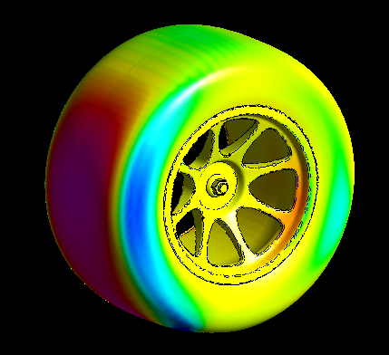
Figure 6 - SBD F399 Front Wheel Pressure Contours
For open wheel race cars, the wheels are problematic, particularly the front wheels. As previously stated, the rotating mass of the wheel, along with the complexity of the wheel geometry causes issues when trying to predict and simulate the wake regime left as a consequence of the rotating bluff body (Figure 7) which acts in an opposing vector to the onset free stream flow. These complex flow formations are often inadequately predicted by the standard RANS (Reynolds Averaged Navier Stokes) equations, although it is stated that LES (Large Eddy Simulation) equations are superior. However, this is at the expense of time and money (Issakhanian, et al., 2009). To simplify the complexity of the problem, studies are often conducted with a wheel in isolation, be it computational simulation or physical (Knowles, et al., 2015).
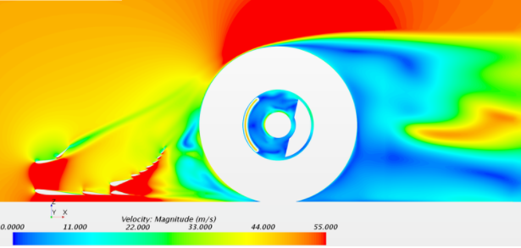
Figure 7 - Open Wheel Wake Formation (Velocity) (Ramesh, 2018)
These large wake formations also contribute the majority of the drag to the overall resistive force of the vehicle, therefore the detail contained within the results plays a vital role in the overall performance of the vehicle.
Consideration also needs to be given to the mechanical properties of the wheel and tyre assembly. A wheel can be considered to have 3 degrees of freedom, those being rotational, vertical (although this works in a radius because of the suspension geometry) and articulation. As a result of this, the problem of the generated complex flows has been exacerbated, there being constant changes in the flow regime (Price, 2011) due to the degrees of freedom. However, most experimental procedures are conducted using a straight forward vector, which neglects the aerodynamic characteristics of the vehicle when in a yaw condition with an applied slip angle. This seems counter intuitive because the maximum possible downforce should be achieved in these conditions, producing better cornering speeds resulting from the increase in grip. However, if the turbulent wake has an impact on the performance of the aerodynamic devices in this scenario, it is potentially overlooked.
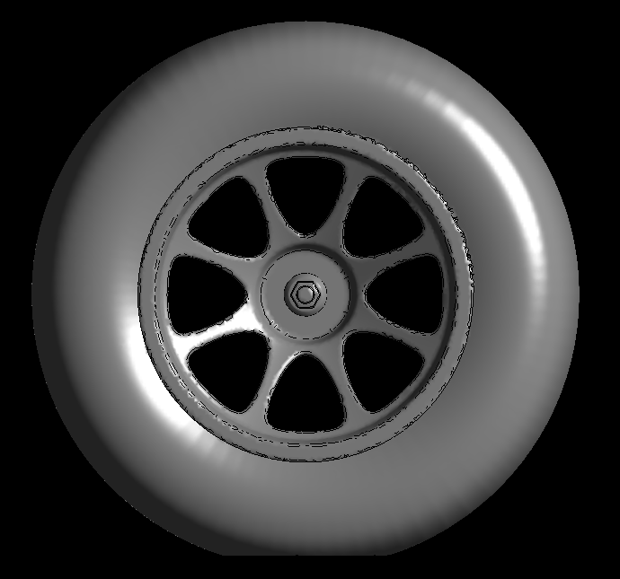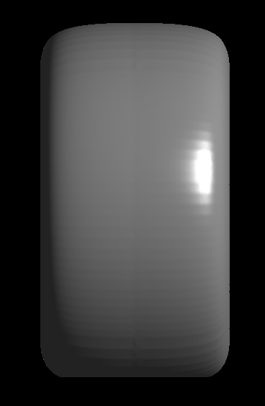
Figure 8 - SBD F399 Front Wheel (Left - Side View, Right - Front View)
Tyres are another variable that needs to be taken into consideration. As tyres are constructed from rubber, this allows them to deform, and the deformation is dependent on the loading that is imposed on it. Even when the vehicle is static, the tyre is in a deformed state due to the loading generated from the sprung mass of the vehicle, creating a contact patch. Unlike a solid cylinder, which when laid on its side, has a contact line, the tyre will deform to create an area of contact with the ground, although this is still often overlooked by engineers (Paton, 2015). Figure 8, illustrates the typical configuration used in tyre geometry. It can be seen that the bottom of the tyre has been flattened to “represent” the contact patch, although when viewing from the front, it is clear that no tyre deformation is present. The deformation around the contact patch produces an area of low energy flow, which can be detrimental to the underfloor performance. This is a dynamic change due to the constant changing loadings altering the deformation of the tyre but this could, however, potentially increase the performance of the vehicle if properly simulated and understood.
However, it is understood that such a task has been undertaken many times, with many degrees of success. Therefore, a consideration would need to be made as to whether exploring tyre deformation with varying loads is necessary, and rather only construct and model the tyre when only vertical loading is applied. This method would then allow further concentrations to be made on the task at hand, rather than skewing the focus of the aims at tyre modelling complexities.

2.3.0 Other Aerodynamic Devices & Considerations
In this section, other devices used for air flow regime control will be discussed, as these are areas of interest due to the interaction they have with the main devices focussed on in this study, though are not main areas of interest.

2.3.1 End Plates
End plates are devices most commonly observed on wings. In recent years, the aeronautics industry has begun to apply them to aeroplanes, however, they’re most frequently used in a motorsport application, as illustrated in Figure 9.
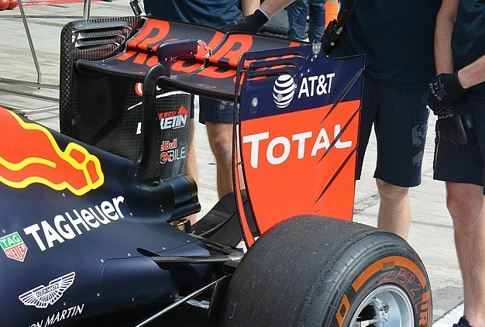
Figure 9 – Red Bull Racing Rear Wing End Plate (Piola & Somerfield, 2016)
These devices are often observed to differ in complexity, some being simple boards and others containing vast contouring and pressure bleed slots. However, the main purpose of an end plate is to simply maximise the lift to drag ratio of the wing (Gogel & Sakurai, 2006).
It does this by splitting the positive pressure gradient developing on the wing, which counters the merging of high pressure with low pressure and minimises the magnitude of the vortex that would otherwise have been generated. This, thus lowers the drag value of the vehicle and maximises the utilised area of the wing span, producing greater downforce (McBeath, 1998).
As Figure 10 suggests, the end plate design can have a critical effect on airflow, and this is important when applied to the front wing of an open wheel race car.
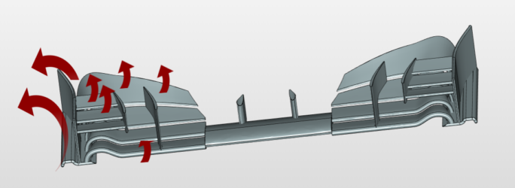
Figure 10 - Front Wing End Plate Air Flow Vector (Harish, 2019)
The end plate is considered to be 5 to 10 times more effective than any other aerodynamic device (Harish, 2019). This is because, other than allowing the utilisation of the entire wing span, end plates can be used to direct high energy air (in the form of vortices) around the front tyres, thereby utilising them as a means to control turbulence. This phenomenon is illustrated in Figure 3.

2.3.2 Barge Boards
A barge board is a device used on open wheel race cars. Its placement is behind the front wheels and in front of the side pods, as indicated in Figure 11.
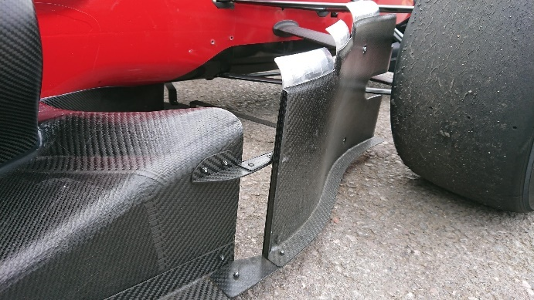
Figure 11 - SBD F399 Barge Board Design Iteration
It is often used as a vortex generator, sending high energy air to the rear of the car, making the floor and diffuser a more effective downforce generator.
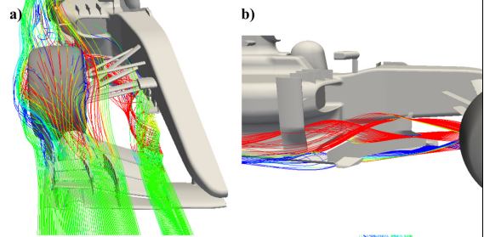
Figure 12 - Streamlines (Velocity) Showing Barge Board Area (Ravelli & Savini, 2018)
Barge boards are also employed to shield the cooling intakes from disruptive wheel wake and generate further outwash (Smith, 2007), illustrated in Figure 12. In the more advanced formula of race car, these devices increase in complexity, with various pressure bleeds and turning vanes contributing the overall air flow regime around the car, further optimising its performance.

3.0.0 Research Questions
This section provides a further breakdown of the objectives based upon the literature provided in chapter 2.0.0.

3.1.0 Understanding the Current State
In order to begin the study, an understanding of how the aerodynamics function on the current state of the SBD F399 car needs to be achieved.
An understanding of the existing condition will provide a foundation upon which further development and understanding can be built. This is important due to the potential expense incurred in the manufacturing of such components, therefore, if a device can be developed that will perform alongside the current aerodynamic package employed on the car, the manufacture of additional components will become more economically viable.
Using this technique may also lead to large gains from relatively small changes, such as creating a simple bracket that provides additional adjustment to the front wing angle, or cutting slots in end plates in order to bleed pressure, thus feeding areas with high energy air. These may seem at first sight to be simple measures, but if they are applied correctly, they can be effective. However, a significant understanding of the principals involved is required if such changes are to be executed successfully.

3.1.1 The Baseline
The objective of this study is to understand how the front wing can interact with the front wheel, therefore studying the wing in isolation will provide a basic understanding of how it reacts in certain conditions, for example, differing angles and heights.
The same can also be said for the wheel, for example, how do the flow structures change from a straight onset flow, to when a slip angle is applied? All of the degrees of freedom (refer to Section 2.2.0) need to be accounted for, which also include the rotational velocity.

3.2.0 Development
Further thought needs to be given as to how the wing can be developed, although this is only based on the assumption it can be used to interact with the front wheel, however, the literature asserts that it can (Harish, 2019).
It is not yet known whether the use of the developed wing should be limited to that of a flow control device, or whether it should also be employed to generate a further increase in downforce. However, this needs to be based upon the data collected from the study of the initial baseline and any driver preferences identified.

3.3.0 Computational Difficulty
As mentioned in chapter 2.2.0, accurately simulating a rotating wheel has proved to be problematic due to the geometry conditions that are functions of the wheel and tyre assembly. These include the accurate modelling of a contact patch, or how a tyre deflects when a lateral load is applied. These properties are primarily ignored, however these characteristics could have a significant impact on how the air flow reacts around the object of interest (Paton, 2015).
Therefore, it needs to be understood whether such a simulation is possible to model within the computational software available, and how it can be achieved? This may involve using load sensors and analysing how much force is applied at a certain velocity to a known radius, and replicating the produced deflection within the CAD drawing. This procedure could be considered time consuming and highlight a number of assumptions, for example, as additional load is applied to the tyre as a result of increased use, the temperature of the tyre material will increase due to the induced friction, altering the ductility of the rubber, making it softer. A Formula One tyre has a Mu value of between 1 and 1.6, depending on the temperature (Sledge & Marshek, 1997), therefore if this value of Mu changes due to loading conditions, the assumption would be that the tyre will deform in a non-uniform way due to the material temperature altering, making the deforming state unique from corner to corner.
It is because of this that a simplification of a deflecting tyre may have to be employed (as stated in chapter 2.2.0). This would allow increased focus to be applied to the considered purpose of this study and hinder a deviation from the considered study timeline.

4.0.0 Research Methods
Due to the nature of this study, both virtual and physical methods of experiment need to be conducted in order for the research to be fully defined. This is because such is the nature of the computational methods applied that they require a validation process in order to provide a degree of confidence in the mathematical modelling employed. A number of the techniques described below will be utilised for the differing forms of data acquisition and analysis, however, during the design development phase, computational methods will be the primary source of information.

4.1.0 Computational Fluid Dynamics
CFD is the computational method used to predict and analyse fluid flow regimes around an object of interest to the user. The governing equations are based on the conservation of mass, momentum and energy in the form of the Navier-Stokes equations (Blazek, 2015) and from this, the properties of the viscous fluid are identified and presented.
Many forms of CFD software are available, however, only the two most popular forms shall be discussed, but others shall be considered and stipulated. One of the main reasons for scepticism in some of the software is that differing results may be presented when applied to the same problem, therefore an amount of specialist knowledge is required in order to examine and evaluate the produced results (Chanatry, 2018), thus suggesting that the value of the data produced by the software depends on the competence of the engineer using it.
The use of CFD software allows for fast design responses and is considered to be an inexpensive method of design testing. This is because it allows complex geometries to be simulated without the need of manufacture, thus allowing fast turnover times. It is for this reasoning that CFD is considered to be the main tool used for the purposes of this study.

4.1.1 Ansys Simulation
Ansys simulation is a form of software specifically designed for use in commercial simulation. Within the software package numerous simulation applications can be conducted, including CFD. Ansys CFD is a professional software suite utilised by many professional industrial businesses across the world, with the aim of making design optimisation more efficient, while providing trustworthy results (Ansys , 2020). It has been stated by Ansys that over the 45 years of their existence, they have been constantly advancing the technology used to produce the simulation software in order to meet the needs of the customer (Ansys, 2020).
It has been suggested that Fluent (the governing simulation solver in Ansys) has a wide range of solving models when predicting flow schemes in complex scenarios (Hilgenstock & Ernst , 1996). As technology advances, and simulation software becomes more readily available, the number of solving models also increases in availability, with numerous other simulation software companies applying the same standardised prediction models (Linfield & Mudry, 2008).

4.1.2 OpenFoam (Helyx - OS)
OpenFoam CFD is an open source CFD code constructed and developed by OpenCFD Ltd., since 2004 (OpenFoam, 2019). The open source CFD code is subsequently distributed to third parties (Helyx – OS) providing ease of access for academic purposes, for which it is primarily used, although commercial forms of the software do exist (Engys, 2020).
It has been suggested that it is possible to achieve comparable results using both OpenFoam and Ansys (Ambrosino & Funel, 2006), however, OpenFoam result predictions appear to have a greater degree of accuracy for the velocity scheme while Ansys appears to be superior at predicting the turbulent kinetic energy (Balogh, et al., 2012). After conducting a comparison experiment using both software packages, it was discovered that when the same meshing strategy was used within both applications, the OpenFoam solver produced a diverged result, whereas the Ansys solver converged, which therefore suggested that OpenFoam is significantly more sensitive to mesh quality, thus requiring a finer mesh, which as a consequence, will increase the computational time required for this solver (Welahettige & Vaagsaether , 2016).

4.2.0 Wind Tunnel (MIRA)
Utilising a wind tunnel would provide basic validation of the CFD methodology. As CFD is based upon mathematical principles, it must follow the strict paths defined by the user in order to achieve the outcome result. Pure fluid flow, however, does not follow a strict path and can be considered unpredictable. It can therefore be assumed that CFD is trying to predict the unpredictable. It is for this reason that wind tunnels are often used as a basis for the validation of computational technique (Qin, 2003).
Horiba Mira wind tunnel is the only full scale open loop wind tunnel in the United Kingdom. It offers full lift and drag force measurements, a turn table that is able to produce yaw, pitch and roll angles, with a maximum air speed of 36m/s (Horiba Mira, 2020). Regardless of this, the wind tunnel does not possess the capabilities of a rolling road, therefore the wheels on the vehicle cannot be rotated. This suggests that a direct comparison of the proposed objectives cannot be conducted. None the less, the wind tunnel can still prove pivotal in the provision of adequate force loading data and general flow structure analysis.

4.2.1 C2 Open Loop 1/12 Scale
For smaller studies, for example, the testing of a proposed wing profile design, the C2 1/12 scale wind tunnel (Figure 13) can be utilised.
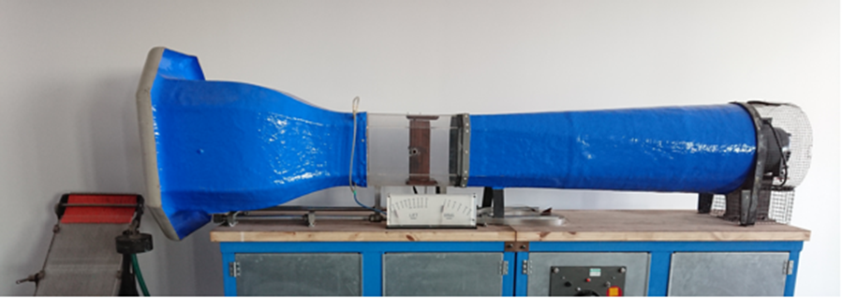
Figure 13 - C2 Open Loop Wind Tunnel
Using a wind tunnel would allow rapid scaled prototypes to be constructed and tested, without the need for a fully manufactured device to be fitted to the vehicle, to then find it that does not achieve the desired objective. This piece of equipment could therefore save time and money. The wind tunnel can provide both lift and drag force measurements, but also offer flow regime monitoring and analysis.
The wind tunnel can also be used as a further means of validation for the computational techniques, by comparing static pressure data from the wind tunnels Naca 0012 profile (which has been pressure tapped), to a virtual representation, thus validating further the computational mathematical model.

4.3.0 Wool Tufts & Flow Visualisation Paint
Aerodynamic wool tuft testing (Figure 14) is a common method of aerodynamic analysis due to its minimal cost of application.
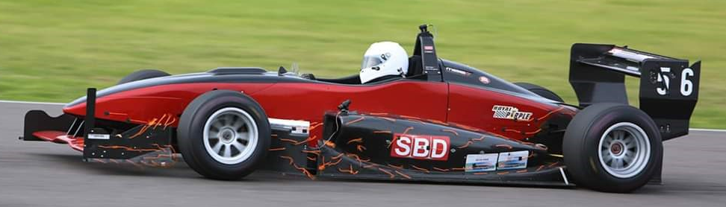
Figure 14 - SBD F399 Wool Tuft Testing
As Figure 14 indicates, the wool tufts can be used as a flow visualisation technique immediately adjacent to the object surface, and provide a basic representation of the flow disturbances (Taherkhani, et al., 2015).
Another method of flow visualisation is the use of a thin oil based paint (Figure 15).
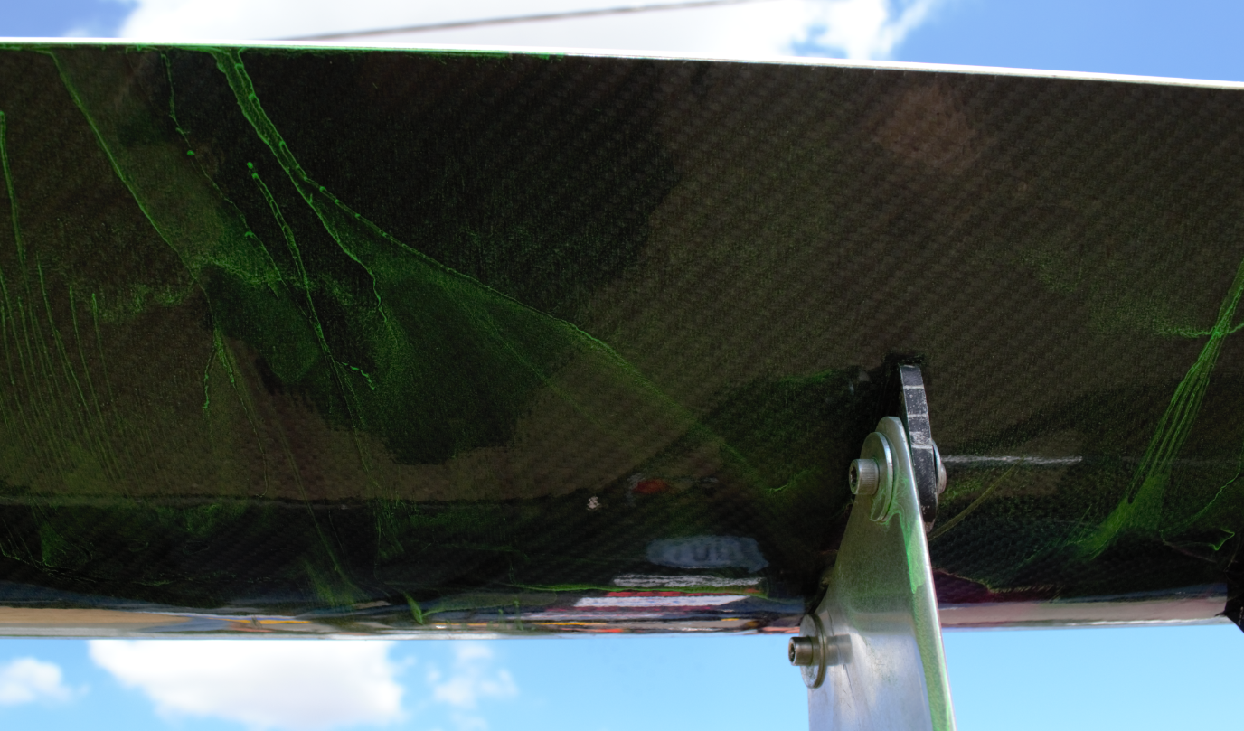
Figure 15 - Flow Visualisation Paint applied to a rear wing
This method is most commonly used in Formula One and used to correlate the wind tunnel and CFD data. It is used in the same way as the wool tufts, however paint can provide a much more detailed array of surface flow information, which is pivotal when trying to improve and develop the aerodynamic performance of a race car (Bang, 2018).

4.4.0 Pitot Sensor Array
A pitot sensor is a device that can be used to measure pressure or velocity depending on its application (Carvill, 1993) (Morris & Langari, 2012). These sensors are most commonly found on aircraft (Houghton, et al., 2017), however, they are now utilised within many forms of motorsport, with large arrays of these sensors being constructed into a “rake” formation (Figure 16).
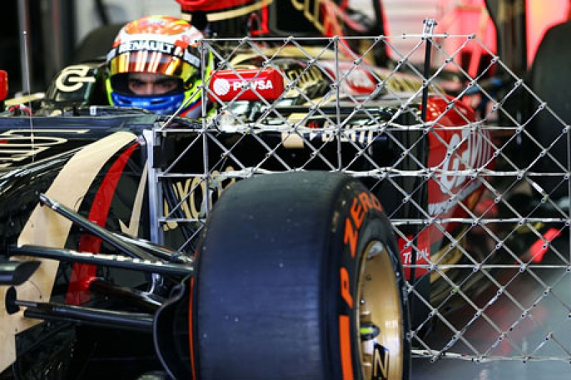
Figure 16 - 2014 Lotus F1 Car with Aero Rake (Scarborough, 2014)
These pitot rakes (arrays) can be assembled to produce many different arrangements to suit the intended purpose. Each pitot tube is able to measure a pressure differential to a reference (usually ambient) pressure, therefore allowing for a full map of pressures to be built within a dynamic situation (McLaren Applied Technologies, 2019). This data could prove to be significant in the understanding of complex flow regimes resulting from the real numerical data provided. The measured pressure data could then be correlated with the CFD findings and the other research methods used.
This method can be limited due to the nature of the data acquisition which requires a consistent driver with the ability to manage a constant velocity, remaining in steady state. Furthermore, environmental variables may have to be contended with, including rain and high, and varying wind directions, these having the potential to skew the generated data.

5.0.0 Evaluation
As mentioned in Chapter 1.0.0, the majority of the induced drag force on an open wheel race car is generated by the exposed wheels. It has been proposed that the front wing could be a suitable device to interact with the turbulent wake field generated by the front wheels, and therefore be used as a management device as well as for the production of downforce and balance.
The intention of this research is to investigate whether or not the front wing on an F399 sprint car can be used in such a manner, and as a result, increase the performance characteristics of the car by providing better handling from any accrued gain in the reduction of drag force, thus increasing straight line speeds, with any improvement in downforce (though maintaining forward and rear aerodynamic balance) increasing the performance of vehicle cornering.
If this is achievable, the reduction in drag force would then reduce the overall rolling resistance of the vehicle, resulting in less power being required to overcome any resistance, therefore fuel consumption will be reduced, which would then provide improved performance as less initial fuel would be required, reducing the cars overall mass.
This would also pay dividends in terms of the emissions produced by the internal combustion engine. As the world population is now becoming ever more concerned with the effects of carbon emissions on the environment (Collins, 2014), this would illustrate how the motor racing fraternity is making positive inroads into tackling the climate issue.

6.0.0 References
Ambrosino, F. & Funel, A., 2006. OpenFoam and Fluent features in CFD simulations on CRESCO High Power Computing System. In Final Workshop of Grid Projects, 1(1), pp. 1-4.
Ansys , 2020. Fluids - Computational Fluid Dynamics. [Online]
Available at: www.ansys.com/products/fluids
[Accessed 17 1 2020].
Ansys, 2020. About Ansys. [Online]
Available at: www.ansys.com/about-ansys
[Accessed 17 1 2020].
Balogh, M., Parente, A. & Benocci, C., 2012. RANS simulation of ABL flow over complex terrains applying an Enhanced k-ε model and wall function formulation: Implementation and comparison for fluent and OpenFOAM. Journal of Wind Engineering and Industrial Aerodynamics, 104 - 106(1), pp. 360 - 368.
Bang, C. S., 2018. Tech Explained - Flow Viz. Market Harborough: Racecar-Engineering.
Bhargava, V., Dwivedi, Y. & Rao, P., 2017. Analysis of Multi-Element Airfoil Configurations: A Numerical Approach. IOSR Journal of Mechanical and Civil Engineering, 14(2), pp. 53-61.
Blazek, J., 2015. Computational Fluid Dynamics: Principles and Applications. 3 ed. Sankt Augustin: Elsevier Ltd.
Carvill, J., 1993. Mechanical Engineer's Data Handbook. 1 ed. s.l.:Elsevier Ltd.
Chanatry, W., 2018. 5 Myths of Computational Fluid Dynamics (CFD), Plano: Siemens.
Collins, S., 2014. Formula 1 and the environment. Sheffield: Racecar-Engineering.
Diasinos, S., Doig, G. & Barber, T. J., 2014. On the interaction of a racing car front wing and exposed wheel, Sydney: The University of New South Wales.
Engys, 2020. OPEN-SOURCE GUI FOR OPENFOAM. [Online]
Available at: www.engys.com/products/helyx-os
[Accessed 17 1 2020].
Fanchi, J. R., 2002. Fluid Flow Equations. In: E. Inc, ed. Shared Earth Modeling. Houston: Gulf Professional Publishing, pp. 150-169.
Gogel, D. & Sakurai, H., 2006. The Effects of End Plates on Downforce in Yaw, Colorado: SAE International.
Hall, N., 2015. Bernoulli's Equation. [Online]
Available at: www.grc.nasa.gov/WWW/K-12/airplane/bern.html
[Accessed 14 1 2020].
Harish, A., 2019. Front Wing of an F1 Car: How to Optimize Its Design. [Online]
Available at: www.simscale.com/blog/2016/10/front-wing-f1-car-optimize/
[Accessed 16 1 2020].
Heyder-Bruckner, J., 2011. The Aerodynamics of an Inverted Wing and a Rotating Wheel in Ground Effect, Southampton: University of Southampton.
Hilgenstock , A. & Ernst , R., 1996. Analysis of installation effects by means of computatiional fluid dynamics - CFD vs experiments?. 4 ed. Dorsten: Elsevier Science Ltd .
Horiba Mira, 2020. Full-Scale Aerodynamic Wind Tunnel. [Online]
Available at: www.horiba-mira.com/facilities/full-scale-aerodynamic-wind-tunnel/
[Accessed 17 1 2020].
Houghton, E. L., Carpenter, P. W., Collicott, S. H. & Valentine, D. T., 2017. Equations of Motion. In: E. Ltd, ed. Aerodynamics for Engineering Students. s.l.:Science Direct, pp. 87 - 149.
Issakhanian, E., Lo, K., Elkins, C. & Eaton, J., 2009. Computational and Experimental Investigation of the Flow Structure and Vortex Dynamics in the Wake of a Formula 1 Tire, Stanford: Society of Automotive Engineers.
James, M. R., Watkins, S. & Watts, M., 2014. The Effect of Upstream Turbulence on an Exposed Wheel Wake, Michigan: SAE International.
Kachare, S. C., 2017. A CFD Study of a Multi-Element Front Wing for a Formula One Racing Car, Grand Valley State: Scholarworks.
Knowles, R. D., 2005. Monoposto Racecar Wheel Aerodynamics: Investigation of Near-Wake Structure & Support-Sting Interference, Cranfield: Cranfield University.
Knowles, R. D., Saddington, A. J. & Knowles, K., 2015. On the Near-Wake of a Formula One Front Wheel, Shrivenham: Cranfield University.
Linfield, P. D. & Mudry, P. E., 2008. Pros and Cons of CFD and Physical Flow Modeling, Livonia: Airflow Sciences Corporation.
McBeath, S., 1998. Competition Car Downforce. 1 ed. Newbury Park: Haynes Publishing.
McLaren Applied Technologies, 2019. Pressure Module Pitot Sensor 16 Channel. Woking: McLaren Applied Technologies.
Mears, A. P. & Dominy, R. G., 2004. Racing Car Wheel Aerodyanmics - Comparisons between Experimental and CFD derived Flow-Field Data, Michigan: SAE International.
Morelli, A., 1969. Aerodynamic Effects on an Automobile, Nuneaton: MIRA.
Morris, A. S. & Langari, R., 2012. Flow Measurement. In: E. Ltd, ed. Measurement and Instrumentation. s.l.:Science Direct, pp. 425 - 459.
Nakagawa, M. & Hojo, T., 2014. Typical Vortical Structures around a Formula 1 Car. Shizuoka, Motorsport Unit Development Division, Toyota Motor Corporation.
OpenFoam, 2019. About OpenFoam. [Online]
Available at: www.openfoam.com/
[Accessed 17 1 2020].
Park, H., 2015. The International Vehicle Aerodynamics Conference. 1 ed. Loughborough: Institute of Mechanical Engineers.
Paton, J., 2015. Coming Full Circle: How and why TotalSim 3D scan tyres. [Online]
Available at: www.totalsimulation.co.uk/coming-full-circle-totalsim-3d-scan-tyres/
[Accessed 15 1 2020].
Piola, G. & Somerfield, M., 2016. Bite-size tech: Red Bull RB12 rear wing endplates. [Online]
Available at: www.motorsport.com/f1/news/bite-size-tech-red-bull-rb12-rear-wing-endplates-720071/720071/?ti=23&tii=1
[Accessed 16 1 2020].
Price, T. A., 2011. 3D CFD on an Open Wheel Race Car Front Wing in Ground Effects, San Luis Obispo: California Polytechnic State University.
Qin, N., 2003. CFD for better understanding of wind tunnel tests, Sheffield: The University of Sheffield.
Ramesh, G., 2018. Turbulence Modelling ForTheWin - Part 1, s.l.: Salient Edge.
Ravelli, U. & Savini, M., 2018. Aerodynamic Simulation of a 2017 F1 Car with Open-Source CFD Code. Journal of Traffic and Transportation Engineering, 6(1), pp. 155-163.
SBD Motorsport Ltd, 2019. SBD Motorsport. [Online]
Available at: www.sbdmotorsport.co.uk/
[Accessed 13 1 2020].
Scarborough, C., 2014. Formula 1's 2014 pre-season testing sensors explained. [Online]
Available at: www.autosport.com/f1/news/112669/formula-1-testing-sensors-explained
[Accessed 17 1 2020].
Schlachter, F., 2012. Has the Battery Bubble Burst?, Washington: APS News.
Schuetz, T., 2016. Aerodynamics of Road Vehicles. 5 ed. Warrendale: SAE International.
Seward, D., 2014. Race Car Design. 1 ed. London: Palgrave.
Sledge, N. H. & Marshek, K. M., 1997. Vehicle Critical Speed - Values for the Coefficient of Friction - A Review, Michigan: SAE International.
Smith, R., 2007. Formula 1 Aerodynamics, Manchester: Symscape.
Soofastaei, A., Aminossadati, S., Kizil, M. S. & Knights, P., 2015. The Effect of Rolling Resistance on Fuel Consumption and Greenhouse Gas Emissions by Haul Trucks in Surface Mines, Queensland: The University of Queensland.
Taherkhani, A. R. et al., 2015. Aerodynamic Drag Reduction of Emergency Response Vehicles. Advances in Automobile Engineering, 4(2), pp. 349 - 355.
Welahettige, P. & Vaagsaether , K., 2016. Comparison of OpenFOAM and ANSYS Fluent. Porsgrunn, University College of Southeast Norway.
www.britishsprint.org/, 2019. THE SBD Motorsport UK HSA BRITISH SPRINT CHAMPIONSHIP. [Online]
Available at: www.britishsprint.org/default.asp
[Accessed 13 1 2020].
Yu, X., Qing, J., Di, B. & Yang, Z., 2018. A Comparative Study of Different Wheel Rotating Simulation Methods in Automotive Aerodynamics, Michigan: SAE International.

