Student name: CAMELIA JURJA
Student id: 2020578
Module name: FOOD & BEVERAGE OPERATIONS BMIH4002
Module Lecturer: KATHRYN ROBERTS

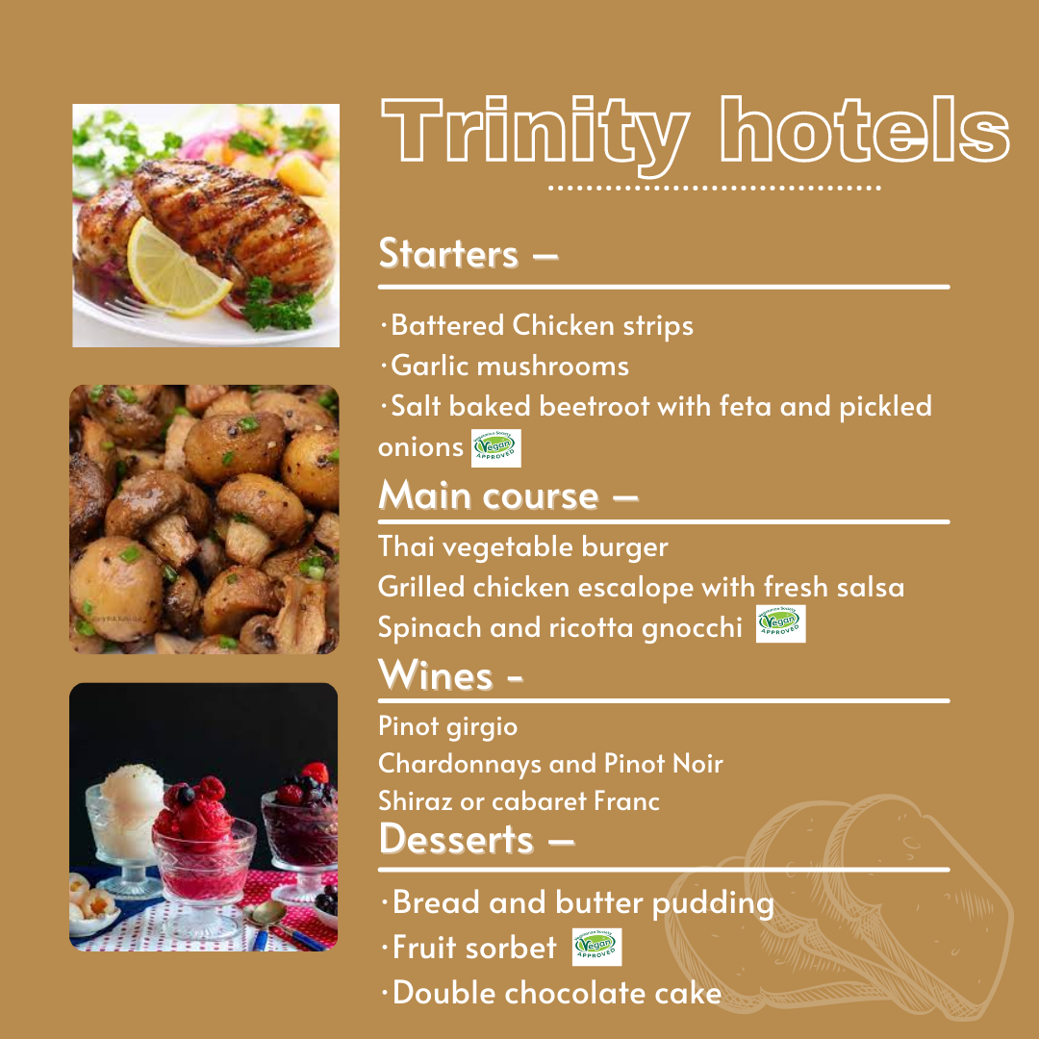
Layout

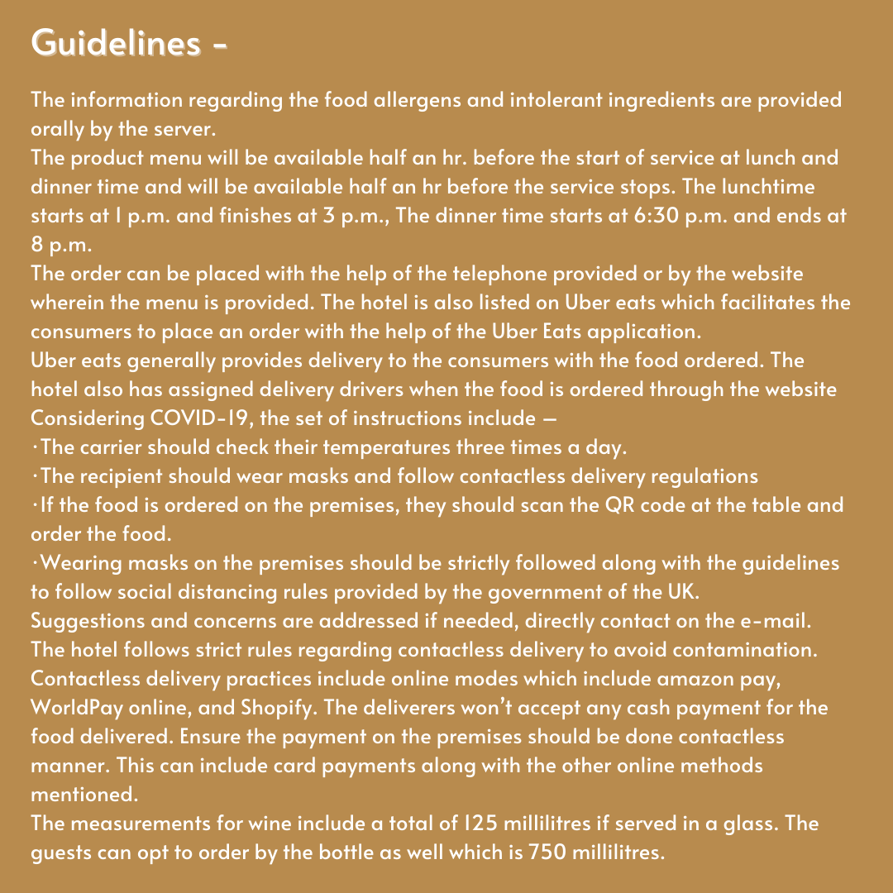

Number of dishes
Starters –
- Battered Chicken strips
- Garlic mushrooms
- Salt baked beetroot with feta and pickled onions
Main course –
- Thai vegetable burger
- Grilled chicken escalope with fresh salsa
- Spinach and ricotta gnocchi
Desserts –
- Bread and butter pudding
- Fruit sorbet
- Double chocolate cake (Menulane.co.uk)

Wine pairings with specific dishes
The wine pairing with grilled chicken should be a wine with an oaky flavour which includes Chardonnays and Pinot Noir. Another wine which can pair with Chicken can is Sauvignon Blanc.
The wine pairing with a Thai vegetable burger includes Shiraz or cabaret Franc. The veggie generally pairs with lighter wines which are mildly acidic and fruity in taste. One more wine which pairs pretty well with burgers is Pinot Grigio but it is often preferred with meaty burgers.

Price-point
Dishes | Prices (Euros)
Starters –
Battered Chicken strips | € 30.5
Garlic mushrooms | € 20
Salt baked beetroot with feta and pickled onions | € 15.5
Main course –
Thai vegetable burger | € 22
Grilled chicken escalope with fresh salsa | € 40
Spinach and ricotta gnocchi | € 20
Desserts –
Bread and butter pudding | € 15
Fruit sorbet | € 30
Double chocolate cake | € 25

What information is needed on a menu
The recommended information for different dishes includes allergens statements along with the vegetarian and vegan symbols (food.gov.uk., 2022).
Dishes | Information to be included.
Starters –
Battered Chicken strips | Milk allergens
Garlic mushrooms | Mushroom allergens
Salt baked beetroot with feta and pickled onions | Vegan and vegetarian logo
Main course –
Thai vegetable burger | Vegan and vegetarian logo
Grilled chicken escalope with fresh salsa | Non-vegetarian
Spinach and ricotta gnocchi | Vegan and vegetarian logo
Desserts –
Bread and butter pudding | Gluten allergy and intolerance
Fruit sorbet | Vegetarian and vegan products
Double chocolate cake | Gluten Allergens
The information regarding the food allergens and intolerant ingredients is provided orally by the server.

Time availability
The product menu will be available half an hr. before the start of service at lunch and dinner time and will be available half an hr before the service stops. The lunchtime starts at 1 p.m. and finishes at 3 p.m., The dinner time starts at 6:30 p.m. and ends at 8 p.m.

Contact details –
The order can be placed with the help of the telephone provided or by the website wherein the menu is provided. The hotel is also listed on Uber eats which facilitates the consumers to place an order with the help of the Uber Eats application.

Instructions
Uber eats generally provides delivery to the consumers with the food ordered. The hotel also has assigned delivery drivers when the food is ordered through the website.
Considering COVID-19, the set of instructions include –
- The carrier should check their temperatures three times a day.
- The recipient should wear masks and follow contactless delivery regulations
- If the food is ordered on the premises, they should scan the QR code at the table and order the food.
- Wearing masks on the premises should be strictly followed along with the guidelines to follow social distancing rules provided by the government of the UK (Gov.uk., 2022).
- Suggestions and concerns are addressed if needed, directly contact on the e-mail.

Contactless delivery
The hotel follows strict rules regarding contactless delivery to avoid contamination.

Payment Options
Contactless delivery practices include online modes which include amazon pay, WorldPay online, and Shopify. The deliverers won’t accept any cash payment for the food delivered. Ensure the payment on the premises should be done contactless manner. This can include card payments along with the other online methods mentioned.

Beverages
The measurements for wine include a total of 125 millilitres if served in a glass. The guests can opt to order by the bottle as well which is 750 millilitres.

REFERENCES
Foo.gov.uk., 2022 Allergen guidance for food businesses Online available at https://www.food.gov.uk/business-guidance/allergen-guidance-for-food-businesses. Last accessed May 2022
Gov.uk., 2022 Guidance for food businesses on coronavirus (COVID-19) Online available at https://www.gov.uk/government/publications/covid-19-guidance-for-food-businesses/guidance-for-food-businesses-on-coronavirus-covid-19. Last accessed May 2022
Menulane.co.uk Menu design Online available at https://www.menulane.co.uk/wp-content/uploads/2019/09/A3-pub-menu-design.jpg. Last Accessed May 2022

