Hofstede Model
Student ID - 2121099
Hasna Begum Kolpona
Executive Summary
While speaking with their international colleagues, professionals must be mindful of the distinct cultures present in each country, including their traditions, habits, and practices. While both China and the United States have strong commercial influences, there are numerous significant variations between them, including how they see values like power distance, individuality, long-term orientation, and indulgence. To build healthy and effective business connections, businesspeople in various nations need to be aware of these distinctions. The report will show cultural differences of the chosen two countries using Hofstede cultural Dimension tool.
Introduction
There are a variety of studies that have been conducted in regards to cultural differencesaffecting global business and economy. Two of the most prevalent are the Global Dimensions ofCulture (conducted by Geert Hofstede in the 1970s), and the GLOBE (Global LeadershipOrganization and Behavior Effectiveness) Project (conducted by the University of Pennsylvaniain the 1990s). Geert Hofstede created a comparison system broken down into six dimensions:individualism vs. collectivism, uncertainty avoidance, power distance, masculinity vs.femininity, long-term vs. short-term orientation, and indulgence vs. restraint (Jackson, 2020). Around twenty years later, faculty at the University of Pennsylvania expanded upon Hofstede's studies and cameup with nine measures of cultural differences and similarities, including: uncertainty avoidance,power distance, societal collectivism, in-group collectivism, gender egalitarianism, assertiveness,future orientation, performance orientation, and humane orientation (Su, 2022).
Country A: China
With a history spanning thousands of years, China is a nation rich in tradition and culture. A diversified and comprehensive culture has emerged as a result of its enormous landmass, varied topography, and complicated history. Confucianism, Taoism, Buddhism, and other philosophical and spiritual traditions have all had an effect on this culture. China's culture is famous for its depth, richness, and complexity across the world. This is true of everything from its distinctive music, literature, art, and rituals to its numerous customs and traditions. In addition to notable developments in science, technology, and medicine, the nation has given birth to some of the most important philosophical and literary masterpieces in history (Xu, 2019).

Country B: United States of America
The country of America, which is sometimes referred to as the "melting pot of civilizations," has a varied and rich cultural environment. The cultural identity of America has been influenced by a wide range of causes over the course of its history, from its Native American heritage and European colonial influences to its current pop culture. This is a nation in which people from many racial, ethnic, religious, and cultural origins have coexisted and contributed to the development of its society, resulting in a distinctive and dynamic fusion of customs, beliefs, and values. America has had a huge cultural impact on the world, as seen by the art, music, literature, movies, and fashion that it has produced. The world also recognizes and honors its democratic values, work ethic, and entrepreneurial spirit.Despite persistent issues with inequality and societal divisions, many people continue to find inspiration, creativity, and innovation in American culture (Carolina, 2019).
Hofstede Model
A popular framework that strives to offer a thorough knowledge of cultural variations between various nations and areas is Hofstede's Cultural Model. The model, which was created by Dutch social psychologist Geert Hofstede, defines six national cultural characteristics that may be used to contrast and compare the beliefs, attitudes, and behavior of individuals from other nations. Power distances, individuality against collectivism, masculinity versus femininity, uncertainty avoidance, long-term versus short-term orientation, indulgence versus restraint are some of these qualities (Su, 2022).The Hofstede Cultural Model may improve cross-cultural communication, cooperation, and business processes by examining these aspects and illuminating cultural subtleties and variations that may affect them. The concept is extensively utilized in international business and has assisted several businesses in overcoming the difficulties of functioning in various cultural environments.
USA and China through Hofstede Dimension
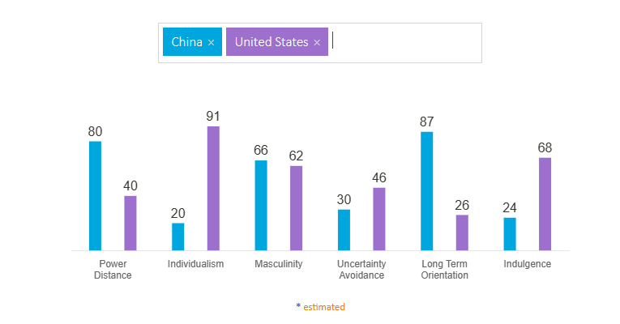
Figure 1: Hofstede Country Comparison, USA and China

Individualism: Individualism is a term that describes how interdependent a society's people are on one another. It has to do with whether people see of themselves as independent "I"s or as members of a group that is represented by the pronoun "we."Individualist cultures encourage people to prioritize their own needs and those of their family, whereas collectivist civilizations encourage people to feel a sense of community (Hofstede, 2001). China got twenty while the United States received 91 in the Hofstede nation comparison's individuality category.
Indulgence: This characteristic describes how much an individual tries to restrain their urges and wants. China scored twenty-four on the Hofstede nation comparison, whereas the United States earned sixty-eight.
Power Distance: How people feel about power disparities in their nation is the subject of this dimension. In this research, China had an overall score of 80 whereas the US received a score of 40.
Long Term Orientation: This dimension describes the relative importance of tradition and traditions in various cultures compared to more practical ideas like saving money and getting an education. China had an overall score of 87, while the United States received a score of 26.
Masculinity: The USA earned 62, while China received a score of 66, demonstrating the country's gender prejudice. The two nations scored nearly equally in the masculinity area, with China receiving a score of 66 and the United States receiving a score of 62. This indicates that both nations have strong "male" ideals and are thus highly motivated by ambition, competitiveness, and success.
Uncertainty Avoidance: Interestingly, the two nations scored nearly identical ratings in the category of uncertainty avoidance, with China scoring thirty and the United States scoring forty-six. So, neither nation will be unduly uncomfortable in circumstances involving ambiguity or uncertain outcomes.
Conclusion
The differences between China and the United States can have a significant influence on successful communication and working relationships. One of the largest trading partnerships in the world is that between China and the United States. The entire two-way commerce between China and the United States in 2020 was $559.5 billion USD (imports + exports), according to the United States Census Bureau. It is imperative that both nations are cognizant of and considerate of one another's cultures and commercial traditions. Cultural sensitivity training will only improve the countries' economic and business relations.
References
Carolina, Ț., 2019 Dimensions of national culture–cross-cultural theories. Studies in Business and Economics, 14(3), pp.220-230.
Jackson, T., 2020 The legacy of Geert Hofstede. International Journal of Cross Cultural Management, 20(1), pp.3-6.
Su, C., 2022 Geert Hofstede’s Cultural Dimensions Theory and Its Implications in SLA. Academic Journal of Humanities & Social Sciences, 5(14), pp.57-61.
Xu, H., Xu, Y., Tang, Q. and Zhu, X., 2019 Exploring regional cultural differences in China using Hofstede's framework of cultural value dimensions. South Asian Journal of Management, 26(4), pp.181-199.

