Marketing plan written for

______(Marriot Budapest.)_____

Student Name
Ionut Paul Poltz
__________________________________________________

Student ID number
_________2022 1194 41__________

Marketing Essentials BMIH4005
Date : 09/12/2022
Lecturer
Luciana Suardi
_______________________________

Table of Contents
Introduction 3
Situation Analysis 4
5 'C's 4
Company: SWOT analysis (Micro analysis) 4
Customers: Segmentation and Targeting/ Customer profile's 4
Competitors: 5
Collaborators: An awareness of the organisation's B2B Relationships, Partnerships, and Franchises. 6
Climate: PESTLE (Macro analysis) 6
Objectives 7
Strategy 7
The value proposition of Marriott, Budapest 7
Bowman's strategy clock 8
Tactics 9
Marketing mix: 9
Action 9
Control 10
Conclusion 11
References 12
Appendices 14

Introduction
A marketing plan can be referred to as a document defining the strategy of marketing for a firm for tracking their strategies of marketing and reaching the potential or target audience (Corporate Finance Institute, 2020). The provided task is a Marketing Plan which has been made for Marriot Hotel in Budapest. The plan will be designed in a SOSTAC model. 5C will be used within situational analysis. A smart objective, tactics, strategy, control and action plan will also be provided. The marketing plan will also provide a better understanding to how Marriot in Budapest can get back their customers after the post scenario caused by Imminent Brexit, Covid-19 and Russia-Ukraine unrest.

Situation Analysis

5 'C's

Company: SWOT analysis (Micro analysis)
Strengths  - Omnipresent of different luxury brands.  - Highest position in the landscape of competition (Edrawsoft, 2022).  - Innovative and proactive. | Weaknesses  - Only a single operation in the nation of Hungary.  - Shortfall of online travel agencies.  - Decline in number of customers post-pandemic(Deka, 2022).
Opportunities  - Rise in worldwide travel (Schaal, 2019).  - Situation being stable which was disrupted by the Covid-19 crisis, Russia Ukraine unrest.  - Opportunities to get back the customers by providing more facilities for customers.  - Opportunities for accelerating the growth of rooms in the future. | Threats  - Competition growing fierce because of new entrants.  - Competitors take their customers by furnishing better services at a reasonable cost.  - Operational threat during political instability for example recent Rusiia Ukraine war.
Table 1: SWOT analysis of Marriot Budapest
(Source: Created by the learner)

Customers: Segmentation and Targeting/ Customer profile's
Geographic Segmentation | Location: Budapest, Hungary.
Geographic Segmentation | Magnificent view of the River Danube from the hotel (Marriott.com, 2022).
Demographic Segmentation | Income category: Businessmen and high-income individuals.
Demographic Segmentation | Marital status: Married couples, singles and families
Psychographic Segmentation | Leisure tourism traveller (Ting, 2018).
Behavioural Segmentation | Loyalty programmes and discounts to different categories of customers (Marriott International, 2019).
Behavioural Segmentation | Remarkable experience, unique design and exceptional services
Behavioural Segmentation | Several facilities in the hotel including EV charging stations.
Table 2: Market Segmentation of Marriot Inc.
(Source: Created by the learner)

Competitors:
Porter's five forces
Competitive Forces | Threats
Threat of New Entrants | Low Threat
Threat of New Entrants | Complicated for new entrants for arranging expansive capital.
The threat of Substitutes | High Threat
The threat of Substitutes | Similar services provided by the Ritz-Carlton, Intercontinental Budapest and many others hotels.
Bargaining power of the suppliers' | Low Threat
Bargaining power of the suppliers' | Numerous suppliers are available for the firm because of the outstanding value of the brand.
Bargaining power of the buyer's | Moderate Threat
Bargaining power of the buyer's | Switching costs are high for the customers.
Competitive rivalry | High Threat
Competitive rivalry | There are numerous competitors for Marriott such as Four Seasons Hotel, Intercontinental Budapest and The Ritz Carlton (Marriott, 2022).
Table 3: Porter’s five forces analysis of Marriott Inc.
(Source: Created by the learner)
Perceptual positioning maps
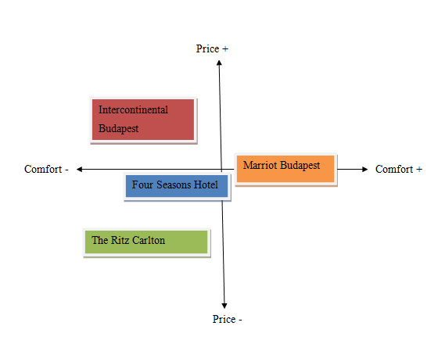Figure 1: Perceptual Map
(Source: Created by the learner)

Collaborators: An awareness of the organisation's B2B Relationships, Partnerships, and Franchises.
B2B Relationships: The Marriot Hotel in Budapest has proved that not every conference room meeting in hotels is required to be soul-crushing and windowless. Cheryl Geoffrion has been assisting in training the CVI consultants for the next generation (Marriott.com, 2022). .
Partnership: Marriot can make partnership with travel partners which may assist the firm in providing a better service.
Franchises: Marriot Inc. is a franchisor. W Hotels worldwide is a part of the organisation and has been willing to open its new operations in Hungary (W Budapest Hotel, 2020).

Climate: PESTLE (Macro analysis)
Political Factors | Indefinite political environment of the European Union
Political Factors | Statement of anti-immigrants and ruffle effect of the ban on travel.
Political Factors | The recent war between Russia and Ukraine, Post Brexit Situation and the instability caused by the covid-19 pandemic (1, 2022).
Economical Factors | Fluctuation of currency impacting tourism
Economical Factors | Fierce competition among airlines.
Social Factors | Rise in experiential travel and spending of the consumer
Social Factors | Changing demand for services according to region
Social Factors | Changing preferences of the consumer.
Technological Factors | Competition in coming up with the latest technology.
Technological Factors | Innovation excelling competitive advantage.
Legal Factors | Safety and health regulations and hotel regulations.
Legal Factors | Varied legal laws of different economies.
Environmental Factors | Rising awareness of the consumers towards sustainability
Environmental Factors | Integration of different norms.
Table 3: PESTLE analysis of Marriot Budapest
(Source: Created by the learner)

Objectives
SMART target: Creating an effective marketing plan for operational fluency in Hotel Marriott, Budapest which may be helpful in attaining the goals of the organisation i.e., getting back customers after the post-crisis of the covid-19 pandemic, Ukraine-Russia war as well as focusing on the impact of the imminent Brexit.

Strategy

The value proposition of Marriott, Budapest
The core values of Marriot Budapest are pursuing excellence, putting people first, serving the world, acting with integrity and embracing change. The firm endeavour for being a force for good (Marriott International, 2019). Marriott International has around thirty brands of hotels within its portfolio. In comparison to reward programmes of other hotels, Marriot Inc. has several participating properties which furnish greater flexibility to the customers while making plans for travel. The way of communicating and delivering value proposition has been provided below
- The firm curates a personalised and seamless experience.
- Marriot’s strategy of customer experiences makes use of data for informing decisions
- The firm offers a full experience of travel.
- The firm cares about its employees and focuses on delivering customer loyalty.
Link value proposition to our customer segments, how will this affect targeting and positioning of the organisation
The value proposition of Marriot i.e., pursuing excellence, putting people first, serving the world, acting with integrity and embracing change will have a positive impact on positioning and targeting the organisation as the firm has chosen the premium customer segment as a customer base.

Bowman's strategy clock
It is an easy-to-use and comprehensive tool of strategy which may furnish choices for positioning within the market which is based on perceived value and price.
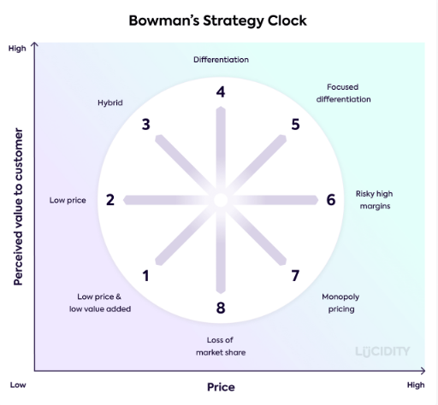
Figure 2: Bowman’s Strategy Clock
(Source: Lucidity, 2022)
Strategy one is about quantity selling. Strategy is about becoming the lowest-cost choice for buyers. Strategy three makes a balance between differentiation and cost. In strategy four business makes a significant focus on differentiating services and products from competitors. Strategy five is about furnishing high value at a high price. strategy six is about going to a higher point of price without perceived value which is very risky. Strategy seven is about controlling price and product by a single firm. Strategy eight is generally the worst position in which a firm may be in a phase of decline (Bhasin, 2018). Marriott Inc should focus on position four where the firm may differentiate its services and products from competitors by summing high perceived value. Marriott in Budapest has lost many of its customers to its consumers and the situation of the economy has been somewhat stable after the impact of the crisis including covid-19, Brexit and Russia Ukraine unrest (Marriott.com, 2022).

Tactics

Marketing mix:
Product
Marriott Inc. manages a diversified and broad hotels and resorts portfolio. The firm manages around 30 brands of hotels belonging to luxury classes and distinctive classes. The firm offers a variety of cuisine and accommodation services.
Place (Distribution)
The firm has a worldwide presence and is present in approx 100 nations with approx 5,500 properties. The hotels of Marriott Inc. are located in prime locations for maintaining their unique quality (Bhasin, 2019). In the nation of Hungary, there is only one Marriot hotel situated in Budapest, the capital city.
Price
Marriott Inc has adopted the strategy of premium pricing because the firm offers services and prices on the basis of value. The firm has targeted high-end customers. The firm has been confident in its policy of pricing.
Promotion
The firm has occupied the leading market position because of its higher recall of the brand. Marriott Hotel in Budapest focuses on launching advertisement campaigns of high impact and has targeted particular customer groups for increasing brand awareness.

Action
Task | Start Date | End Date | Duration
Preparation | 5-Feb | 10-Feb | 6 Days
Market research | 12-Feb | 12-Apr | 60 Days
Marketing channels schedule | 15-Apr | 1-Jun | 45 Days
Gathering feedback | 15-Jun | 10-Jul | 25 Days
Table 4: Action Plan
(Source: Created by the learner)
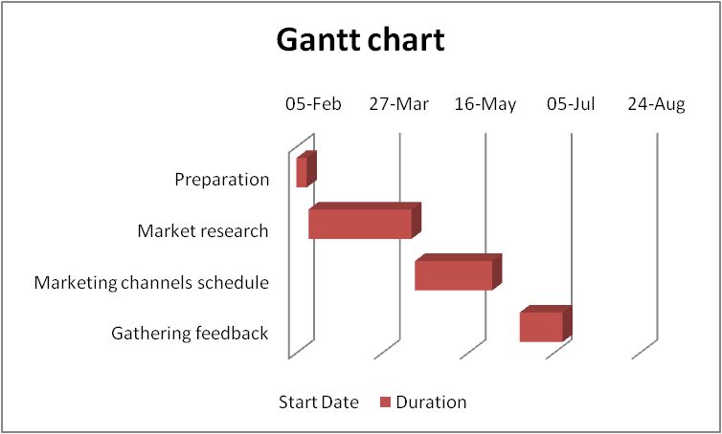
Figure 3: Gantt Chart
(Source: Created by the learner)

Control
The Unique Selling Point of Marriot Inc. is leadership in the global market. The firm has been serving in approx 100 nations across the globe. The Marriot Hotel in Budapest is the one and only Marriot operation in Hungary The firm has around thirty hotel brands.. In comparison to reward programmes of other hotels, Marriot Inc. has several participating properties which furnish greater flexibility to the customers while making plans for travel. As the post-Brexit scenario, the pandemic and Russia-Ukraine unrest have totally imbalanced the entire environment of Marriot, the firm will focus on business success by delivering its outstanding value proposition.

Conclusion
The marketing plan has provided an in-depth analysis of the business and the business environment of Marriott International and its operation in Budapest. Different strategies have been used with the plan which has provided worthy knowledge. The plan has furnished a proper understanding of the operational environment of Marriot and how the firm can do better. The marketing plan has also provided a better understanding of Hotel Marriot at Budapest can get back their customers after political and economic unrest. The plan has provided an in-depth analysis of the firm which may be helpful for the policymakers at Marriot for maintaining their competitive advantage and growth.

References
1., 2022. Hungary - Market Challenges. [online] International Trade Administration | Trade.gov. Available at: https://www.trade.gov/country-commercial-guides/hungary-market-challenges [Accessed 3 Dec. 2022].
‌Bhasin, H., 2018. What is Bowman’s Strategy Clock? [online] Marketing91. Available at: https://www.marketing91.com/what-is-bowmans-strategy-clock/ [Accessed 28 Nov. 2022].
‌Bhasin, H., 2019. Marketing Mix Of Marriott - Marriott Marketing Mix. [online] Marketing91. Available at: https://www.marketing91.com/marketing-mix-marriott/ [Accessed 28 Nov. 2022].
Corporate Finance Institute. 2020. Marketing Plan. [online] Corporate Finance Institute. Available at: https://corporatefinanceinstitute.com/resources/management/marketing-plan/ [Accessed 28 Nov. 2022].
‌Deka, K., 2022. Marriott sees key revenue metric in US, Canada at pre-COVID levels for rest of year. [online] Reuters. Available at: https://www.reuters.com/business/marriott-international-reports-quarterly-profit-surge-travel-demand-2022-05-04/ [Accessed 28 Nov. 2022].
Edrawsoft., 2022. Marriott SWOT Analysis | EdrawMax Online. [online] Available at: https://www.edrawmax.com/article/marriott-swot-analysis.html [Accessed 28 Nov. 2022].
‌Lucidity., 2022. Introduction to Bowman’s Strategy Clock | Lucidity. [online] Available at: https://getlucidity.com/strategy-resources/introduction-to-bowmans-strategy-clock/ [Accessed 28 Nov. 2022].
‌Marriott International. (2019). Core Values and Heritage | Marriott International Corporate Values. [online] Available at: https://www.marriott.com/culture-and-values/core-values.mi [Accessed 28 Nov. 2022].
‌Marriott International., 2019. Discover Marriott Bonvoy | Join The Best Hotel Rewards Program. [online] Available at: https://www.marriott.com/en-us/loyalty.mi [Accessed 28 Nov. 2022].
Marriott. 2022. Marriott Competitors. [online] Comparably. Available at: https://www.comparably.com/companies/marriott/competitors [Accessed 28 Nov. 2022].
Marriott.com. (2022). Brands. [online] Available at: https://www.hotel-development.marriott.com/brands [Accessed 28 Nov. 2022].
Marriott.com., 2022. Budapest Marriott Hotel. [online] Available at: https://whattoexpect.marriott.com/budhu [Accessed 3 Dec. 2022].
‌Marriott.com., 2022. Hotel Platform & Reservation System | Marriott International. [online] Available at: https://www.hotel-development.marriott.com/power-of-marriott [Accessed 28 Nov. 2022].
Schaal, D., 2019. Marriott’s Alibaba Joint Venture in China Is Part of Its Direct-Booking Strategy. [online] Skift. Available at: https://skift.com/2019/07/29/marriotts-alibaba-joint-venture-in-china-is-part-of-its-direct-booking-strategy/ [Accessed 28 Nov. 2022].
Ting, D., 2018. Every One of Marriott’s 30 Hotel Brands, Explained. [online] Skift. Available at: https://skift.com/2018/09/21/every-one-of-marriotts-30-hotel-brands-explained/ [Accessed 28 Nov. 2022].
W Budapest Hotel. 2020. W Budapest Hotel | WEBSITE | Budapest | Hungary. [online] Hu-budapest.com. Available at: https://whotel.hu-budapest.com/ [Accessed 3 Dec. 2022].
‌

‌

Appendices


