
University of Wales Trinity Saint David
School of Engineering
BEng Manufacturing Systems Engineering
Mike Lewis
1909144
Factory Control ACMA6001

Introduction
In this project, I will develop a factory that can stack a lid and a base, then stack them two high inside of a box. A ladder logic programme and an HMI will also be included in the design.

Contents
Introduction 2
Table of Figures 3
Factory Control 4
PLC’s/HMI’s 4
Safety 6
Warning/Alarm strategy 6
Factory from Factory IO 7
Factory operation overview 7
Operational Flow Chart of Factory 8
Detailed description of ladder logic for factory 9
References 11
Bibliography 11

Table of Figures
Figure 1 - Typical siemens PLC rack. SIMATIC S7-1500 Compact CPU 1512C-1 PN (Automation, 2022) 5
Figure 2 - Siemens HMI screen SIMATIC HMI KTP400 BASIC MONO PN (Automation, 2022) 5
Figure 3 - Snap shot of my factory taken from Factory IO 7

Factory Control
Modern factories especially within manufacturing industries require more and more advanced control systems and process automation. Automation nowadays is divided into two categories: continuous process automation (process automation) and discontinuous process automation (production automation). Microelectronics and modem computing bring the two areas closer together. AI approaches are introduced in both sectors. This results in new headlines in industrial automation, such as intelligent manufacturing systems (ims), service robots, and new real-time control jobs. (Kopacek, 1997)
Manufacturing relies on automation, which requires process control to function well. To make goods, modern manufacturing plants employ incredibly complicated machinery. Automation has reduced the number of humans required to run this machinery, but automated machinery need process control to gather data and verify that the plant's output is optimal. To allow for the monitoring and automation of the manufacturing processes it is necessary to use PLC’s.
Manufacturers utilise programmable logic controllers (PLCs) to monitor and automate their manufacturing processes across sectors and applications. PLCs are industrial computers that are built to endure the harsh conditions of an industrial setting. With more businesses attempting to automate their manufacturing processes, the role of PLCs in Manufacturing is becoming more significant. (Process solutions, 2020)

PLC’s/HMI’s
PLCs (Programmable Logic Controllers) are utilised in applications all over the world and play an important part in industrial automation. Control, automation, safety circuits, regulatory control, and strategy are all possible with PLCs on the work floor. PLCs are frequently linked to a control level via a communication network such as Ethernet, allowing the PLC to function in an integrated fashion. (Guedes, 2010)
PLCs have steadily improved in terms of usability. Programmable Logic Controllers are the most often utilised technique of control in industrial plants. Manufacturers are constantly looking to expand their manufacturing sites but not necessarily their footprint, so PLCs provide the flexibility needed for a manufacturing site to become more competitive by constantly developing and updating the software relating to the PLCs and allowing better control over larger pieces of equipment on the shop floor. (Supinski, 1992)
PLCs have traditionally been programmed and maintained by electricians using simple ladder logic. Ladder logic was created to take the role of relay logic. Relay logic necessitates hard wiring of all control circuits to all control functions, whereas ladder logic employs a microprocessor device, generally a PLC. (world, 2021)
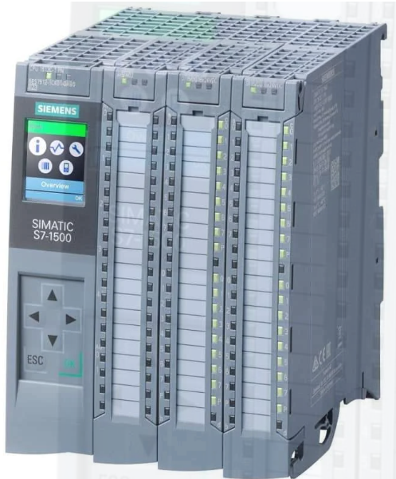
Figure 1 - Typical siemens PLC rack. SIMATIC S7-1500 Compact CPU 1512C-1 PN (Automation, 2022)
The human-machine interface, or HMI for short, has grown in relevance in the automation sector in recent years, and its value continues to expand. The advancement of IT technology, particularly the Internet, will continue to accelerate and will decide how HMI systems will appear in the future. HMI systems that use open standards can also automate operations other than operator control and monitoring, like as diagnostics or control duties. Human-machine systems are increasingly serving as an information hub between the worlds of automation and corporate IT, all the way up to MES (Manufacturing Execution System) or ERP (Enterprise Resource Planning) solutions. (Wucherer, 2001)
HMI’s are used by managers and supervisors in industry to convert complicated data into meaningful information. HMIs, for example, are used to monitor machinery to ensure that it is operating properly. Simple visual displays provide meaning and context to near real-time data concerning vessel temperatures, tank pressures, motor condition and other factors.
However, thanks to the increased capabilities of today's HMIs, managers and supervisors can do much more than just control operations. They provide enormous new potential to improve product quality and make systems more efficient by utilising historical and trending data.
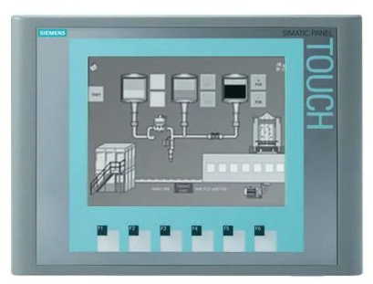
Figure 2 - Siemens HMI screen SIMATIC HMI KTP400 BASIC MONO PN (Automation, 2022)

Safety
Modern facilities' high level of automation necessitates a thorough study of all operational and safety elements of the processes to be automated. When there is a potential for risk and the repercussions must be minimised by the automated system, the process control systems used for automation are also subject to the principles of safety technology. In such instances, the autonomous system plays a safety function and must meet all standards for proper execution. The system must, in particular, avoid safety-related failures and the consequent accidents and damages, including injuries to staff and the general public. (T Vollmer, 2000)

Warning/Alarm strategy
A requirement for the factory in this assignment is to have a warning/alarm strategy.
Workplaces in the United Kingdom are obligated under the Health and Safety at Work Act 1974 to adopt such safety equipment as far as is reasonably practical to minimise the danger to persons within the factory or indeed using machines, and to guarantee the welfare and health of all employees. (The National Archives, 2021)
I've implemented an alert to sound when the conveyor belts are going to start moving to check that the factory developed within Factory IO is compatible with the Act. This allows any possible operator to be forewarned when the equipment will begin to move, giving them enough time to ensure they are clear of the conveyor belts. Alarm management may be a problem at times; an alarm system that has not been properly set up or has gotten overly intricate in its design might have the opposite impact intended.
The HSE advises that alerts be processed in such a way that the operator is not overburdened. The type of alert and its configuration should be determined, allowing the operator to conduct all necessary evaluations and take appropriate action. In this circumstance, get away from any conveyor belts before starting up. (Health and Safety Executive, 2021)

Factory from Factory IO
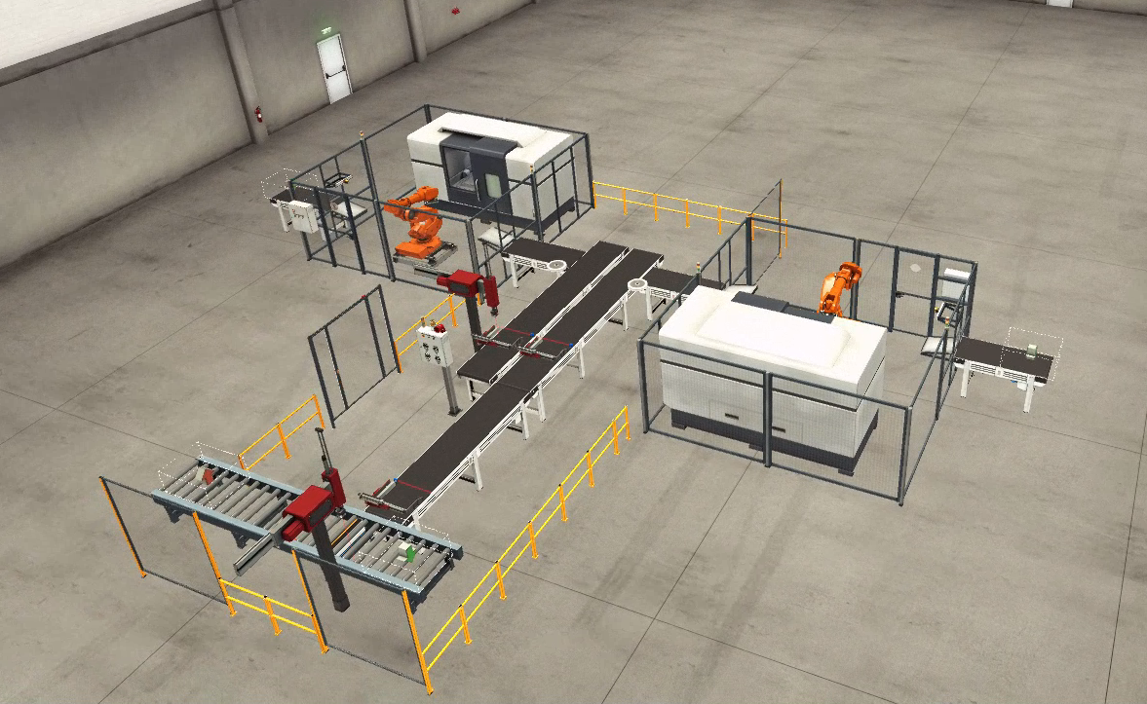
Figure 3 - Snap shot of my factory taken from Factory IO

Factory operation overview
The factory is made up of two machining centres similar to a Mazak integrex i1ooot. These are supplied pucks via two ABB robots. Machining centre 1 receives pucks for machining lids and machining centre 2 receives pucks for machining the bases.
The lids and bases are then transferred to a conveyor belt via the ABB robots where they pass through a sensor and a set of clamps. The clamps secure them and allow the pick and place robot number 1 to lift the lid and move across in X to place the lid on to the base creating a whole component.
There is a right positioner which raises, allowing the component to continue along the conveyor until it comes to another sensor. This sensor activates another clamp, securing the component with another pick and place grabbing the component and placing it in to a box which comes from emitter 3.
The components are placed two high in the box which is held in position via a stopping arm until being allowed to progress along the roller conveyor.

Operational Flow Chart of Factory
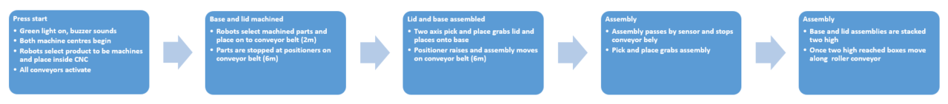
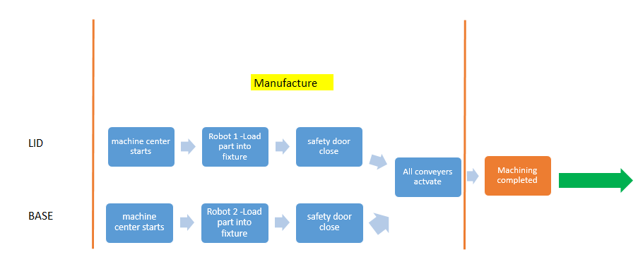
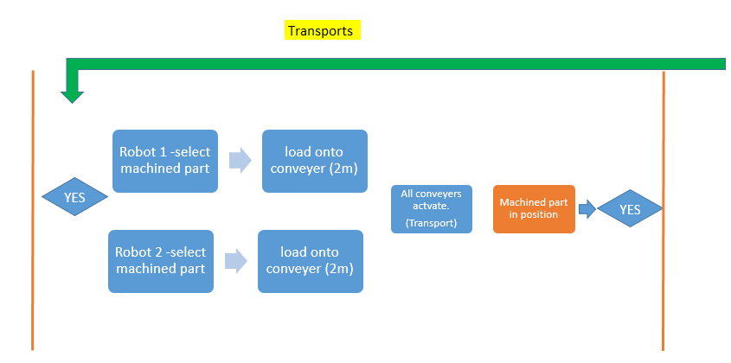

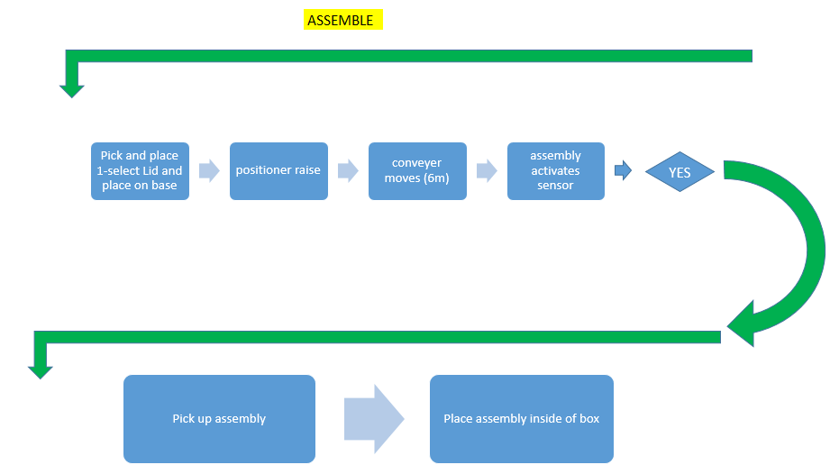

Detailed description of ladder logic for factory
- Network 2 - Factory start up. All equipment and machines are reset to their home positions.

- Network 3 - Green button selected on panel to actually start factory. Alarm siren also goes off to allow for any personnel in are to be made aware of factory starting and moving parts to consider. Stopping arm for boxes also set in up position to stop boxes moving along roller conveyor.

- Network 4 - Belt conveyors start up along with the two machine centres and roller conveyor for boxes.

- Network 5 - Machine centre 1 starts up and machine centre 2 starts to run as puck for base is introduced in to the machining area.

- Network 6 - Machine centre 2 starts up and machine centre 1 starts to run as puck for lid is introduced in to the machining area.

- Network 7 - Both machine centres stop and doors open allowing ABB robot to place the respective pucks in to the machines for machining to begin.

- Network 8 - Machining begins for the final machined base and lid. Once complete ABB robot places lid and base on to conveyor.

- Network 9 - Both lid and base pass through a sensor on each conveyor. When sensor is activated it sends signal to right positioner clamp 1 and 2. These clamps are now set to move across the conveyor and clamp the lid and base securely to await next operation from pick and place. The counter for both lids and bases it also initialised and counts the number of lids and bases moving past the sensors. The counter resets after every pass of the sensor allowing an operator to easily see how many lids and bases have been manufactured.

- Network 10 - Both clamps are reset to their home positions to await more lids and bases.

- Network 11 - Pick and place 1 receives signal that the lid is secured and ready for picking up. Pick and place is set in Z and moves downwards towards the lid. Pick and place is set to grab lid ready for next movement.

- Network 12 - Pick and place resets the home position in Z and then sets in X moving outward toward opposite conveyor. Pick and place is again set in Z after a time delay of 2.5 seconds. Pick and place resets grab after delay of 3.5 seconds and releases the lid onto the base creating a full component. Z is again reset along with X and pick and place moves back to original home position. After a time of 2.5 seconds right positioner 1 is raised allowing the component to continue along the conveyor.

- Network 13 - Component passes sensor 4 and signal is sent to counter 3 to count how many components enter the box which is created from emitter 3. The stopping arm is also set after a 6 second delay to stop the box from moving along the roller conveyor.

- Network 14 - Component passes through sensor 4 and signal is sent to pick and place to set it in X. The pick and place moves outwards towards the now clamped component. A signal is sent to the pick and place and it is set in Z. The pick and place begins lowering towards to component. The pick and place after a delay of 1.5 seconds sets for grabbing the component for 15 milli-seconds. Then the clamp is reset, the pick and place is reset in both Z and X and it returns to its home position still holding the component. Pick and place is again set in Z in readiness for it to place the component inside of the box. Pick and place grab is reset and so is Z. The box is queued until there are two components inside where the stopping arm is reset and the box moves along the roller conveyor.

References

Bibliography
Automation, W. I., 2022. s.l.:s.n.
Automation, W. I., 2022. s.l.:s.n.
Guedes, L. A., 2010. Programmable Logic Controller. [Online]
Available at: https://www.intechopen.com/books/3705
[Accessed 08 August 2021].
Health and Safety Executive, 2021. Control Systems. [Online]
Available at: https://www.hse.gov.uk/comah/sragtech/techmeascontsyst.htm#fivec9e460
[Accessed 20 August 2021].
Kopacek, P., 1997. REALTIME CONTROL IN FACTORY AUTOMATION. In: Algorithms and Architectures for real-time control. Vilamoura: IFAC, p. 15.
Process solutions, 2020. The Role of PLCs in Manufacturing. [Online]
Available at: https://processsolutions.com/the-role-of-plcs-in-manufacturing/#:~:text=Process%20Control%20and%20Automation,switch%2C%20thermometer%2C%20or%20relay.
[Accessed 15 April 2022].
Supinski, S. B. J. a. M. R., 1992. The development of a generic PC-based programmable logic controller simulator. 30(01), p. 151.
T Vollmer, K. B. G. H. R.-D. P., 2000. Process control under safety aspects. Fusion Engineering and Design, 48(1-2), pp. Pages 57-61.
The National Archives, 2021. legislation.gov.uk. [Online]
Available at: https://www.legislation.gov.uk/ukpga/1974/37/section/2
[Accessed 20 August 2021].
world, l. l., 2021. Relay Logic Vs Ladder Logic. [Online]
Available at: https://ladderlogicworld.com/relay-logic-vs-ladder-logic/
[Accessed 08 August 2021].
Wucherer, K., 2001. HMI. The Window to the Manufacturing and Process Industry, 34(16), pp. 101-108.

