

Module: Marketing Fundamentals (LCBB4004)

Student Name: Kristiana Valentinova Slavova

Student ID: 2113217

Assignment Task 1: Blogging to communicate

Lecturer: Mohammad Rahman

BLOG POST I
Title: Introduction of MONAT
Link: https://monatglobal.com/tag/men/
Monat is a privately held company in America, operating globally. The company headquarters is in Doral, Florida, mainly selling skincare, hair care, and wellness products (Baines et al., 2017). This company developed as a subsidiary of the Alcora Corporation. As CEO and chairman, Rayner and Luis Urdaneta co-founded the company in 2014. They added skin care products to their product portfolio in 2019. In 2020, Monat Company scaled up its focus on health and well-being. The wellness line includes a number of products developed in collaboration with Dr. Brent Agin, including dietary supplements, powders, and mixes (Makino et al., 2018). To help combat the coronavirus pandemic, the company began donating 240,000 bottles of hand sanitizer in April 2020 to government organizations, non-profits, and customers across North America increase its awareness of products. Despite having several women's hair care products, Monat has not developed specific man hair skin care and routine products. Therefore, the company's project is to develop men's hair and growth stimulation products. These products will use the most organic ingredients. The target audience, therefore, is men within a different age group. The youth is a more targeted product (project) audience as they positively responded to such an introduction.
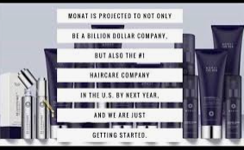
To watch this project's products: https://www.youtube.com/watch?v=4O1WYAnhZiU
Comment…..

BLOG POST 2
Title :( product description) men hair care and hair growth stimulation products
Link: https://monatglobal.com/
These products are made from a range of ingredients. They are grouped into volumizing powders, thickening pastes, and tonics; see salts sprays, hair wax, hair pastes, hair putty, hair clay, hair pomades, and gels. Wax is perfect for shaping your hair because of its thick consistency. Pastina says it's "perfect for a messy, just-woken look." Without the gel's gummy, sticky feel, you have better control. Hair with fine or limp texture can't handle the weight and volume of this product. It's also time-consuming to remove it. Pastes and putties are typically made with wax as a base.
Pomade. Greasers are credited with popularizing the wet, slicked-back look with pomade. Wax-like Pastina claims it is, but it is creamier and easier to deal with (Li et al., 2019). Hair is smoothed out, and frizz is controlled, according to her. This substance makes hair appear shinier and wetter than wax does. Serum. You should use these products if your hair is brittle or dry (Makino et al., 2018). They're not meant to be used to style your hair. They provide the surface with a slight gloss and suppleness as an alternative. Cream. Creams can provide a lot of shine and control with a little grip if you have thick or coarse hair.
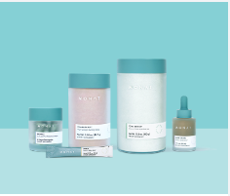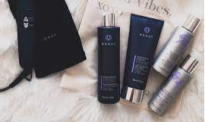
MONAT men air products
Read more https://monatglobal.com/blog/
Comment…….
Reaction:

BLOG POST 3:
Title :( products, price, place, and promotion mix)
Link: https://monatglobal.com/
Product & prices
These products will vary from one to another depending on the effects and use. First is the volumizing powders. All hair can benefit from using volumizing products, but they are most effective when applied to the hair's roots. In spite of their appearance, these products are most useful for boosting the volume of your hair, making it simpler to create larger designs.
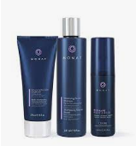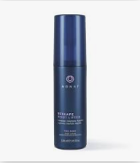

On the other hand, a thickening tonic adheres to the roots of the hair to give it volume and fullness. Paste and cream are both used to create a thickening agent (Zakaria et al., 2021). You may use the Aveda Thickening Paste before and after styling your hair, making it a perfect choice if you want a multipurpose thickening paste. To learn how to use these products, go to our YouTube channel: https:/monatofficial/videos/how-to-apply-monats-thickening-spray/1853800841499191/
The pricing is based on quality and quantity. However, these are affordable as compared to other brands.
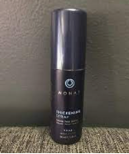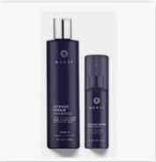

Like other styling solutions, sea salt spray is designed to add natural texture to your hair while enhancing the color's finer particles. To combat the damaging effects of saltwater on hair, many people use natural oils like coconut or olive.
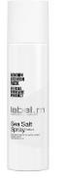
In the styling products, the products with a high degree create a bigger villainous style. Using Monat products can provide the appearance of fuller hair with a more natural finish (read: no shine). Clays are among the least reflective materials. For example, lock Stock and Monat 85 Karat Clays are waxes or putties. Products like creams and pomades can be used to achieve natural, subtle styles like a brushed side part. If you prefer a more slicked-back look, use the extra product. The term "moldability" refers to something's ability to take on the shape of another object (Hugo et al., 2017). Restyle is impossible without adding extra product to gels and paste treatments like Fudge Matte Heed. This is a great alternative for those wishing to keep their shape throughout the day. Pomades and creams with a low hold allow you to restyle your hair as often as you desire. Try the Lock Stock & Barrel 85 Karats Grooming Clay, which has a high amount of hold while allowing you to restructure your hair as needed to keep your look fresh all day long (Cheong and Kaur, 2021). Despite the fact that hair sprays are technically style tools, they are best utilized as a finishing touch. After applying a hair product to achieve the desired look, hairspray can be used to hold the style in place.
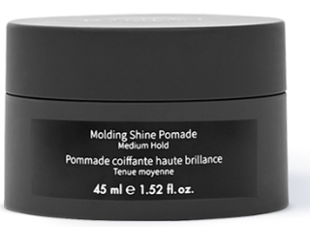

The prices of the Monat products, therefore, are competitive and based on the value of the products sold. Most of the products range from £ 9.00 to £ 17.00. there are also a range of men's hair products that are to be introduced in the company projects that makes it to choose from the variety depending on the needs and specification of the consumers (Rungfarsangaroon, 2018).
Like this content? Check out Monat's top men's air products to be introduced, hair-thickening shampoos, and men's groom products through /; https://monatglobal.com/monat-black-shampoo-conditioner/ and stay up to date with the Monat hair care content.
BLOG 4
Title :( Monat promotion mix)
Link: https://monatglobal.com/wp-content/uploads/2018/05/MixandMatch_FAQs_122017.pdf
Promotion is the act of disseminating the information about the product and the products and increasing the purchase by the customers or prospective buyers. This encourages the consumers to purchase the products at the Monat use of traditional, online advertising, direct marketing, public relations, personal selling, sponsorships, and even sales promotion (Kotler et al., 2015).
First, the monad men hair products to be introduced in the market will sell at the discounting prices every end month; a 10% reduction in the prices helps you as the consumers to purchase at a saving price and can also channel this money to other products that also Monat offers at affordable prices(Lunsford et al., 2018). The Monat products are arranged at an eye-; level in the supermarkets and wholesale stores, making the customers easily view and consider the purchase of the product.
At the moment, loyalty cards have been introduced specifically for these men's hair products. With the purchase, the points can be redeemed to purchase the men's hair care products and other products, including skin care.
The Monat Company uses social media products where you can see the use of these products and prices and have the direct links you can click to view and purchase the products. First, on Twitter, you can click the Twitter handle of Monat, twitter.com/monatofficial; this links has the product variety, prices, and direct mailbox where customers' feedback, complaints, and compliments can be channeled. The company also has hashtags related to these skincare products so that customers can check the functionality of these men's products, prices, and use. Problems related to these products as they are new are also handled through the direct messages (Jahan et al., 2019). In the Monat Twitter, there is also used of the post, and the GIFs, live tweets, hosting and participation in the live chats by the company, interaction with the influencers and the customers, and following the customers. These products can also be viewed on Monat Instagram, which also uses clear and 3D photos to show the customers' variety and how these products work. Videos and reels are on Instagram to show how to apply these products effectively and feedback collection. Follow these on Instagram by clicking @ https://www.instagram.com/monatofficial/. These are also available on the official company Facebook page with most of the company content creators, well-known musicians, and celebrities across the United States and other continents (Rungfarsangaroon, 2018). In addition, you can follow the company through other social media platforms such as LinkedIn, Pinterest, fluckr, Tumblr, Reddit, Tik-Tok, quora, and Viber.
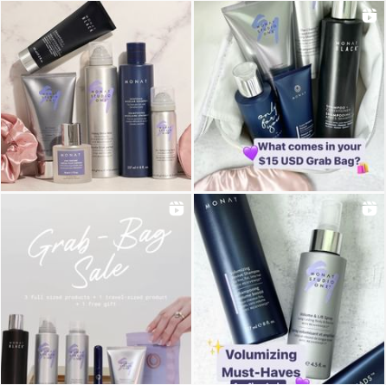
Need to know more about the Monat products? Follow and get updated on the social media platform
https://twitter.com/monatofficial
https://www.facebook.com/monatofficial/
https://www.instagram.com/monatofficial/
Need to rate the content?
BLOG POST 5
Title: place
https://mymonat.com/shop/
These products will be available at supermarkets across the US, UK, and other continents. The products will also be available at the company stores, strategically located at the points where many people can locate and reach (Rungfarsangaroon, 2018). Online purchases can be made through the company website, and delivery is done through various logistic companies such as Amazon to other continents and globally. To use the online website to purchase the product, visit https://monatglobal.com/
BLOG POST 6
Title: conclusion
A range of men's hair products is to be introduced into the market to tap the needs and wants of men. These products have been unavailable in the market. These products will be purchased at the company stores and website. Their prices range from 9.50 to 17.0 pounds
We are modern in nature. Our mission is to help people worldwide live beautiful, healthy, and meaningful lives through our unique, naturally derived products, an exciting and lucrative business opportunity, and a culture of service, gratitude, and thankfulness.
Follow us (Monat Company)

References
Baines, P., Fill, C. and Rosengren, S., 2017. Marketing. Oxford University Press.
Cheong, H.F. and Kaur, S., 2021. From Skin Whitening to Skin Brightening and, Now, Skin Glowing: How L'Oréal Sustains Its Skincare Line from Colourism and Genderism to Racism and Classism. In Social and Sustainability Marketing (pp. 547-562). Productivity Press.
Hugo Pacagnelli Infante, V., Melo, M.O. and Maia Campos, P.M.,2017 Impacts of sun protection and skin care habits in the biophysical and morphological properties of young men skin. Journal of Cosmetic Dermatology.
https://monatglobal.com/
Jahan, F., Happy, A.A., Chowdhury, M.M.H. and Hossain, M.A., 2019. Natural herbs and spices: A great resource for skin care cosmetics. Journal of Plant Sciences, 7(4), pp.86-99.
Kotler, P., Burton, S., Deans, K., Brown, L. and Armstrong, G., 2015. Marketing. Pearson Higher Education AU.
Kotler, P., 2012. Kotler on marketing. Simon and Schuster.
Lunsford, N.B., Berktold, J., Holman, D.M., Stein, K., Prempeh, A. and Yerkes, A., 2018. Skin cancer knowledge, awareness, beliefs and preventive behaviors among black and hispanic men and women. Preventive medicine reports, 12, pp.203-209.
Li, B.S., Cary, J.H. and Maibach, H.I., 2019. Science Behind Cosmetics and Skin Care. Nanocosmetics, pp.3-15.
Makino, E.T., Jiang, L.I., Tan, P., Cheng, T. and Mehta, R.C., 2018. Addressing male facial skin concerns: clinical efficacy of a topical skincare treatment product for men. Journal of drugs in dermatology: JDD, 17(3), pp.301-306.
Rungfarsangaroon, W., 2018. A Study of the Factors Influencing the Rejection of Men Skincare Products Among Thai Male Millennials. Master of Science Program in Marketing (International Program). Faculty of Commerce and Accountancy, Thammasat University.
Zakaria, Z., Ramli, S.Q., Shoid, N.Z.M. and Sulaiman, A., 2021. Malaysian Males Skincare Product Purchases. Asian Journal of Research in Business and Management, 3(3), pp.94-103.

