Drive-cycle Requirement Specifications

Jinhao Xia
2300256
MSc Automotive Engineering
28/04/2024
ACFA7007 Hybrid Powertrain and Control

Tesla Fuel Cell conversion

1.1 Validate a drive cycle
This section focuses on verifying the dynamics model and driving cycle created based on Tesla Model3, the WLTP range and WLTP Consumption obtained through simulation, and comparing these data with the data published by Tesla. If the data are close, it means that the dynamic model we have created meets the requirements. On this basis the simulation of energy storage form conversion is continued.

When the vehicle is running on the road, the vehicle will be subject to air resistance, rolling resistance, gradient resistance and inertial resistance. In this paper, the simulation is carried out under the driving condition specified by WLTP. Since there is no uphill and downhill driving condition in WLTP condition, the gradient resistance is not considered. The formula of air resistance is as follows:
$F_{air}=\frac{1}{2}ρA_{f}C_{d}v^{2}$ (1)
The formula for rolling resistance is as follows:
$F_{RR}=f_{r}mg$ (2)
The formula for inertial resistance is given below:
$F_{IR}=ma$ (3)
Therefore, when the vehicle is running, the total resistance of the vehicle is:
$F_{total}=F_{air}+F_{RR}+F_{IR}$ (4)
The parameters for dynamic modelling based on tesla model3 are shown in Table 1.1.
Table 1.1 Tesla Model 3 Performance Specifications
Parameter | Value
Mass (kg) | 1980
Windward area (m²) | 2.25
Coefficient of drag | 0.23
Coefficient of rolling resistance | 0.01
Battery Capacity (kWh) | 75
Battery Nominal Voltage (V) | 360
Mechanical efficiency | 0.9
Energy recovery efficiency | 0.6
WLTP Range (km) | 530
WLTP Consumption (Wh/km) | 166

It can be seen from Table 1.1 that Tesla's WLTP Range is 530km and WLTP Consumption is 166 Wh/km. Therefore, to achieve this driving range and power consumption rate, 88 kWh batteries are required. But the tesla model 3 has only 75 kWh of battery capacity. The remaining 13 kWh needs to be supplemented by kinetic energy recovery. Therefore, the kinetic energy recovery is added in this simulation. When the vehicle decelerates, the kinetic energy recovery will be started, and the energy recovery efficiency is set to 60%.

The following results are obtained from the simulation, as shown in Figure 1.1, which shows the instant power and energy consumption for a WLTP cycle. From this figure, it is known that the car will consume 4.03 kWh of energy from the battery after completing one WLTP cycle. A plot of instant power and recovered energy for a WLTP cycle is shown in Figure 1.2. From the figure it can be seen that 0.713 kWh of energy is recovered from the battery when the car completes a WLTP cycle.
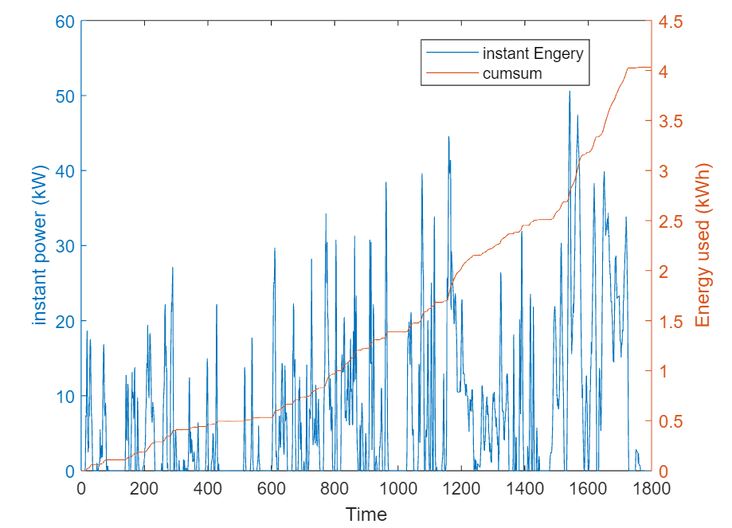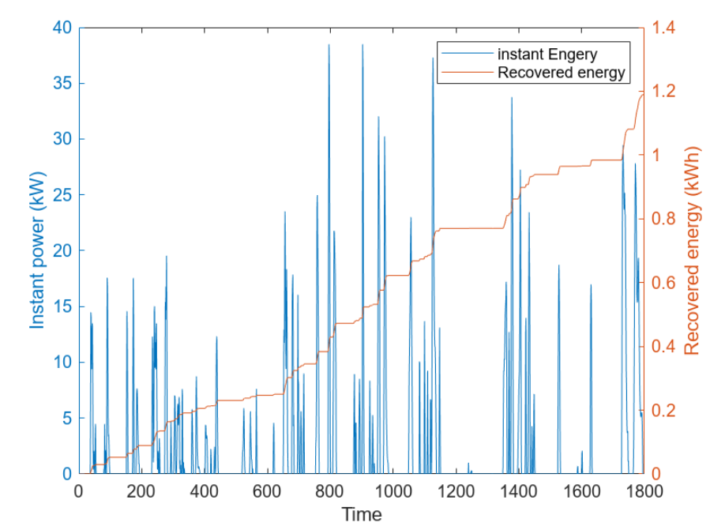
Figure1.1 Energy consumption diagram Figure1.2 Recovered energy diagram
Eventually, when the 75 kWh of energy in the battery is fully consumed, the car can complete 22.6 WLTP cycles, which is 525.5km of driving range. the WLTP Consumption is 142 Wh/km. where the error between the simulated range and the manufacturer's data is 0.85%. However, the difference between the simulated WLTP Consumption and the actual one is large, which may be due to the fact that there are many other electrical devices in the car, such as air-conditioning system, lighting and electronic auxiliary systems, and entertainment and information systems, which are not taken into account in the simulation, and thus the power consumption rate in the simulation is low. In conclusion, the experimental and simulated values are very close to each other and the drive cycle calculation method in this paper is accurate and all the later analyses will be simulated based on this dynamics model.

1.2 Replace 50% of the battery capacity for Fuel Cell
In this section will replace 50% of the Tesla battery capacity with a hydrogen fuel cell and achieve the same WLTP range as in the previous section. A fuel cell is a device that converts chemical energy into electrical energy. Hydrogen fuel cells are one of the most common types, reacting hydrogen with oxygen to produce water and electricity. Compared with the traditional combustion method, fuel cells can convert chemical energy into electricity more efficiently, and the energy utilisation efficiency is higher. At the same time, the reaction product of fuel cell is water, which does not produce pollutants and greenhouse gases, and has significant environmental benefits. Therefore, the energy storage method of half power battery and half fuel cell can meet the regulations after 2035.

In hydrogen fuel cell conversion, the drive system of the car remains unchanged and is still driven by the original electric motor, only the energy storage is changed. Half of the battery capacity is provided by the fuel cell through a chemical reaction. Therefore only the total mass of the car changes in the dynamic model. The next step is to determine the mass that will be transformed into a hydrogen fuel cell vehicle. The hydrogen fuel cell vehicle should contain a fuel cell stack, a hydrogen storage tank, a cathode gas supply system, an anode gas supply system and a thermal management system.

Firstly the mass of the reduced power cell is calculated. The Tesla model 3 uses four battery packs arranged in the form of 2 x 23s46p + 2 x 25s46p, which is 96s46p as shown in Figure 1.3. The cells in them are LG 21700 M50 and the weight of a single cell is 68g [1]. In order to maintain half of the battery capacity and the original output voltage, the new form of battery arrangement was changed to 2 x 23s23p + 2 x 25s23p, which is 96s23p. 2208 cells were reduced and the weight is 150kg.

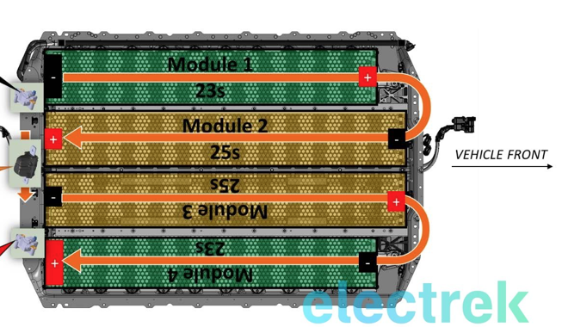
Figure1.3 Tesla model 3 battery pack layout
Next, the mass of hydrogen to be stored to replace 50 percent of the battery capacity of 37.5 kWh is calculated. The energy density of hydrogen is approximately 33.33 kWh/kg, which is the energy released by the complete combustion of hydrogen. The energy conversion efficiency of a hydrogen fuel cell is typically 50 percent. So the required chemistry is 75 kWh, or 2.25 kg of hydrogen. Hydrogen is usually stored at a high pressure of 70mpa. According to ideal gas equation of state.
$PV=nRT$ (4)
Calculations show that a 39.8L hydrogen tank is required to store 2.25kg of hydrogen. The mass of the hydrogen tank of Toyota's hydrogen car mirai is 78.5kg for storing 5kg of hydrogen at a pressure of 70Mpa. Therefore, the weight of the hydrogen tank in this report is assumed to be 40kg, and the weight of the fuel cell stack of Toyota's mirai is 56kg. The total mass of the fuel cell stack, hydrogen storage tank, cathode gas supply system, anode gas supply system and thermal management system is 300kg.

Therefore, the weight of a hydrogen powered vehicle that replaces 50% of the battery capacity is 2130kg. The total weight of the vehicle is then greater than that of a purely electric car, and the range is reduced. In order to achieve the WLTP range of the tesla model 3, the hydrogen storage capacity needs to be increased. With a hydrogen storage capacity of 2.55kg, 42.5kWh of energy can be supplied and a range of 533.3km can be achieved. Also the hydrogen tank needs to be increased to 40L.

The following results are obtained from the simulation, as shown in Figure 1.4, which shows the instant power and energy consumption for a WLTP cycle. From this figure, it is known that the car will consume 4.26 kWh of energy from the battery after completing one WLTP cycle. A plot of instant power and recovered energy for a WLTP cycle is shown in Figure 1.2. From the figure it can be seen that 0.774 kWh of energy is recovered from the battery when the car completes one WLTP cycle.
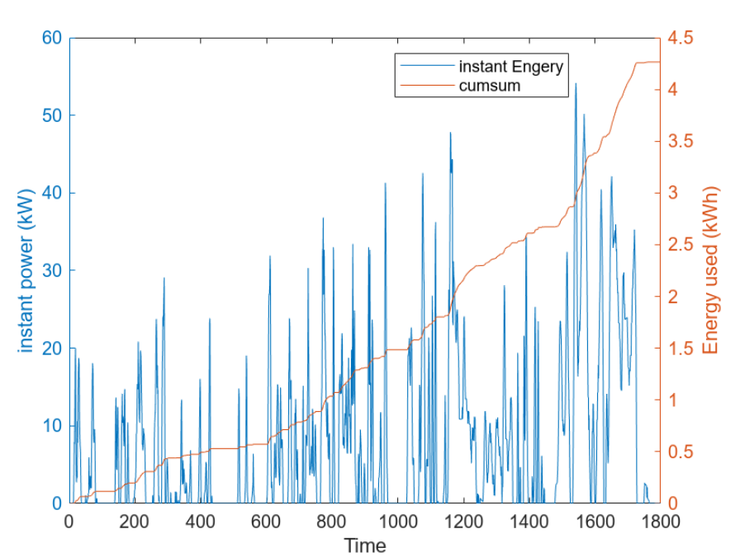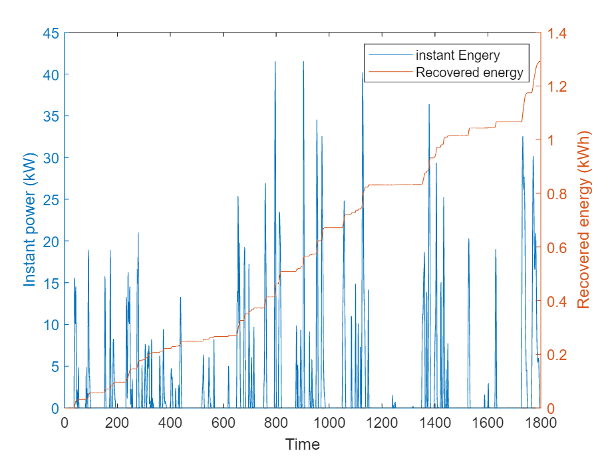
Figure1.4 Energy consumption diagram Figure1.5 Recovered energy diagram

Ultimately, when the 37.5 kWh battery and 2.55kg of hydrogen are fully consumed, the car can complete 22.9 WLTP cycles, or a range of 533.3km. the WLTP Consumption is 150 Wh/km. the range is similar to the manufacturer's figures, but the electricity consumption is increased compared to a purely electric car.

One of the main advantages of hydrogen fuel cells is that hydrogen refuelling time is much faster than battery charging. Hydrogen refuelling is usually completed within three to five minutes. Hydrogen fuel is typically more costly, and despite the higher energy efficiency of hydrogen fuel cell vehicles, the cost of producing, storing and transporting hydrogen may make the cost per kilometre travelled higher than that of pure electric vehicles. In addition, the maintenance and running costs of the hybrid system may also increase. Finally in terms of peak performance, the energy output of a hydrogen fuel cell is usually lower than that of a battery of the same capacity, which may affect the vehicle's acceleration capacity and top speed.

The WLTP driving cycle lacks simulation of high-speed driving scenarios. It is also impossible to simulate the effect of traffic conditions, road conditions and other factors on fuel efficiency. Moreover, the WLTP cycle is conducted in a laboratory environment, which means that the effects of external environmental factors such as temperature, humidity, wind, etc. are ignored. However, these factors can affect vehicle performance and fuel consumption.

Detailed Specifications
This section assumes that customers require 50% of the tesla model 3 battery capacity to be replaced with hydrogen fuel cells, while achieving the original pure electric vehicle WLTP range. And it is required to list all the main components required to complete the power assembly, and indicate the source of the components or strictly specified requirements and design standards.

In the previous section, the driving cycle and dynamics models have been validated through simulation and it has been verified that the vehicle can meet the WLTP range of 530km with the use of 2.55kg of hydrogen and 37.5kWh of batteries.The next section focuses on all the major components required for the fuel cell conversion. The main components should include the fuel cell stack, hydrogen storage tank, cathode gas supply system, anode gas supply system and thermal management system. The specific components are shown in Figure 2.1.
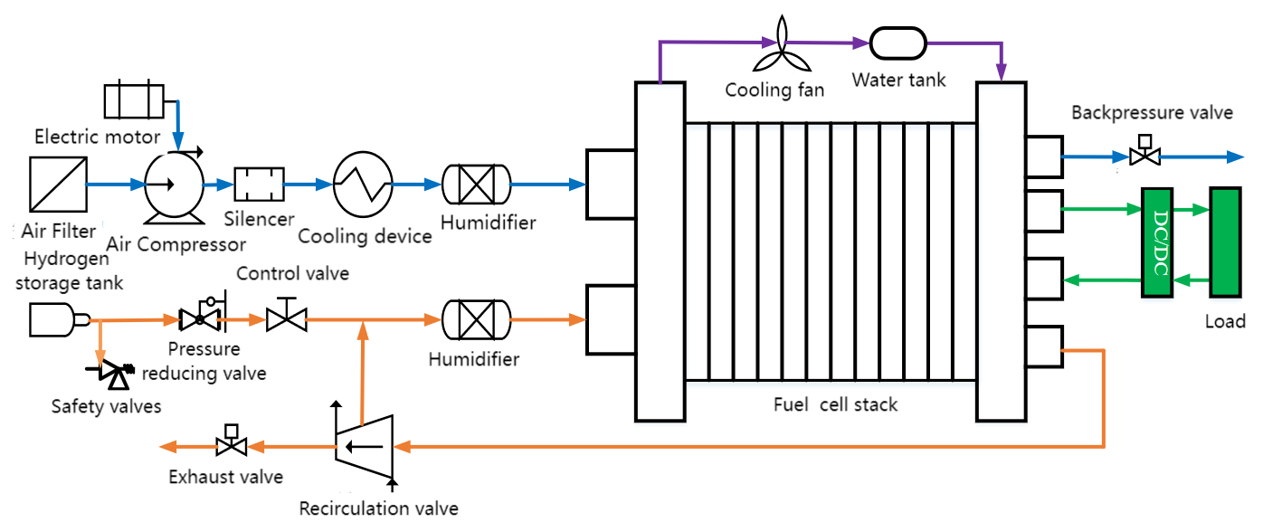
Figure2.1 Composition of Fuel cell

Cathode gas supply system
The fuel cell cathode system is also called air supply system, and its main function is to input appropriate flow, pressure and humidity oxidant for the fuel cell stack. It shall include air filter, air compressor, cooling device and humidifier.

Firstly, the air passes through the air filter to filter out impurities and harmful substances to prevent damage to the air compressor and the internal part of the stack. The air enters the air compressor through the air filter, and the air compressor is driven by the drive motor at an appropriate speed according to the flow and pressure required by the stack. The air then passes through the intercooler to cool down the over-temperature air, and flows through the humidifier to humidify the air, and then the air reaches the flow, pressure, temperature and humidity requirements of the power stack.

Air filters can be selected from MANN + HUMMEL GmbH Cathode Filter Entaron FC 7.5 [2]. During the selection process special attention needs to be paid to the filtration efficiency and the absorption of harmful substances such as Toluene, n-Butane, Sulfur dioxide (SO2), Nitrogen oxides (NOx).
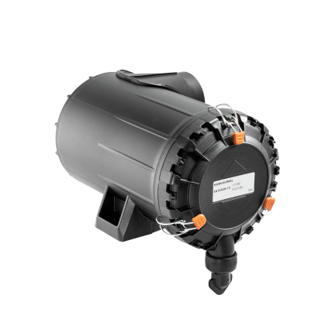
Figure2.2 MANN + HUMMEL GmbH Cathode Filter Entaron FC 7.5

The air compressor can select Infinion or Midsubishi brand[3], [4]. There are three aspects to focus on in the selection process. The first is compression efficiency, which helps to reduce the power consumption of fuel cell system. The second is durability, the oil-free bearing system and the robust rotor design guarantee a longer service life. The third is the lightweight of the structure. The unique lightweight design can reduce the weight of the entire fuel cell.
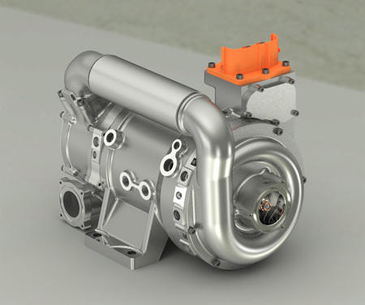
Figure2.3 Mitsubishi air compressor

The cooling device can select AKG group charge air cooler [5]. There are three aspects to focus on in the selection process. The first is cooling efficiency, the cooling system needs to be able to efficiently cool the compressed high temperature gas to prevent overheating of the fuel cell affecting performance and life. The second is the need for high reliability, continuous and stable operation throughout the life cycle of the fuel cell, and low maintenance requirements.

Hydrogen storage tank
According to the previous calculation, a 40L hydrogen tank will be used to store 2.55kg of hydrogen. When the hydrogen is full, the pressure of the hydrogen tank will reach 70 Mpa.The current hydrogen storage methods are compressed gas storage, Cryogenic storage and metal-hydride storage. The structure of the compressed hydrogen tank of Toyota mirai is shown in Fig. 2.4. The hydrogen tank consists of three layers, a plastic liner for hydrogen sealing, a carbon fibre reinforced plastic layer for pressure resistance and a glass fibre reinforced plastic layer for surface protection. Compressed gas storage is also used in this article.
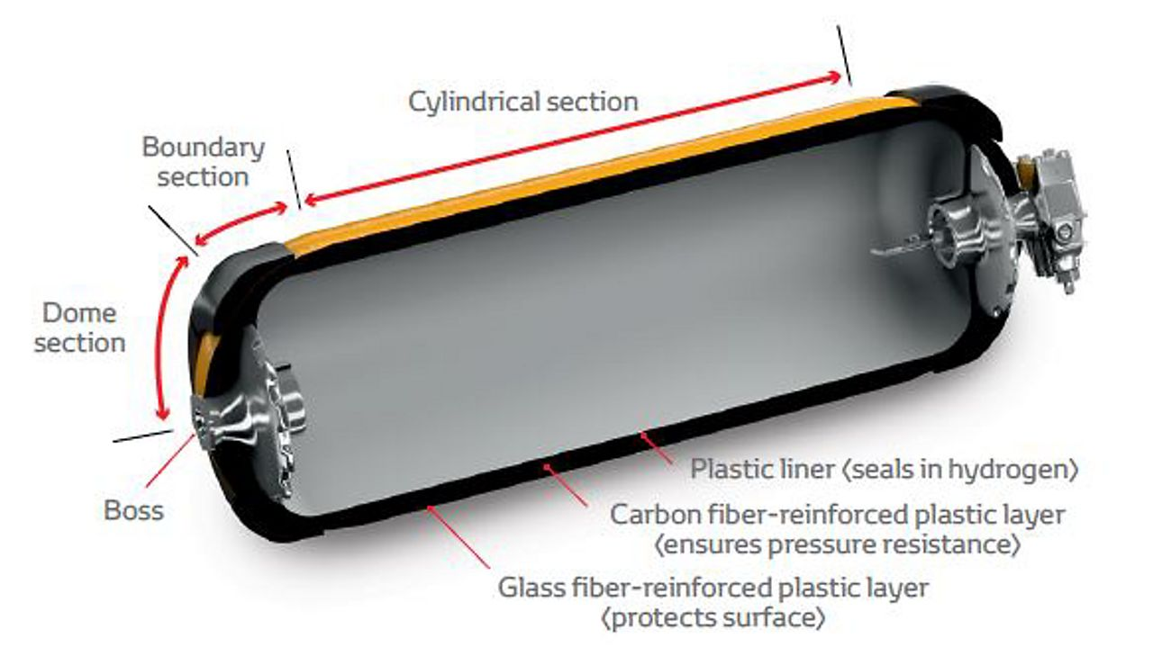
Figure2.4 Hydrogen storage tank structure

The selection of a hydrogen storage tank should focus on the material of the tank, firstly this material must be strong enough to meet the required pressure and strain. Secondly the material is light weight and cheap. Finally the thermal conductivity of the material must be good as heat needs to be controlled during the filling process and if the temperature inside the tank is too high it may lead to a hydrogen explosion.

Anode gas supply system
The fuel cell anode system, also known as the hydrogen supply system, is mainly responsible for providing the fuel cell with the appropriate flow and pressure of hydrogen fuel, including supply, transportation, reaction, exhaust and circulation processes.

There are two types of anode gas supply system layout, namely Dead End Anode and Flow Through Anode [6]. To improve hydrogen fuel utilization, fuel cell performance and economy, Flow Thorough Anode will be used. First, the reacted hydrogen from the fuel cell stack returns to the anode through the circulating pump, which not only discharges the liquid water accumulated in the anode, but also avoids the waste of hydrogen. The hydrogen returned to the anode can also humidify the hydrogen entering the stack. However, after a long time of reaction, the nitrogen of the cathode gradually increases on the anode through the exchange membrane, and the increase will cause the lack of hydrogen on the exchange membrane to a certain extent, affecting the performance of the proton exchange membrane. Therefore, it is also necessary to open the exhaust valve regularly for exhaust.

The pressure reducing valve can be selected from Emerson TESCOM HV-3500 series hydrogen onboard regulator as shown in Figure 2.5[7]. During the selection process of the regulator, attention should be paid to the inlet pressure that it can withstand, in this report, the hydrogen pressure can reach up to 70Mpa. It is also necessary to check whether its flow rate can reach the hydrogen flow rate required for the fuel cell reaction.
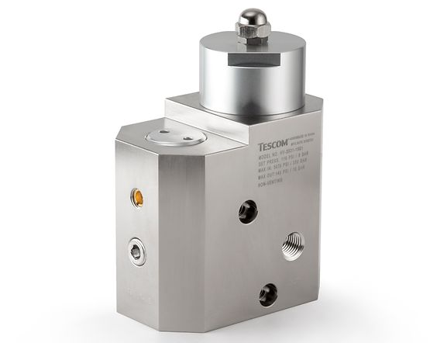
Figure2.5 Emerson TESCOM HV-3500 series hydrogen onboard regulator

The recirculation valve can be selected from the BOSCH Anode recirculation blower, as shown in Figure 2.6[8]. This recirculation blower has the advantage of being compact, so it requires very little installation space. It also has the function of regulating or purifying the anode path of the battery pack.
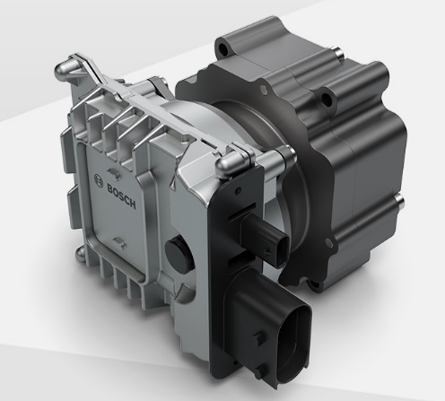
Figure2.6 BOSCH Anode recirculation blower

Fuel cell stack
The stack consists of a number of monolithic fuel cells and is the core of the entire fuel cell system. It is a device that converts its stored chemical energy into electrical energy through a chemical reaction between hydrogen and oxygen.

The reaction process of the fuel cell is that the humidified hydrogen is transported from the anode flow path to the anode diffusion layer. It then spreads from the diffusion layer into the reactor interior to the catalyst layer. Oxidation takes place under the action of a catalyst to produce hydrogen ions and release free electrons. Hydrogen ions are transported to the cathode by conduction through the proton exchange membrane, while electrons are re-transported to the cathode by an external circuit. Similarly, oxygen reaches the diffusion layer through the cathode flow field and spreads to the catalyst layer. The reduction reaction takes place under the action of the catalyst, combines with the electrons transported by the external circuit and the hydrogen ions transferred by the anode to generate water and release the reaction heat.

BOSCH Fuel cell stack can be selected for electric reactor, as shown in Fig. 2.7. The selection process requires attention to output voltage, power density and response speed.
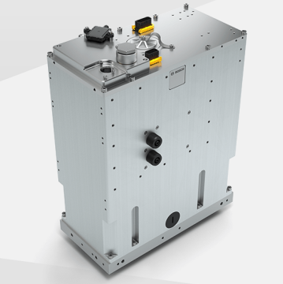
Figure2.7 BOSCH Fuel cell stack

In summary, the various systems and major components of a fuel cell vehicle are described and the criteria for the selection of each component are illustrated. In addition to this, the design process needs to comply with the requirements of relevant UK and European legislation, such as The European Agreement concerning the International Carriage of Dangerous Goods by Road and The Dangerous Substances and Explosive Atmosphere Regulations.

Conclusion
The first part of this report verifies the validity of the dynamic model modelling and the driving cycle through a comparative validation method. The second part of the report analyses the various systems in the hydrogen fuel cell in response to the requirements of customer, and describes in detail the requirements for the selection of each component and the brands and models that can be selected.

Reference
[1] Nigel, ‘LG INR 21700 M50’, Battery Design. Accessed: Apr. 27, 2024. [Online]. Available: https://www.batterydesign.net/lg-21700-m50/
[2] ‘Cathode Filter Entaron FC 7.5 (Right Side Inlet) | HYFINDR’. Accessed: Apr. 28, 2024. [Online]. Available: https://hyfindr.com/en/shop/products/cathode-filter-entaron-fc-7-5-right-side-inlet
[3] I. T. AG, ‘Fuel-Cell Electric Air Compressor - Infineon Technologies’. Accessed: Apr. 28, 2024. [Online]. Available: https://www.infineon.com/cms/en/applications/automotive/fuel-cell-ev-drivetrain/electric-air-compressor/
[4] ‘Mitsubishi Heavy Industries, Ltd. Global Website | Air Compressor for Fuel Cell System’, Mitsubishi Heavy Industries, Ltd. Accessed: Apr. 28, 2024. [Online]. Available: https://www.mhi.com/products/automobile/turbocharger_air-compressor.html
[5] ‘Fuel Cell Cooling System’. Accessed: Apr. 28, 2024. [Online]. Available: https://www.akg-group.com/akg-green/fuel-cell-cooling-system/
[6] J.-J. Hwang, ‘Effect of hydrogen delivery schemes on fuel cell efficiency’, Journal of Power Sources, vol. 239, pp. 54–63, Oct. 2013, doi: 10.1016/j.jpowsour.2013.03.090.
[7] J. Cahill, ‘Hydrogen Fuel Cell Vehicle Reliable Pressure Control’, Emerson Automation Experts. Accessed: Apr. 28, 2024. [Online]. Available: https://www.emersonautomationexperts.com/2022/fluid-control-pneumatics/hydrogen-fuel-cell-vehicle-reliable-pressure-control/
[8] ‘Anode recirculation blower’. Accessed: Apr. 28, 2024. [Online]. Available: https://www.bosch-mobility.com/en/solutions/powertrain/fuel-cell-electric/anode-recirculation-blower/

