THE WAY WE LIVE NOW Evaluation Form

Name: Derek Hughes

Please evaluate your work in relation to the two criteria below.

FINAL WORK:
From the final edit of 6-10 images, select & insert what you consider to be the 3 images that most successfully demonstrate your response to the project title. Please evaluate how resolved the final work seems and explain the conceptual relationship between the work and the original title. (100-150 words)

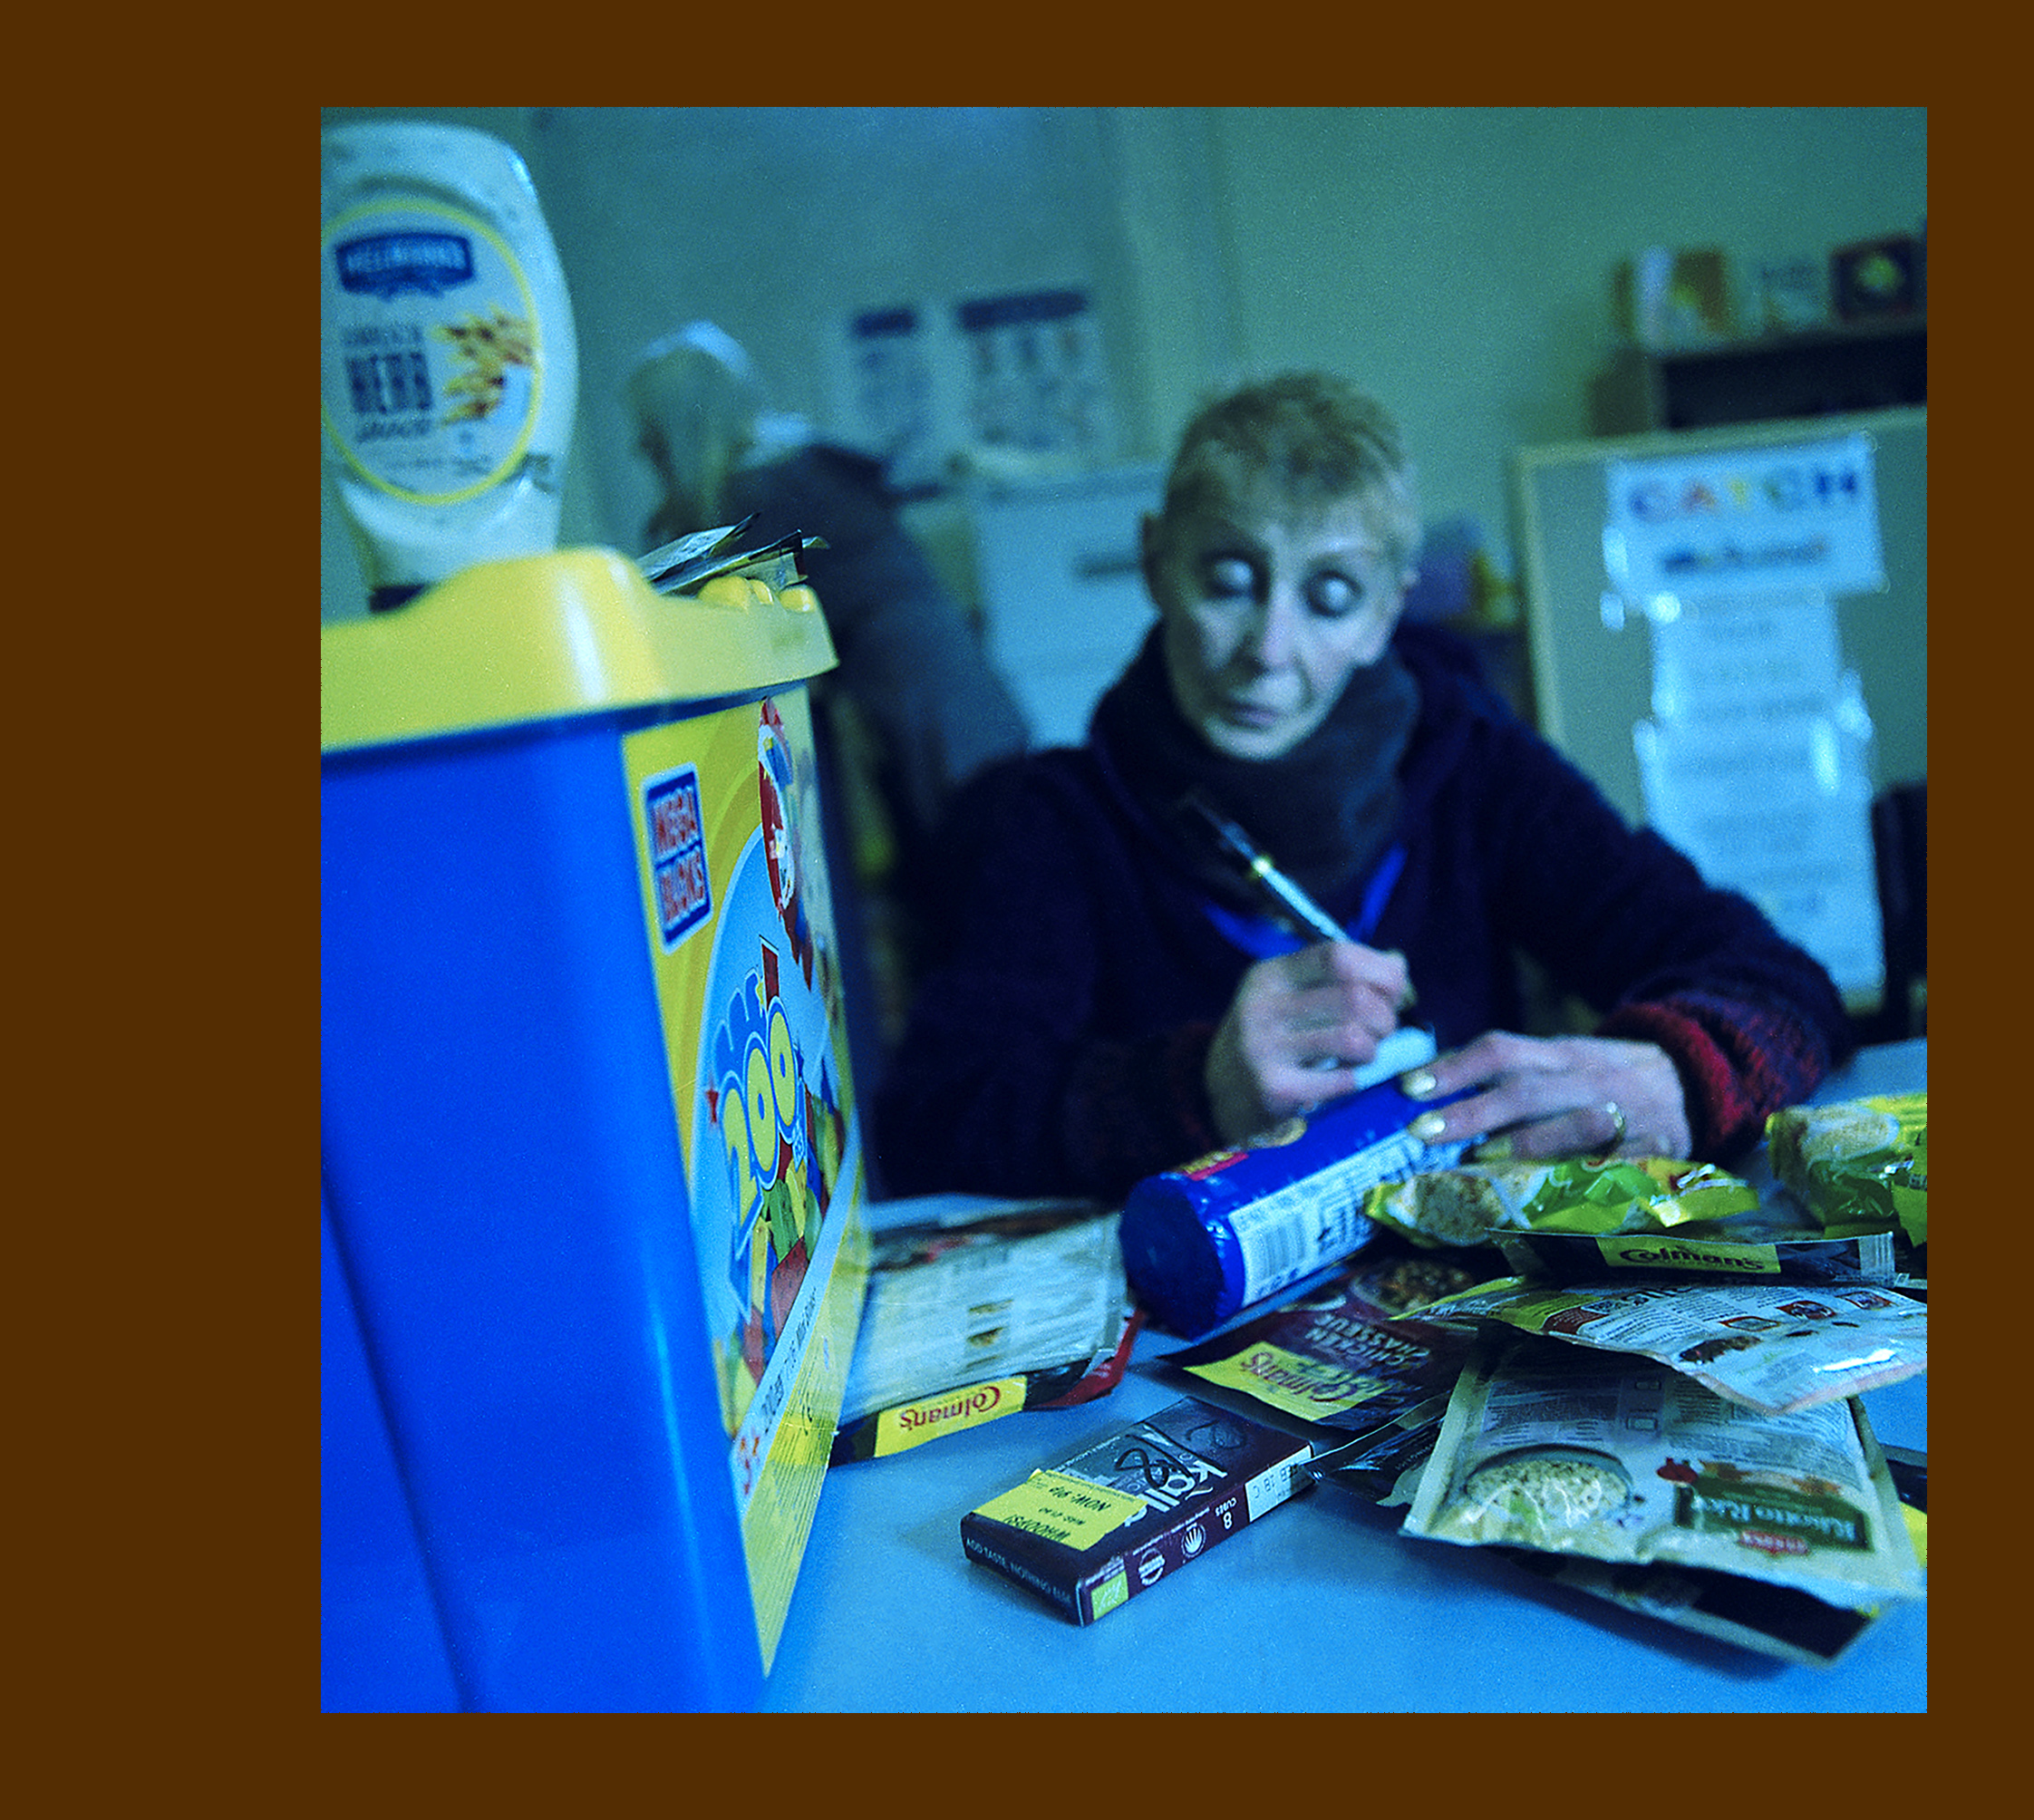
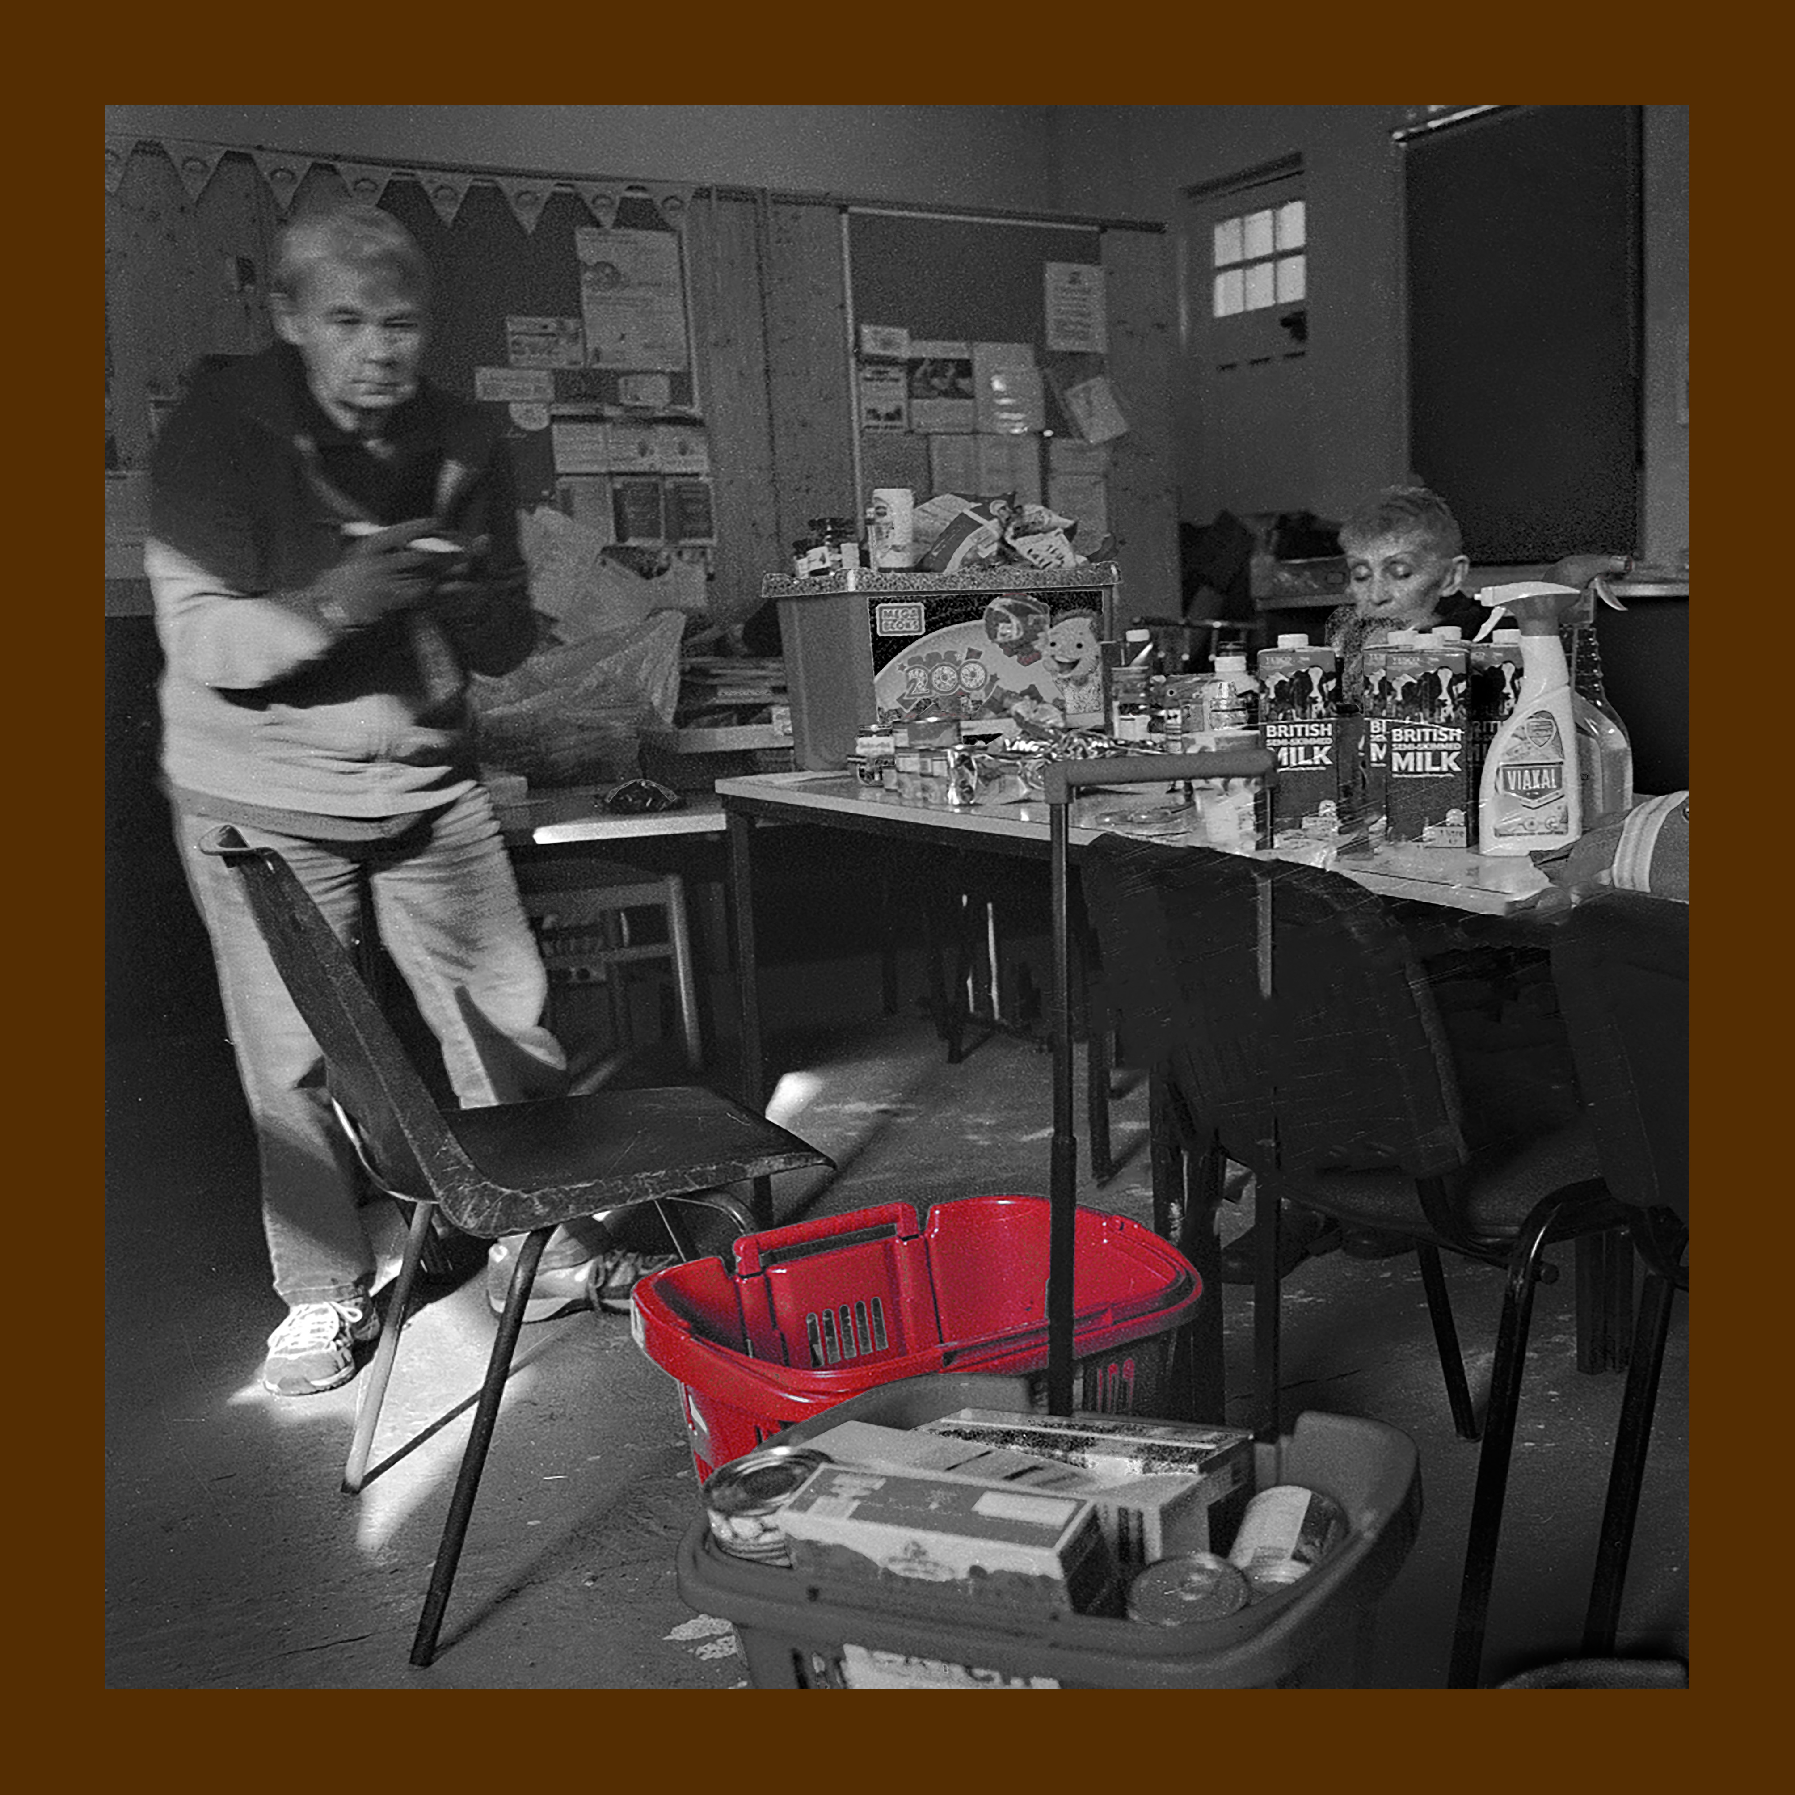
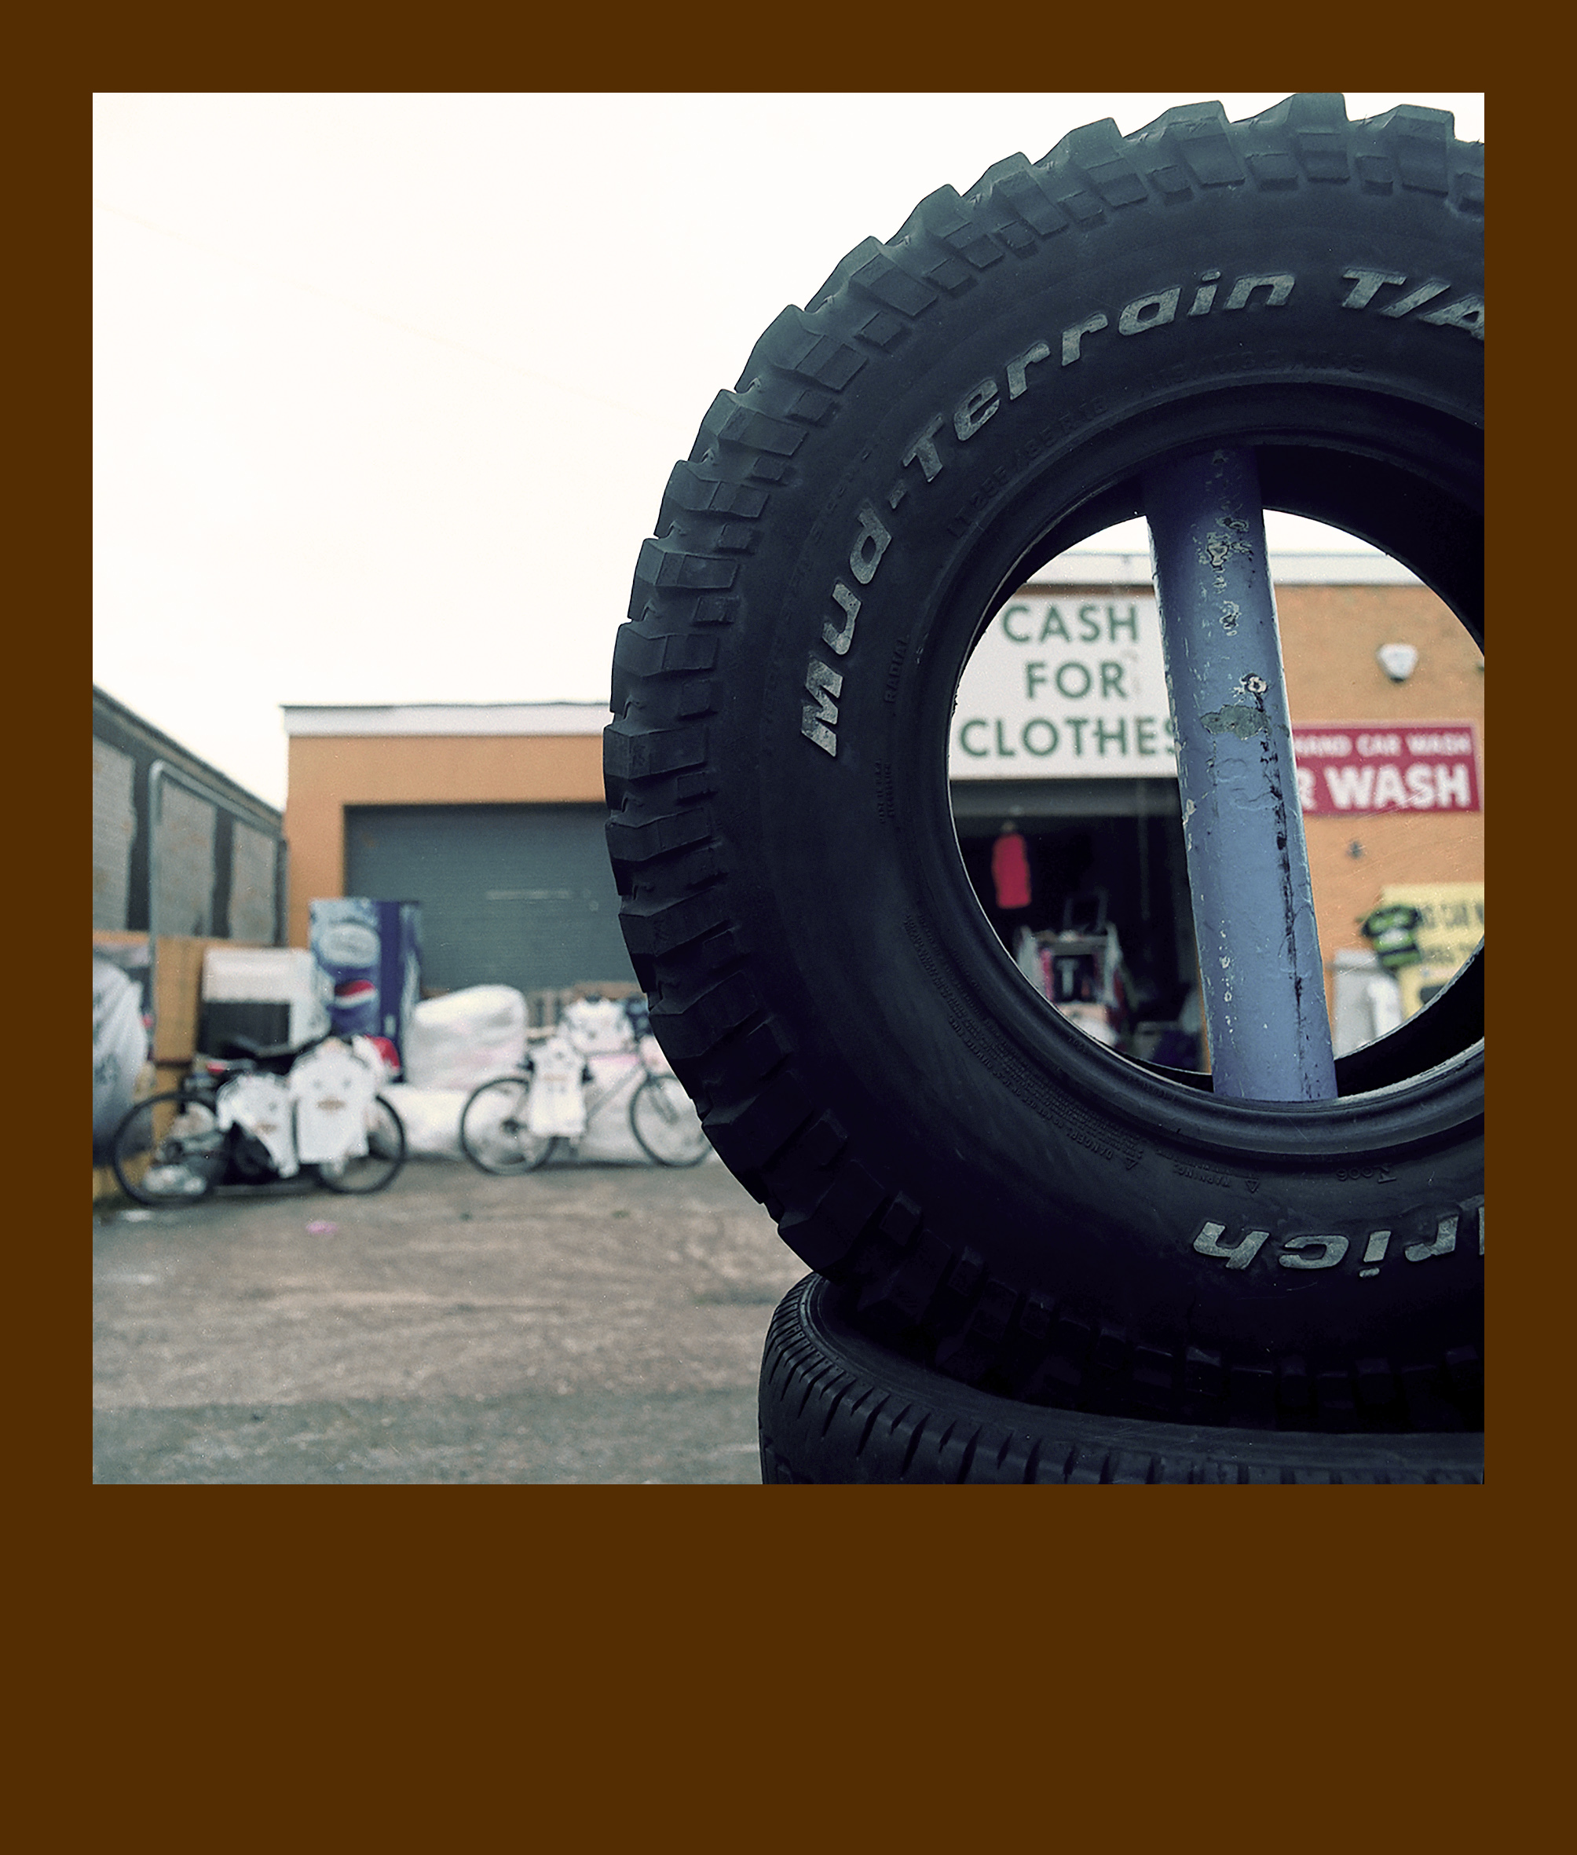

Out of my ten final images, I have chosen these three as my favourites due to me being most satisfied that they are a good reflection, in my opinion, on the title ‘The way we are now’! I was drawn towards emphasising the false impression our government makes that the country and its people are all doing well, as the reality of it is millions of families are struggling to make ends meet and are forced into using charitable organisations like ‘food banks’ and selling/buying second hand clothing through the likes of ‘cash for clothes’. I tried to show the hard-working volunteers, without whom, thousands of people would not be able to manage. I wanted to try and evoke the feeling of ‘hope’ by using bright, flamboyant colours to show that community spirit is still very much alive, and that one simple gesture can make someone so happy and grateful.

RESEARCH:
Please identify the 3 pieces of research that have most influenced your project and discuss how they affected the development of your work. (100-150 words)

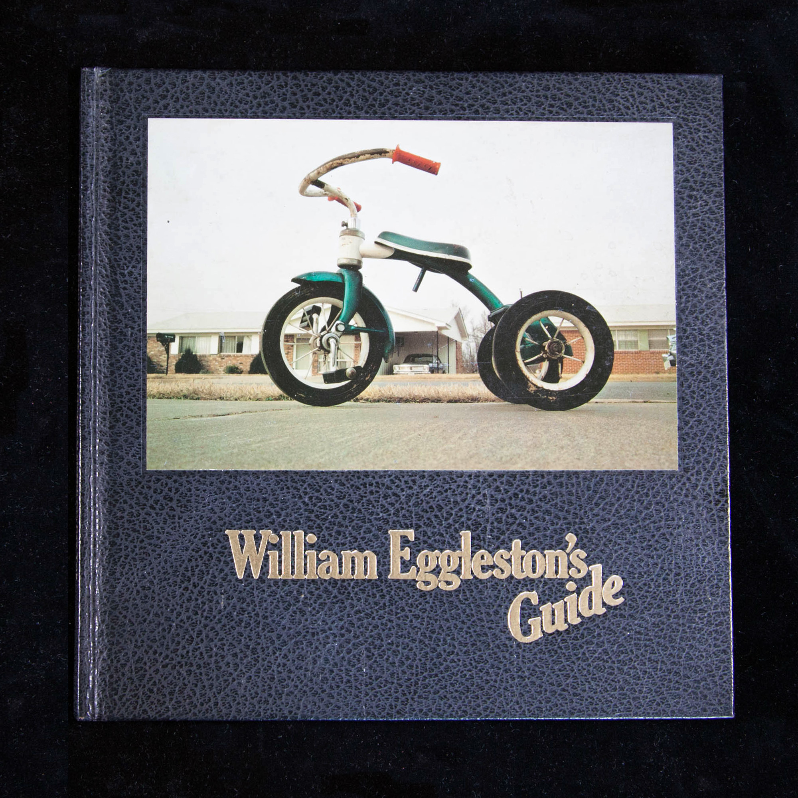
William Eggleston was the first Photographer that I had researched and felt totally mesmerised by his images. I loved his use of stark, bright colours and his use of simple subjects, which showed me that anything can make an interesting image if thought and consideration goes into it.

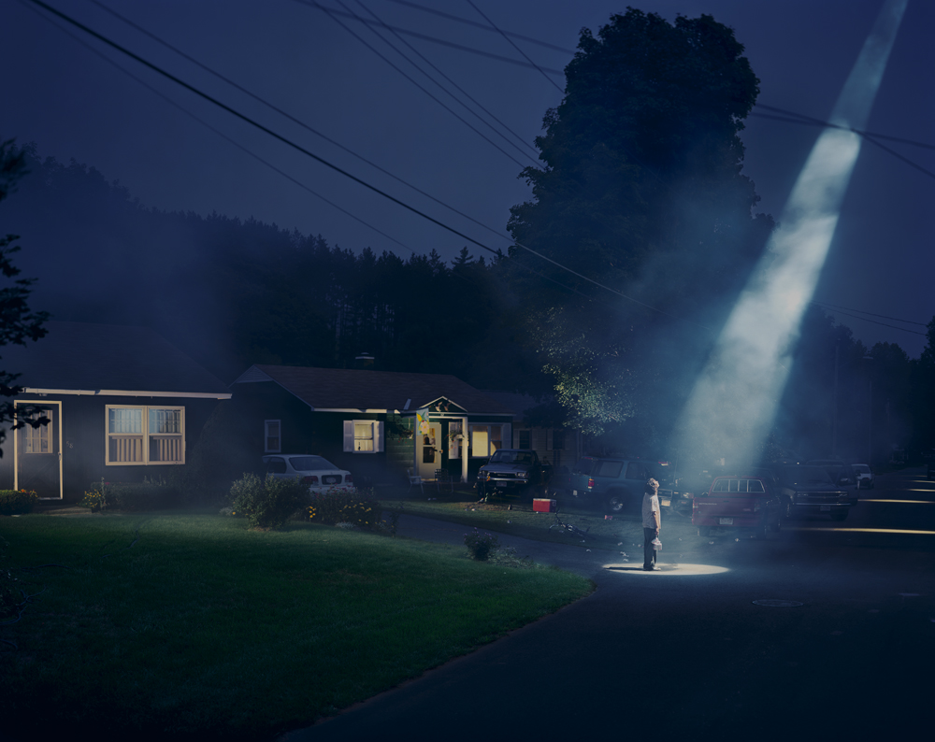
Secondly, I chose Gregory Crewsdon, for two reasons. Firstly, I felt, his use of light is a major part of his success, it endorsed how important correct lighting in an image can be and can also bring it to life. Secondly, I admire how he manages to make his images tell a story, gives context, I feel this to be important.

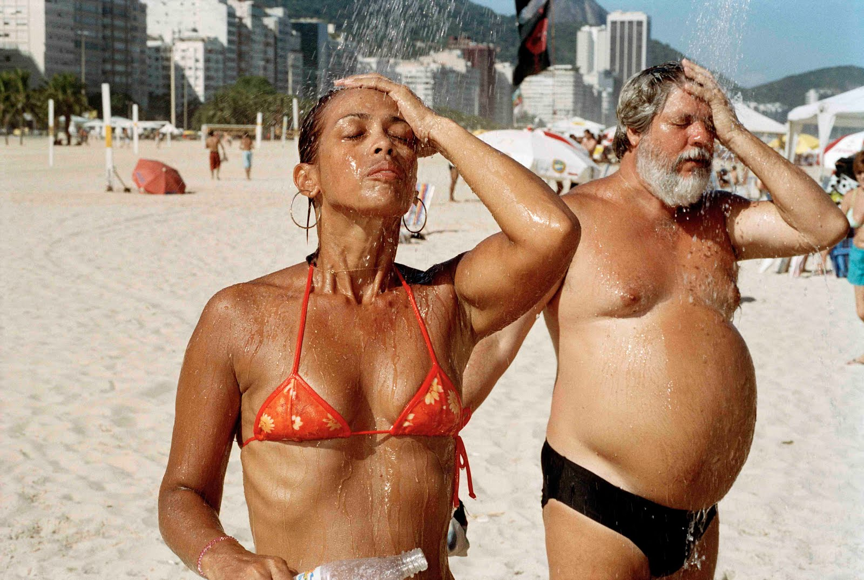
Last, but not least, Martin Parr was a big influence. Similar I feel to William Eggleston (To whom he admired and emulated), The fulgent colours, almost humorous style, made his images unique and certified the need to try and create your own style of imagery.

PLEASE SUBMIT TO MOODLE BY 12 NOON ON MONDAY 20th NOVEMBER

