Management of resources

Siobhan Grattan
1500831
Benjamin Duxbury

Abstract
This research was undertaken to highlight the problems within the National Health Service. The research examines the funding problems, the low staffing problems, the affects age population and chronic conditions are having on the health service.
The research was put together as a case study and the research for the case study was completed by using online reports, online journals, online websites including The Health Foundation and The Kings Fund. All research was carried out using secondary research to complete the case study.
The main findings were that the health service is under pressure due to funding, staffing problems, age population and chronic conditions, when these are all added together this creates extra pressure on the health service.
If people lived a healthier lifestyle for example making better diet choices, then the health service may not be under the pressure that it is now.
All the findings will be included within the case study.

Contents

Title Page 1
Abstract 2
Contents 3
Introduction 4
Main Body 5-9
Conclusion and recommendations 10
References 11

Introduction
This assignment is a case study of the National Health Service (NHS) giving a brief background of the NHS and then focusing on the history of the NHS, age population, chronic conditions, staffing levels, an increase of people using the NHS and financial crisis.
A case study is researching and examining a specific topic using different styles of research from different perspectives and using past and present resources to give a reader an in depth understanding about the particular topic (Thomas, 2011). This case study was researched using secondary data, online journals and using graphs to give readers a clearer and quicker insight to the numbers of people using the NHS.
This case study will critically evaluate the National Health Service within the United Kingdom and will be researched thoroughly through online resources, which were concentrating on the NHS and problems within the NHS. These consist of age population, financial situation within the NHS, the background of the NHS and the lack of staff available to care for patients to a high standard whilst under the care of an NHS professional. This topic of study was undertaken and researched so a reader has a case study that focuses entirely on the NHS illustrating the main problems that are occurring regularly and the reasons why these problems are occurring.
The NHS was founded on the 5th July 1948, and the idea of the NHS was brought in by the Labour party in 1946 (Whitfield, 2016) following the Beveridge report of 1943, the report identified a plan for Britain after World War 2. The Minister of Health, Aneurin Bevan wanted the NHS to be funded by taxation and for the care to be ‘free to the point of use’ this is so people who are poor can still receive the health care they need from different types of health care professions. When the NHS was founded doctors, nurses, pharmacists joined to work in one complete organisation, with them working together within hospitals family health services and local authorities to form a three tier system of health care underneath the Ministry of Health to look after patients need in the most effective way (Campbell, 2016).. The NHS was brought in after World War 2 due to so many people losing their lives through ill health. After this the NHS become a very successful health care system but from 2005-2009 the NHS became neglected due to the increase of the age population and the demand for healthcare and healthcare services (Webster, 2002).
At first there was opposition to the formation of the NHS from local hospitals, charities, charities and local authorities this was because they did not want central government taking overall control and opposition even more so from doctors as they did not want to become government employees due to their powerful positions most remained in the private sector.

Main body
The NHS is a public health care system which is funded entirely through taxation and the government. The NHS is free to the point of delivery meaning that people do not have to pay for their healthcare, and everyone gets treated with no cost no matter how much/how little the individual is earning. The NHS provides different types of services and has a wide range of healthcare professionals working that can provide different types of care such as healthcare, social care and ongoing treatment being cared for by doctors, nurses, health care assistants and people who specialise in certain areas like urologists (NHS, 2019). The NHS has gradually become a larger organisation since it was created.
The history of the NHS goes back to the Second World War, which was brought in as an aim to rebuild the country by providing better services to the public and improve the healthcare of people within the UK. In the nineteenth century the government took over social policy meaning that people will have access to emergency healthcare, better housing which lead people to believe they deserve better health care (Hogg, 2009). As people in the second world war had no access to free healthcare there was little to no treatment meaning there was an increase in communicable diseases such as tuberculosis, hepatitis and malaria (Connolly, 2002). Due to these communicable diseases being untreated there was an increase in mortality as wounded soldiers were unable to access health care quickly. As there was no healthcare available to people illnesses such as tuberculosis were unlikely to be treated which resulted in tuberculosis being ranked in the ten top causes of death within adults (Murray, 2018). In the 19th century charities were doing more to help the public than the government by providing housing, social policy and healthcare (Horton, 2016). Commonwealth fund study ranks the NHS as the world’s top performer even though there were concerns that the NHS would not make it (Niemietz, 2016). With change and investment, the NHS survived due to the public receiving care, having improved lifestyles and feeling happy with the care they received resulting in patient appreciation being doubled by 2009 and the NHS being the most used healthcare system in the UK (Crisp, 2011).
Although the NHS is the most used health care system in the UK, people are more demanding for care and the NHS is under more pressure now than it was in 2009. This is down to the increase and demands of people living in the UK. The NHS is struggling to adapt and accommodate people due to the amount and increase of people living in the UK (Ewbank, 2017), and it is believed that the demand for care an treatment is increasing (Macguire, 2016). More people are attending accident and emergency care units in hospital, between 2014/16 this increased to 18 percent from 12.7 million to 15 million. This added an increased amount of pressure as some people who attended accident and emergency also got admitted into hospital resulting in bed shortages (Macguire, 2016).
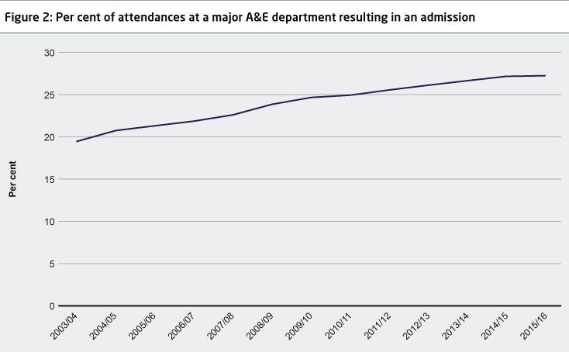
(Macguire, 2016) This graph shows the rise in the amount of people getting admitted into hospital after going to the accident and emergency department.
As the NHS has become more of a reliable healthcare system the NHS has increased the amount of treatments they provide for example chemotherapy, hip replacements and knee replacements. When the NHS was first established there was no such treatments as a hip replacement but as the NHS has increased the treatments provided more people are requiring a hip replacement which can set the NHS back £5,620 (Guardian, 2015). With all these extra treatments the NHS is costing millions each year but has recently saved more than £700 million from reinvesting in new medicines as doctors are maximising the use of the best generic and biological treatments that treat illnesses such as cancer and arthritis. By making the most of these treatments the NHS has managed to cut down on costs and lower the costs to taxpayers to £249 million, by 2021 the aim for the NHS is to make £400 million annual savings (NHS, 2019).
This will become a problem due to age population as more than one in five people in the UK are over 60 and the age population is expected to increase in twenty years’ time going from 14.9 million people in 2014 to 18.5 million in 2025 (NHS, 2016). Age population has added an increased pressure within the NHS as there are more people to provide care for resulting in extra pressure on the management of resources within the NHS. This is because people are living longer than they were when the NHS was first brought in, as elderly people are not as stable as they first where they are more at risk of falling which could result to them staying in hospital due to injuring themselves when trying to mobilise, as when people get older their bodies get weaker meaning they are more prone to causing injury. They may also be needing long term care and are more likely to have chronic illnesses due to their bodies weakening. Chronic illnesses are illnesses which are long lasting and cannot be cured but can be controlled either through diet, exercise or medication. An example of a chronic illness is arthritis, kidney disease and asthma (Health Foundation, 2016) which require regular check-ups with different healthcare professionals, this adds more pressure to waiting lists for other people to see specialists. Age population is adding pressure to the NHS as they need to receive regular treatment for their health conditions, focusing on their physical, emotional and social needs. As the NHS is still free at the point of delivery the elderly must get seen to regardless of how often they are using the NHS. However as people are living longer and unhealthier lifestyles people are becoming more prone to chronic conditions which is resulting in the NHS paying out for treatments for a longer period of time (NHS, 2011). Chronic conditions are costing the NHS more money each year. Chronic conditions need constant treatment and require a range of different specialists to work together to ensure the patient is as comfortable as possible (The Kings Fund, 2012).
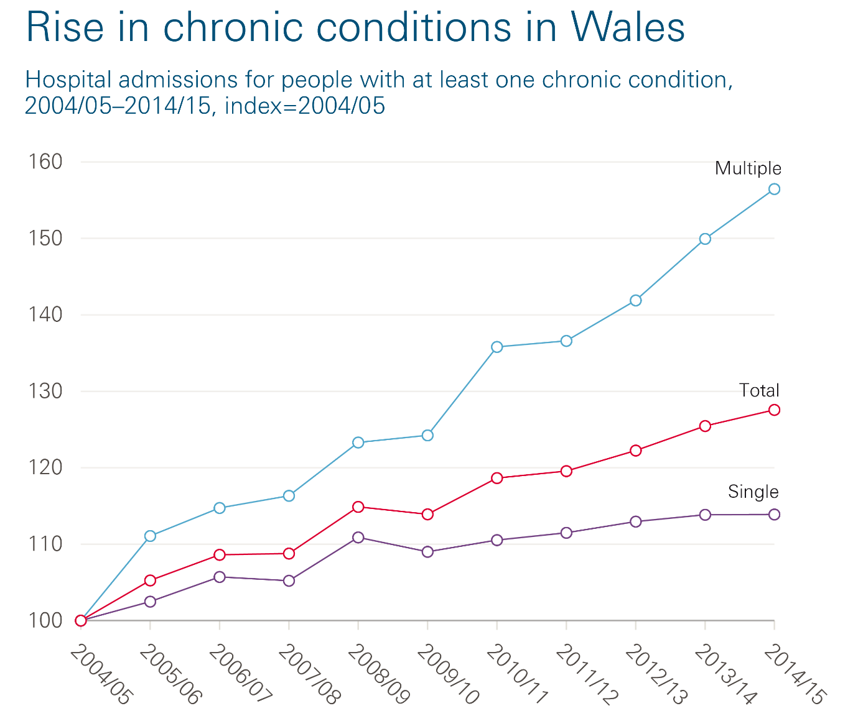
This chart shows the rise of chronic conditions in Wales, which cost the NHS 58% more between 2014-2015 and a 72% more for people aged over 50. The most common chronic conditions which cost the NHS are heart failure, cancer and asthma. It is believed that there has been an increase of chronic conditions in Wales going from 5.1% in 2004/2005 to 6.5% in 2014/2015 (Health Foundation, 2016). This is a total of 64% more of people living with chronic conditions within the UK (Alderwick, 2019). As there are more people with chronic conditions this is adding more pressure and financial problems to the NHS which will need more staff, more so now as the age population in the UK has increased.
Currently there are over three million people aged over 80 living in the UK and it is expected that this will increase by 2050 and the number of people who are living to over 80 is expected to be eight million (Thompson, 2019). As people are living longer people are needing to stay in hospital for treatments which is resulting in financial difficulty within the NHS (Dixon, 2016). The problem with people staying in hospital is not only down to the person needing treatment, it is also down to delayed transfer of care (The Kings Fund, 2018). An example of delayed transfer of care is when an elderly patient is ready to leave hospital, but their home is not safe for their return, with it requiring specific equipment and if it is not in place for them to live at home safely, they will not leave hospital and they will be using a bed up in hospital (Stevenson, 2017). Health care professionals like doctors, nurses, health care workers and physio therapist need to work together to stop the delay of care for the elderly (Wright, 2018). This would free up the beds and relieving the pressure off staff and decrease the financial crisis the NHS is currently in.
The financial crisis for the NHS has increased due to people being out of work. As people are no longer in employment, this is resulting in people paying little to no tax which means the less funding for the NHS. The NHS is then relying heavier on the government for funding and it is believed that this problem is not going to be short term (The Kings Fund, 2019). As mentioned in the case study the NHS is funded through tax and when people are unemployed, the NHS is receiving a decrease in funds. Unemployment also comes with other risks such as an increase of poor health, poor living conditions, poor diet and a decreased access to healthcare due to lack of transport. Unhealthy lifestyles have an impact on the NHS as people who have unhealthy lifestyles can make people more susceptible to avoidable conditions such as diabetes, stroke and heart attacks. There is also a link to people having a greater chance of suffering with depression and anxiety as described by the (The Kings Fund, 2009) whilst being unemployed. As the UK has more people in unemployment the NHS is also suffering from lack of staff.
According to NHS trust there is a shortage of more than 100,000 staff, this is partially caused by staff members feeling like they are under too much pressure and cannot cope so decide to leave due to not being paid enough and feel they are spending too much time in work and not enough time with their families because of having to work over their hours to finish their jobs. A lot of staff complained about having no work-life balance (Campbell, 2019) As so many nurses are leaving there is a risk of the NHS funding of £250 billion being unspent as some patients are not being able to get treatment needed due to no staff and this problem has not improved since 2011-2012 (Buchan, 2019). This is because doctors and nurses are leaving the health care system and difficulties with recruiting more workers to join. This is partially due to funding for training being dropped from 3 percent to 5 percent in 2018/2019 meaning there is a £2 billion decrease in funding for health care jobs. There is also a problem for people to do their training due to funding and lack of staff, trainee nurses and doctors are not having safe places to train in, meaning their quality of practice is decreasing which makes it harder for people to be able to train to become a nurse/doctor (Murray, 2017). All these factors are linking to the management of resources as each crisis decreases the resources the NHS has which means the NHS is becoming under more pressure to treat patients efficiently, with low staffing levels and a high number of patients.
The NHS needs more workers but is struggling to get the workers trained properly and sufficiently in the right working environment, leading to patients treatment and diagnosis being prolonged such as people who are in the early stages of cancer (The Kings Fund, 2018). If patitents who have suffered from breast cancer, throat cancer and lung cancer where in the Netherlands rather than in the UK 9,000 lives wold be saved each year. If patients under the NHS were treated in Germany more than 12,000 lives would be saved per year and if they were treated in Belgium more than 14,000 lives would be saved each year (Niemietz, 2016).
In 2018/2019 the NHS had spent roughly £115 billion, but in other countries they are paying more for healthcare. It is known that Germany spends 30 percent more on healthcare than the UK (NHS, 2019). Other health care systems in different countries are funded differently, Singapore healthcare system is ranked sixth which is above the United States and Singapore spends less money on healthcare system than most countries and (Haseltine, 2013) believes that to have a successful health care system funding should be both through govenrment and private. The Netherlands fund their healthcare through mainly insurance, this is foucsed mainly on a persons income (Cylus, 2018). When people in the Netherlands need to receive healthcare they have to go through their insruance, by doing this they will know the costs of the healthcare they need and when people pay for their healthcare through insurance they will have a premium, with each premium paying for different types of healthcare costs (IPB, 2015). This shows that other health care systems have an improved managmeent of resources compared to the NHS which could be the reason why the NHS is struggling so much. If the NHS had an insurance plan for people who need treatment they could save money and people will only use the NHS if they really need to.

Conclusion
This case study highlighted the problems within the NHS. These problems are mainly the funding of the NHS, low staffing levels, chronic conditions which increases the funds the NHS requires and also the problems age population is having within the NHS. As there is an increase of age population this means that the NHS needs to stretch and increase there staffing and also treatment service to cater for all public members to recieve care. Elderly people seem to require longer hosptial stays which means there are less hospital beds available for other members of the public that need to receive care. Elderly people also need more care as many elderly people suffer with long term conditions such as arthriuts, heart and chest problems and also dementia. This then results in health care proffesionals spending more time treating elderly people and less time treating the younger patients who are using the health care services. This increases the waiting lists and when people are on waiting lists it is more likely their health will deteriorate as they are not receiving care efficiently. Low staffing is causing pressure on the services and this is why there are waiting lists in place as health services are not able to see patients in a quick manner due to the back log of patients. Low staffing also has an affect on the other workers as they are needing to work harder to make up for the staff they have not got. All of these problems require an increase of funding which the NHS is struggling with. The NHS is struggling to accommodate health care for a larger number of people and is struggling to keep up with the costs and demands that it is now under.
Reccomendations
In this case study it highlights that the NHS needs more:
- funding to improve the service, this ranges from money being spent on health care workers, the equiptment they use, treatments they offer and also medical facilities people can access quickly. This would then reduce the amount of people that are currently on waiting list.
- If the NHS had more funding they could fund training programmes and also fund the treatments patients require. More funding would get the NHS more staff as they will be able to afford the correct training. This would decrease the low staffing problems the NHS is currently dealing with, which would then take pressure off the workers working in the NHS sector. This could then have a positive impact on the quality of care patients are receiving.
- Age population is a further problem, if elderly people could receive treatment at home and have quicker transfer to their home this would free up hospital beds.
- If people lived healthier lifestyles, it could improve peoples overall health. This could lead to them being less likely to developing chronic conditions, which would save the NHS millions a year.

References
Alderwick, H., 2019. NHS staff survey shows workforce under pressure , United Kingdom: The Health Foundation .
Buchan, J., 2019. NHS staffing trends, retention and attrition , United Kingdom: The Health Foundation.
Campbell, D., 2016. Nye Bevan's dream: a history of the NHS , s.l.: The Guradian.
Campbell, D., 2019. Record numbers of NHS staff quitting due to long hours , United Kingdom: The Guardian.
Connolly, M. H. D., 2002. Deadly comrades: War and infectious diseases. The Lancet, 360(4), p. 23.
Crisp, N., 2011. 24 hours to save the NHS: The Chief Executive's account of reform 2000 to 2006. Oxford: Oxford University Press.
Cylus, J., 2018. Identifying options for funding the NHS and social care in the UK: international evidence, United Kingdom: The Health Foundation.
Dixon, A., 2016. A radical look at who pays and who gains in later life , United Kingdom: The Health Foundation .
Ewbank, L. T. J. M. H., 2017. NHS hospital bed numbers: past, present, future, England: Kings Fund.
Guardian, T., 2015. How Much Have I Cost The NHS, United Kingdom: The Guardian.
Haseltine, W. A., 2013. Affordable Excellence: The Singapore Healthcare Stor. Washington: Ridge Books .
Health Foundation, 2016. Chart: The rise in people living with chronic conditions in Wales, United Kingdom: The Health Foundation.
Hogg, C., 2009. Citizens, Consumers and the NHS: Capturing Voices. England: palgrave macmillan.
Horton, T., 2016. Spreading improvement: nobody said it was easy , United Kingdom: The Health Foundation.
IPB, 2015. Netherlands Healthcare Sector Organization, Management and Payment Systems Handbook. Netherlands: International Business Publications.
Macguire, D., 2016. How hospital activity in the NHS in England has changed over time , s.l.: Kings Fund.
Murray, R., 2017. Falling number of nurses in the NHS paints a worrying picture, United Kingdom: The Kings Fund.
NHS, 2011. Chronic Conditions. [Online]
Available at: http://www.wales.nhs.uk/healthtopics/conditions/chronicconditions
[Accessed 6th December 2019].
NHS, 2016. Improving care for elderly people. [Online]
Available at: https://www.england.nhs.uk/ourwork/clinical-policy/older-people/improving-care-for-older-people/
[Accessed 29 October 2019].
NHS, 2019. An Introduction to the NHS. [Online]
Available at: https://www.england.nhs.uk/participation/nhs/
[Accessed 18th November 2019].
NHS, 2019. Funding and efficiency. [Online]
Available at: https://www.england.nhs.uk/five-year-forward-view/next-steps-on-the-nhs-five-year-forward-view/funding-and-efficiency/
[Accessed 13th November 2019].
NHS, 2019. NHS cuts medicines costs by three quarters of a billion pounds. [Online]
Available at: https://www.england.nhs.uk/2019/08/nhs-cuts-medicines-costs-by-three-quarters-of-a-billion-pounds/
[Accessed 13th November 2019].
Niemietz, K., 2016. Universal Healthcare without the NHS: Towards a Patient-Centred Health System. London: Institute of Economic Affairs .
Niemietz, K., 2016. Universal Healthcare without the NHS: Towards a Patient-Centred Health System: Towards a Patient-Centred Health System. London: Do Sustainability.
R, M. J. &. L., 2018. Tuberculosis and War: Lessons Learned from World War II. California: Karger.
Stevenson, A., 2017. Can you really link delayed discharge to mortality?, United Kingdom: The Health Foundation .
The Kings Fund, 2009. Mental Health. [Online]
Available at: https://www.kingsfund.org.uk/projects/time-think-differently/trends-disease-and-disability-mental-physical-health
[Accessed 18th November 2019].
The Kings Fund, 2012. Long-term conditions and multi-morbidity. [Online]
Available at: Long-term conditions and multi-morbidity
[Accessed 6th December 2019].
The Kings Fund, 2018. Staffing shortfall of almost 250,000 by 2030 is major risk to NHS long term plan, United Kingdom: The Health Foundation.
The Kings Fund, 2018. The health care workforce in England, United Kingdom: The Healthcare Foundation.
The Kings Fund, 2018. What are delayed transfers of care?, United Kingdom: The Kings Fund.
The Kings Fund, 2019. How The NHS is funded. [Online]
Available at: https://www.kingsfund.org.uk/projects/nhs-in-a-nutshell/how-nhs-funded
[Accessed 18th November 2019].
Thomas, G., 2011. How to do your Case Study: A Guide for Students and Researchers. London: SAGE Publications.
Thompson, C., 2019. Meeting the challenges of an ageing population. [Online]
Available at: https://www.england.nhs.uk/blog/catherine-thompson/
[Accessed 13th November 2019].
Webster, C., 2002. The National Health Service: A Political History. Oxford: Oxford University Press.
Whitfield, M., 2016. The Dispensaries: Healthcare for the Poor Before the NHS. Bloomington: Authour House.
Wright, J., 2018. Sharing learning and data to improve safety during transitions and handovers of care , Bradford: Bradford Distric Care Trust.

