Tamanna sultana
1912525
Living with care: the older person
Joanne Davies
BMHP6009
Part 2: 2000 report

A report on Living with care the older person

Table of content
Contents
1. Introduction 3
2. Discussion and analysis 3
2.1 Meaning of old age 3
2.2 Current Social or health care provisions 4
2.3 Analyses of Government health and services 5
2.4 Discussion of ageing population 5
3. Issues experienced by older age people in the UK 6
3.1 Relevant theory including a theory of ageing 7
4. Conclusion 7
References 8

1. Introduction
Living with and caring for an older person can be a rewarding and fulfilling experience. Moreover, it can also be challenging and requires careful planning and consideration. As older age people they become more vulnerable to falls and other accidents (Batsis et al., 2019). It is important to create a safe environment. While it is important to provide support and assistance, it is also important to encourage independence. This can involve finding ways to help the person maintain their hobbies and interests or finding ways to make daily tasks easier for them to manage on their own. Caring for an older person can involve a lot of tasks, such as managing medications, scheduling appointments, and keeping track of finances. It is important to stay organized and keep important information in one place to make it easier to manage (Batsis et al., 2019).
Older adults can become isolated, especially if they are no longer able to leave the house as often as they used to. It is important to stay connected with family and friends, and to encourage socialization through activities such as volunteering, attending senior centers, or participating in other community events (Donovan & Blazer, 2020). Providing care for an older person can be emotionally and physically demanding. It is important to take care of yourself by getting enough rest, eating healthy foods, and finding time to engage in activities that you enjoy. caring for an older loved one can be challenging, but it can also be an incredibly rewarding experience. By taking the time to plan, organize, and stay connected, you can provide the best possible care for the person you love (Donovan & Blazer, 2020).

2. Discussion and analysis

2.1 Meaning of old age
Old age is typically defined as the later years of a person's life, characterized by a decline in physical and mental abilities. The exact age at which someone is considered "old" varies depending on cultural and societal norms, as well as individual factors like as genetics or health (van Leeuwen et al., 2019). Some other factors of old age are biological age, chronological age, social age, and psychological age. Chronological age is the most basic definition of old age, based on the number of years a person has lived. In many cultures, a person is considered old once they reach age 65 or 70. The psychological age refers to a person's cognitive abilities and emotional well-being and can also vary greatly from person to person. Some people may experience cognitive decline earlier in life due to conditions like dementia, while others may remain sharp and mentally alert well into old age. The social age refers to a person's role and status in society and can be influenced by factors such as retirement, social support networks, and cultural attitudes toward aging. The biological age refers to A person's physical health and functional abilities and can vary greatly from person to person. Some people may experience physical decline earlier in life due to chronic illness or lifestyle factors, while others may maintain their physical abilities well into their 80s or 90s (van Leeuwen et al., 2019). (Anderson et al., 2021)

2.2 Current Social or health care provisions
In the UK, older people receive healthcare through the National Health Service (NHS). The NHS provides a range of services, including primary care, hospital care, and community care (Anderson et al., 2021). Primary care for older people includes visits to a general practitioner (GP) or community nurse for routine check-ups, screening tests, and management of chronic conditions such as diabetes, high blood pressure, and heart disease. GPs also provide prescriptions for medications and referrals to specialists as needed. Hospital care for older people includes emergency treatment, elective surgeries, and specialist care for conditions such as stroke, heart attack, and cancer. There are also specialized hospital units that focus on the care of older people, such as geriatric medicine and stroke units (Anderson et al., 2021).
Community care for older people includes services such as home health care, palliative care, and rehabilitation services. Home healthcare services can help with daily activities such as bathing, dressing, and preparing meals (Anderson et al., 2021). Palliative care focuses on managing symptoms and providing emotional support for individuals with life-limiting illnesses. Rehabilitation services can help older people regain independence and mobility after an illness or injury. In addition to NHS services, there are also numerous organization voluntary and charities that provide support for older people, including befriending services, social activities, and support for caregivers (Anderson et al., 2021).

2.3 Analyses of Government health and services
The UK government and health service response to the current health and provision care system has been multifaceted and dynamic, with a range of policies, practices, and interventions implemented over time. The UK government has made significant investments in the health service to address resource shortages and capacity issues (Girometti et al., 2022). For example, the government has announced a £115 billion increase in funding for the NHS, this will support the recruitment of more doctors and nurses and the implementation of new technologies. The UK government launched a public health policy for the better health of citizens of the UK. The practices recommended by the UK government guide community services of prevention and UK preventive services task force (Girometti et al., 2022).
The health resources and services administration makes clinical guidelines for children, infants, or specific age adolescents that are based on the best scientific availability of evidence (Girometti et al., 2022). The UK government’s intervention to convert the delivery of social or health care that is being applied widely. The effect of these interventions of health enables healthcare teams to learn or to upgrade services or tell about the future policy. The government has also announced plans for social care reform, with a focus on improving access to care and support for older people (Girometti et al., 2022).
The UK government has implemented several policies and initiatives aimed at improving social care for older adults. For example, the Care Act 2023 introduced new standards for social care services and established a cap on the amount that individuals have to pay for their own care (Kerr et al., 2022). The UK's National service in health (NHS) provides a range of services aimed at supporting the well-being or health of older adults. This includes specialized services such as fall prevention clinics, geriatric medicine services, and memory clinics. The UK government has implemented various initiatives aimed at creating age-friendly communities, such as the Age-friendly Communities program. These initiatives are aimed at making public spaces more accessible and inclusive and supporting older adults to stay connected and active in their communities (Kerr et al., 2022).

2.4 Discussion of ageing population
The population of the UK has continued to age, with census 2022 results confirming that there are many people that ever in groups of old age. Over 12 million older people 19% of the total population were aged 70 years or older, comparison with the 17% at the time of previous census 2012. This includes over a million people that were at least 91 years of age. The UK government has established an ageing analyzing team (Campisi et al., 2022). According to them, an ageing population represents opportunities that also have applications for the services, economy, or society. The size or structure of knowing the population is fundamental for makers of decisions or makers of policy in the UK. The census 2022 result will provide further insight into the applications of the lives of older people or an aging population. For a better aging center in the UK, the aging analyzing team works in partnership with organizations. For all the ageing big challenges that come with an aging population are reliant on data to assist to tell a story (Campisi et al., 2022).
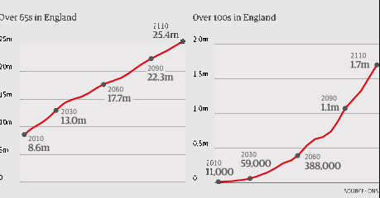
Figure 1: Ageing population graph
Source: (Campisi et al., 2022)

3. Issues experienced by older age people in the UK
Older people in the UK face a range of issues, including financial, social, and health-related challenges. These issues have been further exacerbated by the pandemic of COVID 19, that has a disproportionate effect on the elderly population (Murphy et al., 2021).
Financial Issues: Many older people in the UK face financial challenges, including poverty, social isolation, and limited access to healthcare services (Murphy et al., 2021). The cost of health and social care can be significant for older people, particularly those with chronic conditions or disabilities. Access to quality care can also be a challenge, as waiting lists for treatment and social care services can be long (Murphy et al., 2021).
Elder Abuse: This involves the use of physical force that results in pain or injury to an older person. This can include hitting, slapping, pushing, or restraining. This includes emotional abuse, such as shouting, humiliating, or threatening an older person, as well as verbal abuse, such as name-calling or insults (Murphy et al., 2021).
Mental Health issues: Depression, anxiety, and dementia are common mental health issues affecting older people. Older people may also experience loneliness, which can have a negative impact on their mental wellbeing.
Physical health issues: Many older people in the UK experience chronic health conditions, such as arthritis, heart disease, and diabetes. These conditions can impact mobility and daily activities, and may require ongoing medical treatment (Nagarajan & Sixsmith, 2021).

3.1 Relevant theory including a theory of ageing
Ageing is a multidisciplinary field that draws on a range of theories and perspectives to understand the social, psychological, and biological aspects of aging. Below are some relevant theories that can help to light shed on the experiences of aged people in the UK (Ferri et al., 2020).
Gerontology theory: The theory of gerontology in social is a multidisciplinary field that focuses on the social aging aspects, including the social constructions of aging and age-related roles and expectations. This perspective highlights the impact of societal attitudes toward aging on the experiences of older people, including ageism and stereotyping Gerontology is the study of aging and the elderly population. There are a number of theories within gerontology that seek to explain the processes and experiences of aging (Ferri et al., 2020).
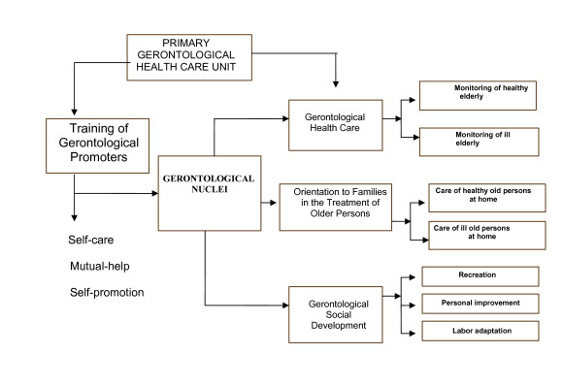
Figure2: Gerontological care model
Source: (Ferri et al., 2020)
Cumulative disadvantage theory: The theory of cumulative disadvantage suggests that disadvantage and inequality accumulate over the life course, leading to increased vulnerability and marginalization in later life (Ferri et al., 2020). This theory helps to explain the financial and social challenges faced by many older people in the UK, particularly those who have experienced disadvantages and discrimination throughout their lives. The perspective life course emphasizes the importance of understanding ageing as a dynamic and ongoing process that is shaped by earlier experiences and trajectories. This perspective highlights the impact of early life experiences, such as childhood poverty or trauma, on later life outcomes, including health and well-being (Ferri et al., 2020).
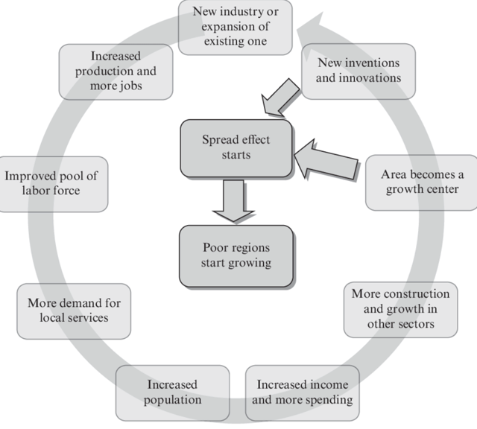
Figure 3: Positive circular or cumulative causation model
Source: (Ferri et al., 2020)

4. Conclusion
This report is about the condition and issues of old age people in the UK. In this report define old age in which a person’s mental or physical abilities decline. The exact age at which someone is considered "old" varies depending on cultural and societal norms, as well as individual factors like as genetics or health. The current social or health care explains about the work of local authorities, privates companies and charity organizations. The policies, practices, and interventions of government towards the older people is described. The discussion of aging population shows the facts that shows increasing amount of older people. The issues faces by older people in UK are financial issues, elder abuse, and physical and mental issues. The two theories gerontology theory and cumulative disadvantage theory are relevant including the theory of aging.

References
Anderson, M., O’Neill, C., Macleod Clark, J., Street, A., Woods, M., Johnston-Webber, C., Charlesworth, A., Whyte, M., Foster, M., Majeed, A., Pitchforth, E., Mossialos, E., Asaria, M. and McGuire, A. (2021). Securing a sustainable and fit-for-purpose UK health and care workforce. The Lancet, 397(10288), pp.1992–2011. doi:https://doi.org/10.1016/s0140-6736(21)00231-2.
Batsis, J.A., DiMilia, P.R., Seo, L.M., Fortuna, K.L., Kennedy, M.A., Blunt, H.B., Bagley, P.J., Brooks, J., Brooks, E., Kim, S.Y., Masutani, R.K., Bruce, M.L. and Bartels, S.J. (2019). Effectiveness of Ambulatory Telemedicine Care in Older Adults: A Systematic Review. Journal of the American Geriatrics Society, [online] 67(8), pp.1737–1749. doi:https://doi.org/10.1111/jgs.15959.
Campisi, J., Kapahi, P., Lithgow, G.J., Melov, S., Newman, J.C. and Verdin, E. (2019). From discoveries in ageing research to therapeutics for healthy ageing. Nature, [online] 571(7764), pp.183–192. doi:https://doi.org/10.1038/s41586-019-1365-2.
Donovan, N.J. and Blazer, D. (2020). Social Isolation and Loneliness in Older Adults: Review and Commentary of a National Academies Report. The American Journal of Geriatric Psychiatry, [online] 28(12). doi:https://doi.org/10.1016/j.jagp.2020.08.005.
Ferri, E., Marzetti, E., Calvani, R., Picca, A., Cesari, M. and Arosio, B. (2020). Role of Age-Related Mitochondrial Dysfunction in Sarcopenia. International Journal of Molecular Sciences, [online] 21(15), p.5236. doi:https://doi.org/10.3390/ijms21155236.
Murphy, M., Scott, L.J., Salisbury, C., Turner, A., Scott, A., Denholm, R., Iyer, G., Lewis, R., MacLeod, J. and Horwood, J. (2021). The implementation of remote consulting in UK primary care following the COVID-19 pandemic: a mixed-methods longitudinal study. British Journal of General Practice, [online] 71(704), p.BJGP.2020.0948. doi:https://doi.org/10.3399/bjgp.2020.0948.
Nagarajan, N.R. and Sixsmith, A. (2021). Policy Initiatives to Address the Challenges of an Older Population in the Workforce. Ageing International. doi:https://doi.org/10.1007/s12126-021-09442-w.
van Leeuwen, K.M., van Loon, M.S., van Nes, F.A., Bosmans, J.E., de Vet, H.C.W., Ket, J.C.F., Widdershoven, G.A.M. and Ostelo, R.W.J.G. (2019). What does quality of life mean to older adults? A thematic synthesis. PLOS ONE, [online] 14(3), p.e0213263. doi:https://doi.org/10.1371/journal.pone.0213263.
Girometti, N., Byrne, R., Bracchi, M., Heskin, J., McOwan, A., Tittle, V., Gedela, K., Scott, C., Patel, S., Gohil, J., Nugent, D., Suchak, T., Dickinson, M., Feeney, M., Mora-Peris, B., Stegmann, K., Plaha, K., Davies, G., Moore, L.S.P. and Mughal, N. (2022). Demographic and clinical characteristics of confirmed human monkeypox virus cases in individuals attending a sexual health centre in London, UK: an observational analysis. The Lancet Infectious Diseases, 22(9). doi:https://doi.org/10.1016/s1473-3099(22)00411-x.
Kerr, S., Joy, M., Torabi, F., Bedston, S., Akbari, A., Agrawal, U., Beggs, J., Bradley, D., Chuter, A., Docherty, A.B., Ford, D., Hobbs, R., Katikireddi, S.V., Lowthian, E., de Lusignan, S., Lyons, R., Marple, J., McCowan, C., McGagh, D. and McMenamin, J. (2022). First dose ChAdOx1 and BNT162b2 COVID-19 vaccinations and cerebral venous sinus thrombosis: A pooled self-controlled case series study of 11.6 million individuals in England, Scotland, and Wales. PLOS Medicine, 19(2), p.e1003927. doi:https://doi.org/10.1371/journal.pmed.1003927.

