Name: Charnai Clarke
Student number: 2007510
Module code: BMSW4003
Module leader: Paul Ranson
Assignment title: Component 2 research methods

Contents page number
Title page 3
Introduction 4
Angela Duckworth 4
What is GRIT 5
Russell L. Ackoff 6
DIKW 6
Collecting my data 7
Data to information 7
Information to knowledge 8
Wisdom of Carol Dweck 9
Summary 10
Refence page 11

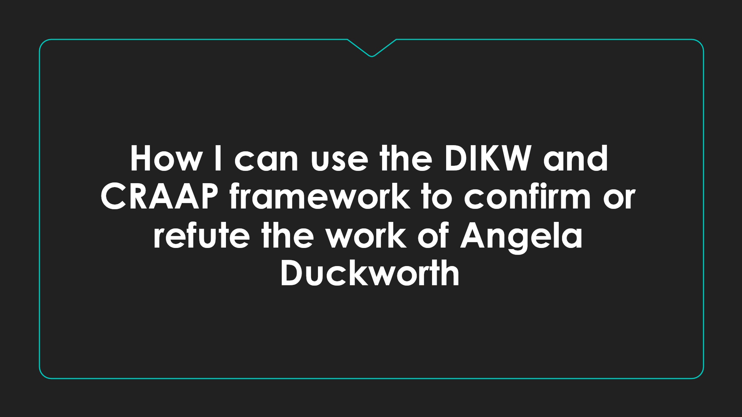


During this assignment I will be able to explain in depth my power point slide and how I was able to use DIKW and CRAAP, then discussing how I am able to link this with Angela Duckworth’s studies and other physicist. I will be able to explain GRIT, explain how effect it was, how much of an impact it had on peoples success, and how it can be improved.
I was able to then use this to collect my data when creating my survey which was carried out to see if the results related to what Duckworth had said in terms of “ consistency of effort over the long run is everything” meaning people who have passion and perseverance for their long terms goals tend to do better than someone who is only driven by fast results, by working hard and smart we will accomplish more in a realistic way. Finally, finishing this assignment with a summary of what I have learnt during this module and ways in which this has helped along with supporting my evidence with a refence page.
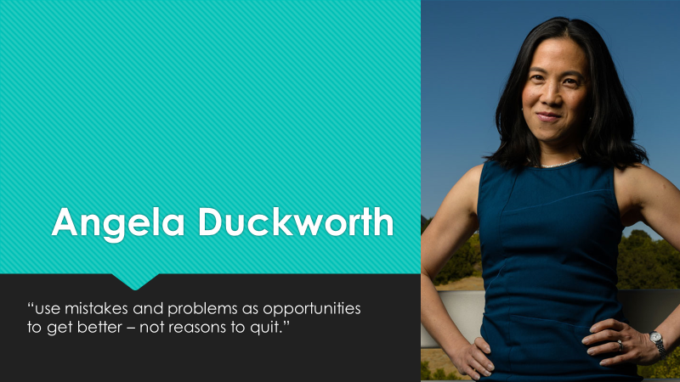
Who is Angela and how does she define GIRT? Angela Duckworth is the founder and CEO of character lab, a non-profit whose mission is to advance scientific insights that help children thrive. Angela defines the girt scale, as she is the world’s leading expert on ‘’GRIT’’. As she defines it, GRIT is a passion and sustained persistence applied toward long term achievement, helping individuals achieve more of their goals. (R J. Vallerand, 2007)
Angela once said ‘’ there are no right or wrong answers, so just answer honestly, considering how you compare to most people. At the end, you will get a score that reflects how passionate and persevering you see yourself to be.’’
This has been shown through her work and studies. As the world’s leading expert who is passionate about the GRIT, Angele has helped many in showing multiple times that this works, as she has been helping many people work towards their long-term achievements, with no particular concern for rewards or recognition along the way. (D. Perkin,2013)
Angela related this to CRAAP which stands for currency (the timeliness of the information), relevance (how the infromaion fits the needs), authority (the source of the information), accuracy (reliability and correctness of the information), and purpose( the reason the information exists), as using this method as it allowed the opportunity to check the objects, reliability of information sources across academic disciplines, which became very helpful when helping to improve her studies and helping to see why some of her students wasn’t performing as well as others.
Having watched Angela’s talks on YouTube it also showed how this increased the grit scores making a lot of people score the average between 36-40 making them “extremely gritty” which meant that those people was most likely to demonstrate greater achievements in their life. (P. Mcniel,2016)
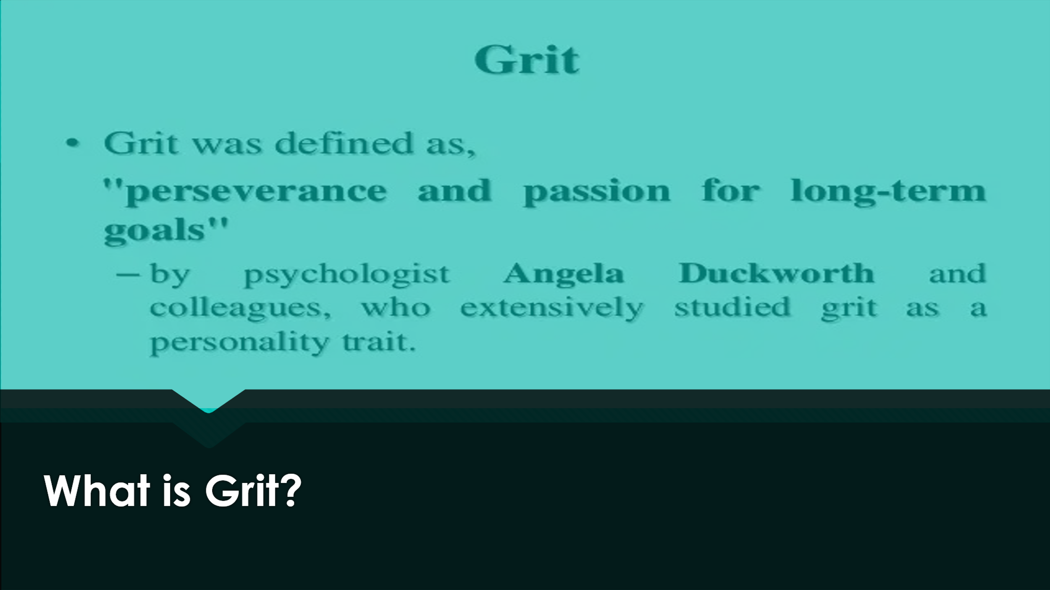
What does this stand for? The grit scale is the measures the extent to which people can maintain focus and interest and preserve in obtaining long term goals. Grit score is the report where scores can be reported. How does the grit have an impact on an individual? The grit has a great impact on an induvial as it is a driver of achievement and success. (A. Duckworth,2007) Without the grit, talents may be nothing more than unmet potential.
It has been shown throughout a lot of researchers that it is only with effort that talent becomes a skill that leads to success, helping with long term goals. Can GRIT be improved? Like conscientiousness, it tends to improve naturally with age, although grit can improve interventions, there is no current way to evaluate such effective intervention.
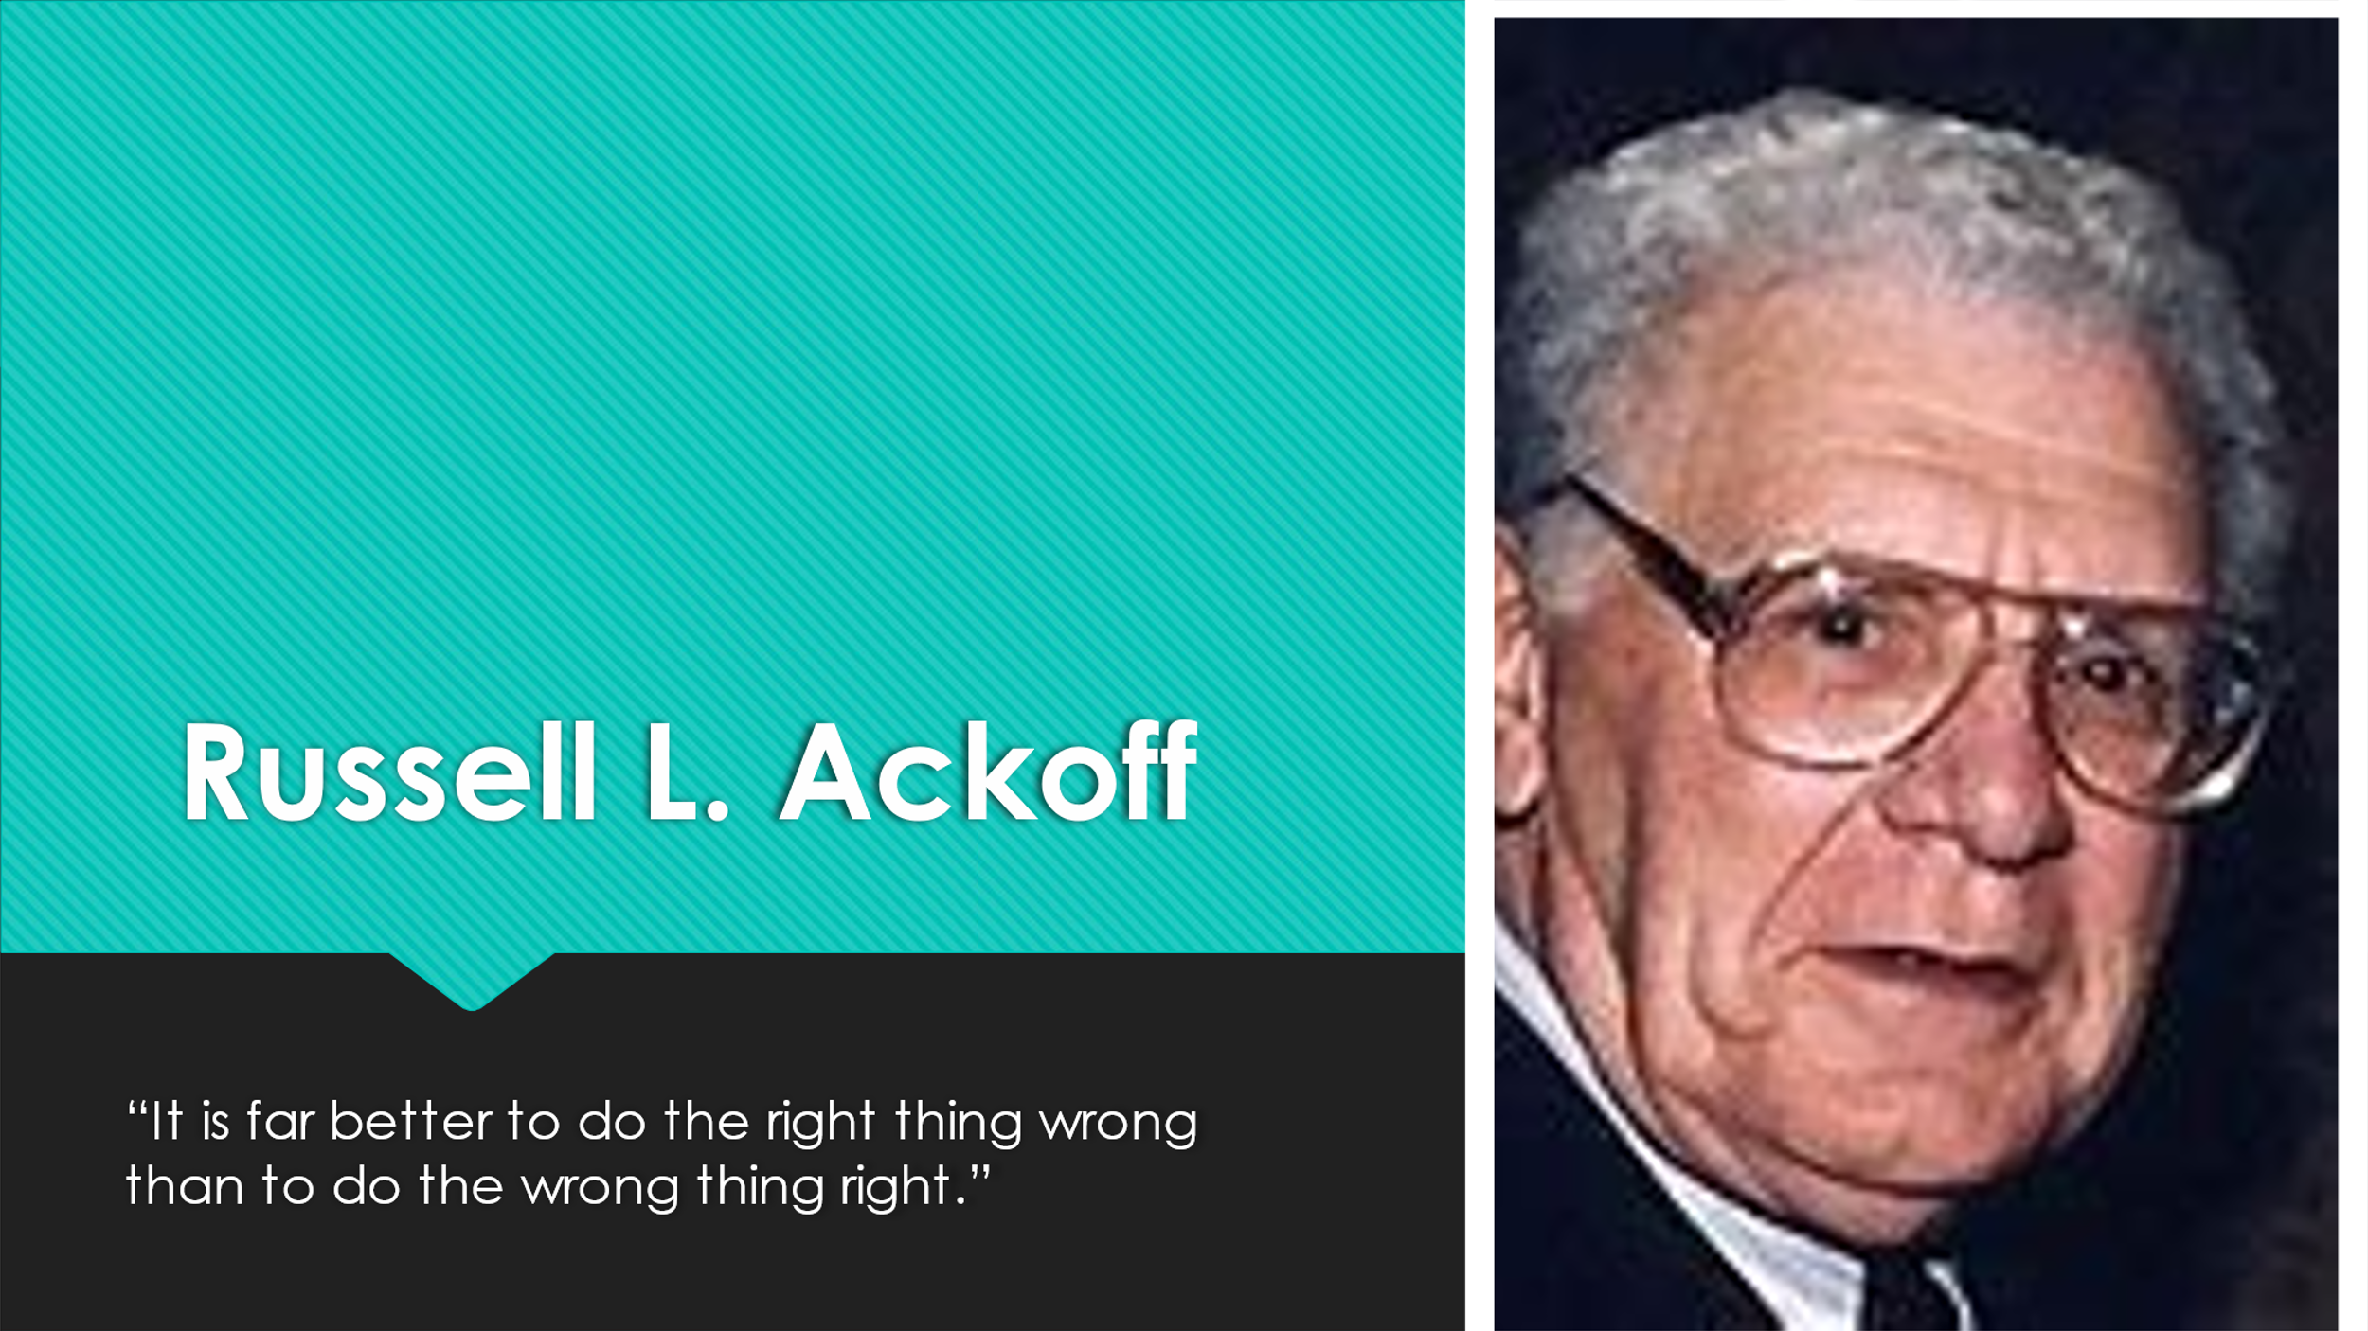
Ackoff was a professor emeritus of management science at the Wharton school at the university of Pennsylvania. He was an important early proponent of the field of operations research and remained a tireless advocate for an expansive vision of what the field could be.
‘’the more efficient you are at doing the wrong thing, the more wrong you become. It is much better to do the right thing wrong than the wrong thing righter. If you do the right thing wrong and correct it, you get better.’’
This was one of Ackoff most famous quotes. If you read closely, it also has a great message behind the words, for me it gave the impression that you can always be right in anything you are doing or learning if you continue to show evidence to support you. There is never a wrong answer. Ackoff was also well known for the DIKW (data, information, knowledge, and wisdom) is the graphical representation of how knowledge can be organised within the organisation. He showed this through his studies and teachings. (Chen, M.2009)
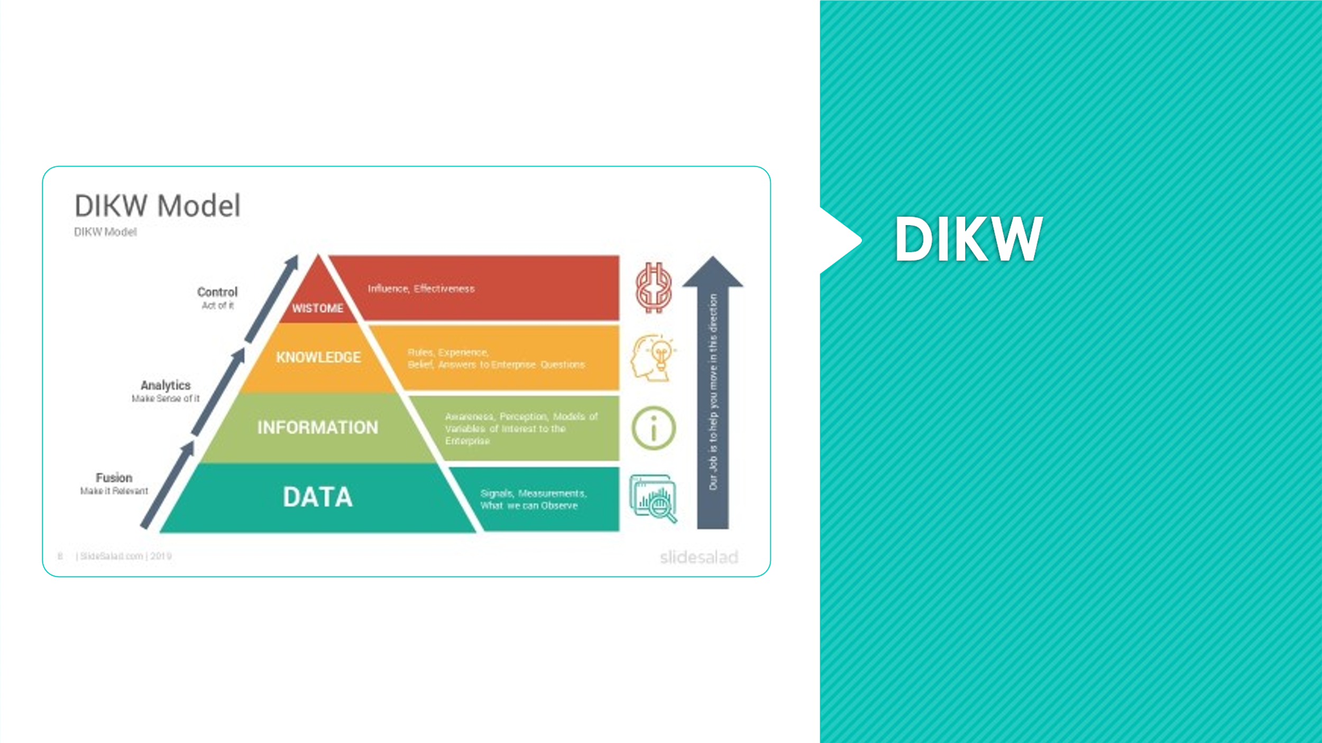
What does this stand for? This DIKW is a pyramid where typical information is defined in terms of data, information, knowledge, and wisdom. Following this sequence of steps helps people process and understand the data/ information better, which may or may not be useful but affective.
Data- this is when you collect raw data which can be in the form of a character or numbers. However, it is important that this is done correctly, if not done correctly this can affect the sequence. For example, in class we were collecting data on each student for highest academic levels. I wrote mine like ‘12345’ a better way of doing this could have been ‘level 1, level 2, level 3.’ this gives me more structure and helps me to remember what exactly the information was that I had collected.
Information- this is the next step on the sequence in the pyramid, which is data that has been cleaned, making it easier to analyse, measure and visualise the data for a specific purpose. For example, when collecting the data for highest academic levels instead of having to count each the list every time to add up the result, this could create a chart or graph making it easier for me to read and saving time.
Knowledge- this is the third step in the sequence, this is one of the most important steps as it is connecting pieces of information to help get a better understanding of the information, we collected to help achieving goals. For example, this could be by simply thinking of the right questions to ask.
Wisdom- this is the final step in the sequence, which is knowledge applied in action. Top of the DIKW hierarchy and to get there, is answering all the relevant questions like, what is best way to achieve our goals, why do we want our academic levels and what could we use them for. I always say without wisdom you cannot reach your full protentional. (A. Branmahary,2019)
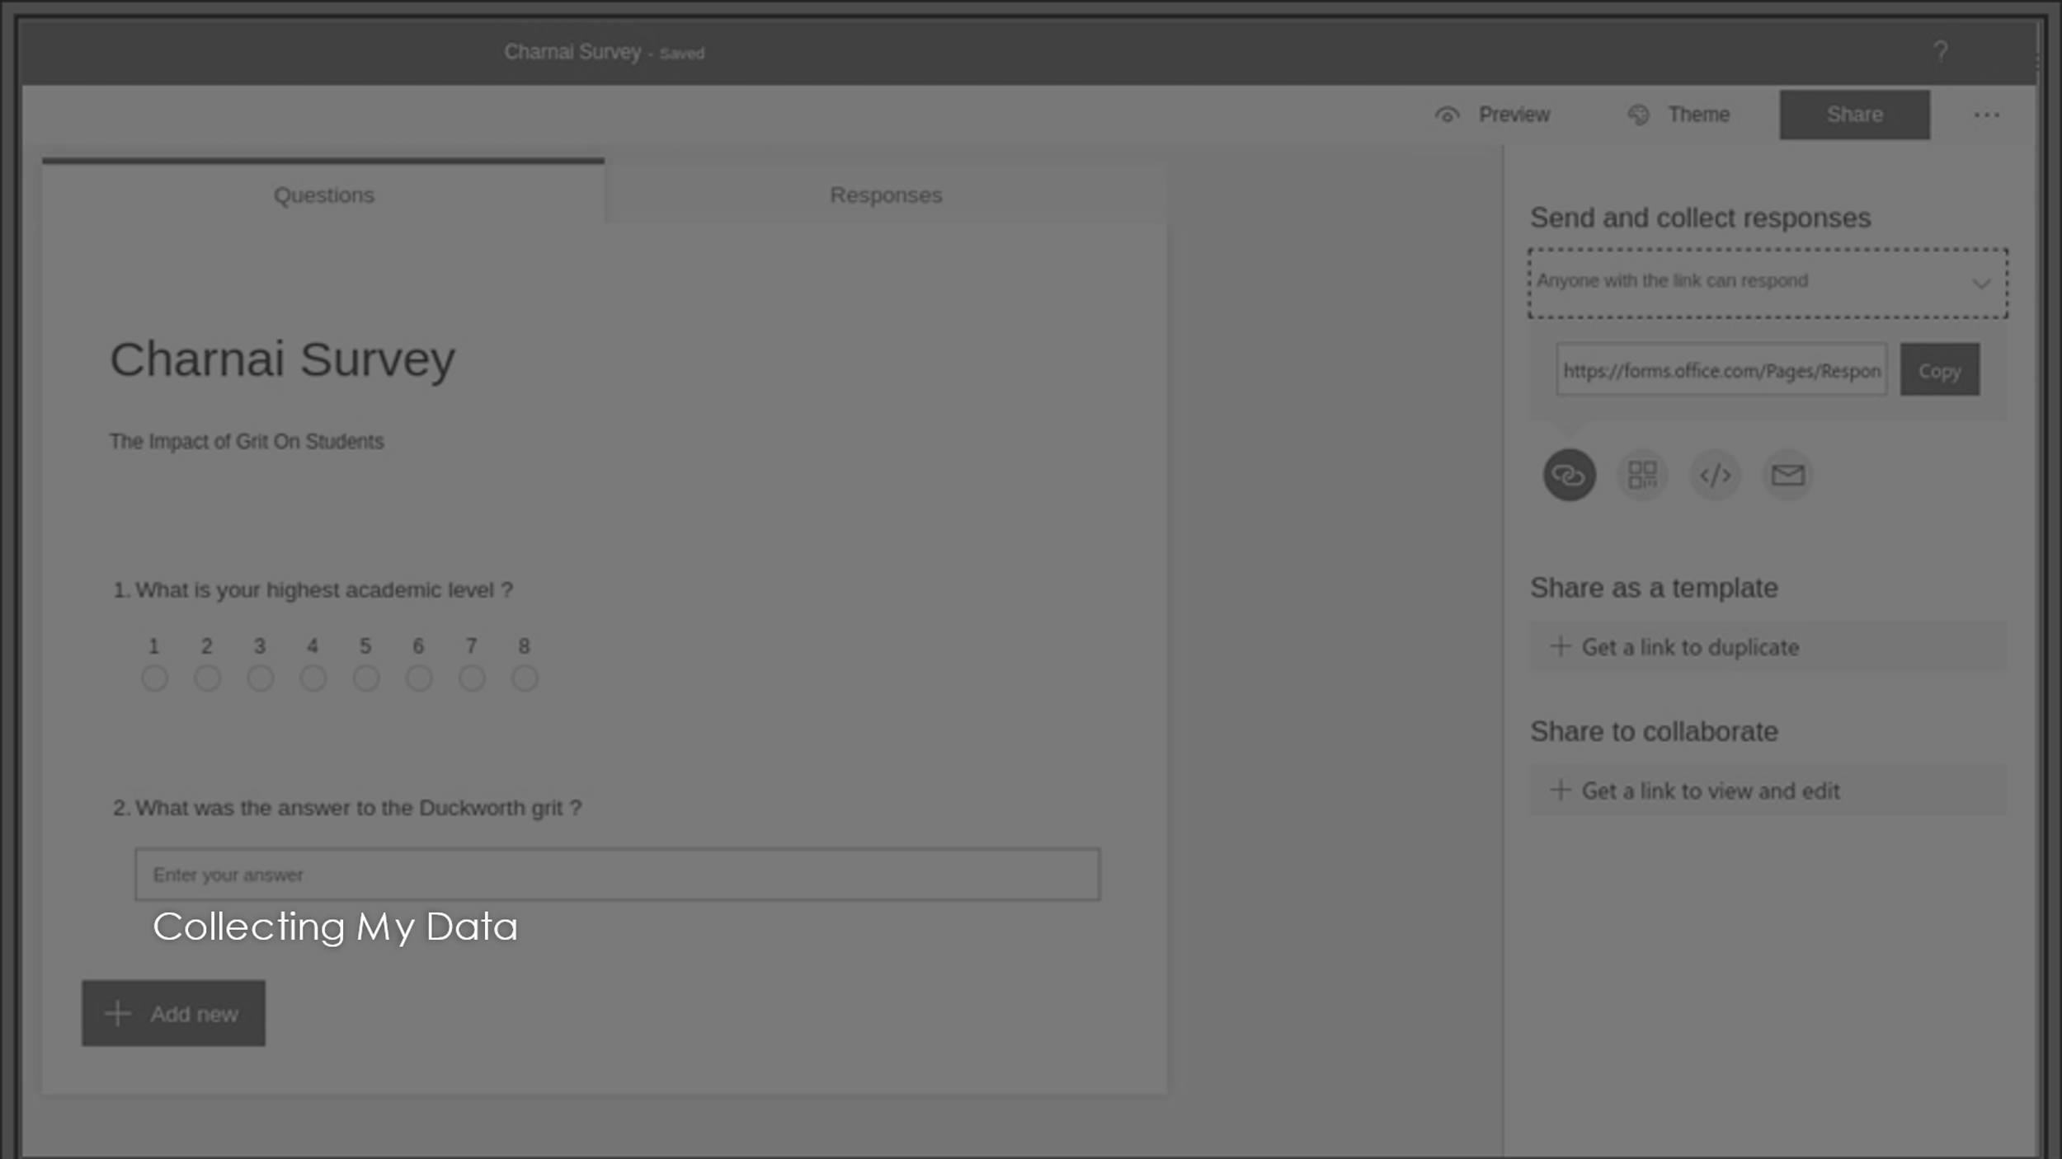
This slide will be discussing how to create an online survey using Microsoft form, having collected the data. During class a task was given to create individual grits and get each class member to fill it out. Starting this survey by using Microsoft form which had been accessed through, Moodle using the university app on the phone. Once opening the app, the top right corner has a plus sign, once clicked on, it should say create new form. Opening the new form, then pressed the top of the screen where it was green, this was to type in the title for the survey.
Underneath it said add questions, there were four different styles people can pick from such as, open question, probing question, leading question and loaded question. Using the two it felt more fitted to the survey. Once typing in the two questions It then completed the survey and was sent to everyone using the share button at the top left corner of the screen, before waiting for responses. This was interesting making the survey as it would help with collecting infromaion for the excel chart that was then created once the results were back from the grit.
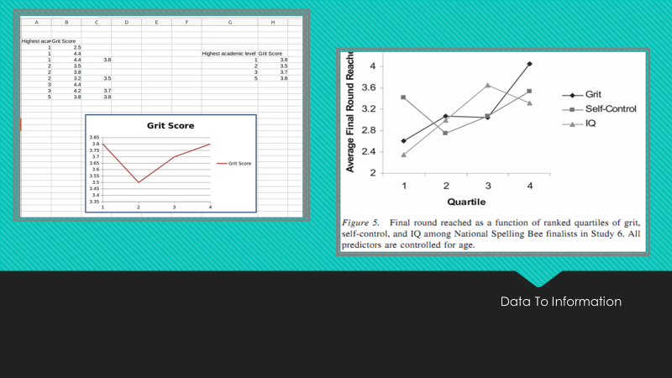
Using the results, it was simple to process the qualitative data into quantitative (picture at the top) Angela’s graph in the bottom picture is showing the results of self-control, girt and IQ. This one was able to show highest academic score and level
Overall, after doing the research of the primary and secondary data, both images show that the more gritter a person is the higher the achievement in their life will be, showing that Angela was correct to say that a person with a high girt score are more likely to be successful and achieve their long-term goals.
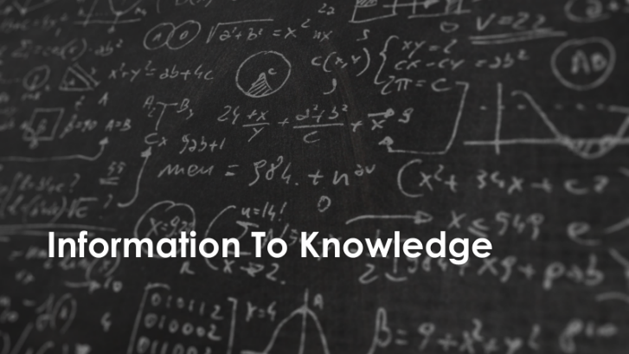
As shown from the previous page of the comparisons of both charts, there is a positive slope going through both, meaning that the two variables are positively related, up being positive, shows that the data collected show an average score of 3=30.97 which shows the possibility values. By these positive outcomes also shows that the data has a great effect in terms of individuals accomplishing great things in the future as they are higher motivated. This suggest that the grit personality traits are valuable which causes can cause a positive performance including perseverance and passion in achieving long term goals as Duckworth stated in multiple talks. For what this is worth using the grit scale to measure data has been proven helpful.

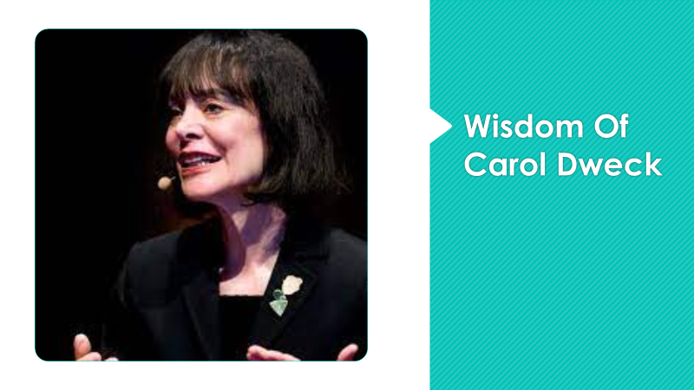
Carol is a psychologist, who is known for her work on the fixed and growth mindset psychological trait. She is one of the world’s leading researchers in the field of motivation. Her research is focused on why people succeed and how to foster success.
Carol Dweck once's said ‘’ if you have only a certain amount of intelligence. A certain personality and a certain moral character…well then you would have to prove that you have a heathy dose of them.’’
This gave me the impression that she meant we can grow our brain capacity to learn and solve problems. This also made me think more about the mindset a lot of people have and that the only person stopping you from doing everything you want is yourself. (C. Dweck,2017) We spent too much time dealing ourselves and not enough time trying to think of ways we can make things work, we could simply do this using DIKW (data, information, knowledge, and wisdom).
Dweck’s discovery of fixed and growth mindset have shape and understanding of learning as she talks about when students believe they can get smarter they understand that effort makes them stronger. Which has led students to make more effort in higher achievement in life, this also related to Duckworth not only by them both being extremely intelligent professors of psychology, but by common interest which is focusing on showing ways in which students can become a lot smarter and successful.


During this assignment I have spoken about GRIT and CRAAP and how much of an impact using them can have in relation to helping individuals when reach their full potential, being able to carry this out creating our own surveys during class and being able to relate it to the average response of Angela I was able to see how affective using DATA in that way would work.
Having mentioned Duckworth, Dweck in relations to GRIT and growth mindset I was able to relate them back to DIKW and Ackoff and gain a better understanding of the different terms. I found this assignment very interesting and helped a lot with expanding my knowledge on these important people.
Being able to use GRIT and CRAAP framework throughout this presentation I am able to confirm that Duckworth’s work is affective and has been known to work well having has high impact and results other the years but although I agree with Duckworth and Dweck’s work and method of helping with growth mindset, I would suggest using smart targets would help to improve grit, as it can make that goal more achievable, as it provides focus and acts as a stepping stone towards the end goal that students are trying to achieve.


Bernstein, JH. (2009) The data- information- knowledge- wisdom hierarchy and its antithesis. pp.68-72. Available at https://academicworks.cuny.edu/cgi/viewcontent.cgi?article=1011&context=kb_pubs
Branmachory, A. (2019) DIKW model: explaining the DIKW pyramid/DIKW hierarchy. Pp. available at https://www.certguidance.com/explaining-dikw-hierarchy/
Chen, M., Ebert, D. (2009) data, information, and knowledge in visualisation. pp.12-19. Doi.10.1109/MCG.2009.6
Duckworth, A.L. (2007) Journal of personality and social psychology: perseverance and passion for long term goals. Pp, 1087-1101. Doi.org/10.1037/0022-3510.92.6.1087
Dweck, C. (2017) mindset updated: changing the way you think to fulfil your potential. pp,.16-24
McNeil, P., McArthur, EC. (2016) information literary in undergraduate and graduate nursing course, pp.480. Doi.org/10.3928/01/484834,20160715-12
Perkin, D. (2013) The significance of GRI: a conversation with Angela Lee Duckworth., pp,14-20. Available at http://68.77.48.18/RandD/Educational%20Leadership/Significance%20of%20Grit%20-%20Duckworth.pdf
Rowley, J. (2006), where is the wisdom that we have lost in knowledge? pp. 251-270. https://Doi.org/10.1108/0022041061065332
V, R J. (2007) on the role of passion in performance. pp,505-534. http://Doi.org/10.1111/J/1467-6494.2007.00447.x.

