Khalil Miah
1709513
Developing Relationships and Workplace Acheivemements
BMSK5002

Executive Summary
This report provides an analysis on select development vehicles; motivation, employee engagement and performance management which are available to both an individual and organisation. Research draws attention the use of different development tools such as Maslow’s hierarchy of needs and its contribution to motivation. It analyses benefits and implications of employee engagement and how it can help an individual and organisation using John Lewis as a prime example. It also considers performance management and how the performance cycle can be used as tool to enhance individual development.

Contents
Executive Summary 1
Introduction 3
Task 1 3
Employee Engagement 3
Motivation 4
Performance Management 7
Task 2 8
Motivation in Context 8
Employee Engagement in Practice 9
Performance Management in Action 9
Task 3 11
Personal Development Plan…………………………………………………………………………………………11,12&13
Conclusion 14
Appendices 15
Figure 1- Maslow’s Hierarchy of Needs 15
Figure 2 – Performance management Cycle 15
Figure 3 - Weaver Linear Model of Communication 16
References……………………………………………………………………………………………………………………………17&18
Bibliography…………………………………………………………………………………………………………………………..19&20

Introduction
This report will look to utilise different tools of motivation which is available to individuals and to help organisations become more competitive. The report is divided into three sections; firstly, it will consider what methods of development are available to organisation to help the development needs of individuals and its implications. It will consider three modes: employee engagement and how positive and negative engagement can potentially heighten or endanger the development needs of employees in the workplace. The second mode will look at motivation, by evaluating Maslow’s Hierarchy of needs model. It will aim to analyse the effectiveness of this model in the development needs of the individual (Figure 1). The last mode will look at performance management; how can performance management be used to help the development needs, this will be rationalised using the performance management cycle (Figure 2).
The second section will aim to identify how these development modes apply in a work environment by using organisational examples and the impact this may have on the organisations. The third segment will focus on personal areas for development; considering both my personal professional life. It will look at how I cam implement these areas for personal development and how I can measure the specific goals set.

Task 1

Employee Engagement
Contemporary HRM indicates that people within an organisation should be considered as useful assets as opposed to just resources (Armstrong 2012). Highlighted by Bratton and Gold (2012), the management and utilisation of employees can be considered a crucial factor in attaining a competitive advantage and organisations should focus resources on initiatives that help enhance commitment. On the other hand, Christy and Mullins (2016) indicate people do not leave their jobs, but rather their bosses. This suggests there are underlying issues in the employer, employee relationship and asks the question what can be done to help improve this relationship so that an organisation can gain a competitive advantage.
Employee engagement is a tool that can be used to help create a mutually beneficial employer-employee relationship. Employee engagement can be described as the psychological contract between the employee and the organisation. Where positive experiences can foster greater organisational commitment (Armstrong 2012). A particular strength of this is, that enhanced employee engagement can lead to greater efficiency and job satisfaction (Bratton and Gold 2012). This shows how positive engagement can help increase the skillset of individuals if managed correctly and should be considered an important tool in the development needs of an employee.
However, when employees become disengaged it can become problematic. For instance, Caldwell (1990) states employee disengagement can lead to poor performance, higher levels of absenteeism and greater employee turnover. (CIPD 2014) high levels of employee turnover can be damaging to an organisation given the costs in recruitment and learning and development. This issue is further demonstrated by CIPD (2015) indicating poor market condition from an employer perspective as a ratio of 2:1 organisations agreeing that the current climate dictates it is currently an ‘employee market’ as opposed to an employer market. This suggests the assets (employees) hold more power as they have greater choice between employers, it is important to manage employee engagement to retain assets to a company.
One way to ensure employee engagement remains intact, is by managing the employment relationship. Armstrong (2012) indicates HR services strongly influence the employment relationship as HRM overarches all the areas in how employees are treated such as recruitment, performance reviews, reward, involvement and participation. There is a underlying presumption that organisations should work hard to manage employee engagement, as positive engagement can enhance an individual’s capabilities, whereas negative engagement can hinder it affecting both employee and employer.

Motivation
Motivation can be described as multifaceted indicates (Mullins and Christy 2016). Motivation is concerned with the direction and strength of behaviour and what drives people to behave in a particular way (Armstrong 2012). Through this definition motivation can be deemed psychological; behaviour is varied, often dependent on the needs of the individual (Armstrong 2012; Bratton and Gold 2012). Therefore, it can be difficult to engage the needs and expectations of individuals, and how to manage them. However, some scholars have hypothesised theories on motivation in order to better understand what stimulates behavioural patterns.
One of the most popular theories in motivation is Maslow’s hierarchy of needs; it is based on 5 factors; Physiological, safety, love, esteem and self-actualisation (see figure 1). Maslow proposes in his theory of individual development and motivation, that human needs are arranged in hierarchical order of importance (Maslow 1954 and Mullins and Christy 2016). (Figure 1), the first two sections in the hierarchy can be considered basic deficiency needs, third tier can be related to psychological. The last two tiers can be considered cognitive growth needs (Maslow 1943). This section will take a in depth look into Maslow’s hierarchy of needs and the potential benefits of this motivational tool when applied to an individual.
Physiological needs are concerned with basic needs for human survival such as food, clothes, drink, warmth, air, shelter and sleep (Maslow 1943&1954). Maslow (1943) indicates, these factors are crucial, as the human body would not operate at optimum level without these needs satisfied, placing physiological needs as the important in the hierarchy model. Safety needs are focused around stability, protection, order and freedom from fear. Love and belongingness is the third tier of the hierarchy and is connected around social elements, the need for interpersonal relationships as a driver of motivation; these can include friendship, trust and acceptance, considered a member of the group (friends, work, family) (Maslow 1954, Armstrong 2012). Esteem can be separated into two categories; firstly, self- esteem: which involves independence, self-achievement, dignity. The second can be deemed more external. It is concerned with status and prestige, gaining the respect from others (Maslow 1943&54 ,Mullins and Christy 2016). Self-actualisation which is at the peak of the hierarchy is in relation to nurturing one’s self, identifying personal potential, peak experience and seeking growth, (Maslow 1987). An example of this can be where employees in organisations participate in activities outside their job descriptions like NDA (Nuclear Decommissioning Authority) managing director Mr Philip Craig being named ‘Ally of the Year’ at the Women in Nuclear (WiN) UK conference in Jan 2019 for being a leading male advocate of gender balance and diversity (WWW.GOV.UK 2019).

The main benefit of Maslow’s hierarchy of needs (Figure 1) is how it aims to conceptualise the cognitive reasons behind human motivation. Furthermore, the model does not only look at the psychological reasons but also the physical, emotional and social elements which impact motivation, thus it can be argued this model portrays a holistic approach to motivation and learning (Maslow 1970, Armstrong 2012&Christy and Mullins 2016). For example, Maslow’s model can be applied in a classroom setting; a tired and hungry student will find it challenging to focus on learning, firstly their basic needs must be met before their cognitive needs and that teachers can help foster those needs by creating a friendly, respected (towards students) classroom environment (Maslow 1970). This shows Maslow’s model can be useful in the development needs of individuals and can be applied to a work context as it takes a holistic approach on motivation.
However, there are some inconsistencies with Maslow’s model. Many have criticised the model’s rigidity (Alderfer 1972, Wahba and Bridwell 1972, Armstrong 2012, Mullins and Christy 2016). Maslow originally stated as per the hierarchical structure a person can only move onto the next the stage once the previous need has been met (1943). Although, critics argue individuals may fulfil multiple needs at once as priorities are variable across individuals, (Alderfer 1972, Armstrong 2012, Mullins and Christy 2016). This later led to Maslow himself critique and revamp model, indicating there should be a degree of flexibility in the model dependant on the circumstances of the individual i.e. one’s inclination for self-esteem is greater than love and belongingness (Maslow 1987).
Although there are some flaws with Maslow’s model, empirical research conducted by Tay and Diener (2011) from 2005-2010 containing over 60,000 participants spanning 123, where the participants responded to a survey regarding six needs which closely resembled Maslow’s model (Figure 1) and rated them against three measures; life evaluation, positive and negative feelings. The results supported Maslow’s view on basic human needs and indicated these needs are present irrespective of cultural differences.

Performance Management
Performance management can be described as systematic process which can aid organisational performance by through the development of individuals or teams (Armstrong 2012). (Figure 2) provides a framework ‘performance management cycle’ for improving performance through creating expectations and formulating development plans, which shall be discussed further (Armstrong 2012&Christy and Mullins 2016).
- Plan: is setting agreed objectives in the roles profile, prepare personal development in a bid to enhance knowledge and required behaviours (Armstrong 2012). Aligning corporate values with an individual can make achieving high organisational performance easier as the relationship is mutually beneficial (Bratton and Gold 2012&CIPD 2015). It is therefore apparent there is a degree of interdependency; employee upon the organisation for increased knowledge and organisation for a competitive advantage. The relationship should be managed effectively by management to mitigate poor performance.
- Act: adhere to plans and changes in demand by carrying out work to meet objectives.
- Monitor: check progress on meeting objectives, performance management should be considered a continuous process as opposed to annual appraisal.
- Review: hosting discussions of progress and achievements in a review meeting, pinpoint action areas to improve performance and revert to the planning stage
As organisations expand and develop likewise it is important employees do also (Bratton and Gold 2012). A particular benefit of this cycle is that it looks at performance management as a continuous process, therefore employee knowledge will not stagnate. An important consideration is how performance is rewarded i.e. intrinsic values; recognition or extrinsic; monetary. Whether both organisation and individual needs are satisfied and whether the system operates in fair, consistent and equitable manner (Armstrong 2012).

Task 2

Motivation in Context
In relation to the workplace, there is consensus amongst scholars that when employees are highly motivated it can lead to greater organisational performance (Armstrong 2012&Bratton and Gold 2012). Supported by Armstrong (2012), highlighting a correlation between high performance with added discretionary effort through being sufficiently motivated. Epitomised by Hunter (1990) research, which highlighted the difference in value added performance between superior and standard performers to be 19% for basic roles, this figure was further exemplified in complex jobs to 48% (Hunter& Armstrong 2012). Adversely, de-motivated staff can have a negative impact on organisational performance, creating disequilibrium and tension through unsatisfied needs (Armstrong 2012).
For example, British Gas have cancelled a major contract with third party contractor Conduit putting up to roughly 1,000 jobs at risk in Cardiff by 31st March 2019 (Decon 2018). The article goes further to explain that some jobs may move in house and transfer to Centrica which operate under British Gas, but it fails to mention how many staff will move. This leaves huge ambiguity in job security. This example can be applied to Maslow’s model (Figure 1). In regard to safety needs, of which Maslow describes as one of essential needs for survival the impending redundancy can negatively impact employees as their jobs are in danger which may spark fear as they lose a stable pay check (Maslow 1943). These fears can lead to demotivation and can have a knock-on effect onto their basic need’s, human needs and Physiological needs like food and shelter as potential job loss will impact their livelihood. Moreover, it is questionable how does British Gas manage to keep its staff motivated when soo many jobs are at risk. As employees become demotivated it can negatively impact performance hindering organisational performance (Bratton and Gold 2012). It is important for British Gas to adhere to the cognitive needs and try to minimise fears so that employees can still perform to consistent level to ensure organisational competitiveness.

Employee Engagement in Practice
As earlier stated, employee engagement deals with the psychological contact, where positive experiences can lead to enhanced organisational commitment through alignment of values (Armstrong 2012). An example of positive employee engagement can be found in John Lewis Partnership. The company refers to all its employees as partners as opposed to ‘employees’ and all partners have a small stake in the business and receive dividends if the company performs well (John Lewis 2018). A positive impact of this that partners can feel more committed to the organisation through their ownership. (Mullins and Christy 2016) indicates enhanced commitment can drive organisational performance. There is an inclination that the partners would be geared to perform at a high level to boost organisational performance as this relationship is mutually beneficial, better organisational performance generates partner rewards.
Moreover, John Lewis hosts quarterly meetings throughout the fiscal year in which partners holding different positions from the bottom to the top are encouraged to put forth their ideas (John Lewis 2018). A positive advantage of this high levels of employee retention (CIPD 2014). (Armstrong 2012&CIPD 2014) state that employee engagement intensifies will create stronger organisational commitment. It can be expensive to train and hire new employees, so retaining talent can be crucial for organisations to gain a competitive advantage (CIPD 2015).

Performance Management in Action
A company that emphasises strong performance management is Deloitte. A study conducted by Deloitte which gains insight from over 10,000 HR professionals and executives finds employees want more regular feedback. In order to touch base with employees more regularly Deloitte instructs quarterly check-ins are hosted as opposed to annual performance appraisals (Deloitte 2017). A benefit of this is that it encourages a more collaborative approach where organisational and individual objectives can better align. This collaborative approach can further be exemplified as Deloitte gives the opportunity for employees to evaluate their managers as opposed to the conventional manger-led evaluation.
However, the same study cites widespread manager bias across 41% of companies. Moreover, 45% believe performance evaluations did not motivate employees (Deloitte 2017). It is important to try comprehending why there is such a large breakdown in performance management. One contributor can be line managers, line mangers are burdened with increased responsibilities and are considered key agents in facilitating employee relations (Evans 2015). Supported by Meijerink and Bondarouk (2013), line managers are beginning to hold greater responsibility in conducting HR policies and practices as opposed to the HR specialists. A negative outcome of this can be that line managers lack motivation and fail to apply practices to adequate level due to the increased pressure and workload (Sikora and Ferris 2014). This can hamper performance management as the primary obligations of line managers diminish due to the increased workload.
A further point of consideration is, whether line managers are being adequately trained to handle the responsibilities. One-way organisations are trying to mitigate poor performance management is by shifting talking about people into talking with people. Employee driven conversations are being used, a positive outcome using this method is that feedback will no longer be one-way (Deloitte 2017). By re-shifting performance management using this it can allow for collaboration, better quality and quantity of conversation which may increase individual and organisational success as objectives can be made clearer.

Task 3

Personal Development Plan
This section will look at some areas of personal growth, I have set some objectives I wish to improve on which will help me in both my personal and professional life. I have created table of some of the objectives I wish to improve on. Please see attachment.

Conclusion
The development methods discussed throughout this report hold many benefits to the development needs of an individual and to the growth and competitiveness of an organisation. It highlights how employee engagement, motivation and performance management can benefit the employee by increasing productivity through managing performance, enhance skillset through motivation and greater organisational and self-commitment through employee engagement (Armstrong 2012, Bratton and Gold 2012, Mullins and Christy 2016). Through the organisational examples provided it also highlights if organisations manage these development mechanisms, they may avoid problem areas such as employee turnover, absenteeism and poor performance (CIPD 2014&15). However, there is a apparent assumption that these development modes are mutually beneficial to both individuals and organisations. Organisations should use these tools to develop their employees to better align with strategic goals and increase organisational competitiveness.
However, companies must be careful and should not solely focus on using these development tools to business goals, there must be a consideration to the individual’s personal objectives and the emphasis should be placed on aligning personal objectives to fit the needs of the business and vice-versa.
By doing my PDP I have realised what are my main weaknesses and by achieving my goals I will reach my full potential academically and professionally also a point to note is that many of these skills can be transferred to other jobs in different fields of employment which is another advantage I would have gained.

Appendices

Figure 1- Maslow’s Hierarchy of Needs (Mullins and Christy 2016)
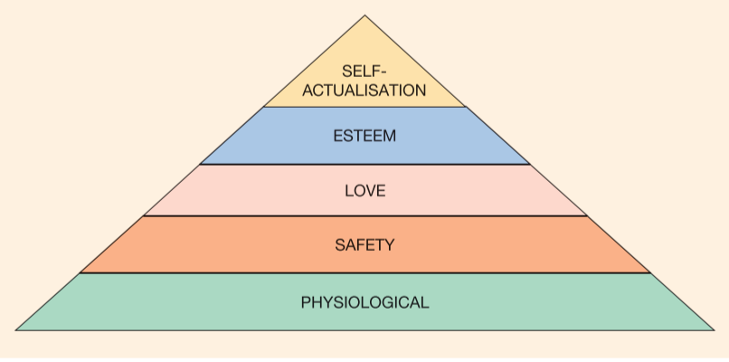

Figure 2 – Performance management Cycle (Armstrong 2012)
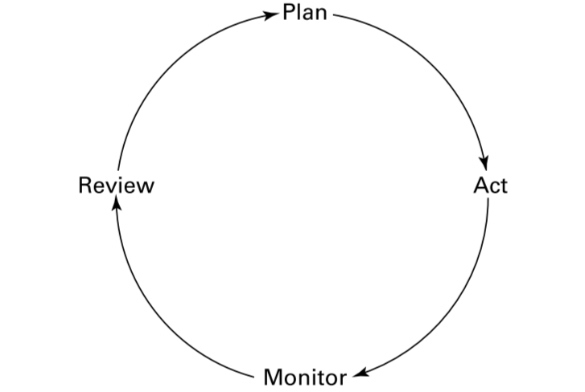

Figure 3 - Weaver Linear Model of Communication (Turk 1985)

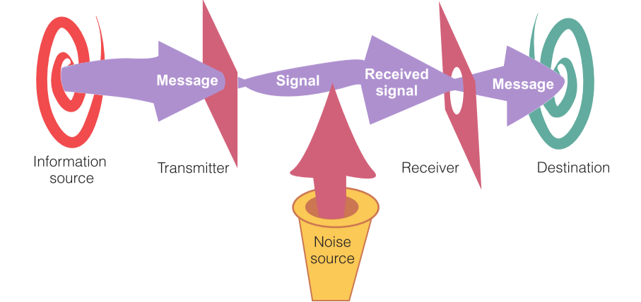

Reference:
Alderfer, C. (1972). Existence, Relatedness and Growth. New York: The Free Press.
Armstrong, M. 2012. Armstrong’s Handbook of Management and Leadership. 3rd Edition. London: Kogan Page.
Bratton, J. and Gold, J. 2012. Human Resource Management Theory and Practice. 5th Edition. London: Macmillan.
CIPD. 2014. Recruiting and developing talented people for SME growth Research Report July 2014. CIPD. [Online]. Available at: www.cipd.co.uk. [Accessed on 23/03/2019]. Pp.1-25.
CIPD. 2015. Resourcing and Talent Planning Survey Report 2015. CIPD. Available at: www.cipd.co.uk. [Accessed 23/03/2019]. Pp. 1-33.
CIPD. 2015. Learning and Development Annual Survey Report 2015. CIPD. Available at: www.cipd.co.uk. [Accessed on 23/03/2019]. Pp. 1-37.

Deacon, T. (2018). Staff Fear up to 1,000 Job Losses at Cardiff Call Centre After It Loses British Gas Contract. Wales Online. [Online]. Available at: https://www.walesonline.co.uk/business/business-news/staff-fear-up-1000-job-15874489. [Accessed on 20/03/2019].

Deloitte. (2017). 2017 Deloitte Global Human Capital Trends: Rewriting the Rules for the Digital Age. Deloitte. [Online]. Available at: https://www2.deloitte.com/insights/us/en/focus/human-capital-trends/2017.html. [Accessed on 20/03/2019].

Evans, S. 2015. Juggling The Line: Employee Relations. Emerald Insight. [Online] 37(4). Available at: http://dx.doi.org/10.1108/ER-06-2014-0066. [Accessed: 28/03/2019]. Pp.459-74.
https://www.gov.uk/government/news/nuclear-employees-win-big-at-national-diversity-conference [Accessed on 16/3/2019]

Hunter, J. Et.al. (1990). Individual Differences in Output Variability as a Function of Job Complexity. Journal of Applied Psychology. 75(1). Pp. 28-40.
John Lewis. (2018). Our Business. John Lewis Partnership. [Online]. Available at: https://www.johnlewispartnership.co.uk/about.html. [Accessed on 28/03/2019].
Maslow, A.H. (1943). A Theory of Human Motivation. Psychological Review. 50(4). Pp. 370-396.
Maslow, A.H. (1954). Motivation and Personality. New York: Harper & Row.
Maslow, A.H. (1970). Religions, Values and Peak Experiences. New York; Penguin.
Maslow, A.H. (1987). Motivation and Personality. 3rd Edition. Delhi: Pearson.
Meijerink, J. and Bondarouk, T. 2013. Exploring the central characteristics of HR shared services: evidence from a critical case study in the Netherlands. The International Journal of Human Resource Management. 24(3). Pp.487-513.
Mullins, J.L. & Christy, G. (2016). Management & Organisational Behaviour. 11th Edition. Harlow: Pearson.
Sikora, D. and Ferris, G. 2014. Strategic Human Resource Practice Implementation: The Critical Role of Line Management. Human Resource Management Review. 24(3). Pp.271-281.
Tay, L. and Diener, E. (2011). Needs and Subjective Well-Being Around the World. Journal of Personality and Social Psychology. 101(2). Pp. 354-365.
Turk, C. (1985). Effective Speaking Communication in Speech. London: Spon Press.
Wahba, M.A, and Bridwell, L.G (1979). Maslow Reconsidered: A Review of Research on the Need Hierarchy Theory. In Sters, R.M and Porter, L.W. (Eds). Motivation and Work Behavior. New York: McGraw Hill

BIBLIOGRAPGHY:
Alderfer, C. (1972). Existence, Relatedness and Growth. New York: The Free Press.
Armstrong, M. 2012. Armstrong’s Handbook of Management and Leadership. 3rd Edition. London: Kogan Page.
Bratton, J. and Gold, J. 2012. Human Resource Management Theory and Practice. 5th Edition. London: Macmillan.
CIPD. 2014. Recruiting and developing talented people for SME growth Research Report July 2014. CIPD. [Online]. Available at: www.cipd.co.uk. [Accessed on 23/03/2019]. Pp.1-25.
CIPD. 2015. Resourcing and Talent Planning Survey Report 2015. CIPD. Available at: www.cipd.co.uk. [Accessed 23/03/2019]. Pp. 1-33.
CIPD. 2015. Learning and Development Annual Survey Report 2015. CIPD. Available at: www.cipd.co.uk. [Accessed on 23/03/2019]. Pp. 1-37.

Coetzee, M., Schreuder, D., & Tladinyane, R. (2014). Employees’ work engagement and job commitment: The moderating role of career anchors. SA Journal of Human Resource Management. 12(1). Pp. 1-12.

Deacon, T. (2018). Staff Fear up to 1,000 Job Losses at Cardiff Call Centre After It Loses British Gas Contract. Wales Online. [Online]. Available at: https://www.walesonline.co.uk/business/business-news/staff-fear-up-1000-job-15874489. [Accessed on 20/03/2019].

Deloitte. (2017). 2017 Deloitte Global Human Capital Trends: Rewriting the Rules for the Digital Age. Deloitte. [Online]. Available at: https://www2.deloitte.com/insights/us/en/focus/human-capital-trends/2017.html. [Accessed on 20/03/2019].

Evans, S. 2015. Juggling The Line: Employee Relations. Emerald Insight. [Online] 37(4). Available at: http://dx.doi.org/10.1108/ER-06-2014-0066. [Accessed: 28/03/2019]. Pp.459-74.
https://www.gov.uk/government/news/nuclear-employees-win-big-at-national-diversity-conference [Accessed on 16/3/2019]

Hunter, J. Et.al. (1990). Individual Differences in Output Variability as a Function of Job Complexity. Journal of Applied Psychology. 75(1). Pp. 28-40.
John Lewis. (2018). Our Business. John Lewis Partnership. [Online]. Available at: https://www.johnlewispartnership.co.uk/about.html. [Accessed on 28/03/2019].
Maslow, A.H. (1943). A Theory of Human Motivation. Psychological Review. 50(4). Pp. 370-396.
Maslow, A.H. (1954). Motivation and Personality. New York: Harper & Row.
Maslow, A.H. (1970). Religions, Values and Peak Experiences. New York; Penguin.
Maslow, A.H. (1987). Motivation and Personality. 3rd Edition. Delhi: Pearson.
Meijerink, J. and Bondarouk, T. 2013. Exploring the central characteristics of HR shared services: evidence from a critical case study in the Netherlands. The International Journal of Human Resource Management. 24(3). Pp.487-513.
Mullins, J.L. & Christy, G. (2016). Management & Organisational Behaviour. 11th Edition. Harlow: Pearson.
Sikora, D. and Ferris, G. 2014. Strategic Human Resource Practice Implementation: The Critical Role of Line Management. Human Resource Management Review. 24(3). Pp.271-281.
Tay, L. and Diener, E. (2011). Needs and Subjective Well-Being Around the World. Journal of Personality and Social Psychology. 101(2). Pp. 354-365.
Turk, C. (1985). Effective Speaking Communication in Speech. London: Spon Press.
Wahba, M.A, and Bridwell, L.G (1979). Maslow Reconsidered: A Review of Research on the Need Hierarchy Theory. In Sters, R.M and Porter, L.W. (Eds). Motivation and Work Behavior. New York: McGraw Hill

