UNIVERSITY OF THE WALES
TRINITY SAINT DAVID

INTERNATIONAL BUSINESS
LCMB7014

NAME: MOHAMMED FARHAN KUNHAYI
LECTURER: JEAN WANG
STUDENT ID: 2132168
COURSE: MASTER’S IN BUSINESS ADMINISTRATION

Table of Contents
Introduction 3
Company Overview 4
Internationalisation Analysis of Samsung 4
VRIO Analysis 6
Which strategy should Samsung use? 9
Host Country (Brazil) Analysis 10
Political Economy 11
Hofsteds’ Cultural Dimensions 13
Porter’s Analysis 14
Samsung’s entry mode strategy in Brazil 16
OLI Paradigm 17
Pros and Cons of its Entry Mode 19
Conclusions and Recommendations 22
References 24

Introduction
When resources are insufficient, one must devise a method to reach one's ultimate objective. Tactics are subservient to strategy because their primary purpose is to help achieve the plan's overarching objectives. Samsung's worldwide success can be attributed to the company's employment of a variety of tried-and-true business strategies. When developing international strategies, Samsung considers several factors, including diversification, expanding into new markets, achieving economies of scale, reducing costs via comparative advantages, taking advantage of favourable tax laws and legal and regulatory regimes, and increasing profits.
Fig: 1 - Samsung Logo
Source: (Tien., 2019)
Samsung employs a number of foreign tactics, the most notable of which is its network of worldwide strategic partnerships, which consists of dozens of completely owned companies and dozens more that are only half-owned by Samsung (Solihin et al., 2021). Although the success of worldwide vertical integration for these subsidiaries is highly variable among business units, geographies, and product categories, as indicated above, it will be seen by many of them.
Samsung is a global conglomerate with offices in essentially all of the world's countries; each of these offices aims to sell the same or a similar product to its native consumers. The method of integration and responsiveness chosen is a crucial part of international strategy for companies of this size. As the host country, Brazil is the primary subject of this study as it examines Samsung's international business strategy in making the country its home base. The smartphone and tablet markets in Brazil are among the most dynamic worldwide. Historically, Brazil has been an important market for Samsung (Tien., 2019). The Korean electronics behemoth has a defined strategy: setting itself out from the competition through first-rate customer service. By using a fresh approach to customer service, businesses may provide their clientele with something truly special.

Company Overview
Among the several sectors in which the South Korean giant Samsung is active are electronics, construction, and consumer appliances. Established in 1938, it has grown to become the largest corporation in South Korea. Over its eight decades in business, Samsung has adopted a wide range of operational models and tactics. Nowadays, it has expanded into a global business with offices in essentially every nation (Zulkapli, 2022). The corporation employs over half a million people and has a market value that ranks among the greatest in the world. This report will analyse Samsung's global business strategy, including the company's global operations, management structure, strategic use of joint ventures, and corporate social responsibility initiatives.

Internationalisation Analysis of Samsung
When it comes to worldwide commerce on a grand scale, Samsung Group is unrivalled. It consists of about 30 companies that are all connected in some way. It's performing the functions of a supplier, manufacturer, engineer, and more besides. The company is able to take advantage of synergies between its activities thanks to the company's usage of leveraging capabilities it has developed in one country and using them in others (Solihin et al., 2021). This allows Samsung to make changes to its products more rapidly and easily than its rivals. Additionally, the firm's widespread international presence allows it to spread its activities out across many markets to mitigate the impact of anyone's potential failure. However, as globalisation expands, it becomes more challenging for businesses to rely on such strategies. In most cases, diversifying the types of products offered will be more effective in lowering risk than expanding into new geographic areas. The global scope of its implementation is also exploited for strategic purposes.
Primary sources may suggest that Samsung aspires to operate on a global scale. The "Galaxy" line of smartphones, for instance, is sold in most countries and has consistent features and specifications independent of local demand (Cats, 2020). Even if Samsung's global strategy doesn't explain why its "Galaxy S" and "Galaxy Note" product lines are the same everywhere they're offered, there is a good rationale. These handset lines serve as cornerstones around which the rest of the company's product offerings can cluster in each market. Samsung is a major player in the smartphone industry. The company's most potent and feature-rich offerings are showcased in ads in an effort to raise brand recognition.
The term "transnational" is used to describe the second category of international strategy. Scale economies, local market adaption, appropriate activity location scouting, and increased information flows and learning are the primary goals of this technique. This strategy is both globally integrated and nationally responsive, at a high level (Tien, 2019). Since most of Samsung's business practices conform to the core principles of this strategy, the term "transnational" can be used to describe the company's approach to international expansion.
Samsung devotes the same attention to the demands of the countries in which it operates. A prime illustration of this regional strategy is a line of inexpensive cell phones named “Galaxy A.” This series is not available in the United States because of the prevalence of carrier subsidies there; however, it is available in nations where this is not the case (Lee, 2019). The "Galaxy A" line of smartphones is less powerful than the flagship "Galaxy S" line and has lower specifications, although it costs a lot less. This strategy helps Samsung attract a wider audience by catering to individuals who cannot afford the company's high-end offerings.
The Samsung home appliance division and other Samsung departments take a similar approach to product diversity. However, they are held to the same high-quality standards as the rest of the company's bestselling products. The ability to compete with the leading makers of cellphones, televisions, electronics, and home appliances was a result of the company's commitment to both global consistency and regional specificity (Cats, 2020). The business takes advantage of economies of scale by producing a wide variety of products tailored to individual markets. It has been demonstrated to be a relatively successful method for the corporation, despite its engagement in a range of diverse industries. Due to their limited presence in international markets, not all of the company's divisions may employ the transnational approach to global business, but the most successful and big divisions do.

VRIO Analysis
In order to get an edge over its rivals, Samsung Electronics typically employs the VRIN/VRIO analysis to create competitive strategies based on the company's fundamental strengths and resources.

Resources | Value | Rare | Imitation | Organization | Competitive Advantage
Opportunities in the E-Commerce Space using Present IT Capabilities | Yes,the e-commerce market is expanding quickly, and a savvy business may take advantage (Cheng et al.,2021). | No, Much of the competition is putting resources into information technology in order to break into the market. | It may be challenging to replicate the AI and in-house analytics. | In reality, this is just the beginning of the group. | In the long run it can provide sustained competitive advantage
Alignment of Activities with Samsung Electronics Corporate Strategy | Yes | No | Organizations vary in their approaches. | The business is well-organized, so you can get the most out of it (Al-Gamdi). | There's a tonne of room for improvement.
Access to Critical Raw Material for Successful Execution | Yes | Yes, rival businesses are forced to acknowledge the firm's monopoly on the market (Al-Gamdi). | Possible to replicate by rivals | Yes | Facilitating Long-Term Competitive Advantage
Expansion Potential of Established Brands | Yes, there is a burgeoning of new markets for previously unmet needs. | No, as they are the areas where the majority of the competition is focusing on as well | Yes, it's possible for rivals to imitate. | Increased advertising spending is necessary for brand extensions. | Temporary Competitive Advantage
Network adaptability in the supply chain | Yes | Yes | The suppliers and few manufacturers serving nearby rivals are interchangeable (Cheng et al.,2021). | Complete Utilisation | Maintains the company's operations
Pricing Strategies | Yes | No | Competitors frequently copy one another's pricing practices. | The company makes use of a pricing analytics system. | Temporary Competitive Advantage
Financial Resources | Yes | No | All of the nearest rivals have access to the same financial tools and market liquidity (Aliekperov, 2021). | The firm's finances are stable and should continue to grow. | Temporary Competitive Advantage
Track Record of Project Execution | Yes, especially in a field where budget overruns are common. | Yes, especially in the segment that Samsung Electronics operates in | No, none else has been able to replicate this level of proficiency. | Yes, the company is successful at it | Offer a Decisive Advantage in the Market
Brand Position compared to the competitor | Yes | No | Competitors may try to copy the strategy but will need a sizable advertising budget to succeed. | Yes, The company has strategically placed its labels to best appeal to its target market (Aliekperov, 2021). | Temporary Competitive Advantage
Leadership's Perspective on the Future Obstacles | Yes | No | Cannot be imitated by the competitors | The evidence, in this case, does not support such a conclusion. | Lead to a Significant Advantage in the Market

Which strategy should Samsung use?
For this reason, Samsung's global portfolio is quite varied, and the company has a large customer base around the world. Samsung's primary goal in selecting a new market is to take advantage of volume discounts. After extensive market research, the corporation chooses to focus on those regions in which it can obtain its primary inputs at the lowest possible cost and sell its essentially standardised products with minimal localization to the greatest number of customers. As a global business, Samsung prioritises cost leadership over product differentiation (Hobday, 2020). The corporation has been called out for its apparent policy of mimicking its competitors. The corporation uses a joint venture strategy more often than any of the other four major methods of entering overseas markets (licencing, exporting, joint venture, and sole venture). Strategic partnerships are important to Samsung, and they've helped the company grow into a global powerhouse in the IT industry. Many times, when there are negative events in any of the partner countries, its diversified portfolio assists in risk aversion (Solihin et al., 2021).
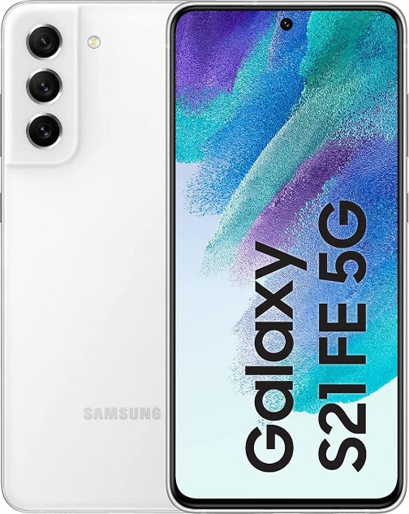
Fig: 2 - Samsung Mobile
(Source: Samsung.com, 2022)
The business acumen of Samsung Electronics has gone global. There is a high degree of global integration and cost savings, but at the same time, the market is not very responsive or differentiated. As with any quality, there are advantages and disadvantages associated with these traits. To begin with, SE creates economies through strategic site selection. Production facilities and research and development hubs are established in the most cost-effective areas across the globe (Teece, 2022). For the Asian market, low-wage countries like China and Vietnam are important sources of supply. The world's largest mobile phone plant is being built by Samsung in Thai Nguyen, Vietnam. Construction began in 2013. Specifically, SE's electrical products for the European market are made in Poland due to the country's advantageous balance of low labour costs and appropriate industry expertise.

Host Country (Brazil) Analysis
Brazil, the host country has the fourth-largest smartphone market and the sixth-highest population in the world. With a smartphone penetration rate of 46%, Brazil is a promising market for software creators and hardware manufacturers alike. For original equipment manufacturers and app developers eyeing the South American market, Brazil is essential (Lee, 2021). The adoption and use of smartphones are expected to skyrocket in the next years due to the country's vast population and low smartphone penetration rate. Because of the proliferation of sophisticated electronic gadgets, the consumer electronics industry is always evolving. Since smartphone sales are responsible for the vast majority of the consumer electronics industry's profits, the market is dominated by a handful of companies like Apple and Samsung that have leveraged their smartphone technologies to expand into other areas of the electronics industry and cement their positions as market leaders (Szot et al., 2019).

The growth of 5G networks, which will allow for the instantaneous transfer of large amounts of data, will promote ideas like smart cities and the interconnectivity of objects; the virtual reality movement, spearheaded by Facebook-owned Metaverse and promising to create a parallel world; and the gaming industry, which can integrate virtual reality technologies to create a galactic experience, will all serve as key drivers in the market.
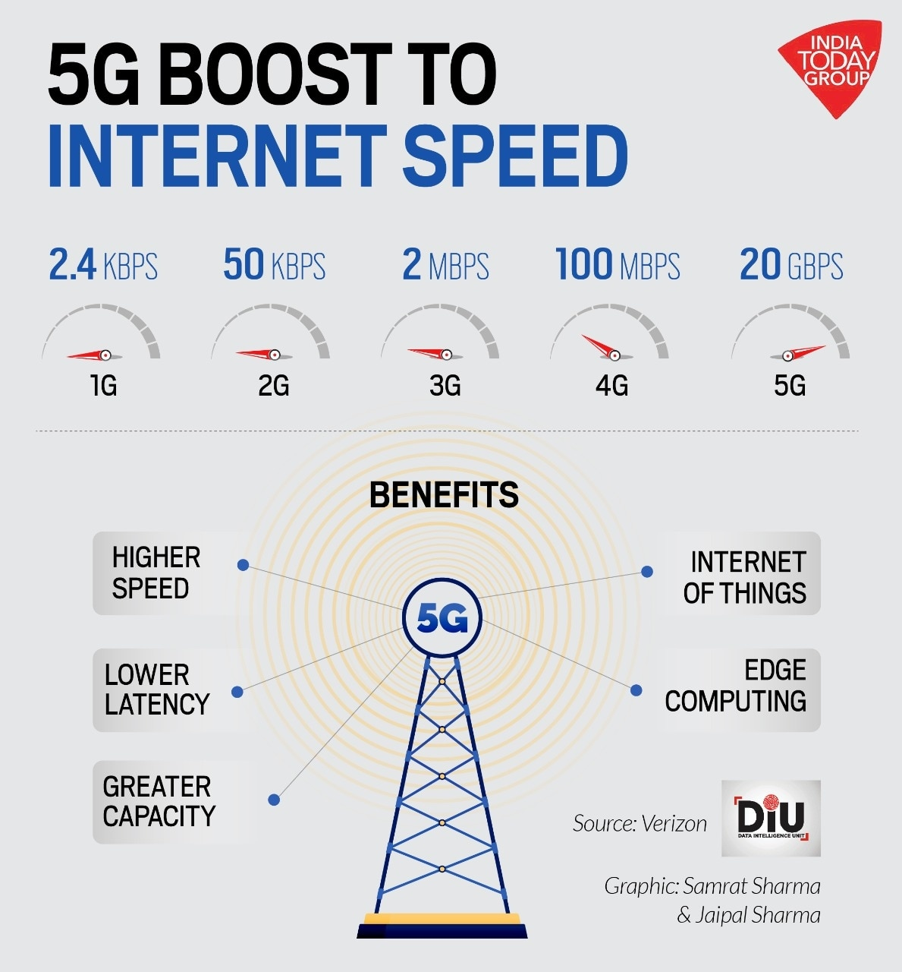
Fig: 3 - 5G
(Source: Lee, 2021)
A MoU for the construction of a chip and semiconductor plant in Brazil has been signed between Brazil and South Korea (Szot et al., 2019). Earlier this week, Brazil's Minister of Communications Fábio Faria made public the fact that South Korean chipmaker Samsung is at the centre of these discussions. Even before signing the contract with Brazil's government, Samsung appeared to be planning to increase its factory footprint. For example, the corporation pledged to spend $17 billion on a new fab in Taylor, Texas, to increase the output of high-tech semiconductors in 2021. It is anticipated that the plant will begin serving customers in the second half of 2024.

Political Economy
As South America's largest economy, Brazil exemplifies both developed and developing trends. Foreign corporations like Samsung are drawn to the country because of its vast consumer market and fast-growing middle class.
Foreign corporations, such as Samsung, may find Brazil's bureaucracy to be a significant obstacle. When establishing a company in Brazil, numerous steps must be taken, and there are many regulations and rules that must be followed (Lim and Ferguson, 2022). To add insult to injury, the judicial system is sometimes unpredictable and delayed, making it hard for businesses to safeguard their intellectual property and enforce contracts.
Businesses also face difficulties under Brazil's high tax rates and tariffs. To import goods or invest in the country, businesses must pay a variety of taxes and levies, including the country's comparatively high corporate tax rate. Consequently, this might raise operating costs for international enterprises doing business in Brazil and make it harder for them to compete with Brazilian companies.
In addition, Brazil has a long history of protectionist economic measures, which have been imposed in order to boost indigenous industry and protect native jobs. Tariffs, import quotas, and other protectionist measures make it harder for foreign firms to break into a country's economy. Companies like Samsung may find this to be an impediment to entry (Rosenblum et al.,2019).
The fact that Brazil's economy is in a constant state of flux is also significant. There have been various times when the economy was unstable or even in crisis in the country. Companies may find it challenging to foresee market conditions and establish long-term plans as a result.
Foreign corporations like Samsung may need to overcome these obstacles and familiarise themselves with local market conditions, consumer preferences, and cultural norms before they can launch successfully (Lim and Ferguson, 2022). In order to cater to the unique requirements and tastes of Brazilian consumers, they may need to make certain adjustments to their products and methods.
Despite these difficulties, Brazil's enormous consumer market and developing middle class present promising potential for multinational corporations like Samsung. The corporation needs to study the local economy, culture, and consumer habits in order to tailor its offerings to the area. Investing in solid alliances and ties with local businesses and organisations may also be necessary for them to successfully traverse the market (Rosenblum et al.,2019). It's also worth noting that Samsung has competition in Brazil's market not just from local businesses, but from multinational corporations as well.

Hofsteds’ Cultural Dimensions
Geert Hofstede's cultural dimensions highlight the ways in which people from different societies think about and deal with topics like authority, individuality, masculinity, and risk. The country of Brazil can also be analysed along these lines.
When compared to other countries, Brazil has a quite high power distance. This indicates that power and status differences are substantial in Brazil and are widely accepted (Litvin, 2019). Remembering this may be vital for Samsung when engaging with local partners and suppliers, who may prefer consider archical structure.
Brazil is not a very individualistic country. There appears to be a strong sense of collectivism and social solidarity in Brazilian society, with communal aims often taking precedence over individual ones. Samsung may want to think about this while crafting advertising and marketing campaigns for the Brazilian market, as messages that focus on the common good rather than on the individual's success may better connect with the locals there.
Brazil has a high level of masculinity, which indicates that there is a widespread emphasis on power, wealth, and status in daily life (Tehrani et al., 2021). This may be significant for Samsung to keep in mind when it positions its products in the Brazilian market, since doing so may require them to place greater emphasis on the superior quality and performance of its wares in order to win over the country's discerning consumers.
Brazil does not fare well on the dimension of risk aversion. This shows that Brazilians are open to new experiences and less prone to see ambiguity and change as dangerous. Samsung might capitalise on this quality by releasing groundbreaking new technologies or innovations into the market, where they are more likely to stand out from the crowd.
It's important to remember that culture has many layers and facets and that these aren't the only ones to think about when trying to grasp Brazil's cultural milieu (Rehman, 2022). Samsung needs to do its own study to better understand the local market because culture can change over time and differ within a region.

Porter’s Analysis
The Five Forces model developed by Michael Porter is a method for studying market profitability and industrial competitiveness. It can be used to visualise the surroundings in which a Samsung factory in Brazil would function.
The threat of new entrants: A new company entering an industry poses a threat, so this group analyses what it takes to break into that market. Tariffs and taxes imposed on imported goods are two examples of such obstacles in Brazil, along with the high costs of opening up shop there and negotiating the country's bureaucracy (Shamout, and Elayan, 2020). Additionally, there are a lot of rivals in this industry. Consequently, Samsung could encounter difficult entrance obstacles.
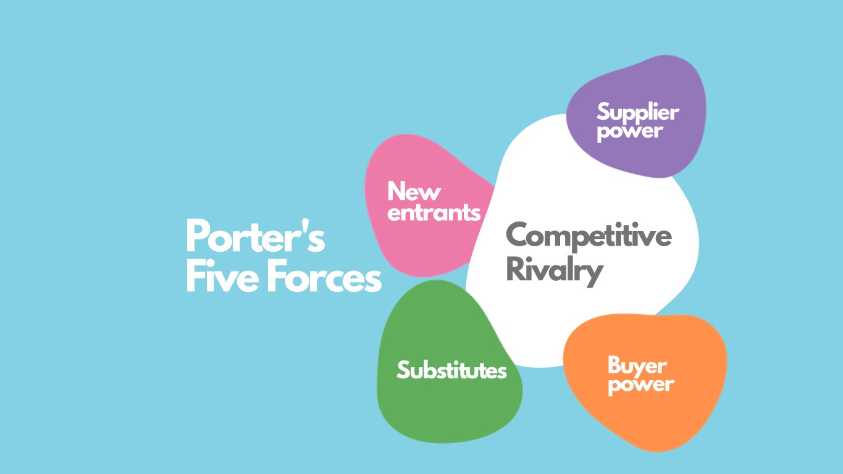
Fig: 4 - Porter’s Forces
Sources: (Shamout, and Elayan, 2020)
The threat of substitute products: This factor considers alternatives to Samsung's offerings that consumers might prefer. There is a significant threat of alternative products due to the large number of domestic and international competitors already existing in the Brazilian market.
Bargaining power of suppliers: Supplier bargaining strength is analysed by this group to see how much sway Samsung's raw material and component suppliers have over Samsung's pricing. Samsung may have trouble securing the materials it requires in Brazil at a fair price due to the country's intense resource competitiveness and high taxes and tariffs, which give Brazilian suppliers considerable leverage in negotiations (Hidiroglu, 2021).
Bargaining power of buyers: Customers' ability to negotiate the price of Samsung's products is analysed by this group. Samsung may have an advantage in Brazil's vast consumer market and quickly growing middle class, but consumers would also benefit from the country's robust competition in the electronics sector.
Competitive rivalry: This force looks at the level of competition in the industry. Many different domestic and international businesses are already present in Brazil's electronics industry. Samsung may find it difficult to expand its market share and boost profits amidst such fierce rivalry.
According to Porter's Five Forces, the overall competitiveness of the electronics market in Brazil may not be in Samsung's favour (Shamout, and Elayan, 2020). Competitive rivalry is fierce due to the high barriers to entry, substantial replacement product threat, strong bargaining power of providers, and moderate negotiating power of customers. Samsung would have to differentiate itself and target a certain market segment, while also establishing solid ties with local partners and suppliers.
Samsung’s entry mode strategy in Brazil
The entry mode strategy that a company like Samsung adopts when breaking into a new market like Brazil will depend on the company's specific objectives, available resources, and the nature of the market being entered (Pandiarajan, 2022). Exporting, licencing, franchising, joint ventures, and totally owned subsidiaries are some of the most frequent entrance mode methods.
A totally owned company in Brazil could be one means through which Samsung enters the market there. To do this, Samsung would establish a wholly-owned subsidiary in Brazil (Joao et al., 2021). Samsung would have full control over its Brazilian operations under this entry option, allowing it to tailor its goods, distribution channels, and marketing campaigns to the specific needs of the Brazilian market. In addition, Samsung would be entitled to 100 per cent of any market earnings.
A joint venture, in which Samsung forms a collaboration with a Brazilian company, is another entry mode method that could be pursued (Lee, 2021). This might help Samsung make use of the local partner's insight into the market and available resources, as well as provide a foothold into the country's convoluted regulatory framework. By operating in this fashion, both businesses are able to divide up the costs and risks associated with entering a new market.
The franchising route is another option for Samsung to enter the market; in this case, the corporation would licence its brand and business model to a local franchisee. Since the franchisee would be responsible for many of the day-to-day operations, while Samsung would still have some control over the business, this could be a low-cost and low-risk approach for Samsung to join the market (Ishigai, 2020).
An alternative means through which Samsung could enter the market would be to licence its products or technologies to local businesses in exchange for payment. As with a wholly owned subsidiary or a joint venture, this would be a low-cost and low-risk route for Samsung to enter the market, but the corporation would have less influence over the business operations.
Last but not least, Samsung might join Brazil's market through exporting, in which case the business would sell its products through distributors or shops rather than directly to consumers (Joao et al., 2021). While this entry method would have low barriers to entry and be simple to implement, Samsung would have less say over the pricing and positioning of its goods in the market.
The company's goals, available resources, and the state of the target market all play a role in determining the best entrance strategy. Samsung will have to figure out what kind of market entry will give them the most leverage, resources, and opportunities in the Brazilian market.
OLI Paradigm
The Ownership-Location-Internalization (OLI) paradigm provides a framework for investigating why and how a corporation would enter a foreign market like Brazil. Benefits associated with ownership, benefits associated with location, and internalisation advantages make up the framework's three components (Caussat et al., 2019).
The term "ownership-specific benefits" is used to describe a company's competitive edge as a result of its ownership structure. Ownership-specific advantages that Samsung may use to compete in the Brazilian market include the company's global prominence in the electronics industry, its breadth of electronic product offerings, and its well-known brand name. The many electrical items Samsung offers and its well-known brand name are assets that might be used to Samsung's benefit in the Brazilian market (Luo, 2021). Samsung has a proven track record of expanding into new areas and successfully tailoring its offerings to satisfy consumer demand in those regions. Samsung could exploit its advantages in the electronics business (resources, technology, and brand reputation) to its advantage in Brazil.
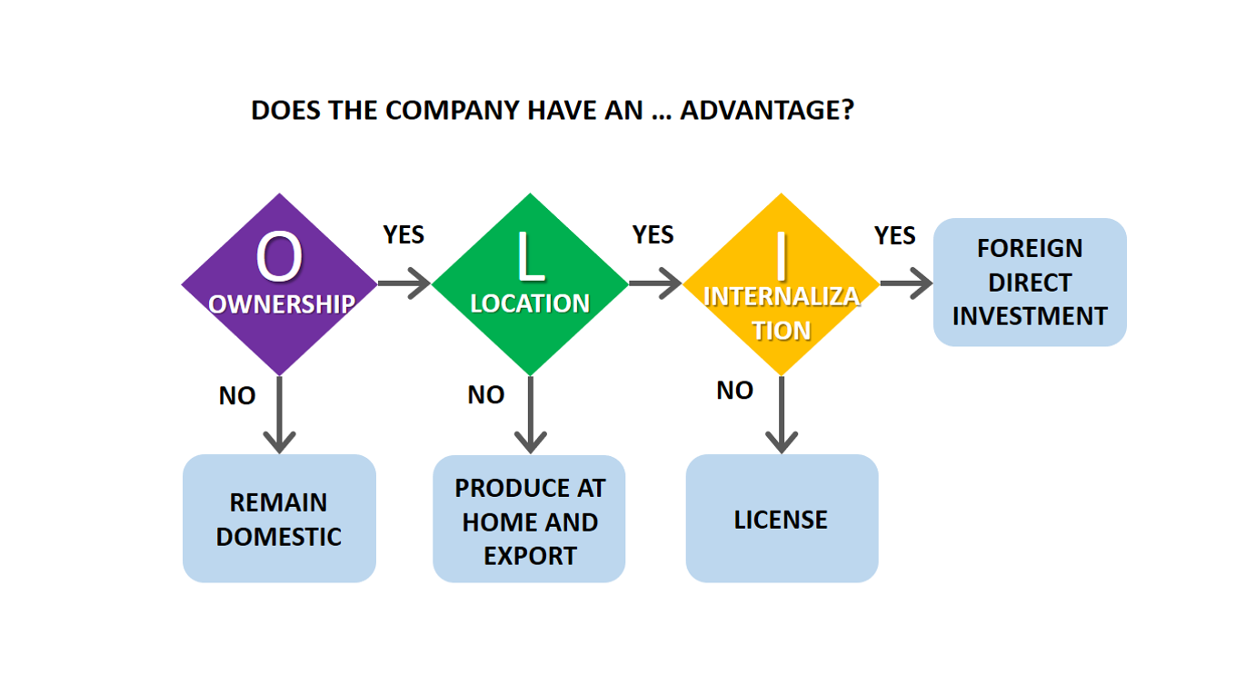
Fig:5 - OLI Paradigm
Source: (Caussat et al., 2019)
Locational benefits are those that are unique to the target market, in this case, Brazil. Samsung sees enormous potential in Brazil because of the country's flourishing economy and rising demand for technology products, as well as it's large and quickly expanding consumer market and growing middle class. Brazil's consumer market is huge and developing, and the country also boasts a sizable and expanding middle class (Bajrami, 2019). There is a huge market for technology items in this country, and a business like Samsung stands to gain substantially from its growth. In addition, Brazil has a large number of young people that are technologically aware and might be a great market for Samsung.
The term "internalisation advantages" is used to describe the positive outcomes that can occur when a business decides to handle a task or procedure in-house as opposed to contracting it out or licencing it (Caussat et al., 2019). By establishing a wholly owned subsidiary or a joint venture in Brazil, Samsung would get access to the resources of the country, more room for innovation and localization, and more control over the quality of its products. Establishing a wholly owned subsidiary or a joint venture in Brazil might provide Samsung with internalisation advantages such as improved control over product quality, access to local resources, and increased room for innovation and localization. Additionally, by taking control of production in-house, Samsung would have a deeper understanding of the Brazilian market, allowing for better product adaptations (Kim et al., 2019). Furthermore, Samsung can strengthen its ties to local suppliers and partners and adapt its business strategy to the region.
The OLI paradigm is helpful for figuring out why a corporation like Samsung would want to expand into a new market like Brazil. Through consideration of these three factors, Samsung would be able to determine whether or not it would be beneficial to establish a wholly-owned subsidiary in the country, thereby maximising its potential to take advantage of the location- and internalization-specific benefits of doing so, as well as the ownership-specific benefits.

Pros and Cons of its Entry Mode
The ideal way for Samsung to join the Brazilian market is to analyse the benefits and drawbacks of each entry mode strategy before deciding which one to implement. Some potential benefits and drawbacks of Samsung's entry mode offerings in Brazil are listed below.
Wholly Owned Subsidiary
Pros
The ability to direct all activities in Brazil. It also has the ability to adapt manufacturing, distribution and advertising to regional needs. There is an ownership of 100 per cent of all market gains (Choi et al.,2022). Furthermore, it has the ability to tap into existing networks and get a thorough understanding of the local market while simultaneously establishing reliable relationships with local partners and suppliers.
Cons
There is a large initial investment and ongoing expenses. A greater degree of danger and difficulty is involved in negotiating Brazil's convoluted bureaucracy and regulations. This will depend on how well the Brazilian subsidiary does and how the Brazilian economy develops.

Joint venture

Pros
Access to the local partner's knowledge of the market and resources. There are shared risks, market knowledge and costs It has the ability to navigate the complex bureaucracy and regulations in the country (Park, 2022). There is an allowance for more localization and adaptation to the market.
Cons
There is a potential for disagreements and conflicts with the local partner. Shared control over the joint venture could limit decision-making and strategic flexibility. Moreover, dependent on the performance of the local partner and the market conditions in Brazil.
Franchising

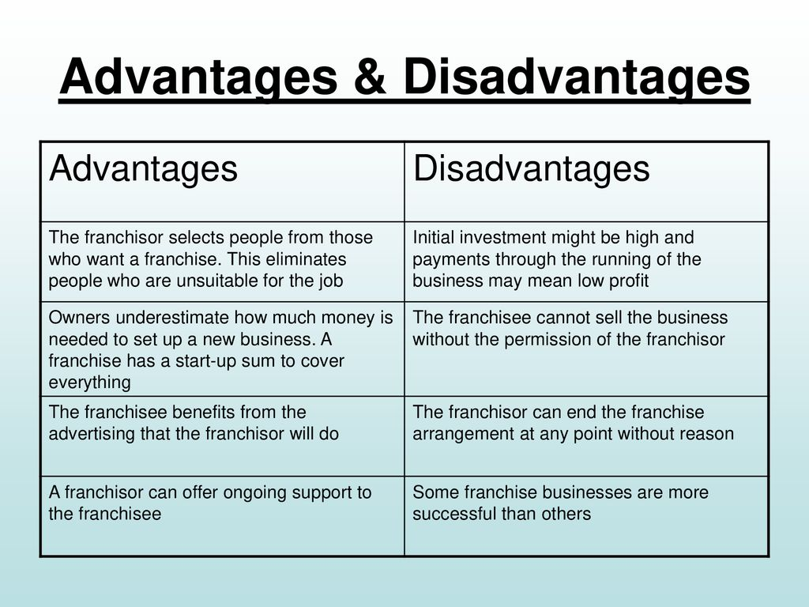
Fig: 6- Franchising
(Source: Choi et al.,2022)

Pros
Low cost and low-risk way to enter the market. The local franchisee handles many of the day-to-day operations. Moreover, Samsung retains some level of control over the business
Cons
Limited control over the business operations is a significant drawback. There exists a dependence on the performance of the local licenses.
In conclusion, the company's objectives, available resources, and the state of the target market all factor into the decision of which entry mode approach to use (Choi et al.,2022). There are pros and cons to every entry strategy, and what works for one business may not be optimal for another. Samsung must consider the advantages and disadvantages of each entry approach in light of the Brazilian market's specific conditions before deciding which one offers the optimal combination of flexibility, efficiency, and chances of success.

Conclusions and Recommendations
It's safe to say that Samsung is one of the world's largest corporations. It operates on a global scale thanks to a network of dozens of major affiliates in different parts of the world. Despite its massive size, the corporation has consistently reported positive financial results throughout the years, demonstrating its impressive capacity for scalability. The company's transnational business plan includes components of the global business strategy. Their flagship phones, TVs, and appliances are all manufactured to the same exacting standards no matter where in the world a customer purchases them. Samsung, however, also aims to meet the needs of customers in regions where pricey smartphones are not economically viable for the average consumer by offering a separate line of devices that are slightly less powerful than the flagship line but still give necessary functionality. As the company gains more name recognition abroad, it can focus on expanding into more lucrative markets rather than worrying about how to make a profit off of those who can't buy its products.
As can be seen from the above, there are a number of obstacles that firms like Samsung must overcome in order to break into the Brazilian market. Intense rivalry, low bargaining power of consumers, and great negotiating power of suppliers and replacement products all contribute to these difficulties. Brazil's cultural and economic setting, with its high taxes and tariffs and convoluted bureaucracy, adds another layer of difficulty.
Despite the difficulties, Samsung has a great opportunity in Brazil thanks to the country's vast and quickly rising consumer market and growing middle class. The company's ownership gives it advantages in key areas, including the breadth of its electrical product offering and the strength of its brand.
If Samsung wants to be successful in the Brazilian market, it may need to adopt a unique entry mode approach that accounts for the realities of the market as well as the company's objectives, resources, and competencies. Creating a wholly-owned subsidiary or a joint venture in Brazil is one option worth considering. This would enable the firm to tailor its offerings, channel tactics, and marketing campaigns to the local market, maximising its potential for success there while also taking full use of the location-specific and internalisation advantages afforded by the country.
In addition, Samsung needs to put effort into developing healthy relationships with regional businesses and organisations. To further its grasp of the local market, culture, and consumer behaviour, the corporation should do its own market research. Samsung may want to think about tailoring its products and methods to better appeal to the tastes of Brazilian customers.
In addition to the aforementioned measures, Samsung may look at establishing a local supply chain in Brazil in order to cut costs and better serve the needs of the local market. Creating local manufacturing facilities or forming agreements with regional suppliers are two examples. This would allow Samsung to not only lower the costs associated with importing items into the country, but to also better manage the quality and delivery of goods, and to be more responsive to changes in the market.
The company could also put money towards CSR projects and community improvement programmes in the areas where it has operations. This can help Samsung improve its image in the country and win over locals by answering any questions or calming any fears that locals may have regarding the business's operations there.
Before breaking into the Brazilian market, Samsung needs to be flexible, forward-thinking, and patient. The business may encounter some early challenges, but with a solid strategy and focused execution, it will ultimately be successful.

Reference List
Aliekperov, A., (2021). Creating Business and Corporate Strategy: An Integrated Strategic System. Routledge. https://books.google.com/books?hl=en&lr=&id=GfQxEAAAQBAJ&oi=fnd&pg=PT7&dq=Aliekperov,+A.,+2021.+Creating+Business+and+Corporate+Strategy:+An+Integrated+Strategic+System.+Routledge.&ots=Xk702i0f33&sig=hCCp7SAkFM3o_zPS9Xggicp_yXw
Bajrami, H., (2019). Theories of foreign direct investment (FDI) and the significance of human capital.http://zbw.eu/econis-archiv/bitstream/11159/4342/1/1694266591.pdf
Cats, A., (2020). Alliance network strategies for cross-industry collaboration and the internationalisation of R&D in the semiconductor industry (Doctoral dissertation, University of Reading).https://centaur.reading.ac.uk/94612/1/22849837_Cats_Thesis.pdf
Caussat, P., Prime, N. and Wilken, R., (2019). How multinational banks in India gain legitimacy: Organisational practices and resources required for implementation. Management International Review, 59(4), pp.561-591.https://www.sciencedirect.com/science/article/pii/S0040162521005539
Cheng, L.C., Chen, K., Lee, M.C. and Li, K.M., (2021). User-Defined SWOT analysis–A change mining perspective on user-generated content. Information Processing & Management, 58(5), p.102613.https://www.sciencedirect.com/science/article/pii/S0306457321001096
Choi, T.M., Kumar, S., Yue, X. and Chan, H.L., (2022). Disruptive technologies and operations management in the Industry 4.0 era and beyond. Production and Operations Management, 31(1), pp.9-31. https://www.emerald.com/insight/content/doi/10.1108/IJOPM-08-2021-0534/full/html
Hidiroglu, D., (2021). The Strategies in Global Semiconductor Industry: The SWOT Analysts of Samsung Electronics Company. American Journal of Management, 21(2), pp.107-118. http://m.www.na-businesspress.com/AJM/AJM21-2/7_HidirogluFinal.pdf
Hobday, M., (2020). Latecomer catch-up strategies in electronics: Samsung of Korea and ACER of Taiwan. In Korean Businesses: (pp. 48-83). Routledge. https://www.taylorfrancis.com/chapters/edit/10.1201/9781315038124-4/latecomer-catch-strategies-electronics-samsung-korea-acer-taiwan-mike-hobday
Ishigai, P.A., 2020. Standardization and adaptation in multinational corporations: applied study on Samsung’s marketing mix strategy (Doctoral dissertation).https://bibliotecadigital.fgv.br/dspace/handle/10438/29092
Joao, B., Castelo, R., Bezerra, D., Piscopo, M., Prates, L. and Serralvo, F., (2021). Global Strategy in LCD Market for Late Movers: A Brazilian Case. https://repositorio.altecasociacion.org/handle/20.500.13048/274
Kim, K.H., Lattemann, C., Park, B.I. and Zhang, W., (2019). New international business theories for China goes global? The importance of institutions, innovativeness and learning. International Journal of Emerging Markets. https://www.emerald.com/insight/content/doi/10.1108/IJOEM-01-2019-574/full/html
Lee, S.H.Y., (2021). The internationalization of South Korea MNC to Brazil (Doctoral dissertation). https://bibliotecadigital.fgv.br/dspace/handle/10438/30234
Lee, Y.W., (2019). Enhancing shared value and sustainability practices of global firms: The case of Samsung electronics. Strategic Change, 28(2), pp.139-145.https://onlinelibrary.wiley.com/doi/abs/10.1002/jsc.2255
Lim, D.J. and Ferguson, V.A., (2022). Informal economic sanctions: the political economy of Chinese coercion during the THAAD dispute. Review of International Political Economy, 29(5), pp.1525-1548. https://www.tandfonline.com/doi/abs/10.1080/09692290.2021.1918746
Litvin, S.W., (2019). Hofstede, cultural differences, and TripAdvisor hotel reviews. International Journal of Tourism Research, 21(5), pp.712-717. https://onlinelibrary.wiley.com/doi/abs/10.1002/jtr.2298
Luo, Y., (2021). New OLI advantages in digital globalization. International Business Review, 30(2), p.101797.https://www.researchgate.net/profile/Abebe-Alemu-2/publication/364495612_Economic_Liberalization_Privatization_and_Globalization_HodgePodges_Ethiopian_Manufacturing_Firms_Retort_from_Marketing_Perspectives/links/636924af431b1f53007a8574/Economic-Liberalization-Privatization-and-Globalization-Hodge-Podges-Ethiopian-Manufacturing-Firms-Retort-from-Marketing-Perspectives.pdf#page=175
Pandiarajan, V., (2022). Business Innovation: A Case Study Approach. Routledge.https://api.taylorfrancis.com/content/books/mono/download?identifierName=doi&identifierValue=10.4324/9781003190837&type=googlepdf
Park, C., (2022). Different determinants affecting first mover advantage and late mover advantage in a smartphone market: a comparative analysis of Apple iPhone and Samsung Galaxy. Technology Analysis & Strategic Management, 34(3), pp.274-289.https://www.emerald.com/insight/content/doi/10.1108/IJOPM-08-2021-0534/full/html
Rehman, A.U., (2022). Consumers' perceived value of luxury goods through the lens of Hofstede cultural dimensions: A cross‐cultural study. Journal of Public Affairs, 22(4), p.e2660. https://onlinelibrary.wiley.com/doi/abs/10.1002/pa.2660
Rosenblum, D., Salomão Filho, C. and Ido, V.H.P., (2019). Emerging global giants: the legal infrastructure and structural causes of economic monopoly: Samsung. In Global Private International Law. Edward Elgar Publishing.https://www.elgaronline.com/abstract/edcoll/9781788119221/9781788119221.00021.xml
Shamout, M.D. and Elayan, M.B., (2020). A Comparative Analysis of Strategic Planning Practices in Gulf Cooperation Council Region: A Case Study of Huawei and Samsung Companies. Journal of Talent Development and Excellence, 12(1), pp.4891-4910. https://www.researchgate.net/profile/Mohamed-Shamout-2/publication/354062694_A_Comparative_Analysis_of_Strategic_Planning_Practices_in_Gulf_Cooperation_Council_Region_A_Case_Study_of_Huawei_and_Samsung_Companies/links/620232bc4d89183b338b463d/A-Comparative-Analysis-of-Strategic-Planning-Practices-in-Gulf-Cooperation-Council-Region-A-Case-Study-of-Huawei-and-Samsung-Companies.pdf
Solihin, D., Ahyani, A. and Setiawan, R., (2021). The Influence of Brand Image and Atmosphere Store on Purchase Decision for Samsung Brand Smartphone with Buying Intervention as Intervening Variables. International Journal of Social Science and Business, 5(2), pp.262-270.https://ejournal.undiksha.ac.id/index.php/IJSSB/article/view/30847
Szot, T., Specht, C., Specht, M. and Dabrowski, P.S., (2019). Comparative analysis of positioning accuracy of Samsung Galaxy smartphones in stationary measurements. PloS one, 14(4), p.e0215562.https://journals.plos.org/plosone/article?id=10.1371/journal.pone.0215562
Teece, D.J., (2022). A wider‐aperture lens for global strategic management: The multinational enterprise in a bifurcated global economy. Global Strategy Journal, 12(3), pp.488-519.https://onlinelibrary.wiley.com/doi/abs/10.1002/gsj.1462
Tehrani, M., Rathgeber, A., Fulton, L. and Schmutz, B., (2021). Sustainability & CSR: The relationship with Hofstede cultural dimensions. Sustainability, 13(21), p.12052. https://www.mdpi.com/2071-1050/13/21/12052
Tien, N.H., (2019). International distribution policy comparative analysis between samsung and apple. International journal of research in marketing management and sales, 2020(1), p.2.https://www.researchgate.net/profile/Nguyen-Tien-32/publication/338719419_International_distribution_policy_comparative_analysis_between_samsung_and_apple/links/613c55f401846e45ef3e4a14/International-distribution-policy-comparative-analysis-between-samsung-and-apple.pdf
Zulkapli, A., (2022). Technology Entrepreneurship Project (ENT 600): Samsung Electronics Co., Ltd. https://ir.uitm.edu.my/id/eprint/55261/

