2019
Project Management Report
University of Wales Trinity Saint David | [Company address]
[Document subtitle]
Andom Alemayo (P151438)
Table of Contents
Introduction 2
Purpose of the risk management 3
Risk management 3
Risk identification 3
External risk factors 4
Internal risk factors 5
Risk Analysis 6
Qualitative descriptors of risk probability 7
Quantitative Risk descriptors of impact 7
Probability impact Matrix 8
Discussion 8
Strategies 9
Code of practice 10
Sustainability 10
Sustainability issues 10
Ethical and legal issues 12
Quality Assurance Issues 13
References 14
Appendence 16
20

Introduction
This assignment details the third and last part of the project report about the DVLA Network Disaster Recovery. This report will focus in four main sections.
The first section will introduce the purpose of the risk management, identify the risk factors, analyse the risk factors and finally cite strategies.
Next, the code of practice which entails sustainability issues and the ethical along with the legal issues will be discussed. Possible legal and ethical predictions about the outcome of the Brexit will be outlined.
Finally, the quality assurance issues for the third sector project along with few encountered challenges will be discussed.

Purpose of the risk management
The main aim of the risk management is to help the researcher to identify, classify and prioritise the existing and future risk factors which have the potential of destroying or affecting the project.

Risk management
Risk is the chance or probability of something occurring which can have an effect or influence on the other objective [1]. It can also be defined as the product of the probability loss and the magnitude of gained loss [2].

Risk identification
Risk identification is the process of recognising the potential risks which are capable of affecting or halt the achievement of the project objectives [3].
While conducting the project, the following risk factors has been identified and classified as external and internal risk factors.

External risk factors
Factors which are beyond the control of the project owner or human being are generally classified as external risk factors. Most of the time these factors are unpredictable and hard control [4].
Some the main external risk factors which have potential risk to devastate the Disaster recovery plan for DVLA are listed below.
- Man-made disasters either they happened deliberately or accidentally can also devastate the whole DVLA building or affect its normal operation. For example deliberately a human being can use explosives to blow the office (terrorism) or any accident can take place due to human errors.
- Natural disasters such as flood, earth quack, hurricane, wildfire, storms and so on can seriously cause damage to the DVLA.
- Services like accessing the database, saving and retrieving the data are heavily relay on Internet. Hence, any interruption of the internet service can affect the online services of DVLA.
- Any damage or failure of the hardware like routers, switches, poor cabling as well as software failure can affect the normal operations of the DVLA.

Internal risk factors
While internal risk factors are those factors which can be identified by the project team members mostly project managers. Internal risk factors belongs to the individual organisation or project [4].
Some the key external risk factors which can harm the Disaster recovery plan for DVLA are listed below.
- Physical security; some of the local employ can enter the server room and physically destroy the hardware in the racks or stole some devices.
- Human error; by nature any human being is expose to act of performing mistakes. Although these mistakes can be decreased through experience, they are an inevitable.
- Power supply can be interrupted due many known and unknown or unpredictable factors which in turn may lead to the power cut or fire accident.

Risk Analysis
As it can be seen in the table below the major risk factors which can cause destruction to DVLA are listed below. The likelihood of occurrence as well as the impact they can leave on the project are assigned numbers (0-10) where, zero (0) value indicates lower chance likelihood and ten (10) indicates higher chance of likelihood. Similarly, risks which have greater impact on the project are indicated with higher value and vice versa.

Risks | Likelihood (0-10) | Impact (0-10) | Risk Factor (Likelihood X Impact)
Cyber attack | 9 | 9 | 81
Earth quack | 8 | 9 | 72
Flooding | 8 | 8 | 64
Hurricane | 6 | 8 | 48
ISP failure | 5 | 9 | 45
Storm | 4 | 8 | 32
Physical damage | 2 | 2 | 4
Router failure | 5 | 6 | 30
Wild fire | 3 | 4 | 12
power supply disruption | 2 | 9 | 18
Table 1

Qualitative descriptors of risk probability
The table shows probability of occurrence along with the description of the range values
Chance of occurrence | Range
High | Values greater than 5 shows high chance of occurrence
Moderate | Values between 3 and 5 indicates moderate chance of occurrence
Low | Values less than 3 demonstrates less probability of happening
Table 2

Quantitative Risk descriptors of impact
The table shows the impact of the possible risk along with the description of the range values
Chance of occurrence | Range
High | Values above 5 marks a greater impact on the project
Moderate | 3 to 5 indicates that there will be moderate impact on the project
Low | Value below 3 shows that there will create a low impact on the project
Table 3

Probability impact Matrix
The figure below shows the probability impact matrix.
Line of tolerance
0.0
10
High
Moderate
Impact
Low
Cyber-attack
Flooding
Earth quack
 | Wild fire | Hurricane  ISP failure
Physical damage

Moderate
High
Low
High
10
0.0
Likelihood
10

Discussion
10
As it can be seen in the probability matrix above risk factors which can cause massive distractions to the project (i.e. DVLA) are sorted out. Most of these risk factors laid above the tolerance line and to make them more visual they are coloured as blue. The occurrence of a single or combination of these risk factors can destroy the whole project and leave a greater impact on the project as well as humans.
Other risk factors such as wild life can cause a moderate effect on the project mainly because immediate action can be taken to tackle incidence.
On the other hand risk factors such as physical damage can gain quick alternative solutions either by calling an expert or making use of the existing backup system.

Strategies
In this project the following strategies are drafted out.
- To the data distraction and disruption of the online services due to natural disasters like storms and flood, servers will be allocated in remote area (i.e. in Bristol).
- Installation of anti-virus to the computers in the office as well as implantation of firewall to protect the possible cyber-attack.
- A system which allows a standby router will be designed to back up the possible hardware failure.
- Making use of the remote data back systems like iCloud
- Provision of security measures to prevent any physical damages.

Code of practice

Sustainability
Although the concept of sustainability has a broad meaning and spectrum, generally it can be defined as the continuous balance in the process of interaction between the carrying capacity of the environment and the human being. Sustainability encourages the population to develop and grow to its full extent while preserving the carrying environment. Some of the most important sustainability domains are; Economic, Social, Spiritual, Material and the domain of life [5].

Sustainability issues
The technological development and advancement in the field of the information and technology (IT) plays a great role simplifying and shaping the way we live today. Nevertheless, such development usually doesn’t come without any consequences or harm to the environment. Thus, the growing challenges are, developing an IT packages which can maintain the suitability of the environment. The impact of the IT to our environment can be classified as first, second and third order.
The complete design and implementation of the Network Disaster Recovery project for the DVLA requires many software and electronic devices such routers, switches, computers, servers and so on. Due to several reasons when these electronic devices reaches the end of their useful life, they become a waste and they are referred as “E-waste” [6]. The E-waste can cause the first order impact on the sustainability of the environment and this is mainly because these devices has the potential of generating heat and they also consume a considerable amount of energy. Moreover, the E-waste contains toxic chemicals like arsenic, mercury, lead and so on, which are hazardous to the environment [7]. First order impact is outcome of the immediate and the direct effect of a particular factor (IT in this case) on sustainability [6].
While the second order is the indirect impact of the application a particular factor (IT in this case) on the sustainability [6]. For example, once the project is completed and became fully functional it saves the time and reduces the costs which can occur as a result of transportation because people will be able to get dynamic online services instead of directly visiting the DVLA office. This in turn reduces the possible air pollution effect which can result from the vehicles used by the costumers. Moreover, as this project is designed to ensure the continuity and availability of the online serves for the customers who are seeking a service from the DVLA, this system minimises consumption of electric energy and paper. It also reduces the amount of heat generation which can be produced from the running electronic devices such as computers, printers and so on. Hence the implementation of this project will offers a great benefits of the second order impacts as compared to the first and third order impacts.
The third order effect is more or less related to the long term socio economic impact of the existing and/ or the emerging technologies on the sustainability [6].
The Network Disaster Recovery project has a potential of changing the people’s driving style as most people to lay on bed and accomplish their tasks online rather directly driving to the DVLA off which could be also smart way saving fuel consumption. In doing so a great caution is required in order to maintain customer’s confidentiality which could be result from network vulnerability. More due to assurance of the continuous network system and fast internet connection the local employers may adapt the habit of surfing on a social media like Facebook, twitter, Instagram and so on which can decrease efficiency of work.

Ethical and legal issues
The advancement of technological development plays a great role in shaping the way we live and communicate. This achievement would have been almost impossible without the use of Internet and electronic devices like computers.
The use of internet and computers requires some ethical and legal issues. The ethical aspects refers to the fairness or moral values used as a guideline for the computer users. While the legal issues refers to the laws set to govern the use of computers and internet although, these laws are revised now then due to the fast growth of the internet [8] [9].
Some of the legal and ethical issues according IEEE and the British Computer Society (BCS) code of conducts which can be implemented in this project are listed below.
- Ensuring the safeguarding, welfare and health of the public and the environment by implementing a sustainable development structure. Implementing a bad design of network for the DVLA project is hazardous to both the public and environment.
- Avoiding discrimination of any whether it is based on the ethnic, sex, race, religion and so on. One of the key factors for the success of any project and particularly this project is the harmony of its team members. Hence, discrimination should not be tolerated in any ways.
- Employees should perform their professional duties with care and diligence as it required by the authorities and at the same time taking their professional judgment into consideration. For instance the use of social media and other non-work related websites during the office working ours.
- Avoiding false accusation of co-workers. For the success of this project co-workers should respect each other.

- Confidentiality and data protection of all the users. Information personal information the users be preserved from destruction or access by irresponsible individuals or organisations such hackers. And since the DVLA contains important and sensitive data care must be taken.
On the coming few months the UK expected leave the European members and remain out of the bond. Consequently, the following ethical and legal issues are predicted to take place.
- There will be some regulation in regard to data protection and sharing between UK and the other European countries [10].
- Action might be taken to alleviate the digital literacy as the UK economic growth and innovations are heavily relay on the digital capacity its people [10].
- Issue of constructing a sound information security sector for that meets UK’s strategy [10].

Quality Assurance Issues
Quality assurance is a systematic approach that helps to ensures that quality of production meets demand and requirement of the costumer. The aim of this methodology is to identify the main quality issues and take an immediate action to satisfy the costumer [11].
At the final stage of the project to check and to assess the quality of the project, an assimilation software tool known as packet tracer is used. And the pinging between the different devices assures existence of a secure network.
The delivery of the intended massage is also assured through travel of the Packet Data Unit (PDU) from the source to the destination in the form of envelope.
There was a time constraints issue due to factor like Christmas and New Year holidays .And this forced the team members to modify the plan and work hard to in order to meet the project objectives and maintain a good quality serves by checking aspects like functionality, usability, efficiency, maintainability, probability and reliability of the system.

References

[1] | Risk Analysis in project Management, London : British Library Cataloguing in Publication Data, 2003.
[2] | P. J. E. a. P. A. Bowen, Risk Management in Project Organisations, Oxford: Butterworth Heinemann, 2005.
[3] | “Risk Identification,” MITRE Systems Engineering (SE) Competency Model , 01 September 2007. [Online]. Available: https://www.mitre.org/publications/systems-engineering-guide/enterprise-engineering. [Accessed 22 January 2019].
[4] | B. Tyson, “Identify Internal vs External Risks in Project Management,” Bright Hub PM, 28 July 2017. [Online]. Available: https://www.brighthubpm.com/risk-management/94946-internal-vs-external-risks-in-project-management/. [Accessed 22 January 2019].
[5] | M. B.-. Eli, Sustainability : definition and five Core Principles, New York: A sustainability Laboratory Publication, 2015.
[6] | A. G. Rudite CEVERE, “Information technology sustainability problems and possible,” Baltic J. Modern Computing, vol. I, no. 12, pp. 1-3, 2017.
[7] | K. Lundgren, The global impact of e-waste:Addressing the challenge, Geneva: International Labour Organization, 2012.
[8] | “Computer Ethics and Legal Isssues,” in slide Share, 15 April 2012. [Online]. Available: https://www.slideshare.net/makyong1/chapter-11-12552701. [Accessed 22 January 2019].
[9] | D. Adu, “The British Computer Society (BCS) and the Code of Conduct,” The Chartered Institute for IT, 13 November 2016. [Online]. Available: https://medium.com/@dadu_64294/the-british-computer-society-bcs-and-the-code-of-conduct. [Accessed 21 January 2019].
[10] | BCS, “BCS on digital Brexit - get involved,” The Chartered Institude for IT, October 2016. [Online]. Available: https://www.bcs.org/content/ConWebDoc/56850. [Accessed 22 January 2019].
[11] | J. Riley, “Q&A - What is involved in quality assurance,” tutor 2u, 19 December 2009. [Online]. Available: https://www.tutor2u.net/business/blog/qa-what-is-involved-in-quality-assurance. [Accessed 23 January 2019].

Appendence

PACKET TRACER DEMONISTRATION SCREENSHOT

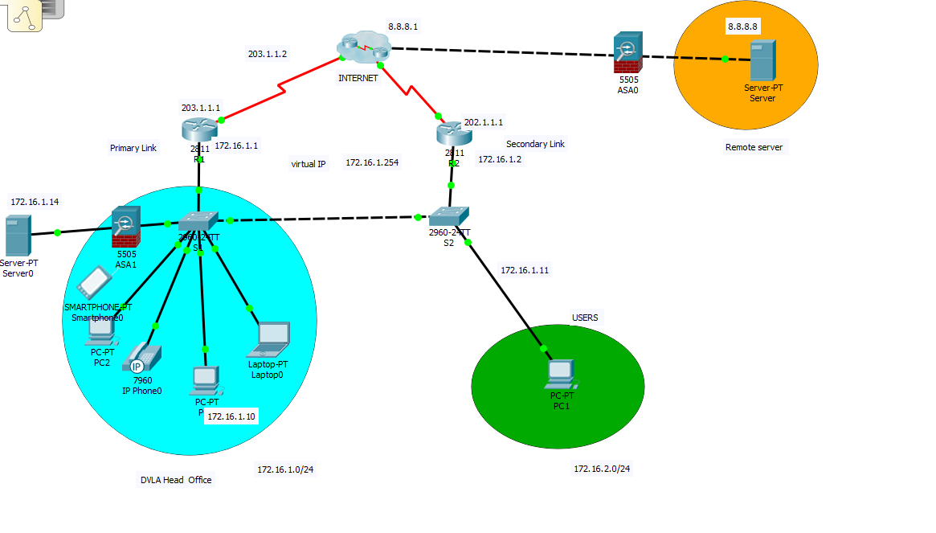

MODIFICATION OF THE RROJECT PLAN

SCHEDULE AND GANTT CHART
BEFORE
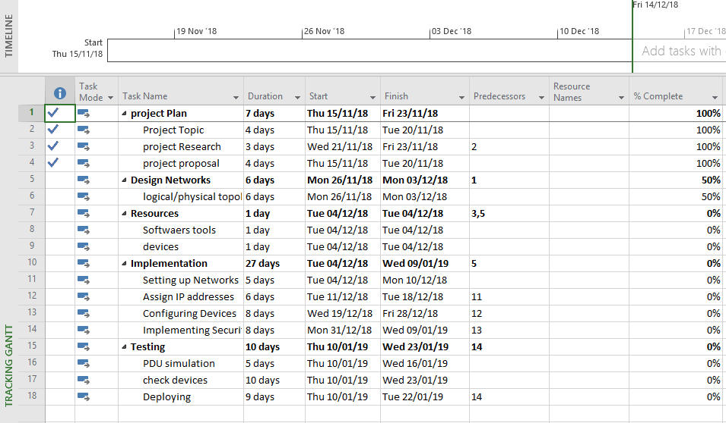

AFTER
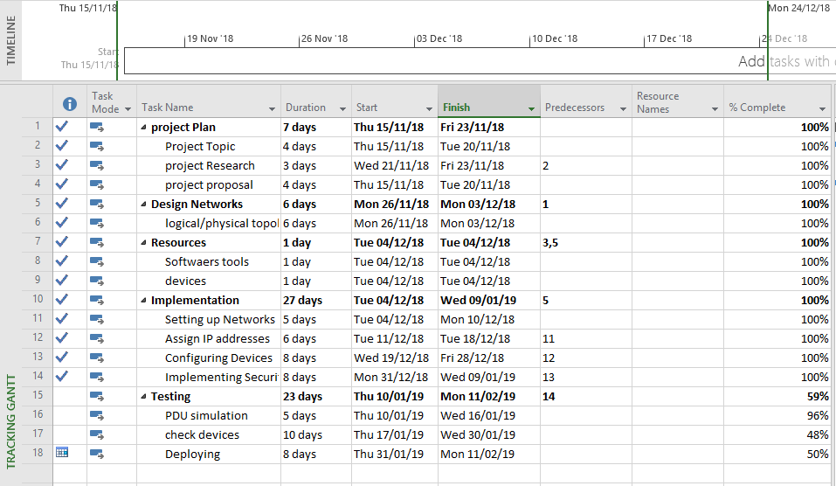

BEFORE
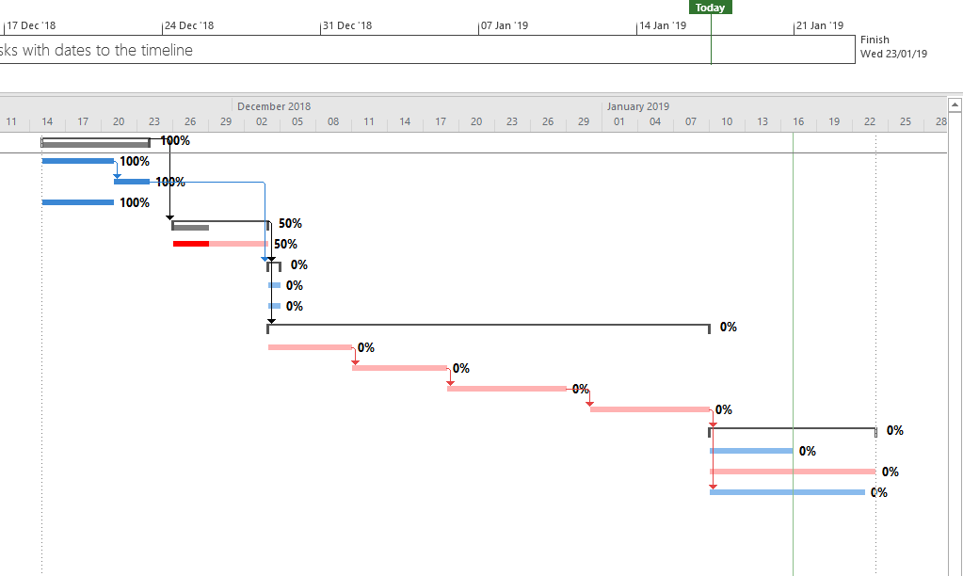

AFTER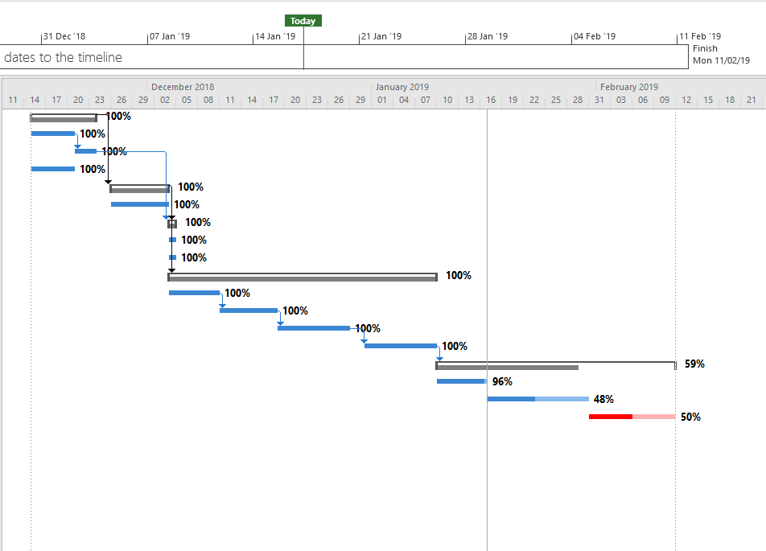

PROJECT RELATIONSHIP
BEFORE

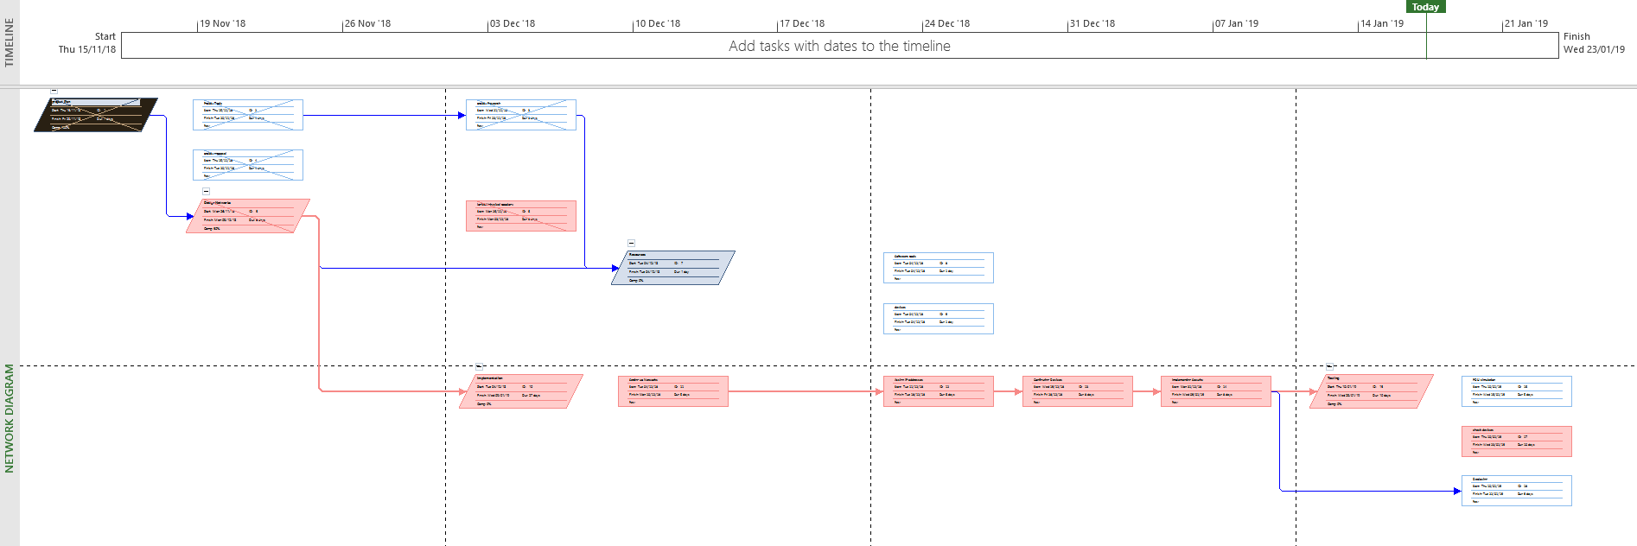

AFTER


