Report Case Study: The Seacrest Lodge

Syeda Shabna Begum
2126655

Module: Financial Management for the Hotel Industry
BMIH5007

Lecturer: Tristan Hawkins

Word Count: 2,161

Executive summary:
The executive summary for Seacrest Lodge addresses the current challenges the resort is facing. Over the past three years, Seacrest lodge has experienced a decline in occupancy and revenue, posing significant concerns for the resort’s sustainability and profitability.
Several factors have contributed to this decline, including increased competition from other resorts in the area, changing customer preferences, a lack of effective marketing strategies and the current economy. As a result, the resort has struggled to attract and retain guest, leading to a decrease in bookings and overall revenue.
To address this decline, Seacrest Lodge needs to implement a comprehensive plan that focuses on revitalising the guest experience, improving marketing efforts, and enhancing the resort’s offerings. This could involve renovating and upgrading facilities, creating unique marketing channels to reach a wider audience.
Additionally, understanding customer preference, the target market and adapting to their needs is crucial. Conducting market research and gathering feedback from guests can provide valuable insights into what will resonate with the target audience and help tailor the resort’s offerings accordingly.
The recommendations to help stabilise the resort would be instead of completely closing the kitchen, close the restaurant and look at optimising cost effective operations. This could involve optimising the menu to focus on high-margin dishes, reducing food waste through better inventory management, and implementing efficiency measures in staffing and operations.
By implementing these strategies and taking proactive measures to address the decline, Seacrest Lodge can regain its competitive edge, attract more guests, and ultimately improve occupancy rates and revenues.

Contents page:

Introduction…………………………………………………………………………………4
Market Analysis…………………………………………………………………………….4
Source Material………………………………………………………………………......4-5
Analysis of the Seacrest Lodge…………………………………………………………5
Financial Analysis Ratios…………………………………………………………………6
Reasons for Topline Revenue Decline……………………………………………….6-7
Reasons for Increase in Operating Expenses………………………………………7-8
Unanswered Questions……………………………………………………………………8
Turnaround Strategy………………………………………………………………………9
S.W.O.T Analysis ………………………………………………………………………….9
Hotel Operational structure…………………………………………………………..9-11
Comprehensive turnaround strategy and recommendations…………………11-12
Conclusion………………………………………………………………………….….12-13
References……………………………………………………………………………..14-16

Introduction:
This report will be looking at the Seacrest Lodge located on the coastline once a thriving business is now a declining resort. The resort is experiencing a decline in revenue, occupancy rate and customer satisfaction. There are many reasons as to why this business could be declining, and this report will look at a turnaround strategy to help the owner of the resort salvage the business.
Market Analysis:
Upon analysis the Seacrest Lodge has seen a decline in their financial performance in the past three years. From year 2021 to 2023 the occupancy rate dropped from 65% to 50% and the Average Room Rate (ARR) also dropped by £50. The Seacrest lodge is located on the coastline and there are now several newer more modern resorts in the vicinity making the coastal market highly competitive. Looking at the lodge’s customer reviews it indicates decline in service quality and outdated amenities, this will shift customer preference to the newer more modern accommodations, resulting in loss of customers which can be seen in their financial information of the drop in their occupancy rate from 65% to 50%. Identifying the target market allows the business to market position. The target market for this coastal resort is tourist, millennials, families, and couples, this is important to identify so the lodge can promote the resort to these groups of people through many channels of marketing, e.g. digital marketing, direct booking, social media.
Scope and Objective:
Source Material:
The source material has provided an overview of financial performance from 2021 to 2023 below:
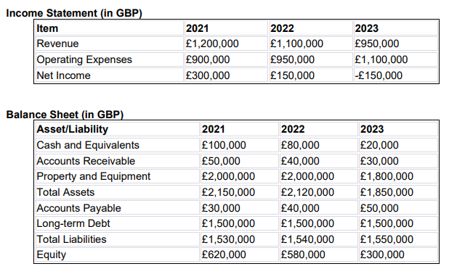
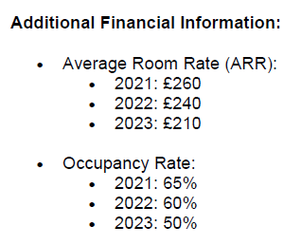
Analysis of the Seacrest Lodge’s financial performance over the past three years:
Upon analysis of the Seacrest Lodge's financial performance, it states that there is a decline in profitability. In the year 2021 they were generating revenue of £1,200,000 which by 2023 had dropped to £950,000. But the operating expenses had gone up from 2021 to 2023 starting at £900,000 to £1,100,000. The net income shows they had a profit of £300,000 in 2021 but by 2023 had fallen massively by 50% going down to -£150,000. The ARR also dropped from £260-£210 and the occupancy rate fell by 15% from 2021-2023 showing decrease in guest occupancy. The Seacrest lodges operating expenses need to be reconsidered as they are spending more on their operating expenses than the revenue they are generating. To make this resort successful there are several things that need to be considered.
Financial Analysis Ratios:
According to (Tuovila, 2023) to determine if a company is stable, solvent, liquid, or profitable enough to justify a financial investment, financial analysis is employed. Looking at the balance sheet for the Seacrest lodge a financial analysis can be conducted:
- Current ratios – Formula: Current assets divided by currents liabilities (Bankrate, 2024).
£1,850,000 / £1,550,000= 1.2 which means the Seacrest Lodge’s current asset is lower than average. As a beneficial estimate should be between 1.5 to 2.
- Quick ratios – Formula: current asset – inventory, divided by current liability.
1,850,000 – 1,800,000 / 1,550,000 = 0.03. Looking at this analysis there is not much liquidity in the Seacrest Lodge.
- Debt-to-Equity ratios – Formula: Is the total liabilities divided by the equity.
1,550,000 / 300,000= 5.16, which means the debt ratio for Seacrest is high
- Return on assets – Formula: Net Income divide by Total Assets (Hargrave, 2024)
-£150,000 / £1,850,000 = -8% According to (Elphick, 2024), in the hotel industry, a return of 6% to 12% annually is seen as good. This means the Seacrest is not doing well.
- Return on Equity – Formula: Net Income divide by Total Equity (Wall Street Prep, 2024).
-£150,000 / £300,00 = 50%. A return of 15-20% is considered good this means the high ROE for the lodge shows there’s risk (FastPay, 2023).

Reasons for Topline Revenue Decline:
Factors contributing to the decline in top line revenue, that can be deciphered from the information available, include:
- Increased competition in the marketplace, with several new, more modern hotels opening recently (SiteMinder, 2024).
- Declining occupancies (Market Penetration MPI), declining Average Daily Rate (ADR) which in turn reduces Revenue per Available Room REVPaR (RGI) which is the key metric to ascertaining a hotels revenue performance.
- Perception of value being eroded can be established by the increase in unfavourable reviews, which in turn will have a negative effect on occupancies as may cause potential bookers to look elsewhere (Whittaker, 2022).
- Current economy - Rising costs of food and utilities (Taylor, 2023).

Reasons for Increase in Operating Expenses:
Economic factors will play a huge part in the increased expenses being experienced at the Seacrest Hotel. In recent years following the global COVID-19 Pandemic the economic environment has also been faced with rising costs due to the Russia-Ukraine war. This is having an outsized impact on the global supply chain, hindering the movement of commodities, generating extreme cost rises and product shortages, and producing catastrophic food shortages worldwide (Stackpole, 2022). With the rise in cost of hotel supplies such as food, beverage, linen, amenities and operational supplies, this has increased expenses having an extreme negative impact on net income.
Additionally, to the above, the UK had experienced a recession in 2022, with the value of GBP falling having a negative impact on any international procurement that the Seacrest Hotel relies upon (Hamlet Hotels, 2024).
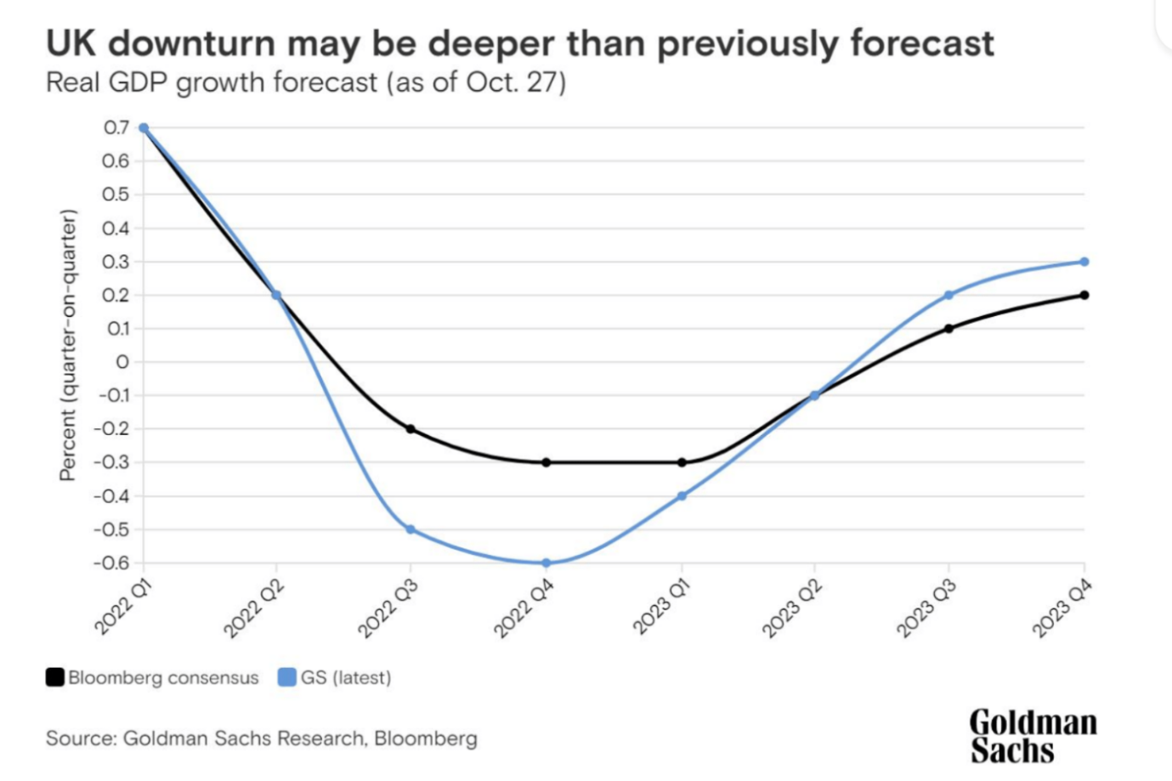
Cost of living is another current economic challenge; the hospitality sector is impacted by the cost of living in many ways. These include labour costs, pricing tactics, consumer affordability, tourism trends, regional dynamics, staff retention, and customer expectations. Companies in this industry need to keep a close eye on these cost issues and adjust as necessary to stay viable and competitive in a shifting economic environment (Taylor, 2023).
Unanswered Questions
The information provided does not state what percentage of revenue is attributed to rooms, F&B or other income (such as parking/cancellations/no-shows) and as such ascertaining this will be key to the turnaround strategy direction.

Turnaround Strategy
In the first instance there is a need to confirm specific information concerning the hotels position and performance in the local market, the overall hotel operation, departmental performance, and its departmental expenses.
S.W.O.T Analysis
First would be to look at the hotels position in its local market and establish where its strengths, weaknesses and opportunities lie, which will be done by the below SWOT Analysis:
Strengths:  - Beautiful beaches and stunning ocean views  - Variety of water activities like swimming, surfing, and snorkelling  - Relaxing and peaceful atmosphere (FinModelsLab, 2024) | Weaknesses:  - Weather conditions can be unpredictable, affecting outdoor activities.  - Seasonal fluctuations in tourist demand  - Limited accessibility for those without transportation (FinModelsLab, 2024).
Opportunities:  - Opportunities with local businesses for unique experiences and packages  - Marketing campaigns targeting specific demographic or events.  - Expansion of eco-tourism initiatives  - Developing partnerships with travel agencies or online booking platforms  - Working with local authorities on long term projects that have an accommodation need that can deliver occupancies in need/shoulder dates (Dixon, 2024). | Threats:  - Competition from other coastal resorts  - Decline in visitor numbers to the local market.  - Negative reviews affecting exterior perceptions.  - Additional competition in the local market  - Potential environmental challenges like erosion or storms (National Ocean Service, 2024).

Hotel operational structure:
The next step will focus on collating information concerning the hotel operational structure and departmental performance and procedures. The departments to be reviewed are:
- Rooms – Front of House Reception & Housekeeping
- F&B – Restaurant & Bar & Kitchen
- Administration – Management, Finance & Operations
- Sales & Marketing
- Property Maintenance

All departments mentioned above would need to establish departmental structure, including number of team members, contractual working arrangements (salaried/casual), financial obligations to bonuses/incentives, operational working hours and associated costs.
Review annual budget and monthly profit and loss accounts for department to gain information on payroll, operational expenses and check for variances by line.
Housekeeping would need to establish operational procedures to understand cost of room turnaround in service, including time taken to clean a room, products used to clean the room and their associated costs, the operational supplies used in putting a room in service (e.g., linen, toilet rolls, toiletries, etc). Once cost to turn room into service established, is this effective? Are savings able to be made from supplies such as chemicals and linen?
Review suppliers’ contracts and costs to ensure value for money is being achieved at its highest potential.
F&B – Restaurant and bar - suppliers pricing evaluate for value for money and ensure potential profit levels are achievable e.g. Beverage cost of sale should fit in range of 28% - 32%, is this being achieved?
F&B – Kitchen - Kitchen and food suppliers pricing evaluate for value for money and ensure potential profit levels are achievable e.g. Food cost of sale should fit in range of 32% - 35%, is this being achieved?
Administration – Finance & Operations - Review accounting nominal lines to establish cost per operating expense and review if value for money – e.g. credit card commission, OTA (Online Travel Agent) commission percentages, operating supplies such as paper, etc.
Property Maintenance - Establish departmental structure, including number of team members, contractual working arrangements (salaried/casual), financial obligations to bonuses/incentives, operational working hours and associated costs.
Review annual budget and monthly profit and loss accounts for department to gain information on payroll, operational expenses, and check for variances by line.
Review costing of supplies e.g. light bulbs, fixtures and fittings, tools etc. (Dixon, 2024).

Comprehensive turnaround strategy and recommendations:
Looking at the Seacrest financial sheet there is visibility that the lodge has a lot of expenditure this could be due to price rise in food, staffing, rise in fuel cost and more. To increase profitability for the Seacrest lodge there could be strategies to implement to cut down on the expenses to help the resort declining and make it a thriving business once again.
By conducting a thorough analysis: Starting with the lodge’s current financial situation, which is declining, market position and customer preference as can be seen also that the customer preference has shifted. This helps identify the root cause of the decline and helps implement the strategy moving forward.
The current economy is a big problem for spiralling costs. As the demand for stock increases so does the cost (Taylor, 2023), looking at the income statement it states that there’s higher operating expenses currently than there is revenue. To cut down on costs it would be ideal to shut the restaurant and only have breakfast This will reduce staff pay and expenses on stock for the kitchen and food supplies, as due to the current economy the price for stock has increased enormously, the Seacrest could also change suppliers and renegotiate prices for their utilities as prices are on the rise, to ensure they are getting the best possible deal to save money. The breakfast menu would be simple and not a buffet breakfast to avoid wastage, resulting in loss of revenue. Additionally, having local suppliers will also reduce cost of delivery. This will also result in reducing staff to 1 chef in kitchen for breakfast due to the restaurant closure again saving money.
Renovate and refresh: According to the guest reviews there have been negative reviews stating that the lodge has outdated amenities. Investment in upgrading the lodge’s facilities, rooms, and amenities would meet or exceed the expectations of modern travellers, renovations enable lodging establishments to compete with or even outperform their rivals (HCD DREAM, 2023). Although due to the finances of the Seacrest a full revamp would not be possible, and due to the business’s liquidity according to the financial analysis, it would be difficult for the business to get a loan from the bank. If the kitchen is shut the expenditure saved from that in the first year could be used to do partial renovations, the following year with more revenue coming in would make it possible to apply for a loan to do further improvements. This could include renovating outdated areas first such as the bedroom as guests prefer a clean and modern room, this could be done by painting-change colours to a more neutral tone, keeping the cost low. As the business would pick up adding new recreational facilities, or incorporating eco-friendly initiatives, as many guests now prefer to stay at more sustainable accommodations according to studies (Razgaitis, 2023).
Competition: Conducting a thorough analysis of the competitive landscape and identifying areas where the lodge can differentiate itself. Offering unique services targeting a specific niche market, the target market for coastal resorts are mostly tourists, including families, couples, millennials (Softinn, 2019). Taking into consideration that this coastal resort does events facilities and the target market, offer personalised wedding packages, including customised décor, personalised menus and exclusive spa treats for the couple. Providing a one-of-a-kind experience that goes beyond will stand out from competitors and attract guests (SiteMinder, 2023).

Conclusion
In conclusion, the Seacrest Lodge, a once-thriving coastal resort, has faced challenges with declining occupancy and revenue. However, by implementing a comprehensive turnaround strategy that focuses on enhancing marketing efforts, upgrading facilities, offering personalised experiences, and strengthening customer service, there is great potential for the resort to regain its collaborating with local partners, leveraging digital platforms, and implementing revenue management strategies, the resort can attract more guests and increase revenue. It’s crucial to continuously monitor and adapt the strategy to ensure long-term success. With dedication and strategic planning, the Seacrest Lodge can overcome its decline and thrive once again.

References

Bankrate (2024) Current ratio: What it is and how to calculate it. Available at: https://www.bankrate.com/investing/current-ratio/#:~:text=You%20can%20calculate%20the%20current,cash%2C%20accounts%20receivable%20and%20inventories. (Accessed: 26 February 2024).

Dixon, R. (2024) Conversation with Syeda Shabna Begum, 27 November.

Elphick, D. (2024) Hotel investment: What is a good hotel ROI? [blog]. Available at: https://www.littlehotelier.com/blog/increase-your-revenue/hotel-investment/#:~:text=Hotel%20investment%20is%20the%20act,in%20many%20shapes%20and%20sizes. (Accessed: 27 February 2024).

FastPay (2023) Return on Equity – what is it and why is it so important? Available at: https://fastpayltd.co.uk/accountancy/what-is-return-on-equity/ (Accessed: 27 February 2024).

FinModelsLab (2024) Beach Hotel. Available at: https://finmodelslab.com/products/beach-hotel-swot-analysis (Accessed: 25 February 2024).

Hamlet Hotels (2024) The current economic situation and how it will affect the hotel industry. Available at: https://www.hamlethotels.com/en/blog/how-current-economic-situation-will-affect-hotel-industry (Accessed: 24 February 2024).

Hargrave, M. (2024) Return on Assets (ROA): Formula and ‘Good’ ROA Defined. Available at: https://www.investopedia.com/terms/r/returnonassets.asp (Accessed: 27 February 2024).

HCD DREAM Interior Solutions Pvt Ltd (2023) Why Renovation is important in a Hotel? Available at: https://www.linkedin.com/pulse/why-renovation-important-hotel-hcddream/ (Accessed: 28 February 2024).

National Ocean Service (2024) What threats do coastal communities face? Available at: https://oceanservice.noaa.gov/facts/coastalthreat.html#:~:text=The%20threats%20to%20coastal%20communities,erosion%20and%20sea%20level%20rise. (Accessed: 25 February 2024).

Razgaitis, R. (2023) Sustainability Drives Consumer Choice For Travelers. Available at: https://www.forbes.com/sites/forbesbusinesscouncil/2023/08/18/sustainability-drives-consumer-choice-for-travelers/ (Accessed: 28 February 2024).

SiteMinder (2023) Hotel sales strategies to effectively increase revenue. Available at: https://www.siteminder.com/r/hotel-distribution/hotel-revenue-management/strategies-increase-hotel-room-sales/ (Accessed: 28 February 2024).

SiteMinder (2024) Calculate your Hotel Occupancy Rate. Available at: https://www.siteminder.com/calculate-your-occupancy-rate/#:~:text=Competitor,can%20draw%20potential%20guests%20away. (Accessed: 24 February 2023).

Softinn (2019) Target Market of Beach Resort. [blog]. 10 December. Available at: https://page.mysoftinn.com/en/target-market-of-beach-resort (Accessed: 28 February 2024).

Stackpole, B. (2022) How is the war in Ukraine impacting the global supply chain?. Available at: Here's how and why the global supply chain is in crisis | World Economic Forum (weforum.org) (Accessed: 23 February 2024).

Taylor, S. (2023) How the Cost of Living is Reshaping the UK Hospitality Industry. Available at: https://www.linkedin.com/pulse/how-cost-living-reshaping-uk-hospitality-industry-simon-taylor/ (Accessed: 26 February 2024).

Tuovila, A. (2023) Financial Analysis: Definition, Importance, Types, and Examples. Available at: https://www.investopedia.com/terms/f/financial-analysis.asp (Accessed: 26 February 2024).

Wall Street Prep (2024) Return on Equity (ROE). Available at: https://www.wallstreetprep.com/knowledge/return-on-equity-roe/ (Accessed: 26 February 2024).

Whittaker (2022) The Impact Of A Hotel Negative Review. Available at: https://www.whittakersystem.com/blog/the-impact-of-a-negative-hotel-review/#:~:text=One%20negative%20review%20can%20undo,placement%20on%20a%20review%20site. (Accessed: 23 February 2024).

