
Prepared by:
Olga Calughin – Student ID 2510354

The program: CERTHE Computing Skills for the Workplace
Module name: Networks and Cyber Security Essentials
Module code: ACCA4024
Lecturer’s name: Dr Muhammad Azeem Abbas

23rd July 2026
Synthesise a solution to a potential real-life scenario

Abstract
The increasing adoption of Industry 4.0 technologies has transformed modern manufacturing environments, but it has also introduced significant cybersecurity risks. Steel Form Manufacturing Ltd (SFM), a medium-sized producer of engineered components, has recently experienced multiple security incidents involving malware, phishing, and unauthorised access attempts. This report examines the internal and external threats facing SFM and proposes a comprehensive cybersecurity and data governance framework to strengthen organisational resilience. The analysis includes threat identification, mitigation strategies, monitoring and incident response procedures, and the development of security policies aligned with industry best practices. A structured training and awareness programme is also presented to ensure staff compliance and promote a security-conscious culture. The findings highlight the need for integrated technical, procedural, and human-centred controls to protect SFM’s operational technology, information assets, and supply chain from evolving cyber threats.

Table of Contents
Contents
Introduction 3
Task 4
1. Identification of Modern Threats 4
2. Modern Security Policies 7
3. Technical Mitigation Measures 9
4. Proactive Monitoring and Incident Response 11
5. Continuous Training and Awareness 12
Conclusion 14
References 14
Appendix 15
Abreviation 18

Introduction
Cybersecurity has become a critical concern for organisations operating within increasingly connected and automated industrial environments. The transition toward Industry 4.0, characterised by smart machinery, Internet of Things/Industrial Internet of Things (IoT/IIoT)–enabled sensors, cloud-based production systems, and integrated supply chains, has significantly expanded the attack surface for modern manufacturing companies. Recent research highlights that Cyber-Physical Production Systems(CPPS) and Supervisory Control and Data Acquisition(SCADA) – driven industrial infrastructures require multilayered, resilient security frameworks to withstand increasingly sophisticated cyber threats [1]. At the same time, global analyses of cybercrime trends show rapid evolution in attack techniques, with manufacturing organisations facing heightened exposure to ransomware, data breaches, and targeted industrial espionage[2].
SFM, a medium-sized manufacturer undergoing digital transformation, has recently adopted these Industry 4.0 technologies to enhance productivity and operational efficiency. However, this shift has also introduced new vulnerabilities. Over the past several months, SFM has experienced multiple security incidents, including malware infections, phishing attempts targeting procurement staff, and unauthorised access to production networks. These incidents have raised significant concerns among senior management regarding industrial espionage, data breaches, and potential operational disruption.
In response to these challenges, this report evaluates the cybersecurity risks facing SFM and proposes a comprehensive set of mitigation measures, monitoring procedures, security policies, and staff training initiatives. The aim is to strengthen the organisation’s overall security posture and support the development of a resilient, secure, and sustainable digital-industrial environment.

Task
This section introduces the foundational elements required to strengthen SFM’s cybersecurity posture in response to the evolving threats affecting its digitally-enabled industrial environment. As highlighted in the assessment brief, the task involves conducting targeted research and synthesising a structured solution that addresses five key areas: identifying threats, developing security policies aligned with industry best practice, proposing mitigation measures, establishing monitoring and incident-response procedures, and designing a staff training and awareness programme.

Identification of Modern Threats
A clear understanding of the cybersecurity landscape is essential for protecting SFM from both operational and information-security risks. The cybersecurity threats facing SFM can be broadly categorised as internal and external, as shown in Tables 1 and 2. While these categories are useful, some threats can span both; for example, firmware tampering on IIoT devices may originate from insiders or external adversaries.
Identifying the full range of potential threats allows SFM to pinpoint specific weaknesses that may expose the organisation to compromise. This awareness is fundamental to developing targeted mitigation strategies, enhancing organisational resilience, and ensuring the continued confidentiality, integrity, and availability of SFM’s information assets and industrial operations.
Table 1: Internal cybersecurity threats relevant to SteelForm Manufacturing Ltd (SFM)
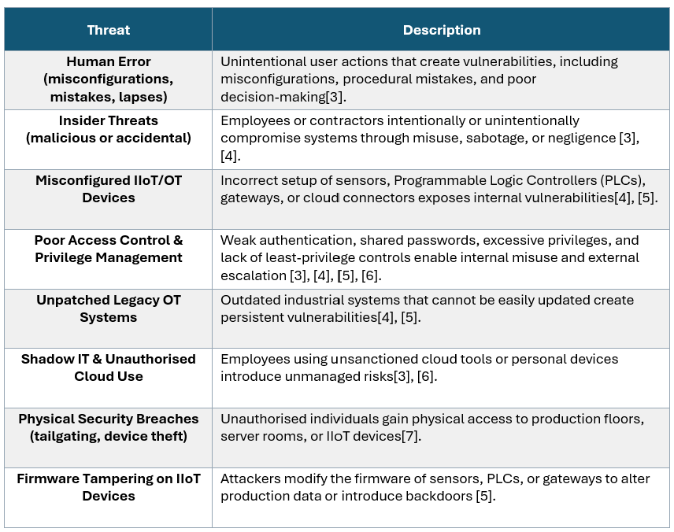
[3][4][5][6][7]

Table 2: External cybersecurity threats relevant to SteelForm Manufacturing Ltd (SFM)
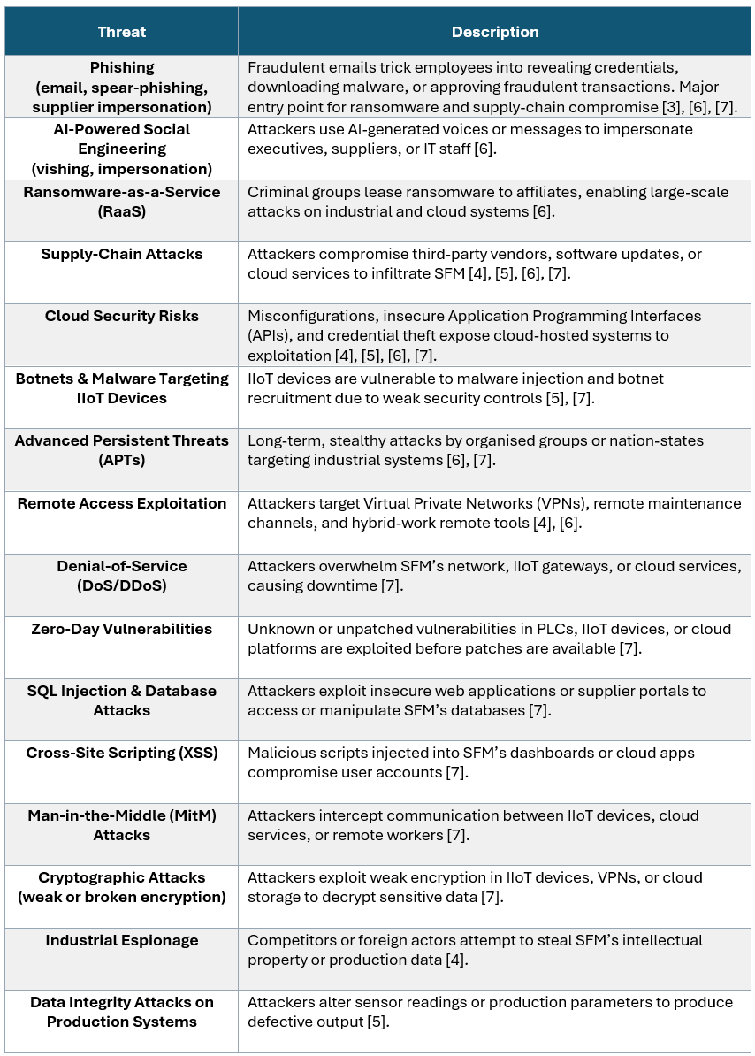

Modern Security Policies
SFM’s security policies adopt a Zero Trust security model, ensuring no user, device, or system is trusted by default[8].
These policies, illustrated in Figure 1, are designed to align with the NIST Cybersecurity Framework (NIST CSF), ISO 27001, and the principles of Confidentiality, Integrity, and Availability (CIA Triad). Together, they create a comprehensive governance framework for safeguarding SFM’s Operational Technology (OT) and Information Technology (IT) environments. These policies apply to all employees, contractors, and third-party vendors, ensuring consistent and resilient security practices throughout the organisation.
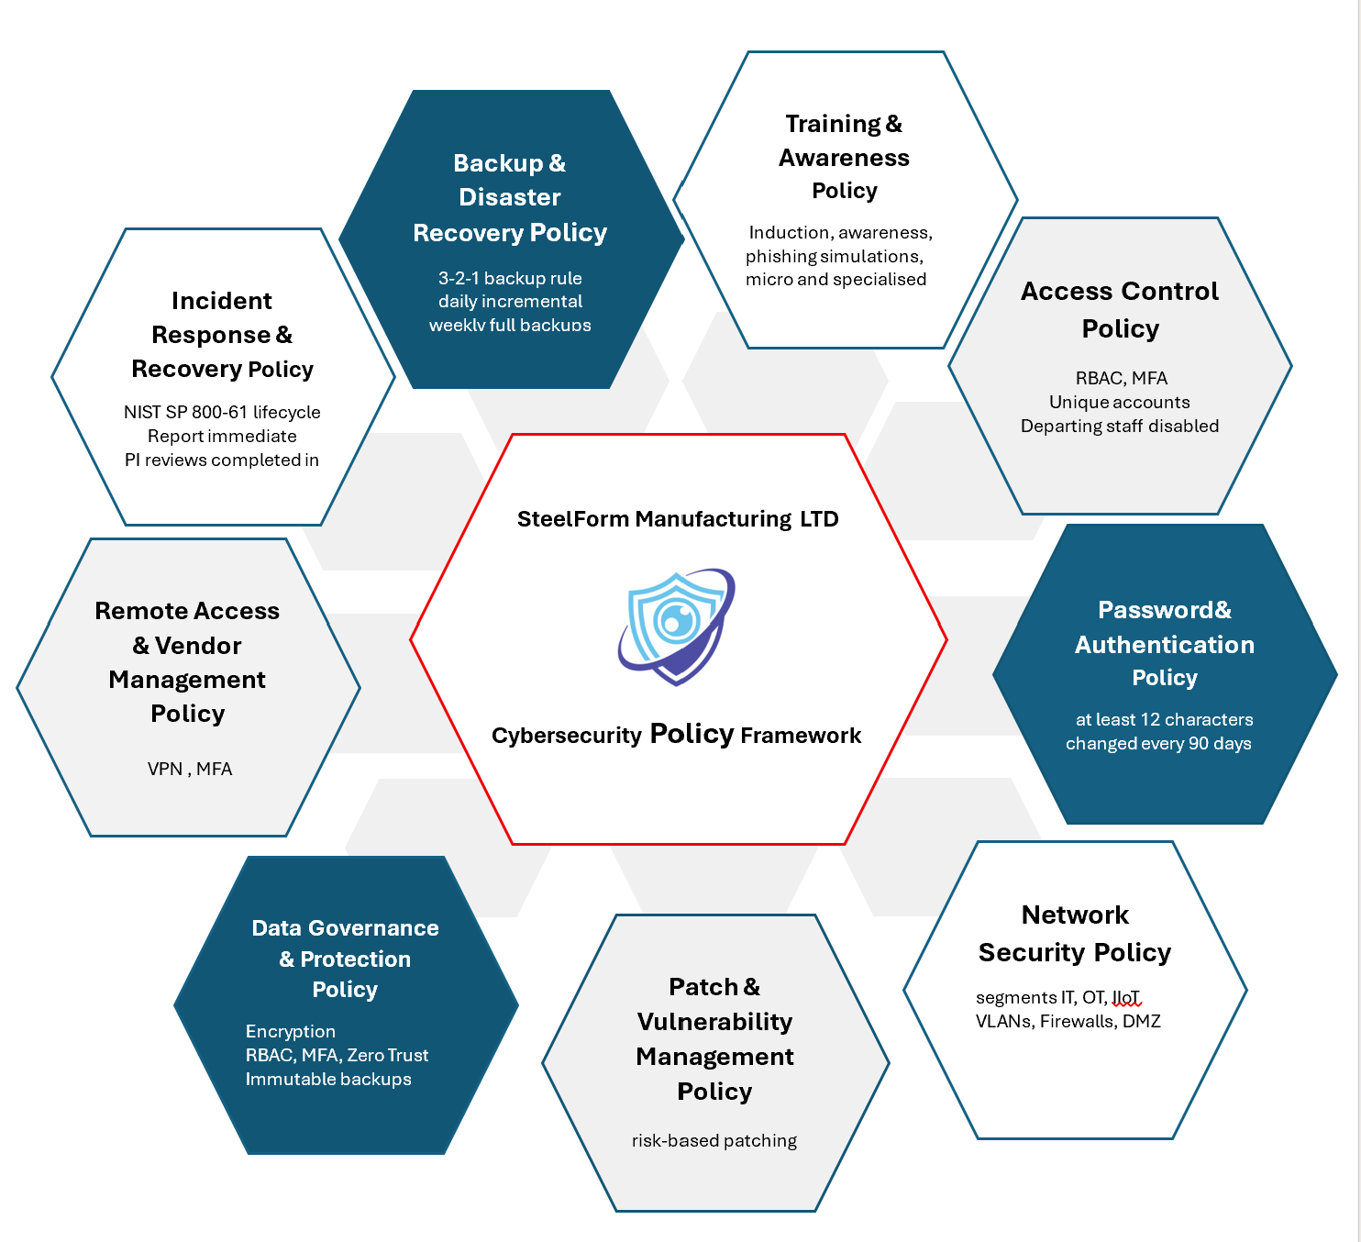
Figure 1: SteelForm Manufacturing Ltd’s Cybersecurity Policy Framework
Access Control Policy
SFM enforces least privilege, Role-Based Access Control (RBAC), and Multi-Factor Authentication (MFA). All accounts must be unique, approved, and reviewed quarterly. Privileged access requires written authorisation, and accounts for departing staff must be disabled promptly. Access to OT systems must be strictly controlled and monitored.
Password and Authentication Policy
Passwords must be at least 12 characters and include letters, numbers, and special characters. Passwords must be changed every 90 days and must not be reused. MFA is mandatory for VPN, cloud services, administrative interfaces, and OT engineering workstations. Failed login attempts must trigger alerts and lockouts.
Network Security Policy
SFM segments IT, OT, IIoT, and vendor networks using Virtual Local Area Networks (VLANs), firewalls, and a Demilitarised Zone(DMZ). All inter-segment traffic must be authenticated and inspected. Wireless networks must use WPA2/WPA3 encryption and remain isolated from OT systems. Unauthorised devices are automatically blocked. Continuous monitoring must include Intrusion Detection and Prevention Systems (IDS/IPS), User and Entity Behaviour Analytics (UEBA), and Security Information and Event Management (SIEM) logging.
Patch and Vulnerability Management Policy
SFM maintains an updated asset inventory and applies risk-based patching. Critical IT vulnerabilities must be patched within 48 hours; OT updates must occur during maintenance windows. IoT/IIoT firmware must be updated monthly. Regular vulnerability scans and quarterly OT assessments ensure visibility.
Endpoint and Device Security Policy
All endpoints must use Endpoint Detection and Response (EDR). Engineering workstations must use application allow-listing. USB storage is restricted to encrypted, company-issued devices. IoT/IIoT devices must be securely configured and isolated.
Data Governance and Protection Policy
SFM protects operational, engineering, and customer data through classification, encryption, RBAC, MFA, and continuous Zero Trust validation. Sensitive OT data is secured at rest, in transit, and in process. Immutable backups support recovery, and SIEM monitoring ensures accountability.
Remote Access and Vendor Management Policy
Remote access is permitted only through a secure VPN with MFA. Vendor access must be time-bound, monitored, and supervised. Third-party partners must comply with SFM’s security requirements.
Incident Response and Recovery Policy
SFM follows a structured incident response lifecycle: Preparation, Detection and Analysis, Containment, Eradication, Recovery, and Post-Incident Activity. All incidents must be reported immediately, and post-incident reviews completed within seven days.
Backup and Disaster Recovery Policy
SFM follows the 3-2-1 backup rule, keeping three copies of data on two different media, with at least one stored offsite or offline, with daily incremental and weekly full backups and performs quarterly disaster recovery tests.
Training and Awareness Policy
All staff must complete induction training, annual awareness training, phishing simulations, and monthly micro-training. Technical staff must complete specialised OT security training twice per year.

Technical Mitigation Measures
SFM requires a multilayered set of mitigation measures to address the cybersecurity risks introduced through its adoption of Industry 4.0 technologies. The following measures, illustrated in Figure 2, are aligned with NIST CSF and designed to uphold the CIA Triad of OT and IT systems, forming a comprehensive framework to protect critical assets, maintain operational continuity, and support secure digital transformation.
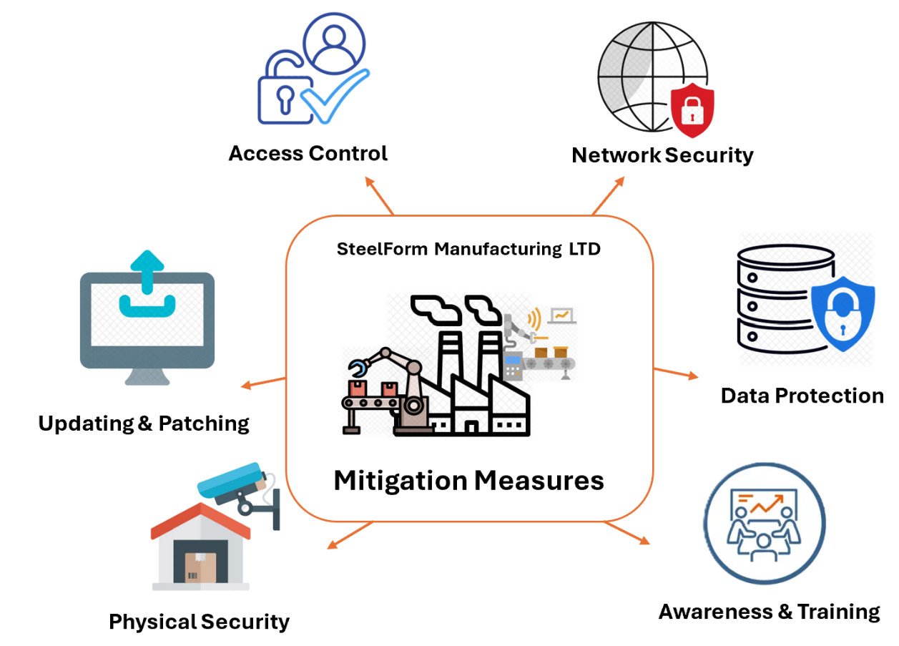
Figure 2: Key cybersecurity measures protecting SteelForm Manufacturing Ltd
Access Control
SFM will enforce strict RBAC to ensure users only access systems required for their operational duties, reducing unnecessary exposure of sensitive OT assets[9]. Strong password policies and MFA will be applied to all accounts, including service accounts, to prevent unauthorised access and credential misuse[10]. These measures support confidentiality by restricting access and integrity by preventing unauthorised changes, aligning with NIST’s Protect function[11].
Network Security
SFM will segment IT, OT, and IIoT environments into isolated VLANs, enforce DMZ separation for cloud-connected gateways, and require authenticated inter-zone communication. Firewalls will be deployed between each zone to inspect and control inter-segment traffic, supporting both confidentiality and availability by isolating critical systems and preventing ransomware spread and DoS/DDoS attacks[10]. These controls align with NIST’s Protect and Detect functions[11].
Data Protection
SFM will encrypt sensitive OT data at rest and in transit to prevent interception or tampering. Standardised secure configuration protocols will be applied across endpoints, servers, and network devices, ensuring consistent hardening and reducing configuration-based vulnerabilities. Antivirus and endpoint security tools will be deployed on all compatible OT components[10]. These measures strengthen confidentiality and integrity while aligning with NIST’s Protect function[11].
Awareness & Training
SFM will implement OT-specific cybersecurity training to ensure staff understand common attack vectors, incident response expectations, and authentication best practices. Regular awareness campaigns will reduce human-factor risks such as spear-phishing and targeted attacks, supporting integrity by preventing unauthorised or accidental changes to systems[10]. These activities align with NIST’s Protect and Respond functions[11].
Physical Security
SFM will strengthen physical security by controlling facility access, deploying surveillance systems, and securing critical OT equipment in restricted zones. These measures protect availability by preventing physical disruption of operations and integrity by preventing tampering with OT hardware[10]. This aligns with NIST’s Protect function[11].
Updating & Patching
SFM will adopt a structured patch management programme prioritising high-risk vulnerabilities and critical OT systems. Regular updates will be applied to OT software, firmware, and applications, with risk-based patching for components exposed to remote access or capable of executing control functions. These measures support integrity by preventing exploitation of vulnerabilities and availability by reducing system downtime caused by attacks[10]. They align with NIST’s Protect and Recover functions[11].
Together, these mitigation measures provide SFM with a robust, layered defence capable of protecting modern manufacturing systems against evolving cyber threats.

Proactive Monitoring and Incident Response
SFM operates a continuous 24/7 monitoring and incident-response capability to ensure rapid detection, containment, and recovery from cybersecurity threats across its IT, OT, and IIoT environments. This capability is aligned with the NIST SP 800-61 incident response lifecycle—Preparation, Detection and Analysis, Containment, Eradication, Recovery, and Post-Incident Activity—as defined in the Computer Security Incident Handling Guide[12] and further explained in industry guidance[12], [13]. These phases, as illustrated in Figure 2, provide a structured and repeatable process that enables SFM to maintain operational resilience and uphold the principles of confidentiality, integrity, and availability.
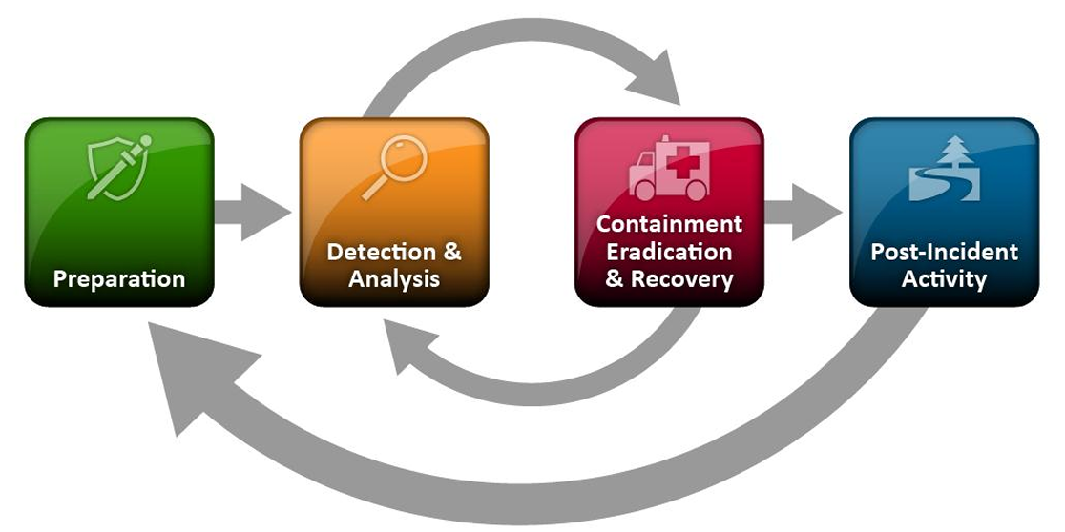
Figure 3: Incident Response lifecycle[12]
Monitoring is achieved through a centralised SIEM platform that aggregates logs from servers, firewalls, OT controllers, IIoT sensors, cloud services, and VPN gateways. The SIEM provides real-time correlation and alerting, allowing analysts to identify suspicious behaviour such as privilege misuse, unauthorised access attempts, or abnormal OT process deviations. This visibility is enhanced by UEBA, which detects anomalies in user actions and device behaviour, and by IDS/IPS that analyse network traffic for malicious signatures or protocol misuse. EDR tools provide behavioural monitoring on engineering workstations and compatible OT devices, enabling rapid isolation of compromised endpoints. Security Orchestration, Automation, and Response (SOAR) technology supports these capabilities by executing predefined playbooks that automate containment actions, such as disabling accounts, blocking IP addresses, or isolating affected VLANs.
SFM’s Incident Response(IR) operations follow the NIST SP 800-61 lifecycle. During the Preparation phase, the organisation maintains IR policies, trained staff, forensic toolkits, and predefined SOAR workflows. Detection and Analysis involve triaging SIEM and UEBA alerts to distinguish legitimate operational deviations from malicious activity, particularly within sensitive OT environments. Containment focuses on limiting the spread of an incident by isolating affected systems or network segments. Eradication removes malicious artefacts, disables compromised accounts, and corrects misconfigurations, while Recovery restores clean PLC logic, validates OT system integrity, and safely returns production lines to normal operation. Post-Incident Activity ensures that lessons learned are documented within seven days and fed back into policy updates, detection rules, and staff training, strengthening SFM’s long-term resilience.
Through continuous monitoring and a structured incident response process, SFM ensures rapid threat identification, coordinated response actions, and minimal operational disruption. This capability reinforces the organisation’s Zero Trust model and aligns with the NIST Cybersecurity Framework’s Detect and Respond functions, providing a robust defence against evolving cyber threats.

Continuous Training and Awareness
A continuous training and awareness programme is essential to ensure all employees understand their responsibilities under SFM’s cybersecurity and data governance policies. The programme outlined in Table 3 is designed to strengthen security culture, reduce human-related risks, and maintain consistent compliance across IT, OT, IoT, and cloud environments.
Table 3: SFM’s Cybersecurity Training Programme
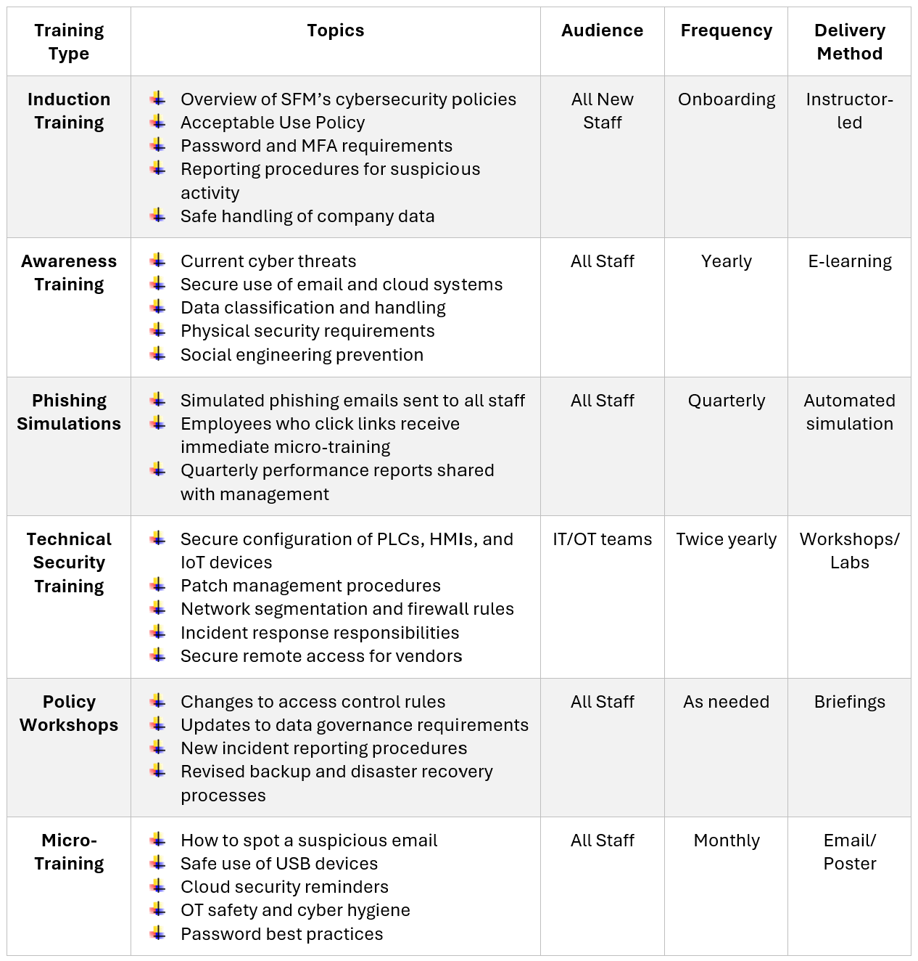
To support ongoing improvement, SFM will monitor completion rates for all training modules, review phishing simulation performance, conduct annual cybersecurity awareness surveys, and analyse incident reports to identify gaps. Training content will be updated regularly to reflect emerging threats and changes in attacker behaviour.
Employees who repeatedly fail phishing simulations will be assigned mandatory remedial training to reinforce secure practices. Persistent non-compliance with security policies may result in disciplinary action. Managers are accountable for ensuring their teams complete all required training and maintain the expected level of security awareness.

Conclusion
SFM’s transition toward Industry 4.0 has expanded its attack surface, making robust cybersecurity essential. Recent incidents—including malware infections and unauthorised access—highlight the need for multilayered protection. Strengthening Zero Trust policies, technical controls, monitoring, and continuous training will enhance resilience. SFM should maintain proactive threat monitoring, enforce strict vendor security, and expand UEBA and OT-specific detection. Future work should include regular red-team exercises, deeper supply-chain assessments, and continuous policy refinement as threats evolve. These actions will help SFM protect operational integrity, safeguard sensitive data, and sustain business continuity against emerging cyber risks.

References
[1] E. Wai and C. Lee, "Seamless industry 4.0 integration: A multilayered cyber-security framework for resilient scada deployments in cpps," vol. 13, no. 21, pp.12008, 2023,
[2] M. Abdullah, M. M. Nawaz, B. Saleem, M. Zahra, E. b. Ashfaq and Z. Muhammad, "Evolution Cybercrime—Key Trends, Cybersecurity Threats, and Mitigation Strategies from Historical Data," vol. 4, no. 3, pp.25, 2025,
[3] S. R. Grandhi and J. D. Still, "Deciphering human error: Improving cybersecurity reporting", in Proceedings of the Human Factors and Ergonomics Society Annual Meeting, pp. 234–239.
[4] J. Pochmara and A. Świetlicka, "Cybersecurity of industrial systems—A 2023 report," vol. 13, no. 7, pp.1191, 2024,
[5] L. L. Dhirani, E. Armstrong and T. Newe, "Industrial IoT, cyber threats, and standards landscape: Evaluation and roadmap," vol. 21, no. 11, pp.3901, 2021,
[6] M. Mijwil, O. J. Unogwu, Y. Filali and I. Bala, "Exploring the top five evolving threats in cybersecurity: An in-depth overview," vol. 3, no. 1, pp.57–63, 2023,
[7] Ö Aslan, S. S. Aktuğ, M. Ozkan-Okay, A. A. Yilmaz and E. Akin, "A comprehensive review of cyber security vulnerabilities, threats, attacks, and solutions," vol. 12, no. 6, pp.1333, 2023,
[8] N. F. Syed, S. W. Shah, A. Shaghaghi, A. Anwar, Z. Baig and R. Doss, "Zero Trust Architecture (ZTA): A Comprehensive Survey," vol. 10, pp.57143–57179, 2022, doi: 10.1109/ACCESS.2022.3174679.
[9] A. Akinsanya, "Securing the future: Implementing a zero-trust framework in us critical infrastructure cybersecurity," vol. 10, no. 3, pp.V1013–V1221, 2024,
[10] A. Alsumayt, N. El-Haggar, M. Alshammari, F. H. Alghamedy and Z. AlFawaer, "Enhancing Security in Operational Technology: The Role of Multi-Factor Authentication Against Cyber Threats," vol. 6, pp.64–78, 2026,
[11] National Institute of Standards and Technology, “NIST Cybersecurity Framework,” NIST, Gaithersburg, MD. [Online]. Available: https://www.nist.gov/cyberframework Accessed: 22-Jul-2026.
[12] K. Scarfone, P. Mell and T. Grance, Computer Security Incident Handling Guide, NIST Special Publication 800‑61 Revision 2, National Institute of Standards and Technology, Gaithersburg, MD, 2012. [Online]. Available: https://www.nist.gov/publications/computer-security-incident-handling-guide
13] ForensicSpot, “NIST SP 800-61 Incident Response Lifecycle,” ForensicSpot, Jun. 24, 2026. [Online]. Available: https://forensicspot.com/topics/incident-response-and-management/nist-sp-800-61-lifecycle

Appendix

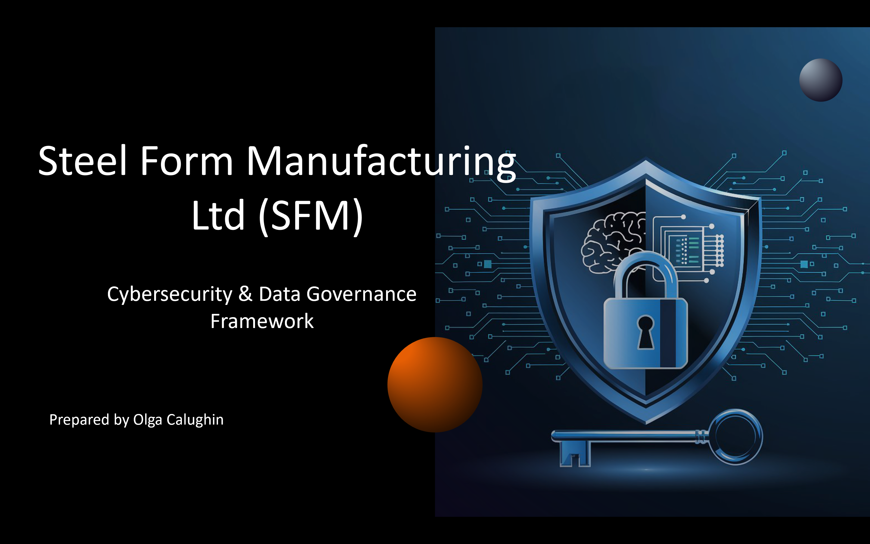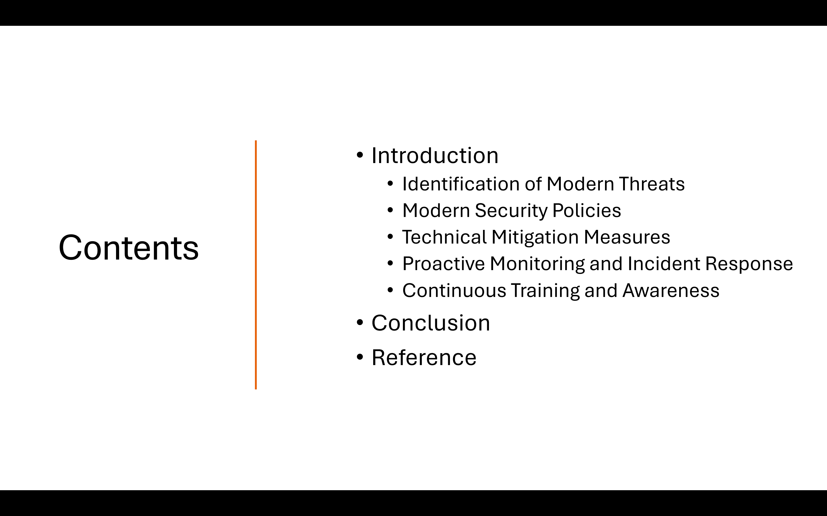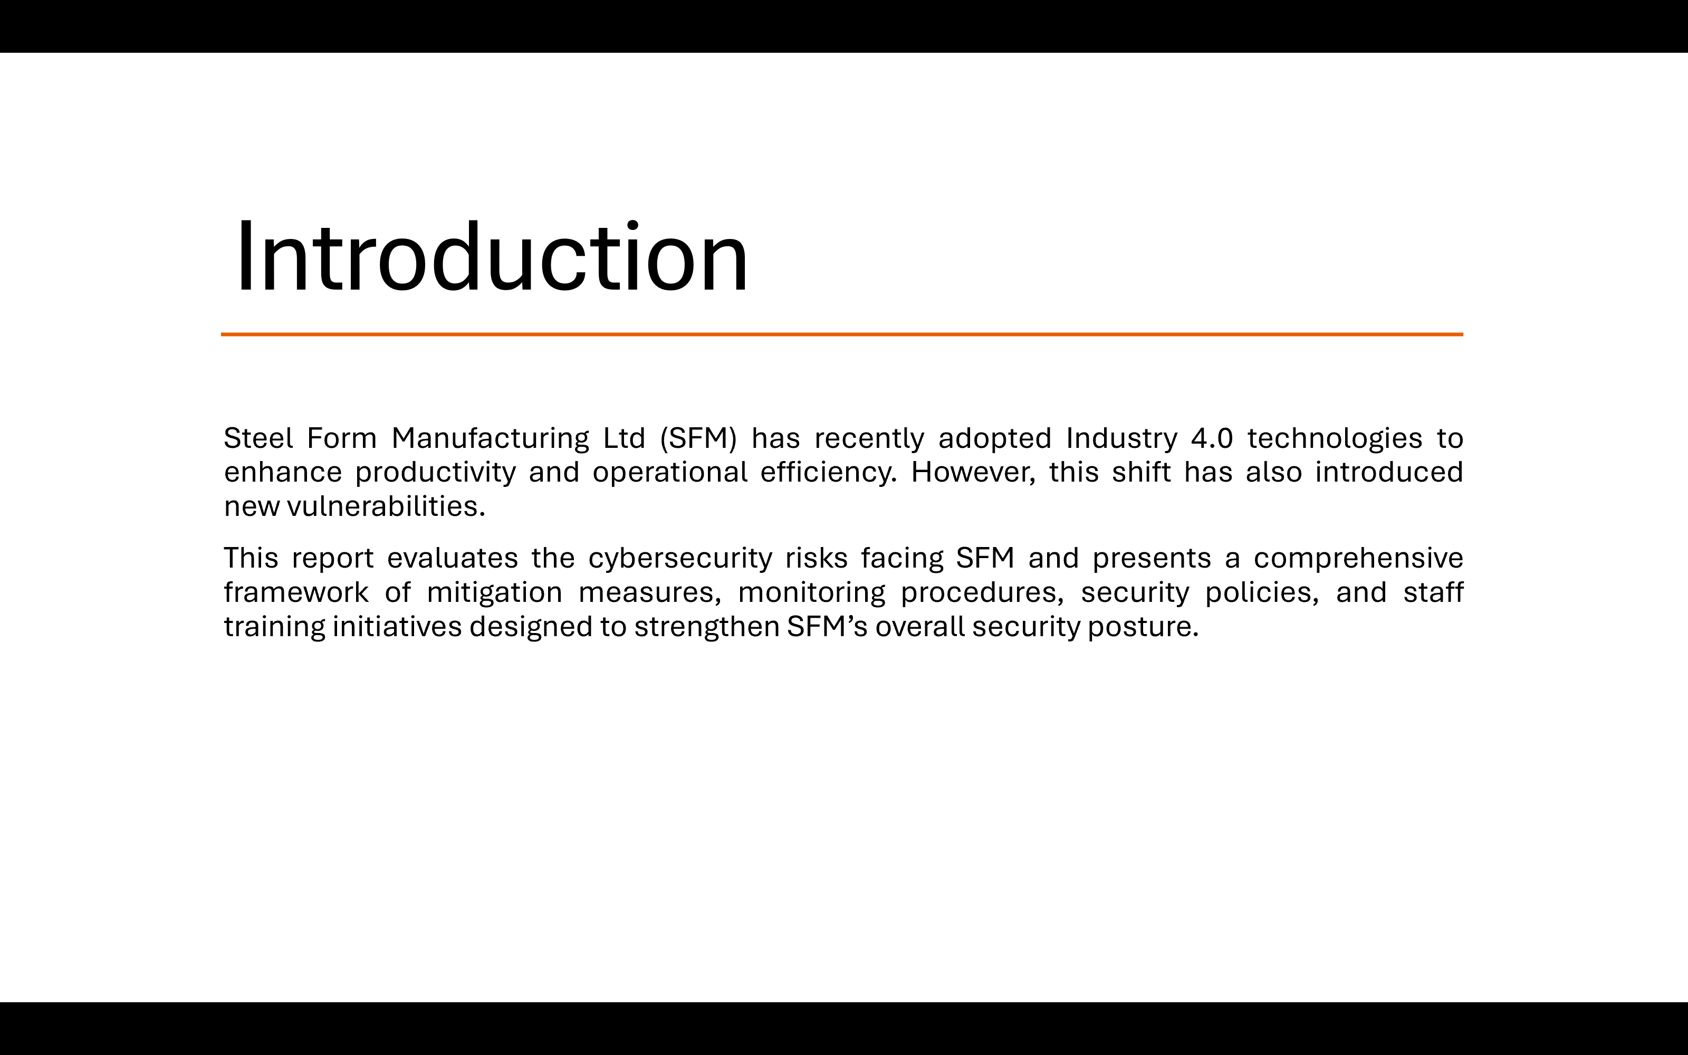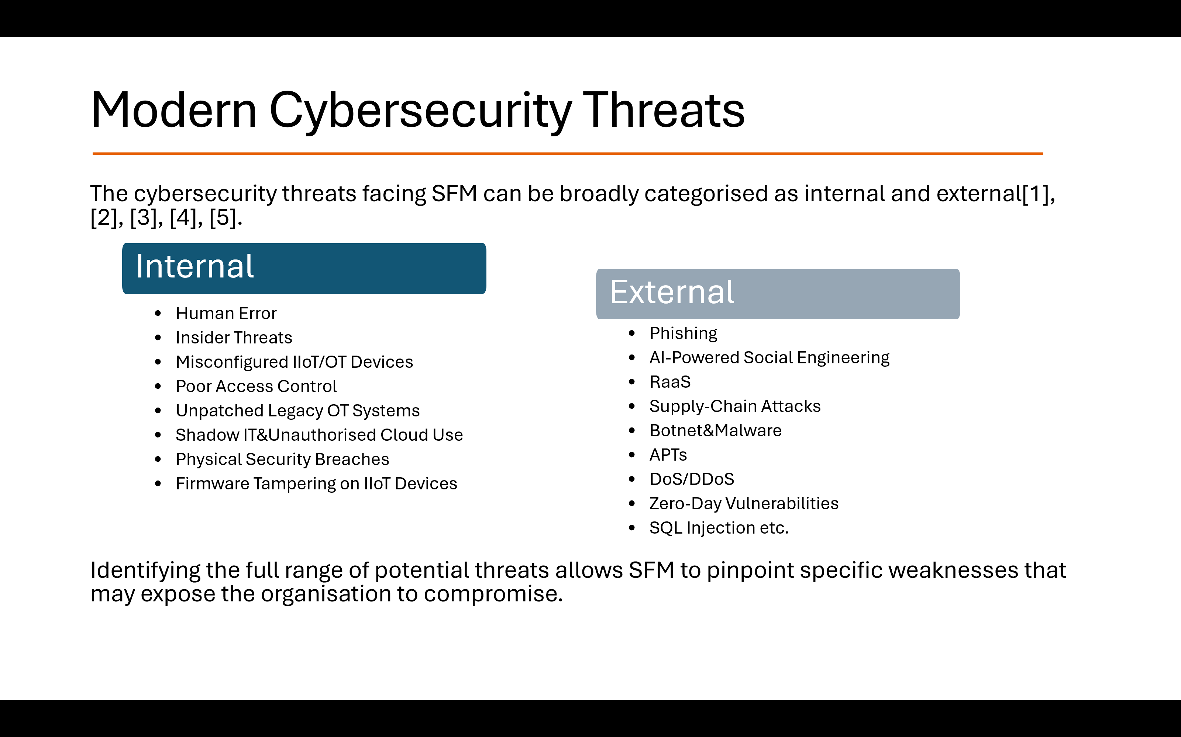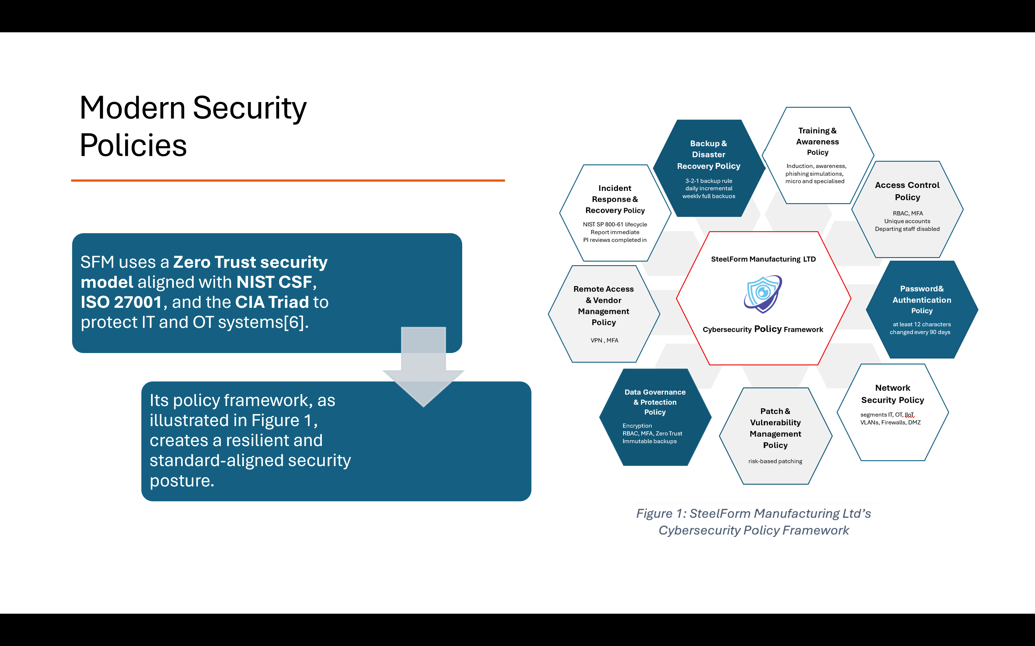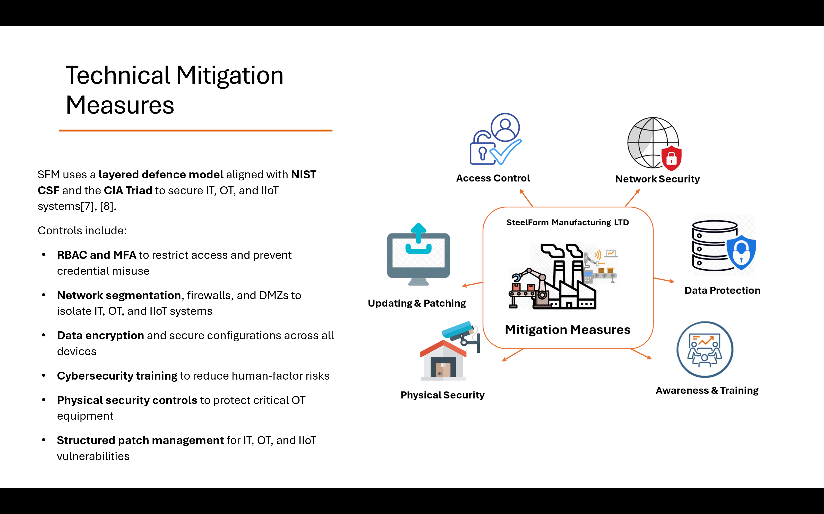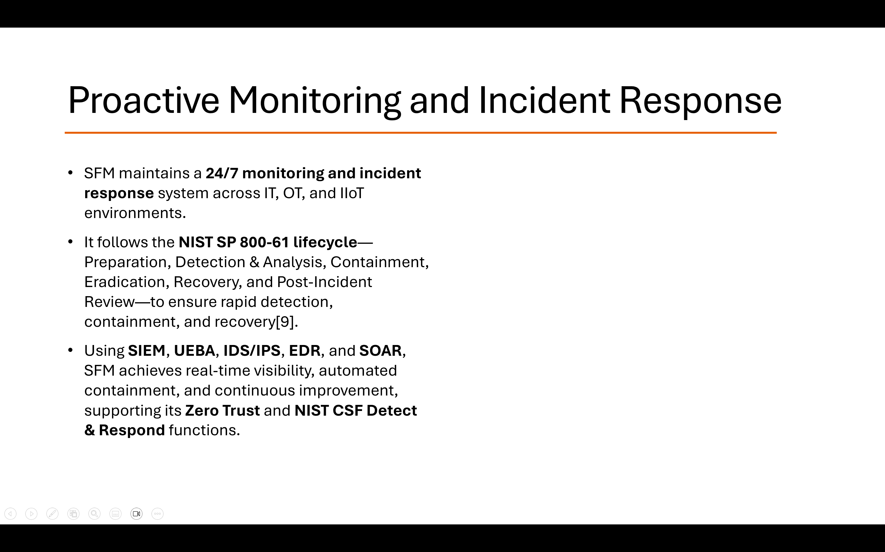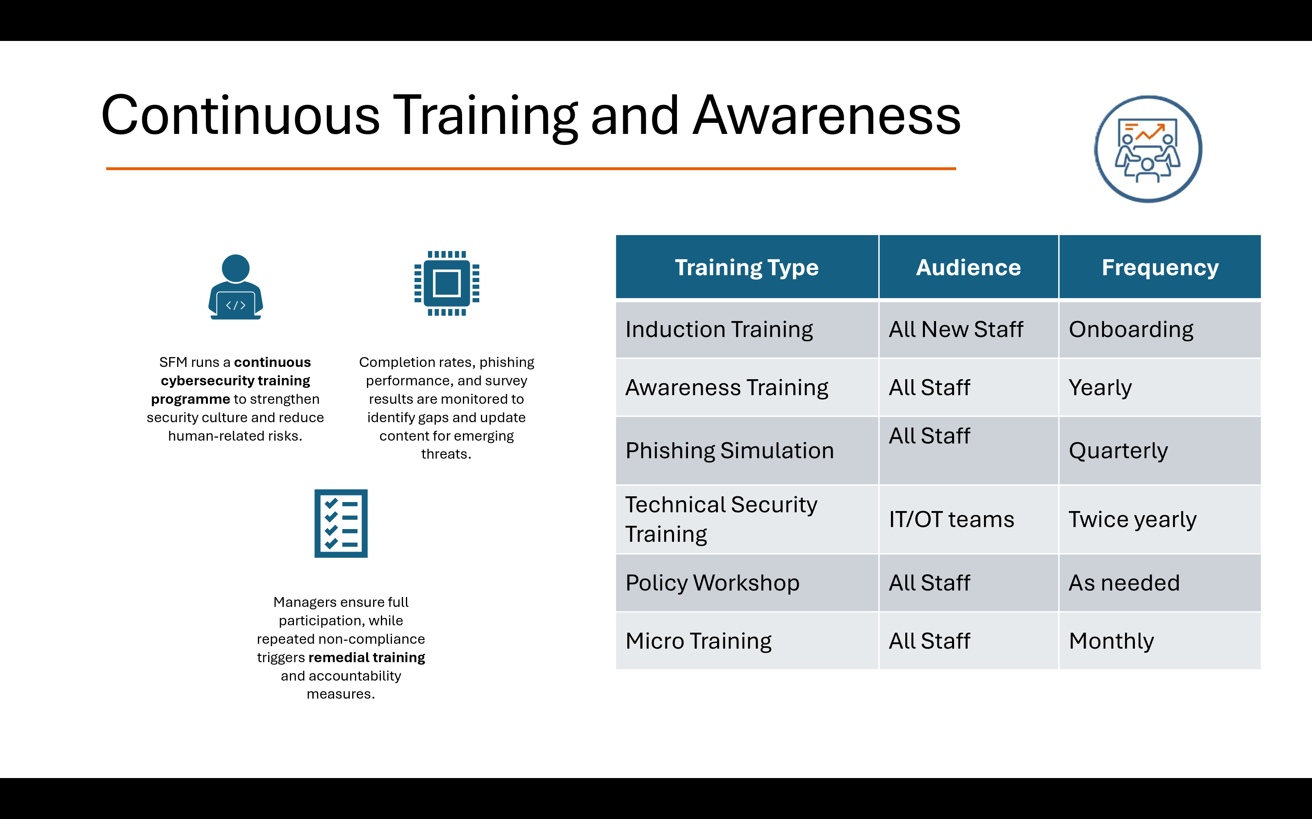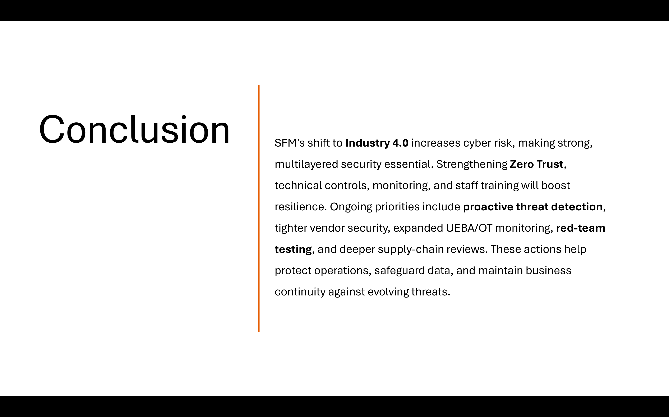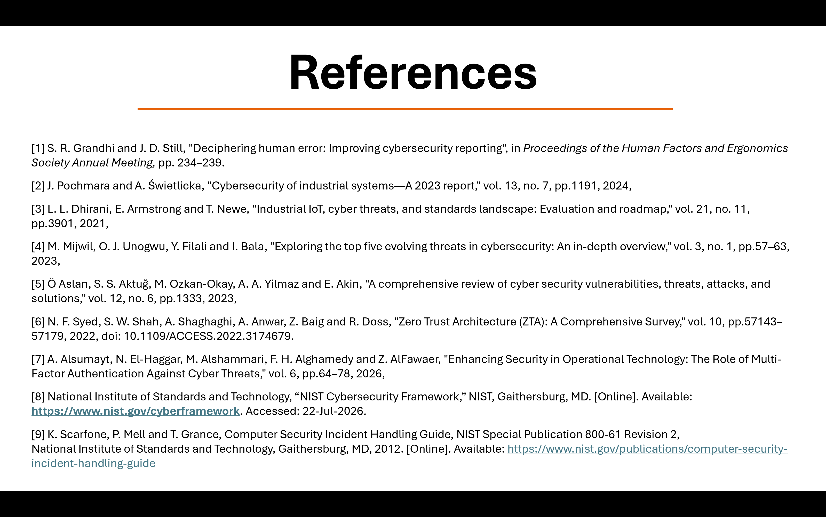

Abreviation
IoT – Internet of Things
IIoT – Industrial Internet of Things
CPPS – Cyber-Physical Production Systems
SCADA – Supervisory Control and Data Acquisition
SFM – SteelForm Manufacturing Ltd
PLCs – Programmable Logic Controllers
APIs – Application Programming Interfaces
VPNs – Virtual Private Networks
AI – Artificial Intelligence
IT – Information Technology
OT – Operational Technology
SQL – Structured Query Language
APTs – Advanced Persistent Threats
MQTT – Message Queuing Telemetry Transport
OPC UA – Open Platform Communications Unified Architecture
DoS/DDoS – Denial of Service /Distributed Denial of Service
XSS – Cross-Site Scripting
MitM – Man-in-the-Middle
NIST CSF – NIST Cybersecurity Framework
ISO – International Organization for Standardization
CIA – Confidentiality, Integrity, Availability
RBAC – Role-Based Access Control
MFA – Multi-Factor Authentication
VLANs – Virtual Local Area Networks
DMZ – Demilitarised Zone
WPA – Wi-Fi Protected Access
KEV - Known Exploited Vulnerabilities
EDR – Endpoint Detection and Response
USB - Universal Serial Bus
SIEM – Security Information and Event Management
RFID – Radio-Frequency Identification
IDS – Intrusion Detection System
IPS – Intrusion Prevention System
UEBA — User and Entity Behaviour Analytics

