BSc Orthopaedic Project
Initially when beginning this project I decided to cast my feet impressions through playdoh moulding, however, when I left the mould to dry unfortunately they began to crack and eventually broke apart when I was transporting them into university. I then proceeded to try other means of casting my foot impressions and decided on using foam. I ordered Podotech foot impressions foam from eBay and begun casting my impressions. Then once I had cast impressions of both of my feet I made a scale and placed it against my moulds so that when I carried out the photogrammetry process I would be able to use the scale as a reference to give the correct scale to my scan data in recap.
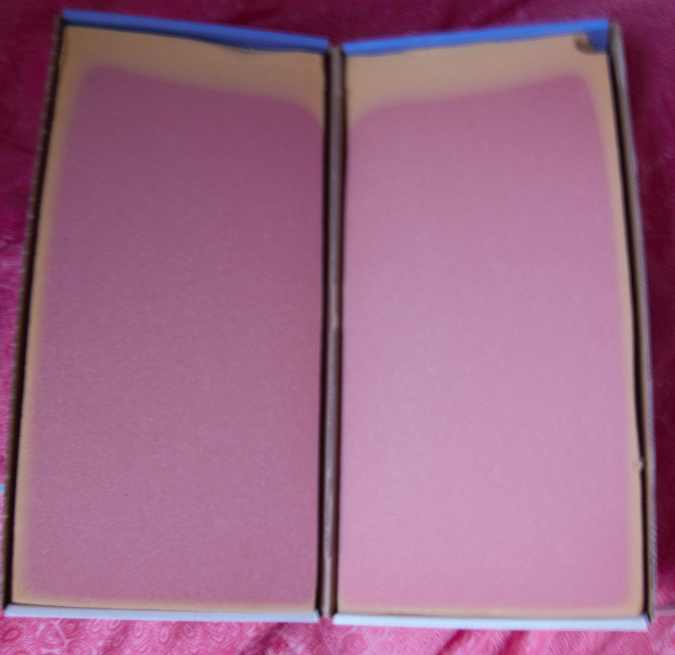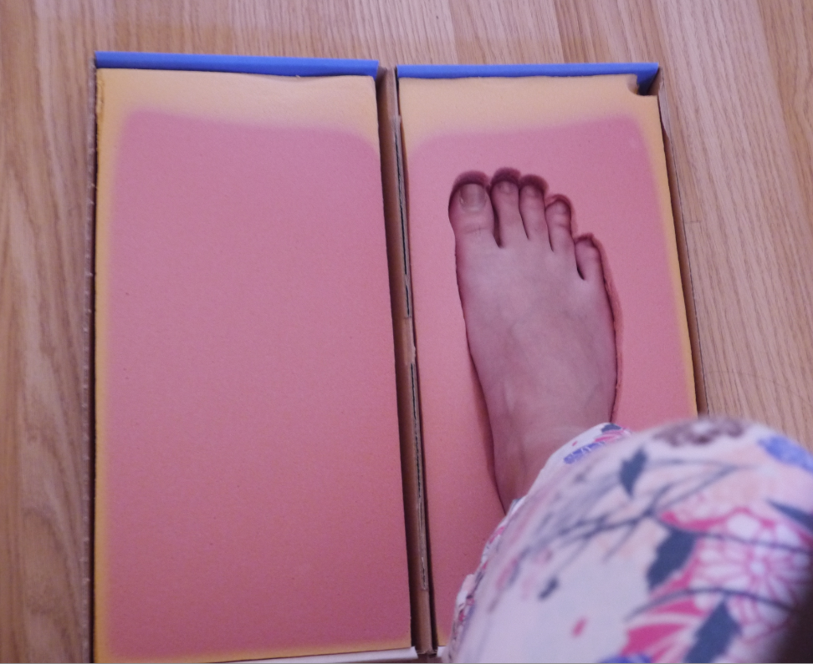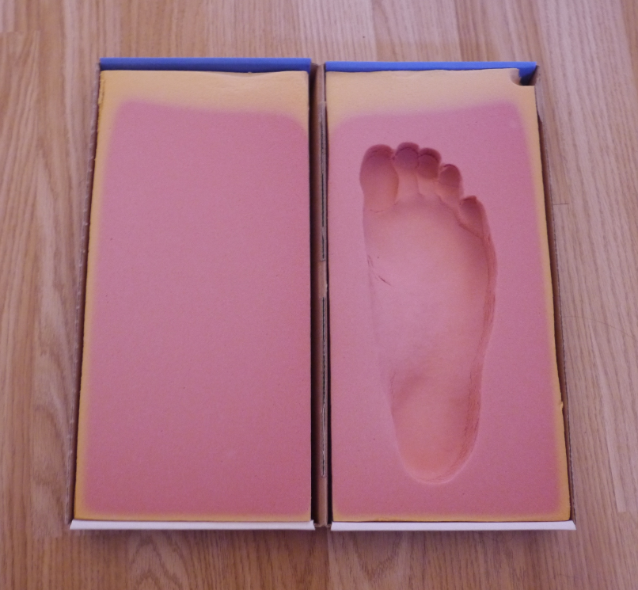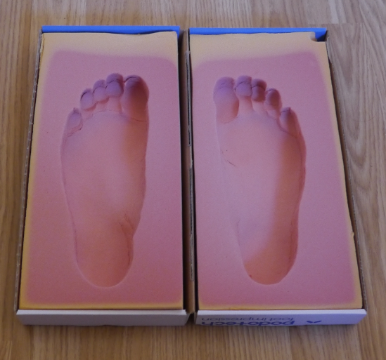
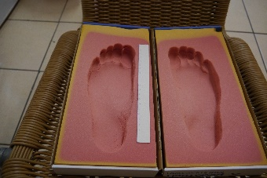
When carrying out the photogrammetry process I made sure I took pictures of the impressions from three different angles and when round the mould in small increments to capture as much detail as possible. A small sample of the photos which I took are displayed below:
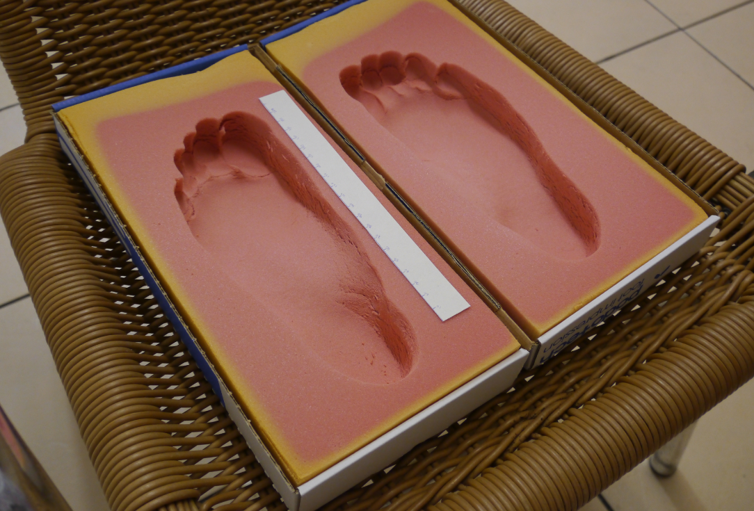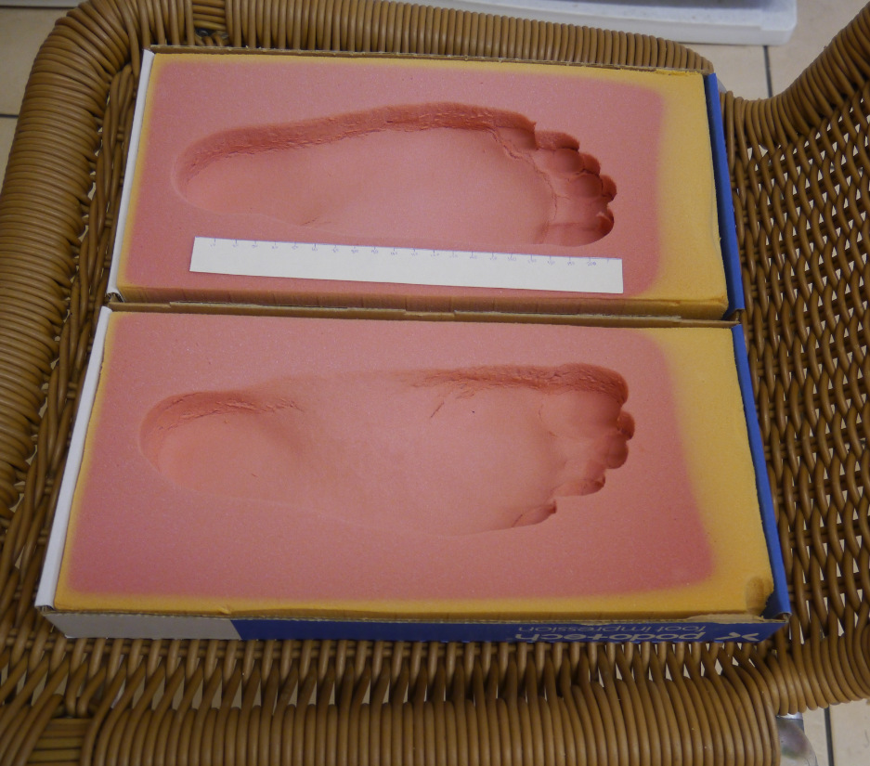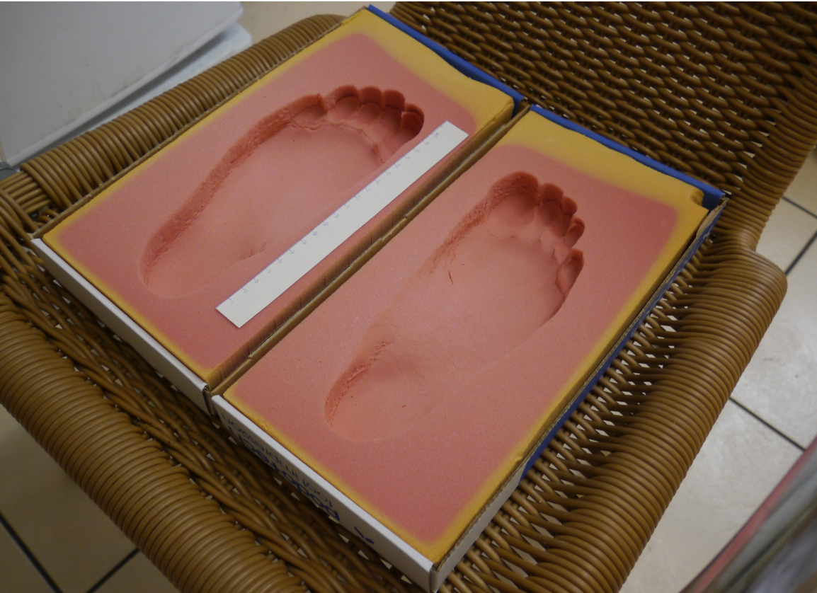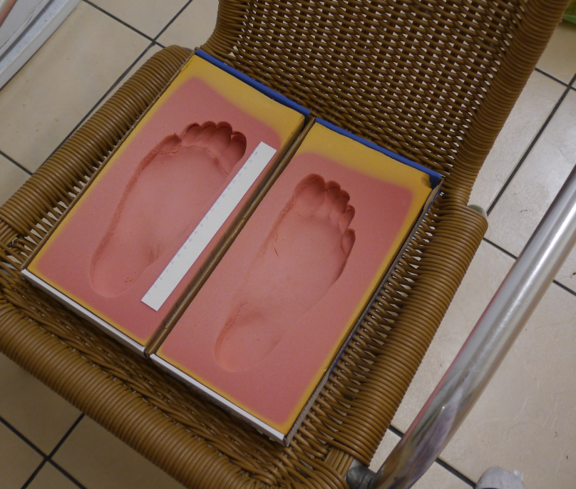
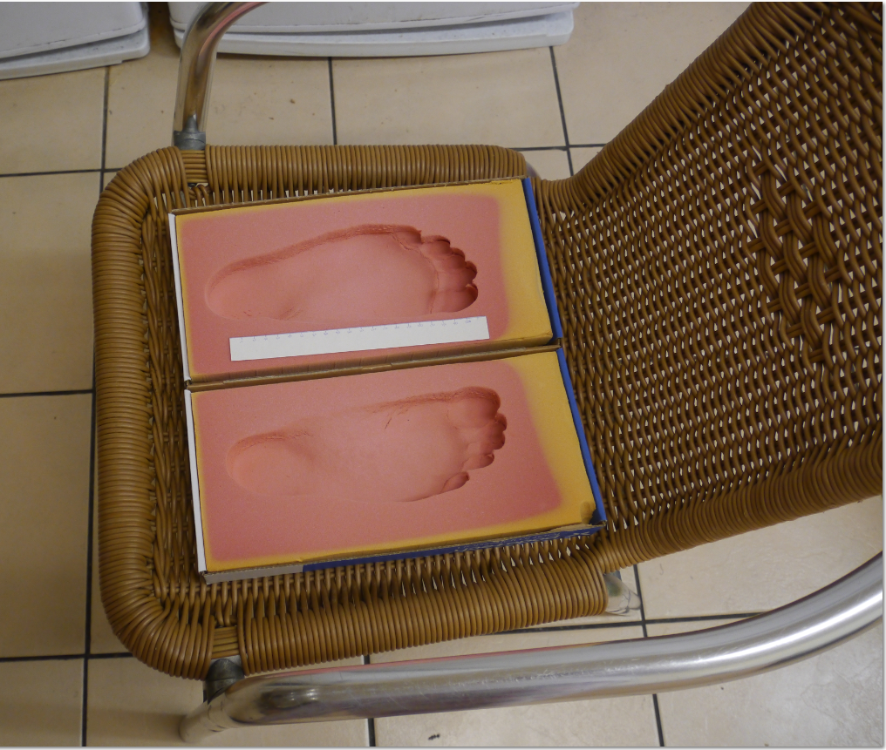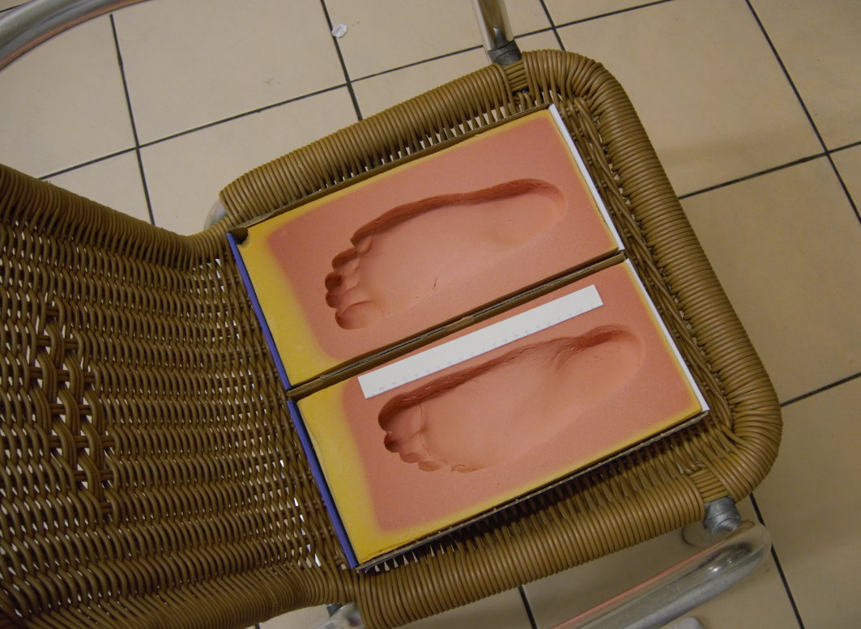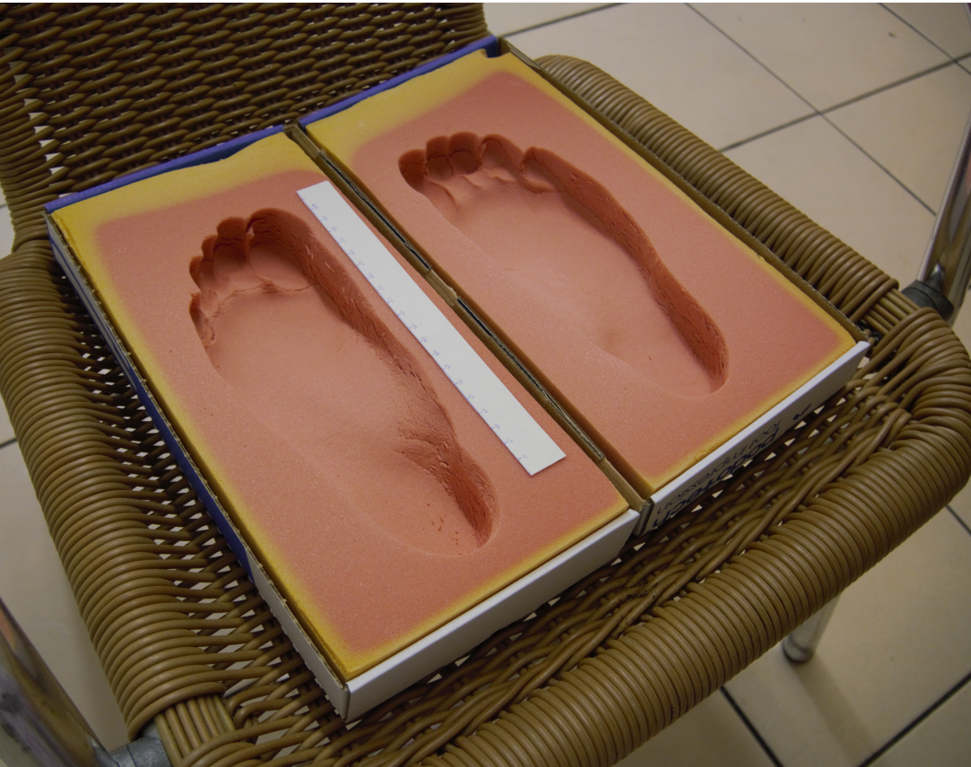
To capture these images of my foot impressions I have used a Panasonic Lumix G3 camera.
Once I had gone 360 degrees round my foot impressions at 3 different angles I then uploaded my photos into recap. As recap limits you to uploading only 100 picture that is the amount of photos I uploaded. After my images had been imported into recap I then asked the software to begin forming the scan from my images. The recap software took approximately 13 hours to digitalise my scan and the result was as follows:
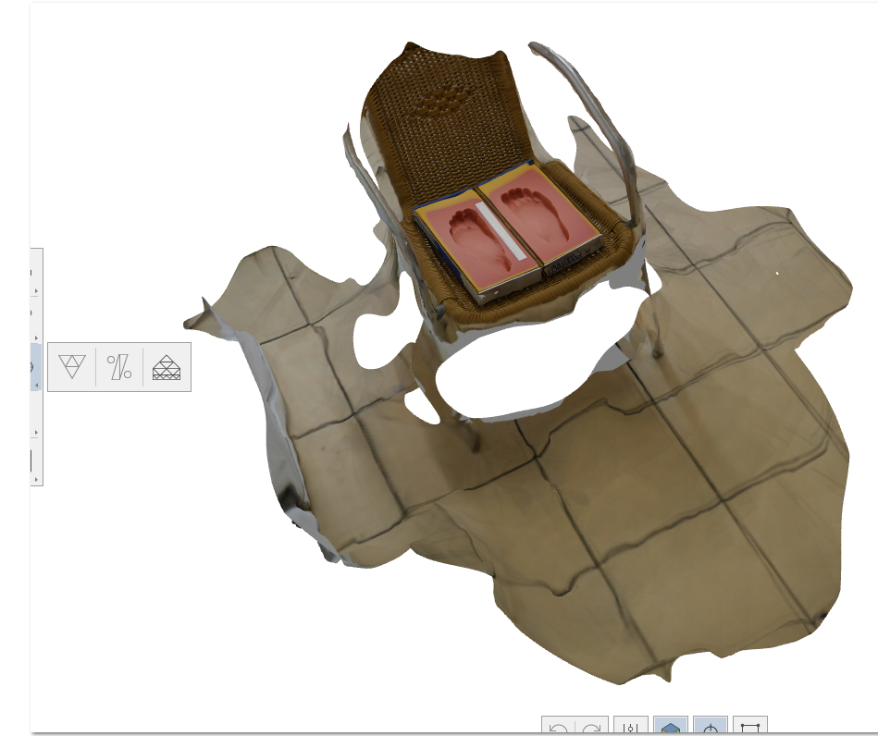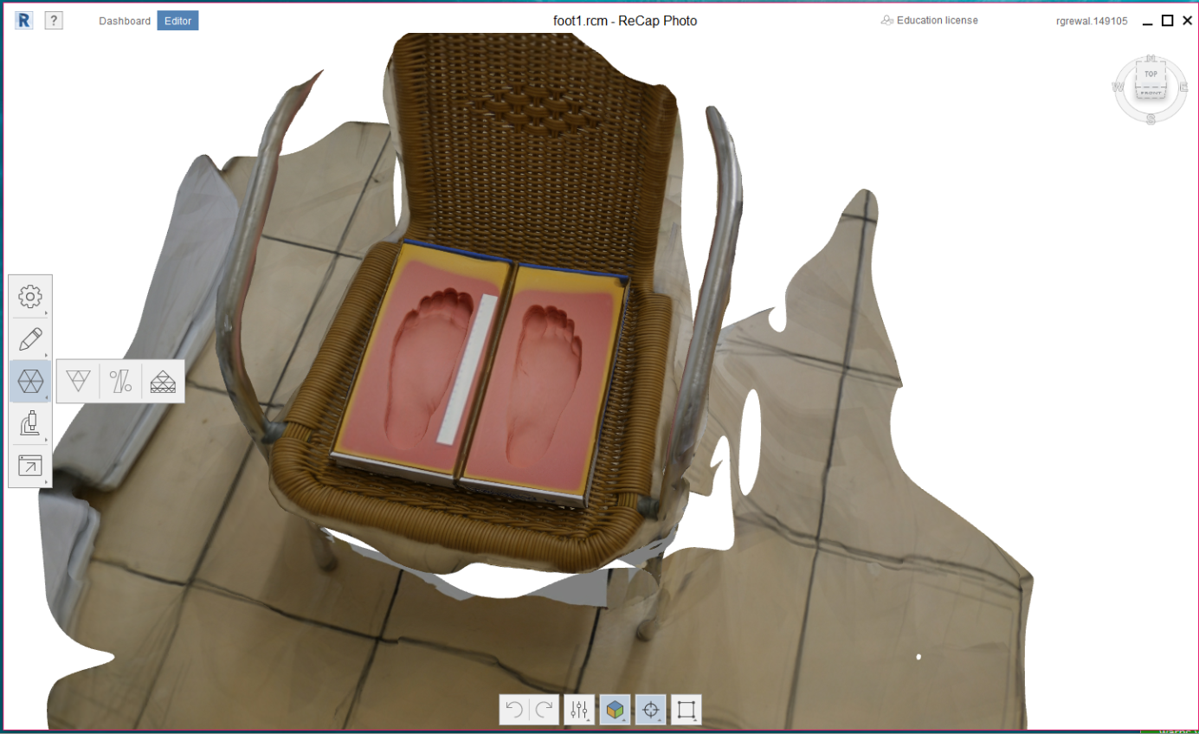
The first thing I did was to clean up the scan data by deleting all of the unnecessary parts like the chair and the floor around the impressions. Once I had finished the scanned data looked like this:
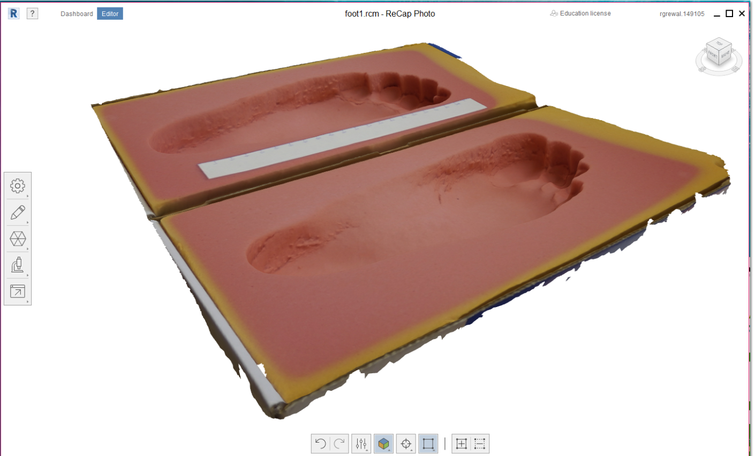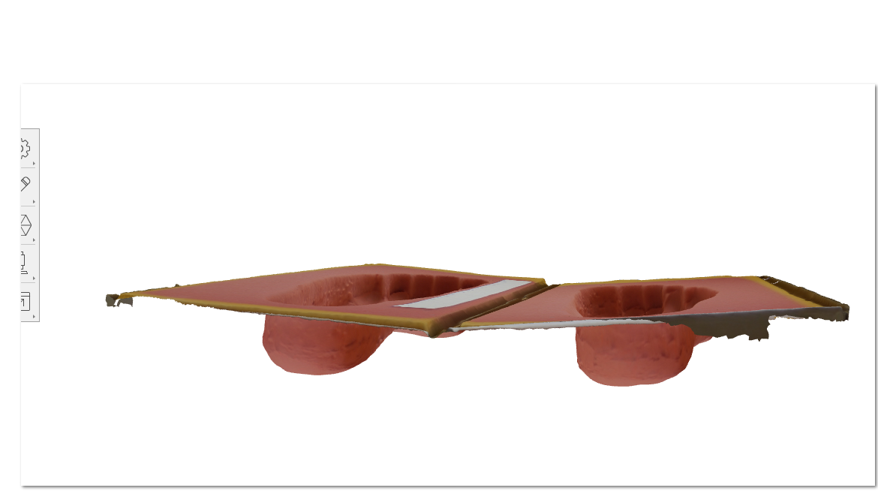

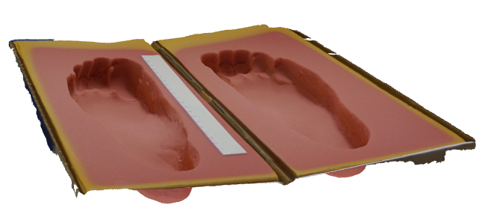
As you can see the recap software was able to capture a very accurate scan of my moulds from the photos that I submitted. The mesh model of the impressions was also of high quality:
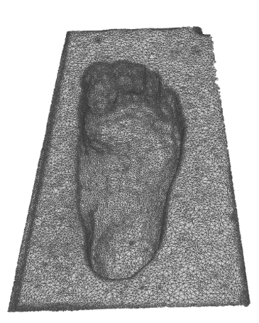
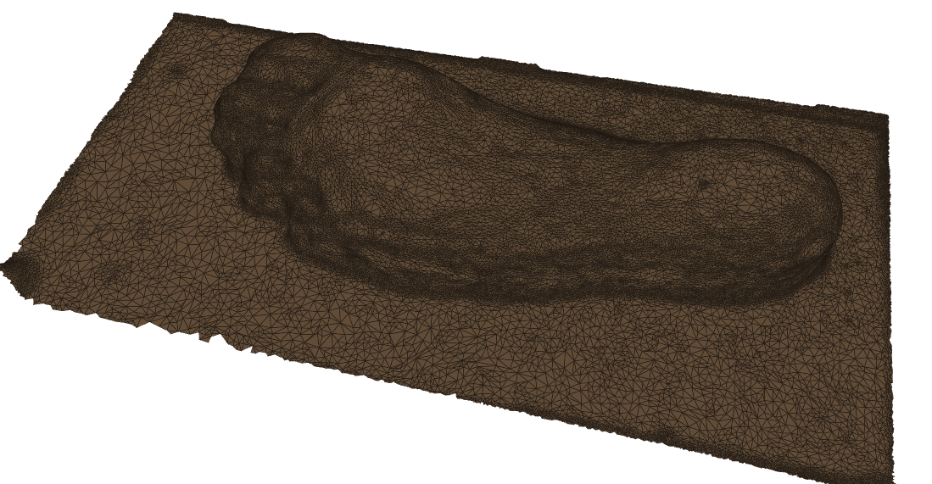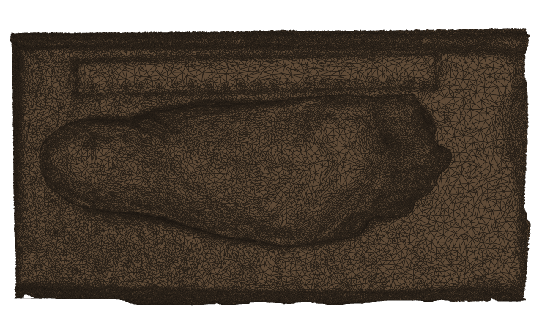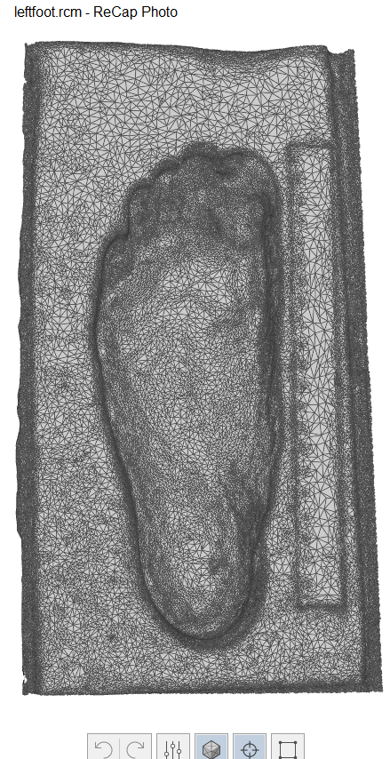

*all of the following steps from here on are for my right foot impression but all of the same steps were issued for the left foot impression, I felt it was not needed to explain all of these steps twice *
In recap I then used the scale I had made to make sure my scan data was of the appropriate size. Once I had done this I did not feel that there was much smoothing necessary for my impression as the data had come up so accurate so instead I proceeded to exporting my scanned data as an object quad file so that I could bring it into Fusion 360.
Once I opened up Fusion 360 and inserted the mesh and transformed the object so that it was in the correct orientation. After this I took my mesh into the Sculpt environment and converted form a “quad mesh to a T Spline” entity.
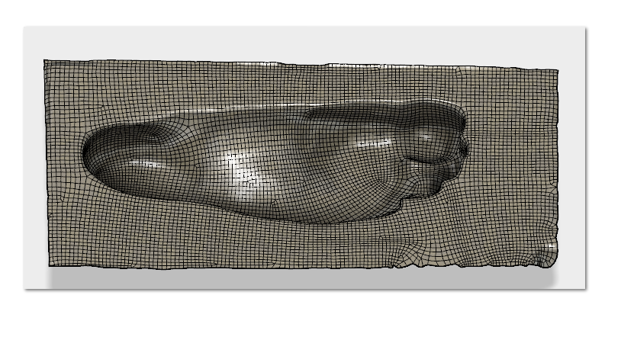
After converting the mesh to a T spline entity this meant that the data now had a surface (demonstrated by the patch work on the image of my scan below):
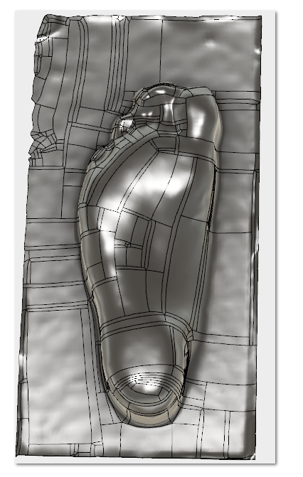
I now had to alter my scan data so it was a solid object ready to be printed. For this, firstly I added a thicken function to the surface to make it a solid:
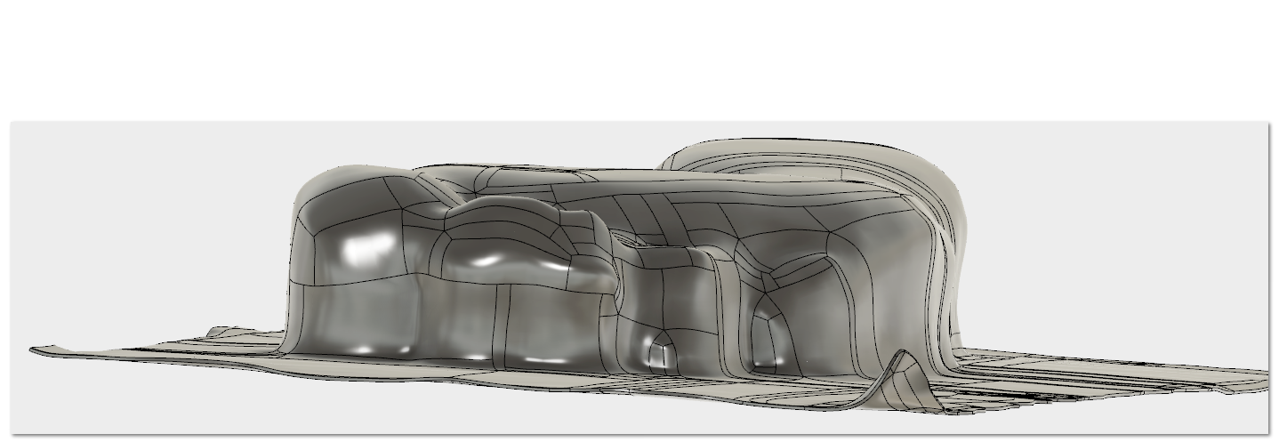
After this I constructed an offset plane at a level which was just underneath the bottom of the sole impression. On this plane began a new sketch around the inside of the underside of the surface.
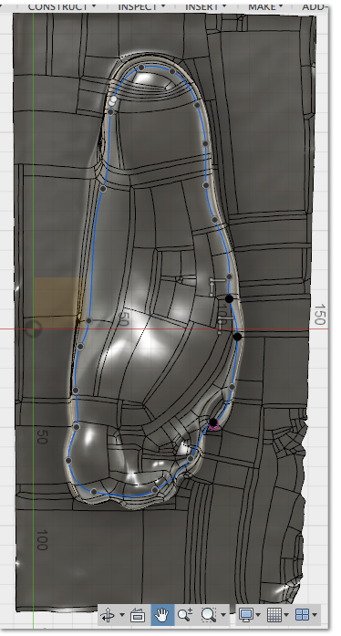
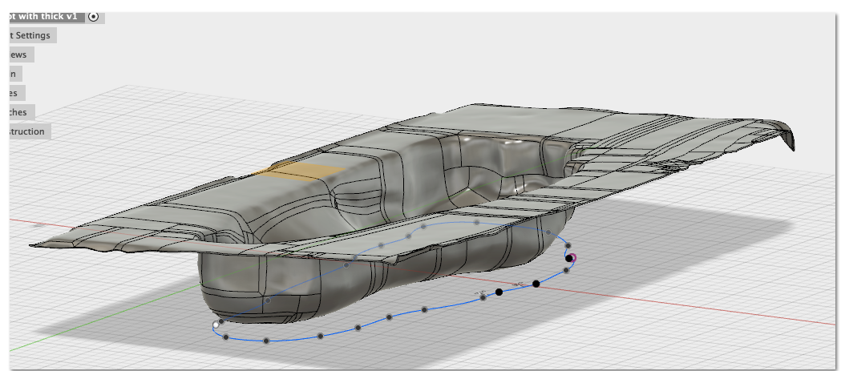
From this sketch I used the extrude tool and clicked on the option extrude “to Object” so that the sketch would merge with the impression surface.
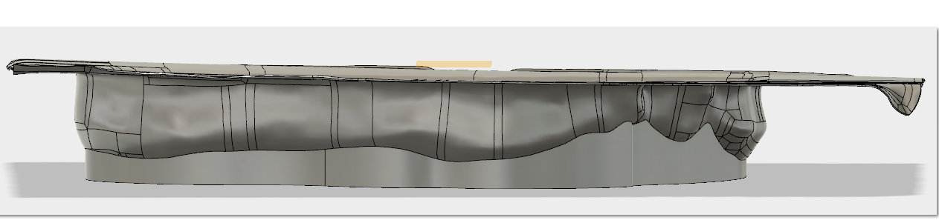
Then to get rid of the flat surface at the top of my data I drew on the right side plane a sketch which would ensure the cut off of any unwanted data from the impression. I drew the sketch with sloped sides to cut lower section off of the toes than the heel as I don’t want the thickness of the toes to be very high and in addition to this, most foot soles will have a thinner section for the toe are as less support is required here. The majority of the support and comfort of most soles are focused around the heel and the foot arch.
I then went on to extrude cut the sketch I had made but I used the “intersect” option in the list so that the important part of my impression was not compromised by the cut due to the surface and the previous extruded step being linked.
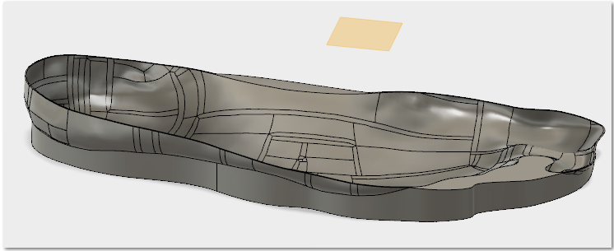
The image above displays the result of the above step. The heel section of my data is still quite high compared to standard orthopaedic soles and the end toe section of the soles is still quite thick so I then went on to edit the sketch for the extrude intersect cut so that it gave my desired shape for the sole.
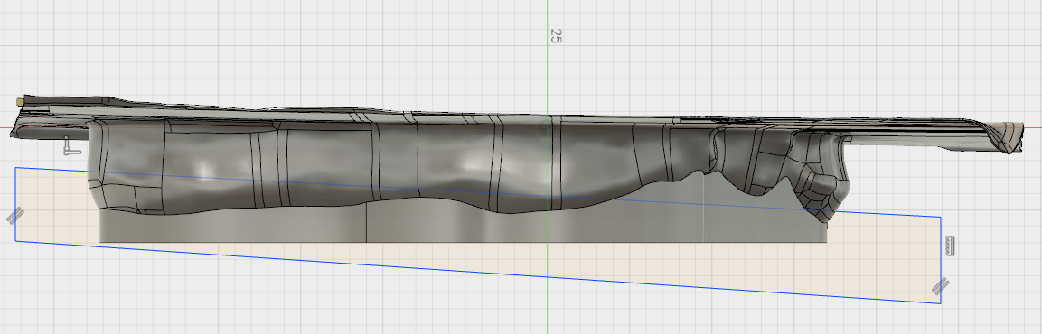
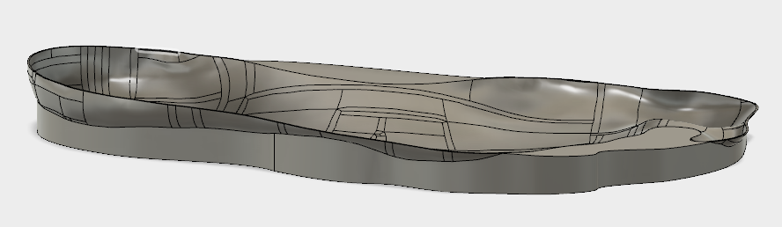
Once I was happy with my foot impression I would then proceed to export the file as an stl. File type so that I can take it into the Cura software.
Once in Cura I will check (and change if needed) the orientation of my data so that it is in level with the ground plane. Then, as my impression has a flat bottom it will not be needing support structures when printing. Then I will proceed to check that all of the settings are correct. i.e. that the print bed is at the correct temperature and the layer height is 0.2mm and as I want my sole impressions to be quite light weight and comfortable I have chosen for the infill to be 20% - allowing for slight flexibility whilst still being comfortable and smooth.

Unfortunately due to Fusion 360 recently having software issues I was slowed down in the process of manipulating my scanned data in fusion as the software kept crashing every time I clicked on a new process. Therefore, I have unfortunately not had enough time to print my 3D foot impression.

