

Module: Sustainable Hospitality & Tourism Management
Module Code: BMIH5006
Programme: BA (Hons) International Hotel Management
Assignment Title: Report
Lecturer: Kathryn Roberts
Student: Oana-Andreea Puscuta
Id: 2232738
Word: 2117

Declaration

I confirm that I have not used any AI tools in the research and creation of this presentation, and I confirm I have not presented any AI generated materials as my own work.

Table of Contents
Introduction 3
Conceptual and Theoretical Framework 3
Industry Analysis 4
Case Studies and Industry Examples 6
Critical Evaluation 7
Recommendations for Future Strategic Development 9
Conclusion 10
Reference List 11

Introduction
The hotel industry is increasingly under pressure to adopt circular and sustainable business practices in response to environmental, regulatory, and consumer pressures. This report critically examines the imperative for hotels to become more sustainable, examining the drivers, challenges, and benefits of such strategies. It explores key theoretical models such as the Triple Bottom Line and Circular Economy concepts and provides practical real-world examples from top hotel chains. The research aims to determine the strategic advantages of sustainability and make evidence-based suggestions for future development in the hospitality sector.

Conceptual and Theoretical Framework
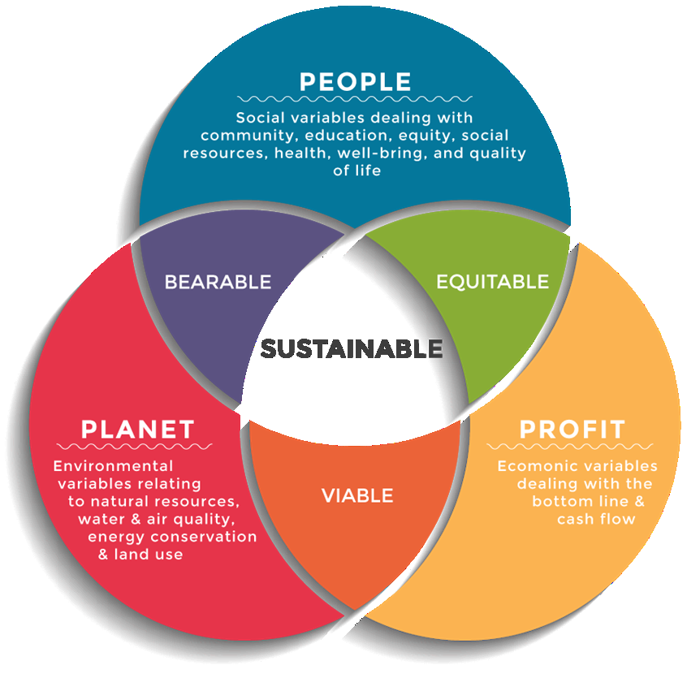
Figure 1: Triple Bottom Line Theory
Source: (Dalibozhko and Krakovetskaya, 2018)
The applications of circular and sustainable business models within the hotel industry is founded upon a synthesis of significant theoretical thinking. First, sustainability, sometimes encapsulated by the popular Triple Bottom Line (TBL) concept, underlines the fusion of environmental, social, and economic performance. This holistic way of thinking serves to address the expectations of stakeholders and value creation in the longer term, in addition to just being profit-driven on the economic performance axis. The linked circular economy paradigm, as envisioned by the Ellen MacArthur Foundation, transforms the single-direction take-make-dispose model into a cyclical system (Wickham, Donnelly and French, 2021). For hotel operators, this encompasses efficiency in using resources, minimisation of waste, and redesigning service to minimize impact, while extracting maximum life-cycle value and recycling resources. Sustainable Business Model Innovation (SBMI), as a strategic dynamic, is a means of infusing all these concepts into the core of the configuration of the hotel operations and throughout sustainable business models. SBMI forces companies to rethink how they generate and capture value, making sustainability possible, for instance, shifting to 100% renewable energy, locally sourced food, and zero-waste building designs. Stakeholder Theory as a strategic theory holds that firms competing in a hospitality context have a responsibility to care about the interests of all the stakeholders ranging from customers and workers to communities and the environment. Conversely, the Resource-Based View (RBV) focuses on the competitive advantage of scarce, replicable resources, such as an excellent sustainability image or green assets (Inkson and Minnaert, 2018). Lastly, Institutional Theory adds to explaining the increasing pressure upon hotels to accommodate societal norms and regulatory demands for sustainability. Collectively, these paradigms establish the platform for a strong foundation upon which to explain how sustainable and circular models must become mandated, and in effect how strategically they can be embedded into hospitality operations.

Industry Analysis
The hospitality sector is driven to operate within an environmentally, economically and socially stressed context. Growing awareness of climate change, resource shortages and responsible consumers demanding responsible holidays have all promoted the shift towards greater circularity and sustainability in business models. Although the recovery and expansion of tourism resumed, international tourism has a green footprint when considered from a hotel and accommodation point of view from energy use to waste (Jauhari, 2021). Sustainability is solidly established not only as an ethical responsibility in the hospitality industry, but indeed a strategic responsibility from a long-term competitiveness, and a compliance requirement. One of the drivers of change is customer demand for sustainable hospitality. Customers are more likely to be towards companies that practice ethical conduct (carbon footprint reduction, use of renewable energy, support for local communities, and many more). Environmental ratings and sustainability certifications for hotels are now extremely powerful drivers of consumer buying behaviour. Also, consumers of Millennials and Generation Z are placing future consumers in a position with expectations when it comes to environmental integrity and social contributions. International policy agendas and regulatory frameworks such as the United Nations Sustainable Development Goals and national carbon-cutting targets are also compelling the hotel industry to green up the paradigms of working (Rossidis et al., 2021). Governments are implementing tougher environmental standards and encouraging green initiatives, and sustainability is becoming a compliance and risk management concern as well as a value proposition.
Despite these pressures, the transition to sustainable or circular models is not straightforward. Most hotels, especially independent and smaller independent hotels, appear to be discouraged by cost constraints on expenses and quite simply cannot afford new green technology, ideas, or renovation. However, all appear to become that much more complicated when businesses are unable to identify common or universal sustainability measures, limited access to expertise, and often complexity around supply chain matters (Denysenko and Yurynets, 2021). There could also be in-house impediments like resistance of staff or leaders to changes from within, or the belief in possible operational consequences on the company because of the costs. The hotel industry is at a fork in the road. The imperative to transform is gathering pace from external and internal drivers. Companies that fail to transform may risk reputational, regulatory, and financial issues, while companies that embrace sustainability are in a prime position to capture resilience, innovation, and sustainable growth.

Case Studies and Industry Examples
A number of large hotel operators have started to institutionalize sustainability and circular economy thinking into their operations, setting the way for the industry. They demonstrate the operational application of sustainable business models and illustrate to practitioners how to strategically value. Marriott International, one of the largest hotel chains in the world, created and incorporated sustainability into its business strategy with its "Serve 360" platform (Marriott International, 2023). The efforts are aligned with four key areas of interest, taking care of our planet, empowering people, sustainable operations, and sustainable sourcing. Marriott is dedicated to conserving water, reducing waste and carbon footprint, and is implementing green building for the majority of its new facilities. Marriott bases its ambitions on a number of international platforms, such as the Science Based Targets, which indicates a deliberate effort to reduce its environmental footprint.
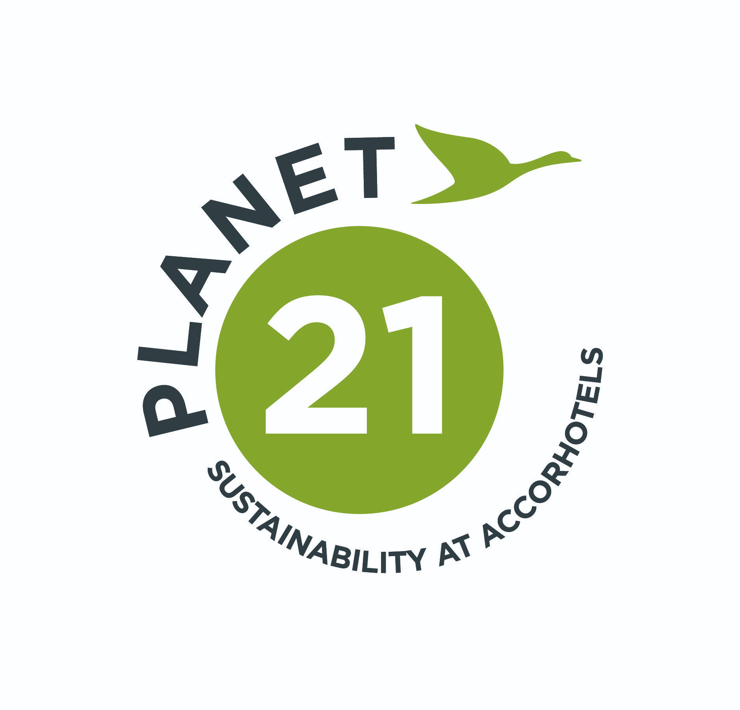
Figure 2: "Planet 21" Program
Source: (Mahiette, 2025)
Accor Hotels has launched the "Planet 21" program that makes very ambitious sustainability targets for every one of their worldwide properties and includes actions such as removing single-use plastics, energy efficiency and co-operated initiatives on a local food supply level. Circular initiatives also take place, like recycling soap for producing hygiene kits for underprivileged communities and recycling material usage when redevelopment of hotels is necessary (Accor, 2024). These initiatives will continue to shape the identity of Accor, while further drawing in green-friendly tourists. Ecological boutique hotels also have a significant role to play in targeting circularity. The Treehotel in Sweden and Whitepod in Switzerland are built with fewer environmental footprints, employ renewable energies, and drive nature-based immersions. Sustainable luxury can therefore be driven without compromising on client satisfaction. These examples show that sustainability is not only about environmental performance but can be extended to social influence and innovation. By adopting circular economy principles, hotels can improve operational efficiency, reduce costs, respond to evolving customer needs, and build competitive advantage.

Critical Evaluation
Though sustainability and circularity in business models can be significant to the hotel industry, uptake remains uneven and bound by real-world limitations. A meta-analysis of the current efforts yields data on promise, as well as significant constraints in terms of strategy, tying it all together, and scaling to make systemic change. As per Robina-Ramírez et al., (2022), large hotel chains such as Marriott and Accor have been better at efficient use of resources, stakeholder-oriented management, and supportive development across much of the global models, but it all still seems in a silo of meaningless activity such as measuring and then cutting existing energy consumption. Whilst quantifiable, this is at best eco-efficiency and not the type of thinking that leads to circularity. Real circularity needs some degree of system change in terms of design, operations management, sourcing, and the footprint of the guest experience in terms of resource usage and waste. The overwhelming majority of hotels are extremely bad at this, and most are still focused on incremental and efficiency improvements rather than transformational innovation.
Furthermore, sustainability efforts are also led by compliance or marketing teams rather than being intrinsic across operation stages. Pizam et al., (2022), have argued that the result is, therefore, a fragmented one where sustainability appears as an afterthought and not part of mainstream strategic agendas. For instance, while brands would eliminate single-use plastics or install towel reuse initiatives, deeper ones such as building modules, regenerative travel, or network transformation of supply chains are not common. Such limited integration weakens the impact of sustainability messages and leads to greenwashing. Another need for consideration is a shortage of standardisation and comparability: several sustainability certifications and self-declared improvements make it impossible for stakeholders (especially consumers) to compare and judge hotel performance. This is less than ideal because it eliminates transparency and accountability, the two largest drivers of change in the industry. Besides, small hotels and independent businesses seldom possess the funds required or the knowledge to implement sustainable measures in a positive manner (Khatter et al., 2021). Limited access to capital, a lack of access to innovation and fear of disrupting the business dissuade those respondents from making investments in circular businesses. Without collaboration across sectors, or government backing, these players may become left out in the process of changing towards the finality of sustainability, and inequality in the sector can persist.
There are also behavioural and cultural barriers. Established work habits, and staff resisting change, can be barriers to adoption, as can guests resisting and altering luxury and convenience expectations. For instance, according to Chan et al., (2021), in an owner-run hotel context, it might be challenging/problematic to encourage guests to reuse, reduce, use less air conditioning or accept plant-based menu choices, without a high level of education and incentivising. Despite the difficulties, people can observe the momentum gathering in favour of sustainability. Hotel groups that adopt a long-term strategy, innovation mindset, and stakeholder involvement are finally starting to gain ground. Sustainability is now being conceptualized in an integrated manner to view brand loyalty, employee involvement, risk mitigation and regulatory compliance as interlinked outcomes (some of the characteristics of business resilience). The hospitality sector could still do better, as far as compliance- and cosmetic, sustainable practices are concerned but obviously, there are limits to this (Prillona et al., 2025). Redefining sustainability as a driver of change and not a box-ticking exercise calls for courageous leadership; cross-sector collaborative action, and a willingness to challenge the way value can be delivered through the lens of a circular economy.

Recommendations for Future Strategic Development
Embed Sustainability across Departments: Sustainability should be a core strategic priority embedded across all departments and not siloed within marketing or CSR teams (Tjong et al., 2025). This requires leadership engagement, cross-functional planning, and transparent performance metrics linked to environmental, social, and financial goals.
Invest in Green Innovation: Hotels need to invest in clean technologies such as smart energy systems, modular and green building, and waste-to-resource (Wang and Zhang, 2021). Collaboration with start-ups, research institutions, and local suppliers can speed up the uptake of new sustainability solutions.
Apply Life-Cycle Thinking to Procurement and Design: A lifecycle approach to design and procurement minimizes waste and maximizes resource use (Demir et al., 2021). Taking into account environmental and social considerations throughout all stages, from acquisition to end-of-life disposal, hotels can minimize their impact on the environment and promote a circular economy.
Encourage Government Incentives and Cooperative Platforms: In order to help smaller hotels, the industry needs to lobby for government incentives and create cooperative platforms for training, procurement, and knowledge transfer (Tong-On et al., 2021). These may be employed to overcome financial gaps and enable increased diffusion of sustainable practices.
Direct Guest Participation Programs: Hotels can engage actively in involving visitors towards sustainability initiatives with incentives to patrons for exemplary conduct such as the reuse of towels, having vegetarian meals, or paying for flight emissions offsets (Liu et al., 2021). This not only benefits sustainability, but also heightens guest loyalty.
Assign High Priority to Workforce Training: The training of the staff at every level is important to develop a culture of sustainability in an organisation (Liang, 2025). Educating employees and equipping them with the ability to contribute to sustainability is important and can have the power to positively impact operational excellence and guest satisfaction immediately.

Conclusion
In conclusion, understandable and workable sustainable and circular business models have become a requirement for sustainable sustainability for hotels long term. Bigger hospitality chains have worked on their models of sustainability but SMEs are lagging behind because of the hindrances of cost, change resistance and not having appropriate, meaningful standardisation. Nevertheless, the demand for sustainable tourism keeps increasing and the reason that sustainable tourism reduces costs of operation and strengthens brand loyalty renders sustainability a strategic necessity. By integrating sustainability into new investments in operations and innovation, as well as stakeholder engagement, hotels can position themselves in a value environment for the global future.

Reference List
Accor, 2024. ALL - Accor Live Limitless | Hotels Stays & Exclusive Deals. [online] all.accor.com. Available at: https://all.accor.com/a/en.html [Accessed on 06.06.2025].
Chan, J., Gao, Y. and McGinley, S., 2021. Updates in service standards in hotels: how COVID-19 changed operations. International Journal of Contemporary Hospitality Management, 33(5), pp.1668-1687.
Dalibozhko, A. and Krakovetskaya, I., 2018. Youth entrepreneurial projects for the sustainable development of global community: evidence from Enactus program. In SHS Web of Conferences (Vol. 57, p. 01009). EDP Sciences.
Demir, M., Demir, Ş.Ş., Dalgıç, A. and Ergen, F.D., 2021. Impact of COVID-19 pandemic on the tourism industry: An evaluation from the hotel managers' perspective. Journal of Tourism Theory and Research, 7(1), pp.44-57.
Denysenko, M. and Yurynets, Z., 2021. Modern hotel management principles and methods for providing a quality product. Економіка та держава, (3), pp.28-33.
Inkson, C. and Minnaert, L., 2018. Tourism management:an introduction. 2nd ed. London: SAGE.
Jauhari, V., 2021. Managing Sustainability in the Hospitality and Tourism Industry: Paradigms and Directions for the Future. 9th edn.Oakville: Apple Academic Press. Inc.
Khatter, A., White, L., Pyke, J. and McGrath, M., 2021. Barriers and drivers of environmental sustainability: Australian hotels. International Journal of Contemporary Hospitality Management, 33(5), pp.1830-1849.
Liang, X., 2025. Discussion on the Effect of Green Exhibition Concept on Resource Management Optimization of Hotel Industry. In SHS Web of Conferences (Vol. 213, p. 01009). EDP Sciences.
Liu, S., Wang, N., Gao, B. and Gallivan, M., 2021. To be similar or to be different? The effect of hotel managers’ rote response on subsequent reviews. Tourism Management, 86, p.104346.
Mahiette, M., 2025. AccorHotels, an official partner of COP 21 - Accor – Newsroom. [online] Accor – Newsroom. Available at: https://press.accor.com/accorhotels-an-official-partner-of-cop-21/?lang=eng [Accessed on 06.06.2025].
Marriott International, 2023. csr-marriott. [online] csr-marriott. Available at: https://serve360.marriott.com/ [Accessed on 06.06.2025].
Pizam, A., Ozturk, A.B., Balderas-Cejudo, A., Buhalis, D., Fuchs, G., Hara, T., Meira, J., Revilla, M.R.G., Sethi, D., Shen, Y. and State, O., 2022. Factors affecting hotel managers’ intentions to adopt robotic technologies: A global study. International Journal of Hospitality Management, 102, p.103139.
Prillona, T., Birton, M.N.A. and Hakim, L., 2025. Isomorphism of Hotel Management Contract and Capital Expenditure. International Journal of Law, Policy, and Governance, 4(2), pp.134-149.
Robina-Ramírez, R., Medina-Merodio, J.A. and Estriegana, R., 2022. What do urban and rural hotel managers say about the future of hotels after COVID-19? The new meaning of safety experiences. Cities, 120, p.103492.
Rossidis, I., Belias, D. and Vasiliadis, L., 2021, June. Strategic hotel management in the “hostile” international environment. In Culture and Tourism in a Smart, Globalized, and Sustainable World: 7th International Conference of IACuDiT, Hydra, Greece, 2020 (pp. 325-336). Cham: Springer International Publishing.
Tjong, F., Goh, E. and Wilk, V., 2025. Crisis planning intentions among hotel managers: what have we learned from the COVID-19 pandemic?. Tourism Recreation Research, pp.1-18.
Tong-On, P., Siripipatthanakul, S. and Phayaphrom, B., 2021. The implementation of business intelligence using data analytics and its effects towards on performance in the hotel industry in Thailand. International Journal of Behavioral Analytics, 1(2).
Wang, Q. and Zhang, B., 2021. Research and implementation of the customer-oriented modern hotel management system using fuzzy analytic hiererchical process (FAHP). Journal of Intelligent & Fuzzy Systems, 40(4), pp.8277-8285.
Wickham, Donnelly, T. and French, L., 2021. Strategic Sustainability Management in the Event Sector. Event Management, 25(3), 279–296.

