TO FURTHER UNDERSTAND AVIATION SAFETY IN THE EXTREME HIGH ALTITUDE PARACHUTING ENVIRONMENT.

Student name: Lee Winter
Student number: 2031012
Assignment number: BMPF7012

Table of Contents
Introduction 3
Learning Application 4
Concrete Experience 4
Reflective Observation 5
Practice Improvement 7
Abstract Conceptualisation 7
Active Experimentation 8
Performance Enhancement 9
Organisational Contribution 11
Critical Reflection 12
Challenges and Solutions 13
Conclusion 13
References 15

Introduction
Safety in aviation is more than just a priority, it is the beginning of every aspect of the operation, especially for freefall parachuting. A parachutist must make decisions between life or death in a matter of seconds. I will be discussing a near miss incident which took place during my first skydiving expedition to the Syanboche Airfield, Nepal in April 2022 (Arnold, S 2022). I have explained this incident involving poorly maintained stowage and an equipment flaw, combined with an oversight during Standard Operating Procedures (SOPs) of a fully qualified and competent parachutist (Winter, L 2024). Having discussed this incident and my following actions I would like to build on this subject as an study case for my further understanding of aviation safety and the measures that can be put in place to mitigate future issues. It has been shown vital that a human element, instrument reliability, and organisational techniques come into play to avoid any safety issues (Zhu et al., 2024).
I have utilised the Reflective Model of Kolb (1986) and James Reason (2016) Swiss Cheese Model as tools to understand the incidence and to prevent its recurrence. These approaches made it possible for me to look at the event from the holistic point of view, and to identify core aspects that require some improvements. Human factors – communications and technical malfunctions – were all analysed in depth (Knott, 2020). That was not a matter of theory, but it was the first step on the way of real change. One of the simplest ways to obtain a comprehensive analysis of our existing procedures and protocol is a bottom-up approach. Hence, I ensure that we have well-structured implementations of safety measures across all levels. Such activities led to revisions of the check lists, new training procedures and the adoption of the new maintenance processes for safety.

Learning Application

Concrete Experience
I was confronted on a freefall parachuting expedition with the near-miss incident that could have resulted in a fatal outcome. In order to summarise my previous work a highly experienced camera jumper completed the second jump of the days program landing with their individual parachute harness chest strap undone. This could have resulted in a fatality. The chest strap not only holds the jumper in the parachute harness but also secures the supplementary oxygen system. After an investigation we discovered a simple damaged elastic stowage loop had left the strap excess exposed the freefall wind and without the final safety stitch back tab the strap had worked out of its buckle (Winter, L 2024).
This event was a case in point that aviation is unpredictable and ordinary flights may lead to critical situations (that can be life threatening) without warning (Luciani et al., 2022). It reinforced the fact that the high standard of safety procedures, proper communication, and faultless equipment should be implemented to minimise risk.

Reflective Observation
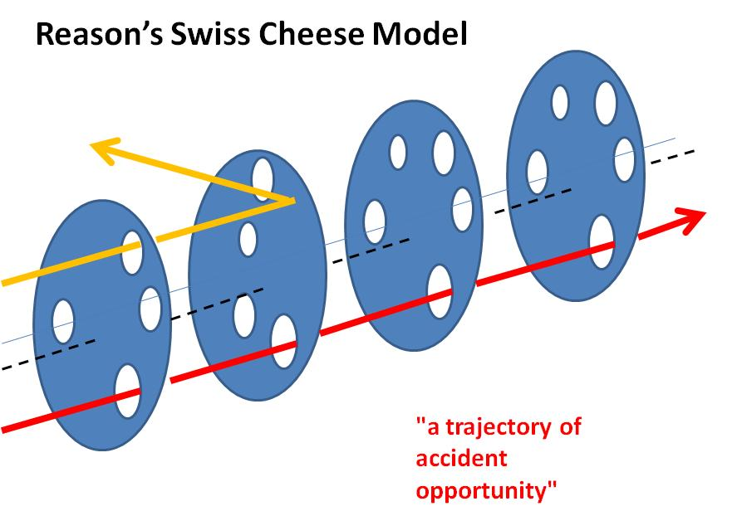
Figure 1 Swiss Cheese Model
Source: (Suedfeld, 2022)
The Swiss Cheese Model is a prism through which the chest strap near-miss incident is analysed, and this helps to bring out the multifaceted nature of the factors that resulted in the incident. This approach shows that an accident can be represented as a situation when holes in different layers of defensive measures are aligned, hence an accident can happen. In the case of the chest strap incident, the different layers of safety procedures failed to function properly, thus leading to the occurrence of the incident. The organisational level also had a number of deficiencies in the pre-flight checklist procedures (Kuzikova, 2021). The checklist, which was carried out before the flight, did not adequately evaluate the condition of the chest strap stowage loop, consequently permitting the problem to develop into an emergency.
Human factors have also been very detrimental to the incident making the safety defences less strong (Rosenberger, 2020). Due to the pressures of the operational situation, the communication between the team members was strained, and this made it difficult for us to organise effective levels of defence. These human errors, along with the equipment deficiency, created a perfect storm of circumstances, which at the end resulted in the incident.
The weakest point of the system is the chest strap stowage loop, a simple elastic band, although it is the smallest part of the system (Farah, Farah and Hutchinson, 2024). Therefore, it is important to equip the system with check-up and maintenance protocols. The failures, in this case, shows the need for continuous improvement in the design of equipment and maintenance programs so that such incidents could be prevented and safety standards could be increased. The Swiss Cheese Model describes the fact that the development of an event is rarely due to a single factor but is rather an accumulative effect of interacting factors at different levels of defence (Monasterio and Brymer, 2021). Through an in-depth assessment of these shortfalls, we will be able to implement the required changes to make the safety measures more effective and avoid such incidents next time.

Practical Improvement
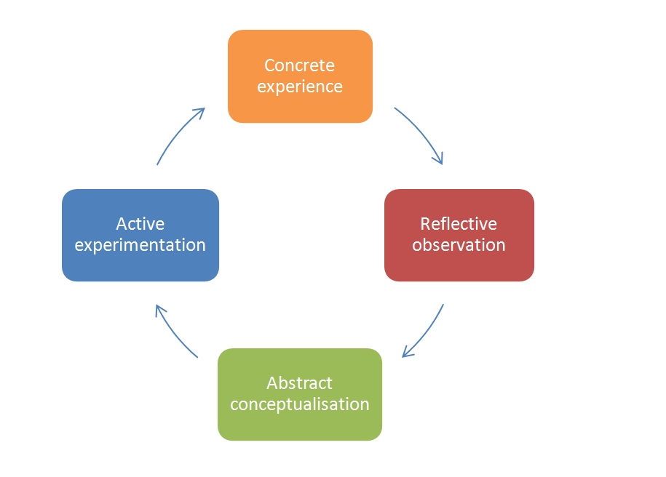
Figure 2 Kolb’s (1986) Reflective Model
Source: (Bradke and Everman, 2020)

Abstract Conceptualisation
The near-miss incident was a revelation for me concerning aviation safety, evidencing the crucial role of cognitive factors, equipment reliability, and safety procedures. The human factor aspect of parachuting safety and altitude is highlighted by (Liao, Peng and Gao, 2024). The accident showed that it is not only technical failures that are the problem, but even human error can aggravate risk. It was clear that training for the program and the awareness of the heightened initiatives were the main factors that had to be considered in order to prevent human errors.
The accident proved the urgent need to Improve on the fault-tolerant design of the parachute systems developed for the purpose of applications in extreme environments (TUKAIEV et al., 2020). I understood the fact that the equipment reliability is of primary importance to keep people safe and that is why during the planning stages I worked closely with parachute systems manufacturers to determine the causes of any failures in the system design and operation. Conducting a strict testing process, upgraded the maintenance procedures, and performing routine equipment inspections have been determined as the main steps which will ensure system reliability.
All the safety processes ranging from pre-flight checklists to emergency procedures run through intensive scrutiny. The incident analysis and the implementation of the lessons learned into updated safety protocols have empowered our organisation to take more effective measures to safeguard against risks and respond to unexpected challenges (Karachalios and Adjekum, 2023).

Active Experimentation
The chest strap near-miss incident is a lesson for me to be dynamic and active in learning from mistakes. The major activity was the adjustment of our Standard Operating Procedures (SOPs) on the use of oxygen systems and excess strapping stowage (Winter, 2022). The SOPs were developed with utmost care and all lessons experienced during the incident are included to ensure that the risks and vulnerabilities have been well covered (Kalavsky, Rozenberg and Tobisova, 2022). The SOPs in crew safety procedures were designed so that there are multiple safety redundancies, at the core of every operation. This was done by the pre-flight and pre-exit checks, equipment maintenance, emergency response procedures, etc.
Additionally, mechanisms were designed to decrease the costs of maintenance, but not at the expense of the safety standards. During the decision process of financial restrictions and safety standards, we had to introduce new techniques that would increase the efficiency of our work. The result is given by applying the most modern technologies for the optimal way of maintenance and reduction of equipment off line (Rooks et al., 2021). The adoption of predictive maintenance technologies and a condition-based approach to maintenance provides an opportunity to reduce the costs of maintenance, but still keep a high safety criteria. In addition to that there were significant improvements in the spare parts management, which were achieved by optimisation of inventory management processes, and as a result the necessary components were stocked on time in case of need thus reducing the total cost of maintenance procedures.
Regarding assessing our methods, I can state that the most important thing is to hit the correct balance between cost-effectiveness and safety. On the one hand to reduce the maintenance costs and on the other hand the desire to continue to meet safety standards (Karachalios and Adjekum, 2023). This must reach a fair compromise between the economic gains and the issues of safety.

Performance Enhancement
The reflective learning experience after the chest strap incident helped me to identify the shortcomings in the protocols and the training that we had in place and as a result, we have made changes to improve both aspects. The detailed scrutiny of the occurrence and the successive adoption of specialised enhancements have led to several sectors of performance improvement, which in turn gave a rise to a safer and more effective operational environment (Kalavsky, Rozenberg and Tobisova, 2022).
In respect of risk management the progress has been one of the greatest developments. By conducting a detailed investigation of the event and focusing on the safety gaps that have been discovered, I have enhanced the preventive measures that have resulted in the reduction of risk. Extensive risk analysis was conducted in areas including human factors, equipment reliability and environmental factors (Suedfeld, 2022). A risk assessment is conducted before each operation. Through this risk assessment we can predict potential hazards and then introduce preventive measures to lessen the impact of the hazards and therefore improve safety.
This reflective process has also been key to the development of heightened awareness in human factors among personnel. As a result, by means of focused training initiatives and the raising of awareness, members of the team have become more knowledgeable about the part that human error can have in safety performance (Kunwar, 2021). This heightened awareness has fuelled the individuals to comprehensively evaluate all probable risks and take timely and appropriate measures such as multifaceted communication, improved decision-making, or enhanced situational awareness. Hence, the team have become more skilful and adept at operating in challenging environmental settings. They are also able to minimise risks, which in turn preserves a safe working environment for the whole team.
Furthermore, the learning process has also enabled me to develop better care for the equipment. Through investigating the event and specifying the equipment-related drawbacks, we have already improved equipment reliability and stipulated more precise equipment handling rules. Such activities include the creation of standardised equipment inspection and maintenance protocols based on the best industry practices, and the development of targeted training programs focused on correct equipment handling techniques (Hancock, 2023).

Organisational Contribution
This chest strap emergency revealed a great lesson that was a launching pad for some of the substantial advances we have implemented that have, in turn, caused a decline in safety records, reduced maintenance expenses, and improved operations efficiency. The control measures that are brought forth to deal with the root causes have led to the transformation of different areas of operation of the expeditions (Suedfeld, 2022). At first, the safety rules improvements and the employees training program have brought significant change in the safety records. To ensure a safety culture and incorporated preventive measures of risk management programs, we managed to significantly reduce the number of safety incidents and near misses. Zero safety incidents reported in 2023 expedition.
Our maintenance system has been upgraded by incorporating smart maintenance methods including predictive maintenance and condition-based maintenance that in turn help us to perfect the maintenance schedules and minimise equipment downtime. Besides the organisation has been able to make some savings and the equipment in good condition and this reduced the risk of accidents and interruptions related to the equipment (Rosenberger, 2020). On the other hand, the company’s ability to continually learn and adapt as part of its ongoing safety and efficiency improvement process has been a significant contributor to this.
In the aftermath of the chest strap case and the implemented reflective learning models we have since developed a culture of the continual improvement which is the situation where each and every incident becomes the opportunity of reflection, learning and improvement (Hancock, 2023). Moreover, it is worth noting that the Swiss Cheese Model, which is rather closely connected with aviation security, is not limited to aeronautical or aviation incidents. This model has been made to be an applicable tool for any barriered incident analysis and mitigation in multiple different areas, thus it is useful and can be applied to security incidents.

Critical Reflection
The learning path that was created by the case of the chest strap accident has been very influential in my immediate reaction and constant challenges handling safety culture and practices in aviation. This was a pivotal realisation for me, I believed I was applying everything required to provide safe working conditions until this incident made me reassess my assumptions and methods to achieve higher safety standards. The incident contributed to the increased understanding of the vital part that human factors play in ensuring aviation security (Liao, Peng and Gao, 2024). We found that preventive technical breakdowns can be reduced by the implementation of the comprehensive maintenance plan, but human errors are a complex problem.
The more the reoccurring incident-led improvements have grown, the more they have changed my safety culture to a transformative one. Our culture of safety is not just a goal, but rather a lifestyle that we have achieved through dedication to transparency, accountability and constant improvement. All jumpers are included at all the levels of the organisation for the identification and management of safety risks and consequently, the safety management becomes proactive and collaborative (Jodehl et al., 2021). Nevertheless, even though there has been progress made, the difficulties of introducing human factors into the safety environment and the balancing between cost and safety standards is still an ongoing one. Human factors are a combination of different factors such as cognitive, behavioural, and emotional ones, which makes them very difficult to assess and deal with in a systematic way (Kuzikova, 2021).

Challenges and Solutions
The deployment of novel SOPs and safety enhancements in my organisation was met with several problems. The first difficulty was the resistance of staff who had been biased to work within the existing structured systems (Suedfeld, 2022). At the beginning some team members experienced challenges to accept the new compliance requirements and this resulted in some misunderstanding of the whole protocol.
In order to deal with these difficulties, my strategy included the following areas of focus – communication, training and ongoing support. We organised regular sessions with the staff to explain the rationale behind the new SOPs and to clear any misunderstandings or worries they might have. A dynamic training program was developed for all personnel to ensure that they fully understood the new sets of procedures and their role in safety regarding this matter (Farah, Farah and Hutchinson, 2024). Besides, the reaction systems were built to collect the input of frontline personnel and improve on those areas that needed to be revised. We learned and improved for each phase of the operation to be able to surpass the initial challenges and the establishment of a culture of continuous development of safety protocols.

Conclusion
The incident was a signal for re-evaluation of the human factors, the improvement of equipment, and the revision of aviation safety SOPs. Kolb’s (1986) Reflective Learning and the Swiss Cheese Model have generated a platform for a continuous improvement process which will lead to the survival and prosperity of a safety culture as well as the reliability of the organisation under extreme conditions. The event developed stricter safety regulations, adopt improved maintenance techniques and the latest safety training programs so as to upscale safety measures and mitigate risks.

References
Arnold, S. April 2022. Brave disabled veterans set record. Mirror, available at https://www.mirror.co.uk/news/world-news/brave-disabled-veterans-set-record-26839617 (Accessed: 10 March 2024)
Bradke, B.S. and Everman, B.R., 2020. Mild hypoxia of a skydiver making repeated, medium-altitude aircraft exits. Aerospace medicine and human performance, 91(2), pp.110-115.
Çalık, D.S., Gürsoy, R. and Saruhan, E., 2021. Evaluation of the psychological and hormonal parameters in paragliding. Central European Journal of Sport Sciences and Medicine, 34(2), pp.15-23.
Farah, O., Farah, G. and Hutchinson, M.R., 2024. Extraction and Rescue Challenges. In Sideline Management in Sports (pp. 461-472). Cham: Springer International Publishing.
Hancock, P.A., 2023. Reacting and responding to rare, uncertain and unprecedented events. Ergonomics, 66(4), pp.454-478.
Jodehl, J.W., Anton, S.V., Bosboom, T.C., Dhiyaneeswaran, S., Dvorak, O., Homola, M., Knöll, N., Menting, E., Sujahudeen, M.S., Pepermans, L. and Britting, T., 2021. Architectures for parachute testing. In 72nd International Astronautical Congress.
Kalavsky, P., Rozenberg, R. and Tobisova, A., 2022. The testing of skydiving equipment in the context of global warming and its impact on the vertical rate of the parachute descent.
Karachalios, M. and Adjekum, D.K., 2023. Air Show Performers: Safety, Risk Management, and Psychological Factors. CRC Press.
Knott, M., 2020. Redefining Creep: A Comprehensive Analysis of Aviation Accident Survivability.
Kolb, D., Lublin, S., Spoth, J., & Baker, R. (1986). Strategic management development: using experiential learning theory to assess and develop managerial competencies. Journal of Management Development, 5(3), 13-24.
Kunwar, R.R., 2021. Extreme sport: understanding the concept, recognizing the value. Journal of Tourism & Adventure, 4(1), pp.89-123.
Kuzikova, S., 2021. THE STUDY OF PERSONALITY'S PSYCHO-ENERGY STATES SELF-REGULATION IN THE EXTREME ENVIRONMENT. Psychology & Personality, 1(19).
Liao, Y., Peng, J. and Gao, Y., 2024. The maximum drop height of high-altitude parachuting based on dynamic and thermodynamic analysis. Highlights in Science, Engineering and Technology, 82, pp.283-291.
Luciani, F., Veneziani, G., Ciacchella, C., Rocchi, G., Reho, M., Gennaro, A. and Lai, C., 2022. Safety at high altitude: the importance of emotional dysregulation on pilots’ risk attitudes during flight. Frontiers in psychology, 13, p.1042283.
Monasterio, E. and Brymer, E., 2021. Feeding Time at the Zoo: Psychological aspects of a serious rock climbing accident. Journal of Adventure Education and Outdoor Learning, 21(4), pp.323-335.
Reason, J. (2016). Managing the risks of organizational accidents. https://doi.org/10.4324/9781315543543
Rooks, T.F., Novotny, B.L., McGovern, S.M., Winegar, A., Shivers, B.L. and Brozoski, F.T., 2021. Evaluation of head and body kinematics experienced during parachute opening shock. Military Medicine, 186(11-12), pp.e1149-e1156.
Rosenberger, T., 2020. An Open-Loop Trajectory Implementation for Free Fall to Powered Flight Transition for Multirotor Aircraft.
Suedfeld, P., 2022. Adventures in Extreme Environments. Adventure Psychology: Going Knowingly into the Unknown.
Tukaiev, s., dolgova, o., van den tol, a.j.m., ruzhenkova, a., lysenko, o., fedorchuk, s., ivaskevych, d., shynkaruk, o., denysova, l., usychenko, v. And iakovenko. 2020. Individual psychological determinants of stress resistance in rock climbers. Journal of Physical Education and Sport, 20(Suppl1).
Wilkes, M., Long, G., Massey, H., Eglin, C. and Tipton, M., 2022. Quantifying risk in air sports: flying activity and incident rates in paragliding. Wilderness & Environmental Medicine, 33(1), pp.66-74.
Winter, L. Feb 2024. Afternoon Activity: Using Kolb’s (1986) reflective learning, I will discuss the Swiss Cheese aviation safety model, BMPF7012. University of Wales Trinity Saint David. Unpublished Assignment.
Winter, L., 2022. Parabellum Tactical Training LTD Supplementary Oxygen and Jump Master Standard Operating Procedures (SOPs)., 2022 Version 2, Updated Sept 2023., (Unpublished) available in submitted folders
Zhu,Yang, X., Haugen, S. and Liu, Y., 2024. A multi-dimensional approach for analysing risk-related decision problems to enhance decision making and prevent accidents. Journal of Loss Prevention in the Process Industries, 87, p.105235.

