

Module Code: LCMB7023
Module Name: Human Capital Management
Assessment Title: The Influence of National and International Labour Markets on HRM and IHRM Strategies

Assessment Component 1: Individual Report
Student Name: Md Forhad Hossen Rony
Student ID: 2433472
Lecturer: Dr Hoang Dang Nguyen
Word Count: 2697
Term-01

Table of Contents
1. Introduction 4
2. Discussion 5
2.1 Technological Advancements and Labour Markets 5
2.1.1 Introduction 5
2.1.2 How Technology Reshapes National and International Labour Markets 5
2.1.3 Implications for HRM and IHRM Strategies 6
2.1.4 Conclusion 6
2.2 Employment Markets (Demographic and Geographic) 7
2.2.1 Introduction 7
2.2.2 Demographic Key Factors Influencing Employment Markets Today 7
2.2.3 Geopolitical Key Factors Influencing Employment Markets 8
2.2.4 Current Challenges 8
2.2.5 Impact on HR Professionals 9
2.2.6 Conclusion 9
2.3 Skills Shortages and Strategic HRM 9
2.3.1 Introduction 9
2.3.2 Analysis of the Problem 9
2.3.3 Strategic HR Response (4B Framework) 10
2.3.4 Sectoral Illustration – Healthcare Sector 11
2.3.5 Conclusion 11
2.4 Reflection on Personal Preparedness for the International Labour Market 12
2.4.1 Introduction 12
2.4.2 Gibbs Model for Reflection 12
2.4.3 Analysis of Current Capabilities 15
2.4.4 Strengths and Weaknesses 15
2.4.5 Conclusion 16
3. Conclusion 17
4. References 18
5. Appendix – SWOT Analysis 20

List of Figures
Figure:1…………………………………………………………………………………………07
Figure:2…………………………………………………………………………………………10
Figure:3…………………………………………………………………………………………12

1. Introduction
Human Capital Management (HCM) is the strategic way of obtaining, training, managing and sustaining an organisational labour force to maximise the employee performance and achievement of organisational goals and objectives (Acho Elendu, 2024). The purpose of this report is to critically discuss the effects of current technological advances, demographic and geopolitical changes, and skills gaps on national and international labour markets and to discuss the implications of this for Human Resource Management (HRM) and International HRM (IHRM) strategies. The report is organised in a way that it discusses the technological redefining of work, the labour market, the strategic planning of HR and individual readiness in global HR functions.

2. Discussion

2.1 Technological Advancements and Labour Markets

2.1.1 Introduction
The speed of innovations in Artificial Intelligence (AI), automation, Internet of Things (IoT), and digital platforms is redefining the labour market functioning across the world (Ferkit, 2024). The technologies are transforming job structures, job skills and organisational workforce strategies and compelling Human Resource Management (HRM) and International HRM (IHRM) to become more agile, ethical and people practices that are more data-driven. The ways in which technological advancements are reshaping the labour market and the implications for HRM and IHRM strategies are as follows:

2.1.2 How Technology Reshapes National and International Labour Markets
A. Transformation of Job Roles through AI and Automation
The use of AI and automation is eliminating monotonous and repetitive jobs and accentuating the need to hire digital and analytic positions. During conventional manual labour, administrative processing, warehouse work, and simple customer service are in the process of becoming automated as corporations become robotised and implement the use of AI-driven service platforms (Ferkit, 2024). On a national scale, nation-states with well-developed innovation ecosystems, including the UK, Germany, and South Korea, are undergoing a quicker shift towards employment based on technology.
B. Rise of Remote Work and Digital Nomadism
Remote and location-independent work has gained momentum through the influence of digital technologies, cloud collaboration technologies, and virtual communication platforms (Prengler and Murphy, 2023). This results in highly skilled individuals, especially in ICT and creative sectors, opting to take global remote jobs instead of getting conventional jobs. Due to the effect of increased local expenditure without having to compete in local labour markets, a number of governments are currently issuing digital nomad visas to foreign freelance professionals.
C. Expansion of Global Freelancing Platforms
Some of the platforms include Upwork, Fiverr, and Toptal, where organisations can hire freelancers across borders. The platforms increase exposure to talent specialisation, minimise recruitment expenses, and provide economies of scale. To the employees, platforms offer them flexibility, the ability to earn multiple incomes, and the availability of international job markets. To employers, though, freelancing emergence poses a threat to workforce planning and retention plans in the long run.

2.1.3 Implications for HRM and IHRM Strategies
HRM Strategies (National Context)
HRM needs to implement a digital-first workforce. The artificial intelligence-based recruiting tools allow predictive screening of candidates and competency analysis, and facilitate performance-based recruitment instead of the traditional CV (Ferkit, 2024). Reskilling through lifelong digital learning is the role of HRM, which is increasingly becoming a responsibility. The use of technology ethically is essential, especially in terms of bias in algorithms and bias in employment.
IHRM Strategies (International Context)
Distributed cross-border teams are now part of IHRM strategies. The most important duties will be navigating global labour regulation, handling data privacy regulations, and ensuring fair compensation among virtual global employees (Yadav and Singh, 2025). IHRM should also bolster Diversity, Equity and Inclusion (DEI) efforts by making opportunities fairly accessible, geography, gender or socioeconomic status.

2.1.4 Conclusion
The increased labour markets are being redefined through technological development that is altering job descriptions, providing borderless employment and increasing freelancing with digital skills. HRM and IHRM need to focus on ethical AI application, reskilling, and diverse workforce policy to be competitive.

2.2 Employment Markets (Demographic and Geographic)

2.2.1 Introduction
The high-speed demographic change and increased levels of geopolitical instability are transforming the global employment markets (Dindarian, 2023). The following section will discuss the impact of geopolitical and demographic factors on the employment market and how they pose challenges for HR professionals:

2.2.2 Demographic Key Factors Influencing Employment Markets Today
This section describes the major demographic characteristics that are currently defining the employment markets and affecting HRM strategies.

Figure 1: Factors Influencing Employment Markets
Source: (Self-Made)
Ageing Workforce: Most developed economies are encountering a fast-ageing labour force which is decreasing the experienced labour. By 2030, 1 out of 4 employees in the EU will be 55 or older, which will drive the demand of flexible working, gradual retirement, and support of automation.
Migration and Global Mobility: The migration patterns directly have an impact on the availability of talent (Oliinyk and Akimov, 2024). For example, Canada accepted more than 437,000 immigrants in 2022, with skilled labour as a priority to resolve labour shortages, whereas post-Brexit UK was losing EU workers, particularly in the health and hospitality sectors, and this exerts pressure on recruitment.
Youth Unemployment: Lack of efficiency in the labour market is caused by high unemployment among the youth (Levy, 2025). There was a global unemployment rate of 13.6 per cent of the youth in the year 2023, considerably more than the adult rate. Employers are supposed to invest in training of interns, apprenticeships, and training of entry-level.
Skills Shortages and STEM Gap: Work places that are driven by technology need specialised skills. Approximately 7 out of 10 employers claim to have a shortage of STEM-related jobs and thus the HR department must invest in reskilling and continuous learning initiatives.

2.2.3 Geopolitical Key Factors Influencing Employment Markets
The pressure between geopolitics directly affects the global labour mobility, talent pipelines, and supply chains. The Russia-Ukraine war and the Middle Eastern unrest interfered with energy and logistics, leading to more job insecurity (Gingeras and Meierding, 2023). Since 2020, trade restrictions have doubled, and it has broken up global production networks. These dynamics are compelling organisations to re-engineer the implementation of the global workforce and creating superior local talent pools.

2.2.4 Current Challenges
The challenges that the HR professionals encounter are following:
- Regulatory complexity - dealing with taxation between countries and visa regulations.
- Diversity culture - the incorporation of multigenerational and multicultural teams.
- Well-being management - in hybrid work, boundaries disappear, and burnout becomes a threat.

2.2.5 Impact on HR Professionals
The evolving demographic and geopolitical environment require the HR to go beyond the administrative roles to strategic foresight roles. To be able to handle international teams, professionals need to acquire intercultural competence, digital literacy, and geopolitical awareness. Skills in projecting the displacement of the workforce, developing mobility programmes that are inclusive, and ensuring psychological safety turn into key areas of HR leadership performance (Oliinyk and Akimov, 2024).

2.2.6 Conclusion
The global working trends and HR duties are reshaped by demographic and geopolitical changes. Strategic HRM and IHRM have to foresee the demographic changes, reduce geopolitical risks, and foster inclusion. HR professional’s plans to match the evolving external conditions so that they stay agile, resilient, and competitive advantage sustainable in the volatile global markets.

2.3 Skills Shortages and Strategic HRM

2.3.1 Introduction
The global labour markets are experiencing an increasing skills gap in the fields of technology, healthcare, and hospitality, which impedes productivity and innovation (Ivanchenko, 2023). The reasons behind shortages in skills are critically assessed, strategic responses to HRM issues are played out with the 4B Model (Build, Buy, Borrow, Bind), and sector-specific cases are presented with data-driven commentary in this section.

2.3.2 Analysis of the Problem
Constant skill gaps are caused by technological dislocation, lack of fit between education and industry, and lack of flexibility in labour markets. According to the survey conducted by Santos (2025), 77 per cent of employers worldwide have a challenge locating skilled workers, the highest level of the last 17 years.
These loopholes are also enhanced by the accelerating automation and the lack of lifelong learning systems. The conventional HRM frameworks based on short-term hiring will not suffice anymore. Consequently, Strategic HRM (SHRM) needs to shift its attention to the talent ecosystem and cease responsive staffing and embrace proactive approaches, incorporating workforce analytics, inclusive training, and internal mobility.

2.3.3 Strategic HR Response (4B Framework)
The 4B Model (Build, Buy, Borrow, Bind) is a holistic approach to skill shortages as it helps HRM to match both HRM and long-term business goals.
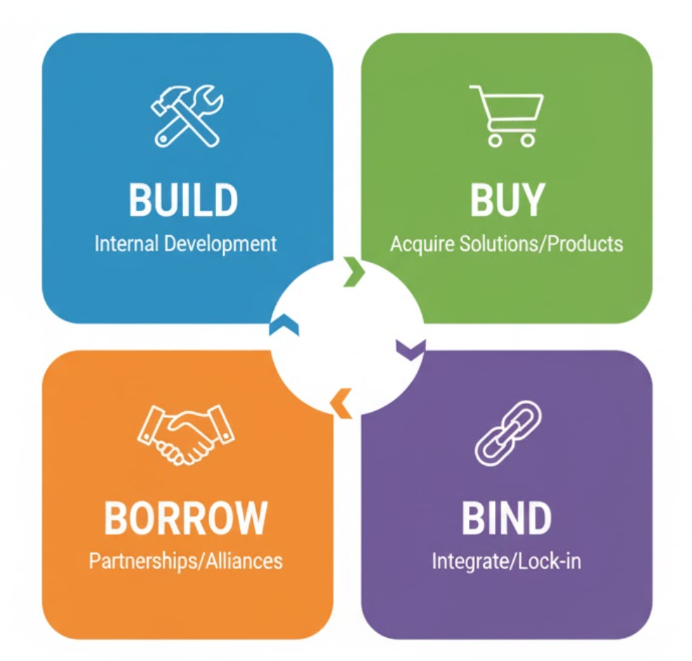
Figure 2: 4B Framework
Source: (Self-Made)
Build:
Organisations ought to invest in building internal capability using perpetual learning and digital reskilling. For example, Siemens deployed its AI-driven learning platform Learn@Work, which increased by 28% the readiness of employees in skills in less than one year.
Buy:
Niche skills are essential to fast-changing industries through external recruitment (Ivanchenko, 2023). Google and Microsoft use global AI recruitment initiatives, focusing on emerging markets such as India and Poland, to recruit digital engineers.
Borrow:
Skills gaps in the short term are resolved by hiring contractors, freelancers and consultants on a flexible basis. There is an upsurge of 20 per cent in corporate projects on platforms such as Upwork and Fiverr in 2025.
Bind:
Career development, mentoring, and well-being programmes are helping organisations to retain high performers, thus enhancing organisational stability (IMD, 2024). The turnover rate at Marriott International was decreasing by 18 per cent due to its internal management training and well-being programmes.

2.3.4 Sectoral Illustration – Healthcare Sector
The healthcare industry is a good example where strategic HR intervention can be applied. With a globally forecasted shortage of 10 million healthcare staff by 2030, healthcare systems such as the UK NHS have taken a Buy and Bind strategy (Goryakin and Scheffler, 2022). The international recruitment programmes are aimed at recruiting skilled nurses in the Philippines and India, whereas the retention programmes are oriented at the local upskilling, flexible working, and support of well-being.

2.3.5 Conclusion
The challenge of skills shortages requires evidence-based and integrated HR approaches that are agile in the external environment and competent in the internal one. The 4B model gives organisations the chance to cultivate, attract and maintain talents within changing environments.

2.4 Reflection on Personal Preparedness for the International Labour Market

2.4.1 Introduction
Reflection helps professionals to review their experiences and recognise their strengths, and create measures to improve themselves on a continuous basis. This section is a reflection of how I am ready to be employed in the international tourism labour market in a Human Resources (HR) setting using Gibbs Model.

2.4.2 Gibbs Model for Reflection
Gibbs Reflective Cycle (1988) offers a systematic way of resource and review experience in six steps that include descriptions, feelings, evaluation, analysis, conclusion and action plan (Ding, 2023). It promotes lifelong learning particularly in fast-changing global industries like tourism where flexibility and intercultural competence are paramount to HR individuals.
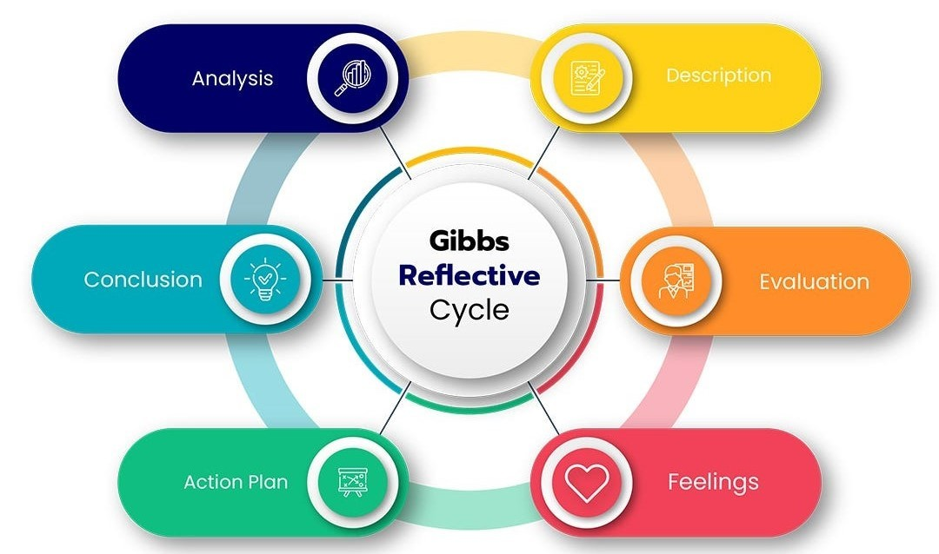
Figure 3: Gibbs Reflective Model
Source: (Ding, 2023)
1. Description: The case I have attempted to relate to is the position I worked as an HR trainee in an international tourism company which handled multicultural teams in various destinations. My task was to assist in the areas of recruitment, onboarding, and employee engagement. The position involved dealing with cross-cultural communication, and work around international employment practises, which exposed me to the reality of International Human Resource Management (IHRM).
2. Feelings: The first thing that I experienced was excitement and being overwhelmed by the fast-paced environment. It was difficult to manage the HR work involving the staff that belongs to other cultural and linguistic backgrounds. Nevertheless, I also realised that I will have a chance to gain the global HR competencies, especially in cultural intelligence (CQ), conflict resolution, and digital HR systems applied to global talent management.
3. Evaluation: My teamwork, effective communication and flexibility has helped advance my knowledge on how international tourism labour market is determined by mobility, seasonality, and global skills demand. I managed to adjust to e-HRs and assisted in the recruitment drive of seasonal employees in Southeast Asian and European countries. Nevertheless, I struggled to interpret the labour laws of various countries and organise distant training in time zones.
4. Analysis: The application of the model used by Gibbs and connecting it with the theories of international HRM brought several insights. Successful global HR professionals are credible activists, positioners, and technology proponents (Trullen, 2023). I was also a strong credible activist by earning the trust of multicultural employees but my role as a strategic positioner needs to be enhanced to align the HR initiatives with the organisational goals in a global environment. International labour mobility is determined by political instability, migration laws, and demographic diversity.
5. Conclusion: This reflection has made me realise that labour market in international tourism requires more than just the knowledge of operational HR to work, it needs cultural empathy, strategic adaptability, and mastery of technology. I have developed in the areas of communication and digital HR technology, but need to develop my analytical, legal, and cross-border management competencies to become a competent international HR professional.
6. Action Plan: To bridge my development gaps and strengthen my employability in the international HR domain, I have created the following action plan:
Objective | Action Steps | Resources/Support Required | Timeline | Expected Outcome
Enhance global HRM knowledge | Enrol in online International HRM and employment law courses (e.g., CIPD, Coursera). | Course fees, study materials, HR mentorship | 3 months | Improved understanding of global employment practices and compliance
Develop cultural intelligence (CQ) | Attend cross-cultural workshops; collaborate with international teams | Training sessions, multicultural group projects | 6 months | Greater ability to manage diverse teams effectively
Strengthen analytical and digital HR skills | Learn HR analytics using Power BI or SAP SuccessFactors | Online tutorials, practice datasets | 9 months | Data-driven decision-making skills
Expand global professional network | Join HR associations; attend webinars/conferences | Membership fees, event access | 12+ months | Access to global trends and job opportunities
Improve leadership & strategic thinking | Seek mentorship from senior global tourism HR managers | Organisational support for mentorship | 12 months | Stronger strategic alignment of HR and business goals

2.4.3 Analysis of Current Capabilities
My reflection and experiences in the profession sector indicate that I possess high interpersonal, communication and teamwork skills, which are very crucial in the multicultural tourism industry. Adaptability and openness to learn have helped me to overcome cultural diversity and be a valuable player in HR activities. Nonetheless, when I contrasted my current competencies with the global HR competency models, I noted that my strategic, technological, and legal competencies need to be improved. The tourism industry works under a complex visa, wage and labour laws, which vary across borders.

2.4.4 Strengths and Weaknesses
When thinking about my path of development, I have realised that the following strengths and weaknesses were major according to the models applied in this report:
Strengths
- Cultural adaptability: I have been able to easily relate with employees of diverse nationalities and show empathy and flexibility.
- Communication and teamwork: I ensure that there is clarity in communication among global teams and that there is great participation among the employees.
- HR exposure: It also increased my operational efficiency through digital exposure to HR software like BambooHR and recruiting websites.
Weaknesses
- Lack of awareness in international employment laws: There is still a problem in managing compliance and international contracts.
- Strategic alignment: I would usually concentrate on administrative, as opposed to long-term HR strategy.
- Analytical skill: I am familiar with HR data; however, my skill in strategic decision-making using measures should be developed.

2.4.5 Conclusion
In general, this reflection based on Gibbs Model has helped me to assess my preparedness to the international tourism labour market through the prism of HR. I have acquired important interpersonal and digital competencies and need to continue to acquire global legal expertise, analytical sense, and strategy.

3. Conclusion
The report emphasises the transformations in the labour markets due to technological innovations, demographic changes, geopolitical factors, and skills gaps that are changing HRM and IHRM practices. It highlights the importance of AI use that is ethical, reskilling, diversity and strategic workforce planning to stay competitive. The 4B framework application proves to have good responses to the gaps in skills and problems with global employment. The value of cultural intelligence, strategic thinking, and digital competency to prepare the international HR landscape has been reiterated in personal reflection.

4. References
Acho Elendu, P.D. (2024). STRATEGIC HUMAN CAPITAL MANAGEMENT AND ORGANISATIONAL PERFORMANCE IN NIGERIA BREWERIES PLC: 2001 - 2020. International Journal of African Innovation and Multidisciplinary Research, [online] 4(2). Available at: https://mediterraneanpublications.com/MEJAIMR/article/view/282 [Accessed 12 Nov. 2025].
Dindarian, K. (2023). Demographics, Education and Employment Dynamics. Future of Business and Finance, 4(3), pp.161–191. Available at: https://doi.org/10.1007/978-3-031-29344-3_13.
Ding (2023). Graham Gibbs and the value of learning by doing. [online] Ding. Available at: https://ding.global/graham-gibbs-and-the-value-of-learning-by-doing/ [Accessed 12 Nov. 2025].
Ferkit, G. (2024). Artificial Intelligence: Opportunities and Challenges in the Future of Labor Market and Work - ProQuest. [online] Proquest.com. Available at: https://www.proquest.com/openview/9869b9de3e1c23f11297a87dc0610e76/1?pq-origsite=gscholar&cbl=2026366&diss=y [Accessed 11 Nov. 2025].
Gingeras, R. and Meierding, E. (2023). Crisis And Opportunity: Russia’s War in Ukraine and the Middle East. [online] Dtic.mil. Available at: https://apps.dtic.mil/sti/html/trecms/AD1214567/ [Accessed 12 Nov. 2025].
Goryakin, Y. and Scheffler, R. (2022). Global Health Workforce Labor Market Projections for 2030. Human Resources for Health, 15(1). Available at: https://doi.org/10.1186/s12960-017-0187-2.
IMD (2024). The 4b talent framework - Management trends - CHRO I by IMD. [online] IMD business school for management and leadership courses. Available at: https://www.imd.org/ibyimd/human-resources/five-trends-that-are-reshaping-the-four-bs/ [Accessed 12 Nov. 2025].
Ivanchenko, T. (2023). SOFT SKILLS GAP AND IMPROVING BUSINESS COMPETITIVENESS BY MANAGING TALENT IN THE HOSPITALITY INDUSTRY. Economics & Education, 5(1), pp.36–48. Available at: https://doi.org/10.30525/2500-946x/2020-1-5.
Levy, F. (2025). How Technology Changes Demands for Human Skills. Minedu.gob.pe, [online] 8(5). Available at: https://hdl.handle.net/20.500.12799/2525.
Oliinyk, O. and Akimov, O. (2024). The impact of migration of highly skilled workers on the country’s competitiveness and economic growth. publikace.k.utb.cz, [online] 17(3). Available at: https://publikace.k.utb.cz/handle/10563/1010443 [Accessed 11 Nov. 2025].
Prengler, M. and Murphy, C.B. (2023). A Grounded Model of Autonomy Calibration in Location-Independent Work Arrangements. Academy of Management Proceedings, 2021(1), p.10281. Available at: https://doi.org/10.5465/ambpp.2021.152.
Santos, D. (2025) Global talent shortage: Impact on businesses. ManpowerGroup. Available at: https://www.manpower.com.vn/en/insights/blogs/2024/04/global-talent-shortage-filling-jobs-gets-even-tougher (Accessed: 12 November 2025).
Trullen, J. (2023). HR professionals’ use of influence in the effective implementation of HR practices. European J. of International Management, 11(5), p.537. Available at: https://doi.org/10.1504/ejim.2017.086695.
Yadav, R. and Singh, S.K. (2025). Policy and Regulatory Frameworks for AI and Global Work. Advances in computational intelligence and robotics book series, [online] 5(2), pp.269–282. Available at: https://doi.org/10.4018/979-8-3373-1270-5.ch015.

5. Appendix – SWOT Analysis
Strengths | Weaknesses | Opportunities | Threats
Cultural adaptability with diverse teams and empathy | Limited knowledge of international employment laws | Enrol in global HR management and employment law courses | Risk of non-compliance in international contracts
Strong communication and teamwork skills | Focus on administrative tasks over strategic HR | Seek mentorship and networking in multinational settings | Challenges keeping up with evolving HR technologies
HR software and recruitment platform experience | Needs improvement in HR data-driven decision-making | Develop HR analytics skills for strategic decisions | Competitive global workforce expectations

