Student Name: Lois James
P Number: 1700345
Programme of Study: Graphic Design
Module: M4X01560

Essay Structure:

Introduction – 193

Context - 485

Artists and Artworks – 516 words

Final Word Count - 1194 Words.

Most artworks and creative pieces sell for millions of pounds at the auctions, works are stolen and sold on the black market, and the authenticity of others have divided thousands worldwide. All this allows us an audience and as artists to generate our own criticisms and opinions. From surrealists to pranksters, art history is filled with examples of tricks and jokers who have generated both praise and outrage. But apart from dividing groups with their perceptions, the most controversial works of art often voice essential critiques to both the art world and society.

As a society, our exposure to controversial topics in all forms of the media is forever growing and its presence has been noted for centuries. Artistic freedom of expression is often abused by the masses for the purpose of commercial gain or even fame. There is a direct correlation between the acceptance of contemporary controversial Art in Society, and the artist’s production of it. In the hope to generate some interest and a buzz for their work, some artists are constantly trying to push the boundaries in the hopes of creating a new piece of work more controversial than their last, losing their reasons for creating art in the first place.

Controversial artwork has long captured our attention due to the underlying topics it can address ranging from artworks that are related to politics, relationships, religion, authenticity and many more. It also has a uniqueness that collectors are drawn to as Lionel Trilling points out in his 1972 book ‘Sincerity and Authenticity’, in which he discusses the fact that authenticity of provenance has acquired a profoundly moral dimension especially to people within the western culture. Our generations need to possess and flaunt the ‘real thing’ has resulted in many works of art being ignored and rejected from museums due to slight reproductions they use that change their value. However, Arthur Koestler in The Act of Creation answers that if forgery fits into an artist’s body of work and produces the same kind of aesthetic pleasure as other works by that artist, there is no reason to exclude it from a museum.

Appropriation in art by definition is “the use of pre-existing objects or images with little or no transformation applied to them” and can be seen in works by many famous artists such as Richard Prince, Marcel Duchamp and Jeff Koons. Critical to our understanding of appropriation is the concept that the new work re-contextualises whatever it borrows in order to create something new. Media scholars Lawrence Lessig coined the term ‘Remix Culture’ in the late 2000’s to describe a generation that weren’t scared to foresee a new age of innovation, useful and entertaining ways for art to be both created and appreciated. Others view the act of appropriation as being lazy and that it creates a limitation of art in that it always references pre-existing concepts and forms. Some have branded the work of these such artists as ‘Recycling with and addiction to the past’. But isn’t it important to give visibility to our history and views of past generations as well as coming up with fresh ideas?

Despite a history of engagement, religion and art are two topics that always cross over and are viewed by many to be enemies. Contemporary art tends be the most talked about as it is often misinterpreted, for example ‘Piss Christ’ by Antonio Serrano. Some may view it as an attack on Christianity and religion and yet it can also be just as easily viewed as being a devoted image created by an artist who was born and raised as a Catholic. This controversy is what makes this piece interesting and gives us as an audience something to talk about.

Controversial images within modern contemporary art are a massive part of society and people’s freedom of expression is something that should be held and respected. Art is all about communicating an idea to an audience, irrespective of it’s subject matter, as an artist it is important to have your own voice regarding events and thoughts of the past, present and future. Everyone can take something from controversial images whether it be about ourselves or society in general.

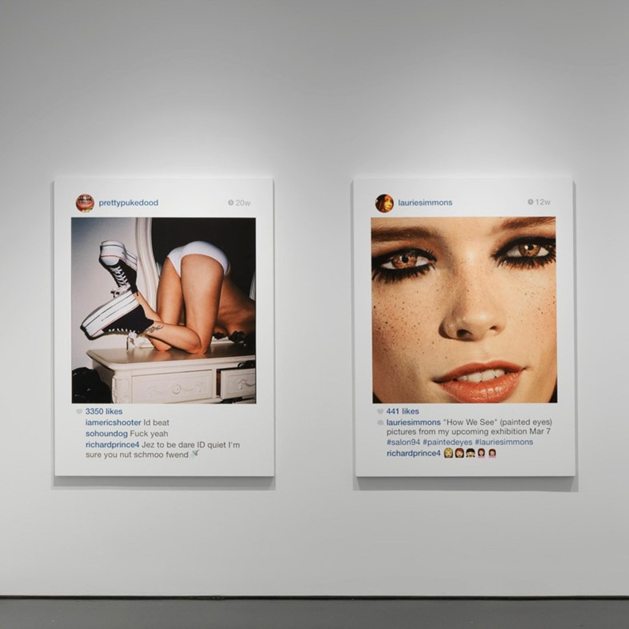

‘New Portraits’ by Richard Prince

In 2014, artist Richard Prince put up a show consisting of other people’s photos which he had screenshotted and printed off their personal Instagram accounts. These works depicted the everyday self-obsession and the new generations need to feel seen and validated by others. The only alteration has been cryptic remarks added to the comments on each photograph.

Richard’s work deals with not only the controversial issues of today’s society but also that of appropriation. Is anything truly unique anymore? Can we be considered as ‘artists’ if all we do is re-produce and copy that of others? Has the digital age ruined the true creative process?
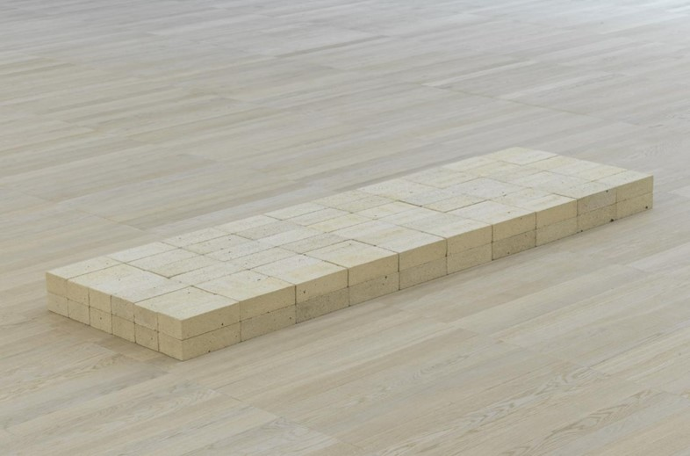

‘Bricks’ by Carl Andre

Throughout time our perception of what art really is has constantly been challenged, be it by poets, play-writes or artists. Carl Andre’s ‘Bricks’ is no exception to this. In 1976 this piece of work became one of the Tate’s top attractions and puzzled the world with the question of ‘Is this art?’.

The controversy surrounding conceptual art has only grown as time continues on and artists such as Martin Creed are winning Turner prizes for works like ‘Shredded Paper Balls’ which utilise everyday materials and claim them as original pieces of art.

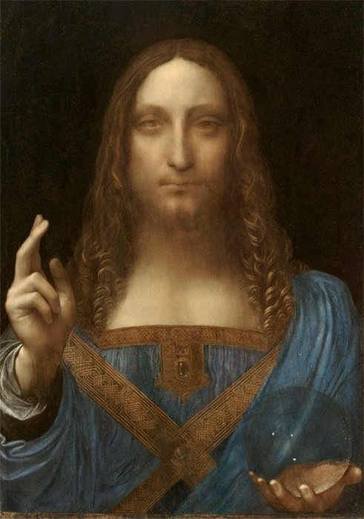

‘Salvator Mundi’ by Leonardo Da Vinci

Authenticity has become somewhat an obsession in modern society, especially in the Western world. So, when this work sold for $450.3 million at auction and became the highest priced work sold at auction or privately and both its authenticity of provenance and authenticity of expression was called into question, the art world went into a state of shock.

The controversy surrounding this painting’s authenticity due to its disappearance in the 16th century and its miraculous recovery in the late 19th century. Others question the glass orb within the painting and claim it doesn’t distort or reflect like a true scientist such as Da Vinci would paint it.
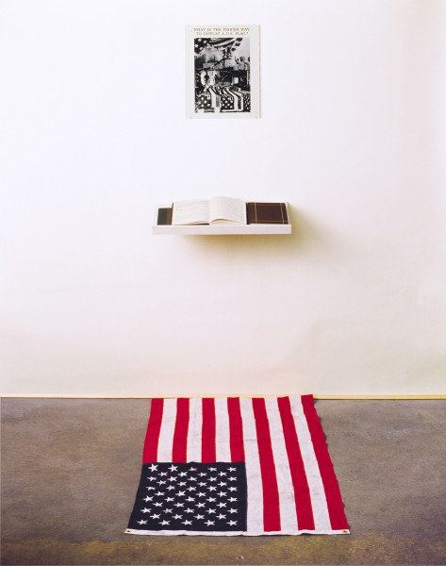

‘What’s the proper way…’ by Dread Scott

In 1989, while on display at the School of the Art Institute of Chicago this work became the centre of national controversy over its use of the American flag. As the active audience wrote their responses in the book they were standing on top of the flag itself. After this work was unveiled the US Congress passed a legislation to protect the flag.

This work calls into question people’s true feelings towards their country and patriotism. It aided society and pointed them towards influencers like George Orwell who discusses the difference between patriotism and nationalism. It questions our sense of identity and how we chose to display it.

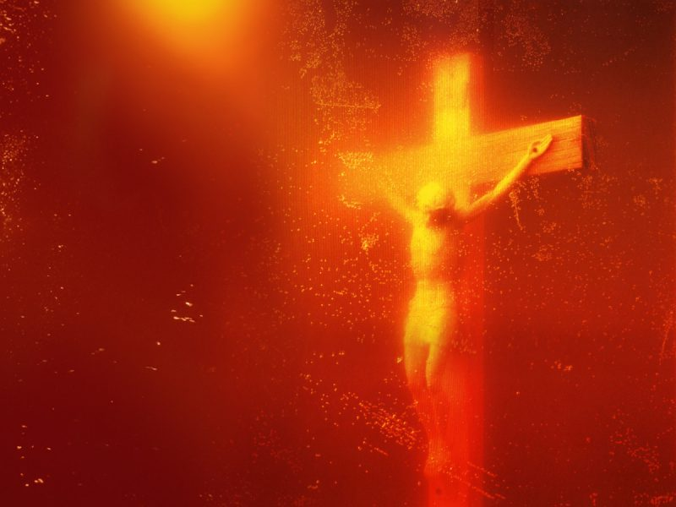

‘Piss Christ’ by Andres Serrano

Andres Serrano sought to express his faith through his work ‘Piss Christ’ which features a photo depicting a small crucifix of Jesus submerged in well, piss. Using such a controversial topic within his work in 1987 he has received multiple death threats and injunctions.

Being raised as a catholic and creating such a controversial piece of artwork caused a stir in the art world and both pleased and upset a wide range of people that it reached.

Gallery Plan
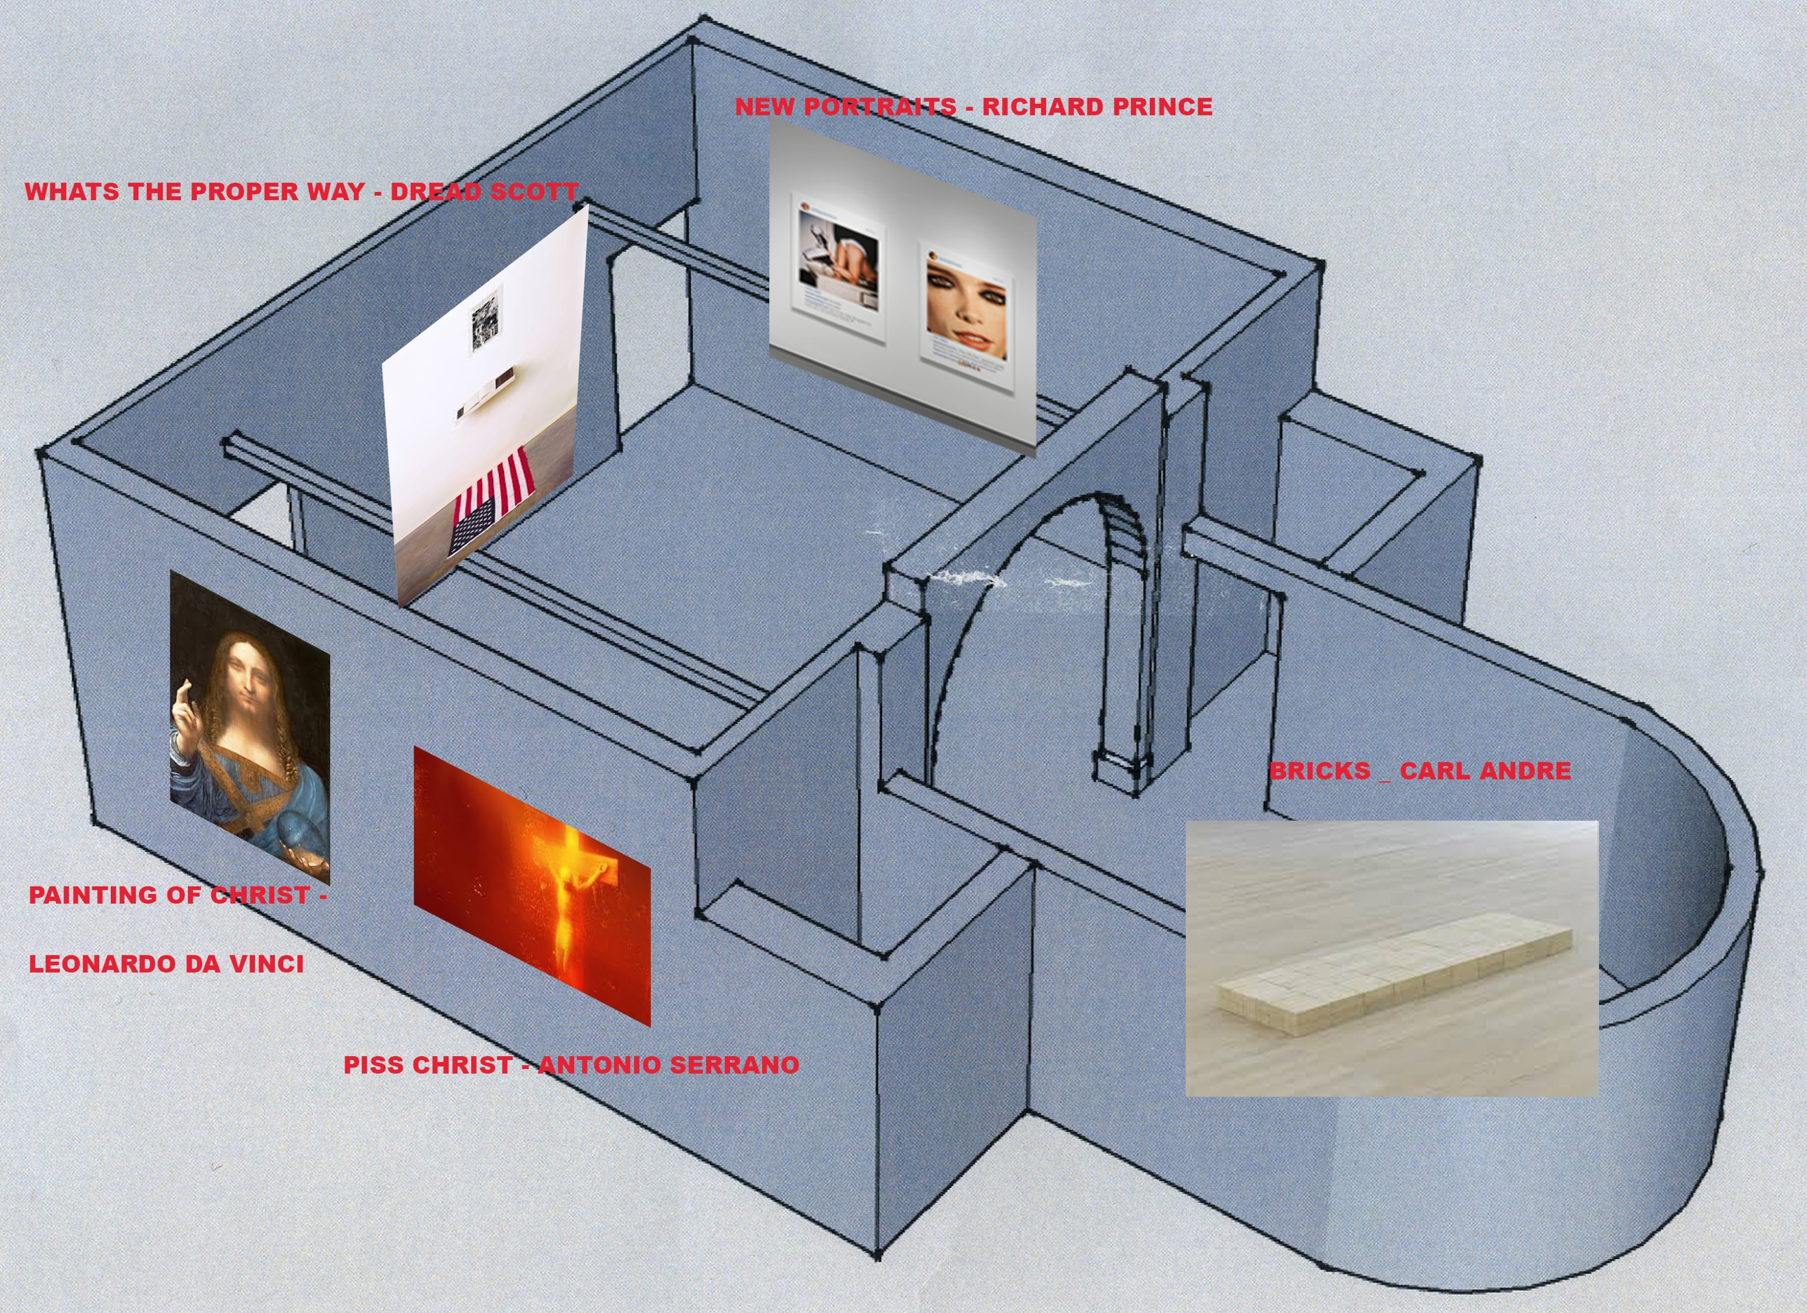

Bibliography

Lionel Trilling, (1972), Sincerity and Authenticity

Arthur Koestler, (1964), The Act of Creation

Lawrence Lessig, (2008), Remix, Penguin Press

George Orwell, (1945), Notes on Nationalism

