Effective Team Work and Communication

Student ID:21
Student Name:

Contents
Introduction 2
Communication Model 3
Transmission Model of Communication 3
Interactive Model of Communication 4
Transaction Model of Communication 5
Communication Skills 7
Non-Verbal Communication 7
Verbal Communication 7
Listening 8
Communication Technology 9
Mobile phone 9
Internet 10
Conclusion 11

Table of Figures:
Figure 1: Transmission Model of Communication (Al-Kinani et al., 2018) 5
Figure 2: Interactive Model of Communication (Paranduk and Karisi, 2021). 6
Figure 3: Transaction Model of Communication (Asongu and Odhiambo, 2019). 7

Introduction
Today, communication is essential in all facets of life. There are three communication models discussed in this assignment. Today, practically everyone either does not have a mobile phone or does not use one. Mobile devices have swiftly gone to the top of the priority list, with almost everyone now regularly using one for a vast array of personal and professional activities. The mobile phone has had a significant influence on contemporary life. The benefits and drawbacks of mobile phones and the internet are also included in this debate. In the tasks, verbal and nonverbal communication skills are also covered.

Communication Model
It may be difficult to pinpoint the beginning and finish of a conversation due to the fluid nature of communication. Alternate modes of expression in interpersonal interaction may be useful at times.
Communication models streamline the process by visualizing the numerous facets of a conversation (Wu et al., 2018). Though some models provide more in-depth explanations of communication than others, not even the most complicated model can fully capture the experience of a human communication interaction. Learning the mechanics of communication allows to reflect on the interactions with others more critically, which in turn improves the ability to plan for the future. "Transmission, interaction, and transaction models" are the three types of communication theories that will be covered (Aceto, Persico and Pescapé, 2018). There are some consistent features among these many types of communication.

Transmission Model of Communication
The sender and the receiver are shown as being in a direct line of sight while the message is sent. This method, which focuses on the sender and the message, is becoming increasingly used. While the role of the receptionist is reflected in the model, it serves more as a terminal than a continuous activity. The message is either received and comprehended by all parties or it is not. These scholars expanded upon Aristotle's triangular paradigm of a speaker, a message, and a receiver. Aspects of telegraphy and radio technology are evident in the procedure (Al-Kinani et al., 2018). Think about how a radio station can reach every car in the world with a broadcast. The radio announcer uses Morse code to encrypt the message, which is then sent from a radio tower through electromagnetic radiation (the channel) and received by a receiver equipped with an antenna and speakers. If the radio transmitter is functioning and the channel is clear of static, the message will be received by the receiver.
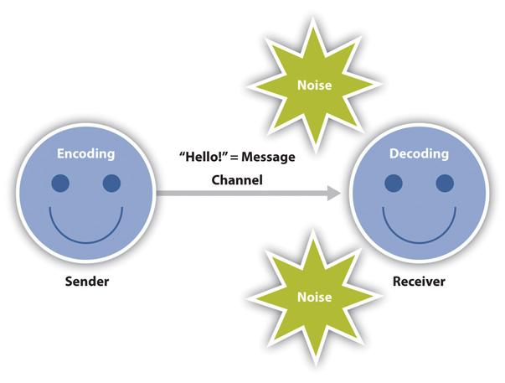
Figure 1: Transmission Model of Communication (Al-Kinani et al., 2018)

Interactive Model of Communication
The interactive and interaction method to communication is shown in Figure 2; in this model, individuals take turns acting as both the receiver and the sender as they exchange letters and build meaning via the exchange of answers. The interactive method encourages responses from the audience, turning communication into a two-way street. The term "feedback" encompasses both received and sent communications (Tang et al., 2021). Any student in the class can get a response from the instructor, just as any student in the room may point to the sofa when his or her roommate wants to use the television. The roles of those involved in a communication system become more convoluted when a feedback loop is included. Messages are sent back and forth between two parties under this model. To keep in touch, participants take turns being the transmitter and the receiver. People automatically and rapidly exchange roles as transmitters and receivers. Messages take a back seat to interaction in the interactive paradigm (Paranduk and Karisi, 2021). In contrast to the linear model's emphasis on message sending and receiving, the interactive model focuses on the conversational exchange between its participants. In this method, it is assumed that not all of the messages sent simultaneously will be received. Accidental information transfer occurs. The success of a conversation is not measured by the number of times a particular message was delivered and received.
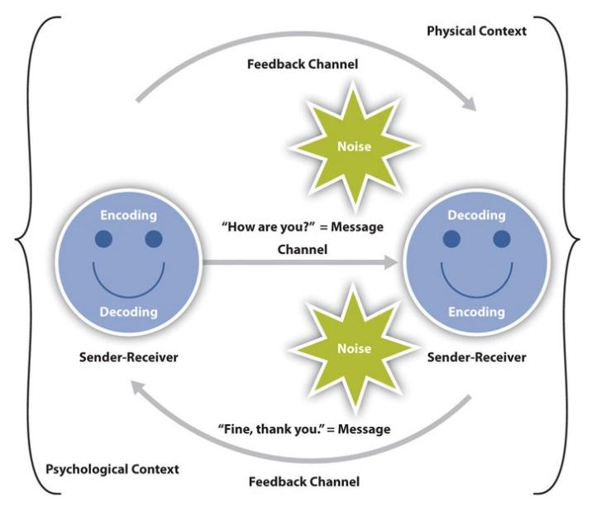
Figure 2: Interactive Model of Communication (Paranduk and Karisi, 2021).

Transaction Model of Communication
Many academics consider communication to encompass more than talking and conveying message. People don't transmit messages like computers and don't rotate between sender and recipient. People can't stop communicating since it's more than messages being sent and received. The transaction model varies from the transmitting and interactivity models in how it conceptualizes communication, sender, recipient, and context. Communication theorists who subscribe to the transactional model argue that speakers shape social realities by influencing structural, interpersonal, and cultural elements. Interaction in Figure 3 is not limited to the exchange of information; rather, it serves as a foundation for the growth of friendships, intercultural bonds, identities, and communities (Zeng, Wu and Zhang, 2019). Different models have different expectations for the roles of the sender and the recipient in the transaction model. Communicators are utilized in place of traditional senders and receivers. In the transaction paradigm, as opposed to the interactive model, people play the roles of both senders and receivers. This addition to the paradigm helps us comprehend how people might adjust their communication, such as a spoken message, depending on what their communication partner is saying. The transaction model incorporates a richer context. In the interaction model, context is physical and psychological elements that assist or hinder communication. Message both transmission and reception are vital in these circumstances (Asongu and Odhiambo, 2019). The transaction framework considers conversation as a mechanism that alters our reality before and after contacts, hence it must care for influencing variables beyond a single interaction. Transaction model analyses how social, social, and cultural factors frame and impact communication interactions.
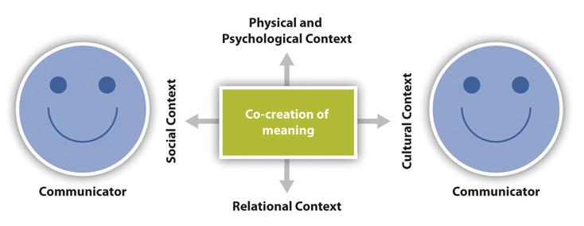
Figure 3: Transaction Model of Communication (Asongu and Odhiambo, 2019).

Communication Skills
Exchanging ideas, feelings, and information via spoken language is called verbal communication. In contrast, nonverbal communication entails the exchange of information without the use of words. Even if people don't say a word, our non-verbal clues may say a lot about how we feel, what people think, and what people intend to do. Studies have revealed that non-verbal cues account for around 80% of the interactions, while words account for the remaining 20% (Mcquail and Windahl, 2016). Even with hearing aids, those who have hearing loss still depend largely on non-verbal clues.

Non-Verbal Communication
Communication that doesn't include words is called nonverbal communication. Communicating nonverbally may complement or contradict what is being said verbally.
Tone of voice, body posture, and eye contact are the three basic components nonverbal communication, and they all have a role in how receiver interpret the message (Bahrini and Qaffas, 2019).
Tone of Voice: Expressing the emotions with anyone's voice's loudness, pitch, and cadence. Others may be able to read sender's emotions through the body language.
Body Language: As far as nonverbal communication goes, body language is arguably the most straightforward kind there is. It conveys a lot of information about the emotional state. Arms crossed across the chest provide the message that a person is not interested in what the other person is saying; arms at the sides send the message that the person open to what's being said.
Eye Contact: In order to show that people pays attention to what the speaker is saying, it is important to maintain eye contact with them throughout the conversation. It may help receiver to pay attention in a discussion and have a deeper understanding of what the other person is saying.

Verbal Communication
Verbal communication refers to any kind of conversation in which the recipient and the sender both use words to convey meaning. It's the best way to get the message through and get responses quickly (Wu et al., 2018). Since the parties are utilizing words to express themselves, the likelihood of misunderstanding is reduced. There are two main types of communication: I oral, which includes things like talking to someone face to face, in a classroom setting, over the phone, at a seminar, etc. (ii) In writing, via letter, email, text message, etc (Mcquail and Windahl, 2016). The two main categories of discourse are:
- Sometimes called "official" communication, "formal" communication refers to a certain method of conveying information from one party to another.
- Commonly referred to as "the grapevine," informal communication occurs when a sender of information does not adhere to a set of rules while disseminating that information.

Listening
A sender can tell someone who is a good listener if they take in what they're saying and apply it correctly. No one enjoys talking to someone who is just interested in hearing whatever they have to communicate. And that's why, in order to become good communicator, the individual need to be a better listener also. benefits to health, happiness, academic performance, social life, and network size; in short, a more sociable and successful person. Blood pressure increases while speaking, but decreases when listening attentively, according to research. Being present does not equate to understanding what is being said (Browaeys, Saelens and Saeys, 2019). One's ability to hear is based on his or her ability to receive and interpret auditory information. It is a physical entity that, if the person does not have any listening impairments, occurs spontaneously. But listening takes more than that; it demands attention and effort, not only in the mind but also in the body. In order to really listen, one must focus not just on the content being conveyed but also on the delivery method, tone of voice, and physical gestures of the speaker. In these other words, it takes cognizance of both spoken and non-verbal cues. The level of perception and comprehension of these information will determine how well a person listen. Listening isn't a passive activity. A listener may and should take as much interest in the conversation as the speaker. The word ‘active listening’ is frequently used to characterize this practice of becoming completely engaged.

Communication Technology
The term "information and communication technology" (or "ICT") is used to describe a group of interrelated devices and methods for exchanging and processing data. Any person or organization that uses more than one kind of technology for communication must have those systems interconnected for maximum effectiveness. Both cutting-edge breakthroughs like AI and more rudimentary devices much like corded telephone may be part of these interactive tool sets. It makes no difference whether the gadget is innovative or has impressive capabilities. It's important to establish a connection between all of a company's or person's technological resources if they're being employed simultaneously (Paranduk and Karisi, 2021). The ways in which people live, work, and interact are constantly evolving as a result of advancements in information and communication technology. These advancements have made machines capable of doing tasks previously thought impossible, such as answering the phone with human-like answers or dictating a message in response to spoken instructions. People can now communicate in the modern technological world because to advances in information and communication technology.

Mobile phone
Smartphones have revolutionized communication. Before mobiles, long-distance communication was done via landline or letter. Mobile phones have advantages and restrictions beyond conversation. Most individuals know mobile phone benefits.
Mobile phones make communication simpler and cheaper. Mobile's decreased pricing has revolutionized the telecom business, where 95% of individuals use mobile phones to communicate (Franchini et al., 2018). Mobile phones aren't only for calls anymore. Social media junkies love smartphones. Twitter, Instagram, snapchat, Facebook, etc. are always accessible. People can modify and share photos and posts from our phones. Mobile provides us 24/7 social media access (Khanna and Kaur, 2019).
Mobile phones offer perks and drawbacks. Mobile makes communication simpler since we can contact friends, family, and coworkers at any time. Mobile lets us make phone calls, videoconference, text messaging, recorded calls, and more. Almost everyone nowadays doesn't have or use a mobile phone. Almost everyone today uses a mobile smartphone for personal and professional purposes. Cell phones have changed society (Der and Gramsbergen-Hoogland, 2019). These are mobile concerns. iPhone IOS is somewhat safe, but android phones make hackers' jobs simpler. Mobile phones pose security risks. People lost money, image, and reputation due to security difficulties.

Internet
Technology has transformed how we communicate. It's revolutionized how people do business and live our private and social lives. Through a connection, people can text, call, and email anybody worldwide (Tang et al., 2021). A person may now virtually go anywhere in the globe. With a good internet connection, a person may now get a degree from any college in the world.
Internet communication has generated several challenges that seem to be becoming worse. The list of internet communication's pros and cons is unlimited, depending on the approach. The user must be careful with personal information, for example. A persom should also verify the information's sources. Internet saves time and money. Information transport is cheaper and faster. Contacting a business colleague or family is also easier (Zeng, Wu and Zhang, 2019). Emails and SMS messages provide immediate global communication. Skype, social networking sites, conferencing, and other services provide face-to-face contact online.
Despite improving several areas, the internet has led to job offshoring, downsizing, and redundancies. The internet has simplified communicating simpler, yet privacy issues have arisen. More individuals are worried about email hacking and phone signal interceptions. Some civilizations have swallowed others since the internet made the world a village (Febriantini, Fitriati and Oktaviani, 2021). Most adolescents in other areas of the globe dress, act, and behave like western teens.

Conclusion
Communicating and understanding what another person says relies heavily on non-verbal clues and language. When it comes to really getting anyone’s point through, though, nothing beats good old fashioned verbal communication. Mobile phone and Internet has improved our lives, but it may also create mayhem. The decisions we make while utilizing it most affect a society or a firm. We may enjoy the benefits and minimize many of the drawbacks with careful application.

Reference list
Aceto, G., Persico, V. and Pescapé, A. (2018). The role of Information and Communication Technologies in healthcare: taxonomies, perspectives, and challenges. Journal of Network and Computer Applications, 107, pp.125–154. doi:10.1016/j.jnca.2018.02.008.
Al-Kinani, A., Wang, C.-X., Zhou, L. and Zhang, W. (2018). Optical Wireless Communication Channel Measurements and Models. IEEE Communications Surveys & Tutorials, 20(3), pp.1939–1962. doi:10.1109/comst.2018.2838096.
Asongu, S.A. and Odhiambo, N.M. (2019). How enhancing information and communication technology has affected inequality in Africa for sustainable development: An empirical investigation. Sustainable Development, 27(4), pp.647–656. doi:10.1002/sd.1929.
Bahrini, R. and Qaffas, A. (2019). Impact of Information and Communication Technology on Economic Growth: Evidence from Developing Countries. Economies, 7(1), p.21. doi:10.3390/economies7010021.
Browaeys, R., Saelens, W. and Saeys, Y. (2019). NicheNet: modeling intercellular communication by linking ligands to target genes. Nature Methods, 17(2), pp.159–162. doi:10.1038/s41592-019-0667-5.
Der, V. and Gramsbergen-Hoogland, Y. (2019). Communication in organizations : basic skills and conversation models. London And New York Routledge.
Febriantini, W.A., Fitriati, R. and Oktaviani, L. (2021). AN ANALYSIS OF VERBAL AND NON-VERBAL COMMUNICATION IN AUTISTIC CHILDREN. Journal of Research on Language Education, 2(1), p.53. doi:10.33365/jorle.v2i1.923.
Franchini, M., Duku, E., Armstrong, V., Brian, J., Bryson, S.E., Garon, N., Roberts, W., Roncadin, C., Zwaigenbaum, L. and Smith, I.M. (2018). Variability in Verbal and Nonverbal Communication in Infants at Risk for Autism Spectrum Disorder: Predictors and Outcomes. Journal of Autism and Developmental Disorders, 48(10), pp.3417–3431. doi:10.1007/s10803-018-3607-9.
Khanna, A. and Kaur, S. (2019). Evolution of Internet of Things (IoT) and its significant impact in the field of Precision Agriculture. Computers and Electronics in Agriculture, [online] 157, pp.218–231. doi:10.1016/j.compag.2018.12.039.
Kurniadi, W. and Mahaputra, M.R. (2021). Determination of Communication in the Organization: Non Verbal, Oral and Written (Literature Review). Journal of Law, Politic and Humanities, [online] 1(4), pp.164–172. Available at: https://www.dinastires.org/JLPH/article/view/80 [Accessed 24 Nov. 2022].
Mcquail, D. and Windahl, S. (2016). Communication models : for the study of mass communications. London: Routledge.
Paranduk, R. and Karisi, Y. (2021). THE EFFECTIVENESS OF NON-VERBAL COMMUNICATION IN TEACHING AND LEARNING ENGLISH: A SYSTEMATIC REVIEW. Journal of English Culture, Language, Literature and Education, 8(2), pp.145–159. doi:10.53682/eclue.v8i2.1990.
Tang, W., Chen, M.Z., Chen, X., Dai, J.Y., Han, Y., Di Renzo, M., Zeng, Y., Jin, S., Cheng, Q. and Cui, T.J. (2021). Wireless Communications With Reconfigurable Intelligent Surface: Path Loss Modeling and Experimental Measurement. IEEE Transactions on Wireless Communications, 20(1), pp.421–439. doi:10.1109/twc.2020.3024887.
Wu, J., Guo, S., Huang, H., Liu, W. and Xiang, Y. (2018). Information and Communications Technologies for Sustainable Development Goals: State-of-the-Art, Needs and Perspectives. IEEE Communications Surveys & Tutorials, 20(3), pp.2389–2406. doi:10.1109/comst.2018.2812301.
Zeng, Y., Wu, Q. and Zhang, R. (2019). Accessing From the Sky: A Tutorial on UAV Communications for 5G and Beyond. Proceedings of the IEEE, 107(12), pp.2327–2375. doi:10.1109/jproc.2019.2952892.

