
Skills for the Workplace
Module Assignment Submission
Student Name: | Anis Miah
Student Number: | 1818723
Module No: | BMSK4002
Module Title: | Effective Team Working and Communication  Part 2

Statement of Confirmation of Authenticity
By the act of making this submission, the student declares that this is the work of the student named above. The work has not, in whole or in part, been knowingly presented elsewhere for assessment, or where assessment has been built on a previous assessment, this has been identified. Where materials have been used from other sources it has been properly acknowledged. If this statement is untrue, the student acknowledges that an assessment offence has been committed.
Attention is drawn to the plagiarism and unfair practice policies of both the University and of ILM.

Table of Contents
Communication 5
The Shannon-weaver mathematical model- 6
Berol’s Model of Communication- 7
Schramm’s Model of Communication- 8
The Shannon Weaver Model of Communication Theory 9
Communications in the workplace- 10
Effective communications- 10
Assessing Own Communication Skills 12
Gap Analysis 12
The report writer GAP below- 12
The report writer PDP below 13
Appendices A 14
Appendices B 16
17
18
Appendices C 19
References 19

Communication

The process by which information is delivered and received is known as communication. Information includes facts, instructions, ideas, suggestions, statistics, and data, among other things. Attitudes, reactions, support, emotional climate, and worry are all examples of information that is part of our emotions. "Communication is the transactional use of symbols that is affected, guided, and understood in the context of relationships," according to a definition.
Duck & McMahan, (2015).
Communication can be various different ways which shows in below-
- Verbal.
- Non-verbal
- Written
- Face to face
- Sign languages fir deaf
- In different languages
- Electronic
- Braille for the blind
- Instant
- Worldwide.
Texts, emails, Facebook, postings, blogs, letters, snapchat, WhatsApp, and Instagram are examples of current communication methods.
Communication elements- There are three types of communication elements, including:
1. Vocal—the tone in which we communicate
2. Visual—This can include things like eye contact and facial expressions. Finally, verbal—what we spoke with our mouths.
There are four different communication styles to choose from. They're -
Assertive aggressive behaviour—The emphasis in this communication method is mostly on the individual's desires and the goal, which is "I win, you lose."
Assertive behaviour comprises expressing one's own demands and ideas while simultaneously considering the needs and opinions of others, resulting in a situation in which "I win, you win.".
Passive aggressive behaviour involves prioritising one's own opinions and needs over those of others, which often results in "I win, you lose" scenarios.
Passive behaviour—Because one's own wants and opinions are less important in this situation than the needs and opinions of others, I lose, and you win.
After completing a Communication Style Questionnaire, the report writer discovered that he has an assertive personality since he values both others and his own opinions and wants. Which shows in Appendices A and Appendices B
There are many models and theories of communication to select from. Communicators frequently blame the audience for not understanding the messages, however this is almost always due to improper encoding.
Few different communication models described below-

The Shannon-weaver mathematical model-

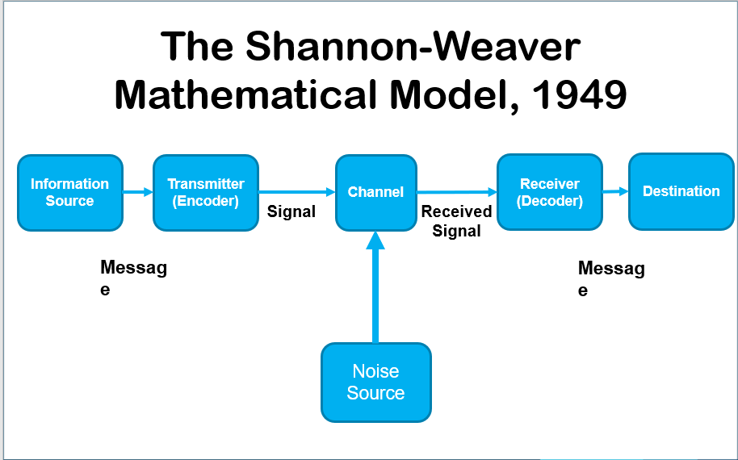

The Shannon and Weaver Model of Communication is a mathematical theory of communication that argues that human communication can be broken down into 6 key concepts: sender, encoder, channel, noise, decoder, and receiver.

Berol’s Model of Communication-
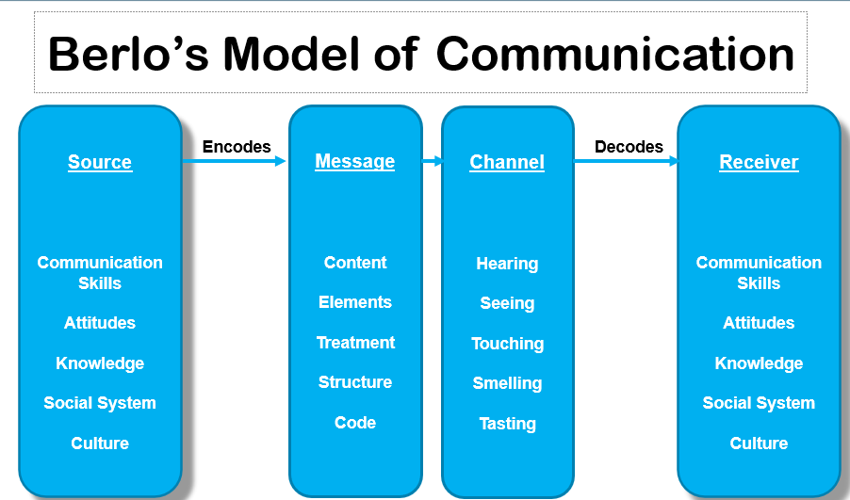

David Berol’s SMCR Model of Communication represents the process of communication in its simplest form. The acronym SMCR stands for Sender, Message, Channel, and Receiver. Berol’s SMCR Model of Communication (1960) describes the different components that form the basic process of communication.

Schramm’s Model of Communication-
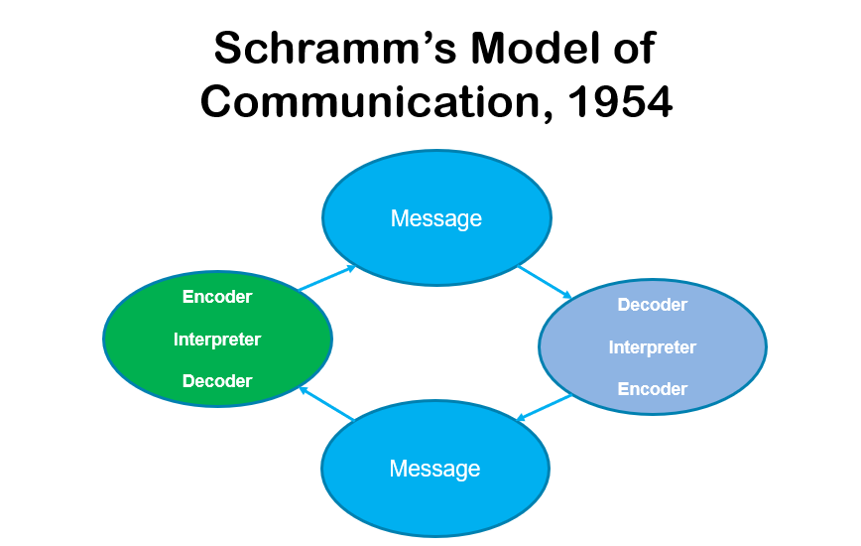

Wilber Schramm proposed the communication paradigm stated by him. Information is useless unless it is meticulously recorded and disseminated. Encoding is critical because it initiates the communication process by converting thoughts into substance. When information reaches the recipient, he must deduce what the speaker is attempting to convey. Unless and until the second party is able to interpret or decode the information that the sender desires to express, the communication is meaningless.

The report writer chooses the Shannon-weaver communication model for his assignment to discuss further because he thinks this model is very clear to understand and apply towards the effective communication process.
Management study guide, (2019).

The Shannon Weaver Model of Communication Theory

When considering communication difficulties in health and social care, it's helpful to break down the many components of the communication process. This allows you to think about all of the numerous processes that occur throughout every interaction with a service user or colleague, as well as all of the potential barriers or challenges that could lead to a communication breakdown.
(Cobley, 2013).
The communication process is studied using a variety of models and theories. We'll look at one of the most well-known models, the Shannon-Weaver model. This model was first introduced in 1948 and has undergone numerous revisions, modifications, and enhancements since then. Warren Weaver was a scientist and Claude Shannon was a mathematician. They were especially interested in "machine translation," or data transmission via early computers, radios, and televisions. On the other hand, the concept is equally applicable to human communication and has had a significant impact in modern social sciences. It is sometimes referred to as "the mother of all models" because it is the cornerstone of most modern communication theories.
(Kovalchick and Dawson, 2004).
The Shannon-Weaver model divides the communication process into five stages:
The sender, the encoder, the channel, the decoder, and the receiver are all parts of the system.
The sender is the person, group, or organisation that comes up with the concept for the message they want to communicate.
This message is converted into signals by the encoder. This is how we communicate with one another, to put it another way. It could be expressed orally, in writing, or by gestures or body language. Encoding can be seen in animated gifs and emoticons.
The mechanism by which communication is transmitted is referred to as the channel. Sound transmitted across the airways during a conversation, or binary data transmitted via email or text, are examples. The broadcaster and receiver may require equipment such as phones or laptops, depending on the channel.
The communication must be decrypted once it has been received. This stage outlines how the communication is interpreted and translated by the recipient. It might be a computer that does this using binary data, or it could be human brains that pick up all of the language and communication data, including words, pictures, intonation, and other parts of a communication transaction.
(Shannon and Weaver, 1998).
Finally, the communication reaches the recipient, who interprets it into something meaningful.
Of course, we all know that the process isn't always straightforward and that there are several hurdles to communication. The Shannon-Weaver model adds the concept of "noise" as a result. Anything that interferes with the model's channel stage is referred to as noise. This could be background noise that makes it difficult for a receiver to hear a message or distractions that make it difficult for them to focus on the conversation. Consider chatting with a client who is suffering from severe physical pain, stress, or mental torment. All of those events would be considered background noise, limiting their capacity to focus on and interpret the information.
(Communication Theory, 2022).
Because the Shannon-Weaver model was designed for electrical communication, it ignores the human factors that can influence how a message is decoded. Language or cultural differences could be crucial in this situation, and they are distinct from any "noise" in the communication channel. These are all important factors to consider, therefore watch the individual video on communication challenges in this course.
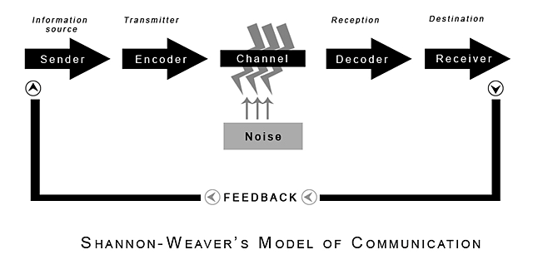
Shannon and Weaver, (1949).

Communications in the workplace-

Communication requires good listening skills. Being a good listener might help you communicate effectively. As a team leader for Lidl, the report writer is in charge of 12 employees who are mostly handled through communication. The report writer trained himself to be an active listener in order to interact effectively with his co-workers.

Effective communications-
- Because it displays honesty and open communication, transparency is an important component of good communication. To be transparent, one must be prepared to provide facts, even if they are unpleasant. Transparency is defined as being honest with oneself about one's actions. As a team leader, the report writer must be transparent in order to understand his colleagues' thoughts, viewpoints, and issues.
Gabler, David (2011).
- Assertiveness is an effective and diplomatic communication style because it is based on mutual respect. Because you're willing to stand up for your own interests and voice your opinions and feelings, being assertive demonstrates that you value yourself. The report writer treats others with mutual respect in order to be treated with the same respect by his co-workers.
- Clarity- Misunderstandings in the workplace lead to wasted productivity, hurt feelings, and unneeded conflict. Communication clarity can aid in avoiding misunderstandings and ensuring that things operate smoothly and amicably. It is each person's obligation to ensure clarity in communication, especially since our ability to communicate effectively is examined on a regular basis. The report writer always has a clear conversation with team members to guarantee good communication.
Deb Calvert, (2014).
Active listening- Since it fosters honesty, openness, and success, this is an important part of your communication skill set. You demonstrate that you are paying attention to your discussion partner when you pay attention to them, which establishes trust and makes them feel as if their comments matter to you.
Masterclass, (2001).
precision- Ask questions to increase communication. The report writer's listening is the most basic instrument for gathering information needed for timely and effective decision making.
- The report writer's weak characteristic is that he does not listen well. He'll go through six steps to become a better listener. The process of sending and receiving information is referred to as communication. Information includes facts, instructions, ideas, proposals, statistics, and data. Attitudes, reactions, support, emotional climate, and worry are all examples of information that is part of our emotions. According to one definition, "communication is the transactional use of symbols that is affected, guided, and understood in the context of relationships." Below-
- Pay attention to who is speaking and refrain from speaking.
- inquire about it
- adhere to the instructions
- Consider what is being said.

Assessing Own Communication Skills

A communication plan can assist you in focusing your message and reaching your target audience. Your communication methods' efficiency and simplicity might also be influenced by a plan. In order to build good communicational interactions between oneself and others, the report writer creates a communication plan for himself. A gap analysis and a PDP are included in the report writer communication plan.
The report writer provides a lesson plan example on appendices C.

Gap Analysis

A gap analysis, also known as a requirements analysis, is essential for any type of organisational performance. It allows companies to evaluate where they are now and where they want to go in the future. A gap analysis is a simple and quick way to assess if your efforts are effective. It will be possible to determine why they aren't being optimised if they aren't.

Strategic plan, (2021).

The report writer GAP below-

 | Current Position | Deficiency | Action
What do I want to do? | What can I already do? | What am I lacking? | How do I fix this?
Improve listening skills to able to understand others. | Able to pay attention and respond appropriately. | Interrupt the speakers with counter arguments. | Allow speaker to finish each point before asking questions.
Improve confidence while speaking. | Able to speak with others when needed to raise a point of view. | Get very nervous while presenting something. | Keep practising in home front of family members first as presenting something.
Keep Time management as a main objective to finish everything before deadlines. | Offer as much as possible to finish by deadlines. | Most of time forget about it because of family commitments. | Plan and offer importance to everything which in their own places.

The report writer PDP below

Objectives | Tasks | Success Criteria | Time Frame | Resources
List your Goals | What do you need to do to achieve these goals? | How will you identify your success? | When do they need to be done by? | Who or what do you need to help you?
1.Improve listening skills | Don’t interpret while others speaking. | Ask for feedback from tutors and pears. | 20.06.2022 | Research and practise online listening tools.
2.improve presenting skills. | Keep practising in home front of mirror or family members to able to overcome from this barrier. | Ask for feedback from tutors and pears. | 20.08.2022 | Select a mentor to help with presenting skills.
3.Time management. | Always plan ahead and leave extra time for emergencies. | Keep monitoring the plan timeframe. | 20.05.2022 | Arrange one to one team meeting if needed with the tutor.

Appendices A
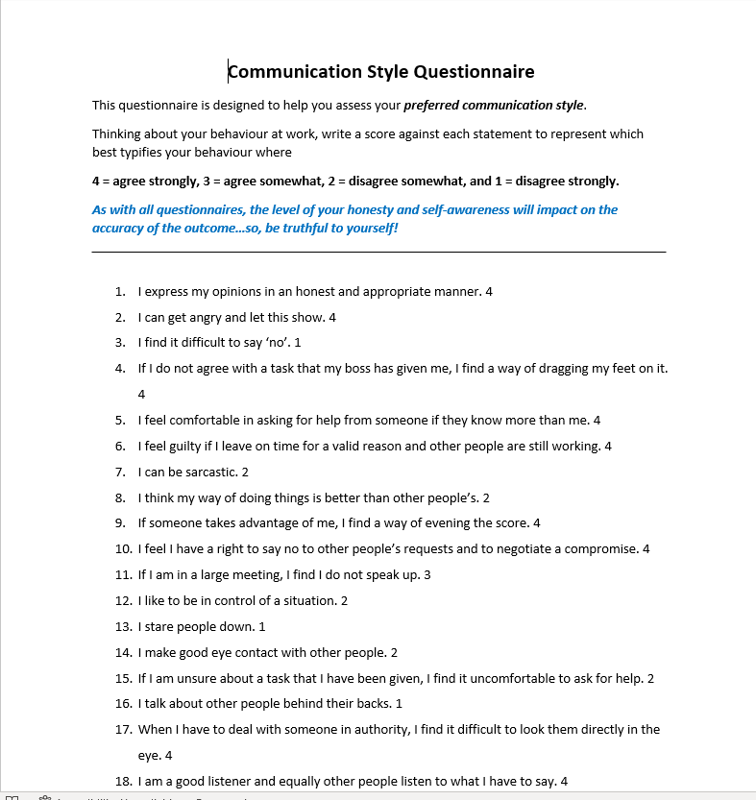

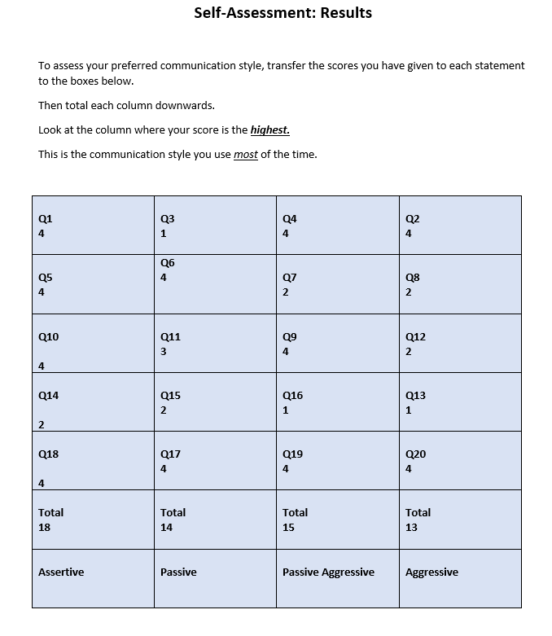

Appendices B

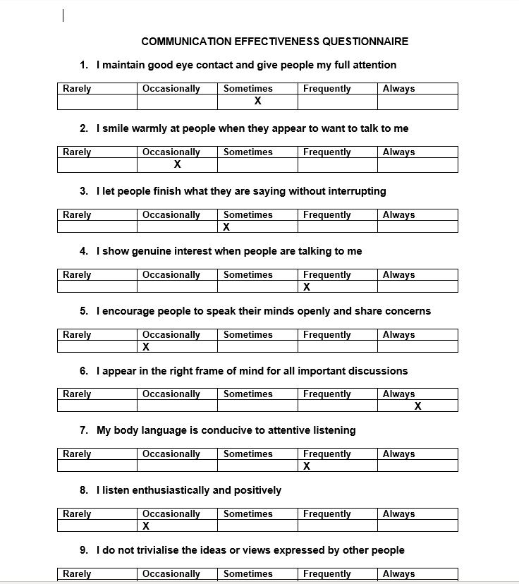

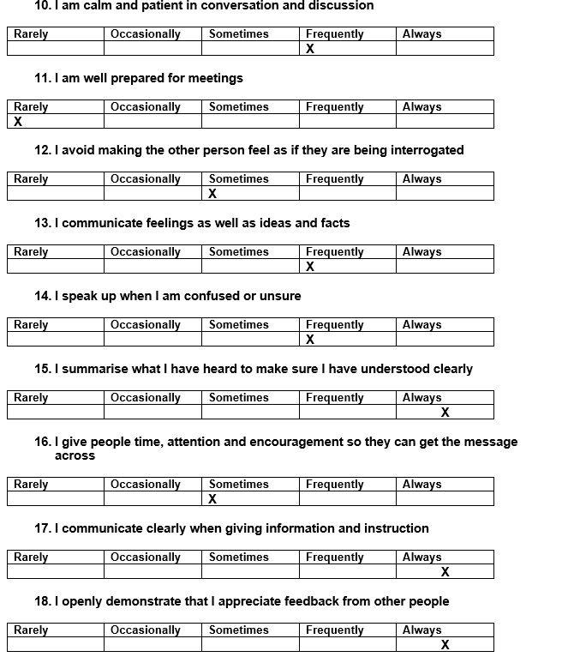

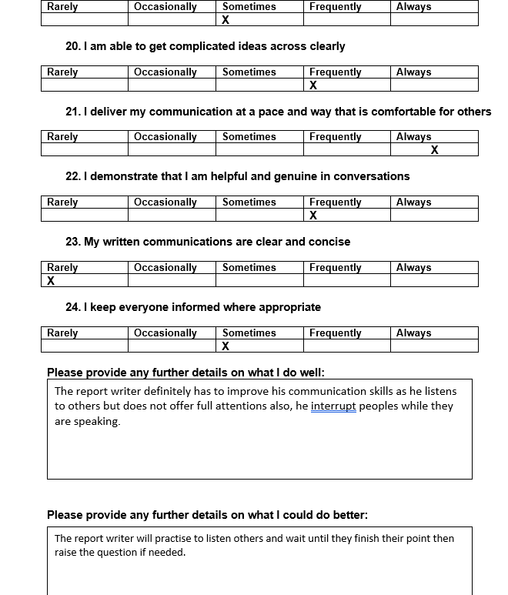

Appendices C

Examples of lesson plan
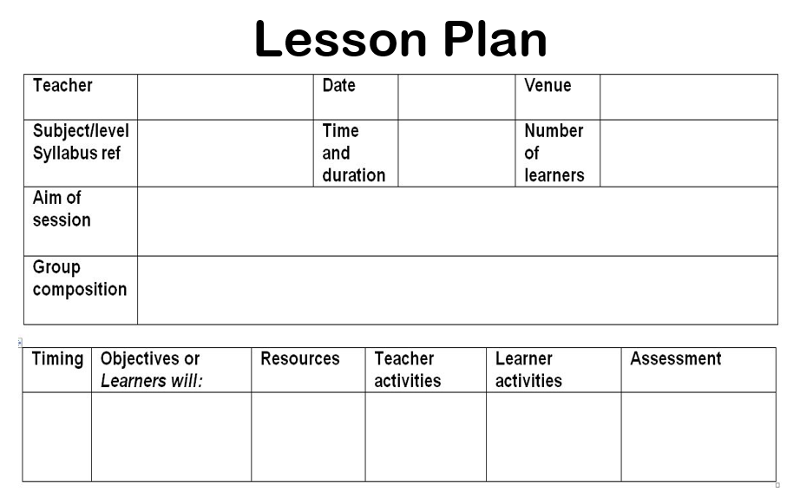

References

Masterclass, (2001). How to use active listening to improve your communications. https://www.masterclass.com/articles/how-to-use-active-listening-to-improve-your-communication-skills

Cobley, P, (2013). Theories and model of communication. De Gruyter. Berlin.
Kovalchick, A and Dawson, K (2004). Education and technology. ABC-CLIO. Santa Barbara, California.
Shannon, C and Weaver, W (1998). The Mathematical Theory of Communication. University of Illinois of Press. Chicago. United states.
Communication Theory, (2022). Shannon and Weaver Model of Communication. Available at: https://www.communicationtheory.org/shannon-and-weaver-model-of-communication/ (Access: 12.05.22).
Berlo, D. (1960). The process of communication. New York.
Shannon, C. and Weaver, W. (1949) The Mathematical Theory of Communication. Urbana:
University of Illinois Press.
Duck, S & McMahan, D.T, (2015), p.5
Blenkinsop, P. (2010) The Communication Cycle. [online] Available at: http://manyana-education.blogspot.com/2010/10/communication-cycle.html Accessed: 15.05.19
MindTools (2019) How good are your communication skills? [online] Available at: https://www.mindtools.com/pages/article/newCS_99.htm Accessed: 15.05.19
Shannon, C. and Weaver, W. (1949) The Mathematical Theory of Communication. Urbana: University of Illinois Press.
Skills You Need (2019) Interpersonal Skills Self-Assessment. [online] Available at: https://www.skillsyouneed.com/ls/index.php/343479 Accessed: 15.05.19
https://www.managementstudyguide.com/shannon-and-weaver-model-of-communication.htm

Management study guide, (2019).
Shannon and Weaver, (1949).
https://www.stockton.ac.uk/media/3546/the-shannon-weaver-model-of-communication-theory-script.pdf.
Deb Calvert, (2014). 7 Tips for Communicating with Clarity
https://www.linkedin.com/pulse/20141124154010-7245993-7-tips-for-communicating-with-clarity

Gabler, David (2011). https://managementhelp.org/blogs/business-ethics/2011/03/14/transparency-is-a-key-to-performance/
Strategic plan, (2021).
https://www.nmblstrategies.com/blog/the-importance-of-gap-analysis-in-strategic-planning

