
Specification Report
Course: Software engineering Module name: Web development

March 3, 2018
Abdurahman Ibrahim
University of Wales Trinity Saint David

This Specification Report is a brief summary and report on the website created by the student using HTML and the purpose of creating this website among other things you are welcome to read and enjoy.

Table:

Table of Contents

1. Website Introduction Section

2. Purpose of my website

3. Site Map

4. Screen shots of the completed website (not code):

5. Wireframes

6. Validation

7. Accessibility:

7.1 Headings

7.2 Images

8. References

[1]

Website Introduction Section
As an avid Barcelona football club fan, a website about this football club has been implemented.
A brief 5-page website was put together in a way that was believed to be basic but also very informative at the same time.

•Looking at the WCAG 2.0 helped the student make sure that the website was more:
•Perceivable: It must be provided to users in a way that is understandable to them
•Operable: Users are able to go through the website without needing any assistants from any one.
•Understandable: The User should be able to understand the website and the way to use this website.
•Robust: If technology advances the user must still be able to access the website, therefore my website is responsive, the more technology advances and the more mobiles and other forms of technology people are using the more important it becomes for the user to be able to use the website properly from different and new technology devices.
[2]
Purpose of the website:
•The purpose of the website was to provide quick and hourly updates for fellow Barcelona hard-core fans to enjoy and be updated on current events, fixtures and results among other things regarding their favourite team.
•This was a very relevant website and idea because there are millions of fellow Barcelona fans around the world that would be interested in a good website to go to regarding their favourite team.

Site Map
•This is a wireframe diagram of the home page, illustrating the layout, the main design elements and content sections of the website.
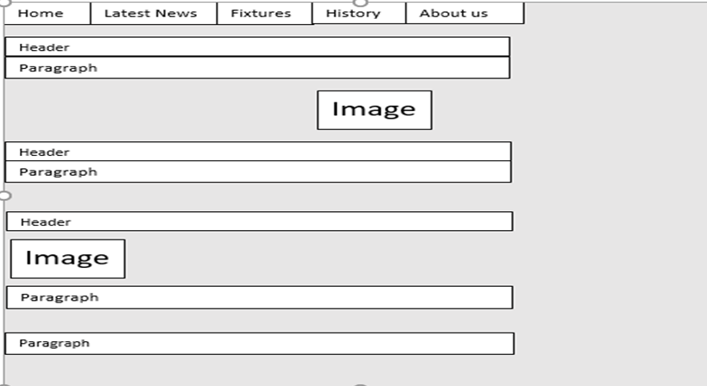
[3]
The first thing that users will notice is the head, all the pages are in here and this is where each page links to the other four pages.
The body has all the main contents of the page, the text, photos, and all the other important things.
The footer has the least important things to the users like the social media icons and contact info among other.

•A 'Site Map' illustrating the structure of the Website and how the individual pages link to each other:
The link below is the link to the website tags and how the pages link to each other.
C:\Users\p150461\Downloads\gloomap.xml
The link provides the XML sitemap.
It’s simply the list of all the pages on my websites, and it shows how the other pages are linked to each page.
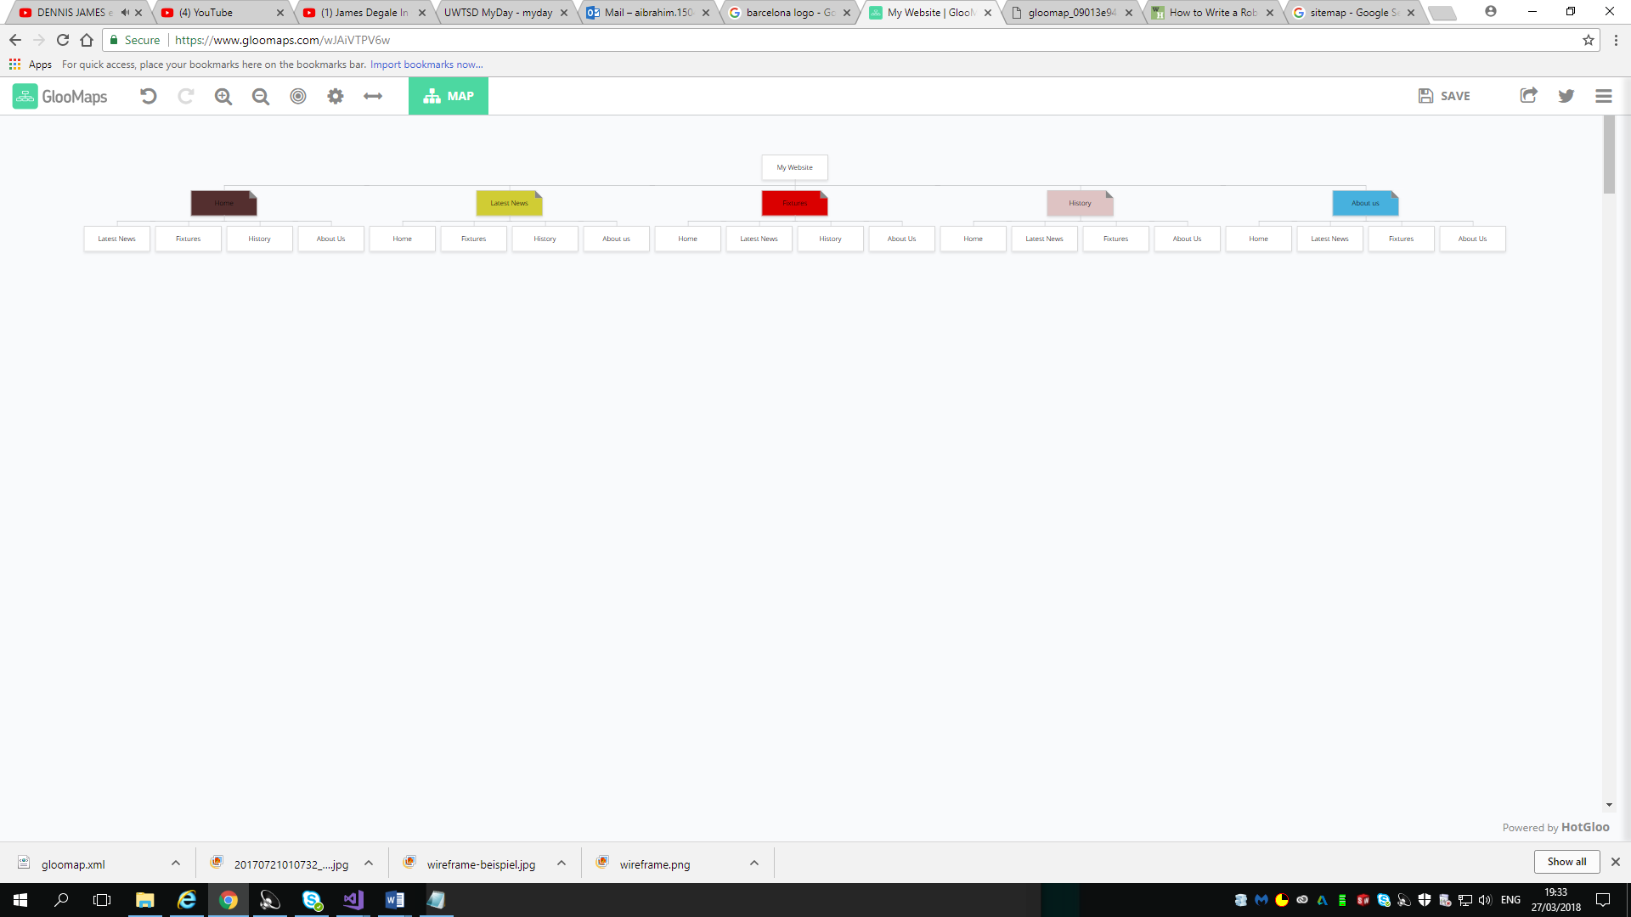
This is my visual sitemap, it simply shows how the website is laid out and how each page is linked to the other pages.
[4]

Screen shots of the completed website (not code):
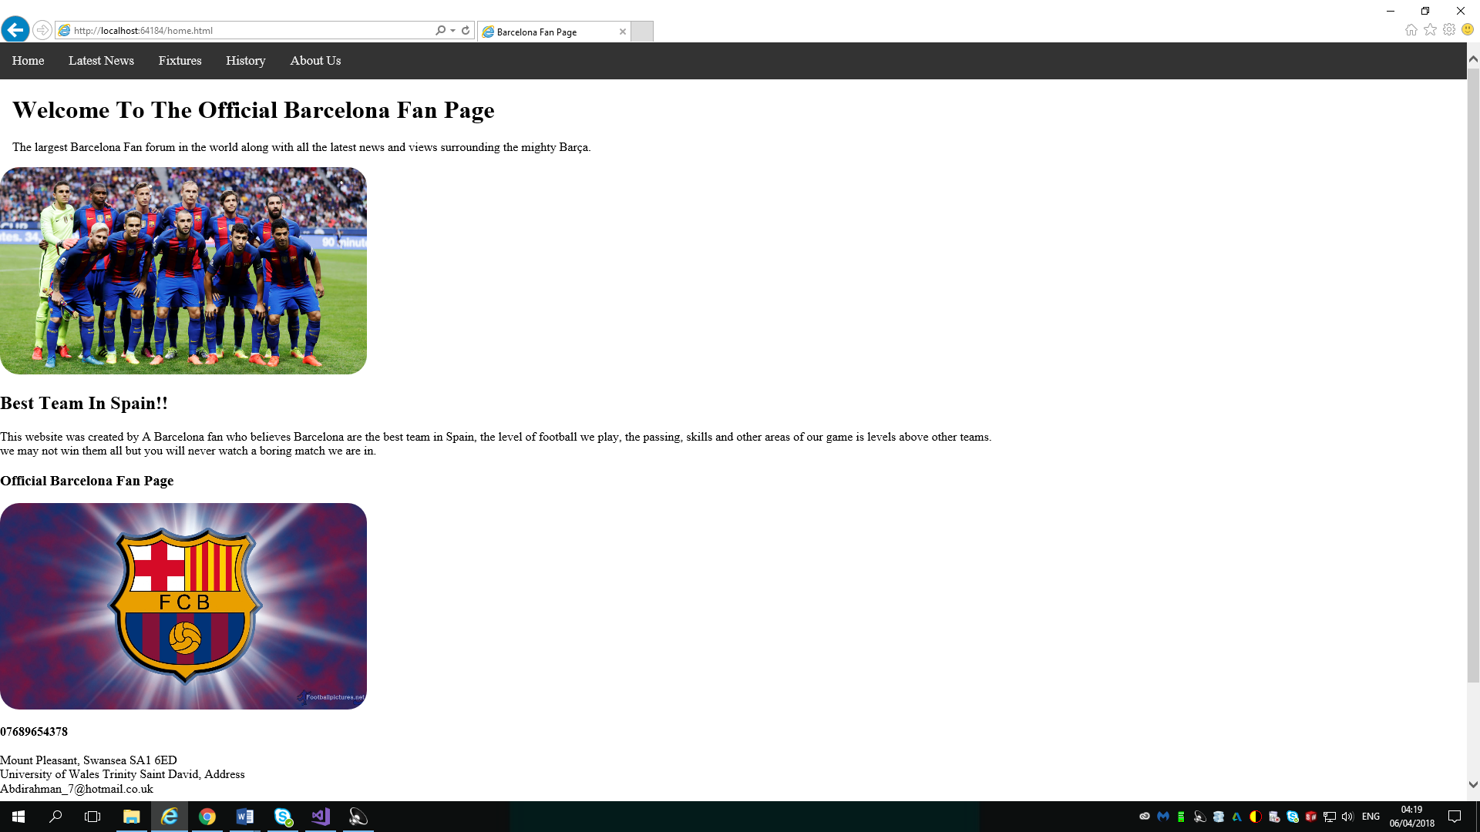
This is the Home Page, it consists of the heading that will provide the links for all the other pages and with one click you can go from one page to another.
Then you can see that the name of the website in big writing at the top of the page.
The student then provides following this is a brief summary and explanation of what his the website is on and consists of.
The student then puts at the bottom of the page, on in the footer area, some contact information and a picture of his university as one of his the logos has been added.

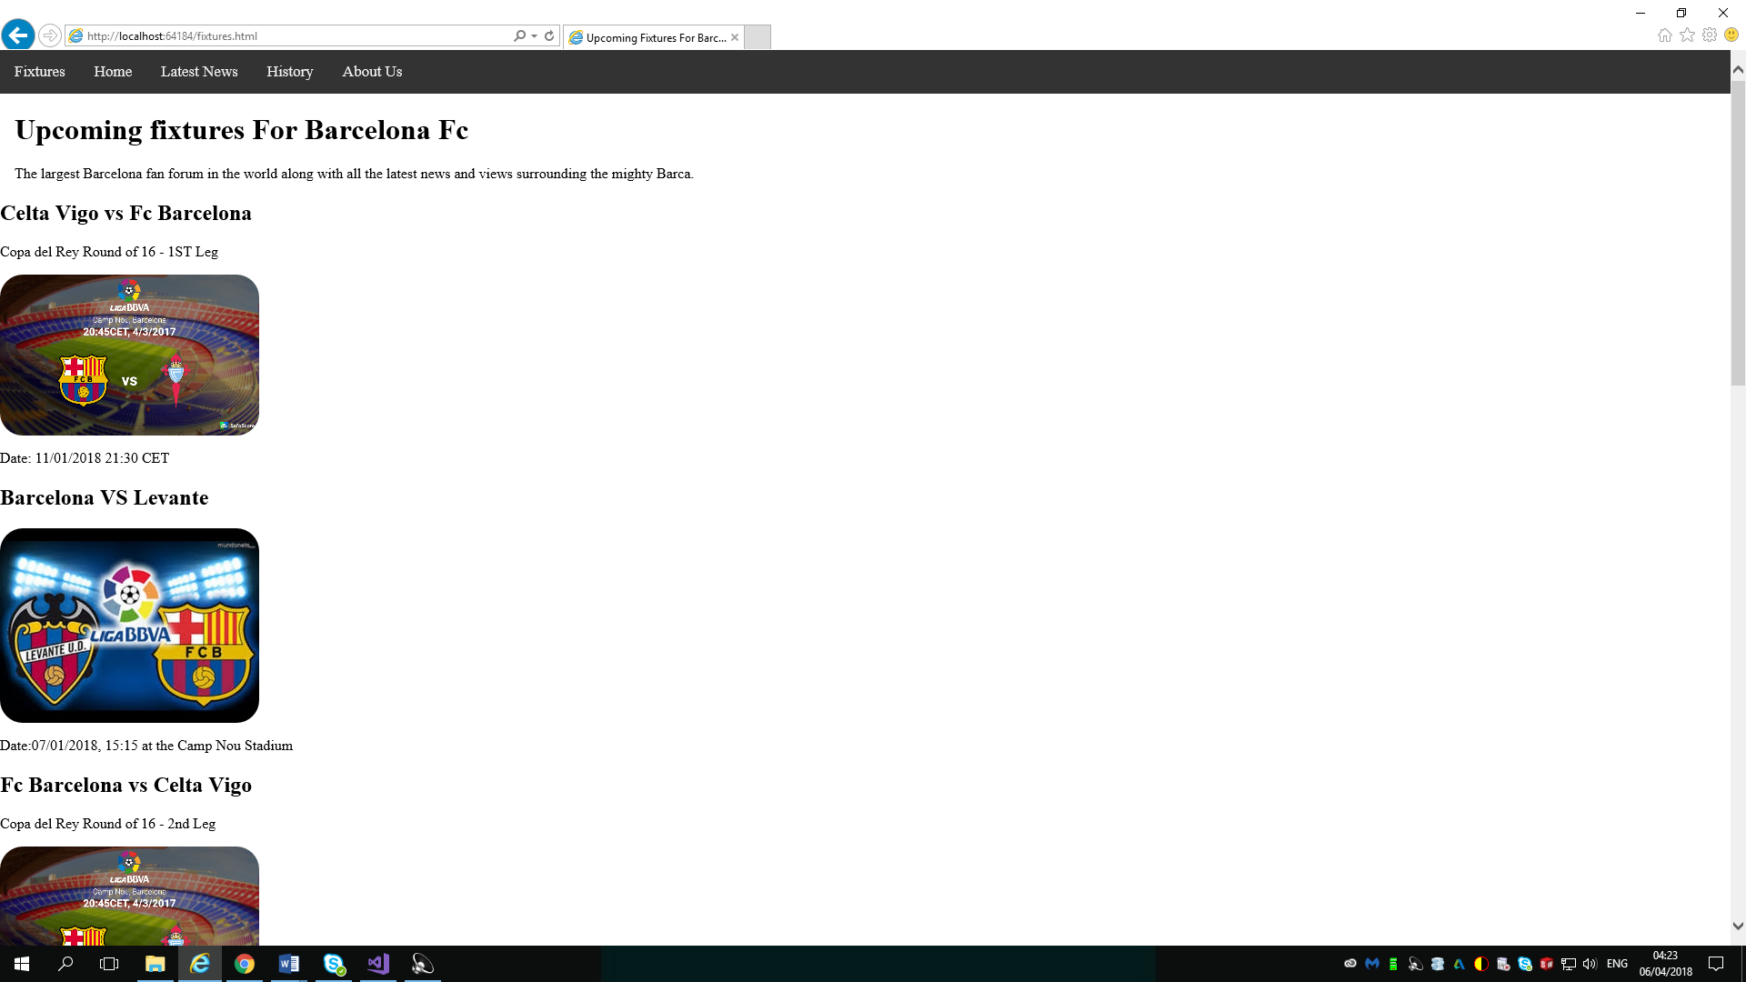
The second page consists of the latest news and updates from Barcelona football club, so for example the student will put up the latest game results, training picture and other latest news on the team.
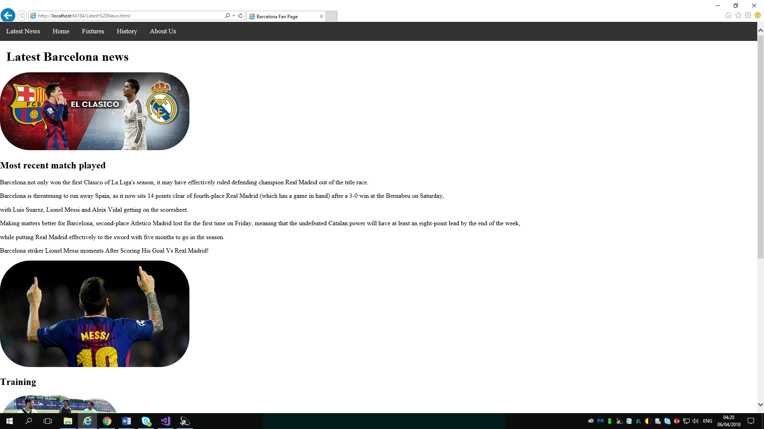
The third page consists of all the upcoming fixtures for Barcelona football club, it includes pictures of each match up and opponent including the time and date for each fight so the fellow fans of Barcelona can keep up to date to watch the match live on TV at the right time.
The second page consists of all the upcoming fixtures for Barcelona football club, it includes pictures of each match up and opponent including the time and date for each fight so the fellow fans of Barcelona can keep up to date to watch the match live on TV at the right time.
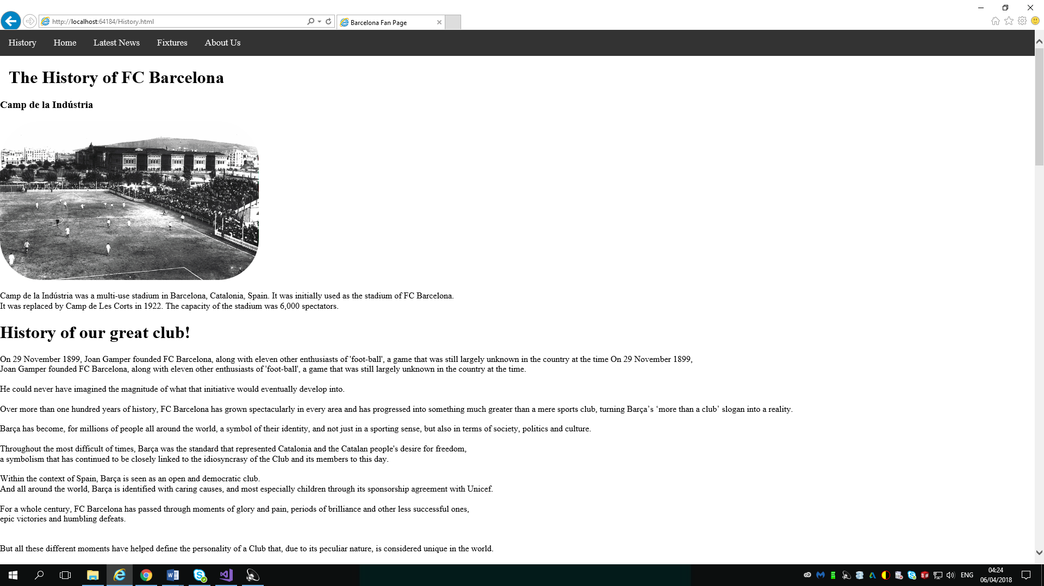
This is the history page on the student’s website, it explains the history of Barcelona football club, and this will help teach the younger fans and even some of the older fans that are not up to date with the history of the club about the first stadium the club played in, including other historic things in the club history like when the club first started up and many other historical things about the club.
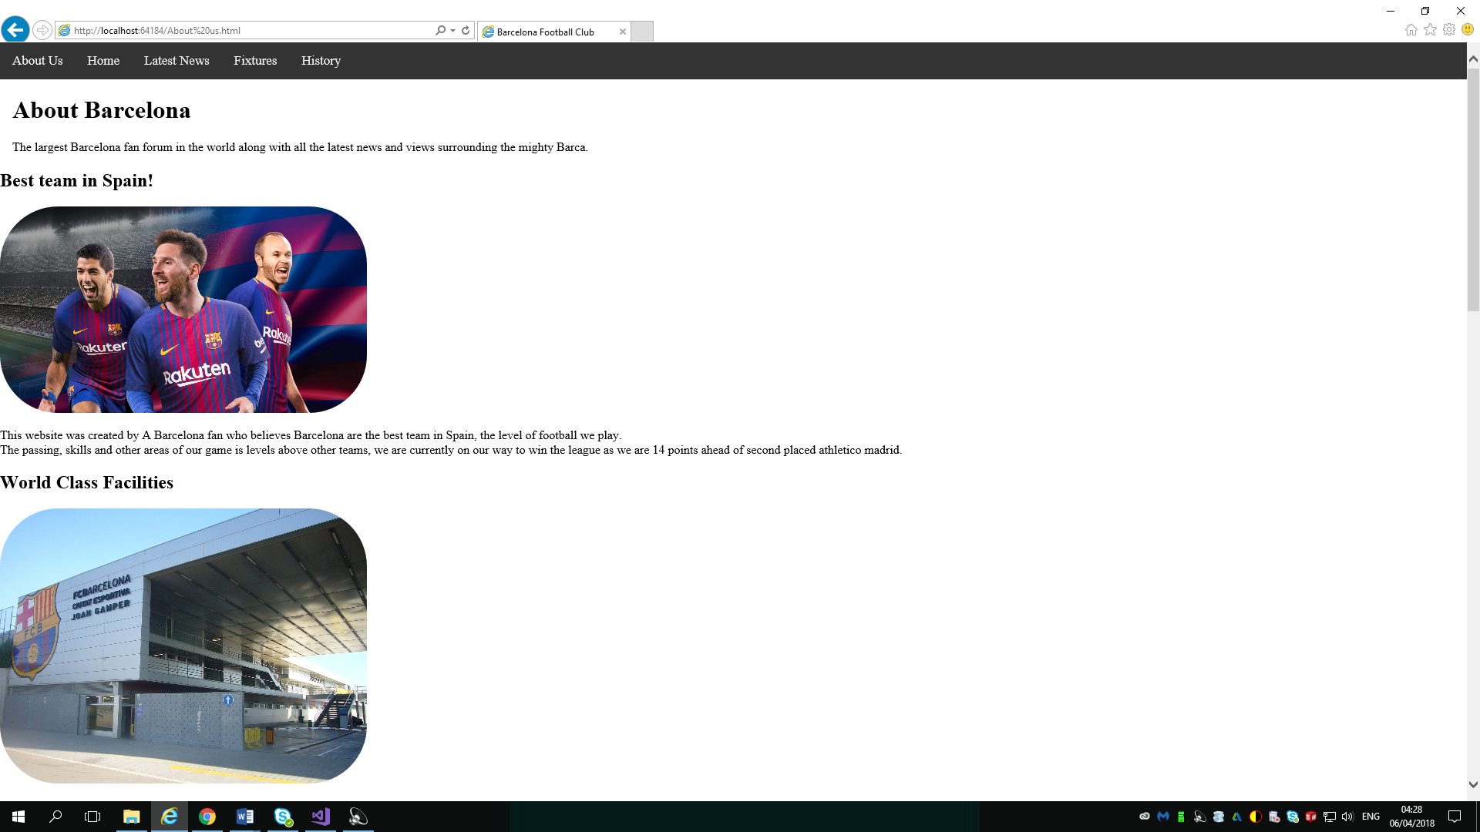

This page was titled the about us page, it is a mixture of information on the club, world class facilities and the current stadium of the club including other records and information on the club.
Accessibility:
Regarding WCAG 2.0, briefly discuss the accessibility of your website with respect to the following as applicable:
Search engines use the headings to index the structure and content of your web pages.
The headings make it easier for users to go through each of the headings in structured steps.
The main heading is inserted in between the <h1> and </h1> sign and the headings go higher in number for least important headings as the web page continues.
[5]
Images:
These are a description and a way to make it easier for users to understand the topic properly.
They are correctly displayed and are put in an appropriate area on the web page for the user to easily see and understand everything.
Text content:
The text content was mainly to describe to the user what the photos are showing and more valid information on Barcelona football club that will be updated every week to help fellow fans keep updated on the past, present and future of the club.
Colour:
The colour was put together in a way in which the student felt comfortable that users would not be scared away by his website but attracted and pushed towards it so they can come back regularly for latest updates and news and maybe even tell their friends and colleagues about the website.
[6]

Evaluation:
The website looks very organized and well written, the colours are not too bright, the headings and layout of the website are very good, there has also been some JavaScript implemented into it and it helped a lot with the feel and look of the website.
It shows the student has a good level of understanding for making a website and the student has created his website from scratch, if he continues the development of the website he can make it into a big fan page of one of the best football teams in the world in fc Barcelona.
The layout chosen for this website was very basic but straight to the point, it was quality content that the fellow fans would appreciate and also gain more knowledge about their favourite team from.
The pictures that were chosen were very recent as the website is updated hourly for new and updated content.
The one thing the student needs more understanding for is the implementation in the future of CSS styling, it was implemented but not as much as the student would have hoped, as the student used same page styling and edited every page separately and never edited all the pages together.

