BUSINESS SKILLS FOR THE INTERNATIONAL HOTEL INDUSTRY

Module code: M4X01917
Lecture: Dale Clarke
Written assignment part 1


Аuthor: Elena Todorova
Student number: 1815652

Contents Table 2
Introduction 3
Skills 4
SWOT 5
Personal Development Plan 6
Conclusion 8
References 9

INTRODUCTION

The purpose of this assessment is to analyse my current academic and employability skills and how I can use these skills to find a job in the hotel and hospitality industry.
According to Mantz Yorke¹, employability skills have been defined as: “a set of achievements – skills, understandings and personal attributes – that makes graduates more likely to gain employment and be successful in their chosen occupations, which benefits themselves, the workforce, the community and the economy.”
Employability is not just about getting a job; it is about a number of academic and transferable skills that will enable me to be successful throughout my working life. In this writing work, I will attempt to analyse my current skills which are essential for a good career.
My professional development depends on my decision to change something, set goals for improvement, and follow a plan to achieve them. Becoming a professional manager is a responsible decision and in order to succeed as a manager I should objectively assess my manager skills, personal strengths and weaknesses.
According Dean Gualco (2016)² “Good managers perform a wide variety of duties and responsibilities, and in order to meet those expectations, they need three broad organizational skills: the ability to plan, the ability to delegate, and the ability to manage time.”

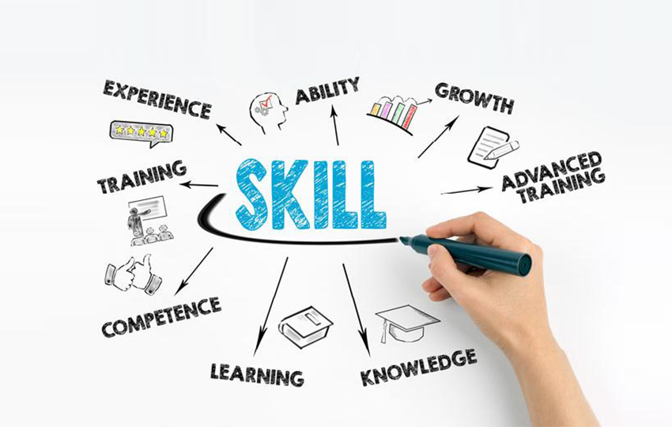

SKILLS

My skills are:
- Self-management - my ability to plan and manage many of my work assignments and tasks, to prioritise myself and adapt to changing working environments.
- Being concise – I am able to filter through all the information that floods us and select the most important
- Friendliness and kindness - the ability to get along well with colleagues and build excellent relationships with everyone
- I am capable of understanding and interacting with people from different cultures in an authentic and positive way; I know how to work effectively and feel good in a different culture other than mine.
- I am a punctual person. As Durkheim, Clayman (1989, p. 660) ³ says “As a general principle, organized social life requires that human activities be coordinated in time”. According to Basu (2002) and Weibull (2002) ⁴ “A person's punctuality is ,also, noted to make life easier for those who they interact with.”

Skills I need to work on:
- Effective communication skills - This skill includes several other skills - listening, speaking and writing skills. I have to learn to correctly interpret what others say, and to organise and express clearly my thoughts in different forms (presentation, discussion, negotiation, email communication, etc.).
- Stress management - develop my ability to recover from failures, learn from them and find ways to get the best out of every situation.
- Adaptability to new ideas and concepts - I have to learn how to deal with the constant changes around me.

Everyone who wants to be a successful manager in today’s competitive world is essential to be able to identify their strengths and weaknesses, as well as the opportunities and threats that are presented. This can be made with the help of SWOT analysis and we can use it as a starting point for a successful career and personal life.

SWOT

SWOT is an abbreviation for Strengths, Weaknesses, Opportunities and Threats. When we recognize these four aspects, we can use them to our advantage. Through SWOT analysis we can see our current skills, improve them and achieve our goals in both the professional and private life. If we can identify, clearly, what our strengths and opportunities are and identify our weaknesses we will know where to tread with confidence and security. In this way, we are able to respond adequately to any situation. Then we can manage and eliminate threats that might impact our ability to move forward. We have to learn how to transform weaknesses into strengths and how to transform threats into opportunities which is much harder to do in real life than to write it down.
Marty Neumeier ⁵ in his book “The 46 Rules of Genius” explains to convert a weakness into a strength. He said: “A good personal style will mostly come from your limitations, not your strengths. It’s the result of working around your shortcomings, using all the skills you can muster. Since your limitations are unique to you, your style will also be unique.”
Following the SWOT model and analysing my strengths and weaknesses along with opportunities and threats to enhance my skills and experience, I did the following personal SWOT analysis:
Strengths - Internal positive aspects | Weaknesses - Internal negative aspects
Solving problems  Team worker  Ability to learn  Self-discipline  Optimism and enthusiasm  Time management  Ability to ask the right questions to find the right answers | Innovative and adaptive thinking  Creative thinking  Leadership skills  Lack of work experience or relevant experience  Lack of education  Uncomfortable speaking in front of groups English is not my first language
Opportunities - Positive external conditions | Threats - Negative external conditions
High demand of professionals  Opportunities I could have if I improve my education and social skills.  Availability of local or global employers’ support  The current economic climate has led to the rapid growth in the hotel and hospitality industry. | Opposing competition  Competition from employees with better education  Tough taxation  Access to free training

Once I have analysed my own strengths, weaknesses, threats and opportunities, I should use this information to create an action plan: what and in what order should I do to achieve the main goal of becoming a good manager. This is called a Personal Development Plan.

PERSONAL DEVELOPMENT PLAN

According to The Employability Guide from the University of Bolton's Careers Service's (undated (c. 2012), p. 6) ⁶ Personal development planning is “a process that allows you to think about, and then record, your skills, achievements and learning outcomes. By completing it you will identify which areas you need to develop further, helping you to plan for your future and your career.”
The Personal Development Plan is a process that involves defining what is important to me; what I want to achieve; the strengths which will help me achieve my goals; and what I need to improve and develop over time.
People have different ambitions and career goals. One of the most important things we can do is to take time to plan for them.
Thinking about my future life I will try to build my personal development plan.

 | Short term | Mid term | Long term
Goals to achieve | 1. Speaking in front of many people  2. Improve my English  3. Being a leader  4. Open- mined person | 1. I will graduate from UWTSD with a Bachelor's of International Hotel Management  2. I will make a list of 10 hotels that I would like to work for and I will apply to two new hotels every week until finding a job  3. I plan to continue to attend UWTSD to earn my MBA | 1. I plan on being a manager in a hotel.  2. I will have opened my own hotel.
Skills and knowledge I will learn | 1. Reading and writing skills  3. Communication skills  4. Innovative and adaptive thinking | 1. Employability skills  2. Skills to manage my time  3. Commitment  4. Knowledge on health and safety | 1. Leadership skills  2. Manager skills
How to acquire them | 1. Writing e-mails, reading books  2. Communication through social media  3. Meetings with different people  4. Doing a language course | 1. Participation in numerous university organisations and business events  2. Work placement at Marriot hotel | 1. Become a member of a team  2. Patience and waiting for the right moment  3. Understanding of Laws
Resources | 1. School projects  2. Books, magazines  3. Online lessons | 1. Hotel research  2. Guidance  3. Finance | 1. Team working  2. EBooks  3. Finance  4. Economic environment
Start date | Now | June 2019 | 2022
Finished date | Anytime in the near future | Complete by June 2022 | Anytime in the next 10 years
Since my long-term career goal is to hold a management position, achieving it may take me from 6 months to more than 5 years. To achieve this type of goal, I need to set a series of short-term goals to improve my leadership skills.

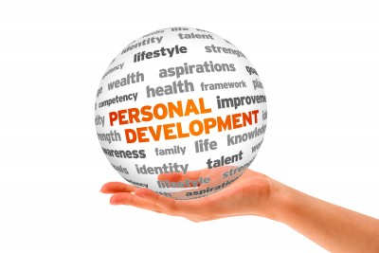

CONCLUSION

During my work, on this report I made a personal SWOT analysis on my academic and employability skills and I found which experience actually made me become more competitive on the job market. After that, I made my Personal development plan which made me feel excited and ready to overcome any challenge. I will follow this plan and I hope it would help me to improve my skills after I complete it. I am sure in what I am doing and that will give me more confidence in following my path career to get a good job in the hotel and hospitality industry.
Anatole Franc, critic writer, from an introductory speech at a session of the Académie Française, December 24, 1896 ⁷ said “To accomplish great things, we must not only act, but also dream; not only plan, but also believe.”
I believe that the success of my career is personal. Professional development requires time and energy, and sometimes it takes me out of my comfort zone. If I have the habits constantly watching myself, analysing others and myself and studying new things, I'm more likely to continue my career, and improve my ability to find new, good job.



REFERENCES

¹ Yorke, M. (2004), Employability in higher education: what it is - what it is not, The Higher Education Academy/ESECT
²Gualco, D. (2016). The Good Manager: A Model for the Twenty-First Century. New York: iUniverse.
³ Clayman, S. (1989), ‘The Production of Punctuality: Social Interaction, Temporal Organization and Social Structure,’ American Journal of Sociology, vol. 59, 659-91.
⁴ Basu, K. and Weibull, J. (2002). Punctuality: a cultural trail as equilibrium. Cambridge, MA: Massachusetts Institute of Technology, Dept. of Economics, Working Paper, 2(26), 1-19
⁵ Neumeier, M. (2014). The 46 rules of genius. [Thousand Oaks, California]: New Riders
⁶ Harvey, L., 2004-19, Analytic Quality Glossary, Quality Research International, http://www.qualityresearchinternational.com/glossary
⁷ France, A., Jackson, W. and Jackson, E. (2010). The works of Anatole France in an English translation. [Charleston, S.C.]: BiblioLife.

Pictures:
Zoyafitfanatic.com. (2019). [online] Available at: http://zoyafitfanatic.com/wp-content/uploads/2012/10/goals-675x320.jpg [Accessed 8 Jul. 2019].
Ied.eu. (2019). [online] Available at: https://ied.eu/wp-content/uploads/2018/08/skill.png [Accessed 10 Jul. 2019].
Hilltopcentre.org.uk. (2019). [online] Available at: http://www.hilltopcentre.org.uk/wp-content/uploads/2014/05/parenting-personal-development.jpg [Accessed 10 Jul. 2019].
Professionalacademy.com. (2019). [online] Available at: https://www.professionalacademy.com/media/images/Personal-development-plan-template.jpg [Accessed 10 Jul. 2019].

